R.I.P.D
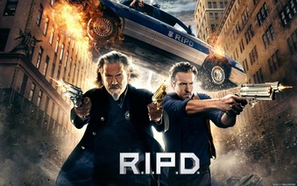
Family Movie: | HIS | HER | AVG
1. Appropriate for teenagers (eg. language, sexuality, violence)? | 8 | 7.5 | 7.75
2. Entertainment value for girl teenagers (12 and up)? | 7.5 | 7 | 7.25
3. Entertainment value for boy teenagers (12 and up)? | 7.5 | 7.5 | 7.5
4. Entertainment value for adult females? | 6.5 | 6.5 | 6.5
5. Entertainment value for adult males? | 6.5 | 6.5 | 6.5
6. Teaching moments, role models, moral of story? | 7.5 | 7.5 | 7.5
7. Is it a “classic”? (Replay value?) | 7 | 6.5 | 6.75
8. Audio/Visual effects? | 7.5 | 7.5 | 7.5
9. Not too cliché (unique and witty, not too slapstick) | 6 | 6 | 6
10. Climax/Resolution/Ending? | 7 | 7 | 7
GRAND TOTALS: |  |  | 70.25%

His Thoughts: Was this movie great? No… Was this movie a classic? No way… Was this movie the worst movie you have ever seen? No… The problem with this movie is that it was marketed like MIB was, towards teenager-middle age youngsters. RIPD is a movie that would find its most captive audience being people aged 8-16 and it was not marketed as such. Older people are going to this movie expecting a MIB movie and are leaving thinking it was one of the worst movies of the summer. You know another movie that suffered the same fate, The Last Airbender (Avatar). That movie was seen mostly by people too old to actually enjoy said film as well. Bottom line is that this movie would actually really be enjoyed by a younger crowd and is only being watched by older people either saying it was “so-so” or the worst movie of the summer. Nothing that bad in this movie, but marketed towards the wrong crowd.
Her Thoughts: The previews made this movie look like it was going to be fun, kind of like Men in Black (cops killing weird alien creatures). However the previews were actually better than the movie itself! Like Micah said, the movie may have appealed to teenage boys, but I think for everyone else it fell flat. Nothing to really keep an adult interested in the story, jokes were weak, and the romantic plot was pretty weak as well. So-So at best, maybe rent it or watch it for free on tv.

