SPY
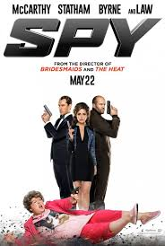

Grown–up’s Movie: | HIS | HER | AVG
1. Appropriate levels of sexuality? | 5 | 5 | 5
2. Appropriate levels of language? | 6 | 6 | 6
3. Appropriate levels of violence? | 9 | 9 | 9
4. Entertainment value for females? | 8 | 7 | 7.5
5. Entertainment value for males? | 7 | 7 | 7
6. Teaching moments, role models, moral of story? | 5 | 5 | 5
7. Is it a “classic”? (Replay value?) | 5 | 5 | 5
8. Audio/Visual effects? | 5 | 5 | 5
9. Not too cliché (unique and witty, not too slapstick) | 5 | 5 | 5
10. Climax/Resolution/Ending? | 7 | 7 | 7
GRAND TOTALS: |  |  | 61.5%

