THE SHAPE OF WATER
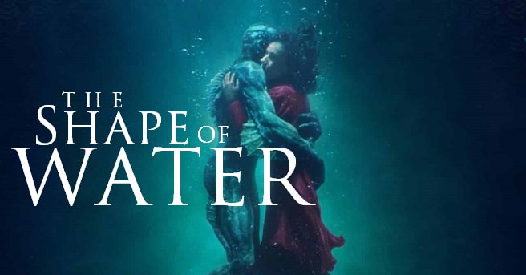
Grown–up’s Movie: | HIS | HER | AVG
1. Appropriate levels of sexuality? | 3 | 3 | 3
2. Appropriate levels of language? | 9 | 9 | 9
3. Appropriate levels of violence? | 8 | 8 | 8
4. Entertainment value for females? | 8.5 | 8.5 | 8.5
5. Entertainment value for males? | 5 | 5 | 5
6. Teaching moments, role models, moral of story? | 0 | 0 | 0
7. Is it a “classic”? (Replay value?) | 7 | 7 | 7
8. Audio/Visual effects? | 8.5 | 8.5 | 8.5
9. Not too cliché (unique and witty, not too slapstick) | 0 | 1 | 0.5
10. Climax/Resolution/Ending? | 3 | 3 | 3
GRAND TOTALS: |  |  | 52.5%

