CINDERELLA
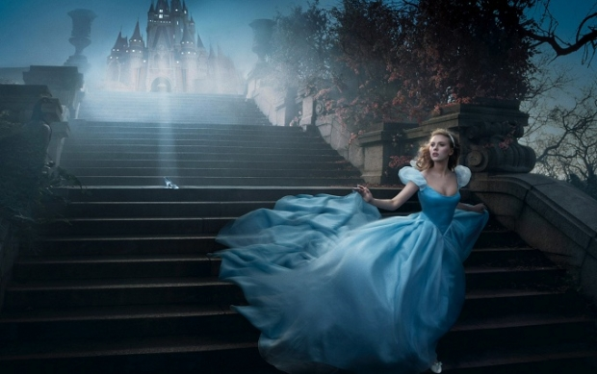
Kids and Family Movie: | HIS | HER | AVG
1. Is it a “Kids Friendly” movie? (eg. not scary, no cursing, sexuality) | 9 | 9 | 9
2. Entertainment value for children 12 and under? | 8.5 | 8.5 | 8.5
3. Entertainment value for teenagers? | 8.5 | 8.5 | 8.5
4. Entertainment value for parents? | 8.5 | 8.5 | 8.5
5. Entertainment value for males? | 8 | 8 | 8
6. Entertainment value for females? | 9 | 9.5 | 9.25
7. Teaching moments, role models, moral of story? | 10 | 10 | 10
8. Is it a “classic”? (Replay value?) | 10 | 10 | 10
9. Audio/Visual effects? | 8.5 | 8.5 | 8.5
10. Not too cliché (unique and witty, not too slapstick or potty)? | 8.5 | 8.5 | 8.5
GRAND TOTALs: |  |  | 88.75%

