DRAFT DAY
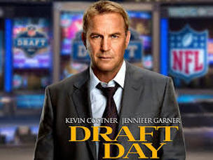
Family Movie: | HIS | HER | AVG
1. Appropriate for teenagers (eg. language, sexuality, violence)? | 9.5 | 9.5 | 9.5
2. Entertainment value for girl teenagers (12 and up)? | 7 | 7 | 7
3. Entertainment value for boy teenagers (12 and up)? | 7 | 7.5 | 7.25
4. Entertainment value for adult females? | 8 | 8 | 8
5. Entertainment value for adult males? | 8 | 8 | 8
6. Teaching moments, role models, moral of story? | 7.5 | 7.5 | 7.5
7. Is it a “classic”? (Replay value?) | 6 | 6 | 6
8. Audio/Visual effects? | 7 | 7 | 7
9. Not too cliché (unique and witty, not too slapstick) | 6 | 7 | 6.5
10. Climax/Resolution/Ending? | 7.5 | 7.5 | 7.5
GRAND TOTALS: |  |  | 74.25%

His Thoughts: Guys: they do not explain anything in a way that your girls who don’t know anything about football or “the draft” will understand a thing that is happening. Girls: instead of actually explaining the process a bit for all of us, they instead decide to just add in a ridiculous half desperate love story while sprinkling some family drama on the top to try and keep you interested. What we end up getting in the end are some confused guys who don’t understand why half of that crap was even in the movie and some other insulted girls who actually would have just preferred that you just explain the freaking process of “the draft” and stay on point- women are not that easy to please! It delivered a so-so movie that you won’t be able to convince yourself to ever go back and see. Why? For the love story? For the family drama? For the football/draft aspects of it? By trying to please everyone in cheap flat uninspiring ways, Hollywood has once again created a movie that only manages to satisfy the very simple.
Her Thoughts: I'm not a huge sports movie fan but I love football movies! They are always just so exciting- the love that people have for the sport is contagious :) I liked, not loved, this movie. Like Micah said, they added some needless drama into it when what they should have done was explain the draft process for those of us who don't know! I turned to Micah quite a few times to ask questions- a movie about draft day should really explain what draft day is and the process behind it! Not very well thought out, this movie was good but not great. I would say rent it.

