INSIDIOUS 2
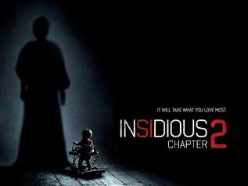
Family Movie: | HIS | HER | AVG
1. Appropriate for teenagers (eg. language, sexuality, violence)? | 9 | 9 | 9
2. Entertainment value for girl teenagers (12 and up)? | 8 | 8.5 | 8.25
3. Entertainment value for boy teenagers (12 and up)? | 8 | 8 | 8
4. Entertainment value for adult females? | 8 | 8.5 | 8.25
5. Entertainment value for adult males? | 8 | 8 | 8
6. Teaching moments, role models, moral of story? | 7 | 7 | 7
7. Is it a “classic”? (Replay value?) | 9 | 9 | 9
8. Audio/Visual effects? | 8 | 8 | 8
9. Not too cliché (unique and witty, not too slapstick) | 7 | 7.5 | 7.25
10. Climax/Resolution/Ending? | 8 | 8.5 | 8.25
GRAND TOTALS: |  |  | 81%

His Thoughts: This movie adds to the first movie, but does it in a way that will make re-watching the first movie a lot less scary; don’t know if that is a bad thing or a good thing? I did enjoy Insidious more than I enjoyed watching The Conjuring, but I enjoyed watching The Conjuring more than Insidious 2… Basically they tried to do (or are trying to do) with this series what become of Saw and Paranormal Activity; change the core formula that made the first work, gut the plot and send a half a dozen of them down the chutes before people realize what we have done. The end of the movie gave me some hope however with the story changing from just “one family” over to another family- meaning they can set the next movies up like the X-Files and Supernatural did (before they both started to suck) with a bunch of individual fun cases (which are always better than following one family or one storyline) that could make each new movie fun and unique, but who knows. All in all this was a relatively fun movie that is much cleaner and appropriate than any of the Paranormal Activity movies.
Her Thoughts: I really liked the first Insidious, definitely in my top 3 favourite scary movies. Insidious 2 was good- it finished up the storyline from the first movie which had left you with a cliff hanger. I'm glad they brought back all of the original cast in this one- seems like they had filmed it right after Insidious because the kids didn't look any older. It's the perfect scary movie with nothing offensive (like bad language or nudity or gore) but it is still scary! Can't wait for the next one! Overall, not as good Insidious or even The Conjuring but still worth seeing!

