PARANORMAL ACTIVITY 5: THE MARKED ONES
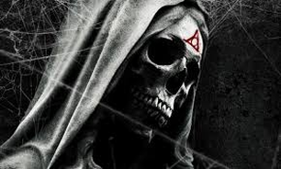

Grown–up’s Movie: | HIS | HER | AVG
1. Appropriate levels of sexuality? | 7.5 | 7.5 | 7.5
2. Appropriate levels of language? | 6.5 | 6.5 | 6.5
3. Appropriate levels of violence? | 8 | 8 | 8
4. Entertainment value for females? | 7 | 6 | 6.5
5. Entertainment value for males? | 5 | 5 | 5
6. Teaching moments, role models, moral of story? | 7 | 7 | 7
7. Is it a “classic”? (Replay value?) | 8 | 8 | 8
8. Audio/Visual effects? | 6 | 6 | 6
9. Not too cliché (unique and witty, not too slapstick) | 5 | 5 | 5
10. Climax/Resolution/Ending? | 5 | 5 | 5
GRAND TOTALS: |  |  | 64.5%

His Thoughts: I honestly don’t even know why Ashley put this on the website; this movie was total trash. It wasn’t “paranormal” at all. This was a terrible version of the Blair Witch Project (which was awful) so this movie was a terrible version of a terrible movie… There is nothing good to say about this movie. Full frontal nudity, not clean in the slightest, boring, people were literally laughing the whole way through, there was not an original idea in the whole movie, not a real scary moment from start to finish… This might be contender for worst movie of the year…
Her Thoughts: This movie was absolutely terrible! I don't even know how it got made... Was so dumb, not scary at all and half of the movie was in Spanish. Skip this movie at all costs!!

