ROBOCOP (2014)
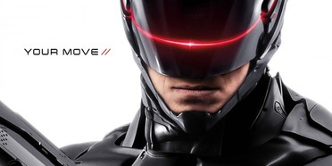
Family Movie: | HIS | HER | AVG
1. Appropriate for teenagers (eg. language, sexuality, violence)? | 8 | 8 | 8
2. Entertainment value for girl teenagers (12 and up)? | 7 | 7 | 7
3. Entertainment value for boy teenagers (12 and up)? | 8 | 8 | 8
4. Entertainment value for adult females? | 6.5 | 6.5 | 6.5
5. Entertainment value for adult males? | 7.5 | 7 | 7.25
6. Teaching moments, role models, moral of story? | 6 | 6 | 6
7. Is it a “classic”? (Replay value?) | 7 | 7 | 7
8. Audio/Visual effects? | 7 | 7 | 7
9. Not too cliché (unique and witty, not too slapstick) | 5 | 5 | 5
10. Climax/Resolution/Ending? | 5 | 5 | 5
GRAND TOTALS: |  |  | 66.25%

His Thoughts: Wow did this movie take cliché to a whole new level. You know the movie The Incredibles? Samuel Jackson plays the black “ice man” named Lucius in the movie. In the movie this conversation takes place:
Lucius: [Bob and Lucius are sitting in a parked car, reminiscing] So now I'm in deep trouble. I mean, one more jolt of this death ray and I'm an epitaph. Somehow I manage to find cover and what does Baron von Ruthless do?
Bob: [laughing] He starts monologuing.
Lucius: He starts monologuing! He starts like, this prepared speech about how *feeble* I am compared to him, how *inevitable* my defeat is, how *the world* *will soon* *be his*, yadda yadda yadda.
Bob: Yammering.
Lucius: Yammering! I mean, the guy has me on a platter and he won't shut up!
This happens in Robocop, not just once, not twice, I mean this literally happens at least three times, and the funniest part? Samuel Jackson is IN Robocop! Needless to say, they made “the smartest possible ‘Robocop’ while making the dumbest plot possible…” This movie was so-so at best.
Her Thoughts: I did not see the original Robocop movie so I can't compare it to that. But compared to other action movies of our time this one was pretty cliché. It was interesting to see how they made him into Robocop but the story was terrible! You could skip this movie and not miss anything at all.

