Temporal Salvation
After going over the parable of the 10 virgins in detail, I feel it important to make this video. In summary, why is a food storage important? Jesus said speaking of the time period of the 10 virgins, the time period of the redemption of Zion and building of New Jerusalem would be “as the days of Noah were.” Noah preached for around 120 years and then was in his ark eating his food storage for the next year. Joseph Smith taught that in the days of Noah the world was baptized by water and in the days to come the world will be baptized by fire. The destroying angels commissioned of the Lord brought the flood and destroying angels commissioned of the Lord will bring the fire.
In 1894 President Woodruff said: “God has held the angels of destruction for many years, lest they should reap down the wheat with the tares. But I want to tell you now, that those angels have left the portals of heaven, and they stand over this people and this nation now, and are hovering over the earth waiting to pour out the judgments. And from this very day they shall be poured out. Calamities and troubles are increasing in the earth, and there is a meaning to these things.
Remember this, and reflect upon these matters. If you do your duty, and I do my duty, we'll have protection, and shall pass through the afflictions in peace and in safety. Read the scriptures and the revelations. They will tell you about all these things. Great changes are at our doors. The next twenty years will see mighty changes among the nations of the earth. You will live to see these things, whether I do or not.” (Wilford Woodruff, Collected Discourses 1888 - 1898, speech given June 24, 1894).
As in the days of Noah, the warning that the destroying angels had been released and would continue to pour out destruction increasing and climaxing 120 years later in the flood, the warning went out for us around 1894. 120 years later of warnings from the prophets puts us at around 2015. Why is this year important? The Lord said he would not sweep us off the land until we are “fully ripe in iniquity.” 2 Nephi 30:10 says: “For the time speedily cometh that the Lord God shall cause a great division among the people, and the wicked will he destroy; and he will spare his people, yea, even if it so be that he must destroy the wicked by fire.” And the reference below for this verse takes you to D&C 63:54: “And until that hour there will be foolish virgins among the wise; and at that hour cometh an entire separation of the righteous and the wicked; and in that day will I send mine angels to pluck out the wicked and cast them into unquenchable fire.” These two scriptures bring us full circle to an understanding of the 10 virgins, separation etc. We are missing one piece of the puzzle though- what makes us fully ripe in iniquity and what does it mean to be destroyed by fire and are the two related? The answer is yes. “And that the whole land thereof is brimstone, and salt, and burning, that it is not sown, nor beareth, nor any grass groweth therein, like the overthrow of Sodom, and Gomorrah, Admah, and Zeboim, which the Lord overthrew in his anger, and in his wrath” (Deut. 29:23). The Bible Dictionary further explains “The fate of [these cities] was regarded as a warning against sensual wickedness.” So what happened in 2015 almost exactly 120 years after President Woodruff’s warning? The United States legalized homosexual marriage. I recommend reading my paper/watching my video “Rebellion vs Weakness”- this is a pure act of rebellion of one of the worst sins, a trump King card. The wickedness of people is now ripe and the cup of the Lord’s wrath is approaching full. And exactly as President Woodruff prophesied, the next 20 years will see “mighty changes among the nations of the earth”, we will once again see a multiple fulfillment of this from the years 2015-2035.
Ezra Taft Benson summarized the responsibilities of parents (especially those resting upon men) as the three great necessities of life: food (water), clothing (hygiene), shelter (protection). Parents will not be accountable before the Lord on their children’s education fund, health insurance, etc. Parents however will be held accountable on not only if they provided theses three necessities but if they had prepared and saved against the season.
There are those that think that they can be “righteous”, according to their standards, and that the Lord will “rain manna down from heaven.” This doctrine is terrifyingly scary, terrifyingly incorrect, and terrifyingly damning (I’d suggest watching or reading my Parable of the 10 Virgins which goes over the primary interpretation of that parable). If this is you, don’t be offended, you are as your fathers who made the same mistake. What am I referring to? The first time the Saints attempted to redeem Jackson County and to build Zion. The manual summarizes this failure crystal clear:
(17-19) Isaiah 52:11–12. Why Does the Lord Counsel That the Departure from Babylon Be Not “with Haste”?
In language closely parallel to Isaiah’s, the Doctrine and Covenants explains that the Lord’s servants, those who “bear the vessels of the Lord” (D&C 133:5), are to flee from Babylon, which is defined as “wickedness, which is spiritual Babylon” (D&C 133:14). Then follows what is almost a direct quotation of Isaiah 52:12 with the additional admonition to “let all things be prepared before you” and to “not look back lest sudden destruction come upon [you]” (D&C 133:15). This addition clarifies Isaiah’s command. He admonished Israel to gather (depart from wickedness) but in an orderly manner under the Lord’s direction. Had the early Saints of this dispensation observed this direction to the letter, their flight to Zion in Missouri and the events that followed might have turned out differently (see D&C 58:56; 63:24; 101:67–68, 70, 74). The presiding elders in Missouri issued the following counsel in July of 1833:
“For the disciples to suppose that they can come to this land without ought to eat, or to drink, or to wear, or anything to purchase these necessaries with, is a vain thought. For them to suppose that the Lord will open the windows of heaven, and rain down angel’s food for them by the way, when their whole journey lies through a fertile country, stored with the blessings of life from His own hand for them to subsist upon, is also vain. For them to suppose that their clothes and shoes will not wear out upon the journey, when the whole of it lies through a country where there are thousands of sheep from which wool in abundance can be procured to make them garments, and cattle upon a thousand hills, to afford leather for shoes, is just as vain. …
“… Do not conclude from these remarks, brethren, that we doubt in the least, that the Lord will provide for His Saints in these last days; or think that we would extend our hands to steady the ark; for this is not the case. We know that the Saints have the unchangeable word of God that they shall be provided for; yet we know, if any are imprudent, or lavish, or negligent, or indolent, in taking that proper care, and making that proper use of what the Lord has made them stewards over, they are not counted wise; for a strict account of every one’s stewardship is required, not only in time, but will be in eternity. Neither do we apprehend that we shall be considered putting out our hands to steady the ark of God by giving advice to our brethren upon important points relative to their coming to Zion, when the experience of almost two years’ gathering, has taught us to revere that sacred word from heaven, ‘Let not your flight be in haste, but let all things be prepared before you.’” (History of the Church, 1:382–83.)
Another bit of what I believe to be crucial evidence to support the claim that we need to prepare and we need to prepare NOW is this: in Ether 13 we are taught that the time period directly before, during, and after the redeeming and building of New Jerusalem will be as the days of Joseph being sold into Egypt, for Joseph being sold into Egypt was “a type” of this to come. The story of Joseph goes, he was in a foreign land and he had seven years to prepare with economic and food being the focus and then there was 7 years of economic and food famine. Two years into the famine Joseph’s brothers (10 tribes) returned and lived in the foreign land with Joseph. In 2014 President Monson penned a First Presidency Message for the Ensign, “Are We Prepared?” At around the same time the Church created its new Self Reliance program; I would suggest if people have the time to read both this talk as well as read the “Personal Finances for Self-Reliance” manual. With that in mind, what President Nelson said in 2019 should send shivers up your spine, “time to prepare is running out.” There is evidence to support the early signs of this economic and famine that will shortly be upon us; floods in China, locusts in Africa are but precursors.
Now that we understand why preparing for temporal salvation is crucial at this moment more than ever, let us shift gears to what we should do about it.
In this paper I will just be addressing the first great necessity of life discussed by President Benson, that is the necessity of food/water. Before I even start, this is written from a perspective of non-farm steading, which is the ideal, but which the majority of members are not currently doing. If you are growing and eating all of your own food and have a potential to maintain that, you are already living after the manner of happiness. For everyone else:
Storage
Food Storage:
One of the most important pieces of information that you need to digest before starting your food storage is given by Harold B Lee:
“Perhaps if we think not in terms of a year’s supply of what we ordinarily would use, and think more in terms of what it would take to keep us alive in case we didn’t have anything else to eat, that last would be very easy to put in storage for a year … just enough to keep us alive if we didn’t have anything else to eat. We wouldn’t get fat on it, but we would live; and if you think in terms of that kind of annual storage rather than a whole year’s supply of everything that you are accustomed to eat which, in most cases, is utterly impossible for the average family, I think we will come nearer to what President J. Reuben Clark, Jr., advised us way back in 1937.” (In Welfare Conference, 1 October 1966.)”
So what is the cheapest, more efficient food storage designed to keep us alive and as healthy as possible?
First, I would like to go over some common recommendations and their pros and cons.
- Buckets of MREs (Meals, Ready-to-Eat)
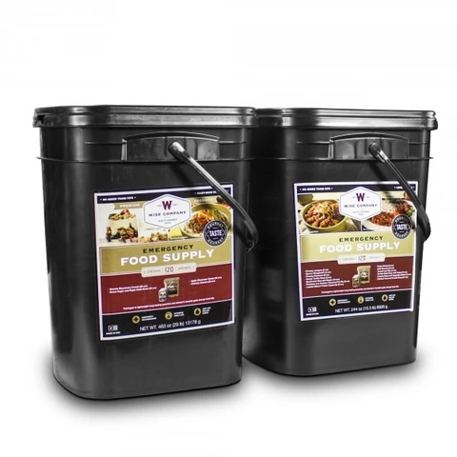
  - Pros:
    - easy to carry: most come in a bucket with a handle and the weight is reasonable
    - waterproof: most come in a bucket that is waterproof
    - long life expectancy: most of these have a shelf life of 10-25 years
    - wide variety: most of these come with a wide range of food stuffs
  - Cons:
    - Cost: this is what kills this one and makes it unfeasible for the general household. Most buckets at 1200 calories a day will last you 2 weeks and costs you over $100, which would cost you more than $7/day per person or over $200/month per person or more than $2500/year per person. A year’s food storage for a family with 4 children would be over $15,000- this is beyond the reach of most members.
    - Space: Although easy to carry, the buckets themselves take up space, making it one of the most space consuming options. Your entire basement or garage would be full of these.
    - Difficulty of cooking: many of these contain such things as pancakes or macaroni and cheese which sounds good on paper but if you were in a severe situation with limited means of cooking, if you for example burnt your pancakes, there goes your meal.
    - Varying nutritional benefit: depending on what you buy the minerals/vitamins vary greatly. If they have been enriched expect the cost to be even more.
    - Accessibility: as of 2020, you might not be able to get your hands of them, almost all online sites have these on backorder. So even if you have the money you might not be able to buy/get them before calamity strikes.

- Bags of Rice and Flour
  - Pros:
    - Cost: Cheaper than MRE, Cheapest available ($0.50/day per person)
    - Accessibility: Locally available
    - Space: amount of space it takes up is small if you keep in large bags (can be easily stacked)
  - Cons:
    - Not waterproof
    - Nutritional value: Even if you get enriched flour, you will never get all the minerals and vitamins you need, so you will need to supplement with vitamins and possibly even protein (we will get to this later)
    - Taste: Biggest con- this is awful to eat.
    - No variety: by far the worse- you will have to boil the rice or flour- if you try to make a pancake out of flour you could ruin it- so rice in water or flour in water is what you will be eating.
    - No Transport: very difficult to move, bags can rip
    - Longevity: pests can easily get in

- Cans of Flour and Rice
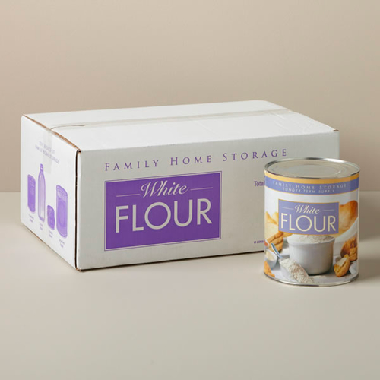

  - Pros:
    - Cost: cheap but obviously not as cheap as bags ($1.20/day per person)
    - Shelf Life: can last 10-20 years
    - Transport: If you keep it in the box the cans come in then it is relatively easy to carry if you are strong. But if the box gets wet then the cardboard is ruined.
  - Cons:
    - Storage: The cans are round which means that you lose the space in the corners when storing on a shelf, and you also lose the space of each can itself- it actually works out to be less space conducive than the MREs and even worse for transporting (because one #10 can on the church website is around 5lbs of flour, which is 16-17 cups, which would only last 5 days for 1 person eating their 1200 calories a day. Which would mean a couple would need 36 cans to last just 3 months. This would be impossible to transport in an emergency without the box). Storage is better if you leave it in the box the cans come in
    - Non-waterproof cardboard
    - Need can opener to open and there is no way to reseal it (Meaning you open your can and your flour will be blowing everywhere in the woods)
    - Nutritional value: Even if you get enriched flour, you will never get all the minerals and vitamins you need, therefore will need to supplement with vitamins and possibly protein
    - Taste: Biggest con- this is awful to eat.
    - No variety: by far the worse- you will have to boil the rice or flour- if you try to make a pancake out of flour you could ruin it- so rice in water or flour in water is what you will be eating.
    - Transport: If you are moving this in the box and you are physically weak, this will be difficult (one box is around 35lbs)

After going over these options I want to talk about the best options I have found and why I find them to be the best.
- If you are not moving, if you plan on being stationary:
  - Hopper Bottom Grain Silo (fed from top, comes out bottom) filled with grain.
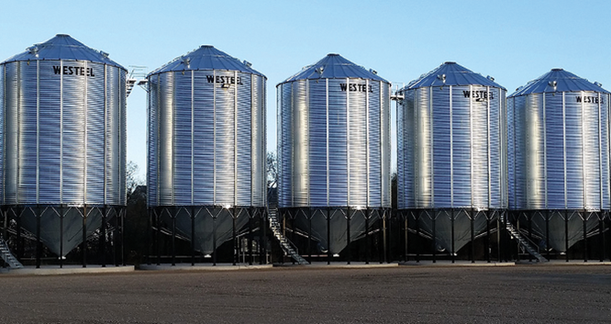
    - Pros:
      - Cost: unbelievably cheap, even cheaper than flour
      - Space efficient: the space is out of your home and is protected.
      - Longevity: Rodent-proof, Weather-proof, lasts years and years
      - Usability: “rotates” automatically (new grain goes in top and oldest grain comes out bottom)- meaning once it is set up you can just fill up every year.
      - Amount: Can store enough for a large family for over 5 years
      - Versatility: you are stuck, just like with flour, with not very diverse meals. However if you have enough grain, you can add a cow, or a goat or chickens (that eat grain) and use them to add huge variety in what you are eating. This is almost a pre-requisite before you seriously get into farm steading.
    - Cons:
      - No transport: this is not moving. If you try to take a load out in your truck and it rains then you are in trouble
      - Cost: upfront cost for the hopper, however there are a lot of silos you can buy used to reduce this cost
      - Location: might not be able to do in the city (local/municipal restrictions)

- All around best choice
  - Top Ramen + Vitamins: to get 1200 calories you would eat 3 packs per day giving you (40g fat, 100% sodium, 160g carbohydrates, 30g protein, 60% iron, 6% calcium, 6% vit A). This would leave you deficient in some vitamins so I would recommend adding: Multivitamins (about $0.05), Calcium (about $0.02), Vitamin D (about $0.05/pill), Vitamin C (about $0.03)

    - Pros:
      - Cost: Top Ramen $0.75/day per person, Vitamins $0.15/day per person, so combined is $0.90/day per person or $330/person/year combined. Substantially cheaper than MRE and also cheaper than canned rice or flour
      - Storage: 2 cases of 24 packs would be equal to most MRE buckets making them smaller (easier to store)
      - Transportable: they are at least 33% lighter than the canned flour/rice. It does take up slightly more space than the canned flour/rice but much easier to carry. It is very easy to get all of your vitamins for a large family and stick them in a duffel bag, making it very easy to transport.
      - Weatherproof: packs come in a box that is wrapped in plastic, so it is waterproof, even the individual packs are in plastic. Vitamins come in waterproof containers.
      - Versatility and Tastiness: Extremely easy to cook, comes in variety of flavors (spices come with package), can choose whether to use seasoning packs or not and use it instead on something else (ie. Fish, rice etc)
      - Extremely easy to ration: you can count how many packs are left!
      - Very easy to build food storage: cost is cheap enough to add to your monthly grocery bill (4 packs per person per month, around $20/person). You can buy a 2 month supply of vitamins at a time until you get a year backup and then do the same thing (buy a month while using the first month you bought) and you will be cycling the year month at a time.
    - Cons:
      - Shelf Life: Most expiry dates are only a year (but expired food is better than no food). Because it doesn’t last 10 years, you will have to rotate your supply. An average size family of 6 (4 kids) would need an area of 28”w x 34”d x 15”h for one month. Or an area 5ft wide, 3 ft deep and 8 ft tall to store a year supply for 6 people. The easiest thing to do would be to build a shelf unit with 12 units and label each unit by month. Tape 4 boxes together (1 month food storage for one person) and write on the box the month you bought them and add 1 year to current date. Put it in that month’s shelf. The next year you get to that date, take the old stuff off (eat or give away) and fill it with new. Continue this rotation. The donating of the food can supplement or even pay your fast offerings; you are commanded to give what your family eats for 2-3 meals- this is what your family would eat for the whole month, you are not commanded to pay for your neighbor’s cell phone bill. This would constitute a very generous fast offering.
- Wild Card: Protein Powder
    - Pros:
      - This will go under a lot of people’s radar- won’t get cleaned out quickly. In a panic, when the stores get cleaned out, for some reason this is missed by the masses.
      - Pure protein: protein is primarily responsible for your immune system. Having a solid source of protein in your diet will keep your immune system up. Protein deficiencies will lead to a slow, painful death
      - Pre-packaged flavor: not only is this good for getting a variety of flavors, it can also be added to purified water to hide the taste of it or the purifiers used (eg. Iodine)
      - Solid longevity: come pre-packaged in plastic, waterproof containers with a life expectancy of two years on the bottle (which means in an emergency can be used for longer than that). It also comes in a useful container which can be used once the powder is done in multiple ways (eg. We store our cat food supply in them)
      - Cost: you can get it for $0.50/scoop
      - If your primary food storage is flour this would be a great thing to add- can be mixed together to greatly improve the awful flavor of flour alone and adds nutritional benefits that plain flour is lacking
    - Con:
      - Low calorie: takes up a reasonable amount of space and it is purely supplementary, you won’t be able to get enough calories to survive off of as your only source of food storage
Water Storage:
- Drums (55 gallon- 2ftx2ftx4ft height)

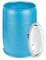
  - Pros:
    - Clean: if storing water ahead of time it will already be purified to a fine degree
    - Water source not required: if city water stops you have enough stored
  - Cons:
    - Cost: 55 gallon drum costs about $50-100 and you will need 2 drums/person/year (1L of water/person/day) = $600-1200 for enough drums
    - Storage space: family of 6 would need twelve 55 gallon drums so you will need a space about 12 ft w x 4 ft d x 4 ft h (far too heavy to stack on top of each other but you could build a table system and slide them under it and then use the table however you see fit)
    - Rotation: can be a lot of work, should be done every 6 months to one year
    - Can’t transport
My thoughts: Best option for large family or anybody not in an apartment. Once a month just go out and empty a couple drums, hose them out and refill.
- 5 gallon Water Jug (costs about $5-10 per jug, need 18 jugs/person/year, shelving unit 2ft w x 2ft d x8ft h with shelves spaced every 2 feet to be able to store 16 of them)
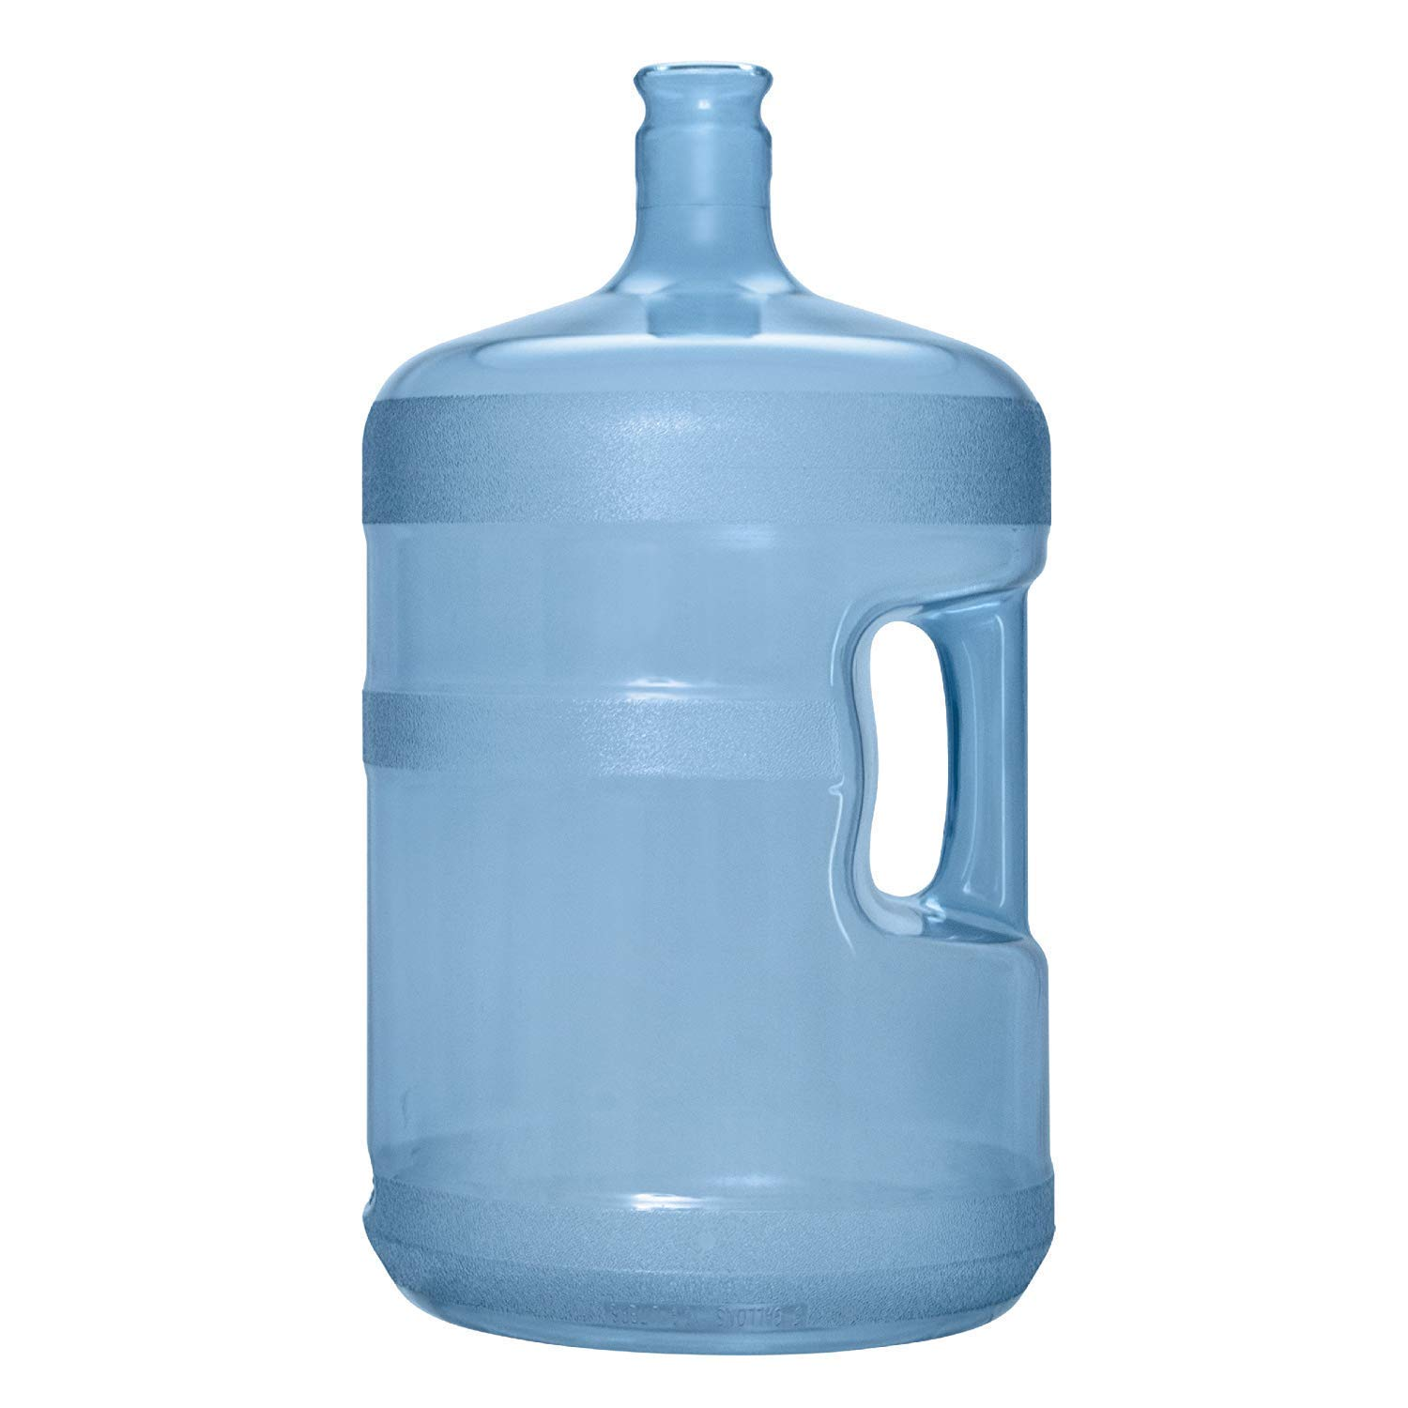
  - Pros:
    - Much easier to cycle your water- when it is empty you can just replace it or refill it
    - Easy to build up over time, relatively cheap
    - If electricity hasn’t gone out you can use in a water dispenser which makes the water cold or hot (can cook soup in the hot water)
    - Heavy but can be transported. If moving in a car can bring with you
    - If you a single or living in the city this might be your only option
  - Cons:
    - The number required: you would need 18 of these per person per year if you were drinking/cooking with 1L per day, for a family of 6 you would need 108, the number is daunting!
    - Unless you build a shelving unit, these will take up a huge amount of floor space. So it will cost you, as you will need materials to build the shelf. For a family of 6, you would need to build 7 shelving units (14ft w x 2ft d x 8ft h)
My thoughts: best option for singles, small families, or people living in an apartment
- Well that is run by manual power or renewable energy: this is just a common well that has either a handle on it that you can manually crank or some form of renewal energy.

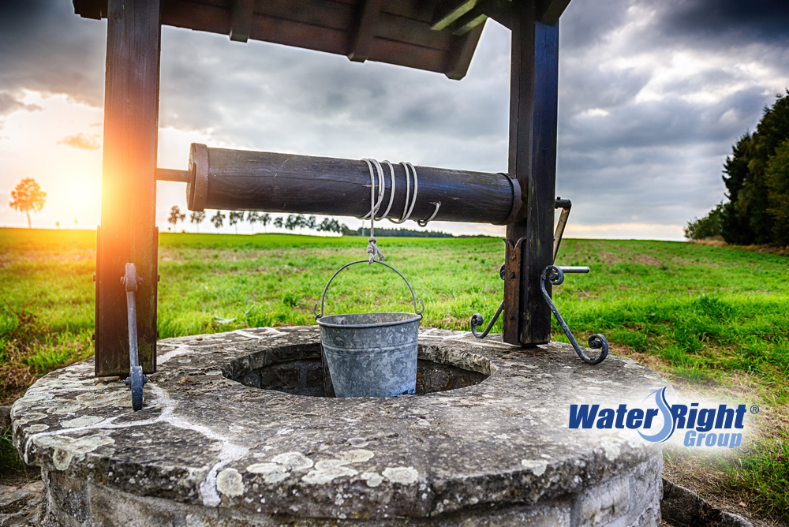
  - Pros:
    - No visible storage space required
    - Relatively clean water
    - Off grid
  - Cons:
    - Cost: if you don’t have a well dug already can be costly, adding a manual pump to a pre-existing well isn’t that expensive. Getting enough renewable energy (ie. Solar) to just power your well isn’t that big of a deal
    - Location: Can’t do in the city
    - Taste: depending on where you are, the taste can be bad for people (iron) vs storing city water in gallons. But versus filtration methods (bleach, iodine) the taste is better
    - One of the repeating themes of signs of the times is that of earthquakes. The first thing to be destroyed in earthquakes is everything in the ground. So if there is a serious earthquake all your pipes are gone.
My thoughts: if you have a well I would call it a bonus but I would never go out of my way to make it. It is too expensive with far too high of a risk that it is just gone. It would make more sense to move on to a property with a lake with the water just sitting there because if something breaks the water is just sitting there vs being trapped beneath your feet.

- Natural water sources (lakes, streams etc)

  - Pros:
    - Natural beauty
    - Massive amounts of stored water
    - Multiple uses of water: because of the abundance can be used for cooking, cleaning and drinking
  - Cons:
    - Purification required: to drink will need to purify
    - Might be seasonal
    - Can be easily contaminated (dead bodies, sewage etc- you don’t know what is happening upstream)
My thoughts: if you can afford to move to a place that has natural water on the property, I would value that. Most people move into a house for vanity sake. If one was willing to sacrifice some (or all) of that vanity, they could obtain untold amounts of security. Saints of God living in vanity should not be fooled into thinking that the Lord, in a crisis, will bless them in their rebellion with the security that they hitherto rejected for vanity.
Produce
Water:
I’m sorry, but when calamity strikes you will not be digging wells, creating distillation chambers etc. You will be getting water from natural sources (river, lake, rain). So how does one take those sources and make them usable?
- Cotton bandana + metal pot + fire: use bandana to filter out large particles, put pot over fire and boil for 1-3 minutes depending on altitude
  - Pros:
    - Cheap
    - Common tools
    - Process can second as cooking (throw in top ramen after it has boiled for 1 minute)
    - If you have a bunch of small cooking containers, each person can easily cook their top ramen in the boiled water
  - Cons:
    - Hot: heat from fire can be exhausting
    - Have to start a fire
    - Taste: can be a problem if you are just drinking
    - If you are using one large pot to boil water for whole family, can be very heavy to transport to fire
    - Time and stationary: takes time to start fire, and can’t bring fire while walking

- Purifiers (iodine or bleach): tincture of iodine (2%= 8 drops/L, 5%= 4 drops/L, 10%= 2 drops/L), bleach (8 drops of Regular Clorox Bleach per gallon (4L) of water)- let sit for 30 minutes
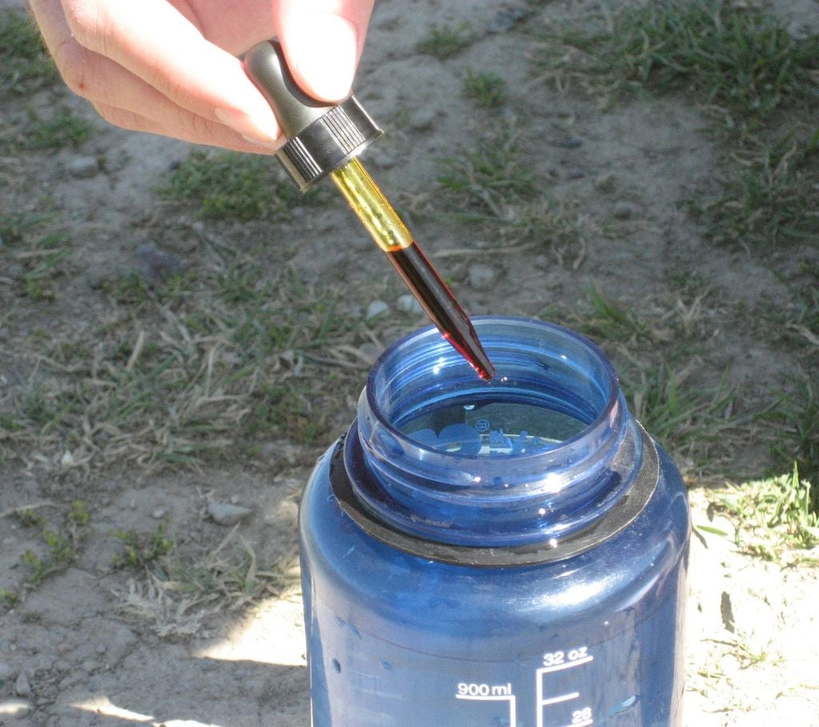
  - Pros:
    - Purifies huge amounts of water (eg. 25ml bottle of iodine could purify 30 gallons)- which means you would need two 25ml bottles/person/year
    - Cheap: around $6/person/year (less than $40 for family of 6)
    - Portable: purifies on the fly (ie. Can add to canteen of 1L and keep walking), lightweight
    - Multiple uses: iodine can also be used to treat wounds, disinfectant for cleaning etc
  - Cons:
    - Taste: can be remedied by using in cooking or adding vit c to water
    - Poisonous: keep out of reach of kids, use proper measurements. Iodine is also flammable

- Filtration systems:
  - Stationary (home filtration systems)
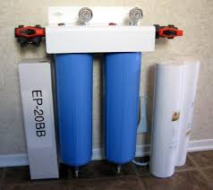
    - Pro: can obtain a very high quality of water
    - Cons: expensive, if water source vanishes system is worthless, requires electricity, minerals etc to run (storing enough system salt or potassium is required), a lot of moving parts (first system to fail)
  - Portable (straws, pumps)
    - Straw:
      - Pros: any water, any time, any where, lasts a full year, cheap, lightweight and space conducive
      - Cons: pure undiluted flavor of the water, once you start using it is “perishable” (lasts about a year), only good for one person (not really shareable)

    - Manual Pump Filter:
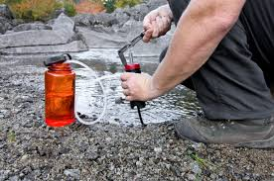
      - Pros: can pump hundreds of gallons before replacing, pumps clean water into another container so can be used for other purposes such as cooking and thus you can add flavor to it (versus straw)
      - Cons: tiring, cumbersome in a backpack, expensive

Food:
This is too dependant on your local area to provide a macro overlay over. Some areas might have fishing, some areas might have natural berries, some areas might have edible scorpions for all I know. For most places in North America, .308 can be used for large game, a 22 LR can be used for small game, a shotgun can be used for fowls, fishing equipment is more abundant than ever with reusable lures (vs. bait). There is also a plethora of reusable traps and the like. Not to mention location vegetation, fruits etc that are edible. Buying or printing off a book with pictures of all the known edible plants and such in your area is not very hard to do.
Like President Monson said, “When the time for decision arrives, the time for preparation is past.” The prophets of God from Joseph Smith to Ezra Taft Benson counselled us to farmstead. That time has passed for most people. We are now in a stage, where I believe, the only thing we have time to do is storage, like Joseph in Egypt. Once that time has passed there will no longer be a time to store and all you will have is the means of gathering. Gathering should not be your primary focus- if you are in that stage it is because everything else has failed. If you are farm steading, storage is already taken care of. If you have stored, gathering is already taken care of. If you have no means to gather then you perish. If you had the means to do and you did not, you have no promise with the Lord. If this is a foreign concept to you, I would recommend watching or reading my video/paper, The Prepared Need Not Fear. The Lord will save us after all we can do. Do you really believe that you can go to the Lord, living in the United States and Canada, and say “I could not maintain/circulate/afford etc $0.55/person/day for water”? Do you really believe that you can go to the Lord, living in the United States and Canada, and say “I could not maintain/circulate/afford etc $0.65/person/day for flour and vitamins”? Do you really believe that you can go to the Lord, living in the United States and Canada, and say “I could not maintain/circulate/afford etc $1.20/person/day to sustain my life for year”? The average minimum wage floats between $6-15 in Canada and the United States. I repeat, the Lord does not hold parents accountable for the number of toys a kid has, the kids having a cell phone, the kids having a laptop, the kids having an education fund, cable, vacations, and on and on and on. The Lord will hold you accountable on two things: the first being what your children are taught (I will get to that in another paper) and the second thing being as Ezra Taft Benson taught, the three great necessities of life: food, clothing and shelter. I will make this bold declaration that any individual who is refusing to take these preparations in the United States and Canada is practicing idolatry in open rebellion. Period. Which is a sin that is far grosser than that of sins of weakness (see Rebellion vs Weakness). There is absolutely no feasible way that a healthy adult, let alone a healthy couple, could not afford $1.20/person/day for food and water storage. Brothers and Sisters, let’s do all we can do so that we can call upon the Lord to save us in our time of need. Otherwise we have no promise.
In the name of Jesus Christ, Amen.
Below is attached President Monson’s talk that I referenced above, for your convenience.
Are We Prepared?
In the vicinity where I once lived and served, the Church operated a poultry project, staffed primarily by volunteers from the local wards. Most of the time it was an efficiently operated project, supplying to the bishops’ storehouse thousands of fresh eggs and hundreds of pounds of dressed poultry. On a few occasions, however, being volunteer city farmers meant not only blisters on the hands but also frustration of heart and mind.
For instance, I shall ever remember the time we gathered the Aaronic Priesthood young men to give the project a spring-cleaning. Our enthusiastic and energetic throng assembled at the project and in a speedy fashion uprooted, gathered, and burned large quantities of weeds and debris. By the light of the glowing bonfires, we ate hot dogs and congratulated ourselves on a job well done.
However, there was just one disastrous problem. The noise and the fires so disturbed the fragile population of 5,000 laying hens that most of them went into a sudden molt and ceased laying. Thereafter we tolerated a few weeds so that we might produce more eggs.
No member of the Church who has helped provide for those in need ever forgets or regrets the experience. Industry, thrift, self-reliance, and sharing with others are not new to us.
We should remember that the best storehouse system would be for every family in the Church to have a supply of food, clothing, and, where possible, other necessities of life.
Of course there may be times when our members are in need of help from the Church. The Lord’s storehouse includes the time, talents, skills, compassion, consecrated material, and financial means of faithful Church members. These resources are available to the bishop in assisting those in need.
We urge all Latter-day Saints to be prudent in their planning, to be conservative in their living, and to avoid excessive or unnecessary debt. Many more people could ride out the storm-tossed waves in their economic lives if they had a supply of food and clothing and were debt-free. Today we find that many have followed this counsel in reverse: they have a supply of debt and are food-free.
I repeat what the First Presidency declared a few years ago:
“Latter-day Saints have been counseled for many years to prepare for adversity by having a little money set aside. Doing so adds immeasurably to security and well-being. Every family has a responsibility to provide for its own needs to the extent possible.
“We encourage you wherever you may live in the world to prepare for adversity by looking to the condition of your finances. We urge you to be modest in your expenditures; discipline yourselves in your purchases to avoid debt. Pay off debt as quickly as you can, and free yourselves from this bondage. Save a little money regularly to gradually build a financial reserve.”
Are we prepared for the emergencies in our lives? Are our skills perfected? Do we live providently? Do we have our reserve supply on hand? Are we obedient to the commandments of God? Are we responsive to the teachings of prophets? Are we prepared to give of our substance to the poor, the needy? Are we square with the Lord?
We live in turbulent times. Often the future is unknown; therefore, it behooves us to prepare for uncertainties. When the time for decision arrives, the time for preparation is past.

