Introduction

Disclaimer: This is a work in progress

The Intertestamental Period
Persian period. Around 539 B.C., Cyrus of Persia conquered Babylon and permitted Jews who had been brought there as captives between 606 and 586 B.C. to return to Judea (see Ezra 1; Bible Dictionary, “Cyrus,” “Persia”). The Jews who chose to return brought the Aramaic language with them from Babylon, and by New Testament times it had replaced Hebrew as the spoken language of most Jews. With permission from Persian rulers, the Jews rebuilt the temple in Jerusalem (around 516 B.C.). Old Testament books written during the Persian period include Daniel, Esther, Ezra, Nehemiah, Haggai, Zechariah, and Malachi. The last Old Testament book, Malachi, was written by the prophet Malachi about 430 B.C. After Malachi, scribes, temple priests (led by the Aaronic high priest), and rabbis gradually replaced prophets as spiritual leaders of the Jewish people.
Hellenistic period. Judea was one of the conquests of Alexander the Great (336–323 B.C.), bringing the influence of Hellenistic (Greek) culture to the land of the Jews (see Bible Dictionary, “Alexander”). Many Jews left Judea to live in other Greek cities, furthering the dispersion of the Jewish people. The presence of Jewish communities and synagogues throughout the Mediterranean world later facilitated the spread of Christianity in the first century A.D. (see Bible Dictionary, “Diaspora,” “Dispersion”). New occupations, such as tax collectors and hired day laborers, found their way into Jewish society during the Hellenistic period. The Jewish governing council, the Sanhedrin, was formed during this time. In the third century B.C., the Old Testament began to be translated into Greek, which had become the common language of the Mediterranean world. The finished translation, known as the Septuagint, was the scripture commonly used during New Testament times. Most of the quotations of the Old Testament found in the New Testament are taken from the Septuagint. This Greek translation of the Jewish scriptures later proved to be of special value in spreading the Christian faith to the Gentile world, for it made the religion of the Jews available to the civilized world (see Bible Dictionary, “Hellenists,” “Septuagint”).
Following the death of Alexander (323 B.C.), his generals fought to gain control of his empire. Seleucus Nicator seized control of Syria, Asia Minor (or Turkey), and Greece, while Ptolemy took control of Egypt. Judea lay directly between the realms of the two rivals and changed hands several times during the ensuing years.
Hasmonean period. The Seleucid ruler Antiochus IV Epiphanes (descendant of Seleucus Nicator) began his rule of the Judean area in 175 B.C. (see Bible Dictionary, “Antiochus Epiphanes”). Believing that a complete Hellenization of the region would bring stability to his kingdom, he banned Judaism completely, including Sabbath observance and circumcision. He made the possession or reading of the Torah (see Bible Dictionary, “Torah”) punishable by death. In Jerusalem, the temple altar was desecrated with the sacrificing of swine, and an altar to pagan gods was placed over the temple altar. Though calculated to embarrass Jews and discourage observance of Jewish law, these atrocities outraged the Jewish community. In response, a priest named Mattathias, of the family of Hasmon, and his five sons led a Jewish revolt in 167 B.C., called the Maccabean revolt (see Bible Dictionary, “Maccabees”). By 165 B.C., Maccabean forces had recaptured Jerusalem and rededicated the temple. The Feast of Dedication (Hanukkah) mentioned in the New Testament commemorated this momentous event (see Bible Dictionary, “Feasts”). Maccabean leaders succeeded in establishing an independent Jewish state for the first time in over 440 years. Simon Maccabeus, a son of Mattathias, became both high priest and governor of Judea, thus establishing the Hasmonean dynasty.
Roman period. Over time, Hasmonean leadership degenerated into a corrupt political entity. In 63 B.C., at a time when two Hasmonean brothers were vying for power, the Roman general Pompey invaded Jerusalem, and the land of the Jews fell under the control of the Roman Empire (see Bible Dictionary, “Roman Empire”). At the time Jesus Christ was born, the Roman-appointed ruler of Judea was the Jewish king Herod the Great, who, threatened by reports of the birth of the Messiah, ordered the slaying of the children of Bethlehem age two and under (see Matthew 2:1–18). A powerful, ruthless leader who was unpopular with his people, Herod attempted to win their favor by undertaking massive building projects, especially the rebuilding of the Jerusalem temple, which continued long after Herod’s death and throughout the duration of Jesus Christ’s ministry (see Bible Dictionary, “Herod,” “Temple of Herod”). After Herod’s death in 4 B.C., his lands were divided between three of his sons. They ruled as tetrarchs (Greek meaning “rulers of a part or portion”) and not as full-fledged kings like their father. One of them, Herod Antipas, ruled Galilee and is the Herod mentioned most frequently during the time of Jesus Christ’s ministry.
Beginning in A.D. 6, after one of Herod’s sons was deposed, leaders of the Roman Empire began to appoint governors over the province of Judea. They were first called praefectus and then procurators from the time of Emperor Claudius (A.D. 41–54) onward (see Acts 11:28). Pontius Pilate was appointed governor in A.D. 26 and ruled until A.D. 36.
Throughout the New Testament period, the office of high priest﻿—the official head of the Aaronic or Levitical Priesthood﻿—was filled by corrupt men. During the Hasmonean era, the legitimacy of the office was increasingly challenged. Under the Seleucid ruler Antiochus IV, the office was sold to the highest bidders, and Herod the Great relegated the office to a marginal role. But with the coming of the Roman governors, the high priest was given greater power so that the office could become a pro-Roman aristocracy. The high priest during Jesus Christ’s adulthood was Caiaphas, who was a son-in-law of Annas (see John 18:24). Annas was high priest from A.D. 6 to 15, and Caiaphas ruled from A.D. 18 to 36. Annas was so powerful that several of his sons went on to become high priests.
The Roman period is generally regarded as ending in A.D. 324.
The events of the intertestamental period help us understand the great desire many Jews felt for the coming of the promised Messiah. After centuries of conquest and humiliation, many felt desperately that only the Messiah could rid them of foreign oppressors and reclaim their national dignity.
New Testament Terms
Lawyers. The same profession we find today.
Pharisees. A group of pious Jews whose name denotes separatists﻿—in particular, they separated themselves from Gentile impurities. Pharisees sought strict observance of the law of Moses and Jewish rituals. They upheld the authority of oral tradition as being of equal value to written scripture. In general, the Pharisees were a major source of opposition to Jesus Christ.
Publicans. A Jewish tax collector for the ancient Romans.
Sadducees. An elite group composed of aristocratic high priestly families who had gained prominence during the Hasmonean period. Though relatively few in number, they held considerable power, especially over the administration of the temple in Jerusalem. They opposed Jesus Christ for His cleansing of the temple, which they regarded as an affront to their authority. They rejected traditions and beliefs not found in the written law of Moses, putting them at odds with the Pharisees and many other Jews. In particular, they rejected belief in angels, immortality, judgment, and resurrection. These beliefs were the cause of much of the animosity they had toward the Savior.
Sanhedrin. This Greek term means “council.” There were many Sanhedrins in different areas of Jewish life. When the term (or its English equivalent “council”) is used without qualification in the New Testament, however, it generally refers to the Great Sanhedrin that was headquartered in Jerusalem. This Jewish council regulated the internal affairs of the Jewish nation. It consisted of 70 members and a high priest who presided over the council. Its membership was drawn from the Jewish elite﻿—chief priests, scribes, Pharisees, Sadducees, and elders. Though Rome retained political power, the Sanhedrin was allowed jurisdiction over the religious laws of Judea as long as it was able to keep the Jews under control.
Scribes. Educated men who made their livelihood as record keepers and as copyists of the scriptures. They supplied scriptures to the growing number of synagogues and also became interpreters and teachers of the law of Moses.
Synagogue. Synagogues were Jewish congregations, or the actual buildings where Jews assembled for prayer and worship on Sabbaths, festivals, and other holy days. The institution of the synagogue became pronounced during the Babylonian exile and the intertestamental period as Jews sought ways to worship the Lord while separated from His temple. Remains of several synagogues dating to New Testament times have been discovered. Jesus and His Apostles taught in such synagogues.
Scriptures. The scriptures used by Jews in Jesus’s day were sometimes divided into three main categories. The Torah, also known as “the Law,” consisted of the five books of Moses (the first five books of the Old Testament). The Prophets referred to a collection of books by and about prophets and included the historical books from Joshua through 2 Kings as well as the books of Isaiah, Jeremiah, Ezekiel, and the 12 “minor prophets” (Hosea through Malachi). The Writings were a collection that included literary works (Psalms, Proverbs, and Job), “the five scrolls” (Song of Solomon, Ruth, Lamentations, Ecclesiastes, and Esther), the book of Daniel, and the historical books of 1 and 2 Chronicles.
Commentary
Compare to Pharisees: Orthodox Judaism is a collective term for the traditionalist branches of contemporary Judaism. Theologically, it is chiefly defined by regarding the Torah, both Written and Oral, as literally revealed by God on Mount Sinai and faithfully transmitted ever since.
Compare to Sadducees: Jewish secularism comprises the non-religious ethnic Jewish people and the body of work produced by them. Among secular Jews, traditional Jewish holidays may be celebrated as historical and nature festivals, while life-cycle events, such as births, marriages, and deaths, may be marked in a secular manner.
Compare to the Sanhedrin:
1. The Illuminati^{[1]} (plural of Latin illuminatus, "enlightened") is a name given to several groups, both real and fictitious. Historically, the name usually refers to the Bavarian Illuminati, an Enlightenment-era secret society founded on 1 May 1776. The society's goals were to oppose superstition, obscurantism, religious influence over public life, and abuses of state power. "The order of the day," they wrote in their general statutes, "is to put an end to the machinations of the purveyors of injustice, to control them without dominating them."^{[2]} The Illuminati—along with Freemasonry and other secret societies—were outlawed through edict by the Bavarian ruler Charles Theodore with the encouragement of the Catholic Church, in 1784, 1785, 1787, and 1790.^{[3]} In the following several years, the group was vilified by conservative and religious critics who claimed that they continued underground and were responsible for the French Revolution.
Many influential intellectuals and progressive politicians counted themselves as members, including Ferdinand of Brunswick and the diplomat Xavier von Zwack, who was the Order's second-in-command.^{[4]} It attracted literary men such as Johann Wolfgang von Goethe and Johann Gottfried Herder and the reigning dukes of Gotha and Weimar.^{[5]}
In subsequent use, "Illuminati" has referred to various organisations which have claimed or have been claimed to be connected to the original Bavarian Illuminati or similar secret societies, though these links have been unsubstantiated. These organisations have often been alleged to conspire to control world affairs, by masterminding events and planting agents in government and corporations, in order to gain political power and influence and to establish a New World Order. Central to some of the more widely known and elaborate conspiracy theories, the Illuminati have been depicted as lurking in the shadows and pulling the strings and levers of power.
2.The Deep State: a hybrid association of elements of government and parts of top-level finance and industry that is effectively able to govern the United States without reference to the consent of the governed as expressed through the formal political process",^{[11]} or consider the deep state to encompass corruption prevalent among career politicians and civil servants.^{[12]}
3. Gadianton Robbers: The society was first founded around 52 BC or 51 BC by Nephite supporters of Paanchi, an unsuccessful candidate for chief judge. Paanchi had been executed for treason when he refused to accept the election of his brother Pahoran II to the judgment seat and then tried to incite a revolution. One of his supporters, Kishkumen (/kɪʃˈkuːmən/),^{[2]} assassinated Pahoran in retaliation. Kishkumen and his associates entered into a pact to keep the assassin's identity a secret.^{[3]}
A man, Gadianton, became the leader of Kishkumen's secret group. He arranged for Kishkumen to assassinate Chief Judge Helaman II by promising that if Gadianton were made chief judge, he would appoint the other members of the band to positions of authority. Kishkumen was apprehended and killed by one of Helaman's servants, and Gadianton and his followers, fearing the same fate, fled into the wilderness.
Within 25 years, Gadianton's band had grown into a large criminal organization known as "Gadianton's robbers and murderers",^{[4]} with both Nephites and Lamanites among its members.
Compare to Scribes: Any person or persons that undertake to gain authority of God by education of temporal things, does not claim to have divine authority, vestiture or counsel with God but rather claims to be able to speak for God based only on obtained knowledge and interpretations from what he reads (pastors, preacher, professor, scholar, Catholic cardinal, etc).

Chapter One
Gentle Healer, by Greg Olsen
Those who have gained a testimony of Jesus the Christ have a sacred obligation to bring others to the same understanding.
1 As I am a messenger of Jesus Christ, and knowing that many have taken in hand to set forth in order a declaration of those things which are most surely believed among us,
2 Even as they delivered them unto us, which from the beginning were eyewitnesses, and ministers of the word;
3 It seemed good to me also, having had perfect understanding of all things from the very first, to write unto thee in order, most excellent Theophilus,
4 That thou mightest know the certainty of those things, wherein thou hast been instructed.
5 The beginning of the gospel of Jesus Christ, the Son of God;

Taken from Mark 1:1, Luke 1:1-4
- See also: 2 Tim 4:13; 1 Ne. 13:24-26
- See also: John 1:14; Acts 5:32; Acts 26:16
- See also: Acts 1:1
- See also: John 20:30-31, 1 Ne. 6:4
- See also: TG Gospel

Chapter Two
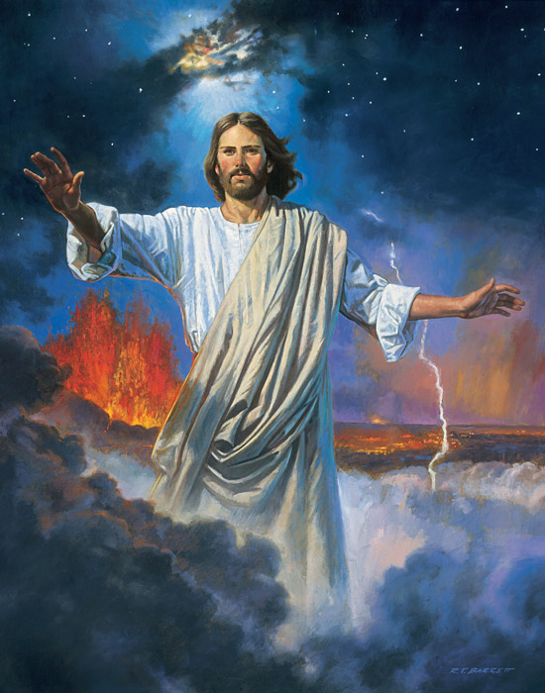
Christ Creating the Earth, by Robert T Barrett
Jesus was chosen before the world was. As Jehovah he has been the mediator for man since The Fall and was the “I AM” in the Old Testament. Jesus fulfilled the law of Moses and brought with him the higher law, even The Gospel of Jesus Christ.
1 In the beginning was the gospel preached through the Son. And the gospel was the word, and the word was with the Son, and the Son was with God, and the Son was of God.
2 The same was in the beginning with God.
3 All things were made by him; and without him was not anything made which was made.
4 In him was the gospel, and the gospel was the life, and the life was the light of men;
5 And the light shineth in the world, and the world perceiveth it not.
6 For in the beginning was the Word, even the Son, who is made flesh, and sent unto us by the will of the Father. And as many as believe on his name shall receive of his fullness. And of his fullness have all we received, even immortality and eternal life, through his grace.
7 For the law was given through Moses, but life and truth came through Jesus Christ.
8 For the law was after a carnal commandment, to the administration of death; but the gospel was after the power of an endless life, through Jesus Christ, the Only Begotten Son, who is in the bosom of the Father.
9 And no man hath seen God at any time, except he hath borne record of the Son; for except it is through him no man can be saved.
Taken from John 1:1-5, 16-19
- See also: D&C 76:39; TG Jesus Christ, Firstborn; Jesus Christ, Foreordained; Jesus Christ, Messenger of the Covenant; Jesus Christ, Relationships with the Father; Jesus Christ, Jehovah; Jesus Christ, Authority of.
- See also: 1 Jn. 1:1; TG Man, Antemortal Existence of.
- See also: TG Creation; God, Power of; Jesus Christ, Creator; Jesus Christ, Mission of; Jesus Christ, Power of.
- See also: 1 Jn. 5:10-21; TG Jesus Christ, Light of the World; Light.
- See also: D&C 6:21; 34:2; 45:7; TG Darkness, Spiritual; 1 Cor. 2:10-14; D&C 45:29.
- See also: Col. 2:10; D&C 93:12.
- See also: TG Law of Moses; Grace; Truth.
- See also: D&C 67:11; 84:22; TG God, Privilege of Seeing; Luke 10:22
- See also: Luke 3:15-16

Chapter Three

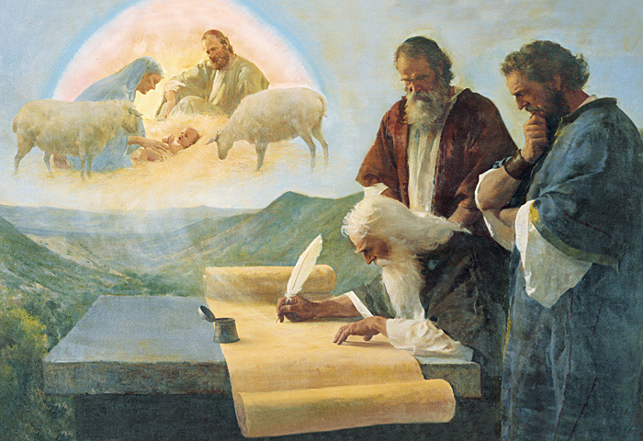
The Prophet Isaiah Foretells Christ’s Birth, by Harry Anderson

The book of the generation of Jesus Christ, (as was supposed), the son of Joseph.

1 Adam was formed of God, and the first man upon the Earth
2 Adam begat Seth
3 Seth begat Enos
4 Enos begat Cainan
5 Cainan begat Maleleel
6 Maleleel begat Jared
7 Jared begat Enoch
8 Enoch begat Mathusala
9 Mathusala begat Lamech
10 Lamech begat Noah
11 Noah begat Shem
12 Shem begat Arphaxad
13 Arphaxad begat Cainan
14 Cainan begat Sala
15 Sala begat Herber
16 Herber begat Phalec
17 Phalec begat Ragau
18 Ragau begat Saruch
19 Saruch begat Nachor
20 Nachor begat Thara
21 Thara begat Abraham
22 Abraham begat Isaac
23 Isaac begat Jacob
24 Jacob begat Judas and his brethren
25 Judas begat Phares and Zara of Thamar
26 Phares begat Esrom
27 Esrom begat Aram
28 Aram begat Aminadab
29 Aminadab begat Naasson
30 Naasson begat Salmon
31 Salmon begat Booz of Rachab
32 Booz begat Obed of Ruth
33 Obed begat Jesse
34 Jesse begat David the King
35 David the King begat Solomon of her who had been the wife of Urias
36 Solomon begat Roboam
37 Roboam begat Abia
38 Abia begat Asa
39 Asa begat Josaphat
40 Josaphat begat Joram
41 Joram begat Ozias
42 Ozias begat Joatham
43 Joatham begat Achaz
44 Achaz begat Ezekias
45 Ezekias begat Manasses
46 Manasses begat Amon
47 Amon begat Josias
48 Josias begat Jechonias and his brethren, about the time they were carried away to Babylon:
49 After they were brought to Babylon, Jechonias begat Salathiel
50 Salathiel begat Zorobabel
51 Zorobabel begat Abiud
52 Abiud begat Eliakim
53 Eliakim begat Azor
54 Azor begat Sadoc
55 Sadoc begat Achim
56 Achim begat Eliud
57 Eliud begat Eleazar
58 Eleazar begat Matthan
59 Matthan begat Jacob
60 Jacob begat Joseph the husband of Mary, of whom was born Jesus as the prophets have written, who is called Christ.
61 So all the generations from Adam to Noah are ten generations; and from Noah to Abraham are twelve generations; and from Abraham to David are fourteen generations; and from David until the carrying away into Babylon are fourteen generations; and from the carrying away into Babylon unto Christ are fourteen generations.

Taken from Matthew 1:1-17, Luke 3:29-44

- See also: Adam; Moses 6:22; TG Man, Physical Creation of
- See also: TG Family, Patriarchal;
12. See also: Gen. 5:3-32
22. See also: Gen. 11:10-26; Gen. 25:19
24. See also: TG Israel, Judah, People of.
25. See also: TG Israel, Judah, People of; Ruth 4:18; 1 Cor. 2:4-15; Gen. 38:30
26. See also: Gen. 38: 1-30; Ruth 4:18-22; 1 Chr. 2:9
30. See also: Num. 1:7
31. See also: Ruth 4:21
35. See also: 2 Sam. 12:24-25; 1 Chr. 3:5
48. See also: TG Israel, Bondage of, in Other Lands
50. See also: 1 Chr. 3:17-19; Ezra 2:1-2; Hag. 1:1
60. See also: 1 Nep. 11:14-21; Mosiah 3:8; Luke 20:14; D&C 93:3-17; TG Jesus Christ,
Davidic Descent of; The Greek title ‘Christ’ and the Hebrew title ‘Messiah’ are synonymous, meaning
‘Anointed One’
61. See also: TG Book of Remembrance

Commentary

- Old Testament prophecies declared that the Messiah would be a descendant of David (see 2 Samuel 7:12–13; Isaiah 9:6–7; Jeremiah 23:5–6) and that an offspring of Abraham would bless “all the nations of the earth” (Genesis 22:18; see also Abraham 2:11).
- Elder Bruce R. McConkie (1915–85) of the Quorum of the Twelve Apostles taught about messianic expectations at the time Jesus was born: “No single concept was more firmly lodged in the minds of the Jews in Jesus’ day than the universal belief that their Messiah would be the Son of David. … They looked for a temporal deliverer who would throw off the yoke of Roman bondage and make Israel free again. They sought a ruler who would restore that glory and worldwide influence and prestige which was enjoyed when the Son of Jesse sat on Israel’s throne” (The Promised Messiah [1978], 188).
- Several women are mentioned in the pedigree of Jesus Christ. Tamar was from Adullam in Canaanite territory (see Genesis 38); Rahab was a Canaanite of Jericho (see Joshua 2:1–7); Ruth was a Moabitess before converting to Judaism (see Ruth 1:4); and Bathsheba was the wife of Uriah, a Hittite (see 2 Samuel 11:3). Thus, all four were either non-Israelites or associated with non-Israelites. The inclusion of this demonstrates that God had worked through Gentiles in the past, thus preparing early Christians to appreciate the commission to “teach all nations” that would come later (Matthew 28:19). Second, the mention of these particular women, each of whom figured in a controversy of some sort in the Old Testament, shows that in Israel’s past, God had worked through people and situations that the Jews would not have expected, thus preparing readers for the account that is to follow﻿—Mary and the virgin birth. Third, it shows all of us today that personal righteousness is not dependent on possessing the “perfect” lineage, since Jesus Christ’s lineage was not perfect.

Chapter Four

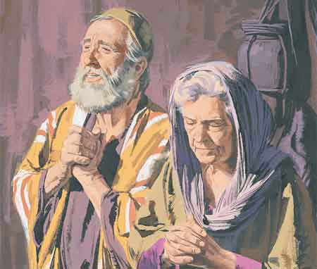
Zacharias and Elisabeth praying, by Paul Mann

Elisabeth and Zacharias’ miraculous story of conception in Jerusalem.
1 There was in the days of Herod, the king of Judæa, a certain priest named Zacharias, of the course of Abia: and his wife was of the daughters of Aaron, and her name was Elisabeth.
2 And they were both righteous before God, walking in all the commandments and ordinances of the Lord blameless.
3 And they had no child, because that Elisabeth was barren, and they both were now well stricken in years.
4 And it came to pass, that while he executed the priest’s office before God in the order of his priesthood,
5 According to the custom of the priest’s office, his lot was to burn incense when he went into the temple of the Lord.
6 And the whole multitude of the people were praying without at the time of incense.
7 And there appeared unto him an angel of the Lord standing on the right side of the altar of incense.
8 And when Zacharias saw him, he was troubled, and fear fell upon him.
9 But the angel said unto him, Fear not, Zacharias: for thy prayer is heard; and thy wife Elisabeth shall bear thee a son, and thou shalt call his name John.
10 And thou shalt have joy and gladness; and many shall rejoice at his birth.
11 For he shall be great in the sight of the Lord, and shall drink neither wine nor strong drink; and he shall be filled with the Holy Ghost, even from his mother’s womb.
12 And many of the children of Israel shall he turn to the Lord their God.
13 And he shall go before him in the spirit and power of Elias, to turn the hearts of the fathers to the children, and the disobedient to the wisdom of the just; to make ready a people prepared for the Lord.
14 And Zacharias said unto the angel, Whereby shall I know this? for I am an old man, and my wife well stricken in years.
15 And the angel answering said unto him, I am Gabriel, that stand in the presence of God; and am sent to speak unto thee, and to shew thee these glad tidings.
16 And, behold, thou shalt be dumb, and not able to speak, until the day that these things shall be performed, because thou believest not my words, which shall be fulfilled in their season.
17 And the people waited for Zacharias, and marvelled that he tarried so long in the temple.
18 And when he came out, he could not speak unto them: and they perceived that he had seen a vision in the temple: for he beckoned unto them, and remained speechless.
19 And it came to pass, that, as soon as the days of his ministration were accomplished, he departed to his own house.
20 And after those days his wife Elisabeth conceived, and hid herself five months, saying,
21 Thus hath the Lord dealt with me in the days wherein he looked on me, to take away my reproach among men.
Taken from Luke 1:5-25
- See also: TG Priesthood, Aaronic; 1 Chr. 24:5,10,19; Neh. 12:4
- See also: TG Ordinances
- See also: TG Barrenness
- See also: TG Priests
- See also: Lev. 7:35
9. See also: Dan. 10:12; TG Foreordination
11. See also: Num. 6:2-8; D&C 89:5,7; D&C 84:27; TG Holy Ghost, Gift of; Holy Ghost, Mission of
13. See also: Elias is Greek form of Elijah; Matt. 11:14; D&C 27:6-8, TG Salvation, for the Dead; TG
Disobedience; Luke 1:76
14. See also: Gen. 15:7-9; Gen. 18:13
15. See also: TG Angels; Dan. 8:16; D&C 27:7; D&C 128:21
16. See also: Dan. 10:15; Mosiah 27:19; Alma 30:47-52; Luke 12:29; Luke 24:25; Morm. 9:11
19. See also: Lev. 8:33
21. See also: TG Barrenness; Reproach

Chapter Five

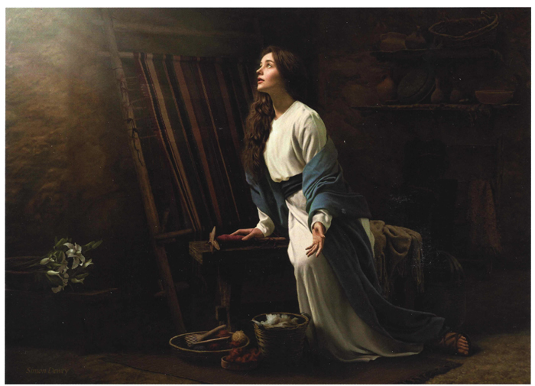
Blessed among Women, by Simon Dewey

Six months later, Mary converses with an angel; story of miraculous conception in Nazareth

1 Now as it is written, the conception of Jesus Christ was on this wise:
2 In the sixth month of Elisabeth’s pregnancy the angel Gabriel was sent from God unto a city of Galilee, named Nazareth,
3 To a virgin espoused to a man whose name was Joseph, of the house of David; and the virgin’s name was Mary.
4 And the angel came in unto her, and said, Hail, thou that art highly favoured, the Lord is with thee: blessed art thou among women.
5 And when she saw him, she was troubled at his saying, and cast in her mind what manner of salutation this should be.
6 And the angel said unto her, Fear not, Mary: for thou hast found favour with God.
7 And, behold, thou shalt conceive in thy womb, and bring forth a son, and shalt call his name Jesus.
8 He shall be great, and shall be called the Son of the Highest: and the Lord God shall give unto him the throne of his father David:
9 And he shall reign over the house of Jacob for ever; and of his kingdom there shall be no end.
10 Then said Mary unto the angel, How shall this be, seeing I know not a man?
11 And the angel answered and said unto her, The Holy Ghost shall come upon thee, and the power of the Highest shall overshadow thee: therefore also that holy thing which shall be born of thee shall be called the Son of God.
12 And, behold, thy cousin Elisabeth, she hath also conceived a son in her old age: and this is the sixth month with her, who was called barren.
13 For with God nothing shall be impossible.
14 And Mary said, Behold the handmaid of the Lord; be it unto me according to thy word. And the angel departed from her.
Taken from Matthew 1:18, Luke 1:26-38
- See also: D&C 20:1
- See also: Moro. 7:29-32
- See also: 1 Ne. 11:13
- See also: TG Woman
6. See also: TG Fearfulness
7. See also: TG Jesus Christ, Birth of
8. See also: TG Godhead; Jesus Christ, Divine Sonship; Jesus Christ, Millennial Reign; Jesus Christ, Davidic Descent of
9. See also: Micah 4:7; TG Jesus Christ, Mission of; 2 Sam. 7:16; Isa. 9:6-7
10. See also: 1 Ne. 11:15-20; Alma 7:7-12
11. See also: Matt. 1:20; 2 Cor. 1:19
12. See also: TG Old Age
13. See also: Gen. 18:14; Rom. 4:21; TG God, Power of

Commentary
- Bethrothed vs Marriage: examples in real life:
  - Buying something online vs it coming in the mail
  - Present under Christmas tree vs opening it on Christmas Day

Chapter Six

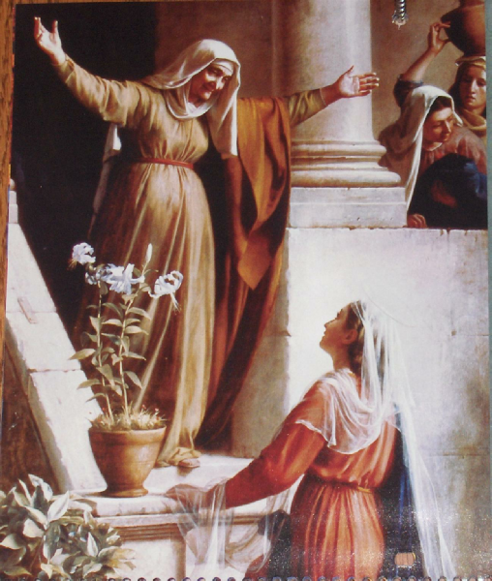

Mary visits Elisabeth for 3 months, gives Song of Mary; Magnificant (latin: Magnifies)

1 And Mary arose in those days, and went into the hill country with haste, into a city of Juda;
2 And entered into the house of Zacharias, and saluted Elisabeth.
3 And it came to pass, that, when Elisabeth heard the salutation of Mary, the babe leaped in her womb; and Elisabeth was filled with the Holy Ghost:
4 And she spake out with a loud voice, and said, Blessed art thou among women, and blessed is the fruit of thy womb.
5 And whence is this to me, that the mother of my Lord should come to me?
6 For, lo, as soon as the voice of thy salutation sounded in mine ears, the babe leaped in my womb for joy.
7 And blessed is she that believed: for there shall be a performance of those things which were told her from the Lord.
8 And Mary said, My soul doth magnify the Lord,
9 And my spirit hath rejoiced in God my Saviour.
10 For he hath regarded the low estate of his handmaiden: for, behold, from henceforth all generations shall call me blessed.
11 For he that is mighty hath done to me great things; and holy is his name.
12 And his mercy is on them that fear him from generation to generation.
13 He hath shewed strength with his arm; he hath scattered the proud in the imagination of their hearts.
14 He hath put down the mighty from their seats, and exalted them of low degree.
15 He hath filled the hungry with good things; and the rich he hath sent empty away.
16 He hath holpen his servant Israel, in remembrance of his mercy;
17 As he spake to our fathers, to Abraham, and to his seed for ever.
18 And Mary abode with her about three months, and returned to her own house.
Taken from Luke 1:39-56
- See also: TG Holy Ghost, Gifts of
- See also: TG Woman
8. See also: TG Singing; 1 Sam. 2:1-10
9. See also: TG Thanksgiving; Jesus Christ, Savior; Salvation
10. See also: 1 Sam. 1:11; Ps. 72:17
11. See also: Ps. 126:2; Ps. 99:3; Isa. 57:15
13. See also: Ex. 18:11
14. See also: Ezek. 21:26
17. See also: Ps. 132:11; Micah 7:20; Gal. 3:16; TG Seed of Abraham

Chapter Seven

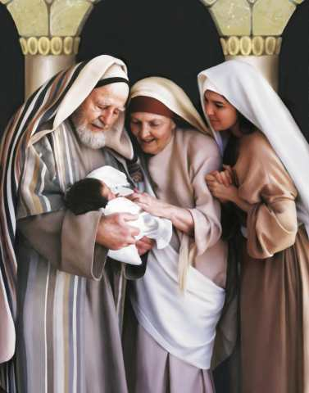

John the Baptist is born and named. Zacharias gives Hymn of Praise: Benedictus (latin: Blessed)

1 Now Elisabeth’s full time came that she should be delivered; and she brought forth a son.
2 And her neighbours and her cousins heard how the Lord had shewed great mercy upon her; and they rejoiced with her.
3 And it came to pass, that on the eighth day they came to circumcise the child; and they called him Zacharias, after the name of his father.
4 And his mother answered and said, Not so; but he shall be called John.
5 And they said unto her, There is none of thy kindred that is called by this name.
6 And they made signs to his father, how he would have him called.
7 And he asked for a writing table, and wrote, saying, His name is John. And they marvelled all.
8 And his mouth was opened immediately, and his tongue loosed, and he spake, and praised God.
9 And fear came on all that dwelt round about them: and all these sayings were noised abroad throughout all the hill country of Judæa.
10 And all they that heard them laid them up in their hearts, saying, What manner of child shall this be! And the hand of the Lord was with him.
11 And his father Zacharias was filled with the Holy Ghost, and prophesied, saying,
12 Blessed be the Lord God of Israel; for he hath visited and redeemed his people,
13 And hath raised up an horn of salvation for us in the house of his servant David;
14 As he spake by the mouth of his holy prophets, which have been since the world began:
15 That we should be saved from our enemies, and from the hand of all that hate us;
16 To perform the mercy promised to our fathers, and to remember his holy covenant;
17 The oath which he sware to our father Abraham,
18 That he would grant unto us, that we being delivered out of the hand of our enemies might serve him without fear,
19 In holiness and righteousness before him, all the days of our life.
20 And thou, child, shalt be called the prophet of the Highest: for thou shalt go before the face of the Lord to prepare his ways;
21 To give knowledge of salvation unto his people by the remission of their sins,
22 Through the tender mercy of our God; whereby the dayspring from on high hath visited us,
23 To give light to them that sit in darkness and in the shadow of death, to guide our feet into the way of peace.
24 And the child grew, and waxed strong in spirit, and was in the deserts till the day of his shewing unto Israel.
Taken from Luke 1:57-80
- See also: TG God, Mercy of
- See also: D&C 84:27-28; TG Circumcision
11. See also: TG Holy Gift, Gifts of
12. See also: TG Thanksgiving; Luke 7:16; TG Jesus Christ, Redeemer
14. See also: TG Prophets, Mission of; Jesus Christ, Prophecies about
16. See also: Micah 7:20; TG Covenants
17. See also: TG Oaths; Vows; Family, Patriarchal
18. See also: Philip. 1:12-17
19. See also: TG Holiness
20. See also: Luke 1:17
21. See also: Luke 11:52; TG Remission of Sins
22. See also: 1 Ne. 1:20
23. See also: TG Jesus Christ, Light of the World; Jesus Christ, Prophecies about; 1 Pet. 3:18-20; TG Darkness, Spiritual; D&C 45:16-17; 138:50-51
Chapter Eight

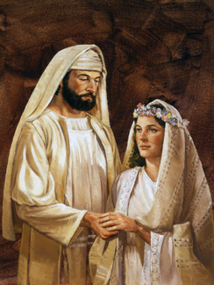
Lyle Beddes

Joseph marries Mary and the two journey to Bethlehem to be taxed.

1 Then Joseph her husband, being a just man, and not willing to make her a publick example, was minded to put her away privily.
2 But while he thought on these things, behold, the angel of the Lord appeared unto him in a dream, saying, Joseph, thou son of David, fear not to take unto thee Mary thy wife: for that which is conceived in her is of the Holy Ghost
3 And she shall bring forth a son, and thou shalt call his name Jesus: for he shall save his people from their sins.
4 Now all this was done, that it might be fulfilled which was spoken of the Lord by the prophet, saying,
5 Behold, a virgin shall be with child, and shall bring forth a son, and they shall call his name Emmanuel, which being interpreted is, God with us.
6 Then Joseph being raised from sleep did as the angel of the Lord had bidden him, and took unto him his wife
7 And it came to pass in those days, that there went out a decree from Cæsar Augustus, that all his empire should be taxed.
8 (And this taxing was first made when Cyrenius was governor of Syria.)
9 And all went to be taxed, every one into his own city.
10 And Joseph also went up from Galilee, out of the city of Nazareth, into Judæa, unto the city of David, which is called Bethlehem; (because he was of the house and lineage of David:)
11 To be taxed with Mary his espoused wife, being great with child.
Taken from Matthew 1:19-24, Luke 2:1-5
- See also: TG Example; Deut. 24:1
- See also: TG Dreams; 2 Ne. 19:7; Luke 1:35; Alma 7:10
- See also: TG Jesus Christ, Prophecies about; Luke 2:21; TG Forgiveness; Jesus Christ, Atonement through; Jesus Christ, Mission of; Jesus Christ, Redeemer; Jesus Christ, Saviour; Redemption; Salvation
5. See also: Isa. 7:14; TG Jesus Christ, Birth of; Name; Jesus Christ, Prophecies about
10. See also: 1 Sam. 16:1; Micah 5:1-2; John 7:41-44; Alma 7:10

Commentary
- When Mary was found to be with child, Joseph, knowing he was not the father, had several options. First, he could have subjected Mary to a public divorce and perhaps even execution, for people would have presumed that Mary was guilty of adultery﻿—a crime punishable by death under the law of Moses (see Leviticus 20:10; John 8:5). Second, Joseph could have had his betrothal to Mary privately annulled before two witnesses. A third option was to proceed with the marriage. Joseph was inclined to show mercy to Mary by quietly annulling the betrothal agreement (see Matthew 1:19). However, when assured by an angel that Mary’s child was the Son of God, Joseph elected to marry her, though doing so could have brought upon him public shame and ridicule (see Matthew 1:20–25; Luke 3:23; John 8:41).
- Joseph, over the course of what we know of him, received at least 4 visions from God, all of which he listened to. (See Matt. 1, Luke 2:4–6, Matt. 2:13–15, 19–22.)
- The name Jesus comes from Iēsous, a Greek form of the Hebrew name Yeshua (Joshua in English). Yeshua means “Jehovah saves,” and the long form of the name, Yehoshua, means “Jehovah is salvation.” Both forms of the name bear witness of the identity and mission of Jesus Christ, who was Jehovah in the premortal life.
- Jesus Christ would be called, in Hebrew, Emmanuel, “which being interpreted is, God with us.” One of the last recorded things Jesus promised his disciples was: “I am with you alway, even unto the end of the world”

Chapter Nine

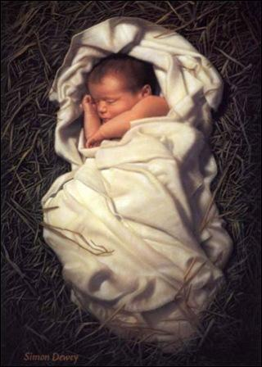

The Savior of Mankind is born in a caravansary outside Bethlehem. Angels rejoice, shepherds visit, wise men see the star and depart from their homeland.
1 And so it was, that, while they were traveling to Bethlehem, the days were accomplished that she should be delivered.
2 And she brought forth her firstborn son, and wrapped him in swaddling clothes, and laid him in a manger; because there was no room for them in the inns outside Bethlehem.
3 Joseph knew Mary not till she had brought forth this firstborn son: and Joseph called his name Jesus.
4 For he was born, not of blood, nor of the will of the flesh, nor of the will of man, but of God.
5 And the same word was made flesh, to dwell among us, and they beheld his glory, the glory as of the Only Begotten of the Father, full of grace and truth.
6 And there were in the same country shepherds abiding in the field, keeping watch over their flock by night.
7 And, lo, the angel of the Lord came upon them, and the glory of the Lord shone round about them: and they were sore afraid.
8 And the angel said unto them, Fear not: for, behold, I bring you good tidings of great joy, which shall be to all people.
9 For unto you is born this day in the city of David a Saviour, which is Christ the Lord.
10 And this shall be a sign unto you; Ye shall find the babe wrapped in swaddling clothes, lying in a manger.
11 And suddenly there was with the angel a multitude of the heavenly host praising God, and saying,
12 Glory to God in the highest, and on earth peace, good will toward men.
13 And it came to pass, as the angels were gone away from them into heaven, the shepherds said one to another, Let us now go even unto Bethlehem, and see this thing which is come to pass, which the Lord hath made known unto us.
14 And they came with haste, and found Mary, and Joseph, and the babe lying in a manger.
15 And when they had seen it, they made known abroad the saying which was told them concerning this child.
16 And all they that heard it wondered at those things which were told them by the shepherds.
17 But Mary kept all these things, and pondered them in her heart.
18 And the shepherds returned, glorifying and praising God for all the things that they had heard and seen, as it was told unto them.
19 At that time the sign of Christ’s birth was given as a new star born in the heavens.
20 And wise men from the East who knew the sign (for they looked and waited for it), saw it in the heavens and immediately took up the gifts they had prepared and departed thence from their country westward.
Taken from Matthew 1:25, Matthew 2:2, Luke 2:6-20, John 1: 13-14
- See also: TG Firstborn
4. See also: TG Holy Ghost, Baptism of
5. See also: TG Flesh and Blood; God, Manifestations of; Jesus Christ, Birth of; Jesus Christ, Condescension of
7. See also: TG God, Glory of
8. See also: TG Gospel; Joy
9. See also: TG Jesus Christ, Birth of; Jesus Christ, Savior; Jesus Christ, Lord
10. See also: TG Signs
12. See also: Luke 19:38; TG Peace
14. See also: TG Haste
17. See also: TG Meditation
19. See also: Hel. 14:5, 3 Ne. 1:21

Chapter Ten
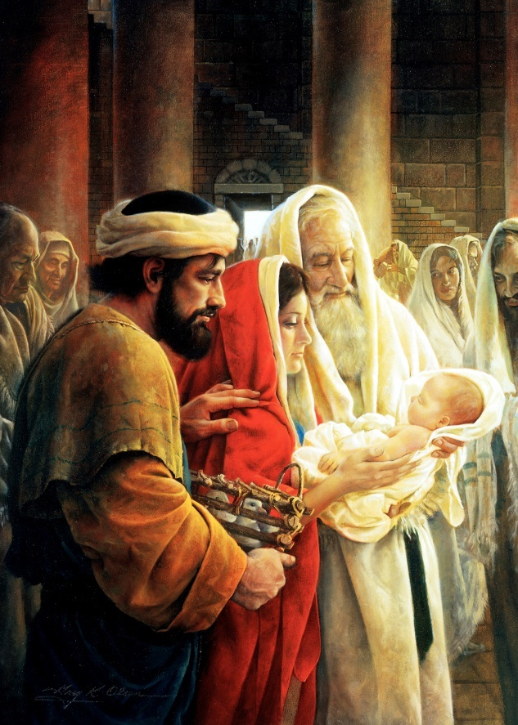
Simeon Reverencing the Christ Child, by Greg Olsen
40 days after birth, Jesus is brought from Bethlehem to Jerusalem for Presentation; Simeon and then Anna prophesy.
1 And when eight days were accomplished for the circumcising of the child, his name was called Jesus, which was so named of the angel before he was conceived in the womb.
2 And when the days of her purification according to the law of Moses were accomplished, they brought him to Jerusalem, to present him to the Lord;
3 (As it is written in the law of the Lord, Every male that openeth the womb shall be called holy to the Lord;)
4 And to offer a sacrifice according to that which is said in the law of the Lord, A pair of turtledoves, or two young pigeons.
5 And, behold, there was a man in Jerusalem, whose name was Simeon; and the same man was just and devout, waiting for the consolation of Israel: and the Holy Ghost was upon him.
6 And it was revealed unto him by the Holy Ghost, that he should not see death, before he had seen the Lord’s Christ.
7 And he came by the Spirit into the temple: and when the parents brought in the child Jesus, to do for him after the custom of the law,
8 Then took he him up in his arms, and blessed God, and said,
9 Lord, now lettest thou thy servant depart in peace, according to thy word:
10 For mine eyes have seen thy salvation,
11 Which thou hast prepared before the face of all people;
12 A light to lighten the Gentiles, and the glory of thy people Israel.
13 And Joseph and his mother marvelled at those things which were spoken of him.
14 And Simeon blessed them, and said unto Mary his mother, Behold, this child is set for the fall and rising again of many in Israel; and for a sign which shall be spoken against;
15 (Yea, a sword shall pierce through thy own soul also,) that the thoughts of many hearts may be revealed.
16 And there was one Anna, a prophetess, the daughter of Phanuel, of the tribe of Aser: she was of a great age, and had lived with an husband seven years from her virginity;
17 And she was a widow of about fourscore and four years, which departed not from the temple, but served God with fastings and prayers night and day.
18 And she coming in that instant gave thanks likewise unto the Lord, and spake of him to all them that looked for redemption in Jerusalem.
19 And Joseph, Mary and the son Jesus returned again to Bethlehem.

Taken from Luke 2:21-38
- See also: TG Circumcision; Matt. 1:21; TG Jesus Christ, Prophecies about
- See also: TG Purification
- See also: Ex. 13:2; 34:19
- See also: Lev. 1:14; 5:7
10. See also: Ps. 67:2
12. See also: TG Jesus Christ, Light of the World
14. See also: Isa. 8:13-15; Matt. 21:43-45; Rom. 9:28-33; 2 Ne. 18:14; Alma 11:40-41
15. See also: John 19:25
16. See also: TG Woman
17. See also: TG Fasting
18. See also: D&C 29:42

Chapter Eleven

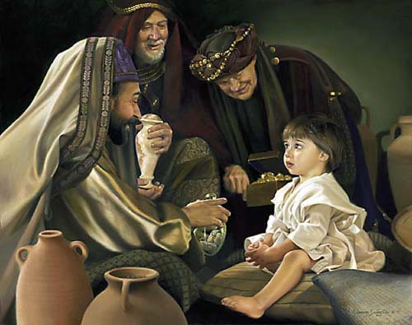
The Holy Men, by Liz Lemon Swindle

Wise men journey to Bethlehem to see the Christ child. Wise men journey home another way and Joseph takes his family to Egypt. King Herod kills children under two. The family stays in Egypt until Herod dies (around 7AD), making Christ around 8 years old; they return to Galilee.

1 Now in the days of Herod the king, behold, there came the wise men from the east to Jerusalem,
2 Saying, Where is he that is born King of the Jews? for we have seen his star in the east, and are come to worship him.
3 When Herod the king had heard these things, he was troubled, and all Jerusalem with him.
4 And when he had gathered all the chief priests and scribes of the people together, he demanded of them saying, where is the place that is written of by the prophets in which Christ should be born? For he greatly feared, yet he believed not the prophets.
5 And they said unto him, It is written by the prophets, that he should be born in Bethlehem of Judæa, for thus they have said,
6 The word of the Lord came unto us, saying, And thou Bethlehem, which lieth in the land of Judea, in thee shall be born a prince, which art not the least among the princes of Judea: for out of thee shall come the Messiah, who shall save my people Israel.
7 Then Herod, when he had privily called the wise men, inquired of them diligently what time the star appeared.
8 And he sent them to Bethlehem, and said, Go and search diligently for the young child; and when ye have found him, bring me word again, that I may come and worship him also.
9 When they had heard the king, they departed; and, lo, the star, which they saw in the east, went before them, till it came and stood over where the young child was.
10 When they saw the star, they rejoiced with exceeding great joy.
11 And when they were come into the house, they saw the young child with Mary his mother, and fell down, and worshipped him: and when they had opened their treasures, they presented unto him gifts; gold, and frankincense, and myrrh.
12 And being warned of God in a dream that they should not return to Herod, they departed into their own country another way.
13 And when they were departed, behold, the angel of the Lord appeareth to Joseph in a dream, saying, Arise, and take the young child and his mother, and flee into Egypt, and be thou there until I bring thee word: for Herod will seek the young child to destroy him.
14 When he arose, he took the young child and his mother by night, and departed into Egypt:
16 Then Herod, when he saw that he was mocked of the wise men, was exceeding wroth, and sent forth, and slew all the children that were in Bethlehem, and in all the coasts thereof, from two years old and under, according to the time which he had diligently inquired of the wise men.
17 Then was fulfilled that which was spoken by Jeremy the prophet, saying,
18 In Rama was there a voice heard, lamentation, and weeping, and great mourning, Rachel weeping for her children, and would not be comforted, because they are not.
15 They family stayed in Egypt until the death of Herod: that it might be fulfilled which was spoken of the Lord by the prophet, saying, Out of Egypt have I called my son.
19 But when Herod was dead, behold, an angel of the Lord appeareth in a dream to Joseph in Egypt,
20 Saying, Arise, and take the young child and his mother, and go into the land of Israel: for they are dead which sought the young child’s life.
21 And he arose, and took the young child and his mother, and came into the land of Israel.
22 But when he heard that Archelaus did reign in Judæa in the room of his father Herod, he was afraid to go thither: notwithstanding, being warned of God in a dream, he turned aside into the parts of Galilee:
23 And he came and dwelt in a city called Nazareth: that it might be fulfilled which was spoken by the prophets, He shall be called a Nazarene.
Taken from Matthew 2:1-23, Luke 2:39

- See also: Isa. 6:5; Jer. 23:5; 2 Ne. 10:14; Alma 5:50; D&C 128:22-23; Moses 7:53; Hel. 14:5; 3 Nep. 1:21; TG Worship
6. See also: TG Jesus Christ, Prophecies about; Israel, Judah, People of
- See also: Lev. 2:1
- See also: TG Dreams
15. See also: TG Tyranny
16. See also: IE Jeremiah
17. See also: Jer. 31:15; TG Mourning; Jer. 40:1
18. See also: TG Jesus Christ, Prophecies about.
19. See also: TG Dreams
20. See also: TG Israel, Land of
22. See also: TG Dreams
23. See also: 1 Ne. 11:13; TG Scriptures, Lost

Commentary
- Micah prophesied (see Micah 5:2) that Jesus, “the Bread of Life” would be born in the city Bethlehem which means, “house of bread.” It was this prophesy that Herod’s men quoted when the wise men came looking for the Messiah.
- The Wise Men’s visit shows that those who should have been aware of the signs accompanying the birth of Jesus Christ failed to recognize them, while righteous people from other lands, directed by the Holy Ghost, not only noticed the signs but acted upon them.
  - In Jesus’ ministry it was evident that Jesus’ enemies threw things in his face (eg. “bastard son”). It is equally probable that the story of the wise men coming from the east to visit this “bastard son” would have been used in retort. The reason for bringing up the wise men was that they were the first tangible evidence that supporters of Christ’s divine story (Joseph and Mary) had to defend Jesus’ divine heritage. The second bit of tangible evidence is Herod murdering all the young children in Bethlehem. It is probable then to assume that the Jews would fall back on their divine heritage as putting them as more qualified or inheriting the ability to identity the Savior and not men from other countries (“We are the seed of Abraham”). This situation could have easily sparked the development of the Parable of the King’s Son’s Wedding Feast (parallels perfectly).
- The Lord does communicate some things of importance to the children of men by means of visions and dreams as well as by the records of divine truth. And what is it all for? It is to teach us a principle” (The Discourses of Wilford Woodruff, ed. G. Homer Durham [1990], 285–86).
- All prophets are a foreshadow or typification of the Savior and no one before was more prevalent in the minds of the people than Moses who the Lord promised “one like unto you” (That Prophet). Jesus miraculously escaping the killing of babies, living in Egypt before escaping back to Nazareth are clear parallels to Moses.

Chapter Twelve

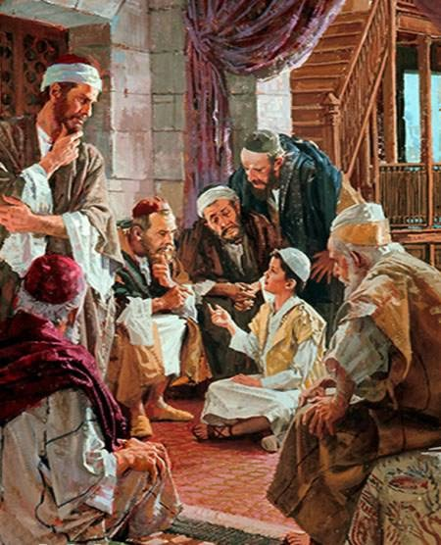

The family (realizing the new King wasn’t a threat after all) take yearly trips to Jerusalem for the Passover (probably around 4 trips between the ages of 4-12). At age 12, Jesus is found preaching at the temple after being lost for 5 days. Christ waits patiently for His time to come.

1 In Nazareth the Christ child grew, and waxed strong in spirit, filled with wisdom: and the grace of God was upon him.
2 Now his parents, seeing that Archelaus wasn’t a threat as was his father Herod, went to Jerusalem every year at the feast of the passover.

3 And when he was twelve years old, they went up to Jerusalem after the custom of the feast.
4 And when they had fulfilled the days, as they returned, the child Jesus tarried behind in Jerusalem; and Joseph and his mother knew not of it.
5 But they, supposing him to have been in the company, went a day’s journey; and they sought him among their kinsfolk and acquaintance.
6 And when they found him not, they turned back again to Jerusalem, seeking him.
7 And it came to pass, after three days they found him in the temple, sitting in the midst of the doctors, and they were hearing him, and asking him questions.
8 And all that heard him were astonished at his understanding and answers.
9 And when they saw him, they were amazed: and his mother said unto him, Son, why hast thou thus dealt with us? behold, thy father and I have sought thee sorrowing.
10 And he said unto them, How is it that ye sought me? wist ye not that I must be about my Father’s business?
11 And they understood not the saying which he spake unto them; but his mother kept all these sayings in her heart.
12 And he went down with his parents, again to Nazareth, and was subject unto them, and he served under his father.
13 And it came to pass that Jesus grew up with his brethren, and waxed strong in wisdom and stature, and in favour with God and man.
14 And he spake not as other men, neither could he be taught; for he needed not that any man should teach him.
25 And waited upon the Lord for the time of his ministry to come, and after many years, the hour of his ministry drew nigh.

Taken from Matthew 3:24-26, Luke 2:40-52
- See also: TG Grace
- See also: Deut. 16:1
7. See also: TG Temples; John 7: 15
8. See also: TG Understanding
10. See also: John 4:34; 6:39; TG God, Father
11. See also: TG Heart
12. See also: TG Family, Children, Duties of; Self-mastery
13. See also: TG God, Wisdom of; Study; D&C 93:12-14; TG Jesus Christ, Relationships with the Father

Commentary

- We learn that the Lord did not need any man to teach him and we learn later why that is when the Savior explained that he was taught by his Father in heaven (see John 8:28-29).

Chapter Thirteen

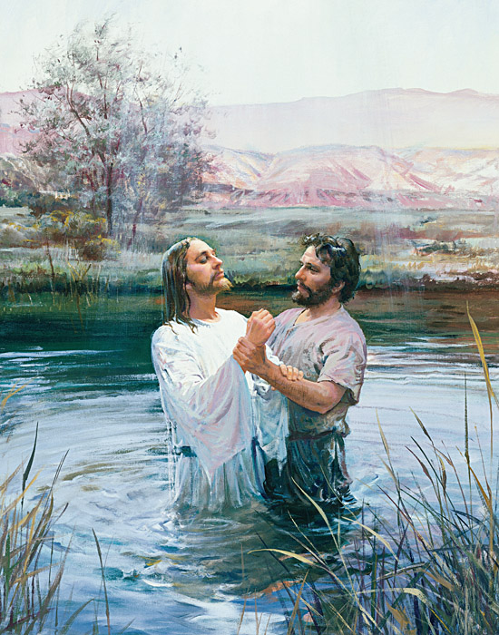
John the Baptist Baptizing Jesus, by Harry Anderson

John the Baptist begins ministry around 30 years of age and preaches for several months. John the Baptist baptizes the Savior and reveals Him.

1 Now in the fifteenth year of the reign of Tiberius Cæsar, Pontius Pilate being governor of Judæa, and Herod being tetrarch of Galilee, and his brother Philip tetrarch of Ituræa and of the region of Trachonitis, and Lysanias the tetrarch of Abilene,
2 Annas and Caiaphas being the high priests, the word of God came unto John the son of Zacharias and he came into all the country about Jordan, in the wilderness, preaching the baptism of repentance for the remission of sins.
3 And the same John had his raiment of camel’s hair, and a leathern girdle about his loins; and his meat was locusts and wild honey.
4 The same came into the world for a witness, to bear witness of the light, to bear record of the gospel through the Son, unto all, that through him men might believe.
5 He was not that light, but came to bear witness of that light,
6 Which was the true light, which lighteth every man who cometh into the world.
7 As it is written in the prophets, Behold, I send my messenger before thy face, which shall prepare thy way before thee.
8 The voice of one crying in the wilderness, Prepare ye the way of the Lord, make his paths straight.
9 And John bear witness of him, and cried, saying, He who cometh after me, is preferred before me; for he was before me; the latchet of whose shoes I am not worthy to stoop down and unloose, (or whose place I am not able to fill). Prepare ye the way of the Lord, and make his paths straight.
10 For behold, and lo, he shall come, as it is written in the book of the prophets, to take away the sins of the world, and to bring salvation unto the heathen nations, to gather together those who are lost, who are of the sheepfold of Israel;
11 Yea, even the dispersed and afflicted; and also to prepare the way, and make possible the preaching of the gospel unto the Gentiles;
12 And to be a light unto all who sit in darkness, unto the uttermost parts of the earth; to bring to pass the resurrection from the dead, and to ascend up on high, to dwell on the right hand of the Father,
13 Until the fullness of time, and the law and the testimony shall be sealed, and the keys of the kingdom shall be delivered up again unto the Father;
14 To administer justice unto all; to come down in judgment upon all, and to convince all the ungodly of their ungodly deeds, which they have committed; and all this in the day that he shall come;
15 For it is a day of power; yea, every valley shall be filled, and every mountain and hill shall be brought low; the crooked shall be made straight, and the rough ways made smooth;
16 And all flesh shall see the salvation of God.
17 Then went out unto him Jerusalem, and all the land of Judea, and all the region round about Jordan, and were all baptized of him in the river of Jordan, confessing their sins

18 But when he saw many of the Pharisees and Sadducees come to his baptism, he said unto them, O generation of vipers, who hath warned you to flee from the wrath to come?
19 Bring forth therefore fruits meet for repentance:
20 Why is it that ye receive not the preaching of him whom God hath sent? If ye receive not this in your hearts, ye receive not me; and if ye receive not me, ye receive not him of whom I am sent to bear record; and for your sins ye have no cloak. Repent, therefore, and bring forth fruits meet for repentance; And think not to say within yourselves, We are the children of Abraham, and we only have power to bring seed unto our father Abraham; for I say unto you, that God is able of these stones to raise up children into Abraham.
21 And now also the axe is laid unto the root of the trees: therefore every tree which bringeth not forth good fruit is hewn down, and cast into the fire.
22 And the people asked him, saying, What shall we do then?
23 He answereth and saith unto them, He that hath two coats, let him impart to him that hath none; and he that hath meat, let him do likewise.
24 Then came also publicans to be baptized, and said unto him, Master, what shall we do?
25 For it is well known unto you, Theophilus, that after the manner of the Jews, and according to the custom of their law in receiving money into the treasury, that out of the abundance which was received, was appointed unto the poor, every man his portion;
26 And after this manner did the publicans also, wherefore John said unto them, Exact no more than that which is appointed you.
27 And the soldiers likewise demanded of him, saying, And what shall we do? And he said unto them, Do violence to no man, neither accuse any falsely; and be content with your wages.
28 And as the people were in expectation, and all men mused in their hearts of John, whether he were the Christ, or not; Jews sent priests and Levites from Jerusalem (and they who were sent were of the Pharisees), to ask him; Who art thou?
29 And he confessed, and denied not that he was Elias; but confessed, saying; I am not the Christ.
30 And they asked him, saying; How then art thou Elias? And he said, I am not that Elias who was to restore all things. And they asked him, saying, Art thou that prophet? And he answered, No.
31 Then said they unto him, Who art thou? that we may give an answer to them that sent us. What sayest thou of thyself?
32 He said, I am the voice of one crying in the wilderness, Make straight the way of the Lord, as saith the prophet Esaias.
33 And they asked him, and said unto him; Why baptizest thou then, if thou be not the Christ, nor Elias who was to restore all things, neither that prophet?
34 John answered them, saying; I baptize with water, but there standeth one among you, whom ye know not;
35 He it is of whom I bear record. He is that prophet, even Elias, who, coming after me, and when he comes he shall baptize, not only with water, but with fire, and with the Holy Ghost.
36 And it is he of whom I shall bear record, whose fan shall be in his hand, and he will thoroughly purge his floor, and gather his wheat into the garner; but in the fullness of his own time will burn up the chaff with unquenchable fire.
37 And many other things in his exhortation preached he unto the people.
38 Then cometh Jesus, (Jesus himself began to be about thirty years of age), from Galilee to Jordan unto John, to be baptized of him.
39 But John forbad him, saying, I have need to be baptized of thee, and comest thou to me?
40 And Jesus, answering, said unto him, Suffer me to be baptized of thee, for thus it becometh us to fulfill all righteousness. Then he suffered him.
41 And John went down into the water and baptized him.
42 And Jesus when he was baptized, went up straightway out of the water; and John saw, and lo, the heavens were opened unto him, and he saw the Spirit of God descending like a dove and lighting upon Jesus.
43 And John bare record of him unto the people, saying, Behold the Lamb of God, who taketh away the sin of the world! This is he of whom I said; After me cometh a man who is preferred before me; for he was before me, and I knew him, and that he should be made manifest to Israel; therefore am I come baptizing with water.
44 And John bare record, saying; When he was baptized of me, I saw the Spirit descending from heaven like a dove, and it abode upon him.
45 And I knew him; for he who sent me to baptize with water, the same said unto me; Upon whom thou shalt see the Spirit descending, and remaining on him, the same is he who baptizeth with the Holy Ghost.
46 And lo, he heard a voice from heaven, saying, This is my beloved Son, in whom I am well pleased. Hear ye him. I have seen and heard, and bare record that this is the Son of God.
47 These things were done in Bethabara, beyond Jordan, where John was baptizing.
Taken from Matthew 3:1-17, Mark 1:2-11, Luke 3:1-24, 27-29, John 1:6-9, 15, 20-34
- See also: Luke 9:7
- See also: John 18: 13; TG Priesthood, Aaronic; Baptism; Remission of Sins
- See also: 2 Kgs. 1:8; Zech. 13:4; Lev. 11:22
7. See also: Mal. 3:1; Matt. 11:10
17. See also: TG Baptism, Immersion; Baptism, Qualifications for; Confession
18. See also: Luke 7:29; Matt. 12:34; 22:33; Alma 9:8; 10:17; TG Warnings
19. See also: TG Baptism, Qualifications for; Repentance
21. See also: Alma 5:36-41; 3 Ne. 14:19; D&C 52:18; 97:7; Luke 13:7; Jacob 5:42-66
23. See also: Mosiah 4:16; D&C 104:14-18; James 2:14-17; 1 Jn. 3:14-23; TG Generosity
24. See also: Matt. 21:28-32; Luke 7:28-30
27. See also: TG Contentment; Wages
28. See also: TG Meditation
30. See also: Mal. 4:5-6
32. See also: D&C 84:28; 65:1
34. See also: D&C 52:10
35. See also: TG Holy Ghost, Gift of
36. See also: 2 Ne. 15:24; Mosiah 7:29-31
38. See also: TG Jesus Christ, Baptism of
40. See also: TG Baptism, Essential; Jesus Christ, Mission of; Righteousness
42. See also: TG Baptism, Immersion; Holy Ghost, Dove, Sign of
44. See also: D&C 93:11, TG Jesus Christ, Baptism of; Holy Ghost, Dove, Sign of
45. See also: Holy Ghost, Baptism of
46. See also: Mark 9:7; Luke 9:34-36; TG God, Body of (Corporeal Nature); God, Manifestations of; Testimony
47. See also: 1 Ne. 10:9

Commentary

- Elder Neal A. Maxwell (1926–2004) of the Quorum of the Twelve Apostles similarly taught about the essential role of confession in repentance:
“True repentance also includes confession: ‘Now therefore make confession unto the Lord God of your fathers.’ (Ezra 10:11.) One with a broken heart will not hold back. As confession lets the sickening sin empty out, then the Spirit which withdrew returns to renew. …
“All sins are to be confessed to the Lord, some to a Church official, some to others, and some to all of these. A few may require public confession. Confessing aids forsaking” (“Repentance,” Ensign, Nov. 1991, 31).
- The “fan” referred to in Matthew 3:12 is a winnowing fan that was used to toss wheat into the air. This allowed the wheat to be separated from the chaff. Wheat kernels would fall back to the ground while the wind blew the lighter chaff away. The wheat was then gathered into a garner, or storehouse, and the chaff was burned with fire. John the Baptist taught that the Savior, who would come after him, would separate believers from nonbelievers in the same way that wheat was separated from chaff.
- At the baptism of Jesus Christ, all three members of the Godhead were separately manifest: Jesus was in the water, the voice of Heavenly Father was heard from heaven, and the Holy Ghost descended upon the Savior like a dove. It is self-evident from the scriptures that the Father, the Son, and the Holy Ghost are separate persons, three divine beings.
- Jesus Christ was baptized to fulfil all righteousness: “And again, it showeth unto the children of men the straitness of the path, and the narrowness of the ªgate, by which they should enter, he having set the ^{b}example before them.” 2 Nephi 31:9
- The voice of Heavenly Father was heard at the time of the Savior’s baptism﻿—one of the few times when the voice of the Father is recorded in scripture (see Matthew 3:17; 17:5; 3 Nephi 11:7; Joseph Smith﻿—History 1:17). In each of these instances, He spoke to introduce His Son to a mortal man.

Chapter Fourteen
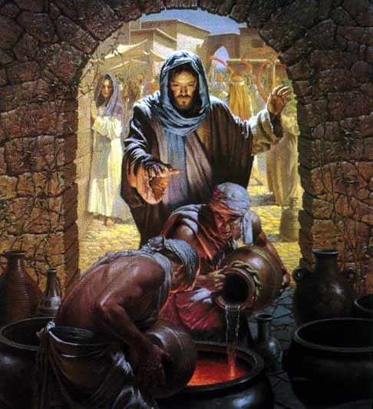
Water Into Wine, by Morgan Weistling
Jesus is introduced to future Apostles. Jesus turns water to wine in Cana. Jesus prepares for the Passover trip in Capernaum.
1 Again the next day after John stood, and two of his disciples;
2 And looking upon Jesus as he walked, he saith, Behold the Lamb of God!
3 And the two disciples heard him speak, and they followed Jesus.
4 Then Jesus turned, and saw them following, and saith unto them, What seek ye? They said unto him, Rabbi, (which is to say, being interpreted, Master,) where dwellest thou?
5 He saith unto them, Come and see. They came and saw where he dwelt, and abode with him that day: for it was about the tenth hour.
6 One of the two which heard John speak, and followed him, was Andrew, Simon Peter’s brother.
7 He first findeth his own brother Simon, and saith unto him, We have found the Messias, which is, being interpreted, the Christ.
8 And he brought him to Jesus. And when Jesus beheld him, he said, Thou art Simon, the son of Jona, thou shalt be called Cephas, which is, by interpretation, a seer, or a stone. And they were fishermen. And they straightway left all, and followed Jesus.
9 The day following Jesus would go forth into Galilee, and findeth Philip, and saith unto him, Follow me.
10 Now Philip was of Bethsaida, the city of Andrew and Peter.
11 Philip findeth Nathanael, and saith unto him, We have found him, of whom Moses in the law, and the prophets, did write, Jesus of Nazareth, the son of Joseph.
12 And Nathanael said unto him, Can there any good thing come out of Nazareth? Philip saith unto him, Come and see.
13 Jesus saw Nathanael coming to him, and saith of him, Behold an Israelite indeed, in whom is no guile!
14 Nathanael saith unto him, Whence knowest thou me? Jesus answered and said unto him, Before that Philip called thee, when thou wast under the fig tree, I saw thee.
15 Nathanael answered and saith unto him, Rabbi, thou art the Son of God; thou art the King of Israel.
16 Jesus answered and said unto him, Because I said unto thee, I saw thee under the fig tree, believest thou? thou shalt see greater things than these.
17 And he saith unto him, Verily, verily, I say unto you, Hereafter ye shall see heaven open, and the angels of God ascending and descending upon the Son of man.
18 And the third day of the week there was a marriage in Cana of Galilee; and the mother of Jesus was there:
19 And both Jesus was called, and his disciples, to the marriage.
20 And when they wanted wine, the mother of Jesus saith unto him, They have no wine.
21 Jesus saith unto her, Woman, what wilt thou have me to do for thee? That will I do; for mine hour is not yet come.
22 His mother saith unto the servants, Whatsoever he saith unto you, do it.
23 And there were set there six waterpots of stone, after the manner of the purifying of the Jews, containing two or three firkins apiece.
24 Jesus saith unto them, Fill the waterpots with water. And they filled them up to the brim.
25 And he saith unto them, Draw out now, and bear unto the governor of the feast. And they bare it.
26 When the ruler of the feast had tasted the water that was made wine, and knew not whence it was: (but the servants which drew the water knew;) the governor of the feast called the bridegroom,
27 And saith unto him, Every man at the beginning doth set forth good wine; and when men have well drunk, then that which is worse: but thou hast kept the good wine until now.
28 This beginning of miracles did Jesus in Cana of Galilee, and manifested forth his glory; and his disciples believed on him.
29 After this he went down to Capernaum, he, and his mother, and his brethren, and his disciples: and they continued there not many days.
Taken from John 1:35-51, John 2:1-12
2. See also: TG Passover
6. See also: TG Apostles
7. See also: Jesus Christ, Messiah
8. See also: Matt 16:18; Luke 6:14; Gal. 2:9
11. See also: TG Jesus Christ, Prophecies about; Record Keeping
13. See also: D&C 41:11; TG Guile
15. See also: TG God, Body of (Corporeal Nature); Jesus Christ, Messiah
21. See also: TG Woman
23. See also: TG Purification
28. See also: John 4:54; TG Miracles
29. See also: Jesus Christ, Family of

Chapter Fifteen

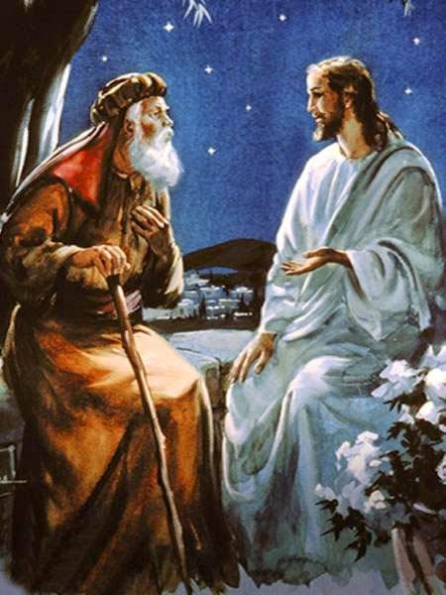

Jesus, family and new disciples go to Jerusalem for Passover. Jesus teaches Nicodemus in Jerusalem. Jesus and disciples baptize around Jerusalem (Jesus prefers the followers to do the baptizing); Jesus’ numbers grow, John the Baptist’s numbers wane.

1 And the Jews’ passover was at hand, and Jesus went up to Jerusalem,
2 Now when he was in Jerusalem at the passover, in the feast day, many believed in his name, when they saw the miracles which he did.
3 But Jesus did not commit himself unto them, because he knew all things,
4 And needed not that any should testify of man: for he knew what was in man.
5 And there was a man of the Pharisees, named Nicodemus, a ruler of the Jews:
6 And the same came to Jesus by night, and said unto him, Rabbi, we know that thou art a teacher come from God: for no man can do these miracles that thou doest, except God be with him.
7 Jesus answered and said unto him, Verily, verily, I say unto thee, Except a man be born again, he cannot see the kingdom of God.
8 Nicodemus saith unto him, How can a man be born when he is old? can he enter the second time into his mother’s womb, and be born?
9 Jesus answered, Verily, verily, I say unto thee, Except a man be born of water and of the Spirit, he cannot enter into the kingdom of God.
10 That which is born of the flesh is flesh; and that which is born of the Spirit is spirit.
11 Marvel not that I said unto thee, Ye must be born again.
12 The wind bloweth where it listeth, and thou hearest the sound thereof, but canst not tell whence it cometh, and whither it goeth: so is every one that is born of the Spirit.
13 Nicodemus answered and said unto him, How can these things be?
14 Jesus answered and said unto him, Art thou a master of Israel, and knowest not these things?
15 Verily, verily, I say unto thee, We speak that we do know, and testify that we have seen; and ye receive not our witness.
16 If I have told you earthly things, and ye believe not, how shall ye believe, if I tell you of heavenly things?
17 And no man hath ascended up to heaven, but he that came down from heaven, even the Son of man which is in heaven.
18 And as Moses lifted up the serpent in the wilderness, even so must the Son of man be lifted up:
19 That whosoever believeth in him should not perish, but have eternal life.
20 For God so loved the world, that he gave his only begotten Son, that whosoever believeth in him should not perish, but have everlasting life.
21 For God sent not his Son into the world to condemn the world; but that the world through him might be saved.
22 He that believeth on him is not condemned: but he that believeth not is condemned already, because he hath not believed in the name of the only begotten Son of God which before was preached by the mouth of the holy prophets; for they testified of me.
23 And this is the condemnation, that light is come into the world, and men loved darkness rather than light, because their deeds were evil.
24 For every one that doeth evil hateth the light, neither cometh to the light, lest his deeds should be reproved.
25 But he that doeth truth cometh to the light, that his deeds may be made manifest, that they are wrought in God.
26 After these things came Jesus and his disciples into the land of Judæa; and there he tarried with them, and baptized.
27 And John also was baptizing in Ænon near to Salim, because there was much water there: and they came, and were baptized.
28 For John was not yet cast into prison.
29 Then there arose a question between some of John’s disciples and the Jews about purifying.
30 And they came unto John, and said unto him, Rabbi, he that was with thee beyond Jordan, to whom thou barest witness, behold, the same baptizeth, and he receiveth of all people who come unto him.
31 John answered and said, A man can receive nothing, except it be given him from heaven.
32 Ye yourselves bear me witness, that I said, I am not the Christ, but that I am sent before him.
33 He that hath the bride is the bridegroom: but the friend of the bridegroom, which standeth and heareth him, rejoiceth greatly because of the bridegroom’s voice: this my joy therefore is fulfilled.
34 He must increase, but I must decrease.
35 He that cometh from above is above all: he that is of the earth is earthly, and speaketh of the earth: he that cometh from heaven is above all.
36 And what he hath seen and heard, that he testifieth; and no man receiveth his testimony.
37 He that hath received his testimony hath set to his seal that God is true.
38 For he whom God hath sent speaketh the words of God: for God giveth him not the Spirit by measure, for he dwelleth in him, even the fulness.
39 The Father loveth the Son, and hath given all things into his hand.
40 And he who believeth on the Son hath everlasting life; and shall receive of his fulness. But he who believeth not the Son, shall not receive of his fulness; for the wrath of God is upon him.
41 When therefore the Pharisees had heard that Jesus made and baptized more disciples than John,
42 They sought more diligently some means that they might put him to death; for many received John as a prophet, but they believed not on Jesus.
43 Now the Lord knew this, though he himself baptized not so many as his disciples;
44 For he suffered them for an example, preferring one another.
Taken from John 2:13, 23-25, John 3:1-36, John 4:1-4
2. See also: TG Passover; Name; Miracles; Signs
3. See also: Luke 6:8
4. See also: Matt. 12:25; Luke 11:17; John 6:61; D&C 62:1
5. See also: John 7:26, 50; 19:39
6. See also: TG Miracles; Ex. 8:19; Luke 11:20; Acts 2:22; 10:38
7. See also: TG Man, New, Spiritually Reborn; D&C 56:18
9. See also: TG Holy Ghost, Baptism; Baptism; Baptism, Essential; Holy Ghost, Mission of; 1 Cor. 6:9; 15:50
11. See also: TG Man, Natural, Not Spiritually Reborn
12. See also: Eccl. 11:5
15. See also: TG Testimony
16. See also: TG Faith
17. See also: TG Jesus Christ, Ascension of; Jesus Christ, Condescension of; John 6:62; Moses 6:57
18. See also: 2 Ne. 25:20; TG Jesus Christ, Prophecies about; Jesus Christ, Types, in Anticipation; Jesus Christ, Son of Man; Symbolism
20. See also: TG God, Father; God, Love of; Love; Mercy; Worth of Souls; World; God, Gifts of; Jesus Christ, Redeemer; Gen. 22:1-14; Jacob 4:5; TG Jesus Christ, Divine Sonship; Faith; D&C 45:5; 1 Jn. 4:9
21. See also: D&C 49:5; 132:24; TG Jesus Christ, Messenger of the Covenant; Luke 9:56; TG Jesus Christ, Atonement through
22. See also: TG Unbelief, Unbelievers; Name
23. See also: TG Light; Light of Christ; Darkness, Spiritual; Secret Combinations; D&C 10:21; 29:45
24. See also: TG Evil; Hate
25. See also: TG Good Works; Truth; Discernment, Spiritual
27. See also: TG Baptism; Baptism, Immersion
31. See also: James 1:17
35. See also: John 8:23
36. See also: TG Testimony
37. See also: TG Seals
38. See also: Isa. 61:1; TG Jesus Christ, Teaching Mode of
39. See also: TG Jesus Christ, Divine Sonship; Authority of; Power of
40. See also: TG Eternal Life; God, Indignation of
42. See also: John 3:22

Commentary

- President Marion G. Romney (1897–1988) of the First Presidency described “The baptism of fire and of the Holy Ghost … effects the great change in the hearts of men referred to by Alma [see Alma 5:14]. It converts them from carnality to spirituality. It cleanses, heals, and purifies the soul. … It is the spiritual rebirth spoken of by Jesus to Nicodemus [see John 3:3–5]. Faith in the Lord Jesus Christ, repentance, and water baptism are all preliminary and prerequisite to it, but it is the consummation. To receive it is to have one’s garments washed in the atoning blood of Jesus Christ” (Learning for the Eternities, comp. George J. Romney [1977], 133).

Chapter Sixteen
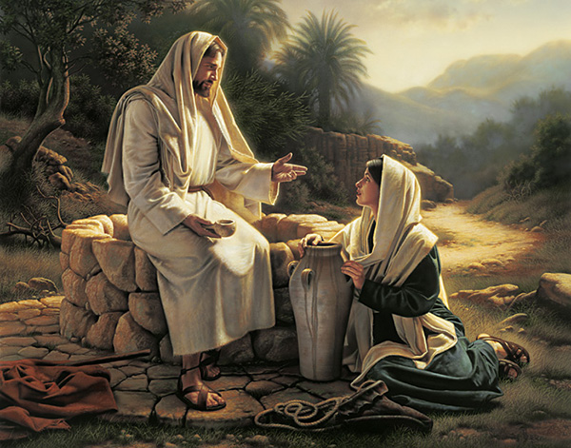
Living Water, by Simon Dewey

Jesus and disciples head back north; while passing through Samaria, Jesus talks to a woman at the well. Jesus casts off followers for the harvest as winter is less than four months away. Jesus is tempted as he fasts for 40 days. Jesus is informed of John the Baptist’s arrest.
1 Then cometh he to a city of Samaria, which is called Sychar, near to the parcel of ground that Jacob gave to his son Joseph.
2 Now Jacob’s well was there. Jesus therefore, being wearied with his journey, sat thus on the well: and it was about the sixth hour.
3 There cometh a woman of Samaria to draw water: Jesus saith unto her, Give me to drink.
4 (For his disciples were gone away unto the city to buy meat.)
5 Then saith the woman of Samaria unto him, How is it that thou, being a Jew, askest drink of me, which am a woman of Samaria? for the Jews have no dealings with the Samaritans.
6 Jesus answered and said unto her, If thou knewest the gift of God, and who it is that saith to thee, Give me to drink; thou wouldest have asked of him, and he would have given thee living water.
7 The woman saith unto him, Sir, thou hast nothing to draw with, and the well is deep: from whence then hast thou that living water?
8 Art thou greater than our father Jacob, which gave us the well, and drank thereof himself, and his children, and his cattle?
9 Jesus answered and said unto her, Whosoever drinketh of this water shall thirst again:
10 But whosoever drinketh of the water that I shall give him shall never ªthirst; but the water that I shall give him shall be in him a well of water springing up into everlasting life.
11 The woman saith unto him, Sir, give me this water, that I thirst not, neither come hither to draw.
12 Jesus saith unto her, Go, call thy husband, and come hither.
13 The woman answered and said, I have no husband. Jesus said unto her, Thou hast well said, I have no husband:
14 For thou hast had five husbands; and he whom thou now hast is not thy husband: in that saidst thou truly.
15 The woman saith unto him, Sir, I perceive that thou art a prophet.
16 Our fathers worshipped in this mountain; and ye say, that in Jerusalem is the place where men ought to worship.
17 Jesus saith unto her, Woman, believe me, the hour cometh, when ye shall neither in this mountain, nor yet at Jerusalem, worship the Father.
18 Ye worship ye know not what: we know what we worship: for salvation is of the Jews.
19 But the hour cometh, and now is, when the true worshippers shall worship the Father in spirit and in truth: for the Father seeketh such to worship him.
20 For unto such hath God promised his Spirit. And they who worship him, must worship in spirit and in truth.
21 The woman saith unto him, I know that Messias cometh, which is called Christ: when he is come, he will tell us all things.
22 Jesus saith unto her, I that speak unto thee am he.
23 And upon this came his disciples, and marvelled that he talked with the woman: yet no man said, What seekest thou? or, Why talkest thou with her?
24 The woman then left her waterpot, and went her way into the city, and saith to the men,
25 Come, see a man, which told me all things that ever I did: is not this the Christ?
26 Then they went out of the city, and came unto him.
27 In the mean while his disciples prayed him, saying, Master, eat.
28 But he said unto them, I have meat to eat that ye know not of.
29 Therefore said the disciples one to another, Hath any man brought him ought to eat?
30 Jesus saith unto them, My meat is to do the will of him that sent me, and to finish his work.
31 Say not ye, There are yet four months, and then cometh harvest? behold, I say unto you, Lift up your eyes, and look on the fields; for they are white already to harvest.
32 And he that reapeth receiveth wages, and gathereth fruit unto life eternal: that both he that soweth and he that reapeth may rejoice together.
33 And herein is that saying true, One soweth, and another reapeth.
34 I sent you to reap that whereon ye bestowed no labour: the prophets have laboured, and ye are entered into their labours.
35 And many of the Samaritans of that city believed on him for the saying of the woman, which testified, He told me all that ever I did.
36 So when the Samaritans were come unto him, they besought him that he would tarry with them: and he abode there two days.
37 And many more believed because of his own word;
38 And said unto the woman, Now we believe, not because of thy saying: for we have heard him ourselves, and know that this is indeed the Christ, the Saviour of the world.
39 Then Jesus was led up of the Spirit into the wilderness to be with God.
40 And when he had fasted forty days and forty nights, and had communed with God, he was afterward an hungred, and was left to be tempted of the devil.
41 And when the tempter came to him, he said, If thou be the Son of God, command that these stones be made bread.
42 But he answered and said, It is written, Man shall not live by bread alone, but by every word that proceedeth out of the mouth of God.
43 Then Jesus was taketh up into the holy city, and the Spirit setteth him on the pinnacle of the temple,
44 Then the devil came unto him and saith unto him, If thou be the Son of God, cast thyself down: for it is written, He shall give his angels charge concerning thee: and in their hands they shall bear thee up, lest at any time thou dash thy foot against a stone.
45 Jesus said unto him, It is written again, Thou shalt not tempt the Lord thy God.
46 And again, Jesus was in the Spirit, and it taketh him up into an exceeding high mountain, and sheweth him all the kingdoms of the world, and the glory of them; and he beheld all kingdoms of the world in a moment of time.
47 And the devil came unto him again, and said, All these things will I give unto thee, All this power will I give thee, and the glory of them: for that is delivered unto me; and to whomsoever I will I give it.
48 If thou therefore wilt worship me, all shall be thine.
49 Then saith Jesus unto him, Get thee hence, Satan: for it is written, Thou shalt worship the Lord thy God, and him only shalt thou serve.
50 And when the devil had ended all the temptation, he departed from him for a season, and angels did come from heaven and minister unto Jesus.
51 And when Jesus was told that John was cast into prison of the angels, he sent them, and, behold, they came and ministered unto John.
52 For Herod the Tetrarch himself had sent forth and laid hold upon John and bound him, and put him in prison for Herodias’ sake, his brother Philip’s wife: for he had married her.
53 For John reproached Herod and said unto him, It is not lawful for thee to have thy brother’s wife.
54 Therefore, Herodias had a quarrel against John, and would have killed him but she could not:
55 For Herod feared John and the multitude, because they counted John as a prophet, knowing that he was a just man and a holy man, and one who feared God and observed to worship him.
Taken from Matthew 4:1-11, Matthew 14:3-5, Mark 6:17-20, Luke 3:25-26, Luke 4:1-13, John 4:5-42
1. See also: TG Israel, Joseph, People of
5. See also: 2 Kgs. 17:29; Luke 10:33
6. See also: TG God, Gifts of; Living Water
10. See also: Ps. 42:2; 143:6; Isa. 55:1; John 6:35; 7:37; D&C 63:23; TG Immortality
15. See also: 1 Ne. 22:20
16. See also: Deut. 11:29
18. See also: D&C 93:19; TG Ignorance
19. See also: TG Worship; Ps. 145:18
20. See also: D&C 93:33; 130:22; TG Truth
21. See also: TG Jesus Christ, Messiah; Deut. 18:18
22. See also: Ex. 3:14, TG Jesus Christ, Jehovah
30. See also: Luke 2:49; John 8:29; TG God, Will of; Luke 9:4
31. See also: Alma 26:5; D&C 4:4; 33:3; TG Missionary Work
32. See also: TG Wages; D&C 18:16; 50:22
33. See also: 1 Cor. 3:6
34. See also: TG Harvest
38. See also: TG Jesus Christ, Messiah; D&C 66:1
39. See also: TG Guidance, Divine; Jesus Christ, Temptation of; Temptation; Test, Try, Prove
40. See also: Mosiah 3:7; TG Fasting; Ex. 24:18
41. See also: TG Devil; Bread
42. See also: Deut. 8:3; D&C 84:44; TG Mortality; Bread; Revelation; God, Body of (Corporeal Nature)
43. See also: Neh. 11:1
44. See also: Matt. 27:40; D&C 20:22
45. See also: D&C 10:29; 24:13; TG Jesus Christ, Temptation of; Test, Try, Prove
46. See also: D&C 10:19; TG Kings, Earthly
47. See also: Rev. 13:2
49. See also: TG Devil; Worship
51. See also: TG Angels
52. See also: Luke 13:31
53. See also: Lev. 18:16; 20:21; TG Divorce
55. See also: Matt. 11:9; 21:26; Luke 20:6

Commentary
- Elder Joseph B. Wirthlin (1917–2008) of the Quorum of the Twelve Apostles described some blessings that come from fasting: “Fasting, coupled with mighty prayer, is powerful. It can fill our minds with the revelations of the Spirit. It can strengthen us against times of temptation. Fasting and prayer can help develop within us courage and confidence. They can strengthen our character and build self-restraint and discipline. Often when we fast, our righteous prayers and petitions have greater power. Testimonies grow. We mature spiritually and emotionally and sanctify our souls. Each time we fast, we gain a little more control over our worldly appetites and passions” (“The Law of the Fast,” Ensign, May 2001, 73).
- It is of interest to note that when the number “forty” is mentioned in the scriptures, it can be understood literally or figuratively. In some instances, forty days can refer to a long period of time.
- Whenever there are great manifestations of the Lord, Satan shows up as the Great Counterfeit. (Moses, Joseph Smith, etc. likewise, Satan showed up here)
- Satan does not attack us in strengths or our moments of strength but in our weaknesses and in our moments of weakness. President Howard W. Hunter explained that Satan’s temptations are often strongest when we are vulnerable: “When Jesus had completed the fast of forty days and had communed with God, he was, in this hungry and physically weakened state, left to be tempted of the devil. … Such a time is always the tempter’s moment﻿—when we are emotionally or physically spent, when we are weary, vulnerable, and least prepared to resist the insidious suggestions he makes. This was an hour of danger﻿—the kind of moment in which many men fall and succumb to the subtle allurement of the devil” (“The Temptations of Christ,” 17).
- President David O. McKay, speaking of the three temptations Jesus suffered, that is to turn stones into bread, to cast Himself from the temple’s pinnacle, and to sell His soul for earth’s treasures said, ‘Classify them, and you will find that under one of those three nearly every given temptation that makes you and me spotted … comes to us as (1) a temptation of appetite; (2) a yielding to the pride and fashion and vanity of those alienated from the things of God; or (3) a gratifying of the … desire for the riches of the world, or power among men’ (in Conference Report, Apr. 1911, 59)” (“Welcome Home,” Ensign, May 1999, 80).
- Elder Neal A. Maxwell said of the Savior’s example in resisting temptation: “By emulating the Master, who endured temptations but ‘gave no heed unto them’ [D&C 20:22], we, too, can live in a world filled with temptations ‘such as [are] common to man’ (1 Corinthians 10:13). Of course Jesus noticed the tremendous temptations that came to Him, but He did not process and reprocess them. Instead, he rejected them promptly. If we entertain temptations, soon they begin entertaining us!” (“Overcome … Even as I Also Overcame,” Ensign, May 1987, 71).
- President Spencer W. Kimball (1895–1985) taught that showing interest in sin can make us more vulnerable to being tempted: “It is extremely difficult, if not impossible, for the devil to enter a door that is closed. He seems to have no keys for locked doors. But if a door is slightly ajar, he gets his toe in, and soon this is followed by his foot, then by his leg and his body and his head, and finally he is in all the way” (Teachings of Presidents of the Church: Spencer W. Kimball [2006], 106–7).
  - Satan does not know the content of our heart or thoughts of our mind. Showing interest in sin by our actions or verbally declaring them is paramount to handing the enemy the battle plans with all of the weaknesses written out clearly. The reason why temptation follows interest is thus: you wouldn’t expect an enemy to receive intel on the weaknesses of his foe and not use it against him; Satan is no different.
- The Savior’s response to each of Satan’s temptations included the phrase, “It is written” (Matthew 4:4, 7, 10; see also Luke 4:1–13). Christ’s knowledge of the scriptures was part of what had prepared and strengthened Him to turn aside from temptation. The Savior later taught, “Whoso treasureth up my word, shall not be deceived” (Joseph Smith﻿—Matthew 1:37). While serving as a member of the Seventy, Elder Merrill J. Bateman noted the strength that scripture study provides against temptation: “There are certain blessings obtained when one searches the scriptures. As a person studies the words of the Lord and obeys them, he or she draws closer to the Savior and obtains a greater desire to live a righteous life. The power to resist temptation increases, and spiritual weaknesses are overcome” (“Coming unto Christ by Searching the Scriptures,” Ensign, Nov. 1992, 28).
- Many appetites can bring us joy when used in moderation but all appetites, when used without reserve become nets that trap us and entangle us. “… We might define a net as anything that entices or prevents us from following the call of Jesus Christ, the Son of the living God. Nets in this context can be our work, our hobbies, our pleasures, and, above all else, our temptations and sins. In short, a net can be anything that pulls us away from our relationship with our Heavenly Father or from His restored Church.
“Let me give you a modern example. A computer can be a useful and indispensable tool. But if we allow it to devour our time with vain, unproductive, and sometimes destructive pursuits, it becomes an entangling net.
“Many of us enjoy watching athletic contests, but if we can recite the statistics of our favorite players and at the same time forget birthdays or anniversaries, neglect our families, or ignore the opportunity to render acts of Christlike service, then athletics may also be an entangling net. …
“It is impossible to list the many nets that can ensnare us and keep us from following the Savior. But if we are sincere in our desire to follow Him, we must straightway leave the world’s entangling nets and follow Him” (“Follow Me,” Ensign, May 2002, 15).

Chapter Seventeen

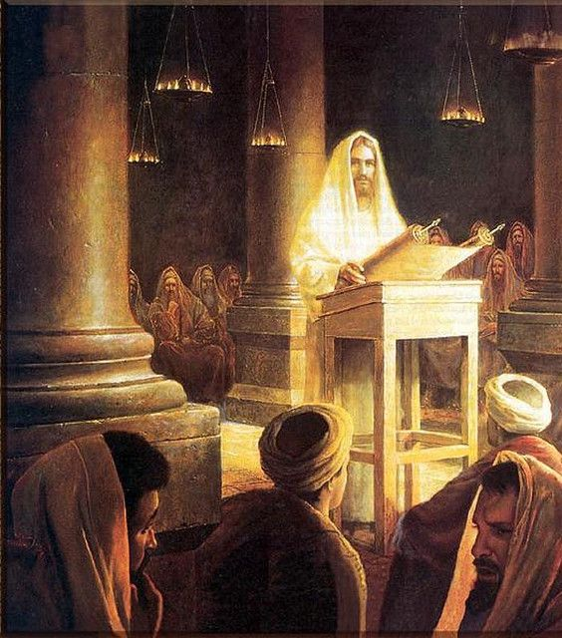
Jesus in the Synagogue at Nazareth, by Greg Olsen

Jesus journeys to Cana and heals a nobleman’s son. He goes back to Nazareth and is rejected.

1 Then went Jesus by the power of the Spirit to Cana.
2 And when he was come into Cana, the Galilæans received him, having seen all the things that he did at Jerusalem at the feast: for they also went unto the feast.
3 So Jesus came again into Cana of Galilee, where he made the water wine. And he taught in their synagogues, being glorified of all, and there went out a fame of him through all the region round about.
4 And there was a certain nobleman, whose son was sick at Capernaum. And he heard that Jesus was come out of Judæa into Galilee, he went unto him, and besought him that he would come down, and heal his son: for he was at the point of death.
5 Then said Jesus unto him, Except ye see signs and wonders, ye will not believe.
6 The nobleman saith unto him, Sir, come down ere my child die.
7 Jesus saith unto him, Go thy way; thy son liveth. And the man believed the word that Jesus had spoken unto him, and he went his way.
8 And as he was now going down, his servants met him, and told him, saying, Thy son liveth.
9 Then inquired he of them the hour when he began to amend. And they said unto him, Yesterday at the seventh hour the fever left him.
10 So the father knew that it was at the same hour, in the which Jesus said unto him, Thy son liveth: and himself believed, and his whole house.
11 This is again the second miracle that Jesus did, when he was come out of Judæa into Galilee.
12 And Jesus again by the power of spirit, came to Nazareth, where he had been brought up: and, as his custom was, he went into the synagogue on the sabbath day, and stood up for to read.
13 And there was delivered unto him the book of the prophet Esaias. And when he had opened the book, he found the place where it was written,
14 The Spirit of the Lord is upon me, because he hath anointed me to preach the gospel to the poor; he hath sent me to heal the brokenhearted, to preach deliverance to the captives, and recovering of sight to the blind, to set at liberty them that are bruised,
15 To preach the acceptable year of the Lord.
16 And he closed the book, and he gave it again to the minister, and sat down. And the eyes of all them that were in the synagogue were fastened on him.
17 And he began to say unto them, This day is this scripture fulfilled in your ears, the kingdom of God is at hand: Repent ye and believe the gospel.
18 And all bare him witness, and wondered at the gracious words which proceeded out of his mouth. And they said, Is not this Joseph’s son?
19 And he said unto them, Ye will surely say unto me this proverb, Physician, heal thyself: whatsoever we have heard done in Capernaum, do also here in thy country.
20 And he said, Verily I say unto you, No prophet is accepted in his own country.
21 But I tell you of a truth, many widows were in Israel in the days of Elijah, when the heaven was shut up three years and six months, when great famine was throughout all the land;
22 But unto none of them was Elias sent, save unto Sarepta, a city of Sidon, unto a woman that was a widow.
23 And many lepers were in Israel in the time of Eliseus the prophet; and none of them was cleansed, saving Naaman the Syrian.
24 And all they in the synagogue, when they heard these things, were filled with wrath,
25 And rose up, and thrust him out of the city, and led him unto the brow of the hill whereon their city was built, that they might cast him down headlong.
26 But he passing through the midst of them went his way,
27 Even the Son of God. He who was in the world, and the world was made by him, and the world knew him not.
28 He came unto his own, and his own received him not.
29 But as many as received him, to them gave he power to become the sons of God; only to them who believe on his name.
Taken from Mark 1:15, Luke 4:14-30, John 1:10-12, John 4:45-54
5. See also: TG Sign Seekers
7. See also: TG Healing
11. See also: John 2:11
14. See also: Isa. 61:1; TG God, Spirit of; Anointing; Jesus Christ, Messiah; Teaching; D&C 137:7; TG Gospel; Poor; Jesus Christ, Mission of; Preaching; Deliverance; Remission of Sins; D&C 138:8; TG Bondage, Spiritual; Salvation, for the Dead; Spirits in Prison; Liberty
15. See also: John 12:47
17. See also: TG Jesus Christ, Prophecies about
18. See also: Ps. 45:2; John 6:42
19. See also: Matt. 13:58
20. See also: TG Prophets, Rejection of
21. See also: 1 Kgs. 17:9; TG Widows; 1 Kgs. 17:1; Matt. 17:3; D&C 110:3
23. See also: TG Leprosy; 2 Kgs. 5:14
26. See also: John 8:59
27. See also: TG World; Creation; Jesus Christ, Creator; Isa. 53:3
28. See also: 3 Ne. 9:16; D&C 6:21
29. See also: D&C 25:1; TG Teachable; D&C 11:30; TG Jesus Christ, Power of; D&C 39:4; TG Sons and Daughters of God; Name

Chapter Eighteen
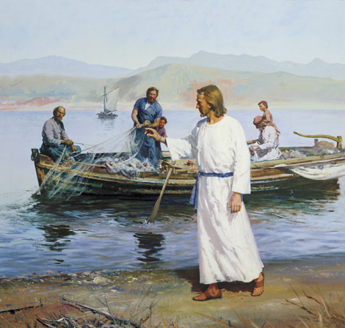
Calling of the Fishermen, by Harry Anderson
Jesus enters Capernaum and casts out unclean spirits. He calls Peter, Andrew, James and John and makes them “fishers of men.”
1 And leaving Nazareth, he came and dwelt in Capernaum, which is upon the sea coast, in the borders of Zabulon and Nephthalim:
2 That it might be fulfilled which was spoken by Isaiah the prophet, saying,
3 The land of Zabulon, and the land of Nephthalim, by the way of the sea, beyond Jordan, Galilee of the Gentiles;
4 The people which sat in darkness saw great light; and to them which sat in the region and shadow of death light is sprung up.
5 From that time Jesus began to preach to them on the Sabbath days, saying, Repent: for the kingdom of heaven is at hand.
6 And they were astonished at his doctrine: for his word was with authority and power, and not as the scribes.
7 And in the synagogue there was a man, which had a spirit of an unclean devil, and cried out with a loud voice,
8 Saying, Let us alone; what have we to do with thee, thou Jesus of Nazareth? art thou come to destroy us? I know thee who thou art; the Holy One of God.
9 And Jesus rebuked him, saying, Hold thy peace, and come out of him. And when the unclean spirit had thrown him in the midst, he came out of him, and hurt him not.
10 And they were all amazed, insomuch that they questioned among themselves, saying, What thing is this? What new doctrine is this? What a word is this! for with authority and power he commandeth the unclean spirits, and they do obey them and come out.
11 And the fame of him went out into every place of the country round about.
12 And it came to pass, that, as the people pressed upon him to hear the word of God, he stood by the lake of Gennesaret,
13 And saw two ships standing by the lake: but the fishermen were gone out of them, and were washing their nets.
14 And he entered into one of the ships, which was Simon’s, and prayed him that he would thrust out a little from the land. And he sat down, and taught the people out of the ship.
15 Now when he had left speaking, he said unto Simon, Launch out into the deep, and let down your nets for a draught.
16 And Simon answering said unto him, Master, we have toiled all the night, and have taken nothing: nevertheless at thy word I will let down the net.
17 And when they had this done, they inclosed a great multitude of fishes: and their net brake.
18 And they beckoned unto their partners, which were in the other ship, that they should come and help them. And they came, and filled both the ships, so that they began to sink.
19 When Simon Peter saw it, he fell down at Jesus’ knees, saying, Depart from me; for I am a sinful man, O Lord.
20 For he was astonished, and all that were with him, at the draught of the fishes which they had taken:
21 And so was also James, and John, the sons of Zebedee, which were partners with Simon. And Jesus said unto Simon, Fear not; for I am he of whom it is written by the prophets; follow me and I will make you fishers of men.
22 And when they had all brought their ships to land, they left Zebedee in the ships with the hired servants and the draught of fishes, forsaking all, and followed him.
Taken from Matthew 4:13-17, 21-22, Mark 1:16-28, Luke 4:31-37, Luke 5:1-11
2. See also: D&C 24:14
3. See also: Isa. 9:1
4. See also: D&C 57:10; TG Jesus Christ, Light of the World; Jesus Christ, Prophecies about
5. See also: TG Preaching; Repentance; Kingdom of God, in Heaven; Isa. 56:1
6. See also: TG Jesus Christ, Authority of; Jesus Christ, Teaching Mode; Teaching with the Spirit
8. See also: TG Holiness
9. See also: TG Healing
10. See also: Mark 1:39; TG Spirits, Evil, Unclean; Authority; Jesus Christ, Authority of
16. See also: TG Industry
21. See also: TG Missionary Work; John 21:2
22. See also: Luke 14:33; TG Apostles

Commentary
- In verse 4 above, Matthew was referring to Isaiah 9:1-2. The tribes Zebulun and Naphtali inhabited the Galilee area, numerous battles were fought over this strategic location. Because of this, Isaiah referred to the people of this region accordingly.

Chapter Nineteen
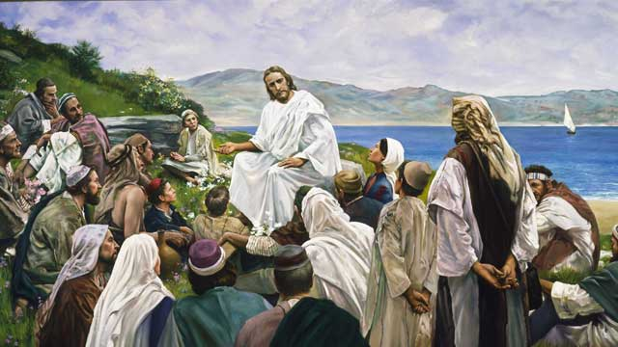
Sermon on the Mount, by Harry Anderson
Jesus teaches the Sermon on the Mount; the Beatitudes
1 And in the morning, rising up a great while before day, Jesus went out, and departed into a solitary place, and there prayed.
2 And Simon and they that were with him followed after him.
3 And when they had found him, they said unto him, All men seek for thee.
4 And seeing the multitudes, Jesus opened his mouth, and taught them, saying,
5 Blessed are the poor in spirit: for theirs is the kingdom of heaven.
6 Blessed are they that mourn: for they shall be comforted.
7 Blessed are the meek: for they shall inherit the earth.
8 Blessed are they which do hunger and thirst after righteousness: for they shall be filled.
9 Blessed are the merciful: for they shall obtain mercy.
10 Blessed are the pure in heart: for they shall see God.
11 Blessed are the peacemakers: for they shall be called the children of God.
12 Blessed are they which are persecuted for righteousness’ sake: for theirs is the kingdom of heaven.
13 Blessed are ye, when men shall revile you, and when they shall separate you from their company, and persecute you, and shall say all manner of evil against you falsely, for my sake.
14 Rejoice, and be exceeding glad: for great is your reward in heaven: for so persecuted they the prophets which were before you.
15 But woe unto you that are rich! for ye have received your consolation.
16 Woe unto you that are full! for ye shall hunger. Woe unto you that laugh now! for ye shall mourn and weep.
17 Woe unto you, when all men shall speak well of you! for so did their fathers to the false prophets.
Taken from Matthew 5:1-12, Mark 1:35-38, Luke 6:20-26
5. See also: TG Blessings; Contrite Heart; Humility; Kingdom of God, in Heaven; Poor in Spirit; 3 Ne. 12:3; James 2:5; D&C 56:18; 88:17
6. See also: TG Mourning; Sorrow; Comfort
7. See also: TG Meekness; Ps. 37:11; Earth, Destiny of
8. See also: 3 Ne. 12:6; TG Teachable; Good Works; Righteousness
9. See also: TG Mercy
10. See also: TG Chastity; Cleanliness; Purity; Heart; God, Presence of; God, Privilege of Seeing
11. See also: TG Contentment; Peace; Peacemakers; Sons and Daughters of God
12. See also: TG Affliction; Persecution; Righteousness; D&C 6:37; 10:55
13. See also: TG Malice; Reviling; Backbiting; Slander
14. See also: 2 Ne. 9:18; D&C 84:38; TG Joy; Reward; Persecution
15. See also: TG Treasure
17. See also: TG Trust Not in the Arm of Flesh; John 15:19; 1 Ne. 22:23; Alma 1:3
Commentary
- The eight attitudes described are commonly referred to the Beatitudes in the Christian world. Harold B. Lee said “They embody in fact the constitution for a perfect life.”

“Blessed Are the Poor in Spirit”: President Harold B. Lee taught that the poor in spirit are “those who are spiritually needy, who feel so impoverished spiritually that they reach out with great yearning for help” (Teachings: Harold B. Lee, 197). The account of the sermon in 3 Nephi states, “Blessed are the poor in spirit who come unto me” (3 Nephi 12:3; italics added).

“Blessed Are They That Mourn”: President Harold B. Lee explained that “they that mourn” relates to those who mourn over their sins: “‘And again, blessed are all they that mourn’ (3 Nephi 12:4; see also Matthew 5:4). … He is talking about repentance. He is talking about the promise that will come to whom? All who would ‘come down into the depths of humility’ and have been baptized and have received the gift of the Holy Ghost (see 3 Nephi 12:2)” (The Teachings of Harold B. Lee, ed. Clyde J. Williams [1996], 112).
Another meaning of this teaching is provided in Mosiah 18:9, which teaches that one requirement of Church membership is being “willing to mourn with those that mourn; yea, and comfort those that stand in need of comfort.”

“Blessed Are the Meek”: To be “meek” means to be “Godfearing, righteous, humble, teachable, and patient under suffering. The meek are willing to follow gospel teachings” (Guide to the Scriptures, “Meek, Meekness”; scriptures.lds.org). Meekness does not imply weakness; rather, as Elder Neal A. Maxwell (1926–2004) of the Quorum of the Twelve Apostles taught, meekness is “kindness and gentleness. It reflects certitude, strength, serenity; it reflects a healthy self-esteem and a genuine self-control” (“Meekly Drenched in Destiny” [Brigham Young University devotional, Sept. 5, 1982], 2; speeches.byu.edu).
While serving as the Presiding Bishop of the Church, Bishop H. David Burton explained the necessity of being meek: “Meekness will allow us to be tutored by the Spirit” (“More Holiness Give Me,” Ensign or Liahona, Nov. 2004, 99).
When Jesus promised that the meek would inherit the earth, He was quoting from Psalm 37:11. To “inherit the earth” (Matthew 5:5) means to inherit the celestial kingdom. This earth will one day be “sanctified from all unrighteousness, that it may be prepared for the celestial glory” (D&C 88:18), and “the meek of the earth shall inherit it” (D&C 88:17).

“Blessed Are They Which Do Hunger and Thirst after Righteousness”:The Greek word that was translated as “filled” also means “to feed or fatten an animal in a stall” and connotes the idea of eating until completely satisfied. This helps us understand the Lord’s promise to those who hunger and thirst after righteousness﻿—He will feed them spiritually until they are completely satisfied. The account of the sermon in 3 Nephi adds, “They shall be filled with the Holy Ghost” (3 Nephi 12:6; italics added).

“Blessed Are the Merciful”:This is one of the many times the Savior taught that the way we treat others affects how God will treat us (see Matthew 6:12, 14–15; 7:1–2; 18:23–35; 25:31–46). President Gordon B. Hinckley (1910–2008) wrote: “I plead for a stronger spirit of compassion in all of our relationships, a stronger element of mercy, for if we are merciful we shall obtain mercy from the Ultimate Judge. … It is impressive to watch those who with a compelling spirit of kindness reach out to those in distress, to help and assist, to feed and provide for, to nurture and to bless. As these extend mercy, I am confident that the God of Heaven will bless them, and their posterity after them, with His own mercy. … One cannot be merciful to others without receiving a harvest of mercy in return [see Matthew 5:7]” (Standing for Something [2000], 75, 77).
The Prophet Joseph Smith (1805–44) placed mercy in the context of forgiving others: “Ever keep in exercise the principle of mercy, and be ready to forgive our brother on the first intimations of repentance, and asking forgiveness; and should we even forgive our brother, or even our enemy, before he repent or ask forgiveness, our heavenly Father would be equally as merciful unto us” (Teachings of Presidents of the Church: Joseph Smith [2007], 392–93).
- “Blessed Are the Pure in Heart”: While serving as a member of the Seventy, Elder Gerald N. Lund explained that a pure heart is free from contamination and open to the Holy Spirit: “In the Sermon on the Mount, the Savior said, ‘Blessed are the pure in heart: for they shall see God’ [Matthew 5:8]. If something is pure, it is not polluted or tainted by things which do not belong to it. Purity of heart is certainly one of the most important qualifications for receiving inspiration from God. While none of our hearts are perfect, the more diligently we strive to eliminate impurity, or push out things which do not belong there, the more we open our hearts to the Holy Spirit” (“Opening Our Hearts,” Ensign or Liahona, May 2008, 33).
Elder Bruce R. McConkie (1915–85) of the Quorum of the Twelve Apostles discussed the connection between being pure in heart and being able to see God: “Purity of heart is a figure for purity of soul. They are the ones who received a remission of their sins in the waters of baptism; who, after baptism, have so lived as to retain a remission of sins; who have had their sins burned out of their souls as though by fire by the power of the Holy Ghost. They are God-fearing and righteous souls; and being pure, they qualify to see and associate with other pure beings, the chief of whom is the Lord of Purity” (A New Witness for the Articles of Faith [1985], 492).

Chapter Twenty
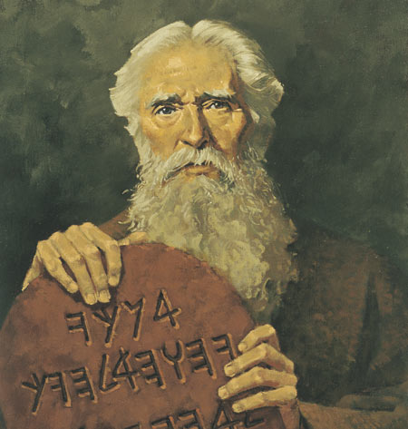
Sermon on the Mount: Jesus fulfills the law
1 And the Pharisees also, who were covetous, heard all these things: and they derided him saying,
2 Good Master, we have the law, and we have Moses and the prophets; and whosever shall live by them, shall he not have life?
3 And Jesus said unto them, Ye are they which justify yourselves before men; but God knoweth your hearts: for that which is highly esteemed among men is abomination in the sight of God.
4 And they said unto him, But as for this man we will not receive him to be our ruler: for he maketh himself to be a judge over us.
5 Then said Jesus unto them, The law and the prophets testify of me; yea, and all the prophets who have written, even until John, have foretold of these days.
6 And ye know not Moses, neither the prophets; for if ye had known them, ye would have believed on me; for to this intent they were written. For I am sent that ye might have life.
7 Since that time, the kingdom of God is preached, and every man who seeketh truth presseth into it.
8 And it is easier for heaven and earth to pass, than for one tittle of the law to fail.
9 And why teach ye the law, and deny that which is written; and condemn him who the Father hath sent to fulfill the law, that ye might all be redeemed?
Taken from Luke 16:14-20
1. See also: Alma 11:24
2. See also: Luke 10:29; TG God, Intelligence of; God, Omniscience of; Man, Natural, Not Spiritually Reborn; Prov. 21:1; 2 Ne. 9:28

Chapter Twenty-One
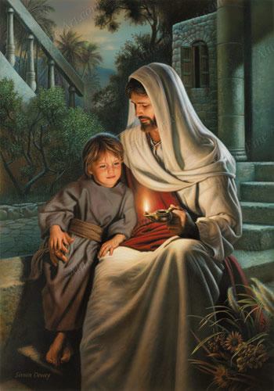
Ye Are the Light of the World, by Simon Dewey
Sermon on the Mount: Salt of the earth, Let your light so shine
1 Therefore, I will liken it unto salt which is good; ye are the salt of the earth: but if the salt have lost its savor wherewith shall it be salted? It is neither fit for the land, nor yet for the dunghill, it is thenceforth good for nothing but to be cast out and to be trodden under foot of men. Ye are the light of the world. A city set on a hill cannot be hid.
2 No man, when he hath lighted a candle, putteth it in a secret place, neither under a bushel, neither putteth it under a bed, but on a candlestick and it giveth light to all who are in the house that they which enter in may see the light.
3 The light of the body is the eye: therefore when thine eye is single to the glory of God, thy whole body also is full of light; but when thine eye is evil, thy body also is full of darkness. If therefore the light that is in thee be darkness, how great is that darkness!
4 If thy whole body therefore be full of light, having no part dark, the whole shall be full of light, as when the bright shining of a candle doth give thee light.
5 Take heed therefore that the light which is in thee be not darkness.
Taken from Matthew 5:13-16, Matthew 6:22-23, Mark 4:21-23, Luke 8:16, Luke 11:33-36, Luke 14:34-37
1. See also: TG Salt; Lev. 2:13; Num. 18:19; TG Mission of Early Saints
2. See also: 3 Ne. 12:15; 18:24; D&C 60:2
3. See also: D&C 88:68; Morm. 8:15; JS-H 1:46; TG Darkness, Spiritual
Commentary

“If the Salt Have Lost His Savour”: In addition to its uses in flavoring and preserving food, salt was added to sacrificial offerings under the law of Moses. Thus salt was associated with joy, permanence, and covenant making. When Jesus admonished disciples to be the “salt of the earth” (Matthew 5:13), part of the meaning was that their lives should reflect their covenants with the Lord and serve as a preservative for the world in general. Elder Carlos E. Asay (1926–99) of the Presidency of the Seventy explained that “A world-renowned chemist told me that salt will not lose its savor with age. Savor is lost through mixture and contamination. Similarly, priesthood power does not dissipate with age; it, too, is lost through mixture and contamination.
“I would offer these simple guidelines, especially to the young men, as the means to preserve one’s savor: If it is not clean, do not think it; if it is not true, do not speak it; if it is not good, do not do it” (“Salt of the Earth: Savor of Men and Saviors of Men,” Ensign, May 1980, 42–43).
- The easiest way to understand, “Let Your Light So Shine,” is the watchtower in Ezekiel 33.

Chapter Twenty-Two
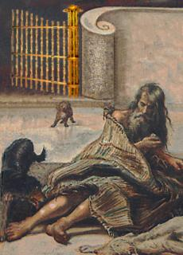
Sermon on the Mount: Parable of the Rich Man and Lazarus
1 O fools! for you have said in your hearts, There is no God. And you pervert the right way; and the kingdom of heaven suffereth violence of you; and you persecute the meek; and in your violence you seek to destroy the kingdom; and ye take the children of the kingdom by force. Woe unto you, ye adulterers!
2 And they reviled him again, being angry for the saying, that they were adulterers.
3 But he continued, saying, Verily I say unto you, I will liken you unto the rich man.
4 There was a certain rich man, whom was clothed in purple and fine linen, and fared sumptuously every day:
5 And there was a certain beggar named Lazarus, which was laid at his gate, full of sores,
6 And desiring to be fed with the crumbs which fell from the rich man’s table: moreover the dogs came and licked his sores.
7 And it came to pass, that the beggar died, and was carried by the angels into Abraham’s bosom: the rich man also died, and was buried;
8 And in hell he lift up his eyes, being in torments, and seeth Abraham afar off, and Lazarus in his bosom.
9 And he cried and said, Father Abraham, have mercy on me, and send Lazarus, that he may dip the tip of his finger in water, and cool my tongue; for I am tormented in this flame.
10 But Abraham said, Son, remember that thou in thy lifetime receivedst thy good things, and likewise Lazarus evil things: but now he is comforted, and thou art tormented.
11 And beside all this, between us and you there is a great gulf fixed: so that they which would pass from hence to you cannot; neither can they pass to us, that would come from thence.
12 Then he said, I pray thee therefore, father, that thou wouldest send him to my father’s house:
13 For I have five brethren; that he may testify unto them, lest they also come into this place of torment.
14 Abraham saith unto him, They have Moses and the prophets; let them hear them.
15 And he said, Nay, father Abraham: but if one went unto them from the dead, they will repent.
16 And he said unto him, If they hear not Moses and the prophets, neither will they be persuaded, though one rose from the dead.
Taken from Luke 16: 21-36
5. See also: TG Poor
7. See also: TG Angels; Alma 40:11
8. See also: TG Hell; Spirits in Prison
11. See also: 1 Ne. 15:28; TG Separation
14. See also: TG Scriptures, Value
15. See also: Alma 32:18; Ether 12:12; D&C 5:7
16. See also: TG Scriptures, Study; Unbelief, Unbelievers; 2 Ne. 33:11; Hel. 13:26; D&C 5:8

Chapter Twenty-Three
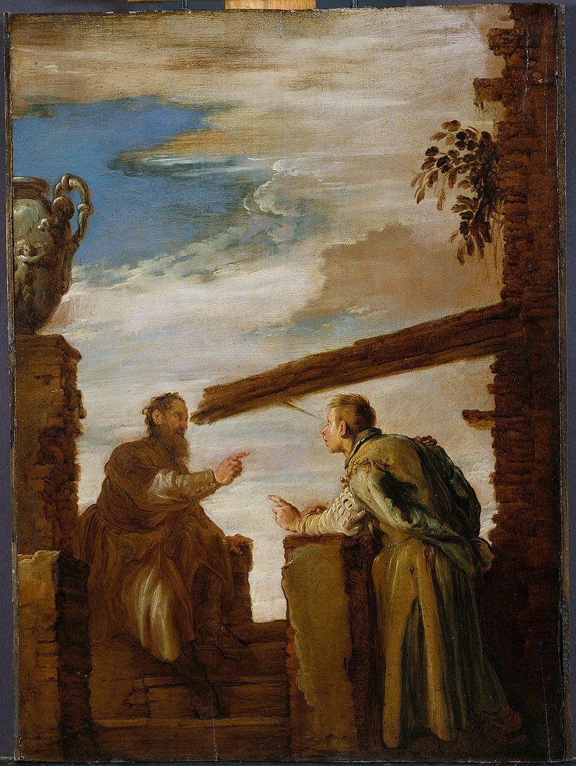
The Parable of the Mote and the Beam, by Domenico Fetti

Sermon on the Mount: Jesus teaches the higher law.
1 Think not that I am come to destroy the law, or the prophets: I am not come to destroy, but to fulfil.
2 For verily I say unto you, Till heaven and earth pass, one jot or one tittle shall in no wise pass from the law, till all be fulfilled.
3 Whosoever therefore shall break one of these least commandments, and shall teach men so to do, he shall in no wise be saved in the kingdom of heaven; but whosoever shall do and teach these commandments of the law until it be fulfilled, the same shall be called great and shall be saved in the kingdom of heaven.
4 For I say unto you, That except your righteousness shall exceed the righteousness of the scribes and Pharisees, ye shall in no case enter into the kingdom of heaven.
5 Ye have heard that it was said by them of old time, Thou shalt not kill; and whosoever shall kill shall be in danger of the judgment:
6 But I say unto you, That whosoever is angry with his brother shall be in danger of the judgment: and whosoever shall say to his brother, Raca, shall be in danger of the council: but whosoever shall say, Thou fool, shall be in danger of hell fire.
7 Therefore if thou bring thy gift to the altar, and there rememberest that thy brother hath ought against thee;
8 Leave there thy gift before the altar, and go thy way; first be \reconciled to thy brother, and then come and offer thy gift.
9 When thou goest with thine adversary to the magistrate, as thou art in the way, give diligence that thou mayest be delivered from him; lest he hale thee to the judge, and the judge deliver thee to the officer, and the officer cast thee into prison.
10 Verily I say unto thee, Thou shalt by no means come out thence, till thou hast paid the uttermost farthing.
11 Ye have heard that it was said by them of old time, Thou shalt not commit adultery:
12 But I say unto you, That whosoever looketh on a woman to lust after her hath committed adultery with her already in his heart.
13 And if thy right eye offend thee, pluck it out, and cast it from thee: for it is profitable for thee that one of thy members should perish, and not that thy whole body should be cast into hell.
14 And if thy right hand offend thee, cut it off, and cast it from thee: for it is profitable for thee that one of thy members should perish, and not that thy whole body should be cast into hell. And now this I speak a parable concerning your sins; wherefore cast them from you, that ye may not be hewn down and cast into the fire.
15 It hath been said, Whosoever shall put away his wife, let him give her a writing of divorcement:
16 But I say unto you, That whosoever shall put away his wife, saving for the cause of fornication, causeth her to commit adultery: and whosoever shall marry her that is divorced committeth adultery.
17 Again, ye have heard that it hath been said by them of old time, Thou shalt not forswear thyself, but shalt perform unto the Lord thine oaths:
18 But I say unto you, Swear not at all; neither by heaven; for it is God’s throne:
19 Nor by the earth; for it is his footstool: neither by Jerusalem; for it is the city of the great King.
20 Neither shalt thou swear by thy head, because thou canst not make one hair white or black.
21 But let your communication be, Yea, yea; Nay, nay: for whatsoever is more than these cometh of evil.
22 Ye have heard that it hath been said, An eye for an eye, and a tooth for a tooth:
23 But I say unto you, That ye resist not evil: but whosoever shall smite thee on thy right cheek, offer also the other; or, in other words, it is better to offer the other, than to revile again.
24 And if any man will sue thee at the law, and take away thy coat, let him have thy cloak also. For it is better that thou suffer thine enemy to take these things, than to contend with him. Verily I say unto you, Your heavenly Father who seeth in secret, shall bring that wicked one into judgment.
25 And whosoever shall compel thee to go a mile, go with him twain.
26 Give to him that asketh thee, and from him that would borrow of thee turn not thou away; forgive, and it shall be given unto you. But do good, and lend, hoping for nothing again; but be ye therefore merciful, as your Father is also merciful, and great shall be your reward.
27 Judge, but judge ye not unrighteously, that ye be not judged; but judge righteous judgment. For with what judgment ye judge, ye shall be judged: and with what measure ye mete, it shall be measured to you again. Forgive and ye shall be forgiven.
28 And again, ye shall say unto them, Why is it that thou beholdest the mote that is in thy brother’s eye, but considerest not the beam that is in thine own eye?
29 Or how wilt thou say to thy brother, Let me pull out the mote out of thine eye; and canst not behold a beam in thine own eye?
30 And Jesus said unto his disciples, Beholdest thou the scribes, and the Pharisees, and the priests, and the Levites? They teach in their synagogues, but do not observe the law, nor the commandments; and all have gone out of the way, and are under sin.
31 Go thou and say unto them, Why teach ye men the law and the commandments, when ye yourselves are the children of corruption?
32 Say unto them, ye hypocrites, first cast out the beam out of thine own eye; and then shalt thou see clearly to cast out the mote out of thy brother’s eye.
33 Go ye into the world, saying unto all, Repent, for the kingdom of heaven has come nigh unto you.
34 Ye have heard that it hath been said, Thou shalt love thy neighbour, and hate thine enemy.
35 But I say unto you, Love your enemies, bless them that curse you, do good to them that hate you, and pray for them which despitefully use you, and persecute you;
36 That ye may be the children of your Father which is in heaven: for he maketh his sun to rise on the evil and on the good, and sendeth rain on the just and on the unjust.
37 For if ye love them which love you, what reward have ye? do not even the sinners do even the same?
38 And if ye lend to them of whom ye hope to receive, what thank have ye? for publicans also lend to sinners, to receive as much again.
39 And if ye salute your brethren only, what do ye more than others? do not even the publicans so?
40 Ye are therefore commanded to love and to be perfect, even as your Father which is in heaven loves and is perfect; Therefore all things whatsoever ye would that men should do to you, do ye even so to them: for this is the law and the prophets.
Taken from Matthew 5:17-48, Matthew 7:1-8, 20, Luke 5:27-42, Luke 12:65-66

1. See also: D&C 10:52; TG Law of Moses
2. See also: TG Law of Moses; D&C 1:38
3. See also: TG Sin; 2 Ne. 28:15; TG Missionary Work
4. See also: TG Righteousness; Scribes
5. See also: TG Commandments of God; Blood, Shedding of; Murder
6. See also: Prov. 29:22; 3 Ne. 12:22; TG Anger; Rashness
8. See also: Matt. 18: 15; TG Forgiveness; Reconciliation
11. See also: D&C 42:22
12. See also: D&C 63:16; TG Body, Sanctity of; Woman; Mosiah 4:30; TG Carnal Mind; Chastity; Fornication; Lust; Motivations; Sensuality; Adultery; Sexual Immorality
13. See also: Matt 18:6-9; TG Offences; Damnation; Hell
15. See also: TG Divorce
16. See also: Ezek. 44:22; D&C 42:74; 1 Cor. 7:10; TG Fornication
17. See also: TG Dedication; Deut. 23:21; TG Oaths
18. See also: TG Honesty; Profanity; Swearing; Isa. 66:1
19. See also: Isa. 60:13; Ezek. 43:7; Ps. 48:2
21. See also: TG Communication
22. See also: Lev. 24:20; 3 Ne. 12:38; TG Punishment
23. See also: TG Evil; Lam. 3:30; TG Patience; Forbearance
26. See also: TG Almsgving; Generosity; Kindness; Poor; Borrowing; Debt; Mercy; God, Mercy of; Reward
27. See also: TG Judgment; Prov. 11:25; D&C 1:10; Esth. 7:10; 1 Ne. 14:3; D&C 10: 26
30. See also: TG Hypocrisy
32. See also: TG Hypocrisy
34. See also: D&C 112:11; TG Neighbor
35. See also: TG Love; Enemies; Opposition; Retribution; Curse; Benevolence; Hate; Job 42:10; Acts 7:60; TG Prayer; Persecution
36. See also: TG Sons and Daughters of God; Job 2:10; 2 Ne. 2:11; Alma 60:13; D&C 5:22; 29:39; 122:7
37. See also: Prov. 19:6
40. See also: D&C 67:13; TG God, the Standard of Righteousness; Godliness; Man, New; Spiritually Reborn; Man, Potential to Become Like Heavenly Father; Mission of Early Saints; Objectives; Perfection; God, Father; God, Perfection of; Benevolence; Law of Moses

Commentary

- The word raca comes from an Aramaic word meaning “imbecile, fool, or empty-headed person.” Elder Bruce R. McConkie explained a broader meaning of the term: “Profane and vulgar expressions vary from nation to nation and age to age, but the intent of this passage is to condemn any language which conveys improper feelings about another” (Doctrinal New Testament Commentary, 3 vols. [1965–73], 1:222).
- Joseph Smith Translation removes “without a cause” in verse 6 making it clear that there is never a good reason to be angry with your brother, ie. Hate the sin, not the sinner
- The Savior here gives some of the best advice for outer relationships between Christians and those not within the faith. Jesus already said to forgive and pray for those who despise you or use you but here he takes it a step further and says not only should you do that but you should do it whilst in the heat of the moment with that person. The Savior in other cases taught that this forgiveness is prerequisite for salvation (freedom and exaltation of the spirit) and here he further explains this will help preserve the freedom and maintenance of the physical tabernacle. Those of the world historically and today teach that forgiveness and mercy are weaknesses (Islam, Paganism etc) and therefore is somebody leaves a confrontation with you thinking you to be their enemy they will most likely seek ways to destroy you, ie. Deliver you to the judges which will bring you to prison etc. So we see by living this commandment we can preserve our physical freedom and guarantee our spiritual freedom.
- The Lord here repeatedly terms the phrase “ye have heard…” It is important to note that the Lord isn’t upgrading commandments or changing commandments but rather is clarifying actual commandments versus false traditions or common sayings of the day. There wasn’t a commandment to “hate your enemies” in fact there was a commandment to love (Lev. 19:18), thus there must have been a common saying to “hate your enemies”. Likewise, the Savior doesn’t say “remember the commandment to not commit adultery” and then proceed to upgrade it, he says, “ye have heard from old time…to not commit adultery.” Most likely there was martial advice that said “as you do not physically commit adultery you will be fine” but the Lord clarifies that there is something more there (coveting what is not yours when you have one already). This act of dispersing the mists of darkness over false traditions and actual doctrine/commandments is the central role of a prophet and restoring truths. Jesus was not an upgrader but a restorer, just like the other prophets.
- Covet: yearn to possess or have something; Lust: passionate desire for something. So another way of saying what Jesus said is, Remember, he that looketh upon something that isn’t his commits the sin of coveting in his heart. The Lord wasn’t creating a new commandment here, he was simply reminding people that coveting is still a sin, even if it is a sin of the heart, something that isn’t tangible or other words visibly seen or witnessed. Also, the sin of coveting (synonym lusting) in today’s context almost exclusively refers to the coveting and lusting after female flesh. Equally destructive (for it was all included equally in the same commandment) was the Lord’s command to not lust or covet after not only thy neighbor’s wife but also thy neighbor’s house, manservant, maidservant (phones, electronics, oven, vacuum- anything that serves you), nor thy neighbor’s ox (tools), ass (mode of transportation) nor anything that is thy neighbor’s.
  - The reason why coveting after things that don’t belong to you is so spiritually damning is because by its very first conception coveting obliterates gratitude. Without gratitude there cannot be a healthy relationship of any kind.
- President Joseph Fielding Smith (1876–1972) taught that the terms “right eye” or “right hand” can mean “close friends or relatives who [endeavor] to lead us from the path of rectitude and humble obedience to the divine commandments we receive from the Lord. If any friend or relative endeavors to lead a person away from the commandments, it is better to dispense with his friendship and association than to follow him in evil practices to destruction” (Answers to Gospel Questions, 5 vols. [1957–66], 5:79). It is interesting to note that President Joseph Fielding Smith was a relative of Emma Smith.

Chapter Twenty-Four

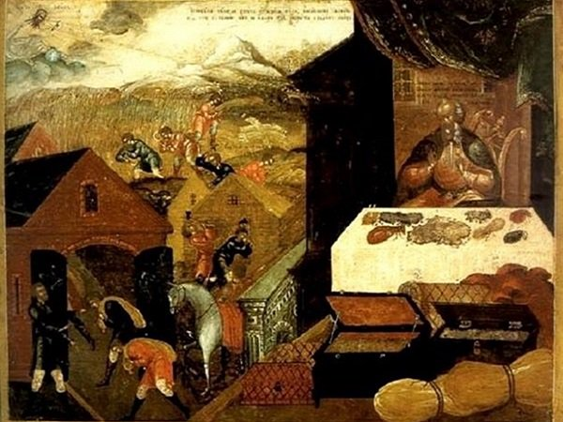

Sermon on the Mount: The Parable of the Foolish Rich Man, Treasures of Heaven
1 And one of the company said unto him, Master, speak to my brother, that he divide the inheritance with me.
2 And he said unto him, Man, who made me a judge or a divider over you?
3 And he said unto them, Take heed, and beware of covetousness: for a man’s life consisteth not in the abundance of the things which he possesseth.
4 And he spake a parable unto them, saying, The ground of a certain rich man brought forth plentifully:
5 And he thought within himself, saying, What shall I do, because I have no room where to bestow my fruits?
6 And he said, This will I do: I will pull down my barns, and build greater; and there will I bestow all my fruits and my goods.
7 And I will say to my soul, Soul, thou hast much goods laid up for many years; take thine ease, eat, drink, and be merry.
8 But God said unto him, Thou fool, this night thy soul shall be required of thee: then whose shall those things be, which thou hast provided?
9 So is he that layeth up treasure for himself, and is not rich toward God.
10 Lay not up for yourselves treasures upon earth, where moth and rust doth corrupt, and where thieves break through and steal:
11 But lay up for yourselves treasures in heaven, where neither moth nor rust doth corrupt, and where thieves do not break through nor steal:
12 For where your treasure is, there will your heart be also.
Taken from Matthew 6:19-21, Luke 12:15-23, 36
3. See also: Ps. 62:10; 119:36; TG Covetousness
7. See also: Eccl. 2:24; Isa. 22:13; 1 Cor. 15:32
8. See also: TG Soul
9. See also: TG Treasure; Hosea 10:1
10. See also: TG Family, Managing Finances in
11. See also: Heb. 10:34; 1 Pet. 1:4; TG Treasure; Stealing

Chapter Twenty-Five
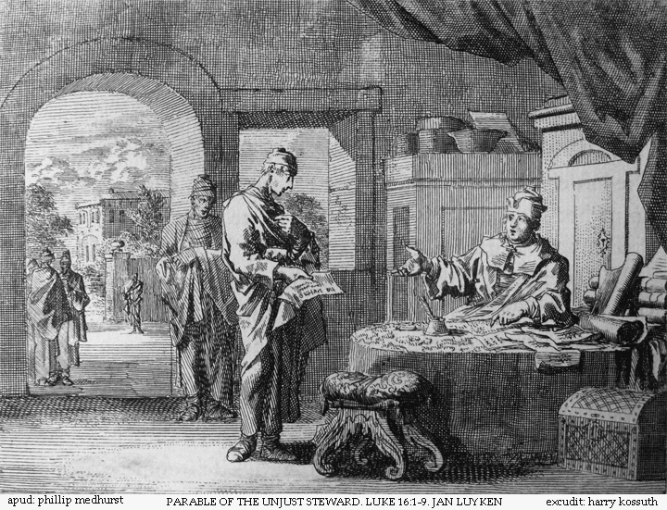
Sermon on the Mount: Parable of the Unjust Steward, Ye cannot serve God and Mammon
1 And Jesus said also unto his disciples, There was a certain rich man, which had a steward; and the same was accused unto him that he had wasted his goods.
2 And he called him, and said unto him, How is it that I hear this of thee? Give an account of thy stewardship; for thou mayest be no longer steward.
3 Then the steward said within himself, What shall I do? For my lord taketh away from me the stewardship: I cannot dig; to beg I am ashamed.
4 I am resolved what to do, that, when I am put out of the stewardship, they may receive me into their houses.
5 So he called every one of his lord’s debtors unto him, and said unto the first, How much owest thou unto my lord?
6 And he said, An hundred measures of oil. And he said unto him, Take thy bill, and sit down quickly, and write fifty.
7 Then said he to another, And how much owest thou? And he said, An hundred measures of wheat. And he said unto him, Take thy bill, and write fourscore.
8 And the lord commended the unjust steward, because he had done wisely: for the children of this world are in their generation wiser than the children of light.
9 And I say unto you, Make to yourselves friends of the mammon of unrighteousness; that, when ye fail, they may receive you into everlasting habitations.
10 He that is faithful in that which is least is faithful also in much: and he that is unjust in the least is unjust also in much.
11 If therefore ye have not been faithful in the unrighteous mammon, who will commit to your trust the true riches?
12 And if ye have not been faithful in that which is another man’s, who shall give you that which is your own?
13 No servant can serve two masters: for either he will hate the one, and love the other; or else he will hold to the one, and despise the other. Ye cannot serve God and mammon.
Taken from Matthew 6:24, Luke 16:1-13
1. See also: TG Waste
2. See also: TG Accountability; Stewardship
8. See also: TG Children of Light; Light
9. See also: D&C 82:22
10. See also: Matt. 25:21; D&C 51:19; 132:44,53
11. See also: TG Trustworthiness; Treasure
13. See also: Alma 5:39; TG Loyalty; Service; Hate; Idolatry; Treasure; Worldliness

Chapter Twenty-Six
Consider the Lilies, by Elspeth Young
Sermon on the Mount: Take No Thought
1 I say unto you, Go ye therefore into the world, and care not for the world; for the world will hate you, and will persecute you, and will turn you out of their synagogues.
2 Nevertheless, ye shall go forth from house to house, teaching the people; and I will go before you.
3 But the mysteries of the kingdom ye shall keep within yourselves; for it is not meet to give that which is holy unto the dogs; neither cast ye your pearls unto swine, lest they trample them under their feet.
4 For the world cannot receive that which ye, yourselves, are not able to bear; wherefore ye shall not give your pearls unto them, lest they turn again and rend you.
5 And your heavenly Father will provide for you, whatsoever things ye need for food, what ye shall eat; and for raiment, what ye shall wear or put on.
6 Therefore I say unto you, Take no thought for your life, what ye shall eat, or what ye shall drink; nor yet for your body, what ye shall put on. Is not the life more than meat, and the body than raiment?
7 Behold the fowls of the air: for they sow not, neither do they reap, nor gather into barns; yet your heavenly Father feedeth them. Are ye not much better than they?
8 Why therefore take ye thought for raiment? Consider the lilies of the field, how they grow; they toil not, neither do they spin:
9 And yet I say unto you, That even Solomon in all his glory was not arrayed like one of these.
10 Wherefore, if God so clothe the grass of the field, which to day is, and to morrow is cast into the oven, how much more will he not provide for you if ye are not of little faith.
11 And which of you with taking thought can add to his stature one cubit?
12 If ye then be not able to do that thing which is least, why take ye thought for the rest?
13 Therefore take no thought, saying, What shall we eat? Or, What shall we drink? Or, Wherewithal shall we be clothed? Neither be ye of doubtful mind.
14 For after all these things do the nations of the world seek after: and your heavenly Father knoweth that ye have need of all these things.
15 Wherefore, seek not the things of this world but seek ye first to build up the kingdom of God, and to establish his righteousness; and all these things shall be added unto you.
16 Take therefore no thought for the morrow: for the morrow shall take thought for the things of itself. Sufficient unto the day is the evil thereof.
17 Fear not, little flock; for it is your Father’s good pleasure to give you the kingdom.
Taken from Matthew 6:25-37, Matthew 7:9-10, Luke 12:24-34
6. See also: Ps. 55:22; Prov. 16:3; Luke 12:22; Phillip 4:6; 3 Ne. 13:25; D&C 84:81; TG Self-sacrifice
8. See also: TG Meditation; Nature
10. See also: TG Faith
13. See also: D&C 84:81; Luke 1:20; 24:25; TG Doubt
14. See also: Hel. 8:8; D&C 84:83
15. See also: 1 Kgs. 3:13; Alma 39:14; D&C 6:7; 11:23; 68:31; 106:3; TG Commitment; Dedication; Priesthood; Magnify Callings within; Col. 3:2; TG Mission of Early Saints; Objectives; Prov. 21:21; TG God, the Standard of Righteousness; Righteousness; Prov. 28:10; TG Blessings; 2 Ne. 5:11; Mosiah 2:41; TG Abundant Life
16: See also: D&C 84:84
17. See also: D&C 35:27; Matt. 25:34; TG Kingdom of God, on Earth

Chapter Twenty-Seven
He Shall Hear My Voice, by Michael Dudash
Sermon on the Mount: The Lord’s Prayer, Acts of devotion should not be done to “be seen of men.”
1 Sell that ye have, and give alms; but heed that ye do not your alms before men, to be seen of them: otherwise ye have no reward of your Father which is in heaven.
2 Therefore when thou doest thine alms, do not sound a trumpet before thee, as the hypocrites do in the synagogues and in the streets, that they may have glory of men. Verily I say unto you, They have their reward.
3 But when thou doest alms, let not thy left hand know what thy right hand doeth:
4 That thine alms may be in secret: and thy Father which seeth in secret himself shall reward thee openly.
5 Moreover when ye fast, be not, as the hypocrites, of a sad countenance: for they disfigure their faces, that they may appear unto men to fast. Verily I say unto you, They have their reward.
6 But thou, when thou fastest, anoint thine head, and wash thy face;
7 That thou appear not unto men to fast, but unto thy Father which is in secret: and thy Father, which seeth in secret, shall reward thee openly.
8 And when thou prayest, thou shalt not be as the hypocrites are: for they love to pray standing in the synagogues and in the corners of the streets, that they may be seen of men. Verily I say unto you, They have their reward.
9 But thou, when thou prayest, enter into thy closet, and when thou hast shut thy door, pray to thy Father which is in secret; and thy Father which seeth in secret shall reward thee openly.
10 And one of his disciples said unto him, Lord, teach us to pray, as John also taught his disciples.
11 And Jesus saith unto them, After this manner therefore pray ye: Our Father which art in heaven, Hallowed be thy name.
12 Thy kingdom come. Thy will be done in earth, as it is in heaven.
13 Give us this day our daily bread.
14 And forgive us our debts, as we forgive our debtors.
15 And suffer us not to be lead into temptation, but deliver us from evil: For thine is the kingdom, and the power, and the glory, for ever. Amen.
16 But when ye pray, use not vain repetitions, as the heathen do: for they think that they shall be heard for their much speaking.
17 Be not ye therefore like unto them: for your Father knoweth what things ye have need of, before ye ask him.
18 Ask of God; ask, and it shall be given you; seek, and ye shall find; knock, and it shall be opened unto you.
19 For everyone that asketh, receiveth; and he that seeketh, findeth; and unto him that knocketh, it shall be opened.
Taken from Matthew 6:1-18, Matthew 7:11-12, Luke 11:1-4, 9-10, Luke 12:35
1. See also: 3 Ne. 13:1; TG Almsgiving; Generosity; Motivations; Poor
2. See also: TG Hypocrisy; D&C 121:35
4. See also: TG Welfare; Luke 14:14
5. See also: Zech. 7:5
7. See also: TG Fasting; Motivations; Reward
8. See also: Alma 31:14
9. See also: Alma 33:7; 34:26; 2 Kgs. 4:33; TG Prayer; Meditation; God, Omniscience of; Reward
10. See also: TG Teaching; Prayer
11. See also: TG Prayer; God, Father; Name
12: See also: TG Kingdom of God, on Earth; Millennium; God, Will of
13. See also: TG Bread
14. See also: TG Debt; Forgiveness
15. See also: TG Temptation; Test, Try, Prove; Deliverance; Evil; Glory; 1 Chr. 29:11
16. See also: Eccl. 5:2; Alma 31:20; 3 Ne. 19:24; TG Heathen
17. See also: D&C 84:83; TG God, Intelligence of; God, Omniscience of; Ps. 23:1
18. See also: Isa. 58:9; Hel. 10:5; D&C 6:5; TG Faith; God, Access to; Prayer; Problem-Solving; Revelation; Meditation; Objectives; Study; Learning
19. See also: TG Education

Chapter Twenty-Eight
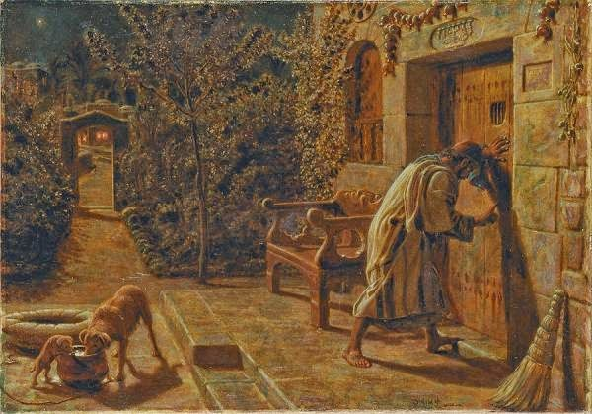
The Importunate Neighbour, by William Holman Hunt
Sermon on the Mount: Parable of the Friend at Midnight
1 And Jesus said unto them, Your heavenly Father will not fail to give unto you whatsoever ye ask of him. And he spake a parable saying, Which of you shall have a friend, and shall go unto him at midnight, and say unto him, Friend, lend me three loaves;
2 For a friend of mine in his journey is come to me, and I have nothing to set before him?
3 And he from within shall answer and say, Trouble me not: the door is now shut, and my children are with me in bed; I cannot rise and give thee.
4 I say unto you, Though he will not rise and give him, because he is his friend, yet because of his importunity he will rise and give him as many as he needeth.
5 What man among you, having a son, and he shall be standing out, and shall say, Father, open thy house that I may come in and sup with thee, will not say, Come in, my son; for mine is thine, and thine is mine?
6 Or what man is there of you, whom if his son ask bread, will he give him a stone?
7 Or if he ask a fish, will he give him a serpent?
8 If ye then, being evil, know how to give good gifts unto your children, how much more shall your Father which is in heaven give good things to them that ask him?
Taken from Matthew 7:15-19, Luke 11:5-8, 11-13
4. See also: TG Brotherhood and Sisterhood; Friendship
6. See also: TG Bread
Chapter Twenty-Nine
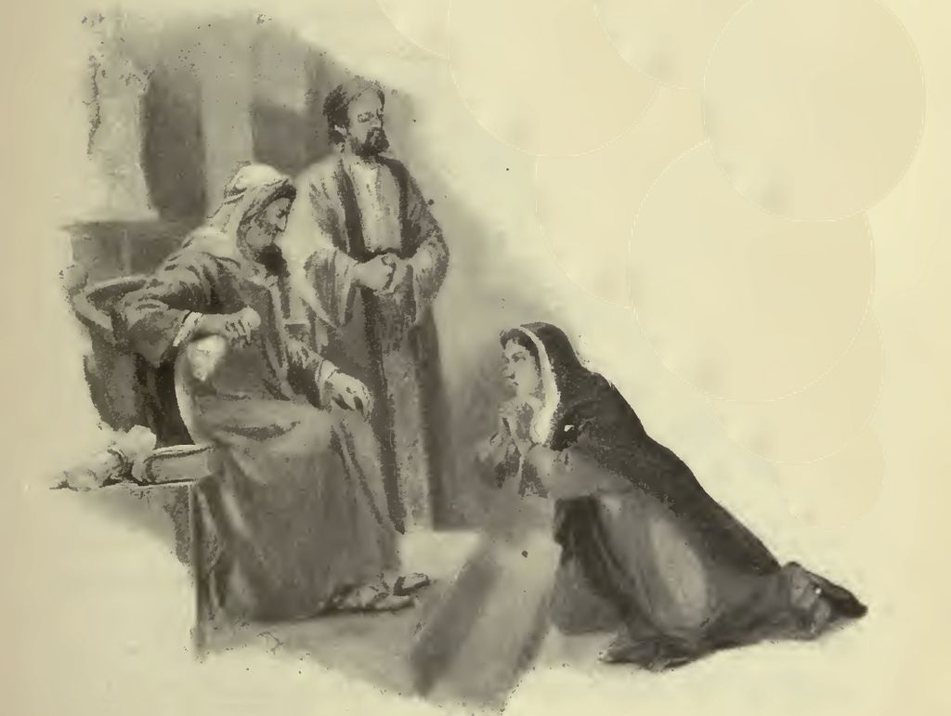
Avenge Me of Mine Adversary, by Anonymous
Sermon on the Mount: Parable of the Importuning Widow and Unjust Judge
1 And Jesus spake a parable unto them to this end, that men ought always to pray, and not to faint;
2 Saying, There was in a city a judge, which feared not God, neither regarded man:
3 And there was a widow in that city; and she came unto him, saying, Avenge me of mine adversary.
4 And he would not for a while: but afterward he said within himself, Though I fear not God, nor regard man;
5 Yet because this widow troubleth me, I will avenge her, lest by her continual coming she weary me.
6 And the Lord said, Hear what the unjust judge saith.
7 And shall not God avenge his own elect, which cry day and night unto him, though he bear long with men?
8 I tell you that he will come, and when he does come, he will avenge his saints speedily. Nevertheless when the Son of man cometh, shall he find faith on the earth?
Taken from Luke 18:1-8
1. See also: TG Perseverance; Prayer; D&C 75:1
6. See also: TG Injustice
7. See also: Num. 31:2; Alma 1:13; D&C 121:5
8. See also: TG Justice
Chapter Thirty
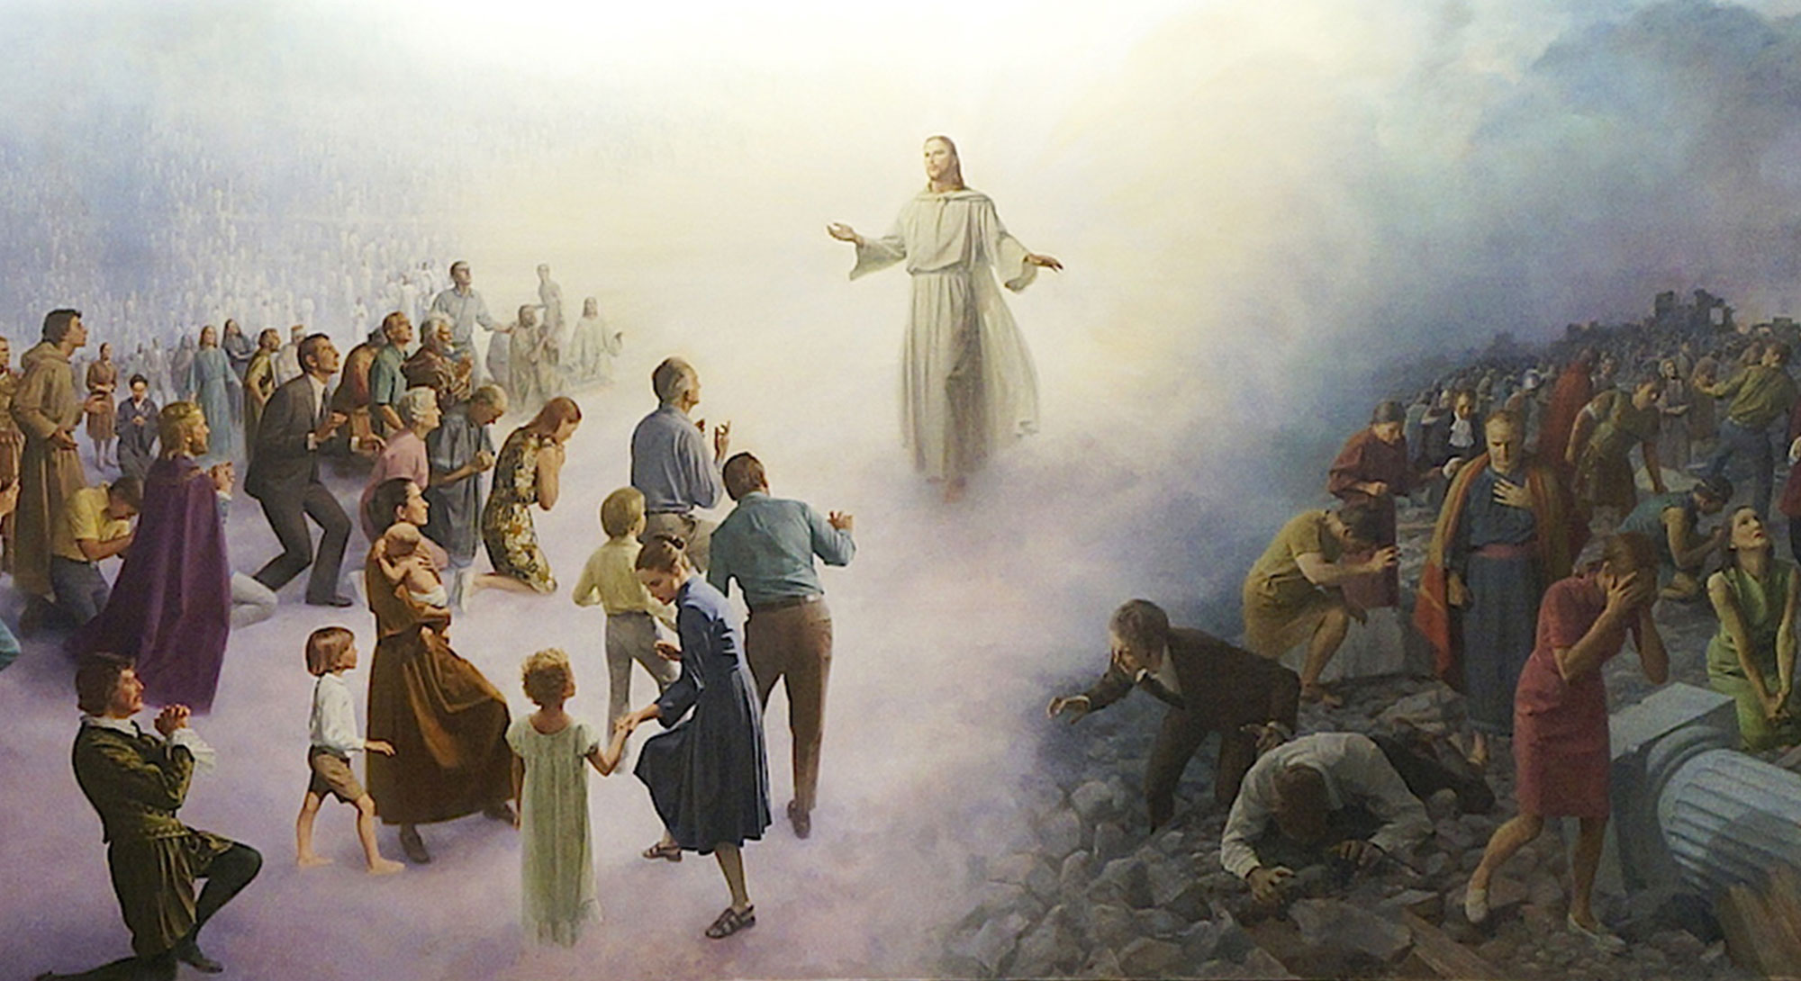
The Last Judgment, by John Scott
Sermon on the Mount: Righteous Judgment, The Strait Gate, Ye Never Knew Me
1 And then said his disciples unto him, They will say unto us, We ourselves are righteous, and need not that any man should teach us and will not hear us.
2 For they will say, We have that which is sufficient for us for our salvation.
3 Then Jesus answered, and said unto his disciples, Thus shall ye say unto them,
4 Not every one that saith unto me, Lord, Lord, shall enter into the kingdom of heaven; but he that doeth the will of my Father which is in heaven. For the day soon cometh, that men shall come before me to judgment, to be judged according to their works.
5 Many will say to me in that day, Lord, Lord, have we not prophesied in thy name? and in thy name have cast out devils? and in thy name done many wonderful works?
6 And then will I say, Ye never knew me; depart from me that work iniquity.
7 Then said one unto him, Lord, are there few that be saved? And he said unto them,
8 Strive to enter in at the strait gate: for many, I say unto you, will seek to enter in, and shall not be able: for wide is the gate, and broad is the way, that leadeth to destruction, and many there be which go in thereat:
9 Because strait is the gate, and narrow is the way, which leadeth unto life, and few there be that find it.
10 Beware of false prophets, which come to you in sheep’s clothing, but inwardly they are ravening wolves.
11 When once the master of the house is risen up, and hath shut to the door, and ye begin to stand without, and to knock at the door, saying, Lord, Lord, open unto us. But the Lord shall answer and say unto you, I will not receive you, for ye know not from whence ye are.
12 Then shall ye begin to say, We have eaten and drunk in thy presence, and thou hast taught in our streets.
13 But he shall say, I tell you, I know you not whence ye are; depart from me, all ye workers of iniquity.
14 There shall be weeping and gnashing of teeth, when ye shall see Abraham, and Isaac, and Jacob, and all the prophets, in the kingdom of God, and you yourselves thrust out.
15 And they shall come from the east, and from the west, and from the north, and from the south, and shall sit down in the kingdom of God.
16 And, behold, there are last which shall be first, and there are first which shall be last.
17 And why call ye me, Lord, Lord, and do not the things which I say?
Taken from Matthew 7:13-14, 21-23, 29-31, Luke 6:46, Luke 13:23-30
4. See also: Titus 1:16; TG Hypocrisy; Sincerity; Hosea 8:2; Luke 6:46; Luke 8:21; D&C 138:4; TG Duty; Good Works; Obedience; God, Will of
5. See also: Jer. 23:25; TG Unrighteous Dominion; D&C 84:67; TG Name
6. See also: Ps. 101:4; Matt. 25:12; Mosiah 26:27; 3 Ne. 14:23; Ps. 119:115; TG Judgment, The Last; Sin
7. See also: 3 Ne. 27:33; D&C 121:34
8. See also: 2 Ne. 9:41; Alma 37:13; 3 Ne. 14:13; D&C 132:22, 25; 3 Ne. 27:33; D&C 22:4; 1 Ne. 12:17; TG Hell
9. See also: Mosiah 3:17; 1 Ne. 8:20; 2 Ne. 33:9; TG Baptism, Essential; Jer. 21:8
10. See also: TG False Prophets; Sheep; Hypocrisy; Guile
11. See also: Isa. 55:6
13. See also: Mosiah 26:27; 3 Ne. 14:23; D&C 29:28
14. See also: Mosiah 16: 2; D&C 133:73; Alma 5:24; TG Exaltation; Kingdom of God, in Heaven
15. See also: Matt 8:11; Acts 10:45; 2 Ne. 10:18; D&C 45:9
16. See also: 1 Ne. 13:42; Jacob 5:63; Ether 13:12; D&C 29:30
17. See also: 1 Ne. 17:41; Alma 37:46; Ezek. 33:31; Hosea 8:2; D&C 112:26; JS-H 1:19; TG Disobedience

Chapter Thirty-One
The Wise and Foolish Builders
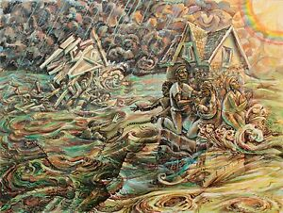
Jesus concludes the Sermon on the Mount with the Parable of the Wise Man and the Foolish Man
1 Therefore whosoever heareth these sayings of mine, and doeth them, I will liken him unto a wise man, which built an house, and digged deep, and laid the foundation on a rock:
2 And the rain descended, and the floods came, and the winds blew, and beat vehemently upon that house; and could not shake it and it fell not: for it was founded upon a ^{c}rock.
3 And every one that heareth these sayings of mine, and doeth them not, shall be likened unto foolish man, which built his house without a foundation upon the sand:
4 And the rain descended, and the floods came, and the winds blew, and beat vehemently upon that house; and it immediately fell: and great was the fall of it.
5 And it came to pass, when Jesus had ended these sayings, the people were astonished at his doctrine:
6 For he taught them as one having authority from God and not as having authority from the scribes.
Taken from Matthew 7:32-37, Mark 1:22, Luke 6:47-49
1. See also: James 1:23; Mosiah 4:10; Hel. 5:12; D&C 41:5; TG Commitment; Obedience; Wisdom; D&C 6:34; 11:24; 3 Ne. 11:39
2. See also: D&C 90:5; TG Adversity; Rock
3. See also: TG Foolishness
98. See also: Prov. 14:11; TG Apostasy, of Individuals
99. See also: Matt. 13:54; John 7:16; 2 Ne. 31:21
100. See also: TG Jesus Christ, Authority of; Jesus Christ, Teaching Mode of; Teaching with the Spirit; Scribes

Chapter Thirty-Two

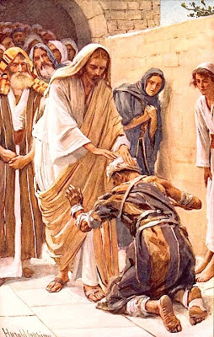
The Healing of the Leper, by Harold Copping

Jesus heals a leper on the way back to Capernaum from the Sermon on the Mount. Jesus tells the people to keep the miracles unto themselves, which is a fulfillment of prophecy.
1 When he was come down from the mountain, great multitudes followed him.
2 And, behold, there came a leper, who when seeing Jesus, fell on his face and worshipped him, saying, Lord, if thou wilt, thou canst make me clean.
3 And Jesus, moved with compassion, put forth his hand, and touched him, saying, I will; be thou clean. And immediately his leprosy was cleansed.
4 And Jesus saith unto him, See thou tell no man; but go thy way, shew thyself to the priest, and offer the gift that Moses commanded, for a testimony unto them.
5 That it might be fulfilled which was spoken by Isaiah the prophet, saying,
6 Behold my servant, whom I have chosen; my beloved, in whom my soul is well pleased: I will put my spirit upon him, and he shall shew judgment to the Gentiles.
7 He shall not strive, nor cry; neither shall any man hear his voice in the streets.
8 A bruised reed shall he not break, and smoking flax shall he not quench, till he send forth judgment unto victory.
9 And in his name shall the Gentiles trust.
10 But the leper went out, and began to publish it much, and to blaze abroad the matter, insomuch that great multitudes did assemble to hear and to be healed of their infirmities.

Taken from Matthew 8:1-4, Matthew 12:17-21, Mark 1:38-45, Luke 5:12-15

2. See also: TG Leprosy
3. See also: TG Compassion; Miracles
5. See also: Isa. 42:1-3
6. See also: TG Jesus Christ, Authority of; Witness of the Father
8. See also: D&C 52:11
9. See also: Jesus Christ, Takin the Name of; Name; 2 Ne. 10:18

Chapter Thirty-Three

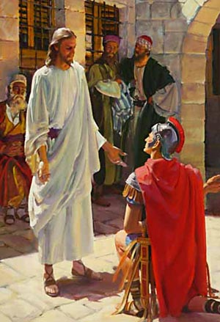

Jesus heals a centurion’s servant in Capernaum

1 And when Jesus was entered into Capernaum, there came unto him a Elders of the Jews, beseeching him,
2 For a certain centurion’s servant, who was dear unto him, was sick, and ready to die.
3 And when the centurion heard of Jesus, he sent unto him the elders of the Jews, beseeching him that he would come and heal his servant.
4 And when they came to Jesus, they besought him instantly, saying, That he was worthy for whom he should do this:
5 For he loveth our nation, and he hath built us a synagogue.
6 And saying, Lord, his servant lieth at home sick of the palsy, grievously tormented.
7 And Jesus saith unto him, I will come and heal him.
8 Then Jesus went with them. And when he was now not far from the house, the centurion came out to him, saying unto him, Lord, trouble not thyself: for I am not worthy that thou shouldest enter under my roof:
9 Wherefore neither thought I myself worthy to come unto thee: but speak the word only, and my servant shall be healed.
10 For I am a man under authority, having soldiers under me: and I say to this man, Go, and he goeth; and to another, Come, and he cometh; and to my servant, Do this, and he doeth it.
11 And when they that followed him heard this, they marvelled, and when Jesus said to them that followed, Verily I say unto you, I have not found so great faith, no, not in Israel.
12 And I say unto you, That many shall come from the east and west, and shall sit down with Abraham, and Isaac, and Jacob, in the kingdom of heaven.
13 But the children of the kingdom shall be cast out into outer darkness: there shall be weeping and gnashing of teeth.
14 And Jesus said unto the centurion, Go thy way; and as thou hast believed, so be it done unto thee. And his servant was healed in the selfsame hour.

Taken from Matthew 8:5-13, Luke 7:1-10

9. See also: TG Healing
10. See also: TG Authority
11. See also: 3 Ne. 17:8; Alma 19:10
12. See also: Luke 13:29; Acts 10:45; 2 Ne. 10:18; D&C 45:9
13. See also: 2 Ne. 30:2; Matt. 22:13; D&C 77:8; 133:72; Isa. 65:14; Matt. 13:42; Rev. 19:20; D&C 112:24

Chapter Thirty-Four

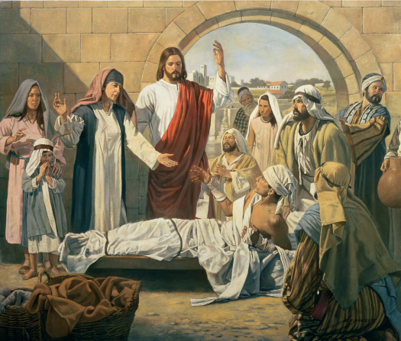
Christ Raises the Son of the Widow of Nain, by Robert T. Barrett

Heading south, Jesus raises a widow’s son from the dead outside of Nain
1 Now there went out a fame of him, insomuch that Jesus could no more openly enter into Capernaum for a time, but was without in desert places:
2 And it came to pass the day after, that he went into a city called Nain; and many of his disciples went with him, and much people.
3 Now when he came nigh to the gate of the city, behold, there was a dead man carried out, the only son of his mother, and she was a widow: and much people of the city was with her.
4 And when the Lord saw her, he had compassion on her, and said unto her, Weep not.
5 And he came and touched the bier: and they that bare him stood still. And he said, Young man, I say unto thee, Arise.
6 And he that was dead sat up, and began to speak. And he delivered him to his mother.
7 And there came a fear on all: and they glorified God, saying, That a great prophet is risen up among us; and, That God hath visited his people.
8 And this rumour of him went forth throughout all Judæa, and throughout all the region round about.
Taken from Mark 1:45, Luke 7:11-17
4. See also: TG Compassion; Mercy
6. See also: TG Death, Power over
7. See also: Alma 19:25; Moses 6:39; Ex. 3:16; Luke 1:68; D&C 110:7
Chapter Thirty-Five

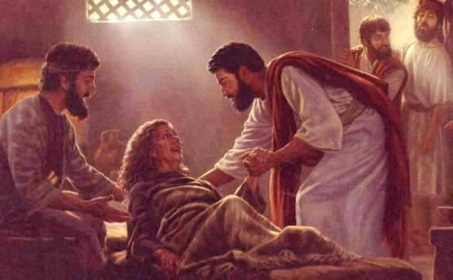

Jesus heals Simon Peter’s mother in law at his house in Capernaum, Jesus then heals and casts out demons throughout the evening in Capernaum.
1 And it came to pass that Simon’s wife’s mother lay sick of a fever, and anon they tell him of her.
2 And forthwith Jesus arose out of the synagogue, and journey unto into Simon’s house in Capernaum.
3 And when they were come, they entered into the house of Simon and Andrew, with James and John.
4 And when Jesus was come in, he saw Peter’s wife’s mother laid, and sick of a fever.
5 And he stood over her, and rebuked the fever; and it left her:
6 And he took her by the hand, and lifted her up; and she ministered unto them.
7 Now when the sun was setting, all they that had any sick with divers diseases brought they unto him; and he laid his hands on every one of them, and healed them.
8 That it might be fulfilled which was spoken by Isaiah the prophet, saying, Himself took our infirmities, and bare our sicknesses.
9 And they brought unto him many that were possessed with devils: and he cast out the spirits with his word, and healed all that were sick:
10 And devils also came out of many, crying out, and saying, Thou art Christ the Son of God. And he rebuking them suffered them not to speak: for they knew that he was Christ.
11 And Jesus did heal all that were gathered together at the door of Capernaum, late into the night.
Taken from Matthew 8:14-17, Mark 1:29-34, Luke 4:38-41
4. See also: 1 Cor. 9:5; 1 Tim. 4:3
5. See also: D&C 84:68
6. See also: TG Healing
7. See also: TG Hands, Laying on of; Administrations to the Sick
8. See also: TG Jesus Christ, Atonement through; Sickness
9. See also: Matt. 4:24; 9:32; TG Spirits, Evil, Unclean; Healing
10. See also: TG Jesus Christ, Messiah

Chapter Thirty-Six
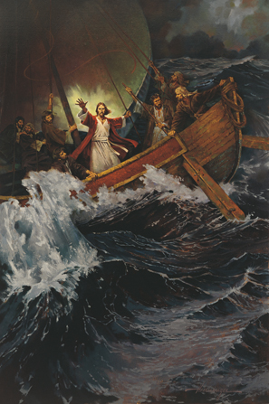
Stilling the Storm, by Ted Henninger
Jesus and his disciples journey across the sea by boat to Gadara (city)/Gergesenes (ancient people)/Gadarenes (people); Jesus calms the sea.
1 Now when Jesus saw great multitudes about him, he gave commandment to depart unto the other side.
2 And a certain scribe came, and said unto him, Master, I will follow thee whithersoever thou goest.
3 And Jesus saith unto him, The foxes have holes, and the birds of the air have nests; but the Son of man hath not where to lay his head.
4 And another of his disciples said unto him, Lord, suffer me first to go and bury my father.
5 But Jesus said unto him, Follow me; and let the dead bury their dead.
6 And another also said, Lord, I will follow thee; but let me first go bid them farewell, which are at home at my house.
7 And Jesus said unto him, No man, having put his hand to the plough, and looking back, is fit for the kingdom of God.
8 And when they had sent away the multitude, they took him even as he was in the ship. And there were also with him other little ships.
9 But as they sailed he fell asleep: and there came down a storm of wind on the lake; and they were filled with fear, and were in danger;
10 Insomuch that the ship was covered with the waves: and they did beat into the ship, so that it was now full.
11 And his disciples came to Jesus and he was in the hinder part of the ship, asleep on a pillow: and they awake him, and say unto him, Save us Master, carest thou not that we perish?
12 And he arose, and rebuked the wind, and said unto the sea, Peace, be still. And the wind ceased, and there was a great calm.
13 And he said unto them, Why are ye so fearful? how is it that ye have no faith?
14 And the men marvelled, saying, What manner of man is this, that even the winds and the sea obey him!
Taken from Matthew 8:18-27, Mark 4: 35-41, Luke 8:22-26, Luke 9:57-62
2. See also: 2 Ne. 31:10; Moro. 7:11; D&C 4:3; 56:2
5. See also: TG Commitment; Death; Called of God; 2 Ne. 31:12
6. See also: 1 Kgs. 19:20
7. See also: TG Commitment
12. See also: TG Peace; Ps. 89:9
13. See also: Matt. 14:31; Mark 16:14; Luke 24:25; Alma 44:4; D&C 4:5
14. See also: Hel. 12:16; TG Nature

Chapter Thirty-Seven
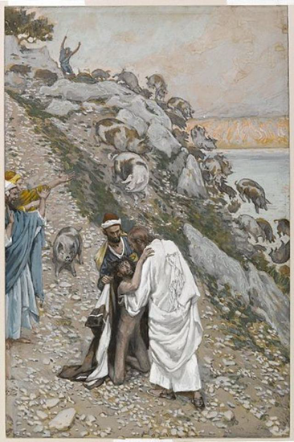
The Swine Driven into the Sea, by James Tissot
Arriving in Gadara, Jesus casts out “Legion” (a roman division consisting of three to six thousand soldiers) into swine that are killed as they run into the sea.
1 And when they were come to the other side of the sea they arrived into the country of the Gergesenes/Gadarenes, which is over against Galilee. There met him a man possessed with unclean spirits who wore no clothes, coming out of the tombs, exceeding fierce, so that no man might pass by that way.
2 For he had his dwelling among the tombs; and no man could bind him, no, not with chains:
3 Because that he had been often bound with fetters and chains, and the chains had been plucked asunder by him, and the fetters broken in pieces: neither could any man tame him.
5 And always, night and day, he was in the mountains, and in the tombs, crying, and cutting himself with stones.
6 But when he saw Jesus afar off, he ran and worshipped him,
7 And Jesus said unto the man, Come out, thou unclean spirit.
8 But cried he with a loud voice, and said, What have I to do with thee, Jesus, thou Son of the most high God? art thou come hither to torment us before the time? I adjure thee by God, that thou torment me not.
9 And Jesus asked him, What is thy name? And he answered, saying, My name is Legion: for we are many.
10 And they besought him much that he would not send them away out of the country, nor command them to go out into the deep.
11 Now there was there nigh unto the mountains a great herd of swine feeding (they were about two thousand).
12 So the devils besought him, saying, If thou cast us out, suffer us to go away into the herd of swine.
13 And forthwith Jesus gave them leave saying unto them, Go. And the unclean spirits went out, and entered into the swine: and the herd ran violently down a steep place into the sea, and were choked in the sea.
14 And they that kept them, when they had seen what was done, fled, and went their ways into the city, and told every thing, and what was befallen to the possessed of the devils.
15 And they that saw it told them how it befell to him that was possessed with the devil, and also concerning the swine.
16 Then they went out to see what was done; and came to Jesus, and found the man, out of whom the devils were departed, sitting at the feet of Jesus, clothed, and in his right mind: and they were afraid.
17 For behold, the whole city had come out to meet Jesus: and when they saw him, they besought him that he would depart out of their coasts; for they were taken with great fear.
18 And when Jesus was come into the ship, he that had been possessed with the unclean spirits prayed him that he might be with him.
19 Howbeit Jesus suffered him not, but saith unto him, Go home to thy friends, and tell them how great things the Lord hath done for thee, and hath had compassion on thee.
20 And he departed, and began to publish in Decapolis how great things Jesus had done for him: and all men did marvel.
Taken from Matthew 8:28-34, Mark 3:11-12, Mark 5:1-20, Luke 8:26-39
7. See also: TG Spirits, Evil, Unclean; Healing
8. See also: James 2:19
9. See also: D&C 29:36
10. See also: Rev. 9:1
17. See also: John 12:18
19. See also: TG Compassion

Chapter Thirty-Eight
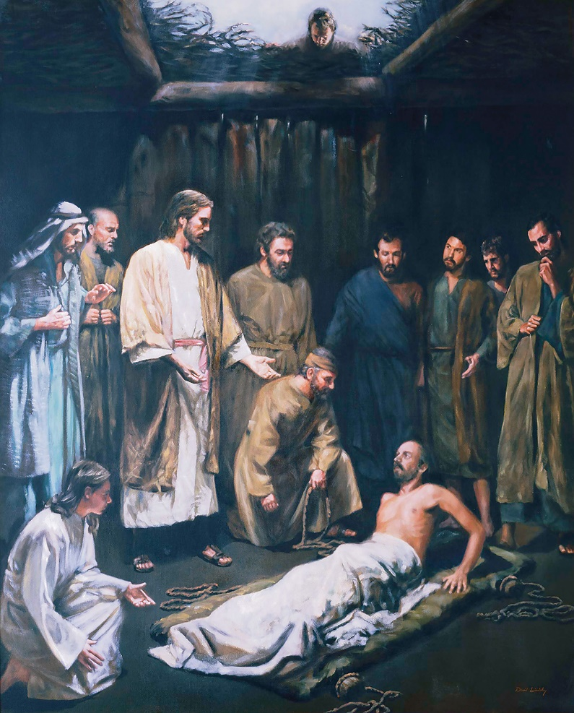
Christ Healing the Palsied Man, by David Lindsley
Party returns to Capernaum; Jesus heals a man of palsy (lifted in via the roof).
1 And they passed over, by ship, and again entered into Capernaum. And it came to pass, that, when Jesus was returned, the people gladly received him: for they were all waiting for him.
2 And it came to pass on a certain day, as he was teaching, that there were Pharisees and doctors of the law sitting by, which were come out of every town of Galilee, and Judæa, and Jerusalem: and the power of the Lord was present to heal them.
3 And straightway many were gathered together, insomuch that there was no room to receive them, no, not so much as about the door: and he preached the word unto them.
4 And they come unto him, bringing one sick of the palsy, which was borne of four.
5 And when they could not come nigh unto him for the press, they uncovered the roof where he was: and when they had broken it up, they let down the bed wherein the sick of the palsy lay.
6 And Jesus seeing their faith said unto the sick of the palsy; Son, be of good cheer; thy sins be forgiven thee.
7 But there were certain of the scribes sitting there, and reasoning in their hearts,
8 Why doth this man thus speak blasphemies? who can forgive sins but God only?
9 And Jesus knowing their thoughts said, Wherefore think ye evil in your hearts?
10 For is it not easier to say, Thy sins be forgiven thee, than to say, Arise, and walk?
11 But that ye may know that the Son of man hath power on earth to forgive sins, (then saith he to the sick of the palsy,) Arise, take up thy bed, and go unto thine house.
12 And immediately he rose before them, and took up his bed, and went forth before them all and departed to his own house; insomuch that when the multitude saw it, they were all amazed, filled with fear and they marvelled, and glorified God saying, We have seen strange things today, for we never saw it on this fashion. Hath God given such power unto men?

Taken from Matthew 9:1-8, Mark 2:1-12, Luke 5:18-26
3. See also: TG Jesus Christ, Teaching Mode of
6. See also: Luke 7:48-50; D&C 68:6; 112:4; D&C 25:3; 62:3; James 5:15
8. See also: TG Blasphemy
9. See also: TG God, Omniscience of
11. See also: TG Jesus Christ, Son of Man; Jesus Christ, Authority of; Forgiveness; Alma 15:10; 3 Ne. 9:13; 3 Ne. 7:22
12. See also: Luke 18:43

Chapter Thirty-Nine
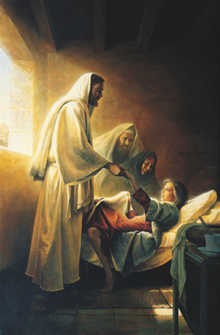
Jesus Blessing Jairus’ Daughter, by Greg Olsen
Jesus recruits Matthew, heals a woman of a blood condition, raises Jairus’ daughter from the dead and heals two blind men.
1 And after these things Jesus went forth, and he saw a publican, named Levi (Matthew), the son Alphaeus, sitting at the receipt of custom: and he said unto him, Follow me.
2 And he left all, rose up, and followed him.
3 And they went forth again by the sea side; and all the multitude resorted unto Jesus, and he taught them.
4 And there were much people gathered unto him as he was nigh unto the sea.
5 While he spake unto them, behold, there cometh one of the rulers of the synagogue, Jairus by name; and when he came to him, he fell down at Jesus’ feet,
6 And besought him greatly, saying, My little daughter lieth at the point of death, yea she is my only daughter, about twelve years of age: I pray thee, come and lay thy hands on her, that she may be healed; and she shall live.
7 And Jesus went with him, and so did his disciples; and much people followed him, and thronged him.
8 And a certain woman, which had an issue of blood twelve years,
9 And had suffered many things of many physicians, and had spent all that she had, and was nothing bettered, but rather grew worse,
10 When she had heard of Jesus, came in the press behind, and touched his garment.
11 For she said, If I may touch but his clothes, I shall be whole.
12 And she came behind Jesus, and touched the border of his garment; and straightway the fountain of her blood was dried up; and she felt in her body that she was healed of that plague.
13 And Jesus, immediately knowing in himself that virtue had gone out of him, turned him about in the press, and said, Who touched my clothes?
14 And Peter and they that were with him said unto him, Thou seest the multitude thronging thee, and sayest thou, Who touched me?
15 And Jesus said, Somebody hath touched me, for I perceive virtue has gone out of me. And he looked round about to see her that had done this thing.
16 And when the woman saw that she was not hid, she came trembling, and falling down before him, she declared unto him before all the people for what cause she had touched him, and how she was healed immediately.
17 And Jesus said unto her, Daughter, be of good comfort: thy faith hath made thee whole; go in peace and be whole of thy plague. And the woman was made whole from that hour.
18 While he yet spake, there came from the ruler of the synagogue’s house certain which said, Thy daughter is dead: why troublest thou the Master any further?
19 As soon as Jesus heard the word that was spoken, he saith unto the ruler of the synagogue, Be not afraid, only believe.
20 And he suffered no man to follow him, save Peter, and James, and John the brother of James.
21 And he cometh to the house of the ruler of the synagogue, and seeth the tumult, and them that wept and wailed greatly.
22 And when he was come in, he saith unto them, Why make ye this ado, and weep? the damsel is not dead, but sleepeth.
23 And they laughed him to scorn, knowing she was dead. But when he had put them all out, he taketh the father and the mother of the damsel, and them that were with him, and entereth in where the damsel was lying.
24 And he took the damsel by the hand, and said unto her, Talitha cumi; which is, being interpreted, Damsel, I say unto thee, arise.
25 And straightway the damsel arose, and walked; and they were astonished with a great astonishment.
26 And he charged them straitly that no man should know it; and commanded that something should be given her to eat.
27 But the fame hereof went abroad into all that land.
28 And when Jesus departed from Jairus’ house, two blind men followed him, crying, and saying, Thou Son of David, have mercy on us.
29 And when he was come into the house, the blind men came to him: and Jesus saith unto them, Believe ye that I am able to do this? They said unto him, Yea, Lord.
30 Then touched he their eyes, saying, According to your faith be it unto you.
31 And their eyes were opened; and Jesus straitly charged them, saying, See that no man know it.
32 But they, when they were departed, also spread abroad his fame in all that country.
Taken from Matthew 9:9, 22-35, Mark 2:13, Mark 5:21-43, Luke 5:27-28, Luke 8:40-56
6. See also: TG Administrations to the Sick; Hands, Laying on of; D&C 66:9
8. See also: Lev. 15:25
10. See also: Matt. 14:36; Acts 5:15; 19:12
13. See also: Luke 6:19
16. See also: TG Healing
17. See also: Hel. 15:9; D&C 46:19; TG Peace of God
23. See also: 2 Chr. 30:10; Alma 26:23; 1 Ne. 8:27; TG Laughter
24. See also: TG Death, Power over
25. See also: TG Healing
28. See also: Matt. 20:30; John 9:1; Mosiah 3:5; 3 Ne. 17:9; D&C 84:69
30. See also: TG Faith
31. See also: Ps. 146:8; TG Healing; Miracles
32. See also: Mark 7:36; John 12:19

Chapter Forty
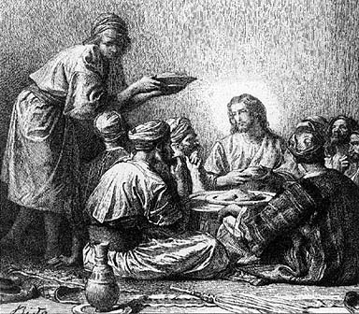
Jesus Eateth with Publicans and Sinners, by Alexandre Bida
Matthew invites Jesus to dinner, with Matthew’s acquaintances. Jesus teaches the parable of the physician..
1 And it came to pass at this time, Levi made Jesus a great feast in his own house: and as Jesus sat at meat in Matthew’s house, many publicans and sinners sat also together with Jesus and his disciples: for there were many, and they followed him.
2 And when the Pharisees saw it, they murmuring, said unto his disciples, Why eateth your Master with publicans and sinners?
3 But when Jesus heard that, he said unto them, They that be whole need not a physician, but they that are sick.
4 But go ye and learn what that meaneth, I will have mercy, and not sacrifice: for I am not come to call the righteous, but sinners to repentance.
Taken from Matthew 9:10-13, Mark 2:15-17, Luke 5:29-32, Luke 15:1-2
2. See also: Isa. 53:3; 65:5
3. See also: Moro. 8:8
4. See also: Hosea 6:6; TG Mercy; 1 Tim. 1:15; TG Righteousness; Repentance

Chapter Forty-One
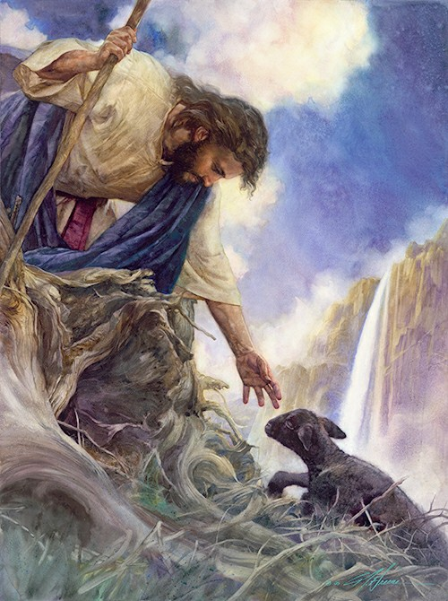
The Rescue, by Nathan Greene
At Matthew’s feast, Jesus teaches the Parable of the Lost Sheep
1 And Jesus spake this parable unto the Pharisees, saying,
2 What man of you, having an hundred sheep, if he lose one of them, doth not leave the ninety and nine and go into the mountains or into the wilderness and seeketh after that which is lost, until he find it?
3 And when he hath found it, he layeth it on his shoulders, rejoicing.
4 And when he cometh home, he calleth together his friends and neighbours, saying unto them, Rejoice with me; for I have found my sheep which was lost. Verily I unto you, he rejoiceth more of that sheep, than of the ninety and nine which went not astray.
5 I say unto you, that likewise joy shall be in heaven over one sinner that repenteth, more than over ninety and nine just persons, which need no repentance.
Taken from Luke 15: 3-7
2. See also: Ezek. 34:16
5. See also: TG Joy; Missionary Work; Repentance

Chapter Forty-Two
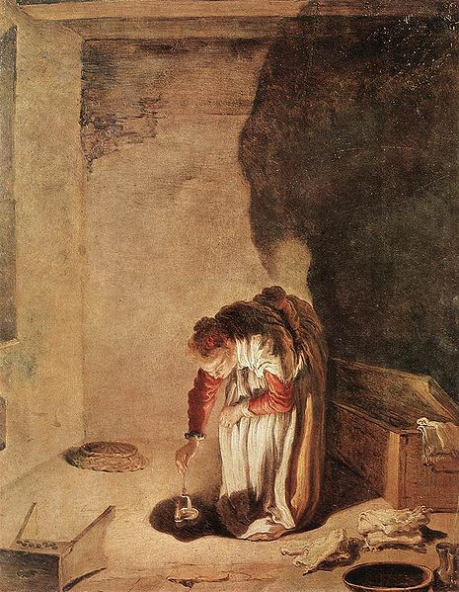
Parable of the Lost Drachma, by Domenico Fetti
Jesus teaches the Parable of the Lost Coin at the feast held by Matthew.
1 Either what woman having ten pieces of silver, if she lose one piece, doth not light a candle, and sweep the house, and seek diligently till she find it?
2 And when she hath found it, she calleth her friends and her neighbours together, saying, Rejoice with me; for I have found the piece which I had lost.
3 Likewise, I say unto you, there is joy in the presence of the angels of God over one sinner that repenteth.
Taken from Luke 15: 8-10
3. See also: TG Angels; Worth of Souls

Chapter Forty-Three
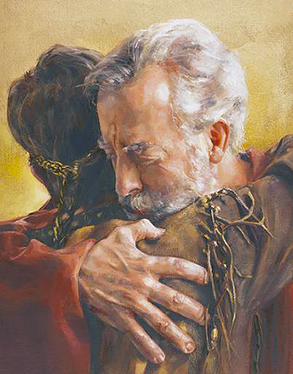
The Parable of the Prodigal Son taught at the feast hosted by Matthew
1 And Jesus said, A certain man had two sons:
2 And the younger of them said to his father, Father, give me the portion of goods that falleth to me. And he divided unto them his living.
3 And not many days after the younger son gathered all together, and took his journey into a far country, and there wasted his substance with riotous living.
4 And when he had spent all, there arose a mighty famine in that land; and he began to be in want.
5 And he went and joined himself to a citizen of that country; and he sent him into his fields to feed swine.
6 And he would fain have filled his belly with the husks that the swine did eat: and no man gave unto him.
7 And when he came to himself, he said, How many hired servants of my father’s have bread enough and to spare, and I perish with hunger!
8 I will arise and go to my father, and will say unto him, Father, I have sinned against heaven, and before thee,
9 And am no more worthy to be called thy son: make me as one of thy hired servants.
10 And he arose, and came to his father. But when he was yet a great way off, his father saw him, and had compassion, and ran, and fell on his neck, and kissed him.
11 And the son said unto him, Father, I have sinned against heaven, and in thy sight, and am no more worthy to be called thy son.
12 But the father said to his servants, Bring forth the best robe, and put it on him; and put a ring on his hand, and shoes on his feet:
13 And bring hither the fatted calf, and kill it; and let us eat, and be merry:
14 For this my son was dead, and is alive again; he was lost, and is found. And they began to be merry.
15 Now his elder son was in the field: and as he came and drew nigh to the house, he heard musick and dancing.
16 And he called one of the servants, and asked what these things meant.
17 And he said unto him, Thy brother is come; and thy father hath killed the fatted calf, because he hath received him safe and sound.
18 And he was angry, and would not go in: therefore came his father out, and entreated him.
19 And he answering said to his father, Lo, these many years do I serve thee, neither transgressed I at any time thy commandment: and yet thou never gavest me a kid, that I might make merry with my friends:
20 But as soon as this thy son was come, which hath devoured thy living with harlots, thou hast killed for him the fatted calf.
21 And he said unto him, Son, thou art ever with me, and all that I have is thine.
22 It was meet that we should make merry, and be glad: for this thy brother was dead, and is alive again; and was lost, and is found.
Taken from Luke 15: 11-32
3. See also: TG Waste; Prov. 28:7; TG Rioting and Reveling
7. See also: Ps. 119:59; TG Repentance
8. See also: Lam. 3:40; TG Confession
10. See also: TG Benevolence; Compassion; Family, Love within; Mercy
11. See also: TG Contrite Heart; Worthiness; Family, Patriarchal
21. See also: TG Family, Love within; D&C 84:38

Chapter Forty-Four
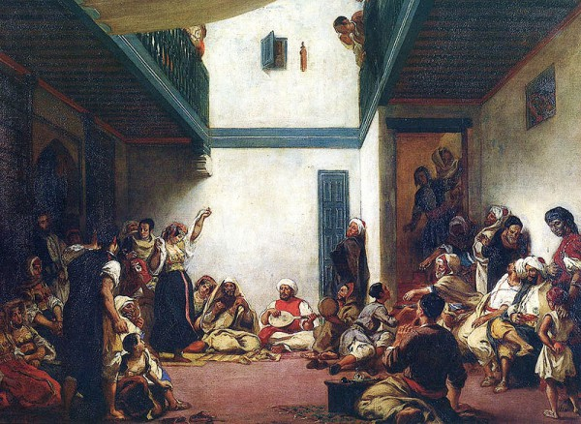
Jewish Wedding in Morocco, by Eugene Delacroix
Jesus shares the Parable of the Children of the Bridechamber to the Pharisees at Matthew’s feast.
1 And the disciples of John and those of the Pharisees, who were used to fasting, come and say unto Jesus, Why do we the disciples of John and of the Pharisees fast, but thy disciples fast not?
2 And Jesus said unto them, Can the children of the bridechamber fast, while the bridegroom is with them? as long as they have the bridegroom with them, they cannot fast.
3 But the days will come, when the bridegroom shall be taken away from them, and then shall they fast in those days.
Taken from Matthew 9:14-15, Mark 2:18-20, Luke 5:33-35
2. See also: D&C 65:3; Matt. 22:2; Rev. 19:7; 21:2
3. See also: TG Fasting; John 16:5; Acts 13:2

Chapter Forty-Five
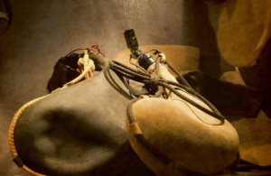
Jesus ends the feast at Matthew’s with parables teaching that he is the new come to replace the old.
1 Then said the Pharisees unto him, Why will ye not receive us with our baptism, seeing we keep the whole law?
2 But Jesus said unto them, Ye keep not the law. If ye had kept the law, ye would have received me, for I am he who gave the law.
3 I receive not you with your baptism, because it profiteth you nothing.
4 For when that which is new is come, the old is ready to be put away.
5 And he spake also a parable unto them; For no man also seweth a piece of new cloth on an old garment: else the new piece that filled it up, when it shrinketh, taketh away from the old, and the rent is made worse.
6 And no man putteth new wine into old bottles; else the new wine will burst the bottles, and be spilled, and the bottles shall perish.
7 But new wine must be put into new bottles; and both are preserved.
8 No man also having drunk old wine straightway desireth new: for he saith, The old is better.
Taken from Matthew 9:16-21, Mark 2:21-22, Luke 5:36-39

Chapter Forty-Six
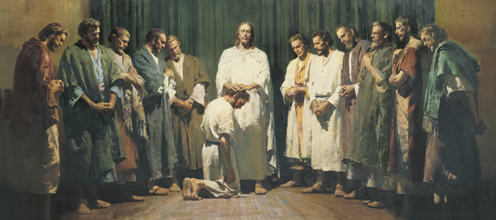
Christ Ordaining the Apostles, by Harry Anderson
Jesus calls and sets apart the twelve apostles and seventies and calls them to the “cities of disciples mission.”
1 And it came to pass that Jesus went out into a mountain to pray, and continued all night in prayer to God.
2 And when it was day, Jesus went into an house and calleth unto him whom he would: and they came unto him. Of them he chose twelve, whom also he named apostles; and the Lord appointed other seventy also, whom also he named the seventy. That they should be with him, and that he might send them forth to preach.
3 And gave he them power against unclean spirits, to cast them out, and to heal all manner of sickness and all manner of disease. For he said unto them, I beheld Satan as lightning fall from heaven.
4 Behold, I give unto you power to tread on serpents and scorpions, and over all the power of the enemy: and nothing shall by any means hurt you.
5 Notwithstanding in this rejoice not, that the spirits are subject unto you; but rather rejoice, because your names are written in heaven.
6 Now the names of the twelve apostles are these; The first, Simon, who is called Peter, and Andrew his brother; James the son of Zebedee, and John his brother; and he surnamed them Boanerges, which is, The sons of thunder:
7 Philip, and Bartholomew; Thomas, and Matthew the publican; James the son of Alphæus, and Lebbæus, whose surname was Thaddæus, also called Judas the son of James.
8 Simon the Canaanite (Simon called Zelotes), and Judas Iscariot, who also betrayed him.
9 These twelve Jesus sent forth, and commanded them, saying, Go not into the way of the Gentiles, and into any city of the Samaritans enter ye not:
10 But go rather to the lost sheep of the house of Israel.
11 And as ye go, preach, saying, The kingdom of heaven is at hand.
12 Heal the sick, cleanse the lepers, raise the dead, cast out devils: freely ye have received, freely give.
13 Provide neither gold, nor silver, nor brass in your purses,
14 Nor scrip for your journey, neither two coats, neither shoes, nor yet staves: for the workman is worthy of his meat.
15 And into whatsoever city or town ye shall enter, inquire who in it is worthy; and there abide till ye go thence and eat such things as are set before you
16 And when ye come into an house, salute it.
17 And if the house be worthy, let your peace come upon it: but if it be not worthy, let your peace return to you.
18 And whosoever shall not receive you, nor hear your words, when ye depart out of that house or city, shake off the dust of your feet for a testimony against them. Notwithstanding be ye sure of this, that the kingdom of God is come nigh unto you
19 Verily I say unto you, It shall be more tolerable for the land of Sodom and Gomorrha in the day of judgment, than for that city.
20 Behold, I send you forth as sheep in the midst of wolves: be ye therefore wise as serpents, and harmless as doves.
21 But beware of men: for they will deliver you up to the councils, and they will scourge you in their synagogues and prisons;
22 And ye shall be brought before governors and kings for my sake, for a testimony against them and the Gentiles.
23 And the gospel must first be published among all nations.
24 But when they shall lead you and deliver you up, take no thought how or what ye shall speak, neither do ye premeditate: for it shall be given you in that same hour what ye shall speak.
25 For it is not ye that speak, but the Spirit of your Father which speaketh in you. For I will give you a mouth and wisdom, which all your adversaries shall not be able to gainsay nor resist.
26 And the brother shall deliver up the brother to death, and the father the child: and the children shall rise up against their parents, and cause them to be put to death.
27 And ye shall be hated of all men for my name’s sake: but he that endureth to the end shall be saved.
28 But when they persecute you in this city, flee ye into another: for verily I say unto you, Ye shall not have gone over the cities of Israel, till the Son of man be come.
29 The disciple is not above his master, nor the servant above his lord: but every one that is perfect shall be as his master.
30 It is enough for the disciple that he be as his master, and the servant as his lord. If they have called the master of the house Beelzebub, how much more shall they call them of his household?
31 Fear them not therefore: for there is nothing covered, that shall not be revealed; and hid, that shall not be known.
32 What I tell you in darkness, that speak ye in light: and what ye hear in the ear, that preach ye upon the housetops.
33 4 And I say unto you my friends, fear not them which kill the body, but are not able to kill the soul: but rather fear him which is able to destroy both soul and body in hell.
34 Are not two sparrows sold for a farthing? And are not five sparrows sold for two farthings? and one of them shall not fall on the ground without your Father.
35 But the very hairs of your head are all numbered, and there shall not an hair of your head perish.
36 Fear ye not therefore, ye are of more value than many sparrows.
37 Whosoever therefore shall confess me before men, him will I confess also before my Father which is in heaven.
38 But whosoever shall deny me before men, him will I also deny before my Father which is in heaven.
39 I am come to send fire on the earth; and what will I, if it be already kindled?
40 But I have a baptism to be baptized with; and how am I straitened till it be accomplished!
41 Think not that I am come to send peace on earth: I came not to send peace, but a sword (division).
42 For I am come to set a man at variance against his father, and the daughter against her mother, and the daughter in law against her mother in law.
43 And a man’s foes shall be they of his own household. For from henceforth there shall be five in one house divided, three against two, and two against three.
44 He that loveth father or mother more than me is not worthy of me: and he that loveth son or daughter or spouse or brethren more than me is not worthy of me.
45 He who seeketh to save his life shall lose it: and he that loseth his life for my sake shall find it.
46 For ye shall be betrayed both by parents, and brethren, and kinsfolks, and friends; and some of you shall they cause to be put to death. And ye shall be hated of all men for my name’s sake.
47 For he that taketh not his cross, and followeth after me, is not worthy of me. Wherefore, settle this in your hearts, that ye will do the things which I shall teach, and command you.
48 For which of you, intending to build a tower, sitteth not down first, and counteth the cost, whether he have sufficient to finish it?
49 Lest haply, after he hath laid the foundation, and is not able to finish it, all that behold it begin to mock him,
50 Saying, This man began to build, and was not able to finish. And this he said, signifying there should not any man follow him, unless he was able to continue; saying,
51 Or what king, going to make war against another king, sitteth not down first, and consulteth whether he be able with ten thousand to meet him that cometh against him with twenty thousand?
52 Or else, while the other is yet a great way off, he sendeth an ambassage, and desireth conditions of peace.
53 So likewise, whosoever he be of you that forsaketh not all that he hath, he cannot be my disciple, for in your patience possess ye your souls.
54 He that receiveth you receiveth me, and he that receiveth me receiveth him that sent me: he that despiseth you despiseth me; and he that despiseth me despiseth him that sent me.
55 He that receiveth a prophet in the name of a prophet shall receive a prophet’s reward; and he that receiveth a righteous man in the name of a righteous man shall receive a righteous man’s reward.
56 And whosoever shall give to drink unto one of these little ones a cup of cold water only in the name of a disciple, verily I say unto you, he shall in no wise lose his reward.
57 And it came to pass, when Jesus had made an end of commanding his twelve disciples, he departed thence to teach and to preach in their cities.
58 And those whom Jesus set apart departed, two by two, and went through the towns, preaching the gospel, and healing every where; for they went out, and preached that men should repent.
59 And they cast out many devils, and anointed with oil many that were sick, and healed them.
Taken from Matthew 10:1-42 Matthew 11:1, Mark 3:13-19, Mark 6: 7-13, Mark 9:41, Mark 13:9-13, Luke 6:12-16,40, Luke 9:1-6, Luke 10: 1, 3-12, 16, 18-20, Luke 12: 2-7, 13-14, 56-60, Luke 14: 25-33, Luke 21:12-19, John 13:20
- See also: Luke 4:42; 5:16; Matt. 14:23; 26:36
- See also: 1 Ne. 12:7; TG Called of God; Apostles; Church Organization; Authority; Priesthood Authority; Missionary Work; Seventy; Preaching
- See also: D&C 50:32; TG Authority; Jesus Christ, Power of; Priesthood, Power of; Spirits, Evil, Unclean; Uncleanness; Healing; Sickness; Council in Heaven; Devil
- See also: TG Priesthood, Power of; Ps. 91:13; Acts 28:5
- See also: D&C 50:33; TG Joy; Ex. 32:32; Heb. 12:23
- See also: Luke 9:54
8. See also: TG Jesus Christ, Betrayal of
9. See also: 3 Ne. 28:34; D&C 107:35; Luke 9:52
10. See also: TG Missionary Work; Sheep
12. See also: D&C 84:67-68; TG Leprosy; Generosity; Isa. 55:1
13. See also: Luke 22:35; D&C 24:18; 84:78
14. See also: 1 Cor. 9:14; Num. 18:31
15. See also: D&C 24:15; 31:5
18. See also: Acts 13:51; D&C 75:20; Acts 18:6; D&C 60:15; 84:92
19. See also: Ezek. 16:48
20. See also: Jacob 6:12; Alma 18:22; Morm. 9:28; D&C 111:11
22. See also: Ps. 119:46; Acts 9:15; D&C 1:23; 124:3
23. See also: TG Gospel; 1 Ne. 13:37; 3 Ne. 20:40; D&C 19:29
24. See also: Dan. 3:16; Acts 20:24; Ex. 4:12; D&C 24:6; TG Teaching
25. See also: TG God, Spirit of; Teaching with the Spirit; Holy Ghost, Mission of; Isa. 50:4; Acts 6:10; D&C 11:21; TG Wisdom
27. See also:1 Ne. 11:34; 22:5; TG Hate; Martyrdom; Persecution; Name; 3 Ne. 15:9; D&C 10:4; 53:7; TG Perseverance; Steadfastness
29. See also: John 15:20; TG Perfection
31. See also: Morm. 5:8
33. See also: John 15:15; TG Peer Influence; Isa. 51:7; Jer. 1:8; Deut. 13:8; D&C 3:7; TG Devil; Soul; Hell
34. See also: TG God, Omniscience of
35. See also: Alma 40:23; D&C 29:25
36. See also: Gen. 39:3; Ps. 37:25; Rom. 8:39; 1 Ne. 17:3; Mosiah 2:41; D&C 121:33; TG Nature
37. See also: TG Witness
38. See also: Rom. 1:16; 2 Tim. 2:12; 2 Ne. 31:14; D&C 101:5
40. See also: Mosiah 3:7
41. See also: John 7:43; TG Peace
43. See also: TG Persecution; Micah 7:6
44. See also: TG Love; 1 Sam. 2:29
45. See also: TG Loyalty; Martyrdom; Self-sacrifice
46. See also: D&C 98:13; 101:35
47. See also: 3 Ne. 12:30; D&C 23:6; TG Worthiness
48. See also: Prov. 24:27; TG Self-mastery; Problem-solving; Commitment
51. See also: Prove. 20:18
53. See also: Luke 5:11; D&C 103:27; 132:50; TG Patience
54. See also: D&C 39:5; 84:36; TG Priesthood, Magnifying Callings within; Teachable; 1 Jn. 4:6; Ex.16:8; TG Hospitality; Mosiah 15:11; 1 Thes. 4:8; John 5:23
55. See also: TG Sustaining Church Leaders; Reward
56. See also: TG Name; D&C 84:90; TG Reward
57. See also: TG Missionary Work
58. See also: TG Gospel; Preaching
59. See also: Ex. 31:11; TG Administrations to the Sick; Anointing

Chapter Forty-Seven
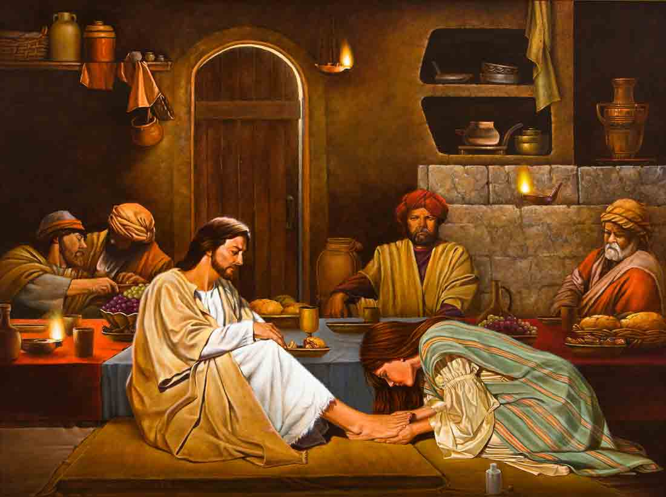
Her Sins Are Forgiven, for She Loved Much, by Roger Cushing

Jesus meets with Simon the Pharisee; woman anoints his feet; Jesus leaves to preach in the other cities of Galilee
1 And it came to pass, whilst Jesus still lingered in Capernaum, one of the Pharisees desired him that he would eat with him. And he went into the Pharisee’s house, and sat down to meat.
2 And, behold, a woman in the city, which was a sinner, when she knew that Jesus sat at meat in the Pharisee’s house, brought an alabaster box of ointment,
3 And stood at his feet behind him weeping, and began to wash his feet with tears, and did wipe them with the hairs of her head, and kissed his feet, and anointed them with the ointment.
4 Now when the Pharisee which had bidden him saw it, he spake within himself, saying, This man, if he were a prophet, would have known who and what manner of woman this is that toucheth him: for she is a sinner.
5 And Jesus answering said unto him, Simon, I have somewhat to say unto thee. And he saith, Master, say on.
6 There was a certain creditor which had two debtors: the one owed five hundred pence, and the other fifty.
7 And when they had nothing to pay, he frankly forgave them both. Tell me therefore, which of them will love him most?
8 Simon answered and said, I suppose that he, to whom he forgave most. And he said unto him, Thou hast rightly judged.
9 And he turned to the woman, and said unto Simon, Seest thou this woman? I entered into thine house, thou gavest me no water for my feet: but she hath washed my feet with tears, and wiped them with the hairs of her head.
10 Thou gavest me no kiss: but this woman since the time I came in hath not ceased to kiss my feet.
11 My head with oil thou didst not anoint: but this woman hath anointed my feet with ointment.
12 Wherefore I say unto thee, Her sins, which are many, are forgiven; for she loved much: but to whom little is forgiven, the same loveth little.
13 And he said unto her, Thy sins are forgiven.
14 And they that sat at meat with him began to say within themselves, Who is this that forgiveth sins also?
15 And he said to the woman, Thy faith hath saved thee; go in peace.
16 And when it was day, he departed and went into a solitary place: and the people sought him, and came unto him, and stayed him, that he should not depart from them.
17 And he said unto them, I must preach the kingdom of God to other cities also: for therefore am I sent.
18 And he preached in the synagogues of Galilee.
Taken from Luke 4:42-44, Luke 7:36-50
2. See also: TG Woman
3. See also: TG Anointing
7. See also: TG Forgiveness; Jesus Christ, Teaching Mode of
12. See also: TG Forgiveness
13. See also: Mark 2:5
14. See also: TG Remission of Sins
15. See also: Matt. 9:2; Ether 12:4; Mosiah 15:18
16. See also: Luke 5:16; 6:12
17. See also: TG Preaching; Jesus Christ, Messenger of the Covenant
18. See also: Matt. 4:23

Chapter Forty-Eight
John the Baptist in Prison, by Josef Anton Hafner

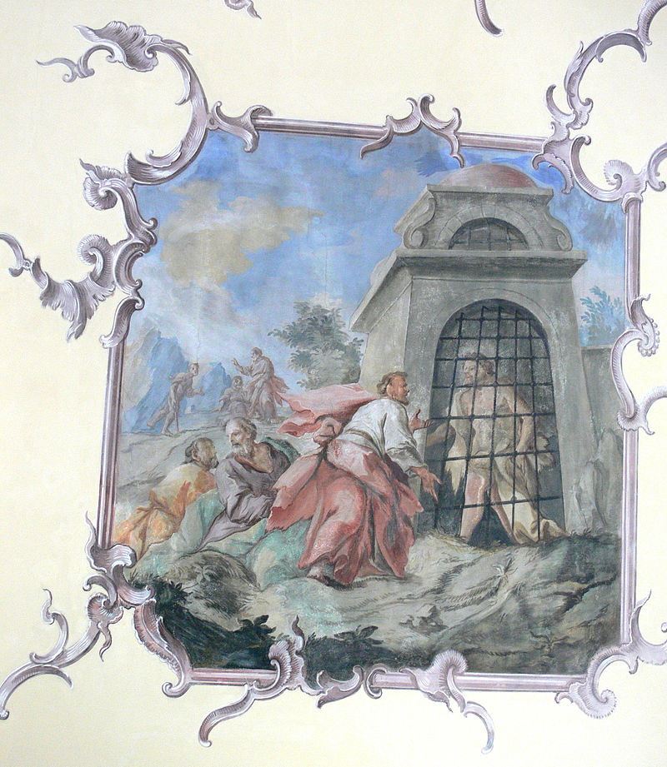
John the Baptist, while in prison, sends two of his followers to Jesus to gain testimonies for themselves of Christ. Jesus confirms that he is the Christ and that John the Baptist was one of the greatest prophets. Jesus also confirms that John the Baptist was an Elias; the Elias who was for to come and prepare all things. Parable of the Barren Fig Tree.
1 And it came to pass that certain disciples of John the Baptist shewed unto him, while he was yet in prison, all the things that Christ had done.
2 Now when John had heard the works of Christ, he saith unto them, Find ye him and ask him, Art thou he that should come or do we look for another?
3 When the disciples of John were come unto Jesus, they said, John the Baptist hath sent us unto thee, saying, Art thou he that should come? or look we for another?
4 And in that same hour Jesus cured many of their infirmities and plagues, and of evil spirits; and unto many that were blind he gave sight.
5 Then Jesus answering said unto them, Go your way, and tell John what things ye have seen and heard; how that the blind see, the lame walk, the lepers are cleansed, the deaf hear, the dead are raised, to the poor the gospel is preached.
6 And blessed is he, whosoever shall not be offended in me.
7 And when the messengers of John were departed, he began to speak unto the people concerning John, What went ye out into the wilderness for to see? A reed shaken with the wind?
8 But what went ye out for to see? A man clothed in soft raiment? Behold, they which are gorgeously apparelled in soft clothing, and live delicately, are in kings’ courts.
9 But what went ye out for to see? A prophet? Yea, I say unto you, and much more than a prophet.
10 For this is he, of whom it is written, Behold, I send my messenger before thy face, which shall prepare thy way before thee.
11 Verily I say unto you, Among them that are born of women there hath not risen a greater than John the Baptist: notwithstanding he that is least in the kingdom of heaven is greater than he.
12 And all the people that heard him, and the publicans, justified God, being baptized with the baptism of John.
13 But the Pharisees and lawyers rejected the counsel of God against themselves, being not baptized of him.
14 And from the days of John the Baptist until now the kingdom of heaven suffereth violence, and the violent take it by force.
15 But the days will come, when the violent shall have no power; For all the prophets and the law prophesied that it should be thus until John.
16 Yea, as many as have prophesied have foretold of these days.
17 And if ye will receive it, verily, he was the Elias, who was for to come and prepare all things.
18 He that hath ears to hear, let him hear.
19 But whereunto shall I liken this generation? And to what are they like? It is like unto children sitting in the markets, and calling unto their fellows,
20 And saying, We have piped unto you, and ye have not danced; we have mourned unto you, and ye have not lamented.
21 For John the Baptist came neither eating bread nor drinking wine; and they say, He hath a devil.
22 The Son of man came eating and drinking, and they say, Behold a man gluttonous, and a winebibber, a friend of publicans and sinners. But wisdom is justified of her children
23 There were present some that told him of the Galilæans, whose blood Pilate had mingled with their sacrifices.
24 And Jesus answering said unto them, Suppose ye that these Galilæans were sinners above all the Galilæans, because they suffered such things?
25 I tell you, Nay: but, except ye repent, ye shall all likewise perish.
26 Or those eighteen, upon whom the tower in Siloam fell, and slew them, think ye that they were sinners above all men that dwelt in Jerusalem?
27 I tell you, Nay: but, except ye repent, ye shall all likewise perish.
28 He spake also this parable; A certain man had a fig tree planted in his vineyard; and he came and sought fruit thereon, and found none.
29 Then said he unto the dresser of his vineyard, Behold, these three years I come seeking fruit on this fig tree, and find none: cut it down; why cumbereth it the ground?
30 And he answering said unto him, Lord, let it alone this year also, till I shall dig about it, and dung it:
31 And if it bear fruit, well: and if not, then after that thou shalt cut it down.
Taken from Matthew 11:2-20, Luke 7:18-35, Luke 13:1-9
4. See also: TG Healing; Sight
5. See also: Alma 32:2
6. See also: 2 Ne. 18:14; Isa. 8:14; Matt. 24:10
8. See also: TG Apparel; Kings, Earthly
9. See also: Matt. 14:5; 21:26, Luke 20:6
10. See also: D&C 45:9; Mal. 3:1; Mark 1:2; 1 Ne. 11:27; D&C 35:4; Isa. 40:3
11. See also: TG Woman; John 5:35; D&C 50:26
12. See also: Luke 3:12; Matt. 3:7
13. See also: Alma 5:41; TG Baptism, Essential
15. See also: Zech. 7:12; 1 Ne. 3:20; Mosiah 15:13; TG Jesus Christ, Prophecies about
17. See also: Luke 1:17
18. See also: Ezek. 33:31; Heb. 5:11; 2 Ne. 9:31; D&C 1:14
20. See also: TG Mourning
24. See also: TG Suffering
25. See also: D&C 3:11; TG Repentance; Ether 8:23; D&C 19:4
28. See also: TG Vineyard of the Lord
29. See also: Matt. 3:10; 7:19; Hel. 14:18

Chapter Forty-Nine
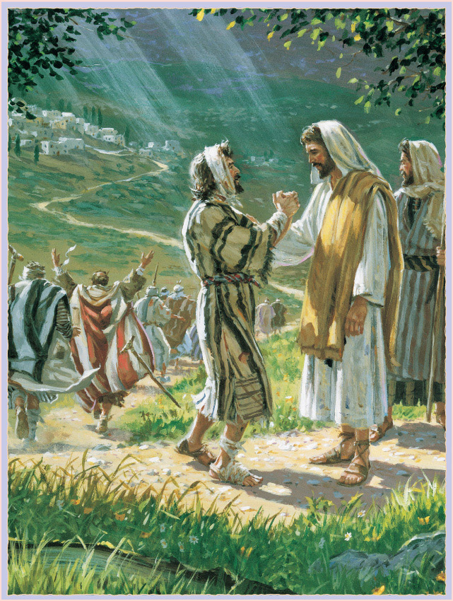
The Ten Lepers, by John Steel

Jesus journeys to Jerusalem for the Feast of the Passover. On the way, in Samaria, he heals ten lepers.
1 After this there was a feast of the Jews; and Jesus went up to Jerusalem.
2 And it came to pass, as he went to Jerusalem, that he passed through the midst of Samaria and Galilee.
3 And as he entered into a certain village, there met him ten men that were lepers, which stood afar off:
4 And they lifted up their voices, and said, Jesus, Master, have mercy on us.
5 And when he saw them, he said unto them, Go shew yourselves unto the priests. And it came to pass, that, as they went, they were cleansed.
6 And one of them, when he saw that he was healed, turned back, and with a loud voice glorified God,
7 And fell down on his face at his feet, giving him thanks: and he was a Samaritan.
8 And Jesus answering said, Were there not ten cleansed? but where are the nine?
9 There are not found that returned to give glory to God, save this stranger.
10 And he said unto him, Arise, go thy way: thy faith hath made thee whole.
Taken from Luke 17:11-19, John 5:1
1. See also: TG Passover
3. See also: TG Leprosy
5. See also: Lev. 13:49
7. See also: TG Thanksgiving
8. See also: TG Purification; Ingratitude

Chapter Fifty
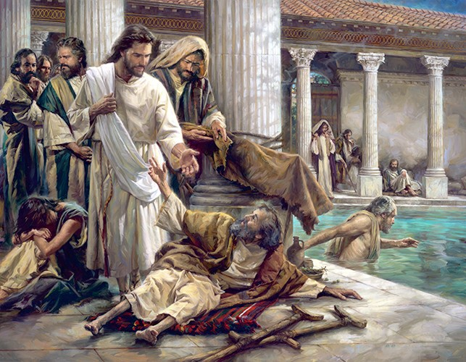
The Pool of Bethesda, by Nathan Greene

Jesus is embroiled in many Sabbath day controversies, starting at Jerusalem and continuing throughout his ministry.
1 And it came to pass that when Jesus was nigh unto Jerusalem for the Passover, there was, by the sheep market, a pool, which is called in the Hebrew tongue Bethesda, having five porches.
2 In these lay a great multitude of impotent folk, of blind, halt, withered, waiting for the moving of the water.
3 For there was an old and false superstition that an angel went down at a certain season into the pool, and troubled the water: whosoever then first after the troubling of the water stepped in was made whole of whatsoever disease he had.
4 And a certain man was there, which had an infirmity thirty and eight years.
5 When Jesus saw him lie, and knew that he had been now a long time in that case, he saith unto him, Wilt thou be made whole?
6 The impotent man answered him, Sir, I have no man, when the water is troubled, to put me into the pool: but while I am coming, another steppeth down before me.
7 Jesus saith unto him, Rise, take up thy bed, and walk.
8 And immediately the man was made whole, and took up his bed, and walked: and on the same day was the sabbath.
9 The Jews therefore said unto him that was cured, It is the sabbath day: it is not lawful for thee to carry thy bed.
10 He answered them, He that made me whole, the same said unto me, Take up thy bed, and walk.
11 Then asked they him, What man is that which said unto thee, Take up thy bed, and walk?
12 And he that was healed wist not who it was: for Jesus had conveyed himself away, a multitude being in that place.
13 Afterward Jesus findeth him in the temple, and said unto him, Behold, thou art made whole: sin no more, lest a worse thing come unto thee.
14 The man departed, and told the Jews that it was Jesus, which had made him whole.
15 And therefore did the Jews persecute Jesus, and sought to slay him, because he had done these things on the sabbath day.
16 But Jesus answered them, My Father worketh hitherto, and I work.
17 Therefore the Jews sought the more to kill him, because he not only had broken the sabbath, but said also that God was his Father, making himself equal with God.
Taken from John 5:2-18
7. See also: John 7:23
8. See also: TG Healing; Matt. 12:1
9. See also: Luke 6:2; TG Sabbath
15. See also: TG Persecution; John 7:1
16. See also: TG God, Work of; John 9:4
17. See also: TG God, Body of (Corporeal Nature); John 10:33; 19:7; D&C 88:107; TG Jesus Christ, Relationships with the Father

Chapter Fifty-One
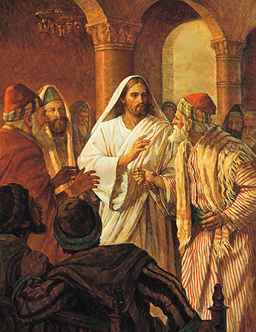
Christ Healing the Man with the Withered Hand, by Robert T. Barrett
Sabbath day controversies continued; Jesus heals a man’s withered hand.
1 And it came to pass also on another sabbath, that he entered into the synagogue and taught: and there was a man whose right hand was withered.
2 And the scribes and Pharisees watched him, whether he would heal on the sabbath day; that they might find an accusation against him.
3 But he knew their thoughts, and said to the man which had the withered hand, Rise up, and stand forth in the midst. And he arose and stood forth.
4 Then said Jesus unto them, I will ask you one thing; Is it lawful on the sabbath days to do good, or to do evil? to save life, or to destroy it? But they held their peace.
5 And he said unto them, What man shall there be among you, that shall have one sheep, and if it fall into a pit on the sabbath day, will he not lay hold on it, and lift it out?
6 How much then is a man better than a sheep? Wherefore it is lawful to do well on the sabbath days.
7 And looking round about upon them all, with anger, being grieved for the hardness of their hearts, he said unto the man, Stretch forth thy hand. And he did so: and his hand was restored whole as the other.
8 And then the Pharisees were filled with madness, and went out, and took counsel with the Herodians against him, and they communed one with another what they might do to Jesus for they sought how they might destroy him.
9 But Jesus knew when they took counsel, and he withdrew himself from thence: and great multitudes followed him, and he healed them all;
10 And charged them that they should not make him known.
Taken from Matthew 12: 9-16, Mark 3:1-6, Luke 6:6-11
3. See also: John 2:24
4. See also: TG Sabbath
7. See also: TG God, Indignation of; Cruelty
8. See also: TG Counsel

Chapter Fifty-Two
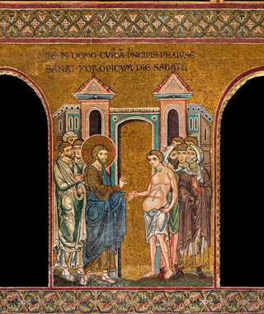
12th-13th century Mosaic
Cathedral of the Assumption, Monreale, Sicily
Sabbath day controversies: Jesus heals a man of dropsy
1 And it came to pass, as he went into the house of one of the chief Pharisees to eat bread on the sabbath day, that they watched him.
2 And, behold, there was a certain man before him which had the dropsy.
3 And Jesus answering spake unto the lawyers and Pharisees, saying, Is it lawful to heal on the sabbath day?
4 And they held their peace. And he took him, and healed him, and let him go;
5 And answered them, saying, Which of you shall have an ass or an ox fallen into a pit, and will not straightway pull him out on the sabbath day?
6 And they could not answer him again to these things.
Taken from Luke 14:1-6
5. See also: TG Sabbath

Chapter Fifty-Three
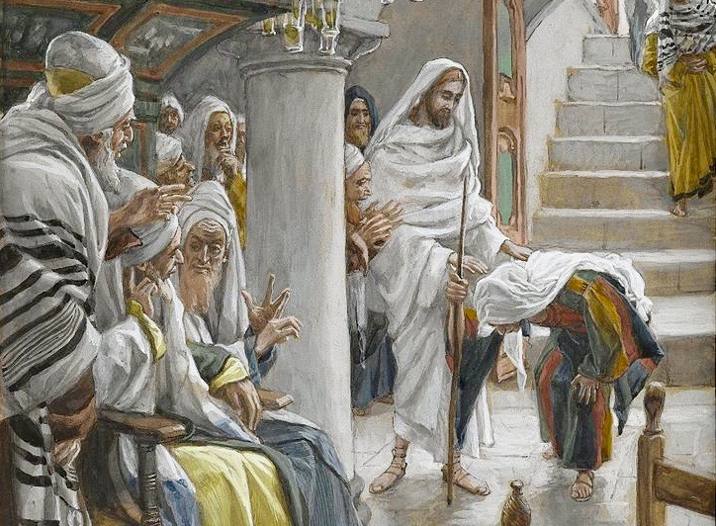
The Woman with an Infirmity of Eighteen Years, by James Tissot
Sabbath day controversies; Jesus heals a woman who can’t stand.
1 And Jesus was teaching in one of the synagogues on the sabbath.
2 And, behold, there was a woman which had a spirit of infirmity eighteen years, and was bowed together, and could in no wise lift up herself.
3 And when Jesus saw her, he called her to him, and said unto her, Woman, thou art loosed from thine infirmity.
4 And he laid his hands on her: and immediately she was made straight, and glorified God.
5 And the ruler of the synagogue answered with indignation, because that Jesus had healed on the sabbath day, and said unto the people, There are six days in which men ought to work: in them therefore come and be healed, and not on the sabbath day.
6 The Lord then answered him, and said, Thou hypocrite, doth not each one of you on the sabbath loose his ox or his ass from the stall, and lead him away to watering?
7 And ought not this woman, being a daughter of Abraham, whom Satan hath bound, lo, these eighteen years, be loosed from this bond on the sabbath day?
8 And when he had said these things, all his adversaries were ashamed: and all the people rejoiced for all the glorious things that were done by him.
Taken from Luke 13:10-17
4. See also: TG Hands, Laying on of; Administrations to the Sick
5. See also: TG Industry
7. See also: TG Sabbath
Chapter Fifty-Four
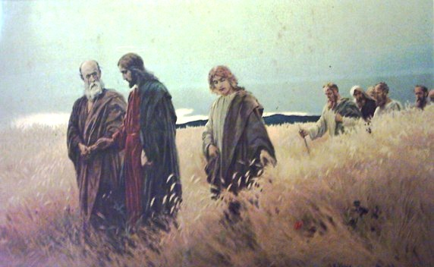
Sabbath day controversies continued; Jesus’ disciples pick corn from the fields on the Sabbath.
1 And it came to pass, that Jesus went through the corn fields on the sabbath day; and his disciples were an hungered and began, as they went, to pluck the ears of corn to eat, rubbing them in their hands.
2 And the Pharisees said unto him, Behold, why do they on the sabbath day that which is not lawful?
3 And he said unto them, Have ye never read what David did, when he had need, and was an hungred, he, and they that were with him?
4 How he went into the house of God in the days of Abiathar the high priest, and did eat the shewbread, which is not lawful to eat but for the priests, and gave also to them which were with him?
5 Or have ye not read in the law, how that on the sabbath days the priests in the temple profane the sabbath, and are blameless?
6 But I say unto you, That in this place is one greater than the temple.
7 But if ye had known what this meaneth, I will have mercy, and not sacrifice, ye would not have condemned the guiltless.
8 And he said unto them, The sabbath was made for man, and not man for the sabbath:
9 Wherefore the Sabbath was given unto man for a day of rest; and also that man should glorify God, and not that man should not eat;
10 For the Son of man made the Sabbath day, therefore the Son of man is Lord also of the Sabbath.
Taken from Matthew 12:1-8, Mark 2:23-29, Luke 6:1-5
1. See also: Deut. 23:25
2. See also: John 5:10
3. See also: TG Jesus Christ, Teaching Mode of
4. See also: Ex. 29:33; Lev. 24:9; 1 Sam. 21:6; TG Bread, Shewbread
5. See also: Num. 28:9
6. See also: TG Temple
7. See also: Hosea 6:6
8. See also: TG Sabbath
9. See also: TG Jesus Christ, Son of Man
10. See also: TG Sabbath

Chapter Fifty-Five
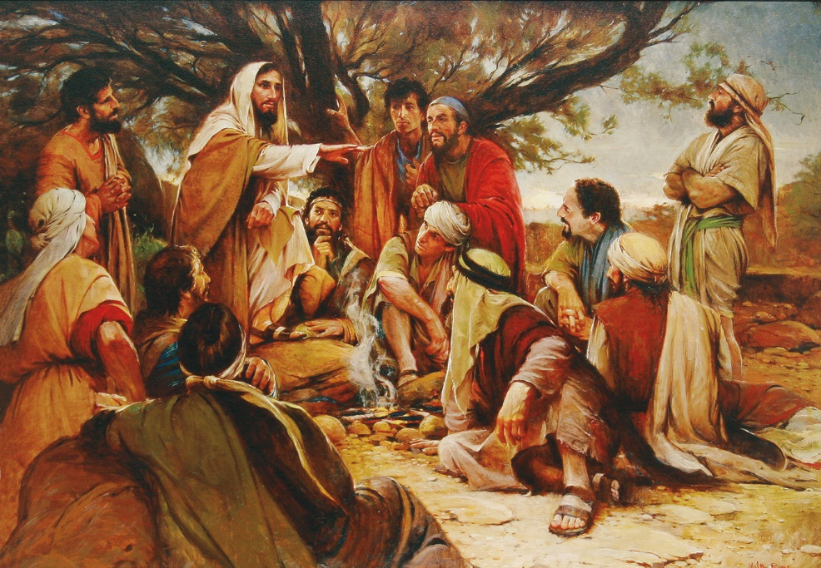
These Twelve Jesus Sent Forth, by Walter Rane
The seventy, the twelve and Jesus Christ preach throughout all of Galilee for a space of almost a year. The apostles’ cities mission concludes and they return to Jesus.
1 And Jesus went about all Galilee, and throughout every city and village, teaching in their synagogues, and preaching and shewing the glad tidings of the kingdom and healing all manner of sickness and all manner of disease among the people which believed on his name.
2 And his fame went throughout all Syria: and they brought unto him all sick people that were taken with divers diseases and torments, and those which were possessed with devils and those which were lunatic and those that had the palsy; and he healed them
3 And there followed him great multitudes of people from Galilee, and from Decapolis, and from Jerusalem, and from Judæa, and from beyond Jordan.
4 And certain women, which had been healed of evil spirits and infirmities, Mary called Magdalene, out of whom went seven devils,
5 And Joanna the wife of Chuza Herod’s steward, and Susanna, and many others, which ministered unto him of their substance.
6 And the apostles and the seventy, when they were returned again with joy, told Jesus all that they had done, saying, Lord, even the devils are subject unto us through thy name.
7 And he came down with them, and stood in the plain, and the company of his disciples, and a great multitude of people out of all Judæa and Jerusalem, and from the sea coast of Tyre and Sidon, which came to hear him, and to be healed of their diseases;
8 But when he saw the multitudes, he was moved with compassion on them, because they fainted, and were scattered abroad, as sheep having no shepherd.
9 Then saith he unto his disciples, The harvest truly is plenteous, but the labourers are few;
10 Pray ye therefore the Lord of the harvest, that he will send forth labourers into his harvest.
11 Then began he to upbraid the cities wherein most of his mighty works were done, because they repented not:
12 Woe unto thee, Chorazin! woe unto thee, Bethsaida! for if the mighty works, which were done in you, had been done in Tyre and Sidon, they would have repented long ago in sackcloth and ^{b}ashes.
13 But I say unto you, It shall be more tolerable for Tyre and Sidon at the day of judgment, than for you.
14 And thou, Capernaum, which art exalted unto heaven, shalt be brought down to hell: for if the mighty works, which have been done in thee, had been done in Sodom, it would have remained until this day.
15 But I say unto you, That it shall be more tolerable for the land of Sodom in the day of judgment, than for thee.
16 At that time Jesus answered and said, I thank thee, O Father, Lord of heaven and earth, because thou hast hid these things from the wise and prudent, and hast revealed them unto babes.
17 Even so, Father: for so it seemed good in thy sight.
18 All things are delivered unto me of my Father: and no man knoweth the Son, but the Father; neither knoweth any man the Father, save the Son, and they to whoms the Son will reveal himself; they shall see the Father also.
19 Come unto me, all ye that labour and are heavy laden, and I will give you rest.
20 Take my yoke upon you, and learn of me; for I am meek and lowly in heart: and ye shall find rest unto your souls.
21 For my yoke is easy, and my burden is light.
22 And the whole multitude sought to touch him: for there went virtue out of him, and healed them all.

Taken from Matthew 4:23-25, Matthew 9:39-42, Matthew 11:21-31, Luke 6:17-19, Luke 8:1-3, Luke 9:10, Luke 10:2, 13-15, 17
1. See also: Luke 4:44; Alma 23:4; D&C 66:5; 71:1; 75:18; 76:40; TG Healing; Miracles; Sickness
2. See also: TG Spirits, Evil, Unclean; Uncleanliness; Matt. 8:16; Mosiah 3:5
4. See also: Mark 16:9
6. See also: TG Seventy
8. See also: TG Compassion; Sheep; Jesus Christ, Good Shepherd; Shepherds
9. See also: TG Harvest
11. See also: Alma 34:31; 3 Ne. 9:3; D&C 84:114
12. See also: Ezek. 3:6; Job 2:8; 42:6
13. See also: D&C 45:54; 75:22
14. See also: TG Haughtiness; Hell
15. See also: Ezek. 16:48
16. See also: Matt. 13:11; D&C 6:11; TG Prudence; Alma 32:23; 3 Ne. 26:16; D&C 128:18
18. See also: TG Jesus Christ, Messiah; Knowledge; God, Privilege of Seeing; John 14:6
19. See also: Ps. 55:22; Isa. 55:3; D&C 10:67; TG Problem-Solving; Labor; Rest
20. See also: 1 Jn. 2:6; TG Jesus Christ, Taking the Name of; D&C 32:1; TG Learning; Humility; Meekness; Contrite Heart; Heart; Mosiah 2:41; Alma 37:34; D&C 54:10; 59:23; TG Comfort
21. See also: 1 Jn. 5:3; Alma 37:46
22. See also: Mark 5:30; Luke 8:46; TG Healing

Commentary
- Verse 1: Those that exercise faith in Jesus Christ will be blessed with His presence, then His teaching and finally the power of His healing.

Chapter Fifty-Six
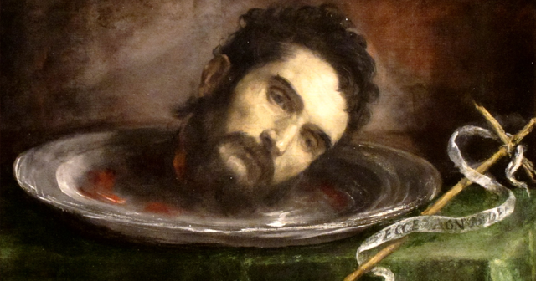
John the Baptist is beheaded.
1 And when a convenient day was come, that Herod on his birthday made a supper to his lords, high captains, and chief estates of Galilee;
2 And when the daughter of the said Herodias came in, and danced, and pleased Herod and them that sat with him, the king said unto the damsel, Ask of me whatsoever thou wilt, and I will give it thee.
3 And he sware unto her, Whatsoever thou shalt ask of me, I will give it thee, unto the half of my kingdom.
4 And she went forth, and said unto her mother, What shall I ask? And she said, The head of John the Baptist.
5 And she came in straightway with haste unto the king, and asked, saying, I will that thou give me by and by in a charger the head of John the Baptist.
6 And the king was exceeding sorry; yet for his oath’s sake, and for their sakes which sat with him, he would not reject her.
7 And immediately the king sent an executioner, and commanded his head to be brought: and he went and beheaded him in the prison,
8 And brought his head in a charger, and gave it to the damsel: and the damsel gave it to her mother.
9 And when his disciples heard of it, they came and took up his corpse, and laid it in a tomb, and went forth to tell Jesus.
Taken from Matthew 14:6-12, Mark 6:21-29
3. See also: TG Swearing; Vows; Esth. 5:3
5. See also: TG Haste; Martyrdom
6. See also: TG Vows
7. See also: TG Tyranny

Chapter Fifty-Seven
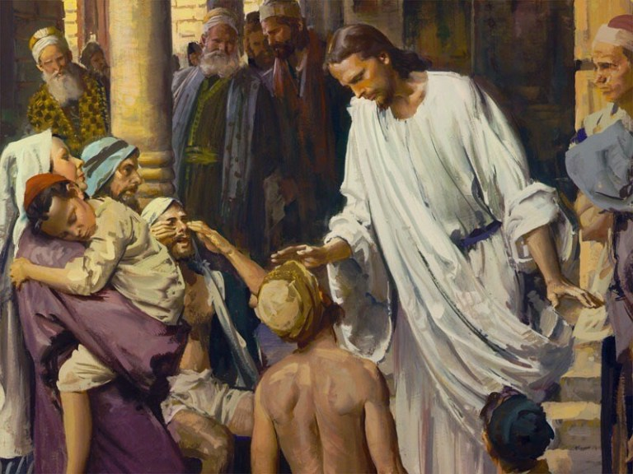
Jesus casts out a devil in a man blind and dumb; he is accused of doing so by the power of Beelzebub.
1 As they went out, behold, friends of a man possessed with a devil, blind and dumb, brought he him to Jesus and saith unto him, Our friend is beside himself.
2 And when the devil was cast out, the dumb spake: and the multitudes marvelled, saying, It was never so seen in Israel. Is not this the son of David?
3 But when the Pharisees and the scribes which came down from Jerusalem saw it they said, This fellow doth not cast out devils, but by Beelzebub the prince of the devils.
Taken from Matthew 9:36-38, Matthew 12:22-24, Mark 3:20-22, Luke 11:14-15
1. See also: Matt. 4:24; 8:16
2. See also: TG Jesus Christ, Davidic Descent of
3. See also: 2 Kgs. 1:2; Mosiah 3:9; Hel. 13:26

Chapter Fifty-Eight
Jesus teaches a house divided cannot stand and by their fruits you shall know them
1 And Jesus knew the thoughts of the Pharisees and said unto them, Every kingdom divided against itself is brought to desolation; and every city or house divided against itself shall not stand:
2 And he called them unto him, and said unto them in parables, How can Satan cast out Satan?
3 And if a kingdom be divided against itself, that kingdom cannot stand.
4 And if a house be divided against itself, that house cannot stand.
5 And if Satan rise up against himself, and be divided, he cannot stand, but hath an end.
6 And when a strong man armed keepeth his palace, his goods are in peace: For no man can enter into a strong man’s house, and spoil his goods, except he will first bind the strong man; and then he will spoil his house.
7 But if I cast out devils with the finger of God, yeah cast I out devils by the Spirit of God, the kingdom of God is come unto you.
8 For if I by Beelzebub cast out devils, by whom do your children cast them out? therefore they shall be your judges.
9 And John answered him, saying, Master, we saw one casting out devils in thy name, and he followeth not us: and we forbad him, because he followeth not us.
10 But Jesus said, Forbid him not: for there is no man which shall do a miracle in my name, that can lightly speak evil of me.
11 For he that is not against us is on our part. He that is not with me is against me; therefore he that gathereth not with me scattereth abroad.
12 For they also cast out devils by the Spirit of God, for unto them is given power over devils, that they may cast them out.
13 Ye shall know them by their fruits. Do men gather grapes of thorns, or figs of thistles?
14 Even so every good tree bringeth forth good fruit; but a corrupt tree bringeth forth ^{d}evil fruit.
15 A good tree cannot bring forth evil fruit, neither can a corrupt tree bring forth good fruit.
16 Every tree that bringeth not forth good fruit is hewn down, and cast into the fire.
17 Wherefore by their fruits ye shall know them.
18 Either make the tree good, and his fruit good; or else make the tree corrupt, and his fruit corrupt: for the tree is known by his fruit.
19 O generation of vipers, how can ye, being evil, speak good things? for out of the abundance of the heart the mouth speaketh.
20 A good man out of the good treasure of the heart bringeth forth good things: and an evil man out of the evil treasure bringeth forth evil things.
21 But I say unto you, That every idle word that men shall speak, they shall give account thereof in the day of judgment.
22 For by thy words thou shalt be justified, and by thy words thou shalt be condemned.
Taken from Matthew 7:24-28, Matthew 12:25-30, 33-37, Mark 3:23-27, 32, Mark 9:38-41, Luke 6:43-45, Luke 9:49-50, Luke 11:17-24
- See also: Ps. 139:2; John 2:25; Mosiah 24:12; D&C 6:16; TG Governments
7. See also: TG Devil; God, Spirit of; Ex. 8:19; John 3:2; Acts 2:22; 10:38
9. See also: Acts 19:13
10. See also: TG Miracles; Name
11. See also: 2 Ne. 10:16; D&C 10:68
13. See also: TG Discernment, Spiritual; Good Works, Prov. 20:11; Jer. 28:9; Moro. 7:6
14. See also: 3 Ne. 14:20
16. See also: Luke 3:9; John 15:2; Jacob 5:26; Alma 5:36; D&C 97:7; Luke 13:7
17. See also: James 2:18; 1 Jn. 3:10
18. See also: 3 Ne. 14:20; Moro. 7:16; Alma 7:24; D&C 84:58; 97:7
19. See also: Matt. 3:7; 23:33; D&C 121:23; James 3:10
20. See also: TG Treasure; Motivations; Heart; Evil; Gossip; James 3:10
21. See also: Eccl. 5:2; Eph. 5:4; TG Gossip; Profanity; Accountability; Judgment, The Last; Alma: 11:43
22. See also: Prov. 18:21

Chapter Fifty-Nine
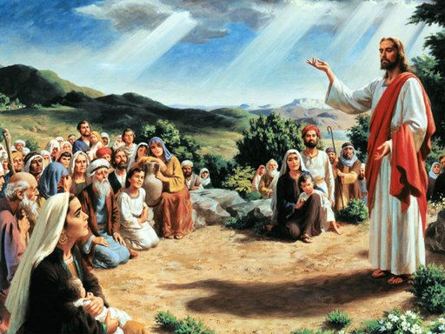
All blasphemy and sin will be forgiven save for denying the Holy Ghost; Jesus condemns this generation. Jesus is not a respector of persons.
1 And then came certain men unto him, accusing him, saying, Why do ye receive sinners, seeing thou makest thyself the Son of God.
2 But he answered them and said, Verily I say unto you, All sins which men have committed, when they repent, shall be forgiven them; for I came to preach repentance unto the sons of men.
3 Also I say unto you, Whosoever shall confess me before men, him shall the Son of man also confess before the angels of God:
4 But he who denieth me before men, shall be denied before the angels of God.
5 Now his disciples knew that he said this, because they had spoken evil against him before the people; for they were afraid to confess him before men.
6 And they reasoned among themselves, saying, He knoweth our hearts, and he speaketh to our condemnation, and we shall not be forgiven. But he answered them, and said unto them,
7 Wherefore I say unto you, All manner of sin and blasphemy shall be forgiven unto men who receive me and repent; and come unto me and do the works they see me do.
8 Wherefore whosoever shall speak a word against the Son of man, and repenteth, it shall be forgiven him; but there is a sin which shall not be forgiven. He that shall blaspheme against the Holy Ghost, hath never forgiveness, neither in this world, neither in the world to come; but is in danger of being cut down out of the world. And they shall inherit eternal damnation.
9 Then came some of the scribes and said unto him, Master, it is written that, Every sin shall be forgiven; but ye say, Whosoever speaketh against the Holy Ghost shall not be forgiven. And they asked him, saying, How can these things be?
10 And he said unto them, When the unclean spirit is gone out of a man, he walketh through dry places, seeking rest and findeth none; but when a man speaketh against the Holy Ghost, then he saith, I will return into my house from whence I came out; and when he is come, he findeth him empty, swept and garnished; for the good spirit leaveth him unto himself.
11 Then goeth the evil spirit, and taketh with himself seven other spirits more wicked than himself, and they enter in and dwell there: and the last state of that man is worse than the first. Even so shall it be also unto this wicked generation.
12 The men of Nineveh shall rise in judgment with this generation, and shall condemn it: because they repented at the preaching of Jonas; and, behold, a greater than Jonas is here.
13 The queen of the south shall rise up in the judgment with this generation, and shall condemn it: for she came from the uttermost parts of the earth to hear the wisdom of Solomon; and, behold, a greater than Solomon is here.
14 There came then his brethren and his mother, and, standing without, sent unto him, calling him.
15 And the multitude was about him, and one said unto him, Behold, thy mother and thy brethren without seek for thee, and they cannot come to thee for the press.
16 And it came to pass, a certain woman of the company lifted up her voice, and said unto him, Blessed is the womb that bare thee, and the paps which thou hast sucked.
17 But he said, Yea rather, blessed are they that hear the word of God, and keep it. For who is my mother, or my brethren?
18 And he looked round about on them which were about him, and said, Behold my mother and my brethren!
19 For whosoever shall hear the will of my Father which is in heaven and do it, the same is my brother, and my sister, and mother.
Taken from Matthew 12:31-32, 43-50, Mark 3:28-31, 33-37, Luke 8: 19-21, Luke 11:25-28, 31-32, Luke 12:8-12
3. See also: Moro. 7:44; D&C 62:3; TG Angels
7. See also: TG Blasphemy; Holy Ghost, Unpardonable Sin against; Holy Ghost, Loss of
8. See also: TG Death, Spiritual, Second; Forgiveness; Eternity; Damnation; Punishment; Apostasy, of Individuals
10. See also: TG Uncleanliness
11. See also: TG Spirits, Evil, Unclean; Alma 24:30
12. See also: Jonah 3:5; TG Repentance
13. See also: 1 Kgs. 10:1
14. See also: TG Jesus Christ, Family of; John 7:3; 1 Cor. 9:5
16. See also: Luke 1:48
17. See also: TG Blessings; Prov. 19:16; 29:18; TG Obedience
18. See also: Mosiah 5:7; TG Marriage, Motherhood
19. See also: 3 Ne. 9:17; Matt. 7:21; TG God, Will of; Brotherhood and Sisterhood

Chapter Sixty
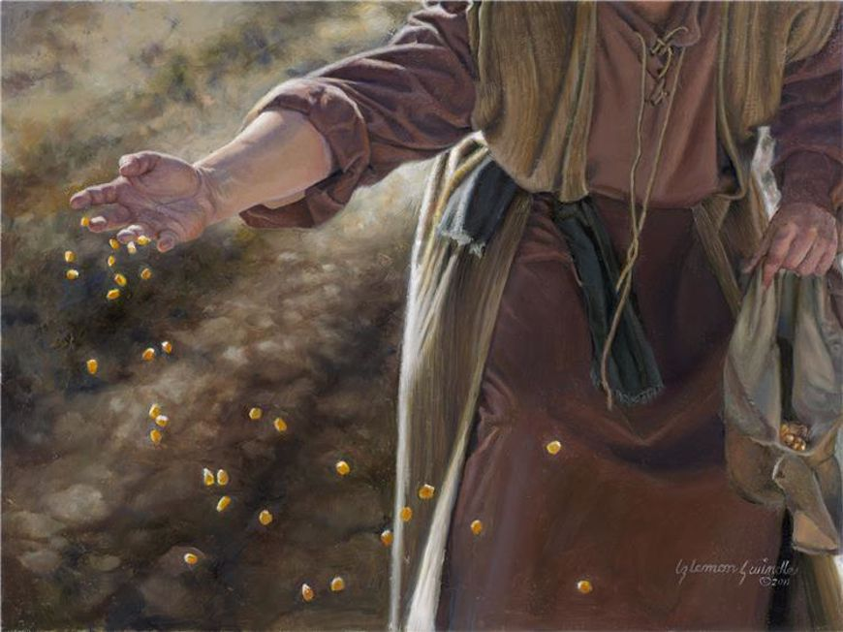
The Sower, by Liz Lemon Swindle
Jesus teaches parables from a boat; begins with the parable of the sower
1 The same day, went Jesus out with his disciples and sat by the sea side and he began again to teach: and there was gathered unto him a great multitude, from Galilee who followed him, and from Judæa,
2 And from Jerusalem, and from Idumæa, and from beyond Jordan; and they about Tyre and Sidon, a great multitude, when they had heard what great things he did, came unto him.
3 And he spake to his disciples, that a small ship should wait on him because of the multitude, lest they should throng him.
4 For he in past times had healed many for simply to touch him; insomuch that they which had divers plagues would press upon him.
5 So Jesus entered into a ship, and sat in the sea; and the whole multitude was by the sea on the land.
6 And he taught them many things by parables, and said unto them in his doctrine,
7 Hearken; Behold, there went out a sower to sow:
8 And it came to pass, as he sowed, some fell by the way side, and the fowls of the air came and devoured it up.
9 And some fell on stony ground, where it had not much earth; and immediately it sprang up, because it had no depth of earth:
10 But when the sun was up, it was scorched; and because it had no root, it withered away.
11 And some fell among thorns, and the thorns grew up, and choked it, and it yielded no fruit.
12 And other fell on good ground, and did yield fruit that sprang up and increased; and brought forth, some thirty, and some sixty, and some an hundred.
13 And he said unto them, He that hath ears to hear, let him hear.
14 And Jesus said unto his disciples, Know ye not this parable? and how then will ye know all parables?
15 The sower soweth the word.
16 And these are they by the way side, where the word is sown; but when they have heard, Satan cometh immediately, and taketh away the word that was sown in their hearts.
17 And these are they likewise which are sown on stony ground; who, when they have heard the word, immediately receive it with gladness;
18 And have no root in themselves, and so endure but for a time: afterward, when affliction or persecution or temptation ariseth for the word’s sake, immediately they are offended.
19 And these are they which are sown among thorns; such as hear the word,
20 And the cares of this world, and the deceitfulness of riches, and the lusts of other things entering in, choke the word, and it becometh unfruitful.
21 And these are they which are sown on good ground; they are they which in an honest and good heart, having heard the word, understand and receive it, and endure; which also bring forth fruit, some thirtyfold, some sixty, and some an hundred.
Taken from Matthew 13:1-9, 18-23, Mark 3:7-10, Mark 4:1-9, 13-20, Luke 8:4-8, 11-15
6. See also: 3 Ne. 11:39
7. See also: D&C 86:2
15. See also: Alma 32:28
16. See also: TG Devil; D&C 84:50; 93:39
17. See also: D&C 40:2; Zech. 7:12
18. See also: 1 Ne. 8:28; TG Affliction; Persecution; Test, Try, Prove; Tribulation; Apostasy, of Individuals; Offenses
19. See also: Jer. 4:3
20. See also: Hel. 7:5; D&C 39:9; TG Worldliness; Deceit; Treasure; Lust; Gal. 6:9
21. See also: D&C 11:10; TG Heart; Teachable; Good Works; Alma 12:30; 32:42
Chapter Sixty-One
Jesus teaching from a boat, by Carl Schmidt
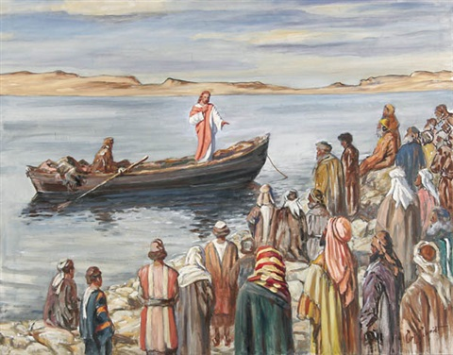
Jesus explains why he teaches in parables.
1 And the disciples said unto him, Why speakest thou unto them in parables?
2 He answered and said unto them, Because it is given unto you to know the mysteries of the kingdom of heaven, but unto them that are without, all these things are done in parables:
3 For nothing is secret, that shall not be made manifest; neither any thing hid, that shall not be known and come abroad.
4 In that hour Jesus rejoiced in spirit, and said, I thank thee, O Father, Lord of heaven and earth, that thou hast hid these things from them who think they are the wise and prudent, and hast revealed them unto babes: even so, Father; for so it seemed good in thy sight, for all things are delivered to me of thee.
5 For whosoever receiveth, to him shall be given, and he shall have more abundance: but whosoever continueth not to receive, from him shall be taken away even that he hath.
6 Therefore speak I to them in parables: because they seeing see not; and hearing they hear not, neither do they understand; lest at any time they should be converted, and their sins should be forgiven them.
7 And in them is fulfilled the sayings of Isaiah the prophet, which he spake, Lord, who hath believed our report? And to whom hath the arm of the Lord been revealed? He hath blinded their eyes; that they should not see with their eyes. He hath closed their ears; by hearing they hear not. He hath hardened their hearts; that they understand not with their heart.
8 For this people’s heart is waxed gross, and their ears are dull of hearing, and their eyes they have closed; lest at any time they should see with their eyes, and hear with their ears, and should understand with their heart, and should be converted, and I should heal them.
9 But blessed are your eyes, for they see: and your ears, for they hear.
10 For verily I say unto you, That many prophets and righteous men have desired to see those things which ye see, and have not seen them; and to hear those things which ye hear, and have not heard them.
11 For these reasons spake Jesus unto the people in parables; and without a parable spake he not unto them:
12 That it might be fulfilled which was spoken by the prophet, saying, I will open my mouth in parables; I will utter things which have been kept secret from the foundation of the world. These things said Isaiah, when he saw his glory, and spake of him.
Taken from Matthew 13:10-17, 34-35, Mark 4:10-12, 24-25, Luke 8:9-10, 17-18, Luke 10:21-24, John 12:38-41
1. See also: Dan. 12:10; TG Jesus Christ, Teaching Mode of
2. See also: Matt. 11:25; D&C 6:11; 19:8; Alma 26:22; Ps. 78:2; TG Mysteries of Godliness
3. See also: D&C 1:3
4. See also: TG Prudence; Alma 32:23; 3 Ne. 26:14; D&C 128:18; TG Jesus Christ, Authority of
5. See also: Matt. 25:29; Prov. 9:9; 2 Ne. 28:29-30; D&C 43:10; 60:3
6. See also: TG Forgiveness
7. See also: Isa. 53:1; Rom. 10:16; TG Spiritual Blindness; Hardheartedness
8. See also: TG Apostasy, of Israel; Unbelief, Unbelievers; 3 Ne. 9:13; 18:32
10. See also: Heb. 11:13; 1 Pet. 1:10; 2 Ne. 25:26; TG Kings, Earthly
12. See also: Ps. 78:2; D&C 35:18; TG Jesus Christ, Appearances, Antemortal; Glory

Chapter Sixty-Two
Jesus teaches another parable in the boat; parable of the mustard seed
1 Another parable put Jesus forth unto them, and he said, Whereunto shall we liken the kingdom of God? Or with what comparison shall we compare it?
2 It is like a grain of mustard seed, which, when it is sown in the earth, is less than all the seeds that be in the earth:
3 But when it is sown, it growth up, and becometh greater than all herbs, and shooteth out great branches; so that the fowls of the air may lodge under the shadow of it.
Taken from Matthew 13:31-32, Mark 4:30-32, Luke 13:18-19
2. See also: Isa. 60:22
3. See also: TG Nature

Chapter Sixty-Three
Jesus teaches the parable of the seed growing secretly
1 And Jesus said, So is the kingdom of God, as if a man should cast seed into the ground;
2 And should sleep, and rise night and day, and the seed should spring and grow up, he knoweth not how.
3 For the earth bringeth forth fruit of herself; first the blade, then the ear, after that the full corn in the ear.
4 But when the fruit is brought forth, immediately he putteth in the sickle, because the harvest is come.
Taken from Mark 4:26-29
2. See also: 1 Cor. 3:6
3. See also: TG Nature
4. See also: TG Harvest

Chapter Sixty-Four
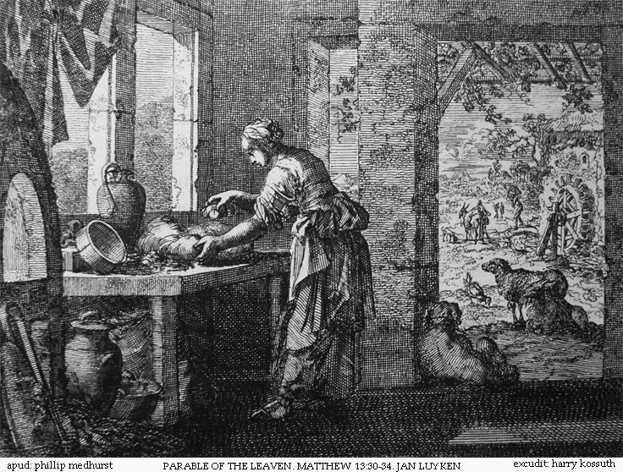
Still teaching from the boat, Jesus shares the parable of leaven
1 And again he said, Whereunto shall I liken the kingdom of God?
2 Another parable spake he unto them; The kingdom of heaven is like unto leaven, which a woman took, and hid in three measures of meal, till the whole was leavened.
Taken from Matthew 13:33, Luke 13:20-21
2. See also: TG Leaven

Chapter Sixty-Five
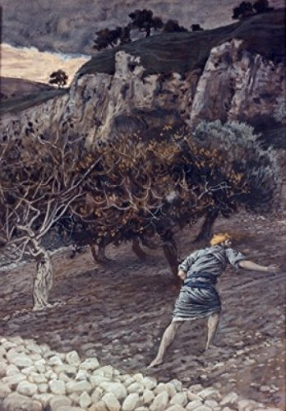
The Enemy Sowing Tares, by James Tissot
Jesus teaches the parable of the wheat and the tares from the boat; sends the multitude away as he had spoken as many parables as they were able to bear. Once alone in a house with his disciples, he expounded all things to them.
1 Another parable put he forth unto them, saying, The kingdom of heaven is likened unto a man which sowed good seed in his field:
2 But while men slept, his enemy came and sowed tares among the wheat, and went his way.
3 But when the blade was sprung up, and brought forth fruit, then appeared the tares also.
4 So the servants of the householder came and said unto him, Sir, didst not thou sow good seed in thy field? From whence then hath it tares?
5 He said unto them, An enemy hath done this. The servants said unto him, Wilt thou then that we go and gather them up?
6 But he said, Nay; lest while ye gather up the tares, ye root up also the wheat with them.
7 Let both grow together until the harvest: and in the time of harvest I will say to the reapers, Gather ye together first the wheat into my barn, and the tares are bound in bundles to be burned
8 Then Jesus sent the multitude away, and went into the house: and his disciples came unto him, saying, Declare unto us the parable of the tares of the field.
9 He answered and said unto them, He that soweth the good seed is the Son of man;
10 The field is the world; the good seed are the children of the kingdom; but the tares are the children of the wicked one;
11 The enemy that sowed them is the devil; The harvest is the end of the world, or the destruction of the wicked.
12 The reapers are the angels, or the messengers sent of heaven.
13 As, therefore, the tares are gathered and burned in the fire, so shall it be in the end of this world, or the destruction of the wicked.
14 For in that day, before the Son of man shall come, he shall send forth his angels and messengers of heaven.
15 And they shall gather out of his kingdom all things that offend, and them which do iniquity, and shall cast them out among the wicked; and there shall be wailing and gnashing of teeth.
16 For the world shall be burned with fire.
Taken from Matthew 13:24-30, 36-44, Mark 4:33-34
1. See also: D&C 86:1; TG Kingdom of God, on Earth
2. See also: TG Apostasy, of the Early Christian Church
7. See also: TG Harvest; D&C 38:12
8. See also: D&C 86:1; 101:65
10. See also: D&C 88:94; TG Devil, Church of
11. See also: TG Harvest
14. See also: TG Angel
15. See also: TG Offenses; Matt. 8:12; Rev. 19:20; D&C 19:5; 29:15; 112:24; TG Pain

Chapter Sixty-Six
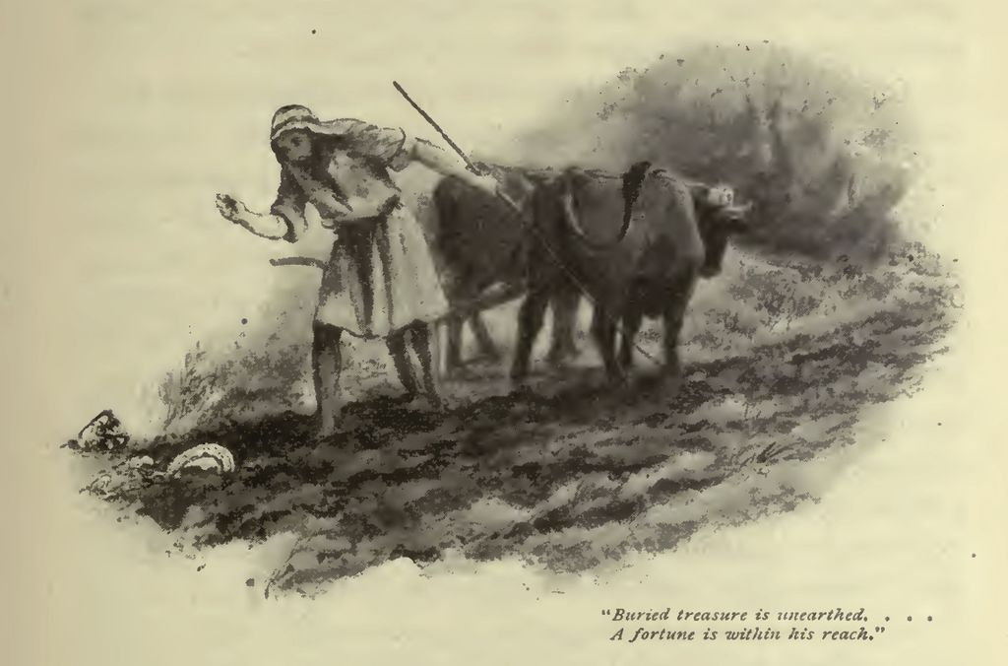
In the house, Jesus teaches the parable of treasure in the field
1 Again, the kingdom of heaven is like unto treasure hid in a field; the which when a man hath found, he hideth, and for joy thereof goeth and selleth all that he hath, and buyeth that field.
Taken from Matthew 13:46
1. See also: TG Treasure

Chapter Sixty-Seven
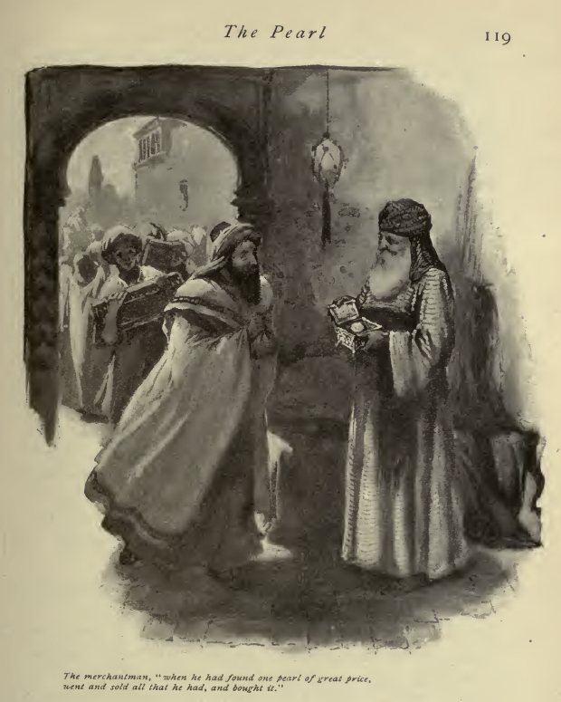
Jesus teaches the parable of the pearl of great price
1 Then shall the righteous shine forth as the sun in the kingdom of their Father. Who hath ears to hear, let him hear.
2 Again, the kingdom of heaven is like unto a merchant man, seeking goodly pearls:
3 Who, when he had found one pearl of great price, went and sold all that he had, and bought it.
Taken from Matthew 13:45-48
1. See also: Ps. 68:3; Alma 40:25; TG Righteousness; Celestial Glory; D&C 76:70
3. See also: Rev. 3:18; Alma 22:15

Chapter Sixty-Eight
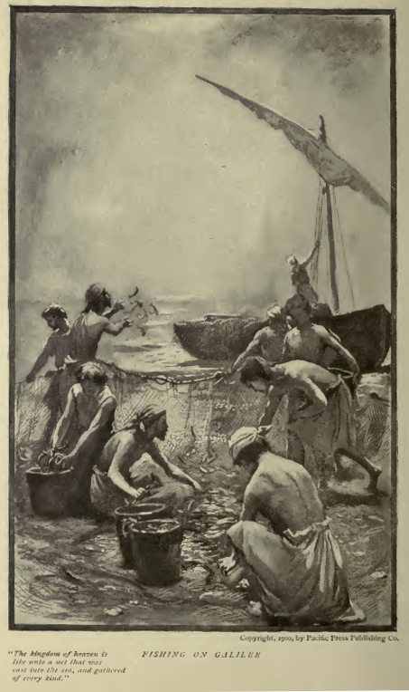
Still in the house, Jesus teaches the parable of the net
1 Again, the kingdom of heaven is like unto a net, that was cast into the sea, and gathered of every kind:
2 Which, when it was full, they drew to shore, and sat down, and gathered the good into vessels, but cast the bad away.
3 So shall it be at the end of the world: the angels shall come forth, and sever the wicked from among the just,
4 And shall cast them out into the world (the world is the children of the wicked) to be burned: there shall be wailing and gnashing of teeth.
Taken from Matthew 13:49-52
1. See also: Matt. 22:10
3. See also: TG World, End of; Righteousness
Chapter Sixty-Nine
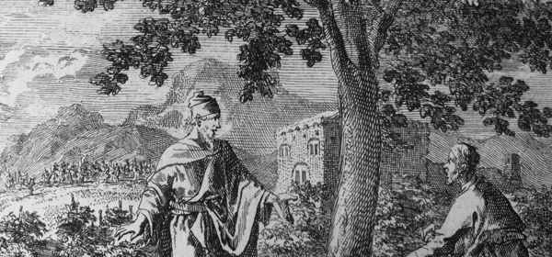
Jesus teaches the parable of the householder
1 Then said he unto them, Therefore every scribe which is instructed unto the kingdom of heaven is like unto a man that is an householder, which bringeth forth out of his treasure things new and old.
Taken from Matthew 13:54
1. See also: TG Scribes

Chapter Seventy
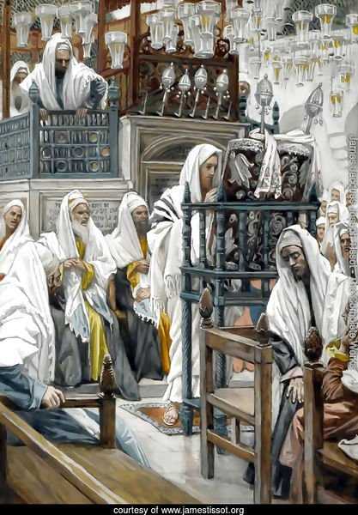
Jesus Unrolls the Book in the Synagogue, by James Tissot
Jesus concludes the parables in the house and leaves for Nazareth. Jesus enters Nazareth and is rejected again.
1 Jesus saith unto them, Have ye understood all these things? They say unto him, Yea, Lord.
2 And it came to pass, that when Jesus had finished these parables, he departed thence to Nazareth and his disciples followed him.
3 And when he was come into his own country and when the Sabbath day was come, he taught them in their synagogue, insomuch that they were astonished, and said, Whence hath this man this wisdom, and that even such mighty works are wrought by his hands?
4 Is not this the carpenter’s son? is not his mother called Mary? and his brethren, James, and Joses, and Simon, and Judas?
5 And his sisters, are they not all with us? Whence then hath this man all these things?
6 And they were offended in him. But Jesus said unto them, A prophet is not without honour, save in his own country, and in his own house and among his own kin.
7 And he did not many mighty works there because of their unbelief, save that he laid his hands upon a few sick folk, and healed them.
8 And he marvelled because of their unbelief. And he went round about the villages, teaching.
Taken from Matthew 13:53, 55-60, Mark 6:1-6
3. See also: Matt. 7:28; TG God, Wisdom of; Jesus Christ, Teaching Mode of
4. See also: TG Jesus Christ, Family of
6. See also: TG Prophets, Rejection of
7. See also: Luke 4:23; Ether 12:12; Moro. 7:37, Morm. 9:18; TG Hands, Laying on of; Administrations to the Sick
Chapter Seventy-One
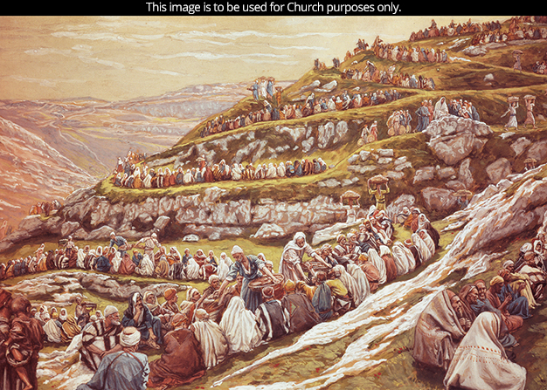
Feeding the Five Thousand, by James Tissot
Jesus hears about John the Baptist’s death; Jesus leaves the house and departs by boat to Bethsaida-Julias. Instead of attending Passover, Jesus feeds the five thousand with five loaves and two fishes.
1 And it came to pass that when the followers of John had brought themselves together unto Jesus, they told him all things, both what had done unto John, and what they had done with John’s body.
2 And when Jesus heard of it he said unto them, Come ye yourselves apart into a solitary place, belonging to the city called Bethsaida, and rest a while: for there were many coming and going, and they had no leisure so much as to eat.
3 And they departed into a solitary place by ship privately, over the sea of Galilee, which is the sea of Tiberias.
4 And when the people saw them departing, and many other heard thereof, and ran afoot thither out of all cities, and outwent them, and came together unto him.
5 And Jesus, when he came out, saw much people waiting, and was moved with compassion toward them, because they were as sheep not having a shepherd: and he began to teach them many things and heal their sick.
6 And Jesus went up into a mountain, and there he sat with his disciples, and the great multitude followed him.
7 And the passover, a feast of the Jews, was nigh.
8 And when the day was now far spent, his disciples came unto him, and said, This is a solitary place, and now the time for departure is come:
9 Send them away, that they may go into the country round about, and into the villages, and buy themselves victuals such as bread: for they have nothing to eat.
10 Jesus answered and said unto them, They need not depart; give ye them to eat. And they say unto him, Shall we go and buy two hundred pennyworth of bread, and give them to eat?
11 When Jesus then lifted up his eyes, and saw the great company come unto him, he saith unto Philip, Whence shall we buy bread, that these may eat?
12 And this he said to prove him: for he himself knew what he would do.
13 Philip answered him, Two hundred pennyworth of bread is not sufficient for them, that every one of them may take a little.
14 He saith unto them, How many loaves have ye? go and see. And when they knew, they say, Five, and two fishes.
15 One of his disciples, Andrew, Simon Peter’s brother, saith unto him,
16 There is a lad here, which hath five barley loaves, and two small fishes: but what are they among so many?
17 And Jesus said, Make the men sit down. Now there was much grass in the place. So the men sat down, in number about five thousand beside women and children. And they sat down in ranks, by hundreds, and by fifties.
18 And when Jesus took the loaves; he looked up to heaven, gave thanks and blessed and brake the loaves, he distributed to the disciples, and the disciples to them that were set down; and likewise of the fishes as much as they would.
19 When they were filled, he said unto his disciples, Gather up the fragments that remain, that nothing be lost.
20 Therefore they gathered them together, and filled twelve baskets with the fragments of the five barley loaves, which remained over and above unto them that had eaten.
21 Then those men, when they had seen the miracle that Jesus did, said, This is of a truth that prophet that should come into the world.
Taken from Matthew 14:13-14, Mark 6:30-44, Luke 9: 10-11, John 6:1-14
2. See also: Mark 3:20
5. See also: TG Compassion; Shepherds; Jesus Christ, Teaching Mode of; Sickness
7. See also: TG Passover
18. See also: D&C 46:32; 59:7; 3 Ne. 18:5; 20:6
19. See also: TG Waste; 2 Kgs. 4:44; Matt. 15:37
21. See also: 3 Ne. 8:1; 20:7; Morm. 9:18; TG Jesus Christ, Prophecies about

Chapter Seventy-Two
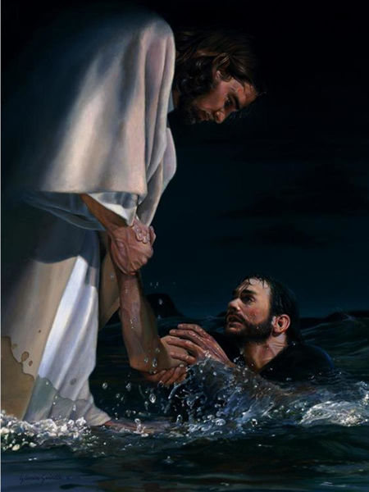
Against the Wind, by Liz Lemon Swindle
Jesus sends his disciples across the sea to Gennesaret and the multitude away. Jesus goes into a mountain to pray and to watch the disciple cross the sea. Jesus walks on water during the fourth watch.
1 And straightway Jesus constrained his disciples to get into the ship, and to go to the other side before unto Bethsaida, to the land of Gennesaret, while he sent away the people.
2 But when Jesus therefore perceived that the people would come and take him by force, to make him a king, he departed again into a mountain himself alone to pray.
3 And when even was now come, his disciples went down unto the sea,
4 And entered into a ship, and went over the sea toward Capernaum. And it was now dark, and Jesus was not come to them.
5 And the sea arose by reason of a great wind that blew.
6 And the ship was now in the midst of the sea, tossed with waves: for the wind was contrary.
7 And Jesus alone on the land watched them toiling in rowing.
8 So when they had rowed about five and twenty or thirty furlongs, and about the fourth watch of the night, Jesus cometh unto them, walking upon the sea, and would have passed by them.
9 But when they saw him drawing nigh unto the ship, walking upon the sea, they supposed it had been a spirit, and cried out for fear:
10 For they all saw him, and were troubled. And immediately he talked with them, and saith unto them, Be of good cheer: it is I; be not afraid.
11 And Peter answered him and said, Lord, if it be thou, bid me come unto thee on the water.
12 And he said, Come. And when Peter was come down out of the ship, he walked on the water, to go to Jesus.
13 But when he saw the wind boisterous, he was afraid; and beginning to sink, he cried, saying, Lord, save me.
14 And immediately Jesus stretched forth his hand, and caught him, and said unto him, O thou of little faith, wherefore didst thou doubt?
15 Then they willingly received them into the ship: and immediately the wind ceased and the ship was at the land whither they went: and they were sore amazed in themselves beyond measure, and wondered.
16 For they considered not the miracle of the loaves: for their heart was hardened.
17 Then they that were in the ship came and worshipped him, saying, Of a truth thou art the Son of God.
Taken from Matthew 14:24-33, Mark 6:45-52, John 6:15-21
2. See also: John 18:36; Matt. 26:36; Luke 6:12; 9:28
10. See also: TG Cheerfulness
13. See also: TG Fearfulness
14. See also: Mark 4:40; 16:14; Luke 24:25; TG Doubt
16. See also: 1 Cor. 2:11; TG Hardheartedness

Chapter Seventy-Three
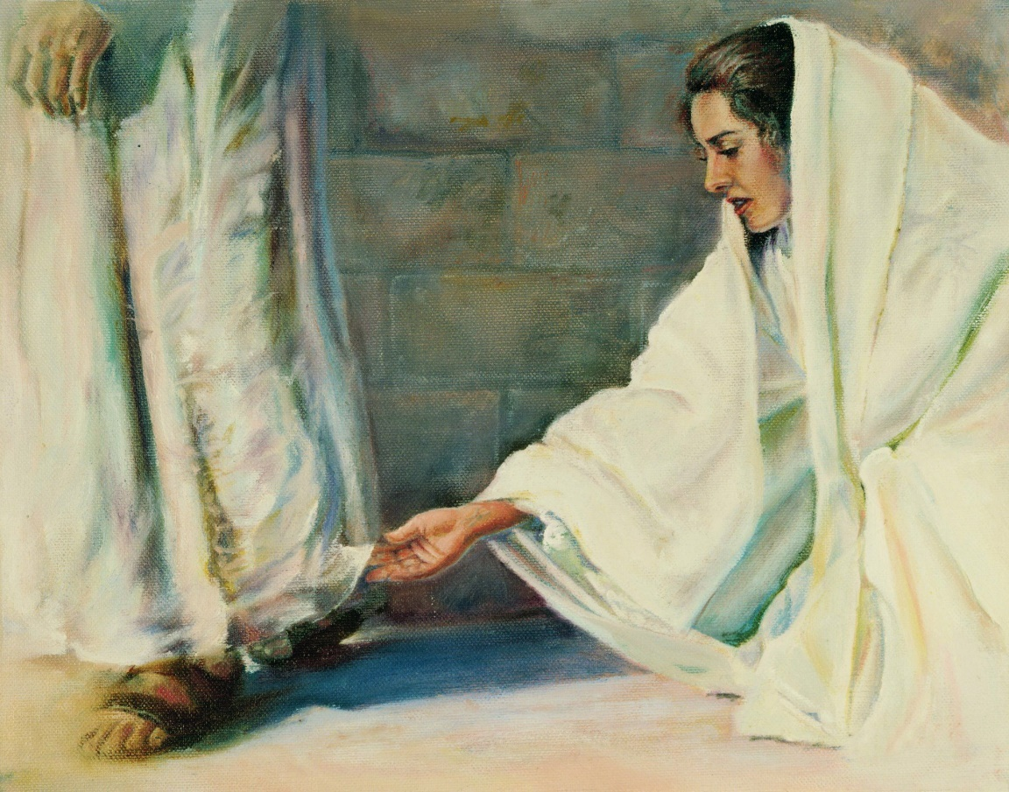
Jesus heals people around Gennesaret by them touching the hem of his garments.
1 And when they had passed over, they came into the land of Gennesaret, and drew to the shore.
2 And when they were come out of the ship, straightway they knew Jesus,
3 And when the men of that place had knowledge of him, they sent out into all that country round about, and brought unto him all that were diseased;
4 And ran through that whole region round about, and began to carry about in beds those that were sick, where they heard he was.
5 And besought him that they might only touch the hem of his garment: and as many as touched were made perfectly whole.
6 And whithersoever he entered, into villages, or cities, or country, they laid the sick in the streets, and besought him that they might touch if it were but the border of his garment: and as many as touched him were made whole.
Taken from Matthew 14:35-36, Mark 6:53-56
5. See also: Mark 5:27; TG Healings

Chapter Seventy-Four
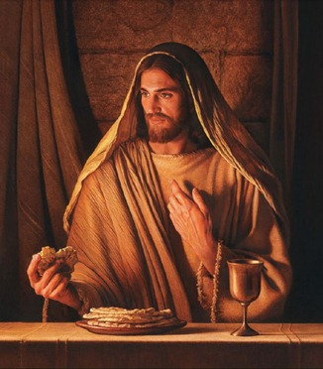
The people from the feeding of the five thousand seek out Jesus- they are upset for being left behind by Jesus. Jesus teaches he is the bread of life.
1 The day following, when the people which stood on the other side of the sea saw that there was none other boat there, save that one whereinto his disciples were entered, and that Jesus went not with his disciples into the boat, but that his disciples were gone away alone;
2 (Howbeit there came other boats from Tiberias nigh unto the place where they did eat bread, after that the Lord had given thanks:)
3 When the people therefore saw that Jesus was not there, neither his disciples, they also took shipping, and came to Capernaum, seeking for Jesus.
4 And when they had found him on the other side of the sea, they said unto him, Rabbi, when camest thou hither?
5 Jesus answered them and said, Verily, verily, I say unto you, Ye seek me, not because ye desire to keep my sayings, neither because ye saw the miracles, but because ye did eat of the loaves, and were filled.
6 Labour not for the meat which perisheth, but for that meat which endureth unto everlasting life, which the Son of man shall give unto you: for him hath God the Father sealed.
7 Then said they unto him, What shall we do, that we might work the works of God?
8 Jesus answered and said unto them, This is the work of God, that ye believe on him whom he hath sent.
9 They said therefore unto him, What sign shewest thou then, that we may see, and believe thee? what dost thou work?
10 Our fathers did eat manna in the desert; as it is written, He gave them bread from heaven to eat.
11 Then Jesus said unto them, Verily, verily, I say unto you, Moses gave you not that bread from heaven; but my Father giveth you the true bread from heaven.
12 For the bread of God is he which cometh down from heaven, and giveth life unto the world.
13 Then said they unto him, Lord, evermore give us this bread.
14 And Jesus said unto them, I am the bread of life: he that cometh to me shall never hunger; and he that believeth on me shall never thirst.
15 But I said unto you, That ye also have seen me, and believe not.
16 All that the Father giveth me shall come to me; and him that cometh to me I will in no wise cast out.
17 For I came down from heaven, not to do mine own will, but the will of him that sent me.
18 And this is the Father’s will which hath sent me, that of all which he hath given me I should lose nothing, but should raise it up again at the last day.
19 And this is the will of him that sent me, that every one which seeth the Son, and believeth on him, may have everlasting life: and I will raise him up in the resurrection of the just at the last day.
20 The Jews then murmured at him, because he said, I am the bread which came down from heaven.
21 And they said, Is not this Jesus, the son of Joseph, whose father and mother we know? how is it then that he saith, I came down from heaven?
22 Jesus therefore answered and said unto them, Murmur not among yourselves.
23 No man can come unto me, except he doeth the will of my Father who hath sent me. And this is the will of him who hath sent me, that ye receive the Son; for the Father beareth record of him; and he who receiveth the testimony, and doeth the will of him who sent me, I will raise up in the resurrection of the just.
24 It is written in the prophets, And they shall be all taught of God. Every man therefore that hath heard, and hath learned of the Father, cometh unto me.
25 Not that any man hath seen the Father, save he which is of God, he hath seen the Father.
26 Verily, verily, I say unto you, He that believeth on me hath everlasting life.
27 I am that bread of life.
28 Your fathers did eat manna in the wilderness, and are dead.
29 This is the bread which cometh down from heaven, that a man may eat thereof, and not die.
30 I am the living bread which came down from heaven: if any man eat of this bread, he shall live for ever: and the bread that I will give is my flesh, which I will give for the life of the world.
31 The Jews therefore strove among themselves, saying, How can this man give us his flesh to eat?
32 Then Jesus said unto them, Verily, verily, I say unto you, Except ye eat the flesh of the Son of man, and drink his blood, ye have no life in you.
33 Whoso eateth my flesh, and drinketh my blood, hath eternal life; and I will raise him up in the resurrection of the just at the last day.
34 For my flesh is meat indeed, and my blood is drink indeed.
35 He that eateth my flesh, and drinketh my blood, dwelleth in me, and I in him.
36 As the living Father hath sent me, and I live by the Father: so he that eateth me, even he shall live by me.
37 This is that bread which came down from heaven: not as your fathers did eat manna, and are dead: he that eateth of this bread shall live for ever.
38 These things said he in the synagogue, as he taught in Capernaum.
Taken from John 6:22-59
6. See also: TG Labor; Objectives; Jesus Christ, Son of Man; Sealing
8. See also: TG Faith
9. See also: Matt. 12:38; Jacob 7:13; Alma 30:43; D&C 46:9
10. See also: Ps. 78:24
14. See also: TG Bread of Life; John 4:14; 7:37
16. See also: 3 Ne. 15:24; D&C 27:14; 50:41; 84:63; John 17:2
17. See also: TG Jesus Christ, Condescension of; Jesus Christ, Mission of; God, Will of
18. See also: Luke 2:49; 3 Ne. 27:13; John 17:12; 18:9; 3 Ne. 15:1; D&C 5:35
19. See also: TG Faith; Eternal Life
21. See also: Luke 4:22
22. See also: TG Murmuring
23. See also: Isa. 55:3; 1 Cor. 12:3; 1 Pet. 1:2; 3 Ne. 27:14; D&C 29:7
24. See also: 1 Thes. 4:9; 1 Jn. 2:27; TG Witness of the Father
25. See also: TG God, Manifestations of; God, Privilege of Seeing; Revelation
26. See also: TG Faith; Eternal Life; Exaltation
28. See also: 1 Ne. 17:28; Mosiah 7:19
30. See also: TG Jesus Christ, Types, in Anticipation; Bread of Life; Jesus Christ, Types, in Memory; Heb. 10:10; TG God, Gifts of; Jesus Christ, Atonement through
32. See also: Mark 14:22; Luke 22:19; Jesus Christ, Son of Man
33. See also: Sacrament; Blood, Symbolism of; Resurrection
35. See also: 1 Jn. 3:24
36. See also: TG Jesus Christ, Messenger of the Covenant; John 5:26

Commentary

- It is self-evident from the scriptures that the Father, the Son, and the Holy Ghost are separate persons, three divine beings.

Chapter Seventy-Five
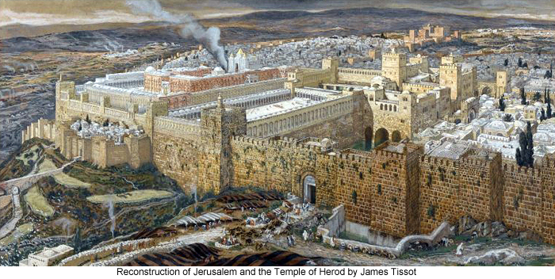
Many of Jesus’ followers and brethren leave Christ at this time. Jesus sends the remainder of his brethren down to Jerusalem to the Feast of Tabernacles (seven weeks after Passover). Jesus secretly follows them down there.
1 Many therefore of his disciples, when they had heard this, said, This is an hard saying; who can hear it?
2 When Jesus knew in himself that his disciples murmured at it, he said unto them, Doth this offend you?
3 What and if ye shall see the Son of man ascend up where he was before?
4 It is the spirit that quickeneth; the flesh profiteth nothing: the words that I speak unto you, they are spirit, and they are life.
5 But there are some of you that believe not. For Jesus knew from the beginning who they were that believed not, and who should betray him.
6 And he said, Therefore said I unto you, that no man can come unto me, except he doeth the will of my Father who hath sent me.
7 From that time many of his disciples went back, and walked no more with him.
8 Then said Jesus unto the twelve, Will ye also go away?
9 Then Simon Peter answered him, Lord, to whom shall we go? thou hast the words of eternal life.
10 And we believe and are sure that thou art that Christ, the Son of the living God.
11 Jesus answered them, Have not I chosen you twelve, and one of you is a devil?
12 He spake of Judas Iscariot the son of Simon: for he it was that should betray him, being one of the twelve.
13 After these things Jesus continued to walk in Galilee: for he would not walk in Jewry, because the Jews sought to kill him.
14 Now the Jews’ feast of tabernacles was at hand.
15 His brethren therefore said unto him, Depart hence, and go into Judæa, that thy disciples also may see the works that thou doest.
16 For there is no man that doeth any thing in secret, and he himself seeketh to be known openly. If thou do these things, shew thyself to the world.
17 For neither did his brethren believe in him.
18 Then Jesus said unto them, My time is not yet come: but your time is alway ready.
19 The world cannot hate you; but me it hateth, because I testify of it, that the works thereof are evil.
20 Go ye up unto this feast: I go not up yet unto this feast; for my time is not yet full come.
21 When he had said these words unto them, his brethren and disciples departed, yet he abode still in Galilee.
22 But when his brethren and disciples were gone up, then went he also up unto the feast, not openly, but as it were in secret.
Taken from John 6:60-71, John 7:1-10
2. See also: John 2:25; TG Offenses
3. See also: TG Jesus Christ, Son of Man; John 3:13; TG Jesus Christ, Ascension of
4. See also: 2 Cor. 3:6
5. See also: John 13:11
7. See also: TG Apostasy, of Individuals; Apostasy, of the Early Christian Church
9. See also: Acts 5:20; Moses 6:59
10. See also: TG God, Body of (Corporeal Nature)
11. See also: 1 Ne. 12:7
13. See also: John 5:16; John 11:53
14. See also: Lev. 23:34
15. See also: Matt. 12:46; 1 Cor. 9:5
18. See also: Matt. 26:18
19. See also: 1 Ne. 16:2; TG Evil

Chapter Seventy-Six
He That Is Without Sin, by Liz Lemon Swindle
Jesus, while teaching at the temple in Jerusalem, has an adulterous woman brought before him.
1 Then the Jews sought Jesus at the feast, and said, Where is he?
2 And there was much murmuring among the people concerning him: for some said, He is a good man: others said, Nay; but he deceiveth the people.
3 Howbeit no man spake openly of him for fear of the Jews.
4 Now about the midst of the feast Jesus went up into the temple, and taught.
5 And early in the morning came he into the temple, and all the people came unto him; and he sat down, and taught them.
6 And the scribes and Pharisees brought unto him a woman taken in adultery; and when they had set her in the midst,
7 They say unto him, Master, this woman was taken in adultery, in the very act.
8 Now Moses in the law commanded us, that such should be stoned: but what sayest thou?
9 This they said, tempting him, that they might have to accuse him. But Jesus stooped down, and with his finger wrote on the ground, as though he heard them not.
10 So when they continued asking him, he lifted up himself, and said unto them, He that is without this sin among you, let him first cast a stone at her.
11 And again he stooped down, and wrote on the ground.
12 And they which heard it, being convicted by their own conscience, went out one by one, beginning at the eldest, even unto the last: and Jesus was left alone, and the woman standing in the midst.
13 When Jesus had lifted up himself, and saw none but the woman, he said unto her, Woman, where are those thine accusers? hath no man condemned thee?
14 She said, No man, Lord. And Jesus said unto her, Neither do I condemn thee: go, and sin no more. And the woman glorified God from that hour, and believed on his name.
15 And the Jews marvelled, saying, How knoweth this man letters, having never learned?
Taken from John 7:11-15; John 8:1-11
3. See also: John 19:38
5. See also: Matt. 26:55; Luke 21:37
6. See also: TG Woman; Adultery
8. See also: Lev. 20:10
9. See also: TG Jesus Christ, Teaching Mode of
10. See also: 3 Ne. 14:5; Deut. 17:7; TG Gossip
12. See also: TG Conscience
14. See also: TG Benevolence; Mercy; D&C 42:25
15. See also: Luke 2:46

Chapter Seventy-Seven
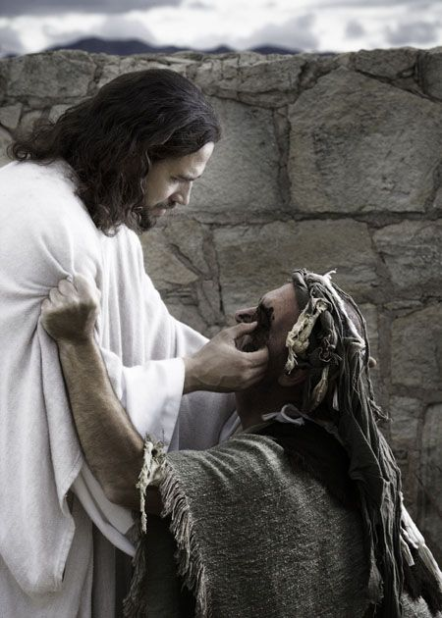
Blind man receives sight from Jesus. He is then questioned by his neighbors.
1 And as Jesus passed by, he saw a man which was blind from his birth.
2 And those that followed Jesus asked him, saying, Master, who did sin, this man, or his parents, that he was born blind?
3 Jesus answered, Neither hath this man sinned, nor his parents: but that the works of God should be made manifest in him.
4 I must work the works of him that sent me, while I am with you; the time cometh when I shall have finished my work, then I go unto the Father. While it is day: the night cometh, when no man can work.
5 As long as I am in the world, I am the light of the world.
6 When he had thus spoken, he spat on the ground, and made clay of the spittle, and he anointed the eyes of the blind man with the clay,
7 And said unto him, Go, wash in the pool of Siloam, (which is by interpretation, Sent.) He went his way therefore, and washed, and came seeing.
8 The neighbours therefore, and they which before had seen him that he was blind, said, Is not this he that sat and begged?
9 Some said, This is he: others said, He is like him: but he said, I am he.
10 Therefore said they unto him, How were thine eyes opened?
11 He answered and said, A man that is called Jesus made clay, and anointed mine eyes, and said unto me, Go to the pool of Siloam, and wash: and I went and washed, and I received sight.
12 Then said they unto him, Where is he? He said, I know not.
13 And it was the sabbath day when Jesus made the clay, and opened his eyes.
14 And many of the people believed on him, and said, When Christ cometh, will he do more miracles than these which this man hath done?
15 The Pharisees heard that the people murmured such things concerning him; and the Pharisees and the chief priests sent officers to take him.
Taken from John 7:31-32, John 9:1-12, 14
1. See also: Matt. 9:28; 20:30; Mosiah 3:5; 3 Ne. 17:9; D&C 84:69
2. See also: TG Man, Antemortal Existence of
3. See also: TG God, Works of; John 11:4
4. See also: John 5:17; John 4:34; TG Good Works; Rom. 13:12; Alma 34:33; TG Darkness, Spiritual
5. See also: TG Jesus Christ, Light of the World; Light of Christ
7. See also: Neh. 3:15; Isa. 8:6
11. See also: 2 Kgs. 5:10; TG Sight
13. See also: TG Sabbath; Healing

Chapter Seventy-Eight
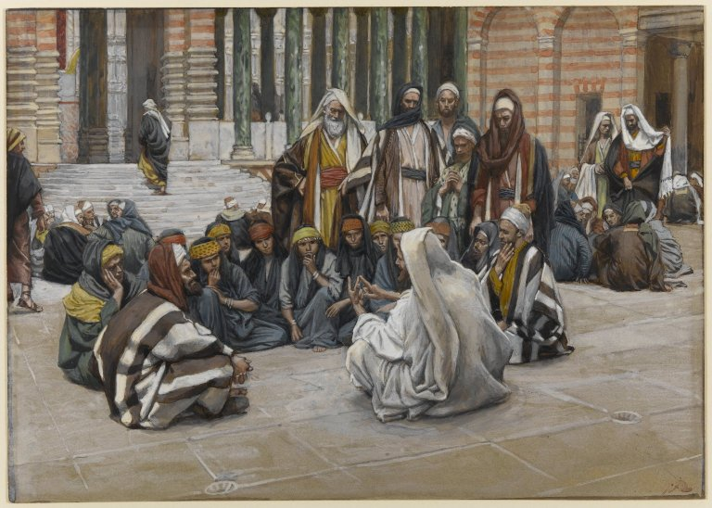
Jesus Speaks Near the Treasury, by James Tissot
Jesus proclaims himself to be “That Prophet” in the treasury in the temple in Jerusalem.
1 These words spake Jesus in the treasury, as he taught in the temple: Verily, verily, I say unto you, The Son can do nothing of himself, but what he seeth the Father do: for what things soever he doeth, these also doeth the Son likewise.
2 For the Father loveth the Son, and sheweth him all things that himself doeth: and he will shew him greater works than these, that ye may marvel. For I am come a ªlight into the world, that whosoever believeth on me should not abide in darkness.
3 For as the Father raiseth up the dead, and quickeneth them; even so the Son quickeneth whom he will.
4 For the Father judgeth no man, but hath committed all judgment unto the Son:
5 That all men should honour the Son, even as they honour the Father. He that honoureth not the Son honoureth not the Father which hath sent him.
6 Verily, verily, I say unto you, He that heareth my word, and believeth on him that sent me, hath everlasting life, and shall not come into condemnation; but is passed from death unto life.
7 And if any man hear my words, and believe not, I judge him not: for I came not to judge the world, but to save the world.
8 He that rejecteth me, and receiveth not my words, hath one that judgeth him: the word that I have spoken, the same shall judge him in the last day.
9 For I have not spoken of myself; but the Father which sent me, he gave me a commandment, what I should say, and what I should speak.
10 And I know that his commandment is life everlasting: whatsoever I speak therefore, even as the Father said unto me, so I speak.
11 Verily, verily, I say unto you, The hour is coming, and now is, when the dead shall hear the voice of the Son of God: and they that hear shall live.
12 For as the Father hath life in himself; so hath he given to the Son to have life in himself;
13 And hath given him authority to execute judgment also, because he is the Son of man.
14 Marvel not at this: for the hour is coming, in the which all that are in the graves shall hear his voice,
15 And shall come forth; they that have done good, unto the resurrection of life; and they that have done evil, unto the resurrection of damnation.
16 I can of mine own self do nothing: as I hear, I judge: and my judgment is just; because I seek not mine own will, but the will of the Father which hath sent me.
17 Then spake Jesus again unto them, saying, I am the light of the world: he that followeth me shall not walk in darkness, but shall have the light of life.
18 The Pharisees therefore said unto him, Thou bearest record of thyself; thy record is not true.
19 If I bear witness of myself, my witness is not true.
20 There is another that beareth witness of me; and I know that the witness which he witnesseth of me is true.
21 Ye sent unto John, and he bare witness unto the truth.
22 And he received not his testimony of man, but of God, and ye yourselves say that he is a prophet, therefore ye ought to receive his testimony. These things I say, that ye might be saved.
23 He was a burning and a shining light: and ye were willing for a season to rejoice in his light.
24 Jesus answered and said unto them, Though I bear record of myself, yet my record is true: for I know whence I came, and whither I go; but ye cannot tell whence I come, and whither I go.
25 Ye judge after the flesh; I judge no man.
26 And yet if I judge, my judgment is true: for I am not alone, but I and the Father that sent me.
27 It is also written in your law, that the testimony of two men is true.
28 But I have a greater witness yet than the testimony of John: for the works which the Father hath given me to finish, the same works that I do, bear witness of me, that the Father hath sent me.
29 And the Father himself, which hath sent me, hath borne witness of me. I am one that bear witness of myself, and the Father that sent me beareth witness of me also.
30 Then said they unto him, Where is thy Father? Jesus answered, Ye have neither heard his voice at any time, nor seen his shape. Ye neither know me, nor my Father: if ye had known me, ye should have known my Father also.
31 And ye have not his word abiding in you: for whom he hath sent, him ye believe not. For he that believeth on me, believeth not on me, but on him that sent me.
32 And he that seeth me seeth him that sent me.
33 Search the scriptures; for in them ye think ye have eternal life: and they are they which testify of me.
34 And ye will not come to me, that ye might have life.
35 I receive not honour from men.
36 But I know you, that ye have not the love of God in you.
37 I am come in my Father’s name, and ye receive me not: if another shall come in his own name, him ye will receive.
38 How can ye believe, which receive honour one of another, and seek not the honour that cometh from God only?
39 Do not think that I will accuse you to the Father: there is one that accuseth you, even Moses, in whom ye trust.
40 For had ye believed Moses, ye would have believed me: for he wrote of me.
41 But if ye believe not his writings, how shall ye believe my words?
42 Ye both know me, and ye know whence I am: and I am not come of myself, but he that sent me is true, whom ye know not.
43 But I know him: for I am from him, and he hath sent me.
44 Then they sought to take him: but no man laid hands on him, because his hour was not yet come.
45 Then said some of them of Jerusalem, Is not this he, whom they seek to kill?
46 But, lo, he speaketh boldly, and they say nothing unto him. Do the rulers know indeed that this is the very Christ?
47 Howbeit we know this man whence he is: but when Christ cometh, no man knoweth whence he is.
Taken from John 5:19-47, John 7:25-30, John 8:12-59, John 12:44-50
1. See also: TG Godhead
2. See also: John 1:9
3. See also: TG Resurrection; 1 Cor. 15:45; TG God, Power of
4. See also: TG Jesus Christ, Authority of; Judgment, The Last
5. See also: TG Honor; Respect; Luke 10:16
6. See also: TG Faith; John 20:31; D&C 20:15; John 11:26; D&C 63:49; 1 Jn. 3:14
7. See also: Luke 4:19
8. See also: D&C 39:9; TG Judgment; Gospel; Judgment, The Last
9. See also: TG Jesus Christ, Authority of
10. See also: Deut. 18:18; 3 Ne. 15:18; TG Jesus Christ, Teaching Mode of
11. See also: TG Death; Genealogy and Temple Work; Salvation, for the Dead; Spirits, Disembodied; Isa. 24:22; 61:1; TG Immortality
12. See also: TG Jesus Christ, Divine Sonship; John 6:57
13. See also: TG Authority; Delegation of Responsibility; Jesus Christ, Authority of; Jesus Christ, Judge; Jesus Christ, Son of Man
14. See also: Dan. 12:2; D&C 76:16
15. See also: D&C 29:26; TG Resurrection; Sin; Damnation; Hell
16. See also: TG God, Justice of; 2 Ne. 31:7; TG Agency; God, Will of
17. See also: 1 Jn. 1:5; TG Jesus Christ, Light of the World; Light; Light of Christ; Walking in Darkness; Darkness, Spiritual
20. See also: TG Holy Ghost, Source of Testimony; Witnesses
21. See also: D&C 35:4; 84:27; John 1:15
23. See also: Matt. 11:11; TG Light
24. See also: John 16: 28; John 9:29
25. See also: John 12:47
26. See also: Jesus Christ, Judge; Judgment; John 16:32
27. See also: TG Witnesses
28. See also: TG God, Works of; Matt. 11:4; John 10:25; TG Jesus Christ, Messenger of the Covenant
29. See also: TG Witness of the Father; God, Privilege of Seeing; God, Father; Godhead; Witness of the Father
30. See also: John 14:7
31. See also: TG Unbelief, Unbelievers; Faith
33. See also: TG Education; Learning; Scriptures, Study; Study; Scriptures, Value; Testimony
34. See also: D&C 66:2
35. See also: John 7:18 TG Honor
36. See also: TG God, Love of; Love
37. See also: TG Jesus Christ, Authority of; Authority; Name; D&C 132:25
38. See also: Luke 18:9; 1 Thes. 2:6; D&C 76:61; TG God, the Standard of Righteousness
40. See also: Luke 24:27; TG Jesus Christ, Prophecies about
41. See also: TG Scriptures, Study
42. See also: TG Truth
43. See also: John 13:3; TG Jesus Christ, Authority of; Jesus Christ, Messenger of the Covenant
44. See also: John 10:39; John 12:23
46. See also: John 3:1

Commentary

- It is self-evident from the scriptures that the Father, the Son, and the Holy Ghost are separate persons, three divine beings.

Chapter Seventy-Nine
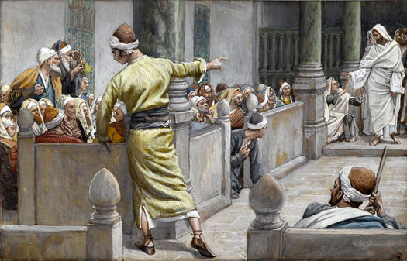
The Healed Blind Man Tells His Story to the Jews, by James Tissot
, by James Tissot
Blind man who received his sight is questioned by the Pharisees with his parents.
1 They brought to the Pharisees him that aforetime was blind.
2 Then again the Pharisees also asked him how he had received his sight. He said unto them, He put clay upon mine eyes, and I washed, and do see.
3 Therefore said some of the Pharisees, This man is not of God, because he keepeth not the sabbath day. Others said, How can a man that is a sinner do such miracles? And there was a division among them.
4 They say unto the blind man again, What sayest thou of him, that he hath opened thine eyes? He said, He is a prophet.
5 But the Jews did not believe concerning him, that he had been blind, and received his sight, until they called the parents of him that had received his sight.
6 And they asked them, saying, Is this your son, who ye say was born blind? how then doth he now see?
7 His parents answered them and said, We know that this is our son, and that he was born blind:
8 But by what means he now seeth, we know not; or who hath opened his eyes, we know not: he is of age; ask him: he shall speak for himself.
9 These words spake his parents, because they feared the Jews: for the Jews had agreed already, that if any man did confess that he was Christ, he should be put out of the synagogue.
10 Therefore said his parents, He is of age; ask him.
Taken from John 9:13, 15-23
4. See also: John 7:40

Chapter Eighty
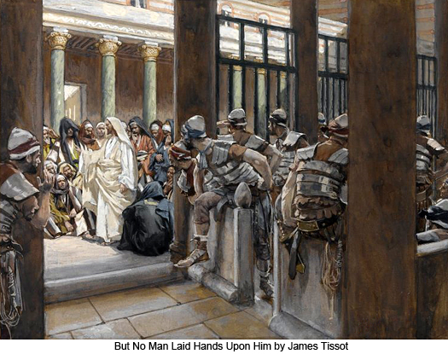
On the last day of the Feast, Jesus foretells his death and resurrection. Jesus also declares himself God of the Old Testament; I Am.
1 In the last day, that great day of the feast, Jesus stood and cried, saying, If any man thirst, let him come unto me, and drink.
2 He that believeth on me, as the scripture hath said, out of his belly shall flow rivers of living water.
3 (But this spake he of the Spirit, which they that believe on him should receive: for the Holy Ghost was promised unto them who believe, after that Jesus was glorified.)
4 If any man will do his will, he shall know of the doctrine, whether it be of God, or whether I speak of myself.
5 He that speaketh of himself seeketh his own glory: but he that seeketh his glory that sent him, the same is true, and no unrighteousness is in him.
6 Then said Jesus unto them, When ye have lifted up the Son of man, then shall ye know that I am he, and that I do nothing of myself; but as my Father hath taught me, I speak these things.
7 And he that sent me is with me: the Father hath not left me alone; for I do always those things that please him.
8 As he spake these words, many believed on him saying, Of a truth this is the Prophet.
9 Others said, This is the Christ. But some said, Shall Christ come out of Galilee?
10 Hath not the scripture said, That Christ cometh of the seed of David, and out of the town of Bethlehem, where David was?
11 So there was a division among the people because of him.
12 Then said Jesus to those Jews which believed on him, If ye continue in my word, then are ye my disciples indeed;
13 And ye shall know the truth, and the truth shall make you free.
14 They answered him, We be Abraham’s seed, and were never in bondage to any man: how sayest thou, Ye shall be made free?
15 Jesus answered them, Verily, verily, I say unto you, Whosoever committeth sin is the servant of sin.
16 And the servant abideth not in the house for ever: but the Son abideth ever.
17 If the Son therefore shall make you free, ye shall be free indeed.
18 Then said Jesus unto them, Yet a little while am I with you, and then I go unto him that sent me.
19 Ye shall seek me, and shall not find me: and where I am, thither ye cannot come.
20 Then said the Jews among themselves, Whither will he go, that we shall not find him? will he go unto the dispersed among the Gentiles, and teach the Gentiles?
21 What manner of saying is this that he said, Ye shall seek me, and shall not find me: and where I am, thither ye cannot come?
22 Then said Jesus again unto them, I go my way, and ye shall seek me, and shall die in your sins: whither I go, ye cannot come.
23 Then said the Jews, Will he kill himself? because he saith, Whither I go, ye cannot come.
24 And he said unto them, Ye are from beneath; I am from above: ye are of this world; I am not of this world.
25 I said therefore unto you, that ye shall die in your sins: for if ye believe not that I am he, ye shall die in your sins.
26 I speak that which I have seen with my Father: and ye do that which ye have seen with your father.
27 They answered and said unto him, Abraham is our father. Jesus saith unto them, I know that ye are Abraham’s seed, but did not Moses give you the law, and yet none of you keepeth the law? I have done one work, and ye all marvel.
28 Moses therefore gave unto you circumcision; (not because it is of Moses, but of the fathers;) and ye on the sabbath day circumcise a man.
29 If a man on the sabbath day receive circumcision, that the law of Moses should not be broken; are ye angry at me, because I have made a man every whit whole on the sabbath day?
30 Judge not according to your traditions, but judge righteous judgment.
31 But now ye seek to kill me, a man that hath told you the truth, which I have heard of God.
32 Why go ye therefore about to kill me? If ye were Abraham’s children, ye would do the works of Abraham; ye seek to kill me, because my word hath no place in you: this did not Abraham.
33 The people answered and said, Thou hast a devil: who goeth about to kill thee?
34 Jesus said unto them, If God were your Father, ye would love me: for I proceeded forth and came from God; neither came I of myself, but he sent me.
35 Ye do the deeds of your father. Then said they to him, We be not born of fornication; we have one Father, even God.
36 Then said they unto him, Who art thou? And Jesus saith unto them, Even the same that I said unto you from the beginning.
37 I have many things to say and to judge of you: but he that sent me is true; and I speak to the world those things which I have heard of him.
38 They understood not that he spake to them of the Father.
39 Why do ye not understand my speech? even because ye cannot bear my word.
40 Ye are of your father the devil, and the lusts of your father ye will do. He was a murderer from the beginning, and abode not in the truth, because there is no truth in him. When he speaketh a lie, he speaketh of his own: for he is a liar, and the father of it.
41 And because I tell you the truth, ye believe me not.
42 Which of you convinceth me of sin? And if I say the truth, why do ye not believe me?
43 He that is of God receiveth God’s words: ye therefore receive them not, because ye are not of God.
44 Then answered the Jews, and said unto him, Say we not well that thou art a Samaritan, and hast a devil?
45 Jesus answered, I have not a devil; but I honour my Father, and ye do dishonour me.
46 And I seek not mine own glory: there is one that seeketh and judgeth.
47 Verily, verily, I say unto you, If a man keep my saying, he shall never see death.
48 Then said the Jews unto him, Now we know that thou hast a devil. Abraham is dead, and the prophets; and thou sayest, If a man keep my saying, he shall never taste of death.
49 Art thou greater than our father Abraham, which is dead? and the prophets are dead: whom makest thou thyself?
50 Jesus answered, If I honour myself, my honour is nothing: it is my Father that honoureth me; of whom ye say, that he is your God:
51 Yet ye have not known him; but I know him: and if I should say, I know him not, I shall be a liar like unto you: but I know him, and keep his saying.
52 Your father Abraham rejoiced to see my day: and he saw it, and was glad.
53 Then said the Jews unto him, Thou art not yet fifty years old, and hast thou seen Abraham?
54 Jesus said unto them, Verily, verily, I say unto you, Before Abraham was, I am.
55 Then took they up stones to cast at him: but Jesus hid himself, and went out of the temple, going through the midst of them, and so passed by.
56 And some of them would have taken him; but no man laid hands on him.
57 Then came the officers to the chief priests and Pharisees; and they said unto them, Why have ye not brought him?
58 The officers answered, Never man spake like this man.
59 Then answered them the Pharisees, Are ye also deceived?
60 Have any of the rulers or of the Pharisees believed on him?
61 But this people who knoweth not the law are cursed.
62 Nicodemus saith unto them, (he that came to Jesus by night, being one of them,)
63 Doth our law judge any man, before it hear him, and know what he doeth?
64 They answered and said unto him, Art thou also of Galilee? Search, and look: for out of Galilee ariseth no prophet.
65 And every man went unto his own house.
Taken from John 7:16-24, 28-30, 33-53, John 8:21-59
1. See also: Ps. 42:2; 143:6; Isa. 55:1; John 4:14; 6:35; TG Living Water
3. See also: TG Holy Ghost, Gift of
4. See also: TG Good Works; Obedience; God, Will of; Discernment, Spiritual; Testimony, Truth
5. See also: John 5:41; D&C 88:67; Moses 4:2
6. See also: John 5:19; TG Authority; Delegation of Responsibility; Deut. 18:18
7. See also: TG Jesus Christ, Authority of; John 8:16; 16:32; TG Jesus Christ, Relationships with the Father; Obedience; John 4:34
8. See also: John 12:42; John 9:17; 1 Ne. 22:20
10. See also: 1 Chr. 5:2; Matt. 2:6; TG Jesus Christ, Davidic Descent of; 1 Sam. 16:1; Micah 5:2; Luke 2:4; TG Jesus Christ, Prophecies about
11. See also: Matt. 10:34
12. See also: TG Commitment; Perseverance; Steadfastness; Matt. 27:57
13. See also: TG Conversion; Testimony; D&C 50:25; TG Education; Gospel; Truth; Moro. 10:5; 3 Ne. 21:4; TG Bondage, Spiritual; Liberty
14. See also: TG Abrahamic Covenant
15. See also: D&C 29:40; TG Sin; Rom. 6:16; Alma 12:11; TG Servants
17. See also: TG Bondage, Spiritual; Liberty
19. See also: John 13:33; D&C 29:29; 76:112; 1 Pet. 3:22; D&C 25:15
22. See also: Moro. 10:26; TG Sin
24. See also: John 3:31; TG World
25. See also: D&C 138:32; TG Faith
28. See also: TG Circumcision
29. See also: TG Sabbath; John 5:8
30. See also: TG Judgment; Isa. 11:3
32. See also: TG Abrahamic Covenant; Seed of Abraham; Good Works
34. See also: John 16:28; 17:8; Gal. 4:4; TG Jesus Christ, Messenger of the Covenant
37. See also: TG Revelation
40. See also: 1 Jn. 3:10; TG Devil; Devil, Church of; Lust; Murder; Truth; Lying; Honesty
42. See also: Heb. 4:15
43. See also: Dan. 12:10; 1 Jn. 4:6; 2 Ne. 33:10
44. See also: Mosiah 3:9
45. See also: TG God, the Standard of Righteousness; Honoring Father and Mother; Respect
47. See also: John 5:24; 11:26; D&C 63:49; TG Death, Spiritual, First; Death, Spiritual, Second
48. See also: D&C 42:46
50. See also: TG God, Body of (Corporeal Nature); Honor
52. See also: Gen. 22:8; Hel. 8:17; TG Joy; Jesus Christ, Appearances, Antemortal
54. See also: TG Man, Antemortal Existence of; Ex. 3:14; TG Jesus Christ, Jehovah
55. See also: John 10:31; Luke 4:30
58. See also: TG Teaching with the Spirit
59. See also: Jacob 4:14
61. See also: TG Curse
62. See also: John 3:1

Chapter Eighty-One
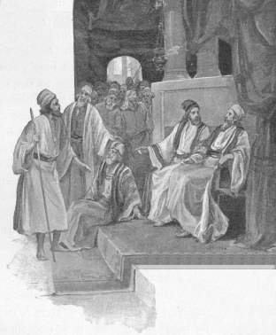
The Pharisees question the man who was healed of blindness by Jesus a final time. He is excommunicated for his testimony of Jesus; Jesus finds him then leaves Jerusalem.
1 Then again called they the man that was blind, and said unto him, Give God the praise: we know that this man is a sinner.
2 He answered and said, Whether he be a sinner or no, I know not: one thing I know, that, whereas I was blind, now I see.
3 Then said they to him again, What did he to thee? how opened he thine eyes?
4 He answered them, I have told you already, and ye did not hear: wherefore would ye hear it again? will ye also be his disciples?
5 Then they reviled him, and said, Thou art his disciple; but we are Moses’ disciples.
6 We know that God spake unto Moses: as for this fellow, we know not from whence he is.
7 The man answered and said unto them, Why herein is a marvellous thing, that ye know not from whence he is, and yet he hath opened mine eyes.
8 Now we know that God heareth not sinners: but if any man be a worshipper of God, and doeth his will, him he heareth.
9 Since the world began was it not heard that any man opened the eyes of one that was born blind except he be of God.
10 If this man were not of God, he could do nothing.
11 They answered and said unto him, Thou wast altogether born in sins, and dost thou teach us? And they cast him out.
12 Jesus heard that they had cast him out; and when he had found him, he said unto him, Dost thou believe on the Son of God?
13 He answered and said, Who is he, Lord, that I might believe on him?
14 And Jesus said unto him, Thou hast both seen him, and it is he that talketh with thee.
15 And he said, Lord, I believe. And he worshipped him.
16 And Jesus said, For judgment I am come into this world, that they which see not might see; and that they which see might be made blind.
17 And some of the Pharisees which were with him heard these words, and said unto him, Are we blind also?
18 Jesus said unto them, If ye were blind, ye should have no sin: but now ye say, We see; therefore your sin remaineth.
19 And Jesus and those that followed him departed thence from Jerusalem again into Galilee.
Taken from John 9:24-41
5. See also: TG Reviling
6. See also: John 8:14
10. See also: Acts 2:22
16. See also: TG Jesus Christ, Judge; Luke 5:32; 1 Tim. 1:13, 15
18. See also: TG Spiritual Blindness; John 15:22; TG Accountability; Sin

Chapter Eighty-Two
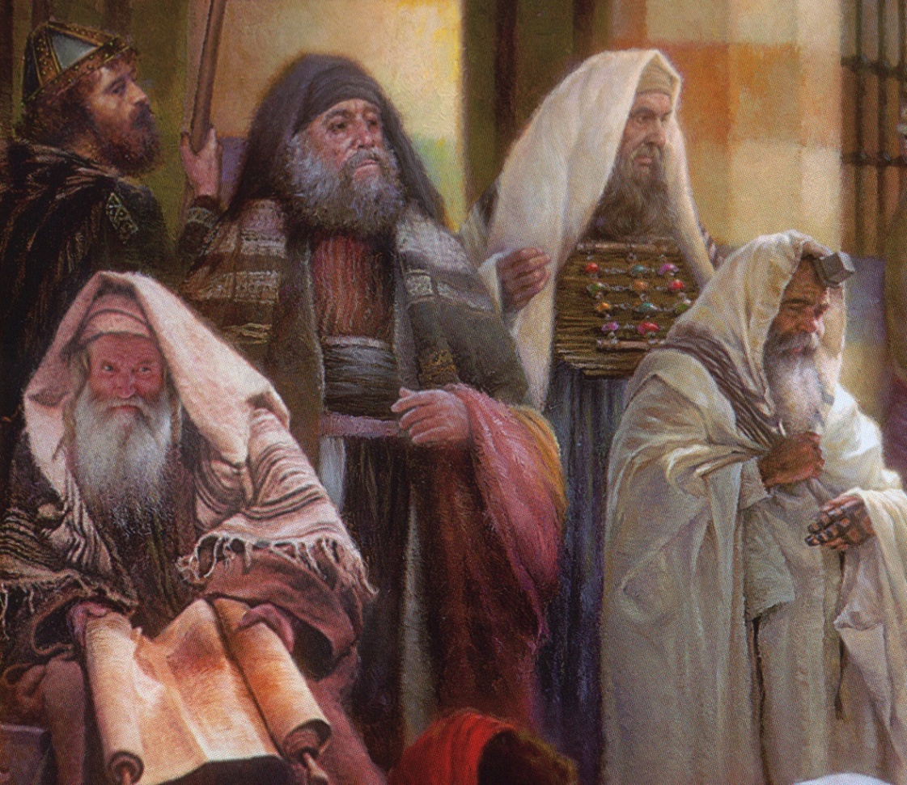
While in Galilee, Jesus is challenged by scribes and Pharisees, who followed him from Jerusalem, because he did not wash his hands before eating
1 Then came together unto him the Pharisees, and certain of the scribes, which came from Jerusalem.
2 And when they saw Christ and some of his disciples eat bread with defiled, that is to say, with unwashen, hands, they found fault.
3 For the Pharisees, and all the Jews, except they wash their hands oft, eat not, holding the tradition of the elders.
4 And when they come from the market, except they wash, they eat not. And many other things there be, which they have received to hold, as the washing of cups, and pots, brasen vessels, and of tables.
5 Then the Pharisees and scribes asked him, Why walk not thee and thy disciples according to the tradition of the elders, but eat bread with unwashen hands?
6 He answered and said unto them, Well hath Isaiah prophesied of you hypocrites, as it is written, This people honoureth me with their lips, but their heart is far from me.
7 Howbeit in vain do they worship me, teaching for doctrines the commandments of men.
8 For laying aside the commandment of God, ye hold the tradition of men, as the washing of pots and cups: and many other such like things ye do.
9 For ye Pharisees make clean the outside of the cup and the platter; but your inward part is full of ravening and wickedness.
10 Ye fools, did not he that made that which is without make that which is within also?
11 But if ye would rather give alms of such things as ye have; and observe to do all things which I have commanded you, then would your inward parts be clean also.
12 And he said unto them, Full well ye reject the commandment of God, that ye may keep your own tradition.
13 Full well is it written of you, by the prophets whom ye have rejected.
14 They testified these things of a truth, and their blood shall be upon you.
15 Ye have kept not the ordinances of God; for Moses said, Honor thy father and thy mother; and whoso curseth father or mother, let him die the death of the transgressor, as it is written in your law; but ye keep not the law.
16 But ye say, If a man shall say to his father or mother, It is Corban, that is to say, a gift, by whatsoever thou mightest be profited by me; he shall be free.
17 And ye suffer him no more to do ought for his father or his mother;
18 Making the word of God of none effect through your tradition, which ye have delivered: and many such like things do ye.
19 And when he had called all the people unto him, he said unto them, Hearken unto me every one of you, and understand:
20 There is nothing from without a man, that entering into him can defile him which is food: but the things which come out of him, those are they that defile the man, that proceedeth forth out of the heart.
21 If any man have ears to hear, let him hear.
22 Then came his disciples, and said unto him, Knowest thou that the Pharisees were offended, after they heard this saying?
23 But he answered and said, Every plant, which my heavenly Father hath not planted, shall be rooted up.
24 Let them alone: they be blind leaders of the blind. And if the blind lead the blind, both shall fall into the ditch.
25 And when he was entered into the house from the people, Peter asked him concerning the parable.
26 And Jesus saith, Are ye so without understanding also? Do ye not perceive, that whatsoever thing from without entereth into the man, it cannot defile him;
27 Because it entereth not into his heart, but into the belly, and goeth out into the draught, purging all meats?
28 And he said, That which cometh out of the man, that defileth the man; for those things which proceed out of the mouth come forth from the heart.
29 For from within, out of the heart of men, proceed evil thoughts, adulteries, fornications, murders,
30 Thefts, covetousness, wickedness, deceit, lasciviousness, an evil eye, blasphemy, pride, foolishness:
31 All these evil things come from within, and defile the man; but to eat with unwashen hands defileth not a man.

Taken from Matthew 15: 1-20, Mark 7:1-25, Luke 6:39, Luke 11:37-41
1. See also: TG Scribes
3. See also: TG Purification; Alma 24:7; D&C 123:7
5. See also: TG Washing
6. See also: TG Apostasy, of Israel; Hypocrisy; Jer. 12:2; Isa. 29:13; Titus 1:16; 2 Ne. 27:25; Ezek. 33:31; Alma 34:28; D&C 45:29
7. See also: Isa. 1:13; Matt. 16:12; Col. 2:22; Titus 1:14; 2 Ne. 28:9; Apostasy, of Israel
8. See also: TG Traditions of Men
9. See also: TG Purification; Titus 1:15; TG Hypocrisy; Wickedness
11. See also: TG Generosity; Almsgiving; Charity; Cleanliness
15. See also: TG Curse; Honoring Father and Mother; Honor; Respect; Capital Punishment
16. See also: Mark 7:11
20. See also: Titus 1:15; 2 Ne. 19:17; D&C 93:35; TG Cleanliness; Gossip; Profanity
23. See also: John 15:2; TG Vineyard of the Lord
24. See also: TG Spiritual Blindness; Governments; Leadership; Trust Not in the Arm of Flesh
28. See also: James 3:6; D&C 88:121; Mosiah 4:30
29. See also: 1 Jn. 2:16; Gen. 6:5; Heb. 3:12; Hel. 12:4; TG Adultery; Sexual Immorality; Fornication; Chastity; Blood, Shedding of; Murder;
30. See also: TG Stealing; Covetousness; Wickedness; Deceit; Fraud; Ps. 27:12; Hel. 7:21
31. See also: TG Motivations; Pollution; Mosiah 4:30

Chapter Eighty-Three
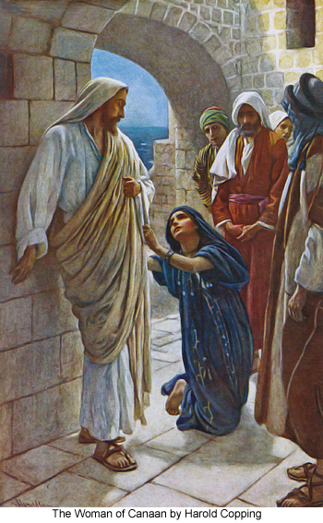
Jesus travels to the coasts of Tyre and Sidon; he heals a Greek woman’s daughter.
1 And from thence Jesus arose, and went into the coasts of Tyre and Sidon, and entered into an house, and would that no man should come unto him. But he could not deny them; for he had compassion upon all men.
2 And, behold, a woman of Canaan heard of him and came and fell at his feet, and cried unto him, saying, Have mercy on me, O Lord, thou Son of David; my daughter is grievously vexed with a devil.
3 But he answered her not a word. And his disciples came and besought him, saying, Send her away; for she crieth after us.
4 But he answered and said, I am not sent but unto the lost sheep of the house of Israel, Let the children of the kingdom first be filled: for the woman was a Greek, a Syrophenician by nation.
5 Then came she and worshipped him, saying, Lord, help me.
6 But he answered and said, It is not meet to take the children’s bread, and to cast it to dogs.
7 And she said, Truth, Lord: yet the dogs eat the crumbs of the children which fall from their masters’ table.
8 Then Jesus answered and said unto her, O woman, great is thy faith: be it unto thee even as thou wilt; the devil is gone out of thy daughter. And her daughter was made whole from that very hour.
9 And when she was come to her house, she found the devil gone out, and her daughter laid upon the bed.
Taken from Matthew 15: 21-28, Mark 7:26-32
4. See also: 3 Ne. 15:23; TG Jesus Christ, Messenger of the Covenant; Israel, Scattering of
6. See also: Prov. 23:9; Matt. 7:6; D&C 6:12; 10:37; 41:6
8. See also: James 5:15
9. See also: 1 Ne. 11:31

Chapter Eighty-Four
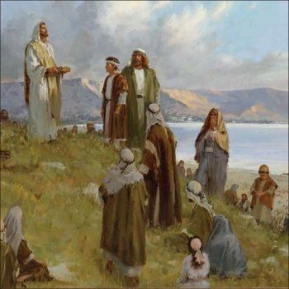
Jesus departs from Tyre and Sidon, traveling through coasts of Decapolis, to the mountain of Gadara. Jesus heals lame, blind, dumb, maimed; miracle of feeding four thousand.
1 And Jesus departed thence from the coasts of Tyre and Sidon; traveling through the midst of the coasts of Decapolis, he came nigh unto the sea of Galilee. There he went up into a mountain and sat down.
2 And they bring unto him one that was deaf, and had an impediment in his speech; and they beseech him to put his hand upon him.
3 And he took him aside from the multitude, and put his fingers into his ears, and he spit, and touched his tongue;
4 And looking up to heaven, he sighed, and saith unto him, Ephphatha, that is, Be opened.
5 And straightway his ears were opened, and the string of his tongue was loosed, and he spake plain.
6 And great multitudes came unto him, having with them those that were lame, blind, dumb, maimed, and many others, and cast them down at Jesus’ feet; and he healed them:
7 And he charged them that they should tell no man: but the more he charged them, so much the more a great deal they published it;
8 And were beyond measure astonished, saying, He hath done all these things well: he maketh the dumb to speak, the maimed to be whole, the lame to walk, and the blind to see: and they glorified the God of Israel.
9 And the multitude being very great, and having nothing to eat, Jesus called his disciples unto him, and saith unto them,
10 I have compassion on the multitude, because they have now been with me three days, and have nothing to eat:
11 And if I send them away fasting to their own houses, they will faint by the way: for divers of them came from far.
12 And his disciples answered him, From whence can a man satisfy these men with bread here in the wilderness?
13 And Jesus asked them, How many loaves have ye? And they said, Seven and a few little fishes.
14 And he commanded the people to sit down on the ground: and he took the seven loaves and the fishes, and gave thanks, and brake them, and gave to his disciples to set before them; and they did set them before the people.
15 So they did eat, and were filled: and they took up of the broken meat that was left seven baskets full.
16 And they that had eaten were about four thousand men, beside women and children: and he sent them away.
Taken from Matthew 15:29-38, Mark 7:33-39, Mark 8: 1-9
2. See also: TG Administrations to the Sick; Hands, Laying on of
5. See also: TG Miracles
7. See also: Matt. 9:31
14. See also: TG Bread
15. See also: 2 Kgs. 4:44; Matt. 14:20

Chapter Eighty-Five
Facing Eternity, by Del Parson
, by James Tissot
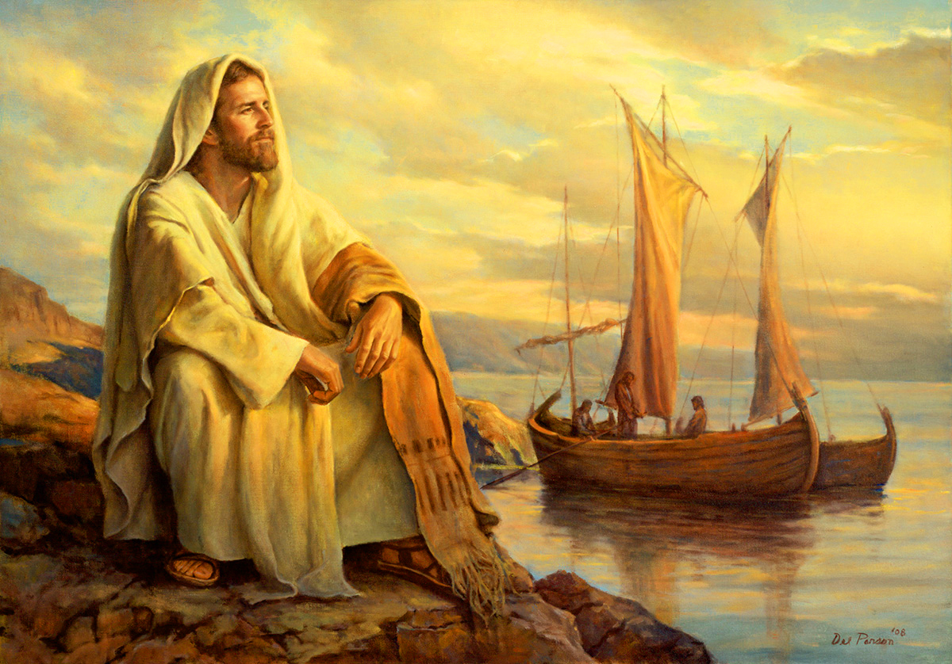
Jesus takes a ship to Dalmanutha in the borders of Magdala/Magadan; Jesus is tempted by the Pharisees and Sadducees to give a sign.
1 And straightway Jesus departed thence from the mountain of Gadara in the coasts of Decapolis, and entered into a ship with his disciples and came into Dalmanutha in the borders of Magdala/Magadan.
2 And it came to pass that the Pharisees also with the Sadducees came, and tempting desired him that he would shew them a sign from heaven.
3 And Jesus sighed deeply in his spirit, and he answered and said unto them, When it is evening, ye say, It will be fair weather: for the sky is red.
4 And in the morning, It will be foul weather to day: for the sky is red and lowring. And when ye see a cloud rise out of the west, straightway ye say, There cometh a shower; and so it is. And when ye see the south wind blow, ye say, There will be heat; and it cometh to pass. O ye hypocrites, ye can discern the face of the sky and of the earth; but can ye not discern the signs of the times?
5 Why doth this generation seek after a sign? Yea, and why even of yourselves judge ye not what is right? For verily I say unto you, A wicked and adulterous generation seeketh after a sign; and there shall no sign be given unto it, but the sign of the prophet Jonas. And he left them, and departed.
Taken from Matthew 15:39; Matthew 16:1-4; Mark 8:10-12; Luke 12:61-64
2. See also: TG Heaven; D&C 46:9; 63:7
3. See also: Prov. 26:5
4. See also: TG Hypocrisy; 2 Pet. 3:4; Esth. 1:13
5. See also: TG Adultery; Jonah 1:17; Jesus Christ, Death of

Chapter Eighty-Six
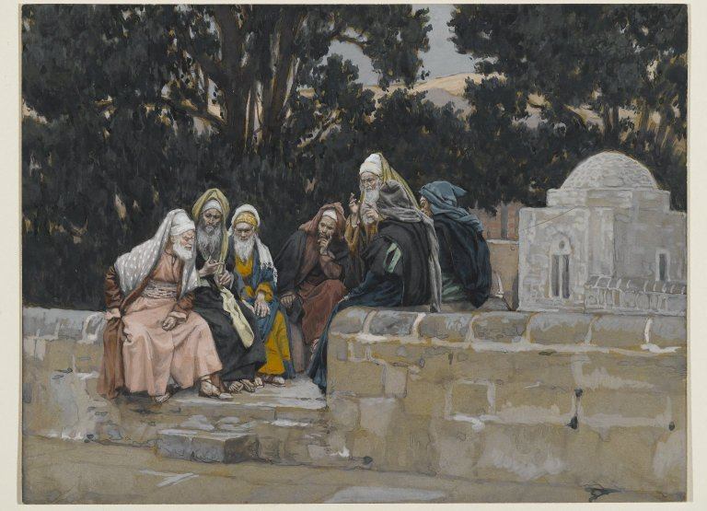
The Pharisees and the Herodians Conspire Against Jesus, by James Tissot
, by James Tissot
Jesus and disciples leave in a ship from Dalmanutha in the borders of Magdala/Magadan to Bethsaida- Julius. Jesus warns them about the doctrine of the Pharisees and Sadducees.
1 And Jesus left them, and entering into the ship again with his disciples, departed to the other side.
2 Now the disciples had forgotten to take bread, neither had they in the ship with them more than one loaf.
3 And he charged them, saying, Take heed, beware of the leaven of the Pharisees, and of the leaven of Herod, which is hypocrisy.
4 And they reasoned among themselves, saying, It is because we have no bread.
5 And when Jesus knew it, he saith unto them, O ye of little faith, why reason ye, because ye have no bread? perceive ye not yet, neither understand? have ye your heart yet hardened?
6 Having eyes, see ye not? and having ears, hear ye not? and do ye not remember?
7 When I brake the five loaves among five thousand, how many baskets full of fragments took ye up? They say unto him, Twelve.
8 And when the seven among four thousand, how many baskets full of fragments took ye up? And they said, Seven.
9 And he said unto them, How is it that ye do not understand that I spake it not to you concerning bread, that ye should beware of the leaven of the Pharisees and of the Sadducees?
10 Then understood they how that he bade them not beware of the leaven of bread, but of the doctrine of the Pharisees and of the Sadducees.
Taken from Matthew 16:5-12, Mark 8:13-21, Luke 12:1
3. See also: TG Leaven; Hypocrisy
5. See also: TG Hardheartedness
10. See also: Matt. 15:9; 22:23

Chapter Eighty-Seven
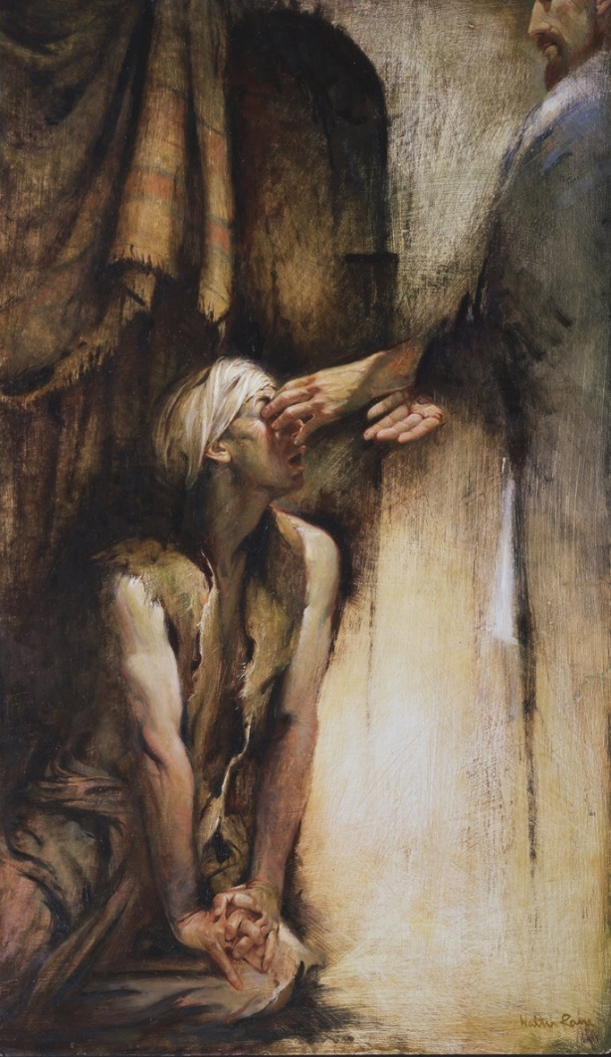
He Anointed the Eyes of the Blind Man, by Walter Rane
Jesus and disciples arrive in Bethsaida; Jesus heals a blind man gradually.
1 And Jesus cometh to Bethsaida with his disciples; and they bring a blind man unto him, and besought him to touch him.
2 And he took the blind man by the hand, and led him out of the town; and when he had spit on his eyes, and put his hands upon him, he asked him if he saw ought.
3 And he looked up, and said, I see men as trees, walking.
4 After that he put his hands again upon his eyes, and made him look up: and he was restored, and saw every man clearly.
5 And he sent him away to his house, saying, Neither go into the town, nor tell it to any in the town.
Taken from Mark 8:22-26
2. See also: TG Administrations to the Sick; Hands, Laying on of
Chapter Eighty-Eight
The Way of Joy, by Greg Olsen
King Herod thinks Jesus is John the Baptist risen from the dead.
1 Now Herod the tetrarch heard of all that was done by Jesus (for his name was spread abroad): and Herod was perplexed, and said unto his servants, John have I beheaded: but who is this, of whom I hear such things? Is John the Baptist risen from the dead, and are therefore mighty works shewing forth themselves in him? And Herod desired to see him.
2 Others said that Elias had appeared; and of others, that one of the old prophets was risen again. Others yet that it was a prophet, or as one like the prophets.
Taken from Matthew 14:1-2, Mark 6:14-16, Luke 9:7-9
1. See also: Luke 3:1

Chapter Eighty-Nine
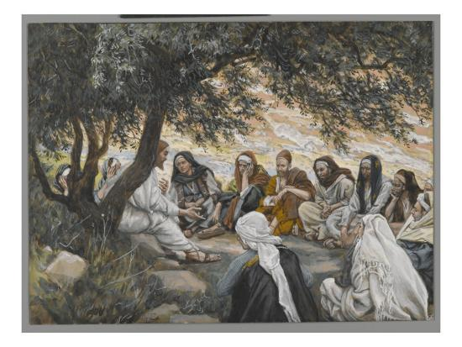
The Exhortation to the Apostles, by James Tissot
Jesus leaves Bethsaida-Julius for the coasts of Caesarea Philippi. On the way, Jesus asks his disciples for their testimonies of him and then teaches the power of revelation.
1 And Jesus went out from Bethsaida-Julius, and his disciples, to the coasts of Cæsarea Philippi. And by the way he asked his disciples, saying unto them, Whom do men say that I am?
2 And they answered, John the Baptist: but some say, Elijah; and others, Jeremias, or one of the prophets. And others yet say, that one of the old prophets is risen again.
3 And he saith unto them, But whom say ye that I am? And Peter answereth and saith unto him, Thou art the Christ, the Son of the living God.
4 And Jesus answered and said unto him, Blessed art thou, Simon Bar-jona: for flesh and blood hath not revealed it unto thee, but my Father which is in heaven.
5 And I say also unto thee, That thou art Peter, and upon this rock I will build my church; and the gates of hell shall not prevail against it.
6 And I will give unto thee the keys of the kingdom of heaven: and whatsoever thou shalt bind on earth shall be bound in heaven: and whatsoever thou shalt loose on earth shall be loosed in heaven.
7 And he charged his disciples that they should tell no man that he was Jesus the Christ.
Taken from Matthew 16:13-20, Mark 8:27-30, Luke 9:18-21
3. See also: TG Jesus Christ, Messiah; Jesus Christ, Divine Sonship; God, Body of (Corporeal Nature); Testimony; Loyalty
4. See also: TG Revelation; Testimony; Witnesses
5. See also: John 1:42; 1 Cor. 3:11; 10:4; D&C 50:44; 128:10; TG Rock; Church Organization; Jesus Christ, Head of the Church; Hell; D&C 17:8; 21:6
6. See also: D&C 7:7; 27:13; TG Delegation of Responsibility; God, Gifts of; Apostles; Priesthood, History of; Priesthood, Keys; Kingdom of God, on Earth; Hel. 10:7; D&C 138:58; TG Genealogy and Temple Work; Marriage, Celestial; Salvation, for the Dead; Sealing
7. See also: TG Jesus Christ, Messiah

Chapter Ninety
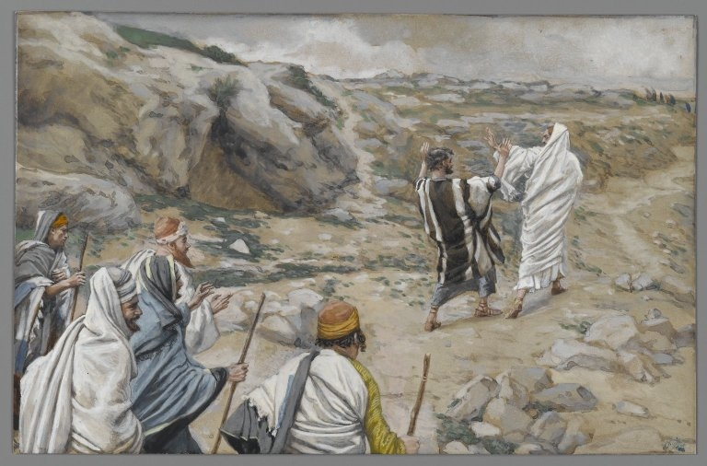
Get Thee Behind Me, Satan, by James Tissot
Jesus teaches his disciples about his future death and resurrection; Peter does not wish this fate upon Jesus and is rebuked for it. Jesus teaches he that loses his life for Jesus’ sake will find it.
1 And Jesus began to teach his disciples, that the Son of man must suffer many things, and be rejected of the elders, and of the chief priests, and scribes, and be killed, and after three days rise again.
2 And he spake that saying openly. And Peter took him, and began to rebuke him, saying, Be it far from thee, Lord: this shall not be unto thee.
3 But when he had turned about and looked on his disciples, he rebuked Peter, saying, Get thee behind me, Satan: thou art an offence unto me: for thou savourest not the things that be of God, but the things that be of men.
4 And when he had called the people unto him with his disciples also, he said unto them, Whosoever will come after me, let him deny himself, and take up his cross daily, and follow me.
5 And now for a man to take up his cross, is to deny himself all ungodliness, and every worldly lust, and keep my commandments.
6 Break not my commandments for to save your lives; for whosoever will save his life in this world, shall lose it in the world to come.
7 And whosoever will lose his life in this world, for my sake, shall find it in the world to come.
8 For whosoever will save his life, shall lose it; or whosoever will save his life, shall be willing to lay it down for my sake; and if he is not willing to lay it down for my sake, he shall lose it.
9 But whosoever shall be willing to lose his life for my sake, and the gospel, the same shall save it.
10 Therefore, forsake the world, and save your souls; For what shall it profit a man, if he shall gain the whole world, and yet he receive him not whom God hath ordained, and lose his own soul, and he himself be a castaway?
11 Or what shall a man give in exchange for his soul? Therefore deny yourselves of these, and be not ashamed of me.
12 Whosoever therefore shall be ashamed of me and of my words in this adulterous and sinful generation; of him also shall the Son of man be ashamed, when he cometh in the glory of his Father with the holy angels; and then he shall reward every man according to his works.
13 And they shall not have part in that resurrection when he cometh.
14 For verily I say unto you, That he shall come; and he that layeth down his life for my sake and the gospel’s, shall come with him, and shall be clothed with his glory in the cloud, on the right hand of the Son of man.
15 And he said unto them, Verily I say unto you, That there be some of them that stand here, which shall not taste of death, till they have seen the kingdom of God come with power.
Taken from Matthew 16:20-30, Mark 8:31-41, Mark 9:1, Luke 9:22-27, Luke 17:33
1. See also: TG Jesus Christ, Teaching Mode of; Jesus Christ, Resurrection; Matt. 21:42; 1 Pet. 2:7
3. See also: Alma 12:5; Hel. 10:4
4. See also: TG Self-mastery; Jesus Christ, Exemplar; Matt. 10:38; 3 Ne. 12:30
7. See also: TG Self-mastery; Self-sacrifice; Abundant Life
9. See also: D&C 103:28; TG Martyrdom; Sacrifice; Matt. 10:39; D&C 98:13
10. See also: Jer. 45:5; 1 Sam. 12:21; Prov. 13:7; Eccl. 1:3; Job 27:8; TG Selfishness; Treasure; Worldliness; Mortality; Soul
12. See also: 1 Ne. 8:28; TG Shame; Jesus Christ, Son of Man; Glory; Jesus Christ, Glory of; Jesus Christ, Second Coming; Jesus Christ, Judge; Judgment, the Last; Retribution; Reward; Good Works; Prov. 24:12; D&C 3:7
15. See also: TG Translated Beings; Millennium; John 21:23; 3 Ne. 28:7; D&C 7:2

Chapter Ninety-One
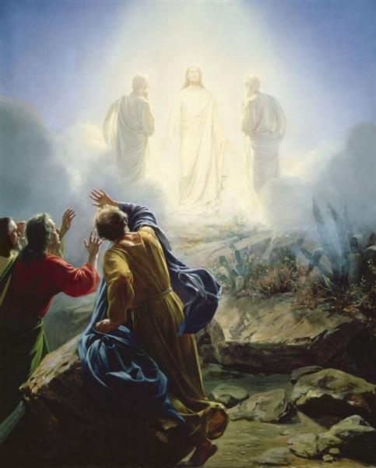
Transfiguration of Jesus, by Carl Bloch
Mount of Transfiguration: after six days in Caesarea - Philippi Jesus leaves and heads north to Mount Hermon. He takes Peter, James and John into a mountain and is transfigured before them. Jesus teaches Elias is a title, not a person.
1 And after six days Jesus taketh with him Peter, and James, and John, who asked him many questions concerning his sayings and Jesus leadeth them up into an high mountain apart by themselves to pray: and as Jesus prayed he was transfigured before them.
2 The fashion of his countenance was altered, and his face did shine as the sun. His raiment became shining and glistering, and was white as the light, yea, exceeding white as snow; so as no fuller on earth can white them.
3 And there appeared unto them Elias with Moses, or in other words, John the Baptist and Moses; who appeared in glory, and they were talking with Jesus and spake of his death, and also his resurrection, which he should accomplish at Jerusalem.
4 And Peter answered and said to Jesus, Master, it is good for us to be here: if thou wilt, let us make three tabernacles; one for thee, and one for Moses, and one for Elias.
5 But Peter and they that were with him were heavy with sleep: and when they were awake, they saw his glory, and the two men that stood with him.
6 And Peter wist not what to say; for they were sore afraid.
7 And there was a cloud that overshadowed them: and a voice came out of the cloud, saying, This is my beloved Son, in whom I am well pleased; hear ye him.
8 And when the disciples heard it, they fell on their face, and were sore afraid.
9 And Jesus came and touched them, and said, Arise, and be not afraid.
10 And suddenly, when they had looked round about, they saw no man any more, save Jesus only with themselves.
11 And as they came down from the mountain, he charged them that they should tell no man what things they had seen, till the Son of man were risen from the dead.
12 And they kept that saying with themselves, questioning one with another what the rising from the dead should mean.
13 And they asked him, saying, Why say the scribes that Elias must first come?
14 And Jesus answered and said unto them, an Elias truly shall first come, and restore all things, as the prophets have written. His name shall be Joseph, and it shall be after the name of his father, and they shall be after the name of Joseph who was sold into Egypt. This shall happen in the last days.
15 And again I say unto you that another Elias has come already, concerning whom it is written, Behold, I will send my messenger, and he shall prepare the way before me; and they knew him not, and have done unto him, whatsoever they listed. This was John the Baptist.
16 Likewise also the Son of man is the Elias and he must suffer many things of them, and be set at nought.
17 But I say unto you, Who is Elias? Behold, this is Elias, whomever I send to restore and to prepare the way before me.
18 Then the disciples understood that Elias was a title and not a person.
Taken from Matthew 17:1-15, Mark 9:2-13, Luke 9:28-36
- See also: 2 Pet. 1:18; Matt. 14:23; 26:36; Luke 6:12; D&C 128:20
- See also: John 1:14; 2 Pet. 1:16; TG Jesus Christ, Glory of; Transfiguration
- See also: D&C 63:21; 110:11; TG Priesthood, Keys; Translated Beings; 1 Kgs. 17:1; Luke 4:25; D&C 110:13; TG Jesus Christ, Death of
5. See also: TG Glory
7. See also: TG God, Manifestations of; God, Body of (Corporeal Nature); Ex. 24:15; Matt. 3:17; 3 Ne. 11:7; JS-H 1:17; TG Witness of the Father; God, Father; Godhead; Jesus Christ, Divine Sonship
8. See also: Ex. 3:6; Deut. 5:5
11. See also: TG Visions; Death
12. See also: John 20:9
14. See also: 2 Ne. 3:11-16; D&C 27:6; 77:14; 110:13-16; TG Dispensations; Restoration of the Gospel
16. See also: TG Jesus Christ, Crucifixion of; Isa. 53:3
Commentary
- All three members of the Godhead were separately manifest… It is self-evident from the scriptures that the Father, the Son, and the Holy Ghost are separate persons, three divine beings.

Chapter Ninety-Two
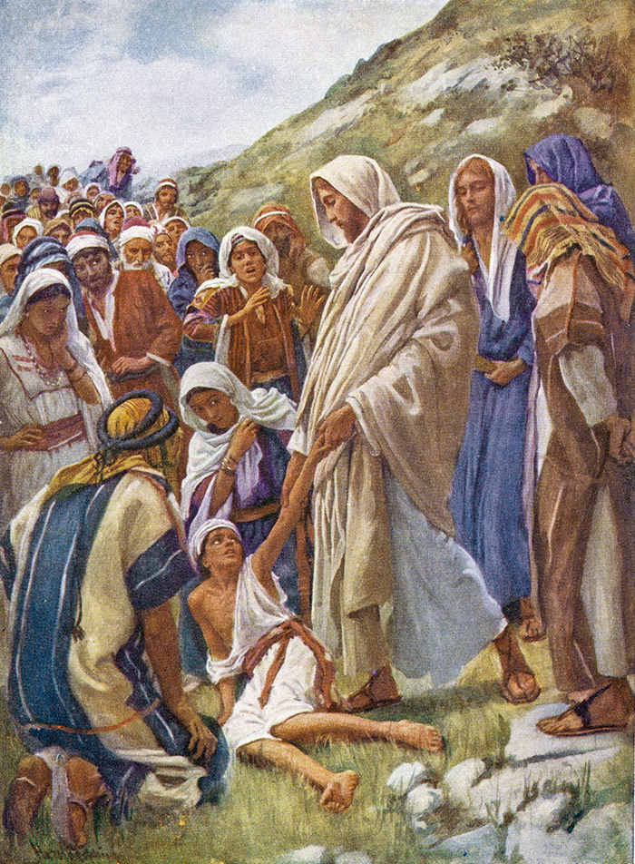
Jesus Heals The Epileptic Boy, by Harold Copping
After coming down the mountain, Jesus heals a lunatic that the disciples could not heal. Jesus teaches certain things can’t be done without fasting.
1 And when he came to his disciples, he saw a great multitude about them, and the scribes questioning with them.
2 And straightway all the people, when they beheld him, were greatly amazed, and running to him saluted him.
3 And he asked the scribes, What question ye with them?
4 And one of the multitude came to him, kneeling down, answered and said, Master, Lord, I have brought unto thee my only son, have mercy on him, for he is lunatic and sore vexed, which hath a dumb spirit;
5 And wheresoever he taketh him, he teareth him: and he foameth, and gnasheth with his teeth, and pineth away: and I spake to thy disciples that they should cast him out; and they could not.
6 He answereth him, and saith, O faithless and perverse generation, how long shall I be with you? how long shall I suffer you? bring him unto me.
7 And they brought him unto him: and when he saw him, straightway the spirit tare him; and he fell on the ground, and wallowed foaming.
8 And he asked his father, How long is it ago since this came unto him? And he said, Of a child.
9 And ofttimes it hath cast him into the fire, and into the waters, to destroy him: but if thou canst do any thing, have compassion on us, and help us.
10 Jesus said unto him, If thou canst believe, all things are possible to him that believeth.
11 And straightway the father of the child cried out, and said with tears, Lord, I believe; help thou mine unbelief.
12 When Jesus saw that the people came running together, he rebuked the foul spirit, saying unto him, Thou dumb and deaf spirit, I charge thee, come out of him, and enter no more into him.
13 And the spirit cried, and rent him sore, and came out of him: and he was as one dead; insomuch that many said, He is dead.
14 But Jesus took him by the hand, and lifted him up; and he arose.
15 And when he was come into the house, his disciples asked him privately, Why could not we cast him out?
16 And Jesus said unto them, Because of your unbelief: for verily I say unto you, If ye have faith as a grain of mustard seed, ye shall say unto this mountain, Remove hence to yonder place; and it shall remove; and nothing shall be impossible unto you.
17 Howbeit this kind goeth not out but by prayer and fasting.
Taken from Matthew 17:16-23, Mark 9:14-29, Luke 9:37-42
6. See also: TG Unbelief, Unbelievers; Deut. 32:5
7. See also: Mark 1:26
9. See also: TG Compassion
10. See also: Dan. 3:29; TG God, Power of; Faith
11. See also: TG Doubt
12. See also: TG Healing; Spirits, Evil, Unclean
14. See also: Acts 3:7
16. See also: TG Doubt; Faith; Ether 12:30; Moses 7:13; TG God, Power of
17. See also: TG Problem-Solving; Fasting; D&C 84:67
Chapter Ninety-Three
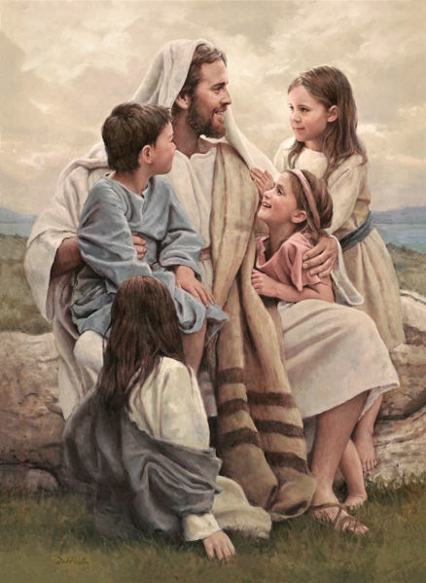
Perfect Love, by Del Parson
Jesus teaches how to become the greatest in the kingdom of God; become as little children.
1 And they departed thence from Caesarae-Philippi and passed through Galilee by land, traveling towards Capernaum; and he would not that any man should know it.
2 And by the way Jesus taught his disciples, and said unto them, Let these sayings sink down into your ears: The Son of man shall be betrayed and delivered into the hands of men, and they shall kill him; and after that he is killed, he shall rise the third day.
3 They were exceeding sorry but understood not that saying, for it was hid from them, that they perceived it not: and were afraid to ask him.
4 Therefore there arose a reasoning, or in other words, a strife among them, which of them should be accounted the greatest.
5 Then came to him the mother of Zebedee’s children with her sons, James and John, worshipping him, and desiring a certain thing of him.
6 And he said unto her, What wilt thou? She saith unto him, Grant that these my two sons may sit, the one on thy right hand, and the other on the left, in thy kingdom.
7 But Jesus answered and said, Ye know not what ye ask. Are ye able to drink of the cup that I shall drink of, and to be baptized with the baptism that I am baptized with? James and John say unto him, We are able.
8 And he saith unto them, Ye shall drink indeed of my cup, and be baptized with the baptism that I am baptized with: but to sit on my right hand, and on my left, is not mine to give, but it shall be given to them for whom it is prepared of my Father.
9 And when the ten heard it, they were moved with indignation against James and John.
10 And when they came to Capernaum and being in the house Jesus asked them, What was it that ye disputed among yourselves by the way?
11 But they held their peace.
12 But Jesus, perceived the thought of their heart, yea, that they desired to know who is the greatest in the kingdom of heaven.
13 And he said unto them, The kings of the Gentiles exercise lordship over them; and they that exercise authority upon them are called benefactors.
14 But ye shall not be so: but he that is greatest among you, let him be as the younger, your minister; and whosoever will be chief among you, let him be your servant:
15 Even as the Son of man came not to be ministered unto, but to minister, and to give his life a ransom for many.
16 For whether is greater, he that sitteth at meat, or he that serveth? Is not he that sitteth at meat? But I am among you as he that serveth.
17 If any man desire to be first, the same shall be last of all, and servant of all for he that is least among you all the same shall be great.
18 And he took a child, and set him in the midst of them: and when he had taken him in his arms, he said unto them,
19 Verily I say unto you, Except ye be converted, and become as little children, ye shall not enter into the kingdom of heaven.
20 Whosoever therefore shall humble himself as this little child, the same is greatest in the kingdom of heaven.
21 And whoso shall receive one such little child in my name receiveth me.
22 Whosoever shall humble himself like one of these children and receiveth me, ye shall receive me, ye shall receive my name. And whosoever shall receive me, receiveth not me only, but him that sent me, even the Father.
23 Take heed that ye despise not one of these little ones; for I say unto you, That in heaven their angels do always behold the face of my Father which is in heaven.
24 For the Son of man is come to save that which was lost, and to call sinners to repentance; but these little ones have no need of repentance, and I will save them.
25 Even so it is not the will of your Father which is in heaven, that one of these little ones should perish.
26 And whosoever shall offend one of these little ones that believe in me, it is better for him that a millstone were hanged about his neck, and that he were cast into the sea and drowned in the depths thereof.
27 Woe unto the world because of offences! For it must needs be that offences come; but woe to that man by whom the offence cometh!
28 Therefore, if thy hand offend thee, cut it off and cast it from thee; or if thy brother offend thee and confess not and forsake not, he shall be cut off. It is better for thee to enter into life maimed, than having two hands, to go into hell.
29 For it is better for thee to enter into life without thy brother, than for thee and thy brother to be cast into hell; into the fire that never shall be quenched, where their worm dieth not, and the fire is not quenched.
30 And again, if thy foot offend thee, cut it off and cast it from thee; for he that is thy standard, by whom thou walkest, if he become a transgressor, he shall be cut off.
31 It is better for thee, to enter halt into life, than having two feet to be cast into hell; into the fire that never shall be quenched.
32 Therefore, let every man stand or fall, by himself, and not for another; or not trusting another.
33 Seek unto my Father, and it shall be done in that very moment what ye shall ask, if ye ask in faith, believing that ye shall receive.
34 And if thine eye which seeth for thee, him that is appointed to watch over thee to show thee light, become a transgressor and offend thee, pluck him out and cast it from thee.
35 It is better for thee to enter into the kingdom of God, with one eye, than having two eyes to be cast into hell fire.
36 And a man’s hand is his friend, and his foot also; and a man’s eye, are they of his own household.
37 For it is better that thyself should be saved, than to be cast into hell with thy brother, where their worm dieth not, and where the fire is not quenched.
38 For every one shall be salted with fire, and every sacrifice shall be salted with salt.
39 Salt is good: but if the salt have lost his saltness, wherewith will ye season it? Have salt in yourselves, and have peace one with another.
Taken from Matthew 17:24-25, Matthew 18:1-11, 14, Matthew 20:20-28, Mark 9:30-37, 42-53, Mark 10:35-45, Luke 9:43-48; Luke 17:1-2; Luke 22:24-27
2. See also: 1 Ne. 11:32; 3 Ne. 27:14; TG Jesus Christ, Son of Man, Jesus Christ, Betrayal of; Jesus Christ, Resurrection
3. See also: John 12:16
4. See also: TG Strife; Matt. 23:11; D&C 50:26
7. See also: TG Jesus Christ, Baptism of
8. See also: TG Godhead
10. See also: TG Disputations
13. See also: TG Kings, Earthly
14. See also: D&C 50:26; Mosiah 2:18; Matt. 23:11; 2 Ne. 9:5; TG Leadership; Priesthood, Magnifying Callings within; Humility; Self-sacrifice; Servants; Service
15. See also: Moses 6:57; TG God, Gifts of; Jesus Christ, Atonement through; Jesus Christ, Redeemer; Redemption; D&C 138:2; Rom. 4:25
16. See also: TG Meekness; Self-sacrifice
17. See also: Prov. 18:17; TG Meekness
19. See also: 1 Cor. 14:20; Mosiah 3:19; TG Children; Salvation, of Little Children
20. See also: TG Humility; Meekness; Children
21. See also: TG Name
22. See also: TG Children; Salvation, of Little Children; Matt. 10:40; Ether 12:27
23. See also: TG Children; Family, Children, Responsibility toward
24. See also: TG Jesus Christ, Son of Man; Jesus Christ, Mission of; Life, Sanctity of; Worth of Souls
25. See also: TG Children; Mosiah 28:3
26. See also: TG Offenses; D&C 121:19
27. See also: TG Sin
28. See also: TG Self-mastery; Hell
29. See also: Isa. 66:24; D&C 76:44
38. See also: TG Salt
39. See also: 1 Thes. 5:13; TG Peace

Chapter Ninety-Four
Peter pays taxes with gold found in fish’s mouth.
1 And it came to pass that while they were in Capernaum, they that received tribute money came to Peter, and said, Doth not your master pay tribute?
2 He saith, Yes. And when he was come into the house, Jesus prevented him, saying, What thinkest thou, Simon? of whom do the kings of the earth take custom or tribute? of their own children, or of strangers?
3 Peter saith unto him, Of strangers. Jesus saith unto him, Then are the children free.
4 Notwithstanding, lest we should offend them, go thou to the sea, and cast an hook, and take up the fish that first cometh up; and when thou hast opened his mouth, thou shalt find a piece of money: that take, and give unto them for me and thee.
Taken from Matthew 17:26-29
1. See also: D&C 58:21
2. See also: TG Kings, Earthly
4. See also: Ex. 30:13; 38:26; TG Citizenship

Chapter Ninety-Five
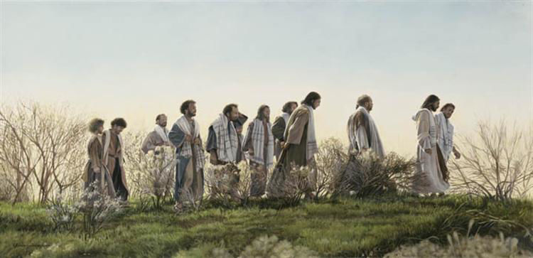
Without Purse or Scrip, by Liz Lemon Swindle
Jesus teaches forgiveness.
1 And it came to pass that Jesus, while yet at Capernaum, taught his disciples, saying, Moreover if thy brother shall trespass against thee, go and rebuke him, telling him his fault between thee and him alone: if he shall hear thee, thou hast gained thy brother and if he repent, forgive him.
2 And if he trespass against thee seven times in a day, and seven times in a day turn again to thee, saying, I repent; thou shalt forgive him.
3 But if he will not hear thee, then take with thee one or two more, that in the mouth of two or three witnesses every word may be established.
4 And if he shall neglect to hear them, tell it unto the church: but if he neglect to hear the church, let him be unto thee as an heathen man and a publican.
5 Verily I say unto you, Whatsoever ye shall bind on earth shall be bound in heaven: and whatsoever ye shall loose on earth shall be loosed in heaven.
6 Again I say unto you, That if two of you shall agree on earth as touching any thing that they shall ask, it shall be done for them of my Father which is in heaven.
7 For where two or three are gathered together in my name, there am I in the midst of them.
8 Then came Peter to him, and said, Lord, how oft shall my brother sin against me, and I forgive him? till seven times?
9 Jesus saith unto him, I say not unto thee, Until seven times: but, Until seventy times seven.
10 Therefore is the kingdom of heaven likened unto a certain king, which would take account of his servants.
11 And when he had begun to reckon, one was brought unto him, which owed him ten thousand talents.
12 But forasmuch as he had not to pay, his lord commanded him to be sold, and his wife, and children, and all that he had, and payment to be made.
13 The servant therefore fell down, and worshipped him, saying, Lord, have patience with me, and I will pay thee all.
14 Then the lord of that servant was moved with compassion, and loosed him, and forgave him the debt.
15 But the same servant went out, and found one of his fellowservants, which owed him an hundred pence: and he laid hands on him, and took him by the throat, saying, Pay me that thou owest.
16 And his fellowservant fell down at his feet, and besought him, saying, Have patience with me, and I will pay thee all.
17 And he would not: but went and cast him into prison, till he should pay the debt.
18 So when his fellowservants saw what was done, they were very sorry, and came and told unto their lord all that was done.
19 Then his lord, after that he had called him, said unto him, O thou wicked servant, I forgave thee all that \debt, because thou desiredst me:
20 Shouldest not thou also have had compassion on thy fellowservant, even as I had pity on thee?
21 And his lord was wroth, and delivered him to the tormentors, till he should pay all that was due unto him.
22 So likewise shall my heavenly Father do also unto you, if ye from your hearts forgive not every one his brother their trespasses.
Taken from Matthew 18:15-35, Luke 17:3-4
- See also: TG Offenses; Reproof; Forgiveness; Matt. 5:24; D&C 42:88
- See also: TG Repentance
- See also: 2 Ne. 29:8; 2 Cor. 13:1; TG Witnesses
- See also: 1 Cor. 6:1; D&C 42:81; Titus 3:10; TG Church
- See also: TG Apostles; Priesthood, Keys; Sealing
- See also: TG Common Consent; D&C 6:32; 42:3; TG Prayer
- See also: TG Church; Unity; Name; D&C 29:5; 32:3; 45:59; 49:27
- See also: TG Forbearance
- See also: D&C 98:40; TG Patience
- See also: TG Accountability; Stewardship; Servants
12. 2 Kgs. 4:1
19. See also: TG Debt
20. See also: TG Ingratitude; Compassion; Mercy
22. See also: TG Forgiveness

Chapter Ninety-Six
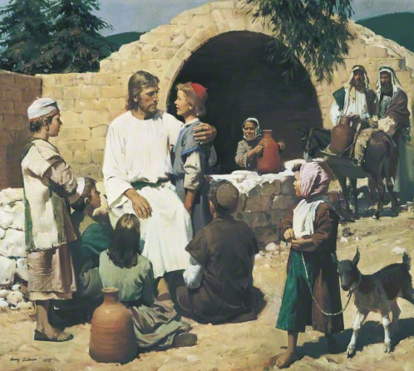
Christ and the Children, by Harry Anderson
Jesus is rejected in Samaria. Jesus teaches about marriage and to suffer the little children.
1 And it came to pass, when the time was come that Jesus should be received up, he steadfastly set his face to go to Jerusalem,
2 And he arose and departed thence from Galilee to go up unto Jerusalem; And as he journeyed towards Jerusalem, he passed through all the cities and villages, teaching by the way, and the people did resort unto him again.
3 And sent messengers before his face: and they went, and entered into a village of the Samaritans, to make ready for him.
4 And they did not receive him, because his face was as though he would go to Jerusalem.
5 And when his disciples James and John saw this, they said, Lord, wilt thou that we command fire to come down from heaven, and consume them, even as Elias did?
6 But he turned, and rebuked them, and said, Ye know not what manner of spirit ye are of.
7 For the Son of man is not come to destroy men’s lives, but to save them. And they went to another village.
8 And they cometh into Judaea by the farther side of Jordan. And great multitudes continued to follow him.
9 And by the way the Pharisees also came unto him, tempting him, and saying unto him, Is it lawful for a man to put away his wife for every cause?
10 And he answered and said unto them, What did Moses command you?
11 And they said, Moses suffered to write a bill of divorcement, and to put her away.
12 And he answered and said unto them, Have ye not read, that he which made them at the beginning made them male and female,
13 And said, For this cause shall a man leave father and mother, and shall cleave to his wife: and they twain shall be one flesh?
14 Wherefore they are no more twain, but one flesh. What therefore God hath joined together, let not man put asunder.
15 They say unto him, Why did Moses then command to give a writing of divorcement, and to put her away?
16 He saith unto them, Moses because of the hardness of your hearts suffered you to put away your wives: but from the beginning it was not so.
17 And in the house his disciples asked him again of the same matter.
18 And Jesus said, I say unto you, Whosoever shall put away his wife, except it be for \fornication, and shall marry another, committeth adultery: and whoso marrieth her which is put away doth commit adultery.
19 And if a woman shall put away her husband, and be married to another, she committeth adultery.
20 And his disciples say unto him, If the case of the man be so with his wife, it is not good to marry.
21 But he said unto them, All men cannot receive this saying, save they to whom it is given.
22 For there are some eunuchs, which were so born from their mother’s womb: and there are some eunuchs, which were made eunuchs of men: and there be eunuchs, which have made themselves eunuchs for the kingdom of heaven’s sake. He that is able to receive it, let him receive it.
23 Then were there brought unto him little children, that he should put his hands on them and pray. And the disciples rebuked them, saying, There is no need, for Jesus hath said, Such shall be saved.
24 But when Jesus saw it, he was much displeased, and said unto them, Suffer little children, and forbid them not, to come unto me: for of such is the kingdom of heaven.
25 Verily I say unto you, Whosoever shall not receive the kingdom of God as a little child, he shall not enter therein.
26 And he laid his hands on them, blessed them, and departed thence.
Taken from Matthew 19:1-15, Mark 10:1-15, Luke 9:51-56, Luke 13:22, Luke 16:23, Luke 18:15-17
3. See also: Matt. 10:5
5. See also: Mark 3:17; 2 Kgs. 1:10
6. See also: TG Spirits, Evil, Unclean
7. See also: TG Jesus Christ, Son of Man; John 3:17; TG Mortality; Life, Sanctity of; Worth of Souls
12. See also: TG Man, Physical Creation of
13. See also: TG Marriage, Husbands; Marriage, Wives; Family, Love within; Marriage, Celestial
14. See also: TG Marriage; Family, Eternal; Genealogy and Temple Work; Divorce
15. See also: TG Divorce
16. See also: TG Hardheartedness; Family, Eternal
18. See also: TG Fornication; Sexual Immorality
24. See also: D&C 137:10; Moro. 8:8, 19; TG Children; Salvation of Little Children; Examples
25. See also: TG Meekness
26. See also: TG Hands, Laying on of; 3 Ne. 17:21

Chapter Ninety-Seven
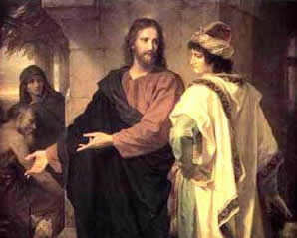
Christ and the Rich Young Ruler, by Heinrich Hofmann
Jesus teaches the difficulty of rich people entering the kingdom of heaven, for in order to inherit eternal life one must forsake all worldly things; he that forsakes in this world shall receive manifold in return. The gifts from God are given by grace, for even after sacrificing everything of the world we still are unprofitable servants.
1 And when Jesus was gone forth into the way, there came one running, and kneeled to him, and asked him, Good Master, what good thing shall I do, that I may have eternal life?
2 And he said unto him, Why callest thou me good? there is none good but one, that is, God: but if thou wilt enter into life, keep the commandments.
3 He saith unto him, Which? Jesus said, Thou shalt do no murder, Thou shalt not commit adultery, Thou shalt not steal, Thou shalt not bear false witness,
4 Honour thy father and thy mother: and, Thou shalt love thy neighbour as thyself.
5 The young man saith unto him, All these things have I kept from my youth up: what lack I yet?
6 Then Jesus beholding him loved him, and said unto him, One thing thou lackest, if thou wilt be perfect, go and sell that thou hast, and give to the poor, and thou shalt have treasure in heaven: and come, take up the cross, and follow me.
7 But when the young man heard that saying, he went away sorrowful: for he had great possessions.
8 Then said Jesus unto his disciples, Verily I say unto you, That a rich man shall hardly enter into the kingdom of heaven.
9 And the disciples were astonished at his words. But Jesus answereth again, and saith unto them, Children, how hard is it for them that trust in riches to enter into the kingdom of God!
10 And again I say unto you, It is easier for a camel to go through the eye of a needle, than for a rich man to enter into the kingdom of God.
11 When his disciples heard it, they were astonished out of measure, and said in their hearts, Who then can be saved?
12 But Jesus beheld their thoughts, and said unto them, With men that trust in riches, it is impossible; but not impossible with men who trust in God and leave all for my sake, for with such all these things I speak are possible.
13 Then answered Peter and said unto him, Behold, we have forsaken all, and followed thee; what shall we have therefore?
14 And Jesus said unto them, Verily I say unto you, That ye which have followed me, in the resurrection when the Son of man shall sit in the throne of his glory, ye also shall sit upon twelve thrones, judging the twelve tribes of Israel.
15 And every one that hath forsaken houses, or brethren, or sisters, or father, or mother, or wife, or children, or lands, for my name’s sake and the gospel’s, he shall receive an hundredfold now in this time, houses, and brethren, and sisters, and mothers, and children, and lands, with persecutions; and in the world to come everlasting life.
16 For the kingdom of heaven is like unto a man that is an householder, which went out early in the morning to hire labourers into his vineyard.
17 And when he had agreed with the labourers for a penny a day, he sent them into his vineyard.
18 And he went out about the third hour, and saw others standing idle in the marketplace,
19 And said unto them; Go ye also into the vineyard, and whatsoever is right I will give you. And they went their way.
20 Again he went out about the sixth and ninth hour, and did likewise.
21 And about the eleventh hour he went out, and found others standing idle, and saith unto them, Why stand ye here all the day idle?
22 They say unto him, Because no man hath hired us. He saith unto them, Go ye also into the vineyard; and whatsoever is right, that shall ye receive.
23 So when even was come, the lord of the vineyard saith unto his steward, Call the labourers, and give them their hire, beginning from the last unto the first.
24 And when they came that were hired about the eleventh hour, they received every man a penny.
25 But when the first came, they supposed that they should have received more; and they likewise received every man a penny.
26 And when they had received it, they murmured against the goodman of the house,
27 Saying, These last have wrought but one hour, and thou hast made them equal unto us, which have borne the burden and heat of the day.
28 But he answered one of them, and said, Friend, I do thee no wrong: didst not thou agree with me for a penny?
29 Take that thine is, and go thy way: I will give unto this last, even as unto thee.
30 Is it not lawful for me to do what I will with mine own? Is thine eye evil, because I am good?
31 For which of you, having a servant plowing or feeding cattle, will say unto him by and by, when he is come from the field, Go and sit down to meat?
32 And will not rather say unto him, Make ready wherewith I may sup, and gird thyself, and serve me, till I have eaten and drunken; and afterward thou shalt eat and drink?
33 Doth he thank that servant because he did the things that were commanded him? I trow not.
34 So likewise ye, when ye shall have done all those things which are commanded you, say, We are unprofitable servants: we have done that which was our duty to do.
35 But there are many who make themselves first, that shall be last; and the last first. For the last shall be first, and the first last: for many be called, but few chosen. This he said, rebuking Peter.
Taken from Matthew 19:16-30, Matthew 20:1-16, Mark 10:16-31, Luke 17:7-10, Luke 18:17-30
1. See also: Luke 10:25; TG Eternity
2. See also: TG God, Perfection of; Ether 4:12; Prov. 4:22; 1 Ne. 22:31
3. See also: TG Blood, Shedding of; Murder; Adultery; Stealing; Fraud; Prov. 25:18; D&C 42:21; 42:24; 42:79; 66:10
4. See also: TG Family, Children, Duties of; Honoring Father and Mother; Citizenship; Love; Fellowshipping; Neighbor
6. See also: TG Commitment; Perfection; Almsgiving; Charity; Sacrifice; Generosity; Poor; Treasure; Jesus Christ, Exemplar; Alma 1:27; 22:15; Mosiah 4:26; D&C 42:30
8. See also: 2 Ne. 9:30; Jacob 2:19; D&C 6:7
9. See also: Jacob 2:19; TG Treasure
10. See also: Prov. 18:11
12. See also: Job 42:2; TG God, Power of
14. See also: Morm. 3:18; D&C 29:12; TG Apostles; Judgment, The Last
15. See also: D&C 19:36; 104:2; 132:55; TG Self-sacrifice; Name; Exaltation; Reward
16. See also: TG Labor
17. See also: TG Vineyard of the Lord
18. See also: Alma 38:12
21. See also: D&C 33:3
23. See also: D&C 39:13; TG Wages
34. See also: Rom. 3:12; Mosiah 2:21; TG Humility; Ingratitude; Duty
35. See also: D&C 29:30; Jacob 5:63; TG Called of God; Foreordination

Commentary
- It is self-evident from the scriptures that the Father, the Son, and the Holy Ghost are separate persons, three divine beings.

Chapter Ninety-Eight
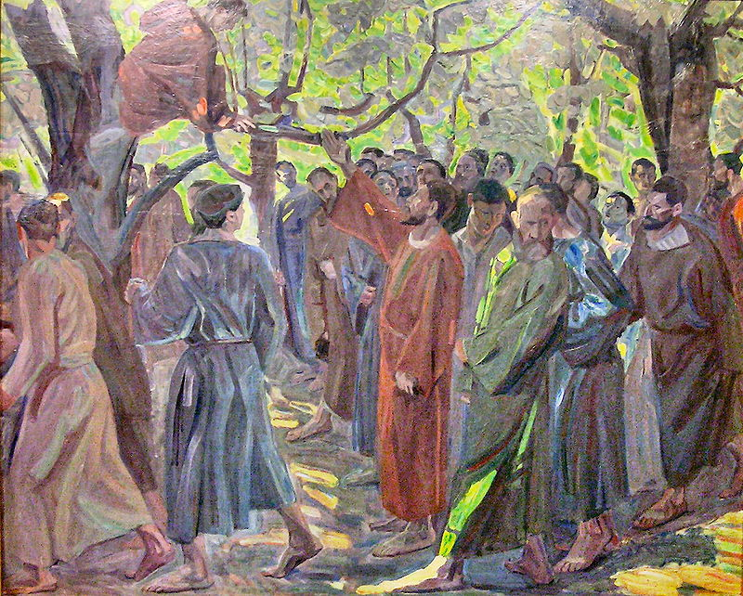
Zacchaeus, by Niels Larsen Stevns
Jesus is received by Zacchaeus in Jericho.
1 And Jesus entered and passed through Jericho.
2 And, behold, there was a man named Zacchæus, which was the chief among the publicans, and he was rich.
3 And he sought to see Jesus who he was; and could not for the press, because he was little of stature.
4 And he ran before, and climbed up into a sycomore tree to see him: for he was to pass that way.
5 And when Jesus came to the place, he looked up, and saw him, and said unto him, Zacchæus, make haste, and come down; for to day I must abide at thy house.
6 And he made haste, and came down, and received him joyfully.
7 And when they saw it, they all murmured, saying, That he was gone to be guest with a man that is a sinner.
8 And Zacchæus stood, and said unto the Lord; Behold, Lord, the half of my goods I give to the poor; and if I have taken any thing from any man by false accusation, I restore him fourfold.
9 And Jesus said unto him, This day is salvation come to this house, forsomuch as he also is a son of Abraham.
10 For the Son of man is come to seek and to save that which was lost.
Taken from Luke 19:1-10
6. See also: TG Hospitality
8. See also: 2 Sam. 12:6
10. See also: TG Life, Sanctity of; Ezek. 34:16; 2 Ne. 26:25

Chapter Ninety-Nine
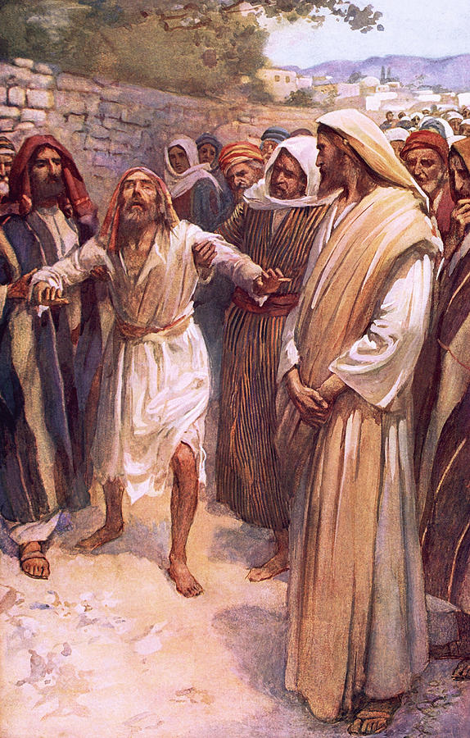
Bartimaeus, by Harold Copping
Jesus heals blind men/man outside of Jericho (Matthew’s account says there were two men, Mark’s and Luke’s accounts say there was one man).
1 And as Jesus and his disciples departed from Jericho, a great multitude followed him.
2 And, behold, two blind men sitting by the way side, when hearing the multitude pass by, asked what it meant.
3 And they told them, that Jesus of Nazareth passeth by.
4 When they heard that Jesus passed by, one Bartimæus, the son of Timæus cried out, saying, Have mercy on us, O Lord, thou Son of David.
5 And many charged him that he should hold his peace: but he cried the more a great deal, Thou Son of David, have mercy on me.
6 And Jesus stood still, and commanded him to be called. And they call the blind man, saying unto him, Be of good comfort, rise; he calleth thee.
7 And he, casting away his garment, rose, and came to Jesus.
8 And Jesus answered and said unto him, What wilt thou that I should do unto thee? The blind man said unto him, Lord, that we might receive our sight.
9 So Jesus had compassion on them, and touched their eyes, and sayeth unto them, Receive thy sight: thy faith hath saved thee: and immediately their eyes received sight, and they followed him, glorifying God: and all the people, when they saw it, gave praise unto God.
Taken from Matthew 20:29-34, Mark 10:46-52, Luke 18:35-43
2. See also: Matt. 9:28; John 9:1; Mosiah 3:5; 3 Ne. 17:9; D&C 84:69
6. See also: 1 Ne. 17:51
9. See also: TG Compassion; Sight; D&C 42:48; 58:43; Luke 5:25

Chapter One Hundred
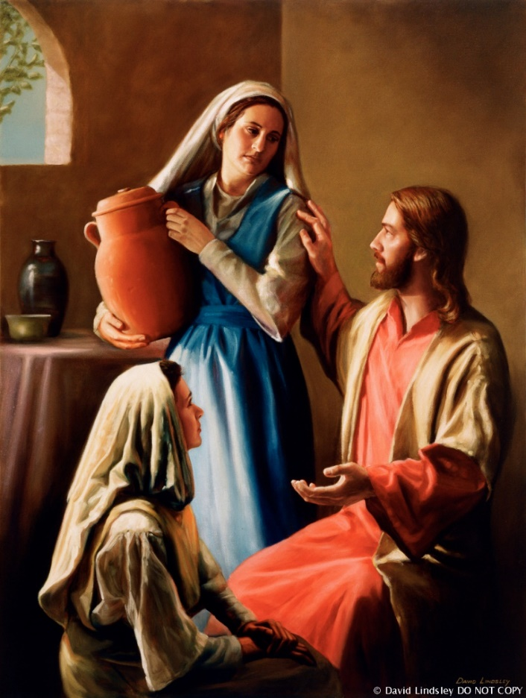
Christ in the Home of Mary and Martha, by David Lindsley
Jesus visits Mary and Martha, sisters of Lazarus.
1 Now it came to pass, as they went, that Jesus entered Bethany: and a certain woman named Martha received him into her house.
2 And she had a sister called Mary, which also sat at Jesus’ feet, and heard his word.
3 But Martha was cumbered about much serving, and came to him, and said, Lord, dost thou not care that my sister hath left me to serve alone? Bid her therefore that she help me.
4 And Jesus answered and said unto her, Martha, Martha, thou art careful and troubled about many things:
5 But one thing is needful: and Mary hath chosen that good part, which shall not be taken away from her.
Taken from Luke 10:38-42
1. See also: John 11:1; 12:2
5. See also: TG Agency

Chapter One Hundred and One
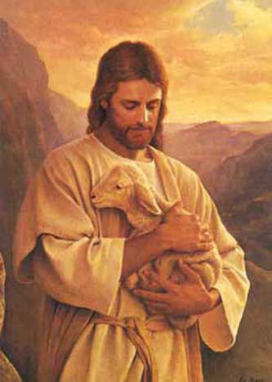
The Lost Lamb, by Del Parson
Jesus and his disciples attend the Feast of the Dedication in Jerusalem. Jesus teaches that he is the good shepherd and that the Father’s and his work is one. The Jews seek to kill him; Jesus and his disciples flee to Perea, the place beyond Jordan where John first baptized.
1 And it came to pass Jesus and his disciples entered into Jerusalem for the feast of the dedication, and it was winter.
2 And Jesus taught the people saying, Verily, verily, I say unto you, He that entereth not by the door into the sheepfold, but climbeth up some other way, the same is a thief and a robber.
3 But he that entereth in by the door is the shepherd of the sheep.
4 To him the porter openeth; and the sheep hear his voice: and he calleth his own sheep by name, and leadeth them out.
5 And when he putteth forth his own sheep, he goeth before them, and the sheep follow him: for they know his voice.
6 And a stranger will they not follow, but will flee from him: for they know not the voice of strangers.
7 This parable spake Jesus unto them: but they understood not what things they were which he spake unto them.
8 Then said Jesus unto them again, Verily, verily, I say unto you, I am the door of the sheep.
9 All that ever came before me who testifieth not of me are thieves and robbers: but the sheep did not hear them.
10 I am the door: by me if any man enter in, he shall be saved, and shall go in and out, and find pasture.
11 The thief cometh not, but for to steal, and to kill, and to destroy: I am come that they might have life, and that they might have it more abundantly.
12 I am the good shepherd: the good shepherd giveth his life for the sheep.
13 But he that is an hireling, and not the shepherd, whose own the sheep are not, seeth the wolf coming, and leaveth the sheep, and fleeth: and the wolf catcheth them, and scattereth the sheep.
14 The ªhireling fleeth, because he is an hireling, and careth not for the sheep.
15 I am the good shepherd, and know my sheep, and am known of mine.
16 As the Father knoweth me, even so know I the Father: and I lay down my life for the sheep.
17 And other sheep I have, which are not of this fold: them also I must bring, and they shall hear my voice; and there shall be one fold, and one shepherd.
18 Therefore doth my Father love me, because I lay down my life, that I might take it again.
19 No man taketh it from me, but I lay it down of myself. I have power to lay it down, and I have power to take it again. This commandment have I received of my Father.
20 There was a division therefore again among the Jews for these sayings.
21 And many of them said, He hath a devil, and is mad; why hear ye him?
22 Others said, These are not the words of him that hath a devil. Can a devil open the eyes of the blind?
23 Then Jesus walked in the temple in Solomon’s porch. And came the Jews round about him, and said unto him, How long dost thou make us to doubt? If thou be the Christ, tell us plainly.
24 Jesus answered them, I told you, and ye believed not: the works that I do in my Father’s name, they bear witness of me.
25 But ye believe not, because ye are not of my sheep, as I said unto you.
26 My sheep hear my voice, and I know them, and they follow me:
27 And I give unto them eternal life; and they shall never perish, neither shall any man pluck them out of my hand.
28 My Father, which gave them me, is greater than all; and no man is able to pluck them out of my Father’s hand.
29 I and my Father are one.
30 Then the Jews took up stones again to stone him.
31 Jesus answered them, Many good works have I shewed you from my Father; for which of those works do ye stone me?
32 The Jews answered him, saying, For a good work we stone thee not; but for blasphemy; and because that thou, being a man, makest thyself God.
33 Jesus answered them, Is it not written in your law, I said, Ye are gods?
34 If he called them gods, unto whom the word of God came, and the scripture cannot be broken;
35 Say ye of him, whom the Father hath sanctified, and sent into the world, Thou blasphemest; because I said, I am the Son of God?
36 If I do not the works of my Father, believe me not.
37 But if I do, though ye believe not me, believe the works: that ye may know, and believe, that the Father is in me, and I in him.
38 Therefore they sought again to take him: but he escaped out of their hand,
39 And went away again beyond Jordan into the place where John at first baptized; and there he abode.
40 And many resorted unto him, and said, John did no miracle: but all things that John spake of this man were true.
41 And many believed on him there.
Taken from John 10:1-42
3. See also: TG Sheep
4. See also: D&C 35:21; Isa. 55:4
5. See also: TG Discernment, Spiritual; Revelation
6. See also: TG Strangers
8. See also: John 14:6
11. See also: TG Stealing; Abundant Life; Happiness; D&C 66:2
12. See also: TG Shepherds; Ezek. 34:2
13. See also: TG Leadership
14. See also: TG Wages
15. See also: TG Jesus Christ, Good Shepherd; Ex. 33:12; 1 Cor. 8:3; 3 Ne. 18:31
16. See also: TG Jesus Christ, Relationships with the Father; Jesus Christ, Atonement through; Martyrdom; 1 Jn. 3:16
17. See also: 3 Ne. 15:21; 16:1; D&C 10:59; Ezek. 37:22; TG Israel, Scattering; Book of Mormon; Israel, Joseph, People of; Israel, Tribes of, Ten Lost; Sheep
18. See also: Luke 23:46; TG Death, Power over; God, Power of; Jesus Christ, Authority of
23. See also: 1 Kgs. 6:3; Acts 3:11; TG Doubt
24. See also: TG Faith; Unbelief, Unbelievers; Miracles; Name; John 5:36
26. See also: TG Sheep; D&C 38:22
28. See also: John 17:2; D&C 50:41
29. See also: D&C 93:3; TG Godhead; Unity
30. See also: John 8:59
32. See also: TG Blasphemy; John 5:18; 19:7; 1 Tim. 3:16
33. See also: TG Man, Potential to Become Like Heavenly Father; Sons and Daughters of God
35. See also: TG Sanctification; Jesus Christ, Messenger of the Covenant; Jesus Christ, Divine Sonship
37. See also: TG Faith; Godhead
38. See also: John 7:30

Chapter One Hundred and Two
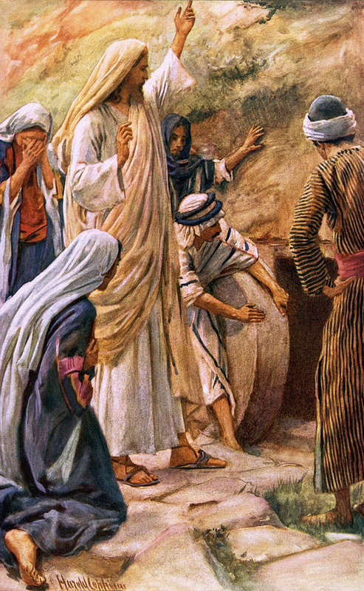
Lazarus Come Forth, by Harold Copping
Jesus goes from Perea and raises Lazarus from the dead.
1 And it came to pass Lazarus, the brother of Mary and Martha, of Bethany, was sick.
2 Therefore his sisters sent unto Jesus, saying, Lord, behold, he whom thou lovest is sick.
3 When Jesus heard that, he said, This sickness is not unto death, but for the glory of God, that the Son of God might be glorified thereby.
4 Now Jesus loved Martha, and her sister, and Lazarus.
5 When he had heard therefore that he was sick, he abode two days still in the same place where he was.
6 Then after that saith he to his disciples, Let us go into Judæa again.
7 His disciples say unto him, Master, the Jews of late sought to stone thee; and goest thou thither again?
8 Jesus answered, Are there not twelve hours in the day? If any man walk in the day, he stumbleth not, because he seeth the light of this world.
9 But if a man walk in the night, he stumbleth, because there is no light in him.
10 These things said he: and after that he saith unto them, Our friend Lazarus sleepeth; but I go, that I may awake him out of sleep.
11 Then said his disciples, Lord, if he sleep, he shall do well.
12 Howbeit Jesus spake of his death: but they thought that he had spoken of taking of rest in sleep.
13 Then said Jesus unto them plainly, Lazarus is dead.
14 And I am glad for your sakes that I was not there, to the intent ye may believe; nevertheless let us go unto him.
15 Then said Thomas, which is called Didymus, unto his fellow disciples, Let us also go, that we may die with him for they feared lest the Jews should take Jesus and put him to death, for as yet they did not understand the power of God.
16 Then when Jesus came to Bethany, to Martha’s house, Lazarus had already been in the grave four days.
17 Now Bethany was nigh unto Jerusalem, about fifteen furlongs off:
18 And many of the Jews came to Martha and Mary, to comfort them concerning their brother.
19 Then Martha, as soon as she heard that Jesus was coming, went and met him: but Mary sat still in the house.
20 Then said Martha unto Jesus, Lord, if thou hadst been here, my brother had not died.
21 But I know, that even now, whatsoever thou wilt ask of God, God will give it thee.
22 Jesus saith unto her, Thy brother shall rise again.
23 Martha saith unto him, I know that he shall rise again in the resurrection at the last day.
24 Jesus said unto her, I am the resurrection, and the life: he that believeth in me, though he were dead, yet shall he live:
25 And whosoever liveth and believeth in me shall never die. Believest thou this?
26 She saith unto him, Yea, Lord: I believe that thou art the Christ, the Son of God, which should come into the world.
27 And when she had so said, she went her way, and called Mary her sister secretly, saying, The Master is come, and calleth for thee.
28 As soon as she heard that, she arose quickly, and came unto him.
29 Now Jesus was not yet come into the town, but was in that place where Martha met him.
30 The Jews then which were with her in the house, and comforted her, when they saw Mary, that she rose up hastily and went out, followed her, saying, She goeth unto the grave to weep there.
31 Then when Mary was come where Jesus was, and saw him, she fell down at his feet, saying unto him, Lord, if thou hadst been here, my brother had not died.
32 When Jesus therefore saw her weeping, and the Jews also weeping which came with her, he groaned in the spirit, and was troubled,
33 And said, Where have ye laid him? They said unto him, Lord, come and see.
34 Jesus wept.
35 Then said the Jews, Behold how he loved him!
36 And some of them said, Could not this man, which opened the eyes of the blind, have caused that even this man should not have died?
37 Jesus therefore again groaning in himself cometh to the grave. It was a cave, and a stone lay upon it.
38 Jesus said, Take ye away the stone. Martha, the sister of him that was dead, saith unto him, Lord, by this time he stinketh: for he hath been dead four days.
39 Jesus saith unto her, Said I not unto thee, that, if thou wouldest believe, thou shouldest see the glory of God?
40 Then they took away the stone from the place where the dead was laid. And Jesus lifted up his eyes, and said, Father, I thank thee that thou hast heard me.
41 And I knew that thou hearest me always: but because of the people which stand by I said it, that they may believe that thou hast sent me.
42 And when he thus had spoken, he cried with a loud voice, Lazarus, come forth.
43 And he that was dead came forth, bound hand and foot with graveclothes: and his face was bound about with a napkin. Jesus saith unto them, Loose him, and let him go.
44 Then many of the Jews which came to Mary, and had seen the things which Jesus did, believed on him.
45 But some of them went their ways to the Pharisees, and told them what things Jesus had done.
46 Jesus therefore walked no more openly among the Jews; but went thence unto a country near to the wilderness, into a city called Ephraim, and there continued with his disciples.
47 And the Jews’ passover was nigh at hand: and many went out of the country up to Jerusalem before the passover, to purify themselves.
48 Then sought they for Jesus, and spake among themselves, as they stood in the temple, What think ye, that he will not come to the feast?
49 Now both the chief priests and the Pharisees had given a commandment, that, if any man knew where he were, he should shew it, that they might take him.
Taken from John 11:1-46, 54-57
1. See also: Luke 10:38; John 12:2
3. See also: 3 Ne. 12:16; Ether 12:4; John 9:3
8. See also: TG Walking with God
10. See also: 2 Kgs. 4:31
14. See also: TG Faith
21. See also: TG God, Gifts of
24. See also: TG Jesus Christ, Resurrection; Resurrection; Jesus Christ, Atonement through; Faith; Death; Alma 37:46; Hel. 8:15; 3 Ne. 15:9
25. See also: John 5:24; 8:51; D&C 42:46; 63:49
26. See also: TG God, Body of (Corporeal Nature)
35. See also: D&C 42:45
37. See also: Matt. 27:60
39. See also: Ex. 16:7
40. See also: TG Thanksgiving
41. See also: TG Jesus Christ, Messenger of the Covenant
42. See also: TG God, Power of
43. See also: 2 Kgs. 8:1; John 20:7; TG Death, Power over
47. See also: TG Purification

Chapter One Hundred and Three
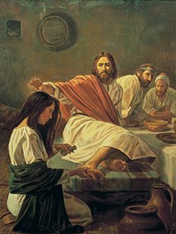
Mary Anoints the Feet of Christ, by Robert T. Barrett
Mary anoints Jesus’ head and feet with oil. Six days before the Passover.
1 Then Jesus six days before the passover came to Bethany, where Lazarus was which had been dead, whom he raised from the dead. And there he sat at meat in the house of Simon the leper.
2 There they made him a supper; and Martha served: but Lazarus was one of them that sat at the table with him.
3 Then came unto Jesus Mary, the sister of Martha and Lazarus, having an alabaster box of a pound of ointment of spikenard, very precious and costly, and she brake the box, and poured it on his head. And anointed the feet of Jesus, and wiped his feet with her hair: and the house was filled with the odour of the ointment.
4 And there were some that had indignation within themselves, and said in their hearts, Why was this waste of the ointment made?
5 When Jesus perceived and understood their hearts, he said unto them, Let Mary alone, why trouble ye her? for she hath wrought a good work upon me.
6 Then saith one of his disciples, Judas Iscariot, Simon’s son, which should betray him,
7 Why was not this ointment sold for three hundred pence, and given to the poor?
8 This he said, not that he cared for the poor; but because he was a thief, and had the bag, and bare what was put therein.
9 Then said Jesus, Ye have the poor with you always, and whensoever ye will ye may do them good: but me ye have not always.
10 She hath done what she could: and this which she has done unto me, shall be had in remembrance in generations to come, wheresoever my gospel shall be preached; for verily she has come beforehand to anoint my body to the burying.
11 Verily I say unto you, Wheresoever this gospel shall be preached throughout the whole world, this also that she hath done shall be spoken of for a memorial of her.
12 And it came to pass that many people of the Jews, knowing that Jesus was there, came unto him, and they came not for Jesus’ sake only, but that they might see Lazarus also, whom Jesus had raised from the dead.
13 Therefore the chief priests consulted that they might put Lazarus also to death;
14 Because that by reason of Lazarus many of the Jews went away, and believed on Jesus.
Taken from Matthew 26:7-13, Mark 14:3-9, John 12:1-11
2. See also: Luke 10:38; John 11:1
4. See also: D&C 117:4; TG Waste
5. See also: TG Benevolence
8. See also: Mosiah 2:36; John 13:29
9. See also: TG Poor

Chapter One Hundred and Four
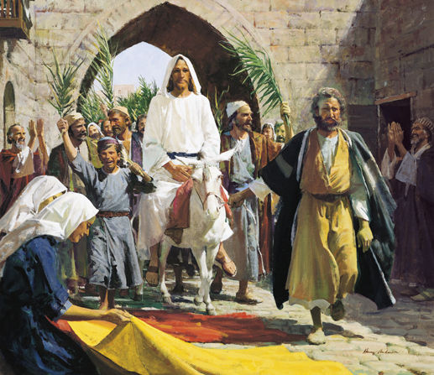
Triumphal Entry, by Harry Anderson
Jesus’ triumphal entry into Jerusalem. Five days before Passover.
1 And they were in the way going up to Jerusalem; and Jesus went before them: and they were amazed; and as they followed, they were afraid. And he took again the twelve, and began to tell them what things should happen unto him,
2 Saying, Behold, we go up to Jerusalem and all things that are written by the prophets concerning the Son of man shall be accomplished; for the Son of man shall be delivered unto the chief priests, and unto the scribes; and they shall condemn him to death, and shall deliver him to the Gentiles:
3 And they shall mock him, and shall scourge him, and shall spit upon him, and shall crucify him: and the third day he shall rise again.
4 And they understood none of these things: and this saying was hid from them, neither knew they the things which were spoken.
5 And when they drew nigh unto Jerusalem, and were come to Bethphage, unto the mount of Olives, then sent Jesus two disciples,
6 Saying unto them, Go into the village over against you, and straightway ye shall find an ass tied, and a colt with her: loose them, and bring them unto me.
7 And if any man say ought unto you, ye shall say, The Lord hath need of them; and straightway he will send them.
8 All this was done, that it might be fulfilled which was spoken by the prophet, saying,
9 Tell ye the daughter of Sion, Behold, thy King cometh unto thee, meek, and sitting upon an ass, and a colt the foal of an ass.
10 And the disciples went, and did as Jesus commanded them.
11 These things understood not his disciples at the first: but when Jesus was glorified, then remembered they that these things were written of him, and that they had done these things unto him.
12 And they went their way, and found the colt tied by the door without in a place where two ways met; and they loose him.
13 And certain of them that stood there said unto them, What do ye, loosing the colt?
14 And they said unto them even as Jesus had commanded: and they let them go.
15 And brought the ass, and brought the colt, and put on it their clothes; and Jesus took the colt and sat thereon; and they followed him.
16 And it came to pass that those who had witnessed Jesus raising Lazarus from the dead, when they had come up to Jerusalem for the feast of the Passover bear record to many of what Jesus had done, for there were many who were come to the feast. And when they had heard of the miracle that Jesus had done and that Jesus was coming to Jerusalem, took branches of palm trees and went forth to meet him; spreading the branches they had cut in the way. And others layed down their garments.
17 And the multitudes that went before, and that followed, began to rejoice and praise God with a loud voice for all the mighty works that they had seen, crying, Hosanna to the Son of David: Blessed is he that cometh in the name of the Lord: that bringeth the kingdom of our father David; Hosanna in the highest. Blessed be the King: peace in heaven, and glory in the highest.
18 And some of the Pharisees from among the multitude said unto him, Master, rebuke thy disciples.
19 And he answered and said unto them, I tell you that, if these should hold their peace, the stones would immediately cry out.
20 The Pharisees therefore said among themselves, Perceive ye how ye prevail nothing? behold, the world is gone after him.
21 And when he was come into Jerusalem, all the city was moved, saying, Who is this?
22 And the multitude said, This is Jesus the prophet of Nazareth of Galilee.
Taken from Matthew 20:17-19, Matthew 21:1-11, Mark 10:32-34, Mark 11:1-11, Luke 18:31-34, Luke 19:28-40, John 12:12-19
2. See also: TG Jesus Christ, Son of Man; Scribes; Jesus Christ, Betrayal of; Jesus Christ, Death of; 1 Ne. 11:33; 2 Ne. 10:3; Mosiah 3:9
3. See also: TG Mocking; Jesus Christ, Trial of; Jesus Christ, Crucifixion of; Martyrdom; Jesus Christ, Resurrection
9. See also: Isa. 62:11; Zech. 9:9
11. See also: Luke 9:45
15. See also: Zech. 9:9
16. See also: Matt. 8:34; D&C 63:10
17. See also: Ps. 118:25-26; Luke 2:14
20. See also: Matt. 9:31

Chapter One Hundred and Five
Jerusalem Jerusalem, by James Tissot
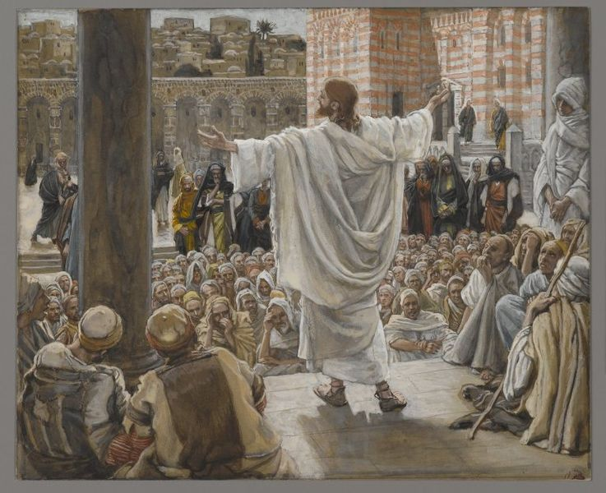
A voice from Heaven proclaims that “I have both glorified it, and will glorify it again.” Jesus begins his daily teachings in the temple, while the Pharisees’ hatred escalates.
1 And there were certain Greeks among them that came up to worship at the feast:
2 The same came therefore to Philip, which was of Bethsaida of Galilee, and desired him, saying, Sir, we would see Jesus.
3 Philip cometh and telleth Andrew: and again Andrew and Philip tell Jesus.
4 And Jesus answered them, saying, The hour is come, that the Son of man should be glorified.
5 Verily, verily, I say unto you, Except a corn of wheat fall into the ground and die, it abideth alone: but if it die, it bringeth forth much fruit.
6 He that loveth his life shall lose it; and he that hateth his life in this world shall keep it unto life eternal.
7 If any man serve me, let him follow me; and where I am, there shall also my servant be: if any man serve me, him will my Father honour.
8 Now is my soul troubled; and what shall I say? Father, save me from this hour: but for this cause came I unto this hour.
9 Father, glorify thy name. Then came there a voice from heaven, saying, I have both glorified it, and will glorify it again.
10 The people therefore, that stood by, and heard it, said that it thundered: others said, An angel spake to him.
11 Jesus answered and said, This voice came not because of me, but for your sakes.
12 Now is the judgment of this world: now shall the prince of this world be cast out.
13 And I, if I be lifted up from the earth, will draw all men unto me.
14 This he said, signifying what death he should die.
15 The people answered him, We have heard out of the law that Christ abideth for ever: and how sayest thou, The Son of man must be lifted up? who is this Son of man?
16 Then Jesus said unto them, Yet a little while is the light with you. Walk while ye have the light, lest darkness come upon you: for he that walketh in darkness knoweth not whither he goeth.
17 While ye have light, believe in the light, that ye may be the children of light. These things spake Jesus, and departed, and did hide himself from them.
18 But though he had done so many miracles before them, yet they believed not on him:
19 Nevertheless among the chief rulers also many believed on him; but because of the Pharisees they did not confess him, lest they should be put out of the synagogue:
20 For they loved the praise of men more than the praise of God.
21 And Jesus did begin from this time forward to teach daily in the temple, while the chief priests and the scribes and the chief of the people sought to destroy him, but could not find what they might do: for all the people were very attentive to hear him.
22 And when Jesus had looked round about upon all things in Jerusalem, and now the eventide was come, he went out unto Bethany with the twelve and he lodged there.
Taken from Matthew 21:17, Mark 11:11, Luke 19:47-48, John 12:20-37, 42-43
1. See also: Acts 17:4; 8:27
4. See also: John 7:30; TG Jesus Christ, Mission of
5. See also: 1 Cor. 15:36; TG Death
6. See also: TG Hate
7. See also: 2 Ne. 31:12
9. See also: TG Godhead; Witness of the Father; D&C 45:4
10. See also: TG Angels
12. See also: TG Devil
13. See also: TG Jesus Christ, Atonement through; Jesus Christ, Crucifixion of; D&C 18:11
14. See also: TG Jesus Christ, Death of
15. See also: 2 Sam. 7:16
16. See also: TG Light of Christ; Light; Darkness, Spiritual; Walking in Darkness
17. See also: TG Faith; Children of Light
18. See also: TG Miracles; Signs; Mosiah 3:9
19. See also: Acts 6:7; John 8:30; Prov. 29:25; John 19:38
20. See also: Mark 12:38; 1 Cor. 1:26; 1 Ne. 8:28; Alma 11:24; D&C 3:7

Chapter One Hundred and Six
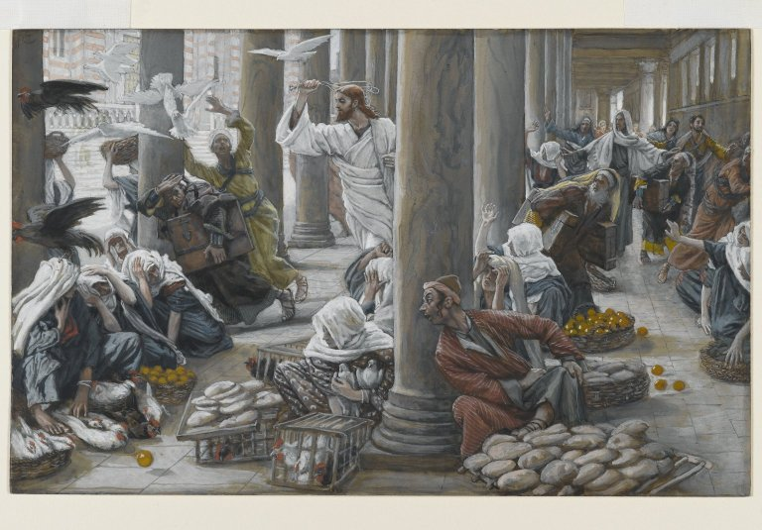
The Merchants Chased from the Temple, by James Tissot
Jesus withers a barren fig tree and cleanses the temple. Four days before Passover.
1 And on the morrow, when they were come from Bethany, Jesus was hungry:
2 And seeing a fig tree in the way afar off having leaves, he came, if haply he might find any thing thereon, for the time of figs was indicated by its leaves: but when he came to it, he found nothing but leaves.
3 And Jesus answered and said unto it, No man eat fruit of thee hereafter for ever. And his disciples heard it.
4 And they come to Jerusalem: and Jesus went into the temple, and found in the temple those that sold oxen and sheep and doves, and the changers of money sitting:
5 And when he had made a scourge of small cords, began to cast out of the temple them that sold and bought with their sheep, and the oxen; and poured out the changers’ money, and overthrew the tables and the seats of them that sold doves;
6 And said unto them that sold doves, Take these things hence; make not my Father’s house an house of merchandise. And he taught, saying unto them, Is it not written, My house shall be called of all nations the house of prayer? But ye have made it a den of thieves.
7 And his disciples remembered that it was written, The zeal of thine house hath eaten me up.
8 And Jesus would not suffer that any man should carry even a vessel through the temple.
9 And the scribes and chief priests heard it, and sought how they might destroy him: for they feared him, because all the people was astonished at his doctrine.
10 And when even was come, he went out of Jerusalem to Bethany and again lodged there.
Taken from Matthew 21:12-13, 18-22, Mark 11:12-19, Luke 19:45-46, John 2:14-17
3. See also: TG Vineyard of the Lord
4. See also: Ps. 69:9
6. See also: Isa. 56:7; Jer. 7:11; D&C 94:8; 109:20; Ps. 27:4; TG Temple; Prayer
7. See also: TG Zeal
9. See also: TG Jesus Christ, Betrayal of

Chapter One Hundred and Seven
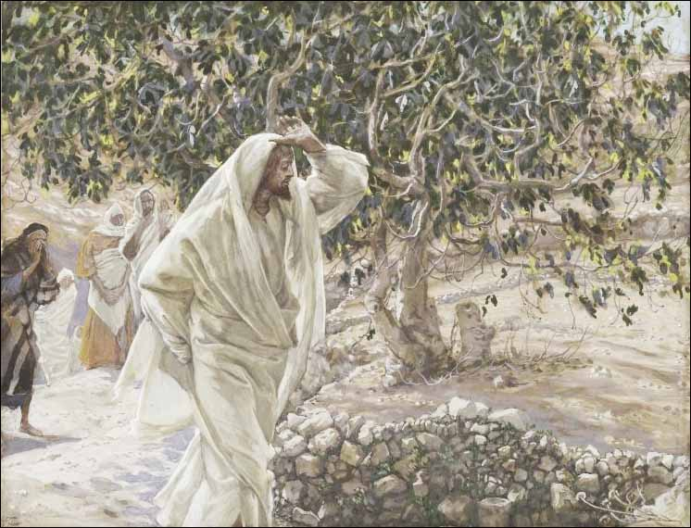
The Accursed Fig Tree, by James Tissot
Three days before Passover. Jesus teaches about faith and the matter of authority.
1 And in the morning, as they journeyed again from Bethany to Jerusalem, they saw the fig tree dried up from the roots.
2 And when the disciples saw it, they marvelled, saying, How soon is the fig tree withered away!
3 And Peter calling to remembrance saith unto him, Master, behold, the fig tree which thou cursedst is withered away.
4 And Jesus answering saith unto them, Have faith in God.
5 And the apostles said unto the Lord, Increase our faith.
6 And the Lord said, If ye had faith as a grain of mustard seed, ye might say unto this sycamine tree, Be thou plucked up by the root, and be thou planted in the sea; and it should obey you.
7 For verily I say unto you, That whosoever shall say unto this mountain, Be thou removed, and be thou cast into the sea; and shall not doubt in his heart, but shall believe that those things which he saith shall come to pass; he shall have whatsoever he saith.
8 Therefore I say unto you, What things soever ye desire, when ye pray, believe that ye receive them, and ye shall have them.
9 And when ye stand praying, forgive, if ye have ought against any: that your Father also which is in heaven may forgive you your trespasses.
10 But if ye do not forgive, neither will your Father which is in heaven forgive your trespasses.
11 And they come again to Jerusalem: and the blind and the lame came to Jesus in the temple and he healed them.
12 And when the chief priests and scribes saw the wonderful things that he did, and the children of the kingdom crying in the temple, and saying, Hosanna to the Son of David; they were sore displeased,
13 And said unto him, Hearest thou what these say? And Jesus saith unto them, Yea; have ye never read, Out of the mouth of babes and sucklings thou hast perfected praise?
14 And the chief priests, and the scribes, and the elders, say unto him, By what authority doest thou these things? and who gave thee this authority to do these things?
15 And Jesus answered and said unto them, I will also ask of you one question, and answer me, and I will tell you by what authority I do these things.
16 The baptism of John, was it from heaven, or of men? answer me.
17 And they reasoned with themselves, saying, If we shall say, From heaven; he will say, Why then did ye not believe him?
18 But if we shall say, Of men; they feared the people lest they would stone them: for all men counted John, that he was a prophet indeed.
19 And they answered and said unto Jesus, We cannot tell. And Jesus answering saith unto them, Neither do I tell you by what authority I do these things.
Taken from Matthew 21:20-27, Mark 11:20-33, Luke 17:5-6
4. See also: TG Faith
6. See also: Moses 7:13
7. See also: TG Doubt
8. See also: TG Prayer; 3 Ne. 18:20; D&C 29:6
9. See also: TG Prayer; Forgiveness
10. See also: D&C 64:9
14. See also: TG Priesthood, Authority
15. See also: TG Authority
18. See also: Matt. 11:9; 14:5
Chapter One Hundred and Eight
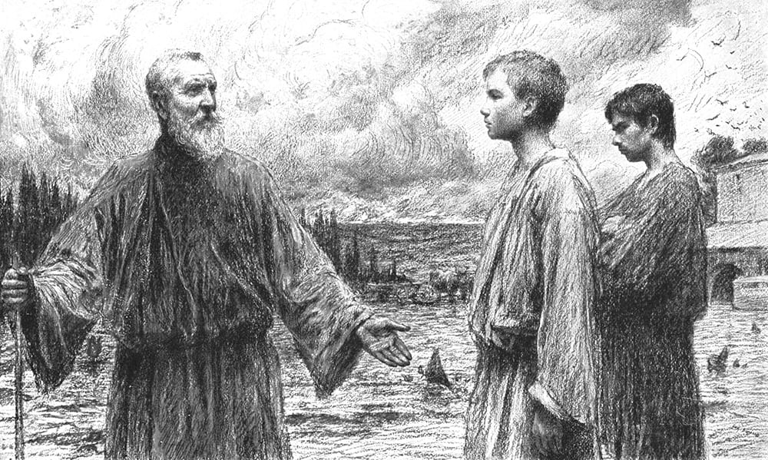
Jesus teaches the parable of the two sons.
1 But what think ye? A certain man had two sons; and he came to the first, and said, Son, go work to day in my vineyard.
2 He answered and said, I will not: but afterward he repented, and went.
3 And he came to the second, and said likewise. And he answered and said, I go, sir: and went not.
4 Whether of them twain did the will of his father? They say unto him, The first. Jesus saith unto them, Verily I say unto you, That the publicans and the harlots go into the kingdom of God before you.
5 For John came unto you in the way of righteousness, and ye believed him not: but the publicans and the harlots believed him: and ye, afterward, when ye had seen me, repented not, that ye might believe him. For he that believeth not John concerning me, cannot believe me, except he first repent. And except ye repent, the preaching of John shall condemn you in the day of judgment.
Taken from Matthew 21:28-32
1. See also: Jacob 5:71
3. See also: TG Hypocrisy; D&C 41:5
5. See also: TG Righteousness; Unbelief, Unbelievers; Luke 3:12; Luke 7:29

Chapter One Hundred and Nine
The Parable of the Wicked Husbandmen, by Marten Van Valckenborch
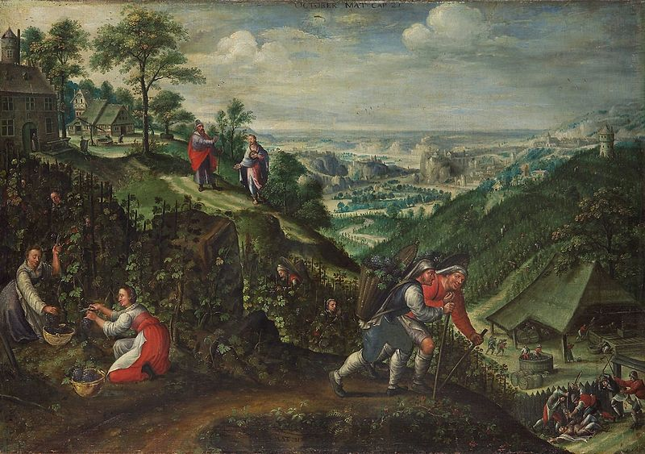
Jesus teaches the parable of the wicked husbandmen.
1 And again, hear another parable: for unto you that believe not, I speak in parables; that your unrighteousness may be rewarded unto you. There was a certain householder, which planted a vineyard, and hedged it round about, and digged a winepress in it, and built a tower, and let it out to husbandmen, and went into a far country:
2 And when the time of the fruit drew near, he sent his servants to the husbandmen, that they might receive the fruits of it.
3 And they caught him, and beat him, and sent him away empty.
4 And again he sent unto them another servant; and at him they cast stones, and wounded him in the head, and sent him away shamefully handled.
5 And again he sent another; and him they killed, and many others; beating some, and killing some.
6 Having yet therefore one son, his wellbeloved, he sent him also last unto them, saying, They will reverence my son.
7 But when the husbandmen saw the son, they said among themselves, This is the heir; come, let us kill him, and let us seize on his inheritance.
8 And they caught him, and slew him and cast him out of the vineyard.
9 When the lord therefore of the vineyard cometh, what will he do unto those husbandmen?
10 And when the Lord therefore of the vineyard cometh, he will destroy those miserable, wicked men, and will let again his vineyard unto other husbandmen, even in the last days, who shall render him the fruits in their seasons. And when they heard it, they said, God forbid.
11 And then understood they the parable which he spake unto them, that the Gentiles should be destroyed also, when the Lord should descend out of heaven to reign in his vineyard, which is the earth and the inhabitants thereof.
Taken from Matthew 21:33-41, 53, Mark 12:1-9, Luke 20:9-16
1. See also: TG Vineyard of the Lord; Stewardship; Watchmen
7. See also: John 11:53; Heb. 1:2

Chapter One Hundred and Ten
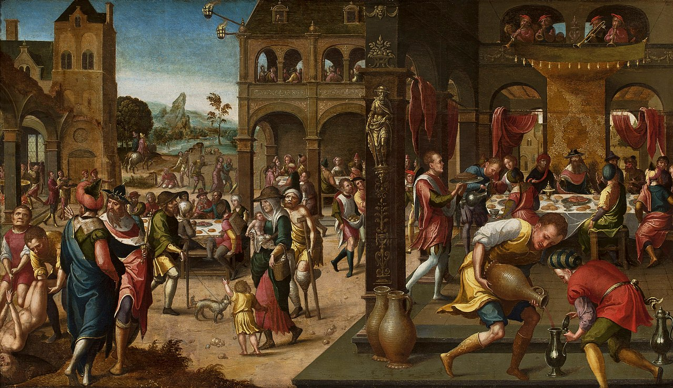
The Parable of the Great Banquet, by Brunswick Monogrammist
Jesus teaches the parable of the marriage of the king’s son.
1 Then said Jesus also to them that bade him, When thou makest a dinner or a supper, call not thy friends, nor thy brethren, neither thy kinsmen, nor thy rich neighbours; lest they also bid thee again, and a recompence be made thee.
2 But when thou makest a feast, call the poor, the maimed, the lame, the blind:
3 And thou shalt be blessed; for they cannot recompense thee: for thou shalt be recompensed at the resurrection of the just.
4 And when one of them that sat at meat with him heard these things, he said unto him, Blessed is he that shall eat bread in the kingdom of God.
5 Then Jesus spake unto them again by parables, and said,
6 The kingdom of heaven is like unto a certain king, which made a marriage for his son,
7 And sent forth his servants to call them that were bidden to the wedding: and they would not come.
8 Again, he sent forth other servants, saying, Tell them which are bidden, Behold, I have prepared my dinner: my oxen and my fatlings are killed, and all things are ready: come unto the marriage.
9 But they made light of it, and they all with one consent began to make excuse. The first said unto him, I have bought a piece of ground, and I must needs go and see it: I pray thee have me excused.
10 And another said, I have bought five yoke of oxen, and I go to prove them: I pray thee have me excused.
11 And another said, I have married a wife, and therefore I cannot come.
12 And they went their ways, one to his farm, another to his merchandise:
13 And the remnant took his servants, and entreated them spitefully, and slew them.
14 But when the king heard thereof, he was wroth: and he sent forth his armies, and destroyed those murderers, and burned up their city.
15 Then saith he to his servants, The wedding is ready, but they which were bidden were not worthy.
16 Go ye therefore quickly into the streets and lanes of the city, and bring in hither the poor, and the maimed, and the halt, and the blind, and as many as ye shall find, bid to the marriage.
17 And the servants went and did as they were commanded. And when they had returned, the servants said, Lord, it is done as thou hast commanded, and yet there is room.
18 And the lord said unto the servants, Go out into the highways and hedges, and compel them to come in, that my house may be filled.
19 For I say unto you, That none of those men which were bidden shall taste of my supper.
20 So those servants went out into the highways and hedges, and gathered together all as many as they found, both bad and good: and the wedding was furnished with guests.
21 And when the king came in to see the guests, he saw there a man which had not on a wedding garment:
22 And he saith unto him, Friend, how camest thou in hither not having a wedding garment? And he was speechless.
23 Then said the king to the servants, Bind him hand and foot, and take him away, and cast him into outer darkness; there shall be weeping and gnashing of teeth.
24 For many are called, but few are chosen wherefore all do not have on the wedding garment.
Taken from Matthew 22:1-14, Luke 14:12-24
2. See also: TG Generosity; Poor
3. See also: TG Blessings; Resurrection; Matt. 6:4
4. See also: Luke 22:30; Rev. 19:9; TG Bread
6. See also: Luke 5:34; Rev. 19:7; 21:2; D&C 65:3
9. See also: Luke 9:62; D&C 121:35
18. See also: 2 Cor. 5:20
19. See also: Matt. 21:43; Acts 13:46
20. See also: Matt. 13:47
21. See also: Rev. 19:8
23. See also: Matt. 8:12; D&C 77:8; 133:72
24. See also: D&C 121:34

Chapter One Hundred and Eleven
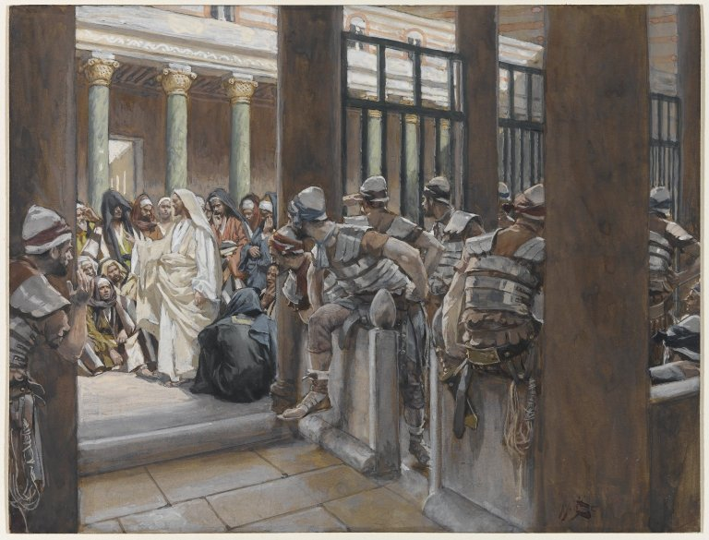
But No Man Laid Hands Upon Him, by James Tissot
Jesus teaches he is the cornerstone.
1 Then Jesus saith unto the chief priests and pharisees, Did ye never read in the scriptures, The stone which the builders rejected, the same is become the head of the corner: this is the Lord’s doing, and it is marvellous in our eyes?
2 Therefore say I unto you, The kingdom of God shall be taken from you, and given to a nation bringing forth the fruits thereof.
3 And whosoever shall fall on this stone shall be broken: but on whomsoever it shall fall, it will grind him to powder.
4 And when the chief priests and Pharisees had heard his parables, they perceived that he spake of them.
5 And they said among themselves, Shall this man think that he alone can spoil this great kingdom? And they were angry with him.
6 But when they sought to lay hands on him, they feared the multitude, because they learned that the multitude took him for a prophet. And they left him and went their way.
7 And henceforth they watched Jesus, and sent forth spies, which should feign themselves just men, that they might take hold of his words, that so they might deliver him unto the power and authority of the governor.
8 And now his disciples came to him, and Jesus said unto them, Marvel ye at the words of the parable which I spake unto them?
9 Verily, I say unto you, I am the stone, and those wicked ones reject me.
10 I am the head of the corner. These Jews shall fall upon me, and shall be broken.
11 And the kingdom of God shall be taken from them, and shall be given to a nation bringing forth the fruits thereof; (meaning the Gentiles.)
12 Wherefore, on whomsoever this stone shall fall, it shall grind him to powder.
Taken from Matthew 21:42-52, Mark 12:10-12, Luke 20:17-20
1. See also: TG Cornerstone; Jesus Christ, Prophecies about; Rock; Luke 9:22; 1 Pet. 2:7; Zech. 10:4
2. See also: Isa. 5:5; Luke 14:24; Acts 13:46; 1 Ne. 13:26; D&C 90:3; Dan. 2:44; Isa. 48:11; TG Nations
3. See also: Isa. 8:14; Luke 2:34; Rom. 9:32; 1 Pet. 2:8
7. See also: Matt. 22:15

Chapter One Hundred and Twelve
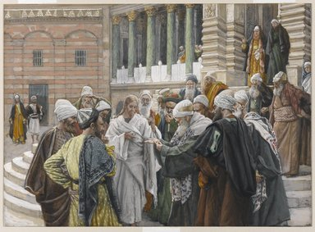
The Tribute Money, by James Tissot
Jesus teaches worldly power isn’t Godly power; render unto Caesar, worldly marriages will not last in heaven.
1 And it came to pass that on another day that Jesus taught in the temple, the Jews send unto him certain of the Pharisees and of the Herodians, to catch him in his words.
2 And when they were come, they say unto him, Master, we know that thou art true, and carest for no man: for thou regardest not the person of men, but teachest the way of God in truth: Is it lawful to give tribute to Cæsar, or not?
3 Shall we give, or shall we not give? But he, knowing their hypocrisy, said unto them, Why tempt ye me? bring me a penny, that I may see it.
4 And they brought it. And he saith unto them, Whose is this image and superscription? And they said unto him, Cæsar’s.
5 And Jesus answering said unto them, Render to Cæsar the things that are Cæsar’s, and to God the things that are God’s. And they marvelled at him and left him and went their way.
6 Then come unto him the Sadducees, which say there is no resurrection; and they asked him, saying,
7 Master, Moses wrote unto us, If a man’s brother die, and leave his wife behind him, and leave no children, that his brother should take his wife, and raise up seed unto his brother.
8 Now there were seven brethren: and the first took a wife, and dying left no seed.
9 And the second took her, and died, neither left he any seed: and the third likewise.
10 And the seven had her, and left no seed: last of all the woman died also.
11 In the resurrection therefore, when they shall rise, whose wife shall she be of them? for the seven had her to wife.
12 And Jesus answering said unto them, Ye do err therefore, because ye know not, and understand not the scriptures, neither the power of God?
13 For the children of this world marry, and are given in marriage:
14 But they which shall be accounted worthy to obtain that world through resurrection from the dead, neither marry, nor are given in marriage:
15 Neither can they die any more: for they are equal unto the angels; and are the children of God, being the children of the resurrection.
16 And as touching the dead, that they rise: have ye not read in the book of Moses, how in the bush God spake unto him, saying, I am the God of Abraham, and the God of Isaac, and the God of Jacob?
17 He is not therefore the God of the dead, but the God of the living; for he raiseth them up out of their graves. Ye therefore do greatly err.
18 And when the multitude heard this, they were astonished at his doctrine. Then certain of the scribes answering said, Master, thou hast well said.
19 And after that they durst not ask him any question at all.
Taken from Matthew 22:23-33, Mark 12:13-27, Luke 20:27-40
1. See also: Luke 11:54; 20:20
2. See also: Prov. 24:23; D&C 58:22
3. See also: TG Test, Try, Prove
5. See also: TG Citizenship; Governments
6. See also: Matt. 16:12; Acts 23:8
7. See also: Deut. 25:5; Ruth 3:13
12. See also: D&C 138:1; TG Jesus Christ, Teaching Mode of; Scriptures, Study; God, Power of
13. See also: TG Marriage; Marriage, Temporal
14. See also: TG Objectives; Resurrection; Marriage; D&C 131:4; 132:16
15. See also: D&C 131:2; TG Angels; Sons and Daughters of God
16. See also: TG Resurrection; God, Manifestations of; Ex. 3:2, 6; Gen. 32:9; 1 Ne. 19:10: D&C 136:21
17. See also: Rom. 14:9; TG Spirits, Disembodied
19. See also: D&C 84:116

Chapter One Hundred and Thirteen
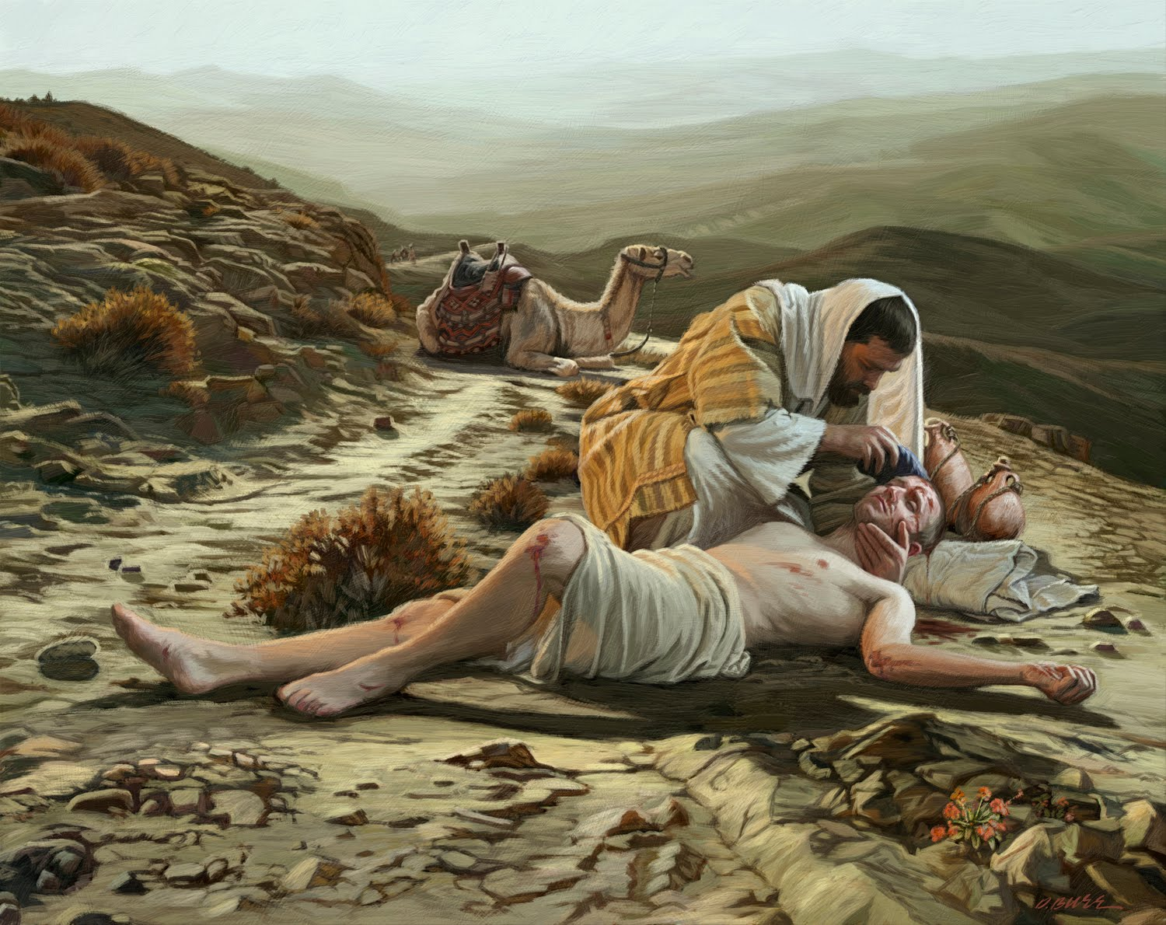
The Good Samaritan, by Dan Burr
The scribes (lawyers) take their turn trying to catch Jesus in his words; Jesus teaches the golden rule, the good Samaritan, and that he is David’s Lord.
1 And it came to pass that a certain group of lawyers, having heard that Jesus had put the Pharisees and Sadducees to silence, gathered themselves together to tempt Jesus. And one of the scribes asked him, Which is the first commandment of all?
2 And Jesus answered him, The first of all the commandments is, Hear, O Israel; The Lord our God is one Lord:
3 And thou shalt love the Lord thy God with all thy heart, and with all thy soul, and with all thy mind, and with all thy strength: this is the first commandment.
4 And the second is like, namely this, Thou shalt love thy neighbour as thyself. There is none other commandment greater than these for on these two commandments hang all the law and the prophets.
5 And the scribe said unto him, Well, Master, thou hast said the truth: for there is one God; and there is none other but he:
6 And to love him with all the heart, and with all the understanding, and with all the soul, and with all the strength, and to love his neighbour as himself, is more than all whole burnt offerings and sacrifices.
7 And when Jesus saw that he answered discreetly, he said unto him, Thou art not far from the kingdom of God.
8 And, behold, another lawyer stood up, and tempted him, saying, Master, what shall I do to inherit eternal life?
9 He said unto him, What is written in the law? How readest thou?
10 And he answering said, Thou shalt love the Lord thy God with all thy heart, and with all thy soul, and with all thy strength, and with all thy mind; and thy neighbour as thyself.
11 And he said unto him, Thou hast answered right: this do, and thou shalt live.
12 But he, willing to justify himself, said unto Jesus, And who is my neighbour?
13 And Jesus answering said, A certain man went down from Jerusalem to Jericho, and fell among thieves, which stripped him of his raiment, and wounded him, and departed, leaving him half dead.
14 And by chance there came down a certain priest that way: and when he saw him, he passed by on the other side.
15 And likewise a Levite, when he was at the place, came and looked on him, and passed by on the other side.
16 But a certain Samaritan, as he journeyed, came where he was: and when he saw him, he had compassion on him,
17 And went to him, and bound up his wounds, pouring in oil and wine, and set him on his own beast, and brought him to an inn, and took care of him.
18 And on the morrow when he departed, he took out two pence, and gave them to the host, and said unto him, Take care of him; and whatsoever thou spendest more, when I come again, I will repay thee.
19 Which now of these three, thinkest thou, was neighbour unto him that fell among the thieves?
20 And he said, He that shewed mercy on him. Then said Jesus unto him, Go, and do thou likewise.
21 Then Jesus asked those lawyers, saying, What think ye of Christ? Whose son is he? They say unto him, The Son of David.
22 He saith unto them, How say the scribes that Christ is the Son of David? How then doth David in the book of Psalms in spirit call him Lord, saying,
23 The Lord said unto my Lord, Sit thou on my right hand, till I make thine enemies thy footstool?
24 If David therefore himself calleth him Lord, how is he his son?
25 And the common people heard him gladly, yet no scribe was able to answer him a word, neither durst any man from that day forth ask him any more questions.
Taken from Matthew 22:34-46, Mark 12:28-37, Luke 10:25-37, Luke 20:41-44
1. See also: TG Scribes; Test, Try, Prove
2. See also: Deut. 6:4
3. See also: Deut. 6:5; TG Commitment; Strength; Dedication; God, Love of; Love; Heart; Mind; Commandments of God
4. See also: TG Love; Rom. 13:10; TG Law of Moses
6. See also: TG Strength
8. See also: Luke 18:18
10. See also: TG Apathy
11. See also: Lev. 18:5
12. See also: Luke 16:15; TG Neighbor
13. See also: TG Cruelty
16. See also: John 4:9; TG Benevolence; Compassion; Kindness
17. See also: TG Charity; Welfare
21. See also: TG Jesus Christ, Davidic Descent of; Matt. 1:16; D&C 93:14
23. See also: Ps. 110:1

Chapter One Hundred and Fourteen
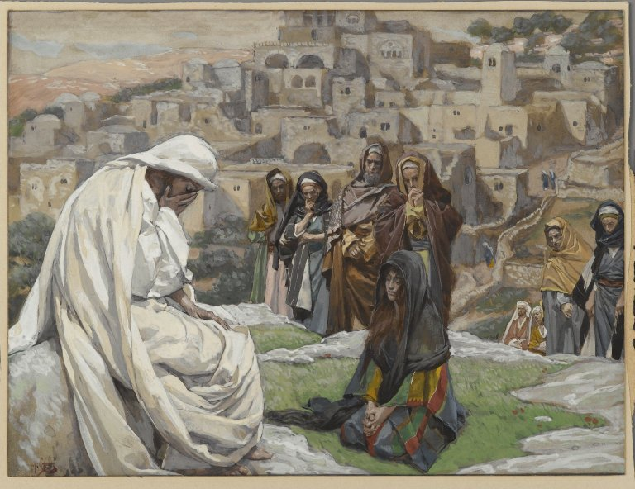
Jesus Wept, by James Tissot
Jesus weeps over Jerusalem. Two days before Passover.
1 And again when Jesus was come near Jerusalem, he beheld the city, and wept over it,
2 Saying, If thou hadst known, even thou, at least in this thy day, the things which belong unto thy peace! but now they are hid from thine eyes.
3 For the days shall come upon thee, that thine enemies shall cast a trench about thee, and compass thee round, and keep thee in on every side,
4 And shall lay thee even with the ground, and thy children within thee; and they shall not leave in thee one stone upon another; because thou knewest not the time of thy visitation.
5 Then in the audience of all the people Jesus said unto his disciples,
6 Beware the scribes and the Pharisees who sit in Moses’ seat:
7 All therefore whatsoever they bid you observe, that observe and do; but do not ye after their works: for they say, and do not.
8 For all their works they do for to be seen of men: they make broad their phylacteries, and enlarge the borders of their garments,
9 And love the uppermost rooms at feasts, and the chief seats in the synagogues,
10 And salutations in the markets, and to be called of men, Rabbi (which is master.)
11 But be not ye called Rabbi: for one is your Master, even Christ; and all ye are brethren.
12 And call no one your creator upon the earth, or your heavenly Father; for one is your creator and heavenly Father, even he who is in heaven.
13 Neither be ye called masters: for one is your Master, even he whom your heavenly Father sent, which is Christ; for he hath sent him among you that ye might have life.
14 But he that is greatest among you shall be your servant.
15 And when thou art bidden of any man to a wedding, sit not down in the highest room; lest a more honourable man than thou be bidden of him;
16 And he that bade thee and him come and say to thee, Give this man place; and thou begin with shame to take the lowest room.
17 But when thou art bidden, go and sit down in the lowest room; that when he that bade thee cometh, he may say unto thee, Friend, go up higher: then shalt thou have worship in the presence of them that sit at meat with thee.
18 And it came to pass that Jesus, perceiving that certain among the people trusted in themselves that they were righteous, and despised others, spake he this parable unto them:
19 Two men went up into the temple to pray; the one a Pharisee, and the other a publican.
20 The Pharisee stood and prayed thus with himself, God, I thank thee, that I am not as other men are, extortioners, unjust, adulterers, or even as this publican.
21 I fast twice in the week, I give tithes of all that I possess.
22 And the publican, standing afar off, would not lift up so much as his eyes unto heaven, but smote upon his breast, saying, God be merciful to me a sinner.
23 I tell you, this man went down to his house justified rather than the other: for every one that exalteth himself shall be abased; and he that humbleth himself shall be exalted.
24 Then answered one of the lawyers, and said unto him, Master, thus saying thou reproachest us also.
25 And he said, Woe unto you also, ye lawyers! for ye lade men with burdens grievous to be borne, and lay them on men’s shoulders but ye yourselves touch not the burdens with one of your fingers.
26 Woe unto you, lawyers! For ye have taken away the key of knowledge, the fullness of the scriptures; ye enter not in yourselves into the kingdom; and those who were entering in, ye hindered.
27 But woe unto you, scribes and Pharisees, hypocrites! for ye shut up the kingdom of heaven against men: for ye neither go in yourselves, neither suffer ye them that are entering to go in.
28 Woe unto you, scribes and Pharisees, hypocrites! for ye devour widows’ houses, and for a pretence make long prayer: therefore ye shall receive the greater damnation.
29 Woe unto you, scribes and Pharisees, hypocrites! for ye compass sea and land to make one proselyte, and when he is made, ye make him twofold more the child of hell than he was before, like unto yourselves.
30 Woe unto you, ye blind guides, which say, Whosoever shall swear by the temple, it is nothing; but whosoever shall swear by the gold of the temple, he is a debtor!
31 Ye fools and blind: for whether is greater, the gold, or the temple that sanctifieth the gold?
32 And, Whosoever shall swear by the altar, it is nothing; but whosoever sweareth by the gift that is upon it, he is guilty.
33 Ye fools and blind: for whether is greater, the gift, or the altar that sanctifieth the gift?
34 Whoso therefore shall swear by the altar, sweareth by it, and by all things thereon.
35 And whoso shall swear by the temple, sweareth by it, and by him that dwelleth therein.
36 And he that shall swear by heaven, sweareth by the throne of God, and by him that sitteth thereon.
37 Woe unto you, scribes and Pharisees, hypocrites! for ye pay tithe of mint and anise and cummin, and have omitted the weightier matters of the law and the love of God, judgment, mercy, and faith: these ought ye to have done, and not to leave the other undone.
38 Ye blind guides, which strain at a gnat, and swallow a camel, who make yourselves appear unto men that ye would not commit the least sin, and yet ye yourselves, transgress the whole law.
39 Woe unto you, scribes and Pharisees, hypocrites! for ye make clean the outside of the cup and of the platter, but within they are full of extortion and excess.
40 Thou blind Pharisee, cleanse first that which is within the cup and platter, that the outside of them may be clean also.
41 Woe unto you, scribes and Pharisees, hypocrites! for ye are like unto whited sepulchres, which indeed appear beautiful outward, but are within full of dead men’s bones, and of all uncleanness.
42 Even so ye also outwardly appear righteous unto men, but within ye are full of hypocrisy and iniquity.
43 Woe unto you, scribes and Pharisees, hypocrites! for ye are as graves which appear not, and the men that walk over them are not aware of them.
44 Woe unto you, scribes and Pharisees, hypocrites! because ye build the tombs of the prophets, and garnish the sepulchres of the righteous,
45 And say, If we had been in the days of our fathers, we would not have been partakers with them in the blood of the prophets.
46 Wherefore ye be witnesses unto yourselves, that ye are the children of them which killed the prophets.
47 Fill ye up then the measure of your fathers.
48 Ye serpents, ye generation of vipers, how can ye escape the damnation of hell?
49 Therefore also said the wisdom of God, behold, I send unto you prophets and apostles, and wise men, and scribes: and some of them ye shall kill and crucify; and some of them shall ye scourge in your synagogues, and persecute them from city to city:
50 That upon you may come all the righteous blood shed upon the earth, from the blood of righteous Abel unto the blood of Zacharias son of Barachias, whom ye slew between the temple and the altar.
51 Verily I say unto you, All these things shall come upon this generation. Ye bear testimony against your fathers, when ye, yourselves are partakers of the same wickedness. Behold your fathers did it through ignorance, but ye do not; wherefore, their sins shall be upon your heads.
52 And it came to pass there came certain of the Pharisees, saying unto him, Get thee out, and depart hence: for Herod will kill thee.
53 And he said unto them, Go ye, and tell that fox, Behold, I cast out devils, and I do cures to day and to morrow, and the third day I shall be perfected.
54 Nevertheless I must walk to day, and to morrow, and the day following: for it cannot be that a prophet perish out of Jerusalem. This he spake, signifying of his death. And in this very hour he began weep over Jerusalem.
55 O Jerusalem, Jerusalem, thou that killest the prophets, and stonest them which are sent unto thee, how often would I have gathered thy children together, even as a hen gathereth her chickens under her wings, and ye would not!
56 Behold, your house is left unto you desolate.
57 For I say unto you, that ye shall not see me henceforth and know that I am he of whom it is written by the prophets, until you have received from the hand of the Lord a just recompense for all your sins; until ye shall say: Blessed is he who cometh in the name of the Lord, in the clouds of heaven, and all the holy angels with him. Then understood his disciples that he should come again on the earth, after that he was glorified and crowned on the right hand of God.
58 And as Jesus spake unto the people the scribes and the Pharisees did continue to urge him vehemently, and to provoke him to speak of many things: Laying wait for him, and seeking to catch something out of his mouth, that they might accuse him.
Taken from Matthew 23:1-39, Mark 12:38-40, Luke 11:42-54, Luke 13:31-35, Luke 14:7-11, Luke 18:9-14, Luke 19:41-44, Luke 20:45-47
3. See also: Luke 21:20; Isa. 37:33; Deut. 28:52
4. See also: Dan. 9:26; Matt. 24:2; Isa. 10:3
6. See also: TG Scribes; Pride
8. See also: Ex. 13:9; Deut. 6:8; Num. 15:38
10. See also: John 12:43
11. See also: Col. 4:1
14. See also: Mark 10:44; Luke 22:24; TG Leadership; Servants
17. See also: TG Humility; Prov. 25:7
18. See also: John 5:44; Alma 32:3
19. See also: TG Prayer
20. See also: Isa. 65:5; Alma 31:16
21. See also: Ex. 34:28; TG Tithing
22. See also: Alma 38:14; TG Contrite Heart
23. See also: 2 Cor. 10:18; TG Haughtiness; Shame; Contrite Heart; Humility; Ether 12:27; D&C 49:10; 101:42; 104:82; 112:3; 124:114; James 1:9
24. See also: TG Reproach
25. See also: Alma 10:27
26. See also: Alma 11:20; Moses 1:23; Acts 13:45; 1 Thes. 2:16
27. See also: TG Scribes; Apostasy, of Israel
28. See also: TG Injustice; Damnation
30. See also: TG Spiritual Blindness
37. See also: TG Love; Hypocrisy; Tithing; Justice; Mercy
39. See also: TG Temperance
40. See also: TG Purification; Washing
41. See also: Acts 23:3; TG Beauty; Cleanliness
42. See also: D&C 10:37; TG Guile
43. See also: TG Scribes; Ps. 5:9; Acts 23:3
45. See also: Matt. 21:35
46. See also: TG Martyrdom; Prophets, Rejection of
47. See also: Judg. 2:19; Acts 7:51; Hel. 13:25
48. See also: Matt. 3:7; 12:34; TG Damnation; Punishment
49. See also: D&C 1:38; 43:25; TG Scribes
50. See also: TG Martyrdom; Prophets, Rejection of; Righteousness
52. See also: Luke 3:19
53. See also: TG Perfection
54. See also: TG Prophets, Rejection of
55. See also: TG Jerusalem; Prophets, Rejection of; Persecution; 3 Ne. 10:6; D&C 29:2; 43:24; TG Israel, Gathering of; D&C 10:65; 138:21; TG Rebellion; Stubbornness
56. See also: Ps. 69:25; Jer. 12:7; 22:5; D&C 84:115
57. See also: Ps. 118:26
58. See also: TG Provoking; 2 Ne. 27:32

Chapter One Hundred and Fifteen
All That She Had, by Simon Dewey
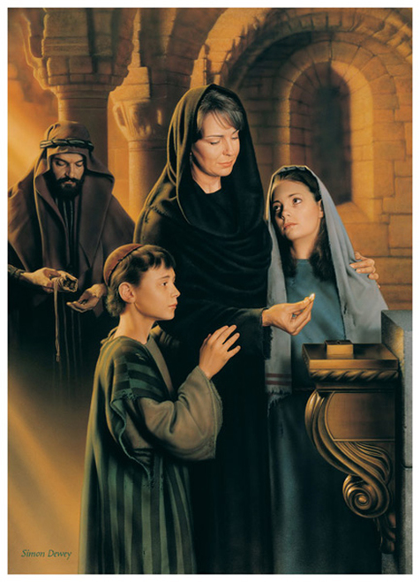
Jesus teaches the widow’s mite.
1 And Jesus sat over against the treasury, and beheld how the people cast money into the treasury: and many that were rich cast in much.
2 And there came a certain poor widow, and she threw in two mites, which make a farthing.
3 And he called unto him his disciples, and saith unto them, Verily I say unto you, That this poor widow hath cast more in, than all they which have cast into the treasury:
4 For all they did cast in of their abundance; but she of her want did cast in all that she had, even all her living.
Taken from Mark 12:41-44, Luke 21:1-4
1. See also: Mosiah 4:23; D&C 56:16
2. See also: TG Poor; Deut. 16:17; D&C 64:34
3. See also: TG Almsgiving
4. See also: TG Treasure; 2 Cor. 8:2; Mosiah 4:24; TG Generosity

Chapter One Hundred and Sixteen
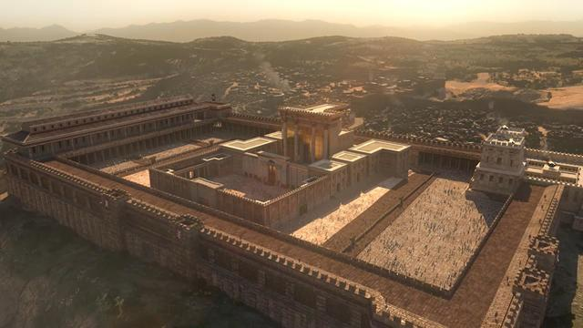
Jesus speaks about the sign of Jonah, foretells destruction of the temple, and declares sign seekers as adulterers.
1 And as Jesus went out of the temple, one of his disciples saith unto him, Master, see what manner of goodly stones and gifts and what buildings are here! Show us concerning the buildings of the temple, as thou hast said—They shall be thrown down, and left unto you desolate.
2 And Jesus answering said unto him, See ye not all these things, and do ye not understand them? Seest thou these great buildings? Verily I say unto you, there shall not be left here, upon this temple, one stone upon another that shall not be thrown down.
3 Then answered the Jews and said unto him, What sign shewest thou unto us, seeing that thou doest these things?
4 Jesus answered and said unto them, Destroy this temple, and in three days I will raise it up.
5 Then said the Jews, Forty and six years was this temple in building, and wilt thou rear it up in three days?
6 But he spake of the temple of his body.
7 When therefore he was risen from the dead, his disciples remembered that he had said this unto them; and they believed the scripture, and the word which Jesus had said.
8 Then certain of the scribes and of the Pharisees answered, saying, Master, we would see a sign from thee.
9 But he answered and said unto them, An evil and adulterous generation seeketh after a sign; and there shall no sign be given to it, but the sign of the prophet Jonah:
10 For as Jonah was a sign unto the Ninevites and was three days and three nights in the whale’s belly; so shall the Son of man be three days and three nights in the heart of the earth, as a sign unto this generation.
11 And when he was demanded of the Pharisees, when the kingdom of God should come, he answered them and said, The kingdom of God cometh not with observation:
12 Neither shall they say, Lo, here! Or, Lo, there! For, behold, the kingdom of God has already come unto you.
Taken from Matthew 12:38-40, JS-M 1:1-3, Mark 13:1-2, Luke 11:16, 29-30, Luke 17:20-21, Luke 21:5-6, John 2:18-22
1. See also: D&C 45:18; Luke 19:44
2. See also: D&C 45:16, 20, 22; TG Last Days; World, End of
3. See also: TG Sign Seekers
4. See also: Matt. 26:61; 27:40, 63; Mark 14:58; TG Jesus Christ, Resurrection; Resurrection
5. See also: TG Temple
8. See also: John 6:30
9. See also: TG Miracles; Sign Seekers; Signs
10. See also: TG Jesus Christ, Death of; Jesus Christ, Types, in Anticipation
11. See also: TG Kingdom of God, on Earth

Chapter One Hundred and Seventeen
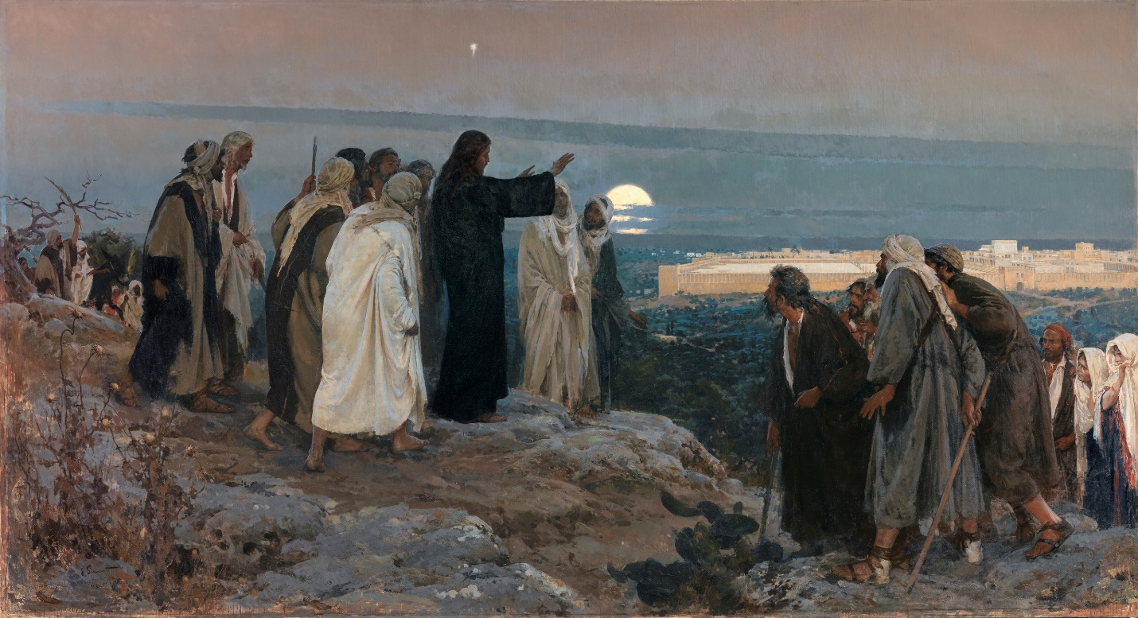
He Wept Over It, by Enrique Simonet
Jesus foretells the destruction of Jerusalem.
1 And it came to pass at night Jesus left them, and went out and abode in the mount that is called the Mount of Olives. And as he sat upon the Mount of Olives, the disciples came unto him privately, saying: Tell us when shall these things be which thou hast said concerning the destruction of the temple, and the Jews; and what is the sign of thy coming, and of the end of the world, or the destruction of the wicked, which is the end of the world?
2 And Jesus answered, and said unto them: Take heed that no man deceive you;
3 For many shall come in my name, saying—I am Christ—and shall deceive many;
4 Then shall they deliver you up to be afflicted, and shall kill you, and ye shall be hated of all nations, for my name’s sake;
5 And then shall many be offended, and shall betray one another, and shall hate one another;
6 And many false prophets shall arise, and shall deceive many;
7 And because iniquity shall abound, the love of many shall wax cold;
8 But he that remaineth steadfast and is not overcome, the same shall be saved.
9 And when ye shall see Jerusalem compassed with armies, then know that the desolation thereof is nigh.
10 When you, therefore, shall see the abomination of desolation, spoken of by Daniel the prophet standing where it ought not, concerning the destruction of Jerusalem, then you shall stand in the holy place; whoso readeth let him understand.
11 Then let them who are in Judea flee into the mountains;
12 Let him who is on the housetop flee, and not return to take anything out of his house;
13 Neither let him who is in the field return back to take his clothes; Remember Lot’s wife.
14 And let them which are in the midst of Jerusalem depart out; and let not them that are in the countries enter thereinto. For these be the days of vengeance, that all things which are written may be fulfilled.
15 And wo unto them that are with child, and unto them that give suck in those days; for there shall be great distress in the land, and wrath upon this people.
16 Therefore, pray ye the Lord that your flight be not in the winter, neither on the Sabbath day;
17 For then, in those days, shall be great tribulation on the Jews, and upon the inhabitants of Jerusalem, such as was not before sent upon Israel, of God, since the beginning of their kingdom until this time; no, nor ever shall be sent again upon Israel.
18 For they shall fall by the edge of the sword, and shall be led away captive into all nations: and Jerusalem shall be trodden down of the Gentiles, and all these things which shall befall them are only the beginning of the sorrows which shall come upon them. For this shall be until the times of the Gentiles be fulfilled.
19 And except those days should be shortened, there should none of their flesh be saved; but for the elect’s sake, according to the covenant, those days shall be shortened.
20 Behold, these things I have spoken unto you concerning the Jews and the destruction of Jerusalem.
Taken from JS-M 1:4-21, Mark 13:3-6, 14-20, Luke 21:7-9, 20-24
1. See also: D&C 45:16; TG Last Days; Jesus Christ, Second Coming; World, End of; Mal. 4:1; D&C 133:64
3. See also: Moses 1:19; TG False Christs
4. See also: 1 Pet. 4:13; TG Hate; Malice
5. See also: Ezek. 32:9; TG Offenses
6. See also: TG False Prophets
7. See also: D&C 45:27
8. See also: 2 Pet. 3:17
9. See also: Luke 19:43; Ezek. 38:16; Rev. 16:16; D&C 45:19
10. See also: TG Abomination of Desolation; Jerusalem; D&C 101:22
11. See also: D&C 133:13
13. See also: Gen. 19:26
15. See also: Luke 23:29
17. See also: Dan. 12:1; JS-M 1:36; TG Affliction; Israel, Judah, People of; Zech. 12:3; 14:2
18. See also: Dan. 12:7; TG Israel. Scattering of; Israel, Bondage of, in Other Lands; Israel, Tribes of, Twelve; Dan. 9:27; D&C 45:25; TG Gentiles
20. See also: D&C 97:25; 2 Ne. 30:2; 3 Ne. 21:22-24

Chapter One Hundred and Eighteen
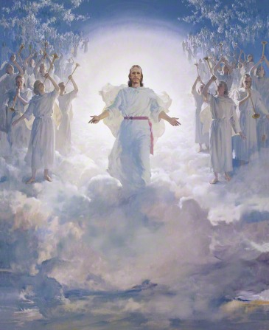
The Second Coming, by Harry Anderson
Jesus tells of the signs to precede his Second Coming.
1 Then his disciples asked him, saying, Master tell us concerning thy coming?
2 And Jesus said unto them, after the tribulation of those days which shall come upon Jerusalem, if any man shall say unto you, Lo, here is Christ, or there, believe him not;
3 For in those days there shall also arise false Christs, and false prophets, and shall show great signs and wonders, insomuch, that, if possible, they shall deceive the very elect, who are the elect according to the covenant.
4 Behold, I speak these things unto you for the elect’s sake; and you also shall hear of wars, and rumors of wars; see that ye be not troubled, for all I have told you must come to pass; but the end is not yet.
5 Behold, I have told you before;
6 Wherefore, if they shall say unto you: Behold, he is in the desert; go not forth: Behold, he is in the secret chambers; believe it not;
7 For as the light of the morning cometh out of the east, and shineth even unto the west, and covereth the whole earth, so shall also the coming of the Son of Man be.
8 And now I show unto you a parable. Behold, wheresoever the carcass is, there will the eagles be gathered together; so likewise shall mine elect be gathered from the four quarters of the earth.
9 And there shall be wars, and rumors of wars, and when ye shall hear of them be ye not troubled: for such things must needs be; but the end shall not be yet.
10 Behold I speak for mine elect’s sake; for nation shall rise against nation, and kingdom against kingdom; there shall be famines, and pestilences, and earthquakes, in divers places.
11 And again, because iniquity shall abound, the love of men shall wax cold; but he that shall not be overcome, the same shall be saved.
12 And again, this Gospel of the Kingdom shall be preached in all the world, for a witness unto all nations, and then shall the end come, or the destruction of the wicked;
13 And again shall the abomination of desolation, spoken of by Daniel the prophet, be fulfilled.
14 And immediately after the tribulation of those days, when the time of the Gentiles is fulfilled, the sun shall be darkened, and the moon shall not give her light, and the stars shall fall from heaven, and the powers of heaven shall be shaken; and upon the earth distress of nations with perplexity, like the sea and the waves roaring. The earth also shall be troubled, and the waters of the great deep;
15 Men’s hearts failing them for fear, and for looking after those things which are coming on the earth.
16 Verily, I say unto you, that generation, in which these things shall be shown forth, shall not pass away until all I have told you shall be fulfilled. Therefore when these things begin to come to pass, look up, and lift up your heads; for your redemption draweth nigh.
17 Although, the days will come, that heaven and earth shall pass away; yet my words shall not pass away, but all shall be fulfilled.
18 And, as I said before, after the tribulation of those days, and the powers of the heavens shall be shaken, then shall appear the sign of the Son of Man in heaven, and then shall all the tribes of the earth mourn; and they shall see the Son of Man coming in the clouds of heaven, with power and great glory;
19 And whoso treasureth up my word, shall not be deceived, for the Son of Man shall come, and he shall send his angels before him with the great sound of a trumpet, and they shall gather together the remainder of his elect from the four winds, from one end of heaven to the other.
Taken from JS-M 1:22-37, Mark 13:7-8, 21-26, 31, Luke 21:10-11, 26-29
3. See also: TG False Christs; False Prophets; Signs
4. See also: D&C 29:7; 45:26
7. See also: Ezek. 43:2
8. See also: Deut. 28:26; Ps. 74:1; 1 Ne. 19:16; D&C 35:25
10. See also: Joel 1:10; D&C 43:25; 87:6; 97:26; 1 Ne. 14:15; 22:14; 2 Ne. 6:15; Mosiah 12:4
11. See also: Isa. 9:19; Mosiah 9:2
12. See also: Matt. 9:35; D&C 84:80; TG Nations
13. See also: JS-M 1:12
14. See also: Joel 2:10; D&C 29:14; Amos 5:18; Ezek. 32:7; TG World, End of
16. See also: D&C 35:26; 45:31
17. See also: D&C 1:38; 29:33; 64:31
18. See also: JS-M 1:18; TG Tribulation; Mourning; Millennium; Matt. 25:31; Dan. 7:13; D&C 34:7; TG Jesus Christ, Son of Man
19. See also: TG Scriptures, Study of; Study; Treasure; Jesus Christ, Second Coming; D&C 29:11; Moses 7:25; TG Israel, Remnant of

Chapter One Hundred and Nineteen
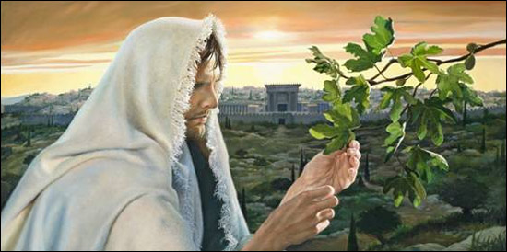
Jesus teaches the parable of the fig tree.
1 Now learn a parable of the fig tree—When its branches are yet tender, and it begins to put forth leaves, you know that summer is nigh at hand;
2 So likewise, mine elect, when they shall see all these things, they shall know that he is near, even at the doors; For verily I say unto you, that generation, the generation when the times of the Gentiles be fulfilled, shall not pass away till all be fulfilled.
3 But of that day, and hour, no one knoweth; no, not the angels of God in heaven, neither the Son, but my Father only.
4 Therefore take heed to yourselves, lest at any time your hearts be overcharged with surfeiting, and drunkenness, and cares of this life, and so that day come upon you unawares.
5 For as a snare shall it come on all them that dwell on the face of the whole earth.
6 Watch ye therefore, and pray always, and keep my commandments, that ye may be accounted worthy to escape all these things that shall come to pass, and to stand before the Son of man when he shall come clothed in the glory of his Father.
7 For as it was in the days of Noah, so it shall be also at the coming of the Son of Man;
8 For it shall be with them, as it was in the days which were before the flood; for until the day that Noah entered into the ark they were eating and drinking, marrying and giving in marriage;
9 And knew not until the flood came, and took them all away.
10 Likewise also as it was in the days of Lot; they did eat, they drank, they bought, they sold, they planted, they builded;
11 But the same day that Lot went out of Sodom it rained fire and brimstone from heaven, and destroyed them all; so shall also the coming of the Son of Man be.
12 I tell you, that in the last days, then shall be fulfilled that which is written, there shall be two married in one bed; the one shall be taken, and the other shall be left.
13 Two women shall be grinding at the mill; the one shall be taken, and the other left.
14 Two men shall be in the field; the one shall be taken, and the other left.
15 And they answered and said unto him, Where, Lord, shall they be taken?
16 And he said unto them, Wheresoever the body is gathered; or, in other words, whithersoever the saints are gathered, thither will the eagles be gathered together; or, thither will the remainder be gathered together.
17 This he spake, signifying the gathering of his saints; and of angels descending and gathering the remainder unto them; the one from the bed, the other from the grinding, and the other from the field, whithersoever he listeth.
18 For verily there shall be new heavens, and a new earth, wherein dwelleth righteousness.
19 And there shall be no unclean thing; for the earth becoming old, even as a garment, having waxed in corruption, wherefore it vanisheth away, and the footstool remaineth sanctified, cleansed from all sin.
Taken from JS-M 1:38-45, Mark 13:28-32; Luke 17:28-41, Luke 21:30-37
1. See also: D&C 35:16; 45:37
2. See also: D&C 45:21
3. See also: D&C 39:21; 49:7; TG Day of the Lord
4. See also: TG Worldliness; Procrastination; 1 Thes. 5:4
5. See also: Rev. 3:3; 16:15; D&C 63:15
6. See also: TG Watchfulness; Prayer; Worthiness
7. See also: Gen. 6:5; TG Earth, Cleansing of; Flood
8. See also: TG Flood
9. See also: TG Apathy
11. See also: Gen. 19:24
14. See also: TG Earth, Cleansing of; Zech. 13:8

Chapter One Hundred and Twenty
Like A Thief in the Night, by Jorge Cocco
Jesus teaches the parable of the thief in the night.
1 For the Son of man is as a man taking a far journey, who left his house, and gave authority to his servants, and to every man his work, and commanded the porter to watch.
2 Watch ye therefore: for ye know not when the master of the house cometh, at even, or at midnight, or at the cockcrowing, or in the morning:
3 Lest coming suddenly he find you sleeping.
4 And what I say unto one, I say unto all men; watch and pray, therefore, for you know not at what hour your Lord doth come.
5 Let your loins be girded about, and your lights burning;
6 And ye yourselves like unto men that wait for their lord, when he will return from the wedding; that when he cometh and knocketh, they may open unto him immediately.
7 For, behold, he cometh in the first watch of the night, and he shall also come in the second watch, and again he shall come in the third watch.
8 And verily I say unto you, He hath already come, as it is written of him; and again when he shall come in the second watch, or come in the third watch, blessed are those servants when he cometh, that he shall find so doing;
9 For the Lord of those servants shall gird himself, and make them to sit down to meat, and will come forth and serve them.
10 And now, verily I say these things unto you, that ye may know this, that the coming of the Lord is as a thief in the night.
11 And it is like unto a man who is an householder, who, if he watcheth not his goods, the thief cometh in an hour of which he is not aware, and taketh his goods, and divideth them among his fellows.
12 And they said among themselves, If the good man of the house had known what hour the thief would come, he would have watched, and not have suffered his house to be broken through and the loss of his goods.
13 And he said unto them, Verily I say unto you, be ye therefore ready also; for the Son of man cometh at an hour when ye think not.
14 Then Peter said unto him, Lord, speakest thou this parable unto us, or unto all?
15 And the Lord said, I speak unto those whom the Lord shall make rulers over his household, to give his children their portion of meat in due season.
16 And they said, Who then is that faithful and wise servant?
17 And the Lord said unto them, It is that servant who watcheth, to impart his portion of meat in due season.
18 Blessed be that servant whom his Lord shall find, when he cometh, so doing.
19 Of a truth I say unto you, that he will make him ruler over all that he hath.
20 But the evil servant is he who is not found watching. And if that servant is not found watching, he will say in his heart, My Lord delayeth his coming; and shall begin to beat the menservants, and the maidens, and to eat, and drink, and to be drunken.
21 The Lord of that servant will come in a day he looketh not for, and at an hour when he is not aware, and will cut him down, and will appoint him his portion with the unbelievers and hypocrites; there shall be weeping and gnashing of teeth.
22 And that servant who knew his Lord’s will, and prepared not for his Lord’s coming, neither did according to his will, shall be beaten with many stripes.
23 But he that knew not his Lord’s will, and did commit things worthy of stripes, shall be beaten with few. For unto whomsoever much is given, of him shall much be required; and to whom the Lord has committed much, of him will men ask the more.
24 And thus cometh the end of the wicked, according to the prophecy of Moses, saying: They shall be cut off from among the people; but the end of the earth is not yet, but by and by.
Taken from JS-M 1:46-55, Mark 13:33-37, Luke 12:37-55
1. See also: TG Authority
3. See also: TG Procrastination; Sleep
4. See also: D&C 45:44; TG Watchfulness; Prayer
5. See also: Matt. 25:7
12. See also: TG Watchfulness
13. See also: D&C 133:11; TG Procrastination
15. See also: TG Trustworthiness; Stewardship
18. See also: TG Commitment; Millennium, Preparing a People for
19. See also: 1 Pet. 5:4; Rom. 8:17; 1 Cor. 3:22; D&C 76:59; 84:38
20. See also: D&C 45:26
21. See also: TG Punishment; Matt. 8:12
22. See also: James 4:17; TG Apostasy, of Individuals; 2 Ne. 9:27; TG Accountability; Procrastination
23. See also: Rom. 2:12; Deut. 25:2; TG Talents; Stewardship; Accountability; Duty; Judgment
24. See also: Ps. 36:11-12; 73:17; 2 Ne. 30:10; D&C 1:9; 29:17; TG World, End of

Chapter One Hundred and Twenty-One
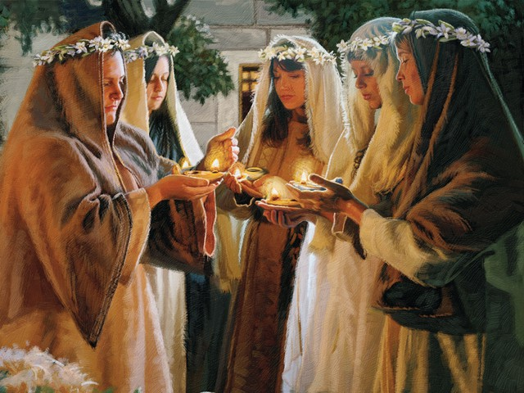
Parable of the Ten Virgins, by Dan Burr
Jesus gives the parable of the ten virgins.
1 And then, at that day, before the Son of Man comes, the kingdom of heaven be likened unto ten virgins, which took their lamps, and went forth to meet the bridegroom.
2 And five of them were wise, and five were foolish.
3 They that were foolish took their lamps, and took no oil with them:
4 But the wise took oil in their vessels with their lamps.
5 While the bridegroom tarried, they all slumbered and slept.
6 And at midnight there was a cry made, Behold, the bridegroom cometh; go ye out to meet him.
7 Then all those virgins arose, and trimmed their lamps.
8 And the foolish said unto the wise, Give us of your oil; for our lamps are gone out.
9 But the wise answered, saying, Not so; lest there be not enough for us and you: but go ye rather to them that sell, and buy for yourselves.
10 And while they went to buy, the bridegroom came; and they that were ready went in with him to the marriage: and the door was shut.
11 Afterward came also the other virgins, saying, Lord, Lord, open to us.
12 But he answered and said, Verily I say unto you, I know you not.
13 Watch therefore, for ye know neither the day nor the hour wherein the Son of man cometh.
Taken from Matthew 25:1-13
1. See also: D&C 45:56; 63:54; Lev. 24:2
5. See also: D&C 35:21; TG Sleep
6. See also: D&C 88:92; 133:10
7. See also: Luke 12:35; D&C 33:17
10. See also: TG Millennium, Preparing a People for; Procrastination
12. See also: Matt. 7:23
13. See also: TG Watchfulness

Chapter One Hundred and Twenty-Two
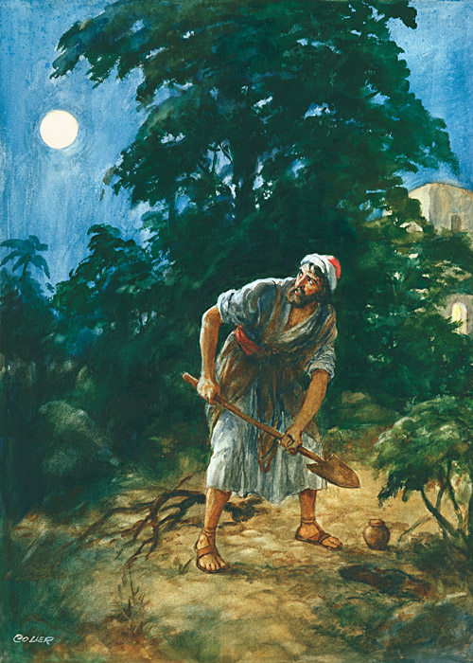
Parable of the Pounds, by Henry Coller
Jesus gives the parable of the talents.
1 And it came to pass Jesus perceived that his disciples thought that the kingdom of God should immediately appear. He spoke therefore a parable unto them saying,
2 For the kingdom of heaven is as a nobleman who went into a far country to receive for himself a kingdom, and then to return, who called his own servants, and delivered unto them his goods.
3 And unto one he gave five talents, to another two, and to another one; to every man according to his several ability; and straightway took his journey.
4 But the citizens of the nobleman did hate him, and did send a message after him, saying, We will not have thee to reign over us when thou returnest.
5 Then he that had received the five talents went and traded with the same, and made them other five talents.
6 And likewise he that had received two, he also gained other two.
7 But he that had received one went and digged in the earth, and hid his lord’s money.
8 After a long time the lord of those servants returned, having received the kingdom, cometh, and reckoneth with them.
9 And so he that had received five talents came and brought other five talents, saying, Lord, thou deliveredst unto me five talents: behold, I have gained beside them five talents more.
10 His lord said unto him, Well done, thou good and faithful servant: thou hast been faithful over a few things, I will make thee ruler over many things: enter thou into the joy of thy lord.
11 He also that had received two talents came and said, Lord, thou deliveredst unto me two talents: behold, I have gained two other talents beside them.
12 His lord said unto him, Well done, good and faithful servant; thou hast been faithful over a few things, I will make thee ruler over many things: enter thou into the joy of thy lord.
13 Then he which had received the one talent came forward with the talent laid up in a napkin and said, Lord, behold, here is thine which I hath kept. I feared thee, for I knew thee that thou art an hard man, reaping where thou hast not sown, and gathering where thou hast not strawed:
14 And I was afraid, and went and hid thy talent in the earth: lo, there thou hast that is thine.
15 His lord answered and said unto him, Thou wicked and slothful servant, thou knewest that I reap where I sowed not, and gather where I have not strawed:
16 Thou oughtest therefore to have put my money to the exchangers, and then at my coming I should have received mine own with usury.
17 Take therefore the talent from him, and give it unto him which hath ten talents.
18 For unto every one that hath shall be given, and he shall have abundance: but from him that hath not multiplied shall be taken away even that which he hath.
19 But those mine enemies, which would not that I should reign over them, bring hither, and slay them before me. And cast ye therefore the unprofitable servants into outer darkness: there shall be weeping and gnashing of teeth.
Taken from Matthew 25:14-30, Luke 19:11-27
1. See also: 2 Thes. 2:2
3. See also: Mark 4:24; TG Talents; Work, Value of
4. See also: TG Citizenship
8. See also: D&C 72:3
10. See also: TG Servants; Luke 16:10; D&C 132:20, 53; Rev. 3:21; TG Leadership; Stewardship; Joy
12. See also: TG Authority; Trustworthiness; D&C 52:13
14. See also: TG Fearfulness; D&C 60:2
15. See also: TG Laziness; Harvest
16. See also: TG Usury
17. See also: D&C 82:18
18. See also: Matt. 13:12; D&C 82:3; Alma 12:11; D&C 1:33; 60:3
Chapter One Hundred and Twenty-Three
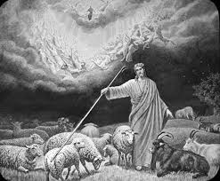
Jesus teaches the parable of the sheep and the goats; poor wayfaring man of grief
1 When the Son of man shall come in his glory, and all the holy angels with him, then shall he sit upon the throne of his glory:
2 And before him shall be gathered all nations: and he shall separate them one from another, as a shepherd divideth his sheep from the goats:
3 And he shall set the sheep on his right hand, but the goats on the left.
4 Then shall the King say unto them on his ªright hand, Come, ye blessed of my Father, inherit the kingdom prepared for you from the foundation of the world:
5 For I was an hungred, and ye gave me meat: I was thirsty, and ye gave me drink: I was a stranger, and ye took me in:
6 Naked, and ye clothed me: I was sick, and ye visited me: I was in prison, and ye came unto me.
7 Then shall the righteous answer him, saying, Lord, when saw we thee an hungred, and fed thee? or thirsty, and gave thee drink?
8 When saw we thee a stranger, and took thee in? or naked, and clothed thee?
9 Or when saw we thee sick, or in prison, and came unto thee?
10 And the King shall answer and say unto them, Verily I say unto you, Inasmuch as ye have done it unto one of the least of these my brethren, ye have done it unto me.
11 Then shall he say also unto them on the left hand, Depart from me, ye cursed, into everlasting fire, prepared for the devil and his angels:
12 For I was an hungred, and ye gave me no meat: I was thirsty, and ye gave me no drink:
13 I was a stranger, and ye took me not in: naked, and ye clothed me not: sick, and in prison, and ye visited me not.
14 Then shall they also answer him, saying, Lord, when saw we thee an hungred, or athirst, or a stranger, or naked, or sick, or in prison, and did not minister unto thee?
15 Then shall he answer them, saying, Verily I say unto you, Inasmuch as ye did it not to one of the least of these, ye did it not to me.
16 And these shall go away into everlasting punishment: but the righteous into life eternal.
Taken from Matthew 25:31-46
1. See also: TG Jesus Christ, Son of Man; Jesus Christ, Second Coming; Millennium
2. See also: TG Nations; Jesus Christ, Judge; Judgment, the Last; Separation; Shepherds; Sheep
3. See also: D&C 29:27
4. See also: Moses 7:56; TG Blessings; Exaltation; Reward; Luke 12:32; Rev. 22:5
5. See also: TG Poor; Almsgiving; Generosity; Hospitality; Strangers
6. See also: Heb. 13:3
9. See also: TG Health
10. See also: Mosiah 2:17; D&C 42:38; TG Good Works; Neighbor; Poor; Welfare
11. See also: D&C 19:5; 29:58; TG Curse; Hell
12. See also: Job 22:7
15. See also: Prov. 14:31
16. See also: D&C 19:11; TG Damnation; Punishment; Righteousness; Resurrection; Eternal Life

Chapter One Hundred and Twenty-Four
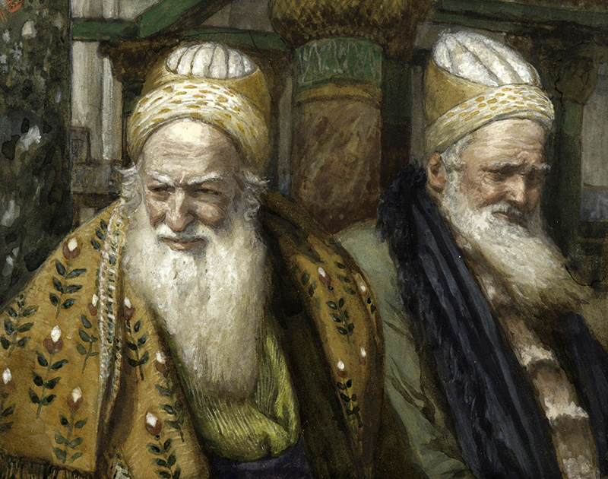
Annas and Caiaphas, by James Tissot
Judas Iscariot meets with the priests and scribes and offers to betray Jesus.
1 And it came to pass, when Jesus had finished all these sayings, he departed from the Mount of Olives and returned to the house of Simon the leper in Bethany.
2 And Jesus saith unto his disciples, Ye know that after two days is the feast of the passover, and the Son of man is betrayed to be crucified.
3 For it came to pass that after two days was the feast of unleavened bread, which is called the Passover, and the chief priests, and the scribes, and the elders of the people, were gathered unto the palace of the high priest, who was called Caiaphas,
4 And consulted how they might take Jesus by subtilty, and kill him. For they had reasoned among themselves that Jesus had done many miracles, and if they let him thus alone, all men would believe on him: and the Romans would come and take away both their place and nation.
5 And one of them, named Caiaphas, being the high priest that same year, had said unto them, Ye know nothing at all,
6 Nor consider that it is expedient for us, that one man should die for the people, and that the whole nation perish not.
7 And this spake he not of himself: but being high priest that year, he prophesied that Jesus should die for that nation;
8 And not for that nation only, but that also he should gather together in one the children of God that were scattered abroad.
9 Then from that day forth they took counsel together for to put him to death.
10 But they also reasoned, Not on the feast day, lest there be an uproar among the people; for they feared the people.
11 Then entered Satan into Judas surnamed Iscariot, being of the number of the twelve for he turned away from Jesus and was offended because of his words.
12 And he went his way, and communed with the chief priests and captains, how he might betray Jesus unto them.
13 And Judas saith unto them, What will ye give me, and I will deliver Jesus unto you? And when they heard it, they were glad, and they covenanted with Judas for thirty pieces of silver.
14 And from that time forth, sought he convenient opportunity to betray Jesus unto them in the absence of the multitude.
Taken from Matthew 26:1-6, 14-16, Mark 14:1-2, 10-11, Luke 22:1-6, John 11:47-53
2. See also: TG Passover; Jesus Christ, Betrayal of; Martyrdom
3. See also: TG Scribes
4. See also: Matt. 27:20; 2 Ne. 10:3; 3 Ne. 19:35; D&C 117:4
5. See also: TG Priesthood, Aaronic
6. See also: TG Jesus Christ, Trial of
8. See also: TG Israel, Gathering of; Sons and Daughters of God
9. See also: TG Counsel; Matt. 21:38; John 7:1
10. See also: TG Rioting and Reveling
13. See also: Ex. 21:32; Zech. 11:12
14. See also: TG Jesus Christ, Betrayal of

Chapter One Hundred and Twenty-Five
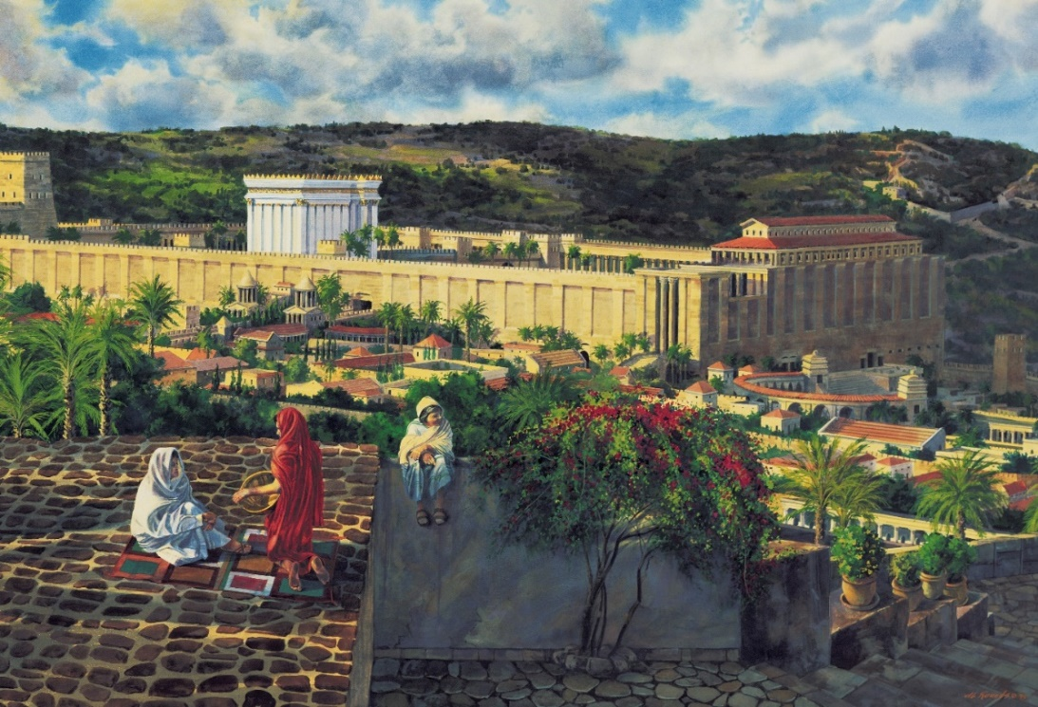
From the Rooftops, by Al Rounds
Jesus prepares for the Passover.
1 And the first day of unleavened bread, when they killed the passover, his disciples said unto Jesus, Where wilt thou that we go and prepare that thou mayest eat the passover?
2 And he sendeth forth Peter and John, and saith unto them, Go and prepare us the passover, that we may eat.
3 And they said unto him, Where wilt thou that we prepare?
4 And he said unto them, Go ye into the city, and there shall meet you a man bearing a pitcher of water: follow him.
5 And wheresoever he shall go in, say ye to the goodman of the house, The Master saith, Where is the guestchamber, where I shall eat the passover with my disciples?
6 And he will shew you a large upper room furnished and prepared: there make ready for us.
7 And his disciples went forth, and came into the city, and found as he had said unto them: and they made ready the passover.
Taken from Matthew 26:17-19, Mark 14:12-16, Luke 22:7-13
1. See also: TG Bread, Unleavened; Passover
5. See also: John 7:6
7. See also: Ex. 12:27
Chapter One Hundred and Twenty-Six
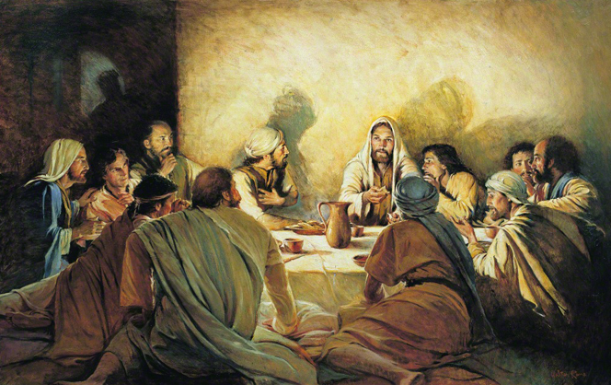
In Remembrance of Me, by Walter Rane
The Last Supper; Jesus eats the passover and institutes the sacrament.
1 And when the hour of passover had come, Jesus sat down, and the twelve apostles with him.
2 And he said unto them, With desire I have desired to eat this passover with you before I suffer:
3 For I say unto you, and of this ye shall bear record, I will not any more eat thereof, until it be fulfilled which is written in the prophets concerning me. Then I will partake with you, in the kingdom of God.
4 And he took bread, and gave thanks, and brake it, and gave unto them, saying, Take it, and eat, This is my body which is given a ransom for you. Behold, this is for you to do in remembrance of my body; for as oft as ye do this ye will remember this hour that I was with you, and ate with you of this bread, even the last time in my ministry.
5 Verily I say unto you, Of this ye shall also bear record; for I will no more drink of the fruit of the vine with you, until that day that I drink it new in the kingdom of God.
6 And he took the cup, and when he had given thanks, he gave it to them; saying, Drink ye all of it, and they all drank of it.
7 And he said unto them, This is in remembrance of my blood which is shed for as many as shall believe on my name, for the remission of their sins, and is the new testament which I give unto you; for of me ye shall bear record unto all the world.
8 And as oft as ye do this ordinance, ye will remember me in this hour that I was with you and drank with you of this cup, even the last time in my ministry.
9 And I give unto you a commandment, that ye shall observe to do the things which ye have seen me do, and bear record of me even unto the end.
10 And as they sat and did eat, Jesus said, Verily I say unto you, One of you which eateth with me shall betray me.
11 And they began to be sorrowful, and to say unto him one by one, Is it I? and another said, Is it I?
12 Then Jesus saith unto them, Thou hast said. The Son of man goeth as it is written of him: but woe unto that man by whom the Son of man is betrayed! it had been good for that man if he had not been born.
13 And now they were sorely grieved, and wept over him.
Taken from Matthew 26:20-30, Mark 14:17-28, Luke 22:14-23
4. See also: D&C 20:77; John 6:53; TG Jesus Christ, Atonement through; Jesus Christ, Redeemer; Jesus Christ, Types, in Memory; Bread; Bread of Life; Bread, Unleavened; Sacrament; Passover
5. See also: D&C 27:5
6. See also: D&C 20:78; 1 Cor. 10:16; TG Sacrament; Thanksgiving
7. See also: Ex. 24:8; Deut. 32:14; Heb. 9:16; TG Jesus Christ, Atonement though; Covenants; Jesus Christ, Redeemer; Remission of Sins
12. See also: TG Foreordination; Jesus Christ, Prophecies about; Jesus Christ, Son of Man; Acts 2:23

Chapter One Hundred and Twenty-Seven
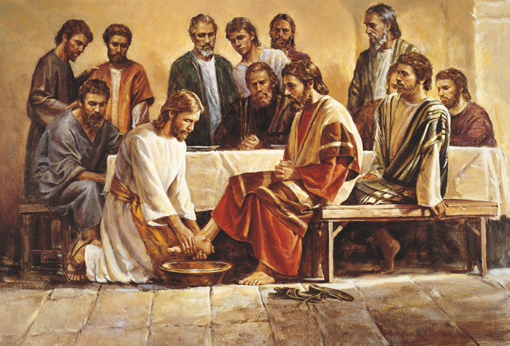
Jesus Washing the Apostles’ Feet, by Del Parson
Jesus washes the apostles’ feet.
1 Jesus riseth from supper, and laid aside his garments; and took a towel, and girded himself.
2 After that he poureth water into a basin, and began to wash the disciples’ feet, and to wipe them with the towel wherewith he was girded.
3 Then cometh he to Simon Peter: and Peter saith unto him, Lord, dost thou wash my feet?
4 Jesus answered and said unto him, What I do thou knowest not now; but thou shalt know hereafter.
5 Peter saith unto him, Thou needest not to wash my feet. Jesus answered him, If I wash thee not, thou hast no part with me.
6 Simon Peter saith unto him, Lord, not my feet only, but also my hands and my head.
7 Jesus saith to him, He that has washed his hands and his head, needeth not save to wash his feet, but is clean every whit; and ye are clean, but not all. Now this was the custom of the Jews under their law; wherefore, Jesus did this that the law might be fulfilled.
8 For he knew who should betray him; therefore said he, Ye are not all clean.
9 So after he had washed their feet, and had taken his garments, and was set down again, he said unto them, Know ye what I have done to you?
10 Ye call me Master and Lord: and ye say well; for so I am.
11 If I then, your Lord and Master, have washed your feet; ye also ought to wash one another’s feet.
12 For I have given you an example, that ye should do as I have done to you.
13 Verily, verily, I say unto you, The servant is not greater than his lord; neither he that is sent greater than he that sent him.
14 If ye know these things, happy are ye if ye do them.
15 I speak not of you all: I know whom I have chosen: but that the scripture may be fulfilled, He that eateth bread with me hath lifted up his heel against me.
16 Now I tell you before it come, that, when it is come to pass, ye may believe that I am he.
17 For Jesus knew that the Father had given all things into his hands, and that he was come from God, and would return to God: for Jesus knew that his hour was come that he should depart out of this world unto the Father, having loved his own which were in the world, he loved them unto the end.
18 And when Jesus had thus spoken he was troubled in spirit.
19 Then the disciples looked one on another, doubting of whom he spake.
20 Simon Peter therefore beckoned to John, who was at the table on the right hand of Jesus, leaning toward his bosom, that he should ask who it should be of whom he spake.
21 John then discreetly saith to Jesus, Lord, who is it?
22 Jesus answered, He it is, to whom I shall give a sop, when I have dipped it. And when he had dipped the sop, he gave it to Judas Iscariot, the son of Simon.
23 And after the sop Satan entered into him. Then said Jesus unto him, That thou doest, do quickly.
24 Now no man at the table knew for what intent Jesus spake this unto him.
25 For they heard not the sayings and some of them thought, because Judas had the bag, that Jesus had said unto him, Buy those things that we have need of against the feast; or, that he should give something to the poor.
26 Judas then having received Satan into himself went immediately out: and it was night.
27 When Judas was gone out, Jesus said, Now is the Son of man glorified, and God is glorified in him.
28 If God be glorified in him, God shall also glorify him in himself, and shall straightway glorify him.
29 Little children, yet a little while I am with you. Ye shall seek me: and as I said unto the Jews, Whither I go, ye cannot come; so now I say to you.
30 A new commandment I give unto you, That ye love one another; as I have loved you, that ye also love one another.
31 By this shall all men know that ye are my disciples, if ye have love one to another.
32 Simon Peter said unto him, Lord, whither goest thou? Jesus answered him, Whither I go, thou canst not follow me now; but thou shalt follow me afterwards.
33 Peter said unto him, Lord, why cannot I follow thee now? I will lay down my life for thy sake.
34 Jesus answered him, Wilt thou lay down thy life for my sake? Verily, verily, I say unto thee, Thou wilt in like manner be slain.
Taken from John 13:1-19, 21-38
2. See also: TG Washing
5. See also: TG Purification
7. See also: TG Purity; D&C 38:10
8. See also: John 6:64; D&C 66:3
11. See also: TG Courtesy; Humility; Jesus Christ, Teaching Mode of
12. See also: TG Example; God, the Standard of Righteousness; Jesus Christ, Exemplar; Leadership
14. See also: TG Happiness
17. See also: TG God, Omniscience of; Jesus Christ, Power of; God, Love of; John 7:29
18. See also: TG Jesus Christ, Betrayal of
23. See also: TG Devil; D&C 10:15; 63:28
25. See also: John 12:6
27. See also: TG Jesus Christ, Son of Man
29. See also: John 7:34
30. See also: TG Love; Family, Love within
31. See also: TG Fellowshipping; God, Love of
33. See also: TG Commitment

Chapter One Hundred and Twenty-Eight
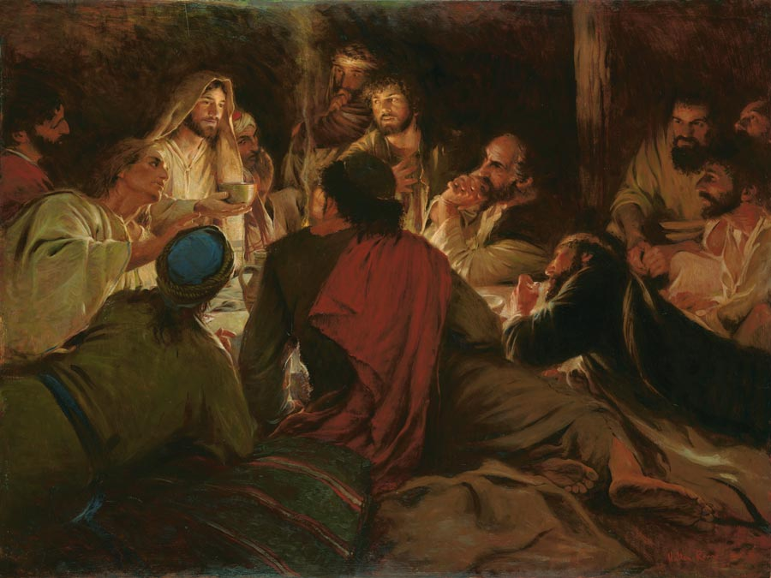
Peace I Leave with You, by Walter Rane
Jesus teaches his apostles; he is the way, the truth and the life.
1 And Jesus spake unto his eleven disciples in the upper room saying, Let not your heart be troubled: ye believe in God, believe also in me.
2 In my Father’s house are many mansions: if it were not so, I would have told you. I go to prepare a place for you.
3 And if I go and prepare a place for you, I will come again, and receive you unto myself; that where I am, there ye may be also.
4 And whither I go ye know, and the way ye know.
5 Thomas saith unto him, Lord, we know not whither thou goest; and how can we know the way?
6 Jesus saith unto him, I am the way, the truth, and the life: no man cometh unto the Father, but by me.
7 If ye had known me, ye should have known my Father also: and from henceforth ye know him, and have seen him.
8 Philip saith unto him, Lord, shew us the Father, and it sufficeth us.
9 Jesus saith unto him, Have I been so long time with you, and yet hast thou not known me, Philip? he that hath seen me hath seen the Father; and how sayest thou then, Shew us the Father?
10 Believest thou not that I am in the Father, and the Father in me? the words that I speak unto you I speak not of myself: but the Father that dwelleth in me, he doeth the works.
11 Believe me that I am in the Father, and the Father in me: or else believe me for the very works’ sake.
12 Verily, verily, I say unto you, He that believeth on me, the works that I do shall he do also; and greater works than these shall he do; because I go unto my Father.
13 And whatsoever ye shall ask in my name, that will I do, that the Father may be glorified in the Son.
14 If ye shall ask any thing in my name, I will do it.
15 If ye love me, keep my commandments.
16 And I will pray the Father, and he shall give you another Comforter, that he may abide with you for ever;
17 Even the Spirit of truth; whom the world cannot receive, because it seeth him not, neither knoweth him: but ye know him; for he dwelleth with you, and shall be in you.
18 I will not leave you comfortless: I will come to you.
19 Yet a little while, and the world seeth me no more; but ye see me: because I live, ye shall live also.
20 At that day ye shall know that I am in my Father, and ye in me, and I in you.
21 He that hath my commandments, and keepeth them, he it is that loveth me: and he that loveth me shall be loved of my Father, and I will love him, and will manifest myself to him.
22 Judas saith unto him, not Iscariot, Lord, how is it that thou wilt manifest thyself unto us, and not unto the world?
23 Jesus answered and said unto him, If a man love me, he will keep my words: and my Father will love him, and we will come unto him, and make our abode with him.
24 He that loveth me not keepeth not my sayings: and the word which ye hear is not mine, but the Father’s which sent me.
25 These things have I spoken unto you, being yet present with you.
26 But the Comforter, which is the Holy Ghost, whom the Father will send in my name, he shall teach you all things, and bring all things to your remembrance, whatsoever I have said unto you.
27 Peace I leave with you, my peace I give unto you: not as the world giveth, give I unto you. Let not your heart be troubled, neither let it be afraid.
28 Ye have heard how I said unto you, I go away, and come again unto you. If ye loved me, ye would rejoice, because I said, I go unto the Father: for my Father is greater than I.
29 And now I have told you before it come to pass, that, when it is come to pass, ye might believe.
30 Hereafter I will not talk much with you; for the prince of darkness, who is of this world, cometh, but hath no power over me, but he hath power over you.
31 But that the world may know that I love the Father; and as the Father gave me commandment, even so I do. Arise, let us go hence.
32 And when they had sung an hymn, they went out thence into the mount of Olives.
Taken from Matthew 26:31, Mark 14:29, Luke 22:39, John 14:1-31
1. See also: D&C 50:41
2. See also: TG Heaven; D&C 59:2; 98:18; TG Eternal Life; Telestial Glory
3. See also: Acts 1:11; D&C 27:18; 132:23; 1 Thes. 4:17; Rev. 22:4
6. See also: Ex. 18:20; 33:13; 1 Sam. 12:23; Ps. 25:4; John 10:7; TG Example; Truth; Matt. 11:27; Luke 10:22; TG God, Access to
7. See also: John 8:19; 1 Jn. 2:23; D&C 88:50
9. See also: TG God, Body of (Corporeal Nature)
10. See also: D&C 93:3
11. See also: D&C 50:43; TG Jesus Christ, Relationships with the Father
12. See also: Acts 9:41; 4 Ne. 1:5; TG Faith, Jesus Christ, Ascension of; God, Father
13. See also: D&C 6:14; 29:6; TG Prayer; Name
15. See also: TG God, Love of; God, the Standard of Righteousness; Love; Duty; Obedience; Commandments of God; Commitment; Good Works
16. See also: TG Jesus Christ, Second Comforter; D&C 20:77
18. See also: TG Comfort
21. See also: TG Obedience; God, Love of; God, Privilege of Seeing; Revelation
23. See also: TG God, Love of; 1 Jn. 3:24; Rev. 3:20; D&C 130:3
26. See also: TG Holy Ghost, Comforter; Guidance, Divine; Name; God, Omniscience of; Holy Ghost, Gifts of; Holy Ghost, Mission of; Inspiration; Learning; Teaching
27. See also: TG Peace of God; Contentment; Peace; Sorrow
28. See also: TG Jesus Christ, Ascension of; Godhead
29. See also: TG Faith
30. See also: TG Devil; Worldliness
31. See also: TG Jesus Christ, Authority of
32. See also: TG Singing

Commentary
- It is self-evident from the scriptures that the Father, the Son, and the Holy Ghost are separate persons, three divine beings.

Chapter One Hundred and Twenty-Nine
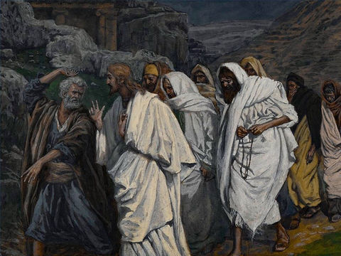
The Walk to the Garden of Gethsemane, by James Tissot
Jesus teaches the mission of the Holy Ghost.
1 And Jesus by the way saith unto them, I am the true vine, and my Father is the husbandman.
2 Every branch in me that beareth not fruit he taketh away: and every branch that beareth fruit, he purgeth it, that it may bring forth more fruit.
3 Now ye are clean through the word which I have spoken unto you.
4 Abide in me, and I in you. As the branch cannot bear fruit of itself, except it abide in the vine; no more can ye, except ye abide in me.
5 I am the vine, ye are the branches: He that abideth in me, and I in him, the same bringeth forth much fruit: for without me ye can do nothing.
6 If a man abide not in me, he is cast forth as a branch, and is withered; and men gather them, and cast them into the fire, and they are burned.
7 If ye abide in me, and my words abide in you, ye shall ask what ye will, and it shall be done unto you.
8 Herein is my Father glorified, that ye bear much fruit; so shall ye be my disciples.
9 As the Father hath loved me, so have I loved you: continue ye in my love.
10 If ye keep my commandments, ye shall abide in my love; even as I have kept my Father’s commandments, and abide in his love.
11 These things have I spoken unto you, that my joy might remain in you, and that your joy might be full.
12 This is my commandment, That ye love one another, as I have loved you.
13 Greater love hath no man than this, that a man lay down his life for his friends.
14 Ye are my friends, if ye do whatsoever I command you.
15 Henceforth I call you not servants; for the servant knoweth not what his lord doeth: but I have called you friends; for all things that I have heard of my Father I have made known unto you.
16 Ye have not chosen me, but I have chosen you, and ordained you, that ye should go and bring forth fruit, and that your fruit should remain: that whatsoever ye shall ask of the Father in my name, he may give it you.
17 These things I command you, that ye love one another.
18 If the world hate you, ye know that it hated me before it hated you.
19 If ye were of the world, the world would love his own: but because ye are not of the world, but I have chosen you out of the world, therefore the world hateth you.
20 Remember the word that I said unto you, The servant is not greater than his lord. If they have persecuted me, they will also persecute you; if they have kept my saying, they will keep yours also.
21 But all these things will they do unto you for my name’s sake, because they know not him that sent me.
22 If I had not come and spoken unto them, they had not had sin: but now they have no cloak for their sin.
23 He that hateth me hateth my Father also.
24 If I had not done among them the works which none other man did, they had not had sin: but now have they both seen and hated both me and my Father.
25 But this cometh to pass, that the word might be fulfilled that is written in their law, They hated me without a cause.
26 But when the Comforter is come, whom I will send unto you from the Father, even the Spirit of truth, which proceedeth from the Father, he shall testify of me:
27 And ye also shall bear witness, because ye have been with me from the beginning.
28 These things have I spoken unto you, that ye should not be offended.
29 They shall put you out of the synagogues: yea, the time cometh, that whosoever killeth you will think that he doeth God service.
30 And these things will they do unto you, because they have not known the Father, nor me.
31 But these things have I told you, that when the time shall come, ye may remember that I told you of them. And these things I said not unto you at the beginning, because I was with you.
32 But now I go my way to him that sent me; and none of you asketh me, Whither goest thou?
33 But because I have said these things unto you, sorrow hath filled your heart.
34 Nevertheless I tell you the truth; It is expedient for you that I go away: for if I go not away, the Comforter will not come unto you; but if I depart, I will send him unto you.
35 And when he is come, he will reprove the world of sin, and of righteousness, and of judgment:
36 Of sin, because they believe not on me;
37 Of righteousness, because I go to my Father, and ye see me no more;
38 Of judgment, because the prince of this world is judged.
39 I have yet many things to say unto you, but ye cannot bear them now.
40 Howbeit when he, the Spirit of truth, is come, he will guide you into all truth: for he shall not speak of himself; but whatsoever he shall hear, that shall he speak: and he will shew you things to come.
41 He shall glorify me: for he shall receive of mine, and shall shew it unto you.
42 All things that the Father hath are mine: therefore said I, that he shall take of mine, and shall shew it unto you.
43 A little while, and ye shall not see me: and again, a little while, and ye shall see me, because I go to the Father.
44 Then said some of his disciples among themselves, What is this that he saith unto us, A little while, and ye shall not see me: and again, a little while, and ye shall see me: and, Because I go to the Father?
45 They said therefore, What is this that he saith, A little while? we cannot tell what he saith.
46 Now Jesus knew that they were desirous to ask him, and said unto them, Do ye inquire among yourselves of that I said, A little while, and ye shall not see me: and again, a little while, and ye shall see me?
47 Verily, verily, I say unto you, That ye shall weep and lament, but the world shall rejoice: and ye shall be sorrowful, but your sorrow shall be turned into joy.
48 A woman when she is in travail hath sorrow, because her hour is come: but as soon as she is delivered of the child, she remembereth no more the anguish, for joy that a man is born into the world.
49 And ye now therefore have sorrow: but I will see you again, and your heart shall rejoice, and your joy no man taketh from you.
50 And in that day ye shall ask me nothing but it shall be done unto you. Verily, verily, I say unto you, Whatsoever ye shall ask the Father in my name, he will give it you.
51 Hitherto have ye asked nothing in my name: ask, and ye shall receive, that your joy may be full.
52 These things have I spoken unto you in proverbs: but the time cometh, when I shall no more speak unto you in proverbs, but I shall shew you plainly of the Father.
53 At that day ye shall ask in my name: and I say not unto you, that I will pray the Father for you:
54 For the Father himself loveth you, because ye have loved me, and have believed that I came out from God.
55 I came forth from the Father, and am come into the world: again, I leave the world, and go to the Father.
56 His disciples said unto him, Lo, now speakest thou plainly, and speakest no proverb.
57 Now are we sure that thou knowest all things, and needest not that any man should ask thee: by this we believe that thou camest forth from God.
58 Jesus answered them, Do ye now believe?
59 Behold, the hour cometh, yea, is now come, that ye shall be scattered, every man to his own, and shall leave me alone: and yet I am not alone, because the Father is with me.
60 These things I have spoken unto you, that in me ye might have peace. In the world ye shall have tribulation: but be of good cheer; I have overcome the world.
Taken from John 15:1-27, John 16:1-33
1. See also: Gen. 49:11; 1 Ne. 15:15
2. See also: Matt. 15:13; Matt. 7:19; Luke 3:9; TG Test, Try, Prove
4. See also: 1 Jn. 2:6; D&C 35:18; 43:3; 50:24
5. See also: TG Vineyard of the Lord; Philip 4:13
6. See also: Col. 1:23
7. See also: TG Problem-Solving; Prayer
8. See also: Isa. 49:3; Matt. 5:16
9. See also: TG God, Love of
10. See also: 1 Ne. 17:35; Mosiah 2:4; D&C 95:12; TG Obedience; Love
11. See also: TG Joy
12. See also: TG Love; D&C 6:20
13. See also: 1 Jn. 3:16; TG Love; Life, Sanctity of; Martyrdom; Brotherhood and Sisterhood; Friendship
14. See also: D&C 84:63; TG Commandments of God
15. See also: Luke 12:4; John 16:12; 3 Ne. 15:16; TG Revelation
16. See also: TG Apostles; Called of God; Election; Priesthood, Qualifying for; Authority; Church Organization; Priesthood, Authority; Priesthood, History of; Priesthood, Melchizedek; Mission of Early Saints; Missionary Work; D&C 18:18
18. See also: TG Hate
19. See also: TG World; Worldliness; Luke 6:26
20. See also: Matt. 10:24; D&C 6:29; TG Persecution
22. See also: John 9:41; 2 Ne. 9:25; D&C 82:3
24. See also: Alma 32: 19
25. See also: TG Hate
26. See also: TG Comfort; Holy Ghost, Comforter; Holy Ghost, Mission of; Holy Ghost, Source of Testimony
27. See also: TG Witness
28. See also: TG Offenses
29. See also: TG Persecution
30. See also: Moses 4:6
32. See also: Luke 5:35
34. See also: TG Holy Ghost, Comforter
35. See also: TG Holy Ghost, Mission of; Reproof; Righteousness
36. See also: TG Sin
39. See also: John 15:15; 3 Ne. 15:16; Heb. 5:11; 3 Ne. 17:2; D&C 50:40; 78:18
40. See also: TG Conscience; God, Omniscience of; Holy Ghost, Gifts of; Holy Ghost, Mission of; Inspiration; Learning; God, Intelligence of; Truth; Revelation
41. See also: Acts 3:13; TG Holy Ghost, Mission of
42. See also: 3 Ne. 28:10; D&C 76:59; 84:38; TG Jesus Christ, Divine Sonship
43. See also: D&C 35:21; 38:8
47. See also: TG Pain; Patience; Joy
48. See also: TG Marriage, Motherhood
49. See also: TG Sorrow; Joy
50. See also: TG Prayer
51. See also: D&C 66:9
54. See also: TG God, Love of; Faith
55. See also: John 8:14,42; 17:8; Gal. 4:4; TG Man, Antemortal Existence of
57. See also: TG God, Omniscience of; God, Perfection of
59. See also: John 8:16, 29; 14:18
60. See also: TG Peace of God; Earth, Purpose of; World; Worldliness; Affliction; Test, Try, Prove; Tribulation; Happiness; Rev. 12:11; D&C 50:41; 76:107

Commentary
- It is self-evident from the scriptures that the Father, the Son, and the Holy Ghost are separate persons, three divine beings.

Chapter One Hundred and Thirty
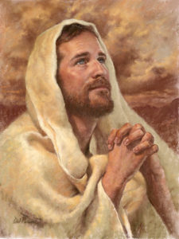
Jesus gives the great intercessory prayer.
1 And when they had arrived at the garden these words spake Jesus, and lifted up his eyes to heaven, and said, Father, the hour is come; glorify thy Son, that thy Son also may glorify thee:
2 As thou hast given him power over all flesh, that he should give eternal life to as many as thou hast given him.
3 And this is life eternal, that they might know thee the only true God, and Jesus Christ, whom thou hast sent.
4 I have glorified thee on the earth: I have finished the work which thou gavest me to do.
5 And now, O Father, glorify thou me with thine own self with the glory which I had with thee before the world was.
6 I have manifested thy name unto the men which thou gavest me out of the world: thine they were, and thou gavest them me; and they have kept thy word.
7 Now they have known that all things whatsoever thou hast given me are of thee.
8 For I have given unto them the words which thou gavest me; and they have received them, and have known surely that I came out from thee, and they have believed that thou didst send me.
9 I pray for them: I pray not for the world, but for them which thou hast given me; for they are thine.
10 And all mine are thine, and thine are mine; and I am glorified in them.
11 And now I am no more in the world, but these are in the world, and I come to thee. Holy Father, keep through thine own name those whom thou hast given me, that they may be one, as we are.
12 While I was with them in the world, I kept them in thy name: those that thou gavest me I have kept, and none of them is lost, but the son of perdition; that the scripture might be fulfilled.
13 And now come I to thee; and these things I speak in the world, that they might have my joy fulfilled in themselves.
14 I have given them thy word; and the world hath hated them, because they are not of the world, even as I am not of the world.
15 I pray not that thou shouldest take them out of the world, but that thou shouldest keep them from the evil.
16 They are not of the world, even as I am not of the world.
17 Sanctify them through thy truth: thy word is truth.
18 As thou hast sent me into the world, even so have I also sent them into the world.
19 And for their sakes I sanctify myself, that they also might be sanctified through the truth.
20 Neither pray I for these alone, but for them also which shall believe on me through their word;
21 That they all may be one; as thou, Father, art in me, and I in thee, that they also may be one in us: that the world may believe that thou hast sent me.
22 And the glory which thou gavest me I have given them; that they may be one, even as we are one:
23 I in them, and thou in me, that they may be made perfect in one; and that the world may know that thou hast sent me, and hast loved them, as thou hast loved me.
24 Father, I will that they also, whom thou hast given me, be with me where I am; that they may behold my glory, which thou hast given me: for thou lovedst me before the foundation of the world.
25 O righteous Father, the world hath not known thee: but I have known thee, and these have known that thou hast sent me.
26 And I have declared unto them thy name, and will declare it: that the love wherewith thou hast loved me may be in them, and I in them.
27 Then saith Jesus unto them, All ye shall be offended because of me this night: for it is written, I will smite the shepherd, and the sheep of the flock shall be scattered abroad.
28 But after I am risen again, I will go before you into Galilee.
29 And the Lord said, Simon, Simon, behold, Satan hath desired to you, that he may sift the children of the kingdom as wheat:
30 But I have prayed for thee, that thy faith fail not: and when thou art converted, strengthen thy brethren.
31 And Peter said unto him, Lord, I am ready to go with thee, both into prison, and to death. Though all men shall be offended because of thee, yet will I never be offended.
32 And Jesus said, I tell thee, Peter, the cock shall not crow this day, before that thou shalt thrice deny that thou knowest me.
33 But Peter spake the more vehemently, If I should die with thee, I will not deny thee in any wise. Likewise also said they all.
34 Then saith Jesus unto them, When I sent you without purse, and scrip, and shoes, lacked ye any thing? And they said, Nothing.
35 And said he unto them, But now, he that hath a purse, let him take it, and likewise his scrip: and he that hath no sword, let him sell his garment, and buy one.
36 For I say unto you, that this that is written must yet be accomplished in me, And he was reckoned among the transgressors: for the things concerning me have an end.
37 And they said, Lord, behold, here are two swords. And he said unto them, It is enough.
Taken from Matthew 26:32-36, Mark 14:30-34, Luke 22:31-38, John 17:1-26
1. See also: TG Jesus Christ, Divine Sonship; Jesus Christ, Mission of
2. See also: TG Jesus Christ, Authority of; Jesus Christ, Power of; John 6:37; 10:29; D&C 50:41
3. See also: TG Eternal Life; 1 Jn. 1:2; 2:25; D&C 132:24; Jer. 9:3; Hosea 2:20; 1 Jn. 4:8; D&C 101:16; TG God Knowledge about; Objectives; Testimony; Godhead; Jesus Christ, Messenger of the Covenant
4. See also: D&C 19:2; 65:6; 76:43; TG Jesus Christ, Atonement through
5. See also: TG Celestial Glory; Jesus Christ, Glory of; Jesus Christ, Foreordination; Man, Antemortal Existence of
6. See also: 1 Kgs. 8:53; 3 Ne. 15:19
7. See also: TG Jesus Christ, Relationships with the Father
8. See also: Deut. 18:18; John 6:68; TG Revelation; John 8:42; 16:28; Gal. 4:4; TG Faith
9. See also: TG Prayer; D&C 27:14; 84:63
11. See also: TG Earth, Purpose of; Unity
12. See also: John 6:39; 18:9; D&C 50:42; 3 Ne. 27:32; TG Damnation; Death, Spiritual, Second; Hell
13. See also: TG Joy
15. See also: TG World; Refuge; Evil
16. See also: TG Worldliness
17. See also: TG Sanctification; Jacob 4:13; 2 Sam. 7:28; Ps. 119:142; TG Truth
18. See also: TG Jesus Christ, Authority of
19. See also: TG Jesus Christ, Atonement through
20. See also: TG Prayer; D&C 45:5
21. See also: 4 Ne. 1:17; D&C 38:27; TG God, Father; Godhead; D&C 35:2; Moses 6:68
22. See also: Gal. 2:20; D&C 93:3
23. See also: TG Perfection; God, Love of
25. See also: TG God, Knowledge about
26. See also: TG Preaching; Name; God, Love of; Jesus Christ, Relationships with the Father
27. See also: TG Offenses; Zech. 13:7
28. See also: TG Jesus Christ, Resurrection
29. See also: TG Devil; Test, Try, Prove
30. See also: TG Prayer; Mosiah 3:19; TG Conversion; D&C 108:7; TG Fellowshipping; Missionary Work; Sustaining Church Leader
34. See also: Matt. 10:9; D&C 84:78
36. See also: Isa. 53:12

Commentary

- During the Intercessory Prayer of Jesus Christ, all three members of the Godhead were mentioned … It is self-evident from the scriptures that the Father, the Son, and the Holy Ghost are separate persons, three divine beings.

Chapter One Hundred and Thirty-One
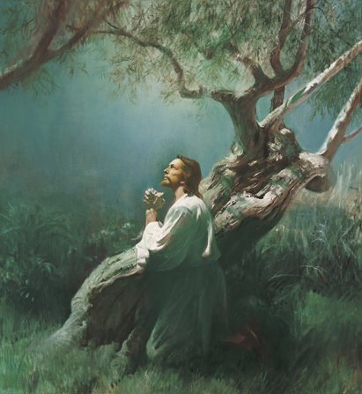
Christ in Gethsemane, by Harry Anderson
Jesus suffers in Gethsemane.
1 When Jesus had spoken these words, he went forth with his disciples over the brook Cedron, where was a garden which was named Gethsemane, into the which he entered, and his disciples.
2 And Judas also, which betrayed him, knew the place: for Jesus ofttimes resorted thither with his disciples.
3 And the disciples began to be sore amazed, and to be very heavy, and to complain in their hearts, wondering if this be the Messiah.
4 And Jesus knowing their hearts, said to his disciples, Sit ye here, while I shall pray.
5 And he taketh with him, Peter, and James, and John, and began to be sore amazed, and to be very heavy and rebuked them, and said unto them, My soul is exceeding sorrowful, even unto death; tarry ye here and watch that ye enter not into temptation.
6 And he went forward a little, about a stone’s cast, and fell on the ground, and prayed that, if it were possible, the hour might pass from him. Saying, O my Father, if it be possible, let this cup pass from me: nevertheless not as I will, but as thou wilt.
7 And he cometh unto the disciples, and findeth them asleep, and saith unto Peter, Why sleep ye? What, could ye not watch with me one hour?
8 Rise, watch and pray, lest ye enter into temptation: the spirit indeed is willing, but the flesh is weak.
9 He went away again the second time, a little further, and fell on his face, and prayed, saying, O my Father, if this cup may not pass away from me, except I drink it, thy will be done.
10 And he came again and found them asleep for sorrow: for their eyes were heavy.
11 And he left them alone, and went away again, and prayed the third time, saying,
12 Abba, Father, all things are possible unto thee; take away this cup from me: nevertheless not what I will, but what thou wilt.
13 And there appeared an angel unto him from heaven, strengthening him.
14 And being in an agony he prayed more earnestly: and he sweat as it were great drops of blood falling down to the ground.
15 And when he rose up from prayer, then cometh he to his disciples and saith unto them, Sleep on now, and take your rest: it is enough, the hour is come; behold, the Son of man is betrayed into the hands of sinners.
Taken from Matthew 26:37-46, Mark 14:35-44, Luke 22:40-46, John 18:1-2
1. See also: TG Jesus Christ, Atonement through
3. See also: Ps. 69:20
4. See also: Matt. 14:23; Luke 6:12; 9:28
5. See also: TG Pain, Sorrow
6. See also: Heb. 5:7; TG Prayer; God, Father; Mosiah 3:7; D&C 19:18; Isa. 50:5; TG Agency; Godhead; Obedience; Self-mastery
7. See also: TG Sleep; D&C 76:107; 122:8
9. See also: Acts 21:14; TG God, Will of
8. See also: TG Watchfulness; Prayer; Temptation; D&C 20:33; 23:1; 31:12
12. See also: 3 Ne. 11:11; D&C 19:17; Moses 4:2; TG God, Will of
13. See also: TG Angels
14. See also: TG Pain; Mosiah 3:7; D&C 19:18; TG Jesus Christ, Atonement through
15. See also: TG Jesus Christ, Betrayal of

Commentary

- It is self-evident from the scriptures that the Father, the Son, and the Holy Ghost are separate persons, three divine beings.

Chapter One Hundred and Thirty-Two
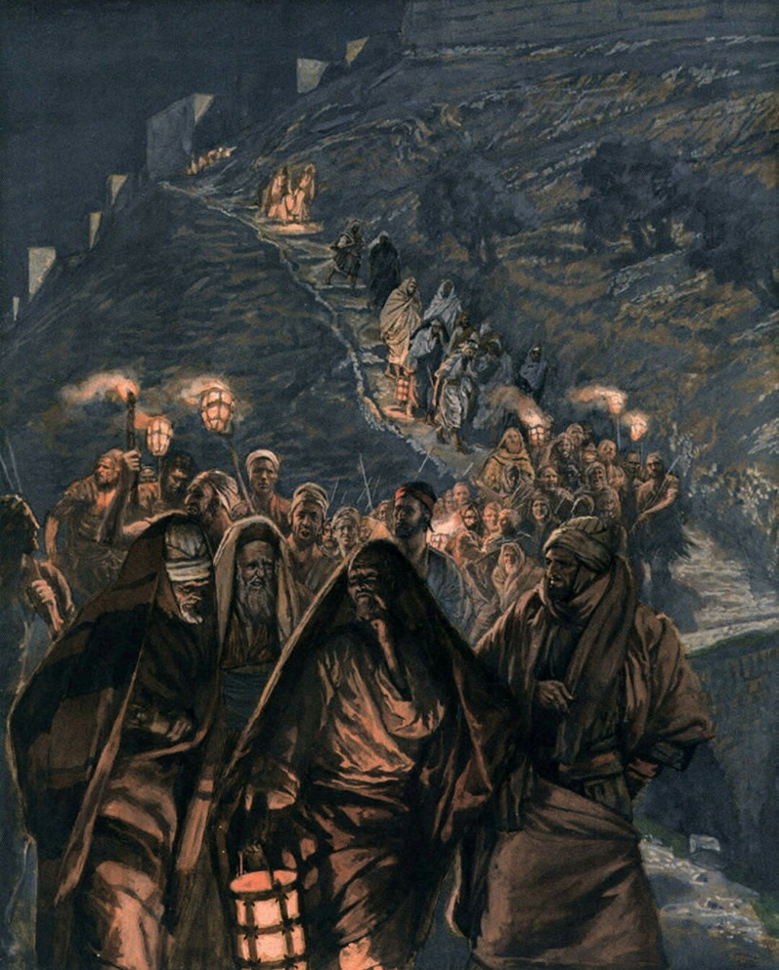
The Procession of Judas, by James Tissot
Jesus is betrayed by Judas.
1 Rise up, let us go; lo, he that betrayeth me is at hand.
2 And immediately, while Jesus yet spake, cometh Judas, one of the twelve, and with him a great multitude of men and officers with swords and staves, from the chief priests and the scribes and the elders.
3 And he that betrayed him had given them a token, saying, Whomsoever I shall kiss, that same is he; take him, and lead him away safely.
4 Jesus therefore, knowing all things that should come upon him, went forth, and as soon as Judas was come, he goeth straightway to him, and saith, Master, master; and kissed him.
5 And Jesus said unto him, Judas, betrayest thou the Son of man with a kiss? Whom seek ye?
6 They answered him, Jesus of Nazareth. Jesus saith unto them, I am he. And Judas also, which betrayed him, stood with them.
7 As soon then as he had said unto them, I am he, they went backward, and fell to the ground.
8 Then asked he them again, Whom seek ye? And they said, Jesus of Nazareth.
9 Jesus answered, I have told you that I am he: if therefore ye seek me, let these go their way:
10 Then came they, and laid hands on Jesus, and when they which were about him saw what would follow, they said unto him, Lord, shall we smite with the sword?
11 Then Simon Peter having a sword drew it, and smote the high priest’s servant, and cut off his right ear. The servant’s name was Malchus.
12 Then said Jesus unto Peter, Put up thy sword into the sheath: Thinkest thou that I cannot now pray to my Father, and he shall presently give me more than twelve legions of angels?
13 But how then shall the scriptures be fulfilled, that thus it must be? The cup which my Father hath given me, shall I not drink it?
14 Therefore, suffer ye this, for all they that take the sword tonight shall perish with the sword.
15 And Jesus touched Malchus’ ear, and healed him.
16 And then all the disciples forsook him, and fled.
17 And there followed him a certain young man, being a disciple of Christ, having a linen cloth cast about his naked body; and the multitude laid hold on him:
18 And he left the linen cloth, and fled from them naked.
19 And all this was done, that the scriptures of the prophets might be fulfilled, and that the saying might be fulfilled, which Jesus spake, Of them which thou gavest me have I lost none.
20 Then Jesus said unto the chief priests, and captains of the temple, and the elders, which were come to him, Be ye come out, as against a thief, with swords and staves to take me?
21 When I was daily with you in the temple teaching, ye stretched forth no hands against me: but this is your hour, and the power of darkness.
Taken from Matthew 26:47-57, Mark 14:45-55, Luke 22:47-53, John 18:3-11
3. See also: TG Jesus Christ, Betrayal of
5. See also: Acts 1:16; Prov. 26:6
11. See also: TG Rashness
13. See also: 2 Ne. 9:7; Mosiah 3:15; 3 Ne. 11:11
14. See also: TG Punishment; Retribution
15. See also: TG Healing
19. See also: John 6:39; 17:12
21. See also: Luke 21:7; John 8:2; TG Teaching; Darkness, Spiritual

Chapter One Hundred and Thirty-Three
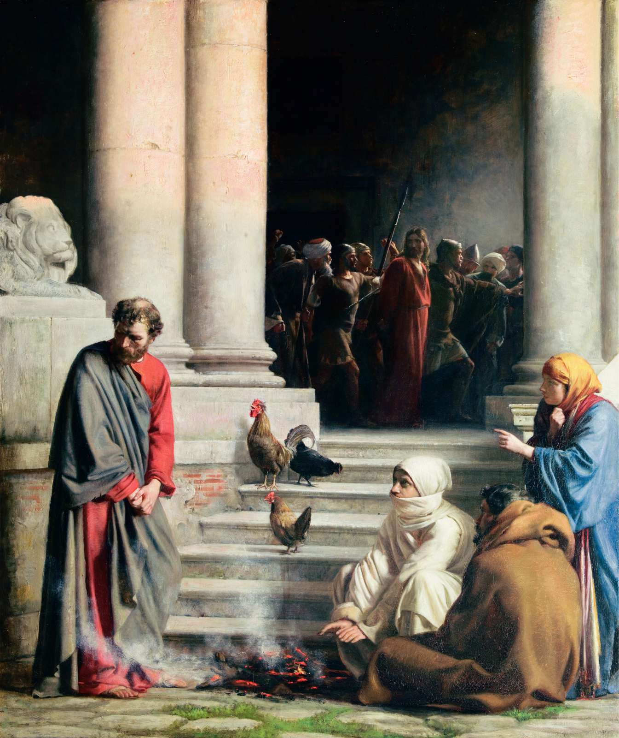
The Denial of Peter, by Carl Heinrich Bloch
Jesus is arrested and brought before Annas and Caiaphas; Peter denies Jesus.
1 Then the band and the captain and officers of the Jews took Jesus, and bound him,
2 And led him away to Annas first; for he was father in law to Caiaphas, which was the high priest that same year.
3 Now Caiaphas was he, which gave counsel to the Jews, that it was expedient that one man should die for the people.
4 And Simon Peter followed Jesus afar off, and so did another disciple: that disciple was known unto the high priest, and went in with Jesus into the palace of the high priest.
5 But Peter stood at the door without. Then went out that other disciple, which was known unto the high priest, and spake unto her that kept the door, and brought in Peter.
6 And when they had kindled a fire in the midst of the hall, and were set down together, Peter sat down among the servants without in the palace.
7 The high priest then asked Jesus of his disciples, and of his doctrine.
8 Jesus answered him, I spake openly to the world; I ever taught in the synagogue, and in the temple, whither the Jews always resort; and in secret have I said nothing.
9 Why askest thou me? Ask them which heard me, what I have said unto them: behold, they know what I said.
10 And when he had thus spoken, one of the officers which stood by struck Jesus with the palm of his hand, saying, Answerest thou the high priest so?
11 Jesus answered him, If I have spoken evil, bear witness of the evil: but if well, why smitest thou me?
12 And there cometh one of the maids of the high priest who beheld Peter as he sat by the fire, and earnestly looked upon him, and said, Thou also wast with Jesus of Nazareth.
13 But Peter denied, saying, Woman, I know not, neither understand I what thou sayest. And he went out into the porch; for the servants and officers stood there, who had made a fire of coals; for it was cold: and they warmed themselves: and Peter stood with them, and warmed himself.
14 They said therefore unto him, Art not thou also one of his disciples? And again he denied with an oath, I do not know the man.
15 And after about the space of one hour another maid saw Peter and began to confidently affirm to those nearby, Of a truth this fellow also was with him: for he is a Galilæan.
16 And after a while came unto him they that stood by, and said to Peter, Surely thou art one of them; for thy speech bewrayeth thee, for thou art a Galilaean and thy speech agreeth thereto.
17 Then one of the servants of the high priest, being his kinsman whose ear Peter cut off, saith, Did not I see thee in the garden with him?
18 Then began he to curse and to swear, saying, I know not the man of whom ye speak. And immediately the cock crew.
19 Now at this time Annas had sent Jesus bound to Caiaphas the high priest, and the Lord turned, and looked upon Peter. And Peter remembered the word of the Lord, how he had said unto him, Before the cock crow, thou shalt deny me thrice.
20 And Peter went out, and wept bitterly.
Taken from Matthew 26:58-59, 70-76, Mark 14:56-57, 69-75, Luke 22:54-62, John 18:12-27
2. See also: Matt. 26:57; Luke 3:2; TG Jesus Christ, Trial of
3. See also: John 19:11
10. See also: Acts 23:2
19. See also: TG Jesus Christ, Lord; Honesty

Chapter One Hundred and Thirty-Four
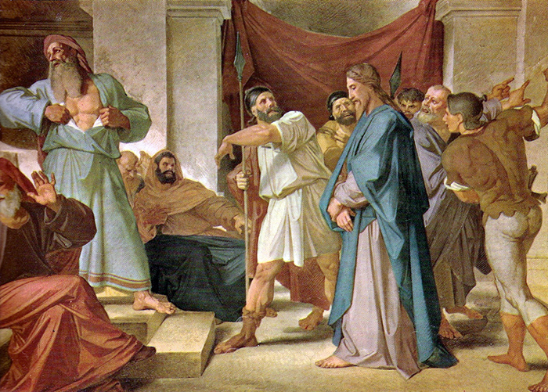
Jesus Before the High Priest, by Alessandro Mantovani
Jesus is brought before the high priest; is abused and mocked.
1 And straightway in the morning the chief priests led Jesus bound and held a consultation with the elders and scribes and the whole council.
2 And the chief priests and all the council sought for witness against Jesus to put him to death; and found none.
3 For many bare false witness against him, but their witness agreed not together.
4 And there arose certain, and bare false witness against him, saying,
5 We heard him say, I will destroy this temple that is made with hands, and within three days I will build another made without hands.
6 But neither so did their witness agree together.
7 And the high priest stood up in the midst, and asked Jesus, saying, Answerest thou nothing? what is it which these witness against thee?
8 But Jesus held his peace, and answered nothing. Again the high priest asked him, and said unto him, I adjure thee by the living God, that thou tell us whether thou be the Christ, the Son of God.
9 And Jesus said, I am, nevertheless ye will not believe, and if I also ask you ye will not answer me or let me go. But hereafter ye shall see the Son of man sitting on the right hand of power, and coming in the clouds of heaven.
10 Then the high priest rent his clothes, and saith, He hath spoken blasphemy; What need we any further witnesses?
11 Behold ye have heard the blasphemy: what think ye? And they all condemned him to be guilty and worthy of death.
12 Then did they spit in his face, and buffeted him; and others when they had blindfolded him, smote him with the palms of their hands,
13 Saying, Prophesy unto us, thou Christ, Who is he that smote thee?
14 And the whole multitude of them arose, and led him unto Pilate.
Taken from Matthew 26:60-69, Matthew 27:1-2, Mark 14:58-68, Mark 15:1 Luke 22:63-71, Luke 23:1
2. See also: TG Jesus Christ, Death of; Slander
3. See also: TG Lying
4. See also: Deut. 19:15
5. See also: Matt. 27:40; John 2:19; Heb. 9:11
8. See also: Isa. 53:7; TG Oath; Swearing; Jesus Christ, Messiah; Jesus Christ, Trial of
9. See also: TG Jesus Christ, Son of Man; Celestial Glory; Jesus Christ, Second Coming
10. See also: TG Blasphemy; Jesus Christ, Trial of; Jesus Christ, Death of
11. See also: TG Jesus Christ, Trial of; Guilt
12. See also: TG Jesus Christ, Trial of; Mocking; Isa. 50:6
14. See also: TG Jesus Christ, Trial of

Chapter One Hundred and Thirty-Five
Christ Mocked by Soldier, by Carl Heinrich Bloch
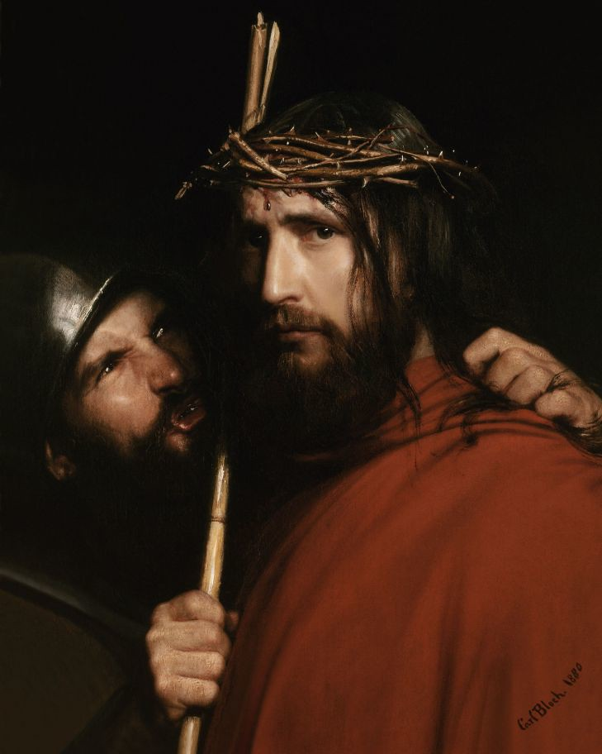
Jesus is taken before Pilate and Herod; is mocked by soldiers.
1 Then led they Jesus from Caiaphas unto the hall of judgment: and it was early; and they themselves went not into the judgment hall, lest they should be defiled; but that they might eat the passover.
2 Pilate then went out unto them, and said, What accusation bring ye against this man?
3 They answered and said unto him, If he were not a malefactor, we would not have delivered him up unto thee.
4 Then said Pilate unto them, Take ye him, and judge him according to your law. The Jews therefore said unto him, It is not lawful for us to put any man to death:
5 That the saying of Jesus might be fulfilled, which he spake, signifying what death he should die.
6 And they began to accuse him, saying, We found this fellow perverting the nation, and forbidding to give tribute to Cæsar, saying that he himself is Christ a King.
7 And Pilate asked him, saying, Art thou the King of the Jews? And he answered him and said, I am, thou sayest truly; for thus it is written of me.
8 And the chief priests accused him of many things: but he answered nothing
9 Then said Pilate unto him, Hearest thou not how many things they witness against thee?
10 And he answered him to never a word; insomuch that the governor marvelled greatly.
11 Then said Pilate to the chief priests and to the people, I find no fault in this man.
12 And they were the more fierce, saying, He stirreth up the people, teaching throughout all Jewry, beginning from Galilee to this place.
13 When Pilate heard of Galilee, he asked whether the man were a Galilæan.
14 And as soon as he knew that he belonged unto Herod’s jurisdiction, he sent him to Herod, who himself also was at Jerusalem at that time.
15 And when Herod saw Jesus, he was exceeding glad: for he was desirous to see him of a long season, because he had heard many things of him; and he hoped to have seen some miracle done by him.
16 Then he questioned with him in many words; but he answered him nothing.
17 And the chief priests and scribes stood and vehemently accused him.
18 Then the soldiers of Herod took Jesus into the common hall, called Prætorium and gathered unto him the whole band of soldiers.
19 And when they had stripped him, they scourged him and put on him a purple robe.
20 And when they had plaited a crown of thorns, they put it upon his head, and a reed in his right hand: and they bowed the knee before him, and mocked him, saying, Hail, King of the Jews!
21 And they spit upon him, and took the reed, and smote him on the head.
22 And after that they had mocked him, they took the robe off from him, and put his own raiment on him, and led him again to Pilate.
Taken from Matthew 27:11-14, 27-31, Mark 15:2-5, 16-20, Luke 23:2-11, John 18:28-32, John 19:1-3
1. See also: John 19:14
2. See also: TG Jesus Christ, Trial of
6. See also: D&C 63:26; Alma 5:50
8. See also: Isa. 53:7; Mosiah 14:7
11. See also: TG Jesus Christ, Trial of
15. See also: TG Miracles; Sign Seekers
16. See also: Mosiah 14:7; 15:6
17. See also: TG Scribes
19. See also: Mosiah 15:5
20. See also: TG Jesus Christ, Trial of; Mocking; D&C 45:53; 1 Ne. 11:32
21. See also: 1 Ne. 19:9
22. See also: TG Mocking

Chapter One Hundred and Thirty-Six
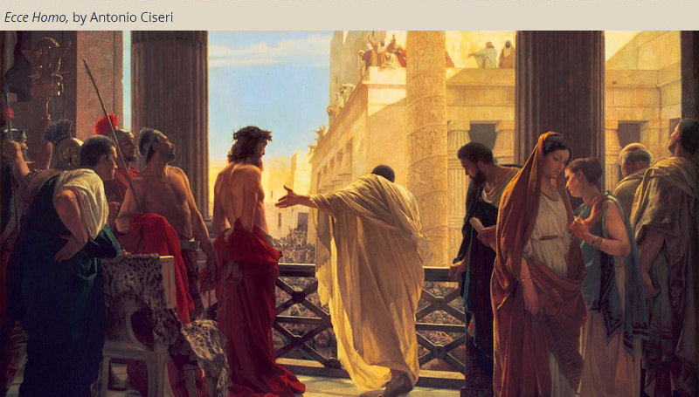
Jesus is accused and condemned before Pilate; the multitude choose to release Barabbas and demand that Jesus be crucified.
1 And the same day Pilate and Herod were made friends together: for before they were at enmity between themselves.
2 And Pilate, when he had called together the chief priests and the rulers and the people, entered into the judgment hall again, and called Jesus, and said unto him, Art thou the King of the Jews?
3 Jesus answered him, Sayest thou this thing of thyself, or did others tell it thee of me?
4 Pilate answered, Am I a Jew? Thine own nation and the chief priests have delivered thee unto me: what hast thou done?
5 Jesus answered, My kingdom is not of this world: if my kingdom were of this world, then would my servants fight, that I should not be delivered to the Jews: but now is my kingdom not from hence.
6 Pilate therefore said unto him, Art thou a king then? Jesus answered, Thou sayest that I am a king. To this end was I born, and for this cause came I into the world, that I should bear witness unto the truth. Every one that is of the truth heareth my voice.
7 Pilate saith unto him, What is truth? And when he had said this, he went out again unto the Jews and said unto them, Ye have brought this man unto me, as one that perverteth the people: and, behold, I, having examined him before you, have found no fault in this man touching those things whereof ye accuse him:
8 No, nor yet Herod: for I sent you to him; and, lo, nothing worthy of death is done unto him.
9 But ye have a custom, that I should release unto you one at the Passover. Now at that feast the governor was wont to release unto the people a prisoner, whom they would.
10 And they had then a notable prisoner, called Barabbas (who for a certain sedition made in the city, and for murder, was cast into prison.)
11 Therefore when they were gathered together, Pilate said unto them, Whom will ye that I release unto you? Barabbas, or Jesus which is called Christ, the King of the Jews?
12 For he knew that for envy they had delivered him.
13 But the chief priests and elders persuaded the multitude that they should ask Barabbas, and destroy Jesus.
14 The governor answered and said unto them, Whether of the twain will ye that I release unto you?
15 Then cried they all, saying, Not this man, but Barabbas.
16 Pilate therefore, willing to release Jesus, spake again to them, saying,
17 Behold, I bring him forth to you, that ye may know that I find no fault in him.
18 Then came Jesus forth, wearing the crown of thorns, and the purple robe. And Pilate saith unto them, Behold the man!
19 When the chief priests therefore and officers saw him, they cried out, saying, Crucify him, crucify him. Pilate saith unto them, Take ye him, and crucify him: for I find no fault in him.
20 The Jews answered him, We have a law, and by our law he ought to die, because he made himself the Son of God.
21 When Pilate therefore heard that saying, he was the more afraid;
22 And went again into the judgment hall, and saith unto Jesus, Whence art thou? But Jesus gave him no answer.
23 Then saith Pilate unto him, Speakest thou not unto me? knowest thou not that I have power to crucify thee, and have power to release thee?
24 Jesus answered, Thou couldest have no power at all against me, except it were given thee from above: therefore he that delivered me unto thee hath the greater sin.
25 And from thenceforth Pilate sought to release him: but the Jews cried out, saying, If thou let this man go, thou art not Cæsar’s friend: whosoever maketh himself a king speaketh against Cæsar.
26 Pilate therefore sat down in the judgment seat in a place that is called the Pavement, but in the Hebrew, Gabbatha.
27 And when he was set down on the judgment seat, his wife sent unto him, saying, Have thou nothing to do with that just man: for I have suffered many things this day in a dream because of him.
28 When Pilate heard that saying, he brought Jesus forth and it was the preparation of the passover, and about the sixth hour: and he saith unto the Jews, Behold your King!
29 But they cried out, Away with him, away with him, crucify him. Pilate saith unto them, Shall I crucify your King? The chief priests answered, We have no king but Cæsar.
30 And Pilate said unto them the third time, Why, what evil hath he done? I have found no cause of death in him: I will therefore chastise him, and let him go.
31 And they were instant with loud voices, requiring that he might be crucified.
32 When Pilate therefore saw that he could prevail nothing, but that rather a tumult was made, he took water, and washed his hands before the multitude, saying, I am innocent of the blood of this just person: see ye to it.
33 Then answered all the people, and said, His blood be on us, and on our children.
34 And so Pilate, willing to content the people, released unto them Barrabas, that for sedition and murder was cast into prison, whom they desired, and delivered Jesus to their will to be crucified.
Taken from Matthew 27:15-26, Mark 15:6-15, Luke 23:12-25, John 18:33-40, John 19:4-16
5. See also: John 6:15; TG World
6. See also: 1 Tim. 6:13; Isa. 55:4; 3 Ne. 11:31; TG Truth
12. See also: TG Envy; Jesus Christ, Betrayal of
13. See also: TG Priestcraft; Matt. 26:4; Acts 3:13; 13:28; 2 Ne. 10:5
17. See also: Mosiah 14:9
19. See also: Jesus Christ, Trial of; Acts 3:13
20. See also: Lev. 24:16; John 5:18; 10:33; Mosiah 15:2
22. See also: Mosiah 14:7; 15:6
24. See also: Rom. 13:1; D&C 134:1; John 18:14
27. See also: TG Dreams
28. See also: John 18:28; TG Passover; D&C 45:53
29. See also: 2 Ne. 10:3,14; TG Jesus Christ, Trial of
31. See also: 2 Ne. 10:3
32. See also: TG Rioting and Reveling
33. See also: Ps. 69:27; Acts 5:28; 2 Ne. 6:10
34. See also: Acts 3:14

Chapter One Hundred and Thirty-Seven
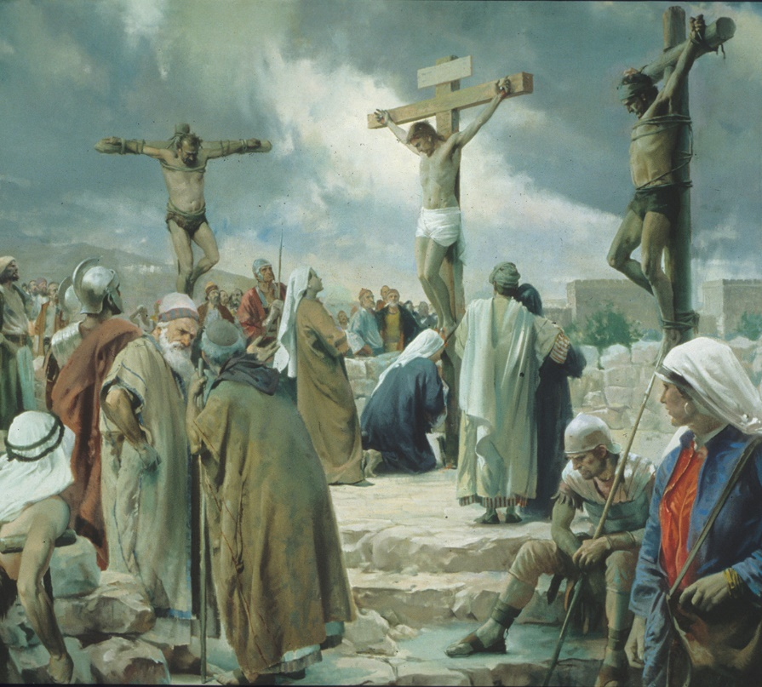
Crucifixion, by Harry Anderson
Jesus is mocked and crucified. Prophecies are fulfilled.
1 And as they led Jesus away, they laid hold upon Simon, a Cyrenian, the father of Alexander and Rufus, coming out of the country, and on him they laid the cross, that he might bear it after Jesus.
2 And there followed him a great company of people, and of women, which also bewailed and lamented him.
3 But Jesus turning unto them said, Daughters of Jerusalem, weep not for me, but weep for yourselves, and for your children.
4 For, behold, the days are coming, in the which they shall say, Blessed are the barren, and the wombs that never bare, and the paps which never gave suck.
5 Then shall they begin to say to the mountains, Fall on us; and to the hills, Cover us.
6 For if they do these things in a green tree, what shall be done in the dry? This he spake, signifying the scattering of Israel, and the desolation of the heathen, or in other words, the Gentiles.
7 And there were also two other, malefactors (thieves), led with him to be put to death.
8 And when they were come to the place called the place of a burial, which is called in the Hebrew Golgotha or Calvary in Latin, they gave him to drink wine mingled with myrrh and vinegar mingled with gall: but he received it not.
9 And there they crucified him in the third hour, and the malefactors also, one on the right hand, and the other on the left.
10 And the scripture was fulfilled, which saith, And he was numbered with the transgressors.
11 Then said Jesus, Father, forgive them; for they know not what they do (meaning the soldiers who crucified him,)
12 Then the soldiers, when they had crucified Jesus, took his garments, and made four parts, to every soldier a part; and also his coat: now the coat was without seam, woven from the top throughout.
13 They said therefore among themselves, Let us not rend it, but cast lots for it, whose it shall be: that the scripture might be fulfilled, which saith, They parted my raiment among them, and for my vesture they did cast lots. These things therefore the soldiers did.
14 And Pilate wrote a title, and put it on the cross. And the writing of his accusation was, Jesus of Nazareth the King of the Jews.
15 This title then read many of the Jews: for the place where Jesus was crucified was nigh to the city: and it was written in Hebrew, and Greek, and Latin.
16 Then said the chief priests of the Jews to Pilate, Write not, The King of the Jews; but that he said, I am King of the Jews.
17 Pilate answered, What I have written I have written.
18 And they that passed by railed on him, reviling him and deriding him, wagging their heads, and saying, Ah, thou that destroyest the temple, and buildest it in three days,
19 Save thyself, and come down from the cross.
20 Likewise also the chief priests mocking said among themselves with the scribes and elders, He saved others; himself he cannot save.
21 Let Christ, the chosen of God, the King of Israel, descend now from the cross, that we may see and believe.
22 For He trusted in God; let him deliver him now, if he will have him: for he said, I am the Son of God.
23 And the soldiers also mocked him, coming to him, and offering him vinegar,
24 And one of the malefactors which were hanged railed on him, saying, If thou be Christ, save thyself and us.
25 But the other answering rebuked him, saying, Dost not thou fear God, seeing thou art in the same condemnation?
26 And we indeed justly; for we receive the due reward of our deeds: but this man hath done nothing amiss.
27 And he said unto Jesus, Lord, remember me when thou comest into thy kingdom.
28 And Jesus said unto him, Verily I say unto thee, To day shalt thou be with me in paradise.
29 And it was about the sixth hour, and there was a darkness over all the earth until the ninth hour.
30 Now there stood by the cross of Jesus many women beholding, which followed Jesus from Galilee, ministering upon him: among which Mary (his mother), Salome, his mother’s sister (wife of Zebedee, the mother of James and John), Mary the wife of Cleophas (mother of James the Younger, Joses), and Mary Magdalene (the one whom he cast devils from) and many other women who came up with him unto Jerusalem.
31 When Jesus therefore saw his mother and John standing by, whom he loved, he saith unto his mother, Woman, behold thy son!
32 Then saith he to John, Behold thy mother! And from that hour that John took Mary unto his own home.
33 And at the ninth hour Jesus cried with a loud voice, saying, Eloi, Eloi, lama sabachthani? which is, being interpreted, My God, my God, why hast thou forsaken me?
34 And some of them that stood by, when they heard it, said, Behold, he calleth Elias.
35 After this, Jesus knowing that all things were now accomplished, that the scripture might be fulfilled, saith, I thirst.
36 Now there was set a vessel full of vinegar: and one ran and filled a sponge with vinegar, and put it upon hyssop, and put it to his mouth to drink.
37 But the rest said, Let alone; let us see whether Elias will come to take him down.
38 When Jesus therefore had received the vinegar, he said, It is finished, Thy will is done. Then Jesus cried with a loud voice, saying, Father, into thy hands I commend my spirit: after having said thus, he bowed his head and gave up the ghost.
39 And, behold, the sun was darkened, and the veil of the temple was rent in twain from the top to the bottom; and the earth did quake, and the rocks rent;
40 And now when the centurion, and they that were with him, watching Jesus, saw the earthquake, and those things that were done, they feared greatly, and glorified God, saying, Truly this was a righteous man, the Son of God.
41 And all the people that came together to that sight, beholding the things which were done, smote their breasts, and returned.
42 The Jews therefore, because it was the preparation, that the bodies should not remain upon the cross on the sabbath day, (for that sabbath day was an high day,) besought Pilate that their legs might be broken, and that they might be taken away.
43 Then came the soldiers, and brake the legs of the first, and of the other which was crucified with him.
44 But when they came to Jesus, and saw that he was dead already, they brake not his legs:
45 But one of the soldiers with a spear pierced his side, and forthwith came there out blood and water.
46 And he that saw it bare record, and his record is true: and he knoweth that he saith true, that ye might believe.
47 For these things were done, that the scripture should be fulfilled, A bone of him shall not be broken.
48 And again another scripture saith, They shall look on him whom they pierced.
Taken from Matthew 27:32-51,54, Mark 15:21-41, Luke 23:26-47,49, John 19:17-37
1. See also: Gen. 22:6; Luke 14:27
3. See also: TG Jerusalem
4. See also: Matt. 24:19
5. See also: Hosea 10:8; Rev. 6:16
6. See also: D&C 135:6
7. See also: Isa. 53:9; Mosiah 14:9
8. See also: Heb. 13:12; Ps. 69:21
9. See also: TG Jesus Christ, Crucifixion of
10. See also: Isa. 53:12
11. See also: Luke 6:28; Acts 7:60; TG Benevolence; Forgiveness; Mercy
13. See also: Ps. 22:18
14. See also: D&C 45:53; Mosiah 15:5
18. See also: TG Reviling; Matt. 26:61; Mark 14:58; John 2:19
20. See also: Ps. 22:7
21. See also: TG Jesus Christ, Relationships with the Father; Matt. 4:6; D&C 20:22
22. See also: Ps. 22:8; TG Deliverance; Jesus Christ, Divine Sonship
23. See also: TG Mocking; Ps. 69:21
24. See also: TG Malice; Reviling
26. See also: TG Reward
28. See also: John 20:17; Alma 40:21; TG Immortality; Paradise; Spirits, Disembodied
29. See also: 3 Ne. 8:19; Amos 8:9; Hel. 14:20; TG Darkness, Physical
30. See also: Luke 2:35; TG Marriage, Motherhood; Woman; Luke 24:18
31. See also: John 20:2; D&C 7:1; TG Woman
32. See also: TG Family, Love within; Honoring Father and Mother; Jesus Christ, Family of
33. See also: TG Jesus Christ, Crucifixion of; Ps. 22:1; D&C 121:1
36. See also: Ps. 69:21
38. See also: TG Commitment; Ps. 31:5; John 10:18; TG Man, a Spirit Child of Heavenly Father; Death; Spirits, Disembodied; Jesus Christ, Crucifixion of
39. See also: TG Jesus Christ, Types, in Anticipation; Veil; 3 Ne. 8:6; Moses 7:56
40. See also: TG Righteousness
42. See also: TG Jesus Christ, Crucifixion of; Ex. 12:14,16; Cp. Levi 23;7; Deut. 21:23
44. See also: TG Jesus Christ, Types, in Anticipation; Passover
46. See also: John 1:14; 21:24; John 1:7
47. See also: Ex. 12:46; Num. 9:12
48. See also: TG Jesus Christ, Crucifixion of; Jesus Christ, Prophecies about

Commentary
- It is self-evident from the scriptures that the Father, the Son, and the Holy Ghost are separate persons, three divine beings.

Chapter One Hundred and Thirty-Eight
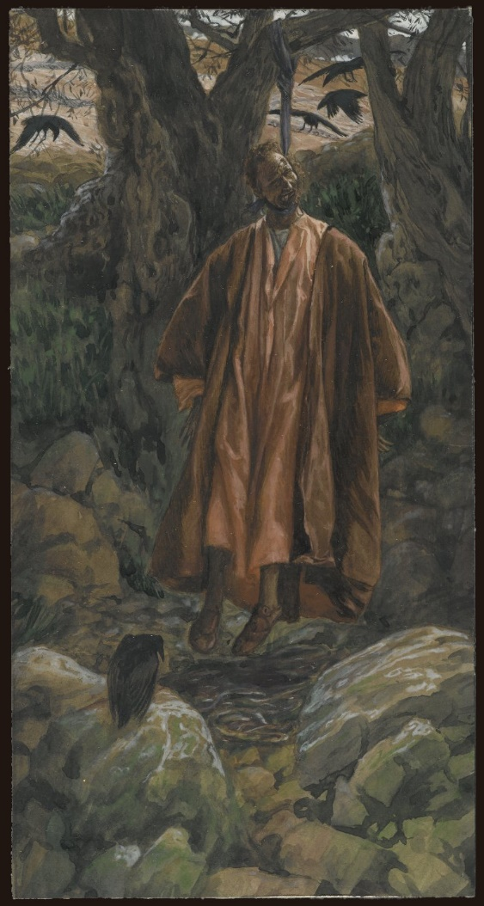
Judas Hangs Himself, by James Tissot
Judas takes his own life after betraying Christ.
1 Then Judas, who had betrayed Jesus, when he saw that he was condemned, repented himself, and brought again the thirty pieces of silver to the chief priests and elders,
2 Saying, I have sinned in that I have betrayed the innocent blood. And they said, What is that to us? see thou to it; thy sins be upon thee.
3 And he cast down the pieces of silver in the temple, and departed, and went and hanged himself on a tree. And straightway he fell down, and his bowels gushed out, and he died.
4 And the chief priests took the silver pieces, and said, It is not lawful for to put them into the treasury, because it is the price of blood.
5 And they took counsel, and bought with them the potter’s field, to bury strangers in.
6 Wherefore that field was called, The field of blood, unto this day.
7 Then was fulfilled that which was spoken by Jeremy the prophet, saying, And they took the thirty pieces of silver, the price of him that was valued, whom they of the children of Israel did value;
8 And gave them for the potter’s field, as the Lord appointed me.
Taken from Matthew 27:3-10
2. See also: TG Jesus Christ, Betrayal of; Blood, Shedding of
3. See also: Acts 1:18
5. See also: Zech. 11:13; TG Strangers
7. See also: TG Jesus Christ, Betrayal of

Chapter One Hundred and Thirty-Nine
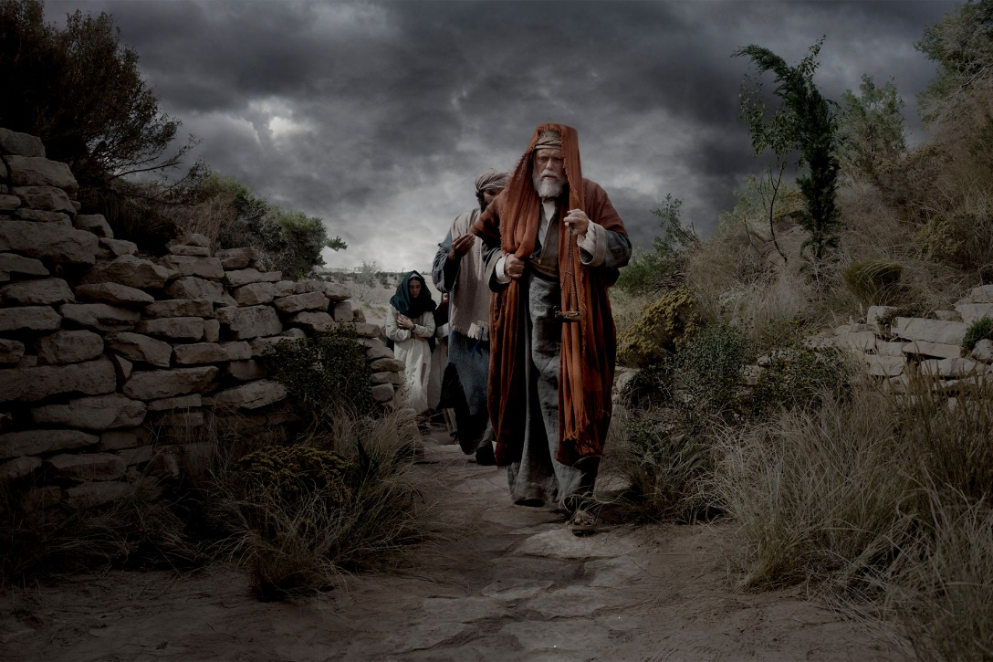
Jesus is buried in the tomb of Joseph Arimathaea.
1 And now when the even was come, Joseph, a rich man of Arimathæa (a city of the Jews), an honourable counsellor (The same had not consented to the counsel and deed of them), which also waited for the kingdom of God, being a disciple of Jesus, but secretly for the fear of the Jews, came, and went in boldly unto Pilate, and craving the body of Jesus did beg for it.
2 And Pilate marvelled if he were already dead: and calling unto him the centurion, he asked him whether he had been any while dead.
3 And when he knew it of the centurion, he gave the body to Joseph.
4 And there came Nicodemus unto Joseph, which at the first came to Jesus by night, and brought a mixture of myrrh and aloes, about an hundred pound weight.
5 Then took they the body of Jesus, and wound it in fine linen clothes with the spices, as the manner of the Jews is to bury.
6 Now in the place where he was crucified there was a garden; and in the garden Joseph’s own new sepulchre, wherein was never man yet laid, which was hewn out of a rock.
7 And they took his body and laid him in the sepulchre. And they did this therefore because of the Jews’ preparation day, that is, the day before the sabbath; for the sepulchre was nigh at hand. And when they had finished, they rolled a great stone unto the door of the sepulchre and departed.
8 And Mary Magdalene and Mary the mother of James the Younger and Joses beheld where Jesus was laid, for they sat over against the sepulchre.
9 And that day was the preparation, and the sabbath drew on. Therefore they returned also, and prepared spices and ointments; and rested the sabbath day according to the commandment.
Taken from Matthew 27:57-61, Mark 15:42-47, Luke 23:50-56, John 19:38-42
1. See also: TG Counselors; Prov. 29:25; John 7:13; 8:31; 12:42
4. See also: John 3:1; Ps. 45:8
6. See also: Mosiah 14:9; 1 Ne. 19:10; 2 Ne. 25:13
7. See also: TG Passover; John 11:38; 20:1
8. See also: Luke 24:1
9. See also: TG Passover; Rest

Chapter One Hundred and Forty
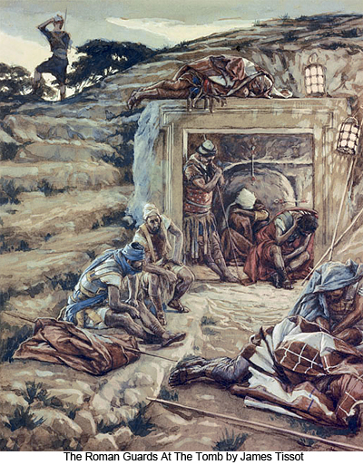
Guards are set at Jesus’ tomb.
1 Now the next day, that followed the day of the preparation, the chief priests and Pharisees came together unto Pilate,
2 Saying, Sir, we remember that that deceiver said, while he was yet alive, After three days I will rise again.
3 Command therefore that the sepulchre be made sure until the third day, lest his disciples come by night, and steal him away, and say unto the people, He is risen from the dead: so the last error shall be worse than the first.
4 Pilate said unto them, Ye have a watch: go your way, make it as sure as ye can.
5 So they went, and made the sepulchre sure, sealing the stone, and setting a watch.
Taken from Matthew 27:62-66
1. See also: TG Passover
4. See also: John 2:19
Chapter One Hundred and Forty-One
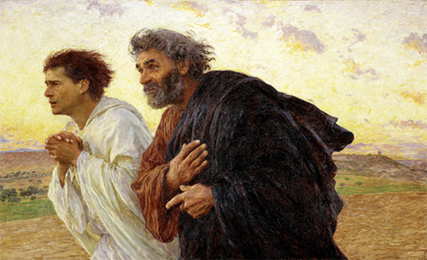
The Disciples Peter and John, by Eugene Burnand
Mary Magdalene finds the tomb empty; Peter and John visit the empty tomb but don’t believe. Jesus appears to Mary.
1 The first day of the week cometh, and, behold, there was a great earthquake: for two angels of the Lord descended from heaven, and came and rolled back the stone from the door, and sat upon it.
2 And their countenance was like lightning, and their raiment white as snow:
3 And for fear of him the keepers did shake, and became as dead men.
4 And the graves were opened; and many bodies of the saints which slept arose,
5 And came out of the graves after his resurrection, and went into the holy city, and appeared unto many.
6 Then cometh Mary Magdalene early, when it was yet dark, unto the sepulchre, and seeth the stone taken away from the sepulchre and she knew not the meaning thereof. So she runneth to Peter and John for fear.
7 Now when she was going, behold, the keepers did awake and some of the watch came into the city, and shewed unto the chief priests all the things that were done.
8 And when they were assembled with the elders, and had taken counsel, they gave large money unto the soldiers,
9 Saying, Say ye, His disciples came by night, and stole him away while we slept.
10 And if this come to the governor’s ears, we will persuade him, and secure you.
11 So they took the money, and did as they were taught: and this saying is commonly reported among the Jews until this day.
12 And it came to pass that when Mary cometh to Simon Peter, and to John, she saith unto them, They have taken away the Lord out of the sepulchre, and I know not where they have laid him.
13 Peter therefore went forth with John, and came to the sepulchre.
14 So they ran both together: and John did outrun Peter, and came first to the sepulchre.
15 And he stooping down, and looking in, saw the linen clothes lying; yet went he not in.
16 Then cometh Simon Peter following him, and went into the sepulchre, and seeth the linen clothes lie,
17 And the napkin, that was about his head, not lying with the linen clothes, but wrapped together in a place by itself.
18 Then went in also John, which came first to the sepulchre, and when he saw, he believed Mary.
19 For as yet they knew not the scripture, that he must rise again from the dead.
20 Then John and Peter went away again unto their own home, wondering in themselves at that which was come to pass.
21 But Mary stood without at the sepulchre weeping: and as she wept, she stooped down, and looked into the sepulchre,
22 And seeth two angels in white sitting, the one at the head, and the other at the feet, where the body of Jesus had lain.
23 And they say unto her, Woman, why weepest thou? She saith unto them, Because they have taken away my Lord, and I know not where they have laid him.
24 And when she had thus said, she turned herself back, and saw Jesus standing, and knew not that it was Jesus.
25 Jesus saith unto her, Woman, why weepest thou? whom seekest thou? She, supposing him to be the gardener, saith unto him, Sir, if thou have borne him hence, tell me where thou hast laid him, and I will take him away.
26 Jesus saith unto her, Mary. She turned herself, and saith unto him, Rabboni; which is to say, Master.
27 Jesus saith unto her, Hold me not; for I am not yet ascended to my Father: but go to my brethren, and say unto them, I ascend unto my Father, and your Father; and to my God, and your God.
28 Mary Magdalene came and told the disciples that she had seen the Lord, and that he had spoken these things unto her, as they mourned and wept
29 And the disciples, when they had heard that he was alive, and had been seen of her, believed not.
Taken from Taken from Matthew 27:52-53, Matthew 28:1-8, 11-15, Mark 16:9-11, Luke 24:11, John 20:1-18
1. See also: TG Sabbath; Angels
2. See also: D&C 20:6
4. See also: TG Jesus Christ, Prophecies about; D&C 129:1; TG Saints; Resurrection
5. See also: Neh. 11:1
6. See also: Matt. 27:60; John 13:23; 19:26; 21:24; 1 Ne. 14:27; D&C 7:1
12. See also: TG Jesus Christ, Lord
17. See also: John 11:44
19. See also: Mark 9:10; Hel. 14:16; D&C 18:12; Isa. 25:8
22. See also: TG Angels
24. See also: TG Jesus Christ, Appearances, Postmortal
27. See also: Luke 23:43; Alma 40:11; TG Jesus Christ, Ascension of; God, Father; Godhead

Chapter One Hundred and Forty-Two
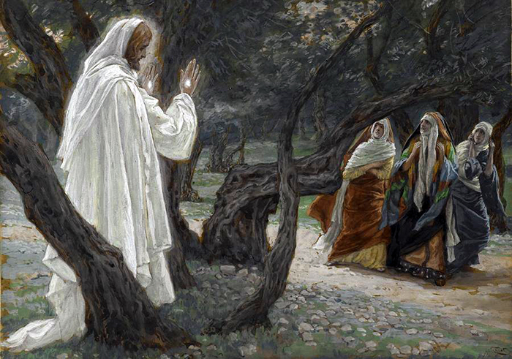
Christ Appears to Holy Women, by James Tissot
Mary Magdalene gather the other women and take them to the tomb where they see two angels. Jesus appears to them on the road.
1 And it came to pass that Mary Magdalene went and told the other women what had happened and they believed. And they did buy sweet spices that they might come to anoint him.
2 And among the women were Mary Magdalene, Mary the mother of James, Salome, Joanna, and other women.
3 And as they came unto the sepulchre they said among themselves, Who shall roll us away the stone from the door of the sepulchre?
4 But when they looked, they saw that the stone was rolled away, (for it was very great,) and two angels sitting thereon, clothed in long shining white garments; and they were affrighted and did bow down their faces to the earth.
5 But the angels said unto them, Be not affrighted; we know that ye seek Jesus of Nazareth, who was crucified; But why seek the living among the dead? For he is risen as he said; he is not here. Come, behold the place where the Lord lay;
6 And go your way quickly, tell his disciples and Peter, that he is risen from the dead and behold he goeth before you into Galilee; there shall ye see him as he said unto you. Remember how he spake unto you when he was yet in Galilee,
7 Saying, The Son of man must be delivered into the hands of sinful men, and be crucified, and the third day rise again.
8 And they, entering into the sepulcher, saw the place where they laid Jesus, and not finding the body of Jesus, they were much perplexed thereabout. And they remembered his words.
9 And they went out quickly, and fled from the sepulchre with fear and great joy; for they trembled and were amazed: neither said they any thing to any man; for they were afraid but did go directly to the disciples.
10 And as they went to tell his disciples, behold, Jesus met them, saying, All hail. And they came and held him by the feet, and worshipped him.
11 Then said Jesus unto them, Be not afraid: go tell my brethren that they go into Galilee, and there shall they see me.
12 And it came to pass that they told all these things unto the eleven, and to all the rest.
13 But their words seemed to them as idle tales, and they believed them not.
Taken from Matthew 28:9-10, Mark 16:1-8, Luke 24:1-10
1. See also: Luke 23:55
4. See also: TG Clothing
5. See also: TG Immortality; Jesus Christ, Resurrection; Resurrection; Jesus Christ, Lord
10. See also: TG Jesus Christ, Appearances, Postmortal

Chapter One Hundred and Forty-Three
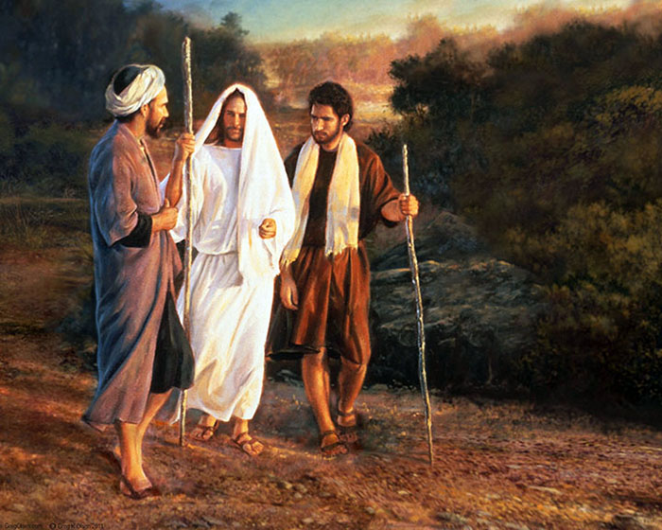
Road to Emmaus, by Greg Olsen
Christ appears to two disciples on the road to Emmaus
1 After that he appeared in another form unto two of them, as they walked, and went into the country that same day to a village called Emmaus, which was from Jerusalem about threescore furlongs.
2 And they talked together of all these things which had happened.
3 And it came to pass, that, while they communed together and reasoned, Jesus himself drew near, and went with them.
4 But their eyes were holden that they should not know him.
5 And he said unto them, What manner of communications are these that ye have one to another, as ye walk, and are sad?
6 And the one of them, whose name was Cleopas, answering said unto him, Art thou only a stranger in Jerusalem, and hast not known the things which are come to pass there in these days?
7 And he said unto them, What things? And they said unto him, Concerning Jesus of Nazareth, which was a prophet mighty in deed and word before God and all the people:
8 And how the chief priests and our rulers delivered him to be condemned to death, and have crucified him.
9 But we trusted that it had been he which should have redeemed Israel: and beside all this, to day is the third day since these things were done.
10 Yea, and certain women also of our company made us astonished, which were early at the sepulchre;
11 And when they found not his body, they came, saying, that they had also seen a vision of angels, which said that he was alive.
12 And certain of them which were with us went to the sepulchre, and found it even so as the women had said: but him they saw not.
13 Then he said unto them, O fools, and slow of heart to believe all that the prophets have spoken:
14 Ought not Christ to have suffered these things, and to enter into his glory?
15 And beginning at Moses and all the prophets, he expounded unto them in all the scriptures the things concerning himself.
16 And they drew nigh unto the village, whither they went: and he made as though he would have gone further.
17 But they constrained him, saying, Abide with us: for it is toward evening, and the day is far spent. And he went in to tarry with them.
18 And it came to pass, as he sat at meat with them, he took bread, and blessed it, and brake, and gave to them.
19 And their eyes were opened, and they knew him; and he vanished out of their sight.
20 And they said one to another, Did not our heart burn within us, while he talked with us by the way, and while he opened to us the scriptures?
21 And they rose up the same hour, and returned to Jerusalem, and found the eleven gathered together, and them that were with them,
22 Saying, The Lord is risen indeed, and hath appeared to Simon.
23 And they told it unto the residue, what things were done in the way, and how he was known of them in breaking of bread: neither believed they them.
Taken from Mark 16:12-13, Luke 24:12-34
3. See also: TG Jesus Christ, Appearances, Postmortal
4. See also: Heb. 13:2; Ether 3:25; D&C 25:4
6. See also: John 19:25
13. See also: Matt. 14:31; Mark 4:40; 16:14; Luke 1:20; 12:29; Alma 22:7
15. See also: John 5:46; Acts 3:18; 1 Pet. 1:10; TG Scriptures, Study; Jesus Christ, Prophecies about
20. See also: D&C 9:8; TG Heart; Teaching with the Spirit; Jesus Christ, Teaching Mode of
22. See also: TG Jesus Christ, Appearances, Postmortal; 1 Cor. 15:5

Chapter One Hundred and Forty-Four
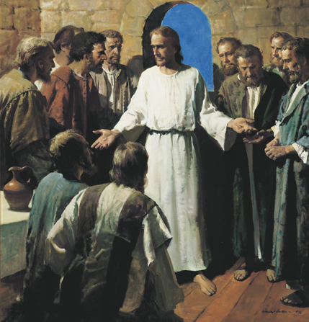
Jesus Shows His Wounds, by Harry Anderson
Jesus appears to the apostles.
1 Then the same day at evening, being the first day of the week, when the doors were shut where the disciples were assembled in Jerusalem for fear of the Jews, came Jesus and stood in the midst, and saith unto them, Peace be unto you.
2 But they were terrified and affrighted, and supposed that they had seen a spirit.
3 And he said unto them, Why are ye troubled? and why do thoughts arise in your hearts?
4 Behold my hands and my feet, that it is I myself: handle me, and see; for a spirit hath not flesh and bones, as ye see me have.
5 And when he had thus spoken, he shewed them his hands and his feet.
6 And while they yet believed not for joy, and wondered, he said unto them, Have ye here any meat?
7 And they gave him a piece of a broiled fish, and of an honeycomb.
8 And he took it, and did eat before them.
9 And he said unto them, These are the words which I spake unto you, while I was yet with you, that all things must be fulfilled, which were written in the law of Moses, and in the prophets, and in the psalms, concerning me.
10 Then opened he their understanding, that they might understand the scriptures,
11 And said unto them, Thus it is written, and thus it behoved Christ to suffer, and to rise from the dead the third day:
12 And that repentance and remission of sins should be preached in his name among all nations, beginning at Jerusalem.
13 And ye are witnesses of these things.
14 And, behold, I send the promise of my Father upon you: but tarry ye in the city of Jerusalem, until ye be endued with power from on high.
15 Then said Jesus to them again, Peace be unto you: as my Father hath sent me, even so send I you.
16 But Thomas, one of the twelve, called Didymus, was not with them when Jesus came.
17 The other disciples therefore said unto him, We have seen the Lord. But he said unto them, Except I shall see in his hands the print of the nails, and put my finger into the print of the nails, and thrust my hand into his side, I will not believe.
18 And after eight days again his disciples were within, and Thomas with them: then came Jesus, the doors being shut, and stood in the midst, and said, Peace be unto you.
19 Then saith he to Thomas, Reach hither thy finger, and behold my hands; and reach hither thy hand, and thrust it into my side: and be not faithless, but believing.
20 And Thomas answered and said unto him, My Lord and my God.
21 Jesus saith unto him, Thomas, because thou hast seen me, thou hast believed: blessed are they that have not seen, and yet have believed.
22 Afterward he appeared unto the eleven as they sat at meat, and upbraided them with their unbelief and hardness of heart, because they believed not them which had seen him after he was risen.
23 And he said unto them, Go ye into all the world, and preach the gospel to every creature.
24 He that believeth and is baptized shall be saved; but he that believeth not shall be damned.
25 And these signs shall follow them that believe; In my name shall they cast out devils; they shall speak with new tongues;
26 They shall take up serpents; and if they drink any deadly thing, it shall not hurt them; they shall lay hands on the sick, and they shall recover.
27 And many other signs truly did Jesus in the presence of his disciples, which are not written in this book:
28 But these are written, that ye might believe that Jesus is the Christ, the Son of God; and that believing ye might have life through his name.
29 And it came to pass that Jesus led them out as far as to Bethany, and he lifted up his hands, and blessed them.
30 And saith unto them, Receive ye the Holy Ghost: Whose soever sins ye remit, they are remitted unto them; and whose soever sins ye retain, they are retained.
31 So then after the Lord had spoken unto them, he was carried and received up into heaven, and sat on the right hand of God.
32 And they worshipped him, and returned to Jerusalem with great joy:
33 And they went forth, and preached every where, the Lord working with them, and confirming the word with signs following.
34 And were continually in the temple, praising and blessing God. Amen.
Taken from Mark 16:14-20, Luke 24:35-52, John 20:19-23
1. See also: TG Assembly, for Worship; Meetings; Jesus Christ, Appearances, Postmortal; Peace of God; D&C 19:23
4. See also: 3 Ne. 11:14; TG Man, Potential to Become Like Heavenly Father; Spirits, Disembodied; D&C 129:2; TG God, Body of (Corporeal Nature); Jesus Christ, Appearances, Postmortal; Resurrection; God, Knowledge about
5. See also: TG Jesus Christ, Resurrection; Jesus Christ, Appearances, Postmortal
9. See also: TG Jesus Christ, Prophecies about
10. See also: TG Understanding
11. See also: TG Resurrection
12. See also: TG Repentance; D&C 137:6; TG Forgiveness; Remission of Sins; Apostles; Mission of Early Saints
13. See also: Acts 1:8; 22:15; D&C 27:12; TG Witnesses
14. See also: TG Promises; D&C 20:8; 38:32
15. See also: TG Jesus Christ, Divine Sonship; Jesus Christ, Authority of; Authority
17. See also: TG Jesus Christ, Crucifixion of
19. See also: 3 Ne. 11:14; TG Doubt; Unbelief, Unbelievers
21. See also: TG Jesus Christ, Appearances, Postmortal; D&C 34:4; 1 Pet. 1:8; Alma 32:21; TG Faith
22. See also: TG Apostles; Matt. 14:31; Mark 4:40; Luke 24:25; TG Stiffneckedness
23. See also: Acts 6:4; D&C 66:5; TG Israel, Mission of; Gospel; Acts 11:18; D&C 68:8; 124:128; TG Missionary Work
24. See also: TG Baptism, Qualifications for; Faith; Baptism; Baptism, Essential; Damnation
25. See also: D&C 84:65; TG Holy Ghost, Gifts of; Miracles; Signs; D&C 63:9; TG Name; D&C 24:13; 35:9; TG Spirits, Evil, Unclean; Language
26. See also: Acts 28:3; TG Protection, Divine; Administrations to the Sick; Hands, Laying on of; Healing
27. See also: TG Signs; John 21:25; 1 Ne. 14:25; D&C 93:6
28. See also: 1 Jn. 5:13; Luke 1:4; John 1:7; 1 Ne. 6:4; Morm. 5:14; TG Faith; Jesus Christ, Messiah; John 5:24; TG Jesus Christ, Taking the Name of; Name
30. See also: TG Priesthood, Keys; Remission of Sins
31. See also: TG Jesus Christ, Lord; Jesus Christ, Ascension of
34. See also: Acts 2:46

Chapter One Hundred and Forty-Five
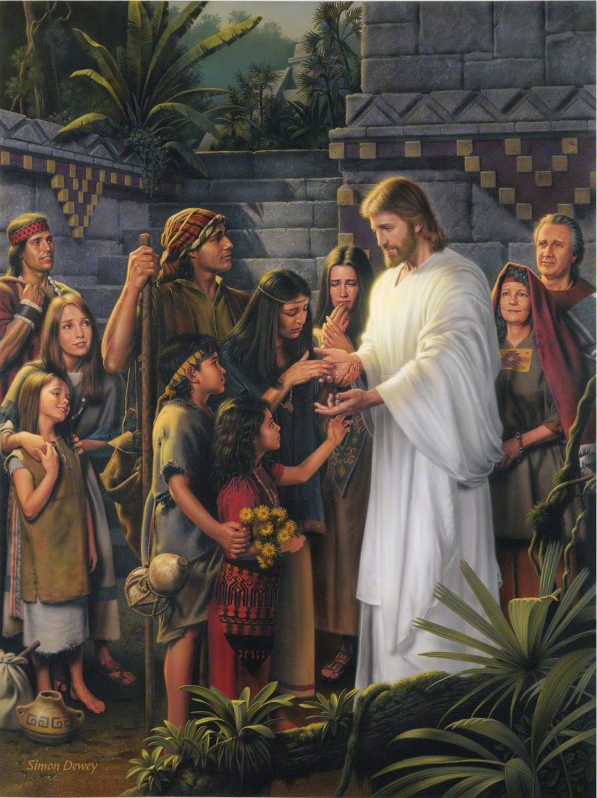
Christ in the Land Bountiful, by Simon Dewey
1 After these things Jesus did show himself unto the lost remnants of the house of Israel.

Taken from 3 Nephi Chapters 11-30

Chapter One Hundred and Forty-Six
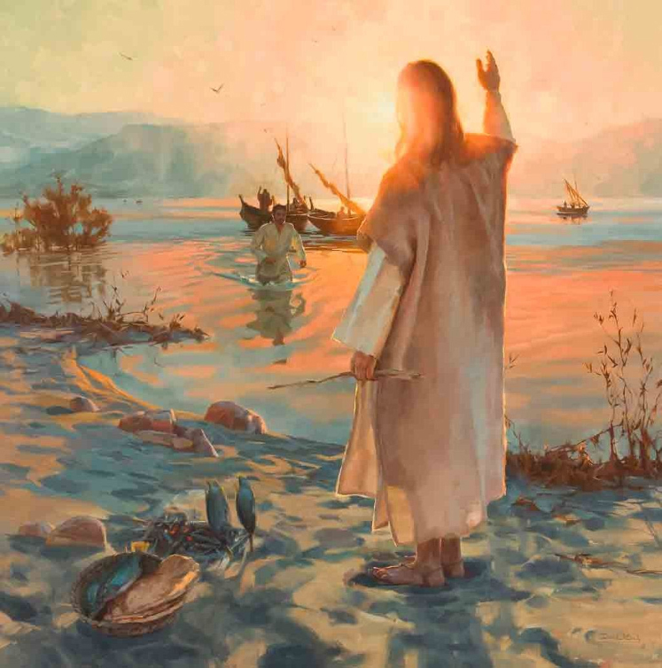
Feed My Sheep, by David Koch
Jesus appears to the apostles at the sea of Tiberias; he implores them to “Feed my sheep.”
1 After these things Jesus shewed himself again to the disciples at the sea of Tiberias; and on this wise shewed he himself.
2 There were together Simon Peter, and Thomas called Didymus, and Nathanael of Cana in Galilee, and the sons of Zebedee, and two other of his disciples.
3 Simon Peter saith unto them, I go a fishing. They say unto him, We also go with thee. They went forth, and entered into a ship immediately; and that night they caught nothing.
4 But when the morning was now come, Jesus stood on the shore: but the disciples knew not that it was Jesus.
5 Then Jesus saith unto them, Children, have ye any meat? They answered him, No.
6 And he said unto them, Cast the net on the right side of the ship, and ye shall find. They cast therefore, and now they were not able to draw it for the multitude of fishes.
7 Therefore that disciple whom Jesus loved saith unto Peter, It is the Lord. Now when Simon Peter heard that it was the Lord, he girt his fisher’s coat unto him, (for he was naked,) and did cast himself into the sea.
8 And the other disciples came in a little ship; (for they were not far from land, but as it were two hundred cubits,) dragging the net with fishes.
9 As soon then as they were come to land, they saw a fire of coals there, and fish laid thereon, and bread.
10 Jesus saith unto them, Bring of the fish which ye have now caught.
11 Simon Peter went up, and drew the net to land full of great fishes, an hundred and fifty and three: and for all there were so many, yet was not the net broken.
12 Jesus saith unto them, Come and dine. And none of the disciples durst ask him, Who art thou? Knowing that it was the Lord.
13 Jesus then cometh, and taketh bread, and giveth them, and fish likewise.
14 This is now the third time that Jesus shewed himself to his disciples, after that he was risen from the dead.
15 So when they had dined, Jesus saith to Simon Peter, Simon, son of Jonas, lovest thou me more than these? He saith unto him, Yea, Lord; thou knowest that I love thee. He saith unto him, Feed my lambs.
16 He saith to him again the second time, Simon, son of Jonas, lovest thou me? He saith unto him, Yea, Lord; thou knowest that I love thee. He saith unto him, Feed my sheep.
17 He saith unto him the third time, Simon, son of Jonas, lovest thou me? Peter was grieved because he said unto him the third time, Lovest thou me? And he said unto him, Lord, thou knowest all things; thou knowest that I love thee. Jesus saith unto him, Feed my sheep.
18 Verily, verily, I say unto thee, When thou wast young, thou girdedst thyself, and walkedst whither thou wouldest: but when thou shalt be old, thou shalt stretch forth thy hands, and another shall gird thee, and carry thee whither thou wouldest not.
19 This spake he, signifying by what death he should glorify God. And when he had spoken this, he saith unto him, Follow me.
20 Then Peter, turning about, seeth the disciple whom Jesus loved following; which also leaned on his breast at supper, and said, Lord, which is he that betrayeth thee?
21 Peter seeing him saith to Jesus, Lord, and what shall this man do?
22 Jesus saith unto him, If I will that he tarry till I come, what is that to thee? follow thou me.
23 Then went this saying abroad among the brethren, that that disciple should not die: yet Jesus said not unto him, He shall not die; but, If I will that he tarry till I come, what is that to thee?
24 This is the disciple which testifieth of these things, and wrote these things: and we know that his testimony is true.
25 And there are also many other things which Jesus did, the which, if they should be written every one, I suppose that even the world itself could not contain the books that should be written. Amen.
Taken from John 21:1-25
1. See also: TG Jesus Christ, Resurrection
2. See also: Matt. 4:21
4. See also: TG Jesus Christ, Appearances, Postmortal
16. See also: 1 Pet. 5:2; D&C 112:14
17. See also: TG Fellowshipping; Jesus Christ, Teaching Mode of; Missionary Work; Sheep
18. See also: TG Old Age
19. See also: 2 Pet. 1:14
22. See also: Rev. 10:11; D&C 7:3; TG Translated Beings; Jesus Christ, Exemplar
23. See also: Luke 9:27
24. See also: John 1:14; 13:23; 19:35; 20:2; TG Scriptures, Writing; 3 Ne. 8:1
25. See also: John 20:30; 1 Ne. 14:25; 3 Ne. 26:6

Chapter One Hundred and Forty-Seven
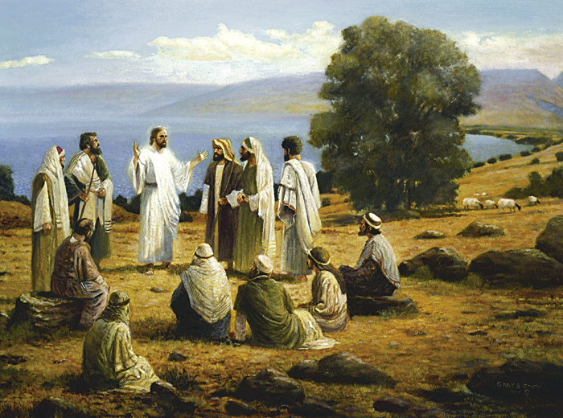
The Resurrected Christ in Galilee, by Gary Smith
Christ teaches the apostles in Galilee; he sends them to teach and baptize all nations.
1 After these things Jesus shewed himself again to the eleven disciples; and on this wise shewed he himself.
2 When the eleven disciples went away into Galilee, into a mountain where Jesus had appointed them.
3 And when they saw him, they worshipped him: but some doubted.
4 And Jesus came and spake unto them, saying, All power is given unto me in heaven and in earth.
5 Go ye therefore, and teach all nations, baptizing them in the name of the Father, and of the Son, and of the Holy Ghost:
6 Teaching them to observe all things whatsoever I have commanded you: and, lo, I am with you alway, even unto the end of the world. Amen.
Taken from Matthew 28:16-20
3. See also: TG Doubt
4. See also: TG Jesus Christ, Appearances, Postmortal; Heb. 2:8; 1 Ne. 9:6; TG God, Power of; Jesus Christ, Messiah; Jesus Christ, Power of; Priesthood, Power of
5. See also: TG Apostles; Israel, Mission of; Mission of Early Saints; Mission of Latter-day Saints; Missionary Work; Teaching; Nations; Baptism; Baptism, Essential; Godhead
6. See also: TG Prophets, Mission of; Baptism, Qualifications for; Jer. 1:7; D&C 30:11; 31:13; 61:10; 62:9; TG Guidance, Divine; Protection, Divine; D&C 24:8; 132:49; TG World, End of

Chapter: The Great Apostasy

The Canonization of New Testament Texts
The earliest surviving New Testament text dated to the first half of the second century A.D. There are no surviving autographs of New Testament books﻿—original manuscripts written by the author. The earliest full manuscripts of individual New Testament books date to around A.D. 200, while the earliest collections of all the books of the New Testament date to the fourth century.
The Apostasy began to occur in the early Christian Church while the Apostles were still alive (see Acts 20:29–30; 1 Corinthians 1:10–13; Galatians 1:6–8; 2 Peter 2:1–3; 3 John 1:9–10; Jude 1:3–4, 18–19). After apostolic authority was taken from the earth through the deaths of the Apostles, which resulted in the loss of priesthood keys, the Apostasy accelerated, and diverse and competing groups of Christians claimed scriptural support for their beliefs. As debates over the authenticity and value of various texts intensified, Christians felt a need to gather together an accepted collection of authentic Christian writings. It was generally understood that some writings were authentic and others were questionable, with some being of greater value than others. In time, Christian leaders of the third and fourth centuries determined which texts would be included in the accepted canon of scripture﻿—based on whether texts had known apostolic authority, continuous and widespread support among Christian communities, and an absence of false teachings. Using these criteria, in A.D. 367 Athanasius of Alexandria recommended a list of the 27 books currently in the New Testament. This collection was confirmed by the third council of Carthage in A.D. 397.
From the first century, Christians began producing copies of New Testament texts in codex form﻿—a “book” format with separate pages bound together﻿—rather than scroll form, which had been the customary way to write Old Testament texts. This may have been a factor in the development of the collection of books now known as the Bible. The word Bible derives from the Greek biblia and literally means “books.” With a codex, a collection of multiple books could be created in one bound volume. The earliest complete text of the New Testament is the Codex Sinaiticus, written in the fourth century A.D.

Translations of the Bible
Once the 27 books of the New Testament were canonized, they were translated and organized into the Bibles we use today. Following is an overview of a few of the major translations of the Bible throughout history. As this overview makes clear, many of the people responsible for bringing the Bible to the four corners of the earth “sacrificed, even to the point of death, to bring the word of God out of obscurity” (D. Todd Christofferson, “The Blessing of Scripture,” Ensign or Liahona, May 2010, 32).
The Vulgate: Jerome’s Latin Translation. (In Latin, vulgate means “common.”) When the need arose to take the scriptures into Latin-speaking areas, such as northern Africa, Latin translations were made of the Greek Septuagint (Old Testament) and the New Testament. However, because these translations were not closely controlled, church leaders soon became concerned about the many corruptions and variances in the separate texts. To address this problem, Pope Damasus in A.D. 383 commissioned his secretary, Jerome, a very able scholar in Greek and Latin, to produce a new suitable Latin translation. In the preface to his Vulgate translation of the New Testament, Jerome wrote a letter to Pope Damasus, describing the problem with creating a new translation: “For if we are to pin our faith to the Latin texts, it is for our opponents to tell us which; for there are almost as many forms of texts as there are copies. If, on the other hand, we are to glean the truth from a comparison of many, why not go back to the original Greek and correct the mistakes introduced by inaccurate translators, and the blundering alterations of confident but ignorant critics, and, further, all that has been inserted or changed by copyists more asleep than awake?” Jerome’s words describe the same problem Joseph Smith dealt with as he created the Joseph Smith Translation of the Bible.
Jerome’s Latin Bible, known as the Vulgate, eventually supplanted all other translations and became the Bible of the western world for close to a thousand years. The Vulgate was given official sanction at the Council of Trent (1545–63). It has been said that the Vulgate was the pillar that preserved Europe’s spiritual and intellectual heritage against attacking waves of northern barbarism.
The Luther Bible: Martin Luther’s German translation. The history of the Bible’s translation into German began in A.D. 348. To escape religious persecution by a Gothic chief, a Catholic priest named Wulfila (sometimes known as Ulfilas) fled with his followers from Germany to what is now northern Bulgaria. There, Wulfila translated the Bible from Greek into the Gothic dialect. This version established much of the Germanic Christian vocabulary that is still in use today. In the late 15th and early 16th centuries, a number of German translations of the Bible were produced, but the German translation that had the greatest influence was the one produced by Martin Luther. Luther was a German priest and theologian, whose break from the Catholic church helped to fuel the Protestant Reformation. He disagreed with many church practices that he felt did not accord with the teachings of scripture, and he came to regard the Bible rather than the church as the reliable source of authority for Christians.
After publicly announcing his disagreements with the church in 1517, Martin Luther began to work on translating the Bible into German. He completed work on the New Testament in 1522 and published his translation of the entire Bible in 1534. This translation into the vernacular of German-speaking peoples was one of the most important acts of the Reformation. It not only gave the German people access to the Bible, but it influenced German culture, standardized German religious and literary language, and helped create national unity. Its influence on the German language is comparable to the influence the King James Bible had on the English language. The Luther Bible was also one of the factors leading to the production of the King James Bible. A 2017 revision of the Luther Bible is widely used today.
It is of interest to know that the Prophet Joseph Smith possessed a copy of the New Testament in several languages, including Martin Luther’s translation of the Bible into the German language. He compared the various translations of some New Testament passages and felt that Luther’s translation was very good (see History of the Church, 6:307).
John Wycliffe’s English translation. A century and a half before Martin Luther, the work of translating the Bible into English was pioneered by John Wycliffe. One of the most prominent scholars of his day, Wycliffe loved the scriptures and was troubled by the ignorance of scripture that he observed among many clergymen and lay persons alike. Like Luther, he grew disillusioned with the church and concluded that the only accurate guide the people still had was the Bible; thus he embarked on the arduous task of taking “God’s law” to his countrymen in the English language they understood. Working from Jerome’s Latin translation, Wycliffe and his associates completed an English translation of the New Testament in 1380 and portions of the Old Testament in 1382. Approximately 30 years after his death, he was denounced as a heretic. Later, in 1432, by order of Pope Martin V, his bones were dug up and burned and the ashes scattered. His followers, the Lollards, were persecuted long after his death.
William Tyndale’s English translation. Despite Wycliffe’s pioneering efforts, English speakers did not have widespread access to the Bible until after the time of William Tyndale, who has been called “the father of the English Bible.” Elder D. Todd Christofferson of the Quorum of the Twelve Apostles described the contributions made by Tyndale:
“Tyndale, born in England about the time Columbus sailed to the new world, was educated at Oxford and Cambridge and then became a member of the Catholic clergy. He was fluent in eight languages, including Greek, Hebrew, and Latin. Tyndale was a devoted student of the Bible, and the pervasive ignorance of the scriptures that he observed in both priests and lay people troubled him deeply. In a heated exchange with a cleric who argued against putting scripture in the hands of the common man, Tyndale vowed, ‘If God spare my life, ere many years I will cause a boy that driveth the plough, shall know more of the Scripture than thou dost!’
“He sought the approval of church authorities to prepare a translation of the Bible in English so that all could read and apply the word of God. It was denied﻿—the prevailing view being that direct access to the scriptures by any but the clergy threatened the authority of the church and was tantamount to casting ‘pearls before swine’ (Matthew 7:6).
“Tyndale nevertheless undertook the challenging work of translation. In 1524 he traveled to Germany, under an assumed name, where he lived much of the time in hiding, under constant threat of arrest. With the help of committed friends, Tyndale was able to publish English translations of the New Testament and later the Old Testament. The Bibles were smuggled into England, where they were in great demand and much prized by those who could get them. They were shared widely but in secret. The authorities burned all the copies they could find.”
In 1535 Tyndale was arrested for heresy and treason, and for nearly a year and a half he was imprisoned in a castle dungeon near Brussels, Belgium. The dungeon was dark, cold, and solitary. On October 6, 1536, he was taken outside the castle wall and fastened to a post. Elder Christofferson continued:
“He had time to utter aloud his final prayer, ‘Lord! open the king of England’s eyes,’ and then he was strangled. Immediately, his body was burned at the stake. …
“ … Within three years of Tyndale’s death, God did indeed open King Henry VIII’s eyes, and with publication of what was called the ‘Great Bible,’ the scriptures in English began to be publicly available. Tyndale’s work became the foundation for almost all future English translations of the Bible, most notably the King James Version” (“The Blessing of Scripture,” Ensign or Liahona, May 2010, 32).
Tyndale’s was the first English translation of the Bible to draw directly from both Hebrew and Greek texts and the first English translation to take advantage of the recently invented Gutenberg printing press, which allowed for wide distribution.

King James Version. From 1604 through 1611, a team of approximately 50 translators commissioned by King James I of England (1566–1625) worked on a new English translation of the Bible, which became known as the King James Version, sometimes called the Authorized Version. The translators used Tyndale’s text and consulted other helpful resources, including other translations of the Bible in English, Spanish, French, German, and Italian; numerous scholarly works; and manuscripts of Bible texts in Hebrew, Aramaic, and Greek. The resulting translation had a tremendous influence on the English language, similar to the impact of the Luther Bible on German. It was the King James Version of the Bible that was studied and used by the Prophet Joseph Smith. Its vocabulary and style of language can be seen throughout the Book of Mormon and the Doctrine and Covenants (see D&C 1:24). The King James Version is of lasting value in the restored Church of Jesus Christ of Latter-day Saints.
In August of 1992, the First Presidency of the Church﻿—Ezra Taft Benson, Gordon B. Hinckley, and Thomas S. Monson﻿—released a statement on the King James Version of the Bible. Part of the statement reads: “While other Bible versions may be easier to read than the King James Version, in doctrinal matters latter-day revelation supports the King James Version in preference to other English translations. All of the Presidents of the Church, beginning with the Prophet Joseph Smith, have supported the King James Version by encouraging its continued use in the Church. In light of all the above, it is the English language Bible used by The Church of Jesus Christ of Latter-day Saints” (“First Presidency Statement on the King James Version of the Bible,” Ensign, Aug. 1992, 80).
Reina-Valera Spanish translation. As early as 1490, a translation was made of the four Gospels from the Latin Vulgate into Spanish. In 1543 Francisco de Enzinas, a Protestant, translated a complete New Testament and was imprisoned for what were considered perverse readings. In 1569 Casiodoro de Reina produced and published a translation of the entire Bible in Spanish. Reina had been a monk, but he left the Catholic church after hearing the message of the reformers. Like many other reformers and Bible translators, he faced persecution and threats on his life﻿—King Philip of Spain put a price on Reina’s head in 1564﻿—and he spent much of his life in exile. One of Reina’s colleagues, Cipriano de Valera, worked for 20 years to revise and improve Reina’s translation, and in 1602 at the age of 70, he published what has become known as the Reina-Valera translation. This version has become the classic translation of the Bible in Spanish. It has been as central to the understanding of the scriptures in Spanish as the King James Version has been in English. Over the centuries, numerous revisions have been made to the Reina-Valera version. Reina and Valera are remembered with honor as “two men in whose hearts existed the noble purpose of giving to Spain the Bible in their mother tongue” (Eduardo Balderas, “How the Scriptures Came to Be Translated into Spanish,” Ensign, Sept. 1972, 27).
In 2009, under the direction of the First Presidency and the Quorum of the Twelve Apostles, The Church of Jesus Christ of Latter-day Saints produced an LDS edition of the Reina-Valera version, with updated language, new chapter headings, footnotes, cross-references to all the standard works of the Church, maps, and other study aids (see “Church Publishes LDS Edition of the Holy Bible in Spanish,” Ensign, Sept. 2009, 77–78).

