THE HEAT
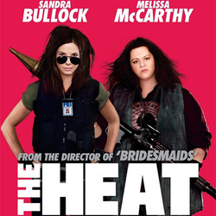

Grown–up’s Movie: | HIS | HER | AVG
1. Appropriate levels of sexuality? | 7 | 7 | 7
2. Appropriate levels of language? | 0 | 0 | 0
3. Appropriate levels of violence? | 8 | 8 | 8
4. Entertainment value for females? | 8 | 8 | 8
5. Entertainment value for males? | 7 | 7 | 7
6. Teaching moments, role models, moral of story? | 7.5 | 7.5 | 7.5
7. Is it a “classic”? (Replay value?) | 7 | 7 | 7
8. Audio/Visual effects? | 7 | 7 | 7
9. Not too cliché (unique and witty, not too slapstick) | 6 | 7 | 6.5
10. Climax/Resolution/Ending? | 6 | 7 | 6.5
GRAND TOTALS: |  |  | 64.5%

His Thoughts: Meh? This movie had more sex, language and even violence than that of The Hangover and it has Sandra Bullock in it; don’t think you are getting a “Miss Congeniality” here, many will go home offended. This movie was really hard around the edges and not funny enough to keep you from getting offended in some way, shape, or form by the end of the movie. It had sex, sex talk, extreme language, and even violence and gore. This movie didn’t have anything in it that would make it stand out as a comedy or anything unique enough to make it a classic while having plenty in it to offend a broad audience. I can’t for the life of me think that this movie will do well; it shouldn’t.
Her Thoughts: Didn't really know what to expect from this movie... While watching it I thought, "it's not bad" but now trying to remember it I can't think of anything I liked. Sandra Bullock has done this role before- was done better in Miss Congeniality! At times funny, but a little inappropriate.

