THE LONE RANGER
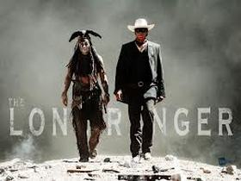
Family Movie: | HIS | HER | AVG
1. Appropriate for teenagers (eg. language, sexuality, violence)? | 6 | 7 | 6.5
2. Entertainment value for girl teenagers (12 and up)? | 7 | 6 | 6.5
3. Entertainment value for boy teenagers (12 and up)? | 7.5 | 7 | 7.25
4. Entertainment value for adult females? | 6.5 | 6.5 | 6.5
5. Entertainment value for adult males? | 7.5 | 7.5 | 7.5
6. Teaching moments, role models, moral of story? | 6.5 | 7 | 6.75
7. Is it a “classic”? (Replay value?) | 9 | 7 | 8
8. Audio/Visual effects? | 7.5 | 7 | 7.25
9. Not too cliché (unique and witty, not too slapstick) | 7 | 7 | 7
10. Climax/Resolution/Ending? | 7 | 7 | 7
GRAND TOTALS: |  |  | 70.25%

His Thoughts: You have probably heard by now that this movie wasn’t very good; they are correct. The movie should have been called “The Lone Tonto” as he had 80% of the screen time. This movie pushes what is “acceptable in a PG-13 movie” to the edge or reasonable. Extremely violent with a slug of other problems this movie was a disaster. Jack Sparrow needs to return before Jonny Depp is totally washed up…What a failure! Most people will find this movie extremely boring and not worth seeing, and the rest will find themselves offended by the crudeness of the movie. Not recommending this one!
Her Thoughts: I was so bored in this movie! I think I feel asleep for a couple of minutes and we watched it in the theatre! I liked Jonny Depp in Pirates of the Carribean but now he does the same thing for all of his roles! Nothing special in this movie for me to ever watch it again...

