“I am not at all astonished at what has happened to you, neither what has happed to Zion, and I could tell you all the whys and wherefores of all these calamites. But alas, it is in vain to warn and give precepts, for all men are naturally disposed to walk in their own paths as they are pointed out by their own fingers, and are not willing to consider and walk in the path which is pointed out by another, saying, This is the way, walk ye in it, although he should be an unerring director, and the Lord his God sent him… [they] are blind, and they lead the blind, and they fall into the ditch together. They build with hay, wood, and stubble, on the old revelations, without the true priesthood or spirit of revelation. If I had time, I would dig into hell, hades, sheol, and tell what exists there…”
- Joseph Smith (Teaching of the Prophet Joseph Smith, 26-27, 311)

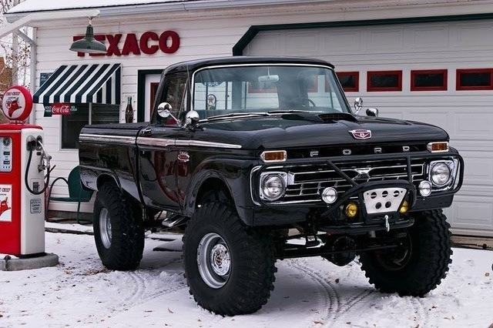
The Truck
There was a man who lived at the base of a large mountain, a large hazardous mountain, and the man from his house had to witness many travelers attempt to get over the mountain, but perish on the hazardous road. Many perished because they simply did not know the way, others because their vehicle could not or would not survive the trip. One day the man cried onto the Lord, “Oh Lord, what can I do to help save some of my brothers and sisters on their journey!” The Lord responded and asked the man, “do you love me?” to which the man responded “yea Lord, thou knowest that I love you!”, the Lord then asked the man, “have you consecrated all your time, heart, mind, and all that thou possess to me?” to which the man replied “yea Lord, thou knowest that everything I own is thine!”, the Lord then told the man to fix up his truck, add a GPS to it, and give it free of charge to those journeying up the mountain. The man did so. Fixing and painting his truck, polishing and tuning and adding a GPS. It wasn’t long before a family in a broken down van was pulling up the street towards the mountain. The man ran out into the street and stopped the family, “wait!” cried he, “we need to talk!” The family stopped and heard the man out, he explained what he has to see on a daily basis with families perishing going up the mountain, he explained the prayers he had and what he was told to do, and then he shows the family the truck. “Free you say?” asks the father, “yes!” says the man, “please, take it! Just don’t perish!” The family enters the car and takes their seats and then the father notices that the car is reading in kilometers per hour and not miles per hour, “Oh no, this just won’t do!” says the man, this speedometer offends me!” confused, the man explains “well sir, the car is free, it will save your life, and you can always click this button here and change it to MPH”. The father looked disgruntled, “you’re telling me, that in order for me to be able to stand this vehicle, that I will have to push a button?!” The man now completely puzzled “yes sir… but the car is free, and it will save your life, and all you have to do is push a single button-“ the man was interrupted by the wife “oh honey! This won’t do! Look at the GPS! The voice is that of Brian Reagan!” the man tried to point at the GPS and explain, “oh, you can change that or mute it right-“ but the family had had enough, “that’s it family, we are leaving this brand new 4x4 with a GPS! The Lord would never expect so much from us! I mean the nerve… to tell us to push a button? Mute or change the voice? Pish posh!” the wife scowled and shook her head all the way back to their broken down van and ripped map, “you should be ashamed of yourself sir!”. The man looked on, as the shock of what he was witnessing was rocking his body, “why?” thought he as he watched the family drive up the road. It wasn’t long before the car flipped and exploded into a blazing display of fire and ash. “Why?” asked the man to the Lord, “Why? I did all you asked, I provided for free, and it could have helped save them!” The Lord comforted the man, “Son, their blood is not on your hands, do ye my work and continue in my ways and ye shall be saved”. So the man continued his work, some on the road accepted the free truck with thanksgiving in their hearts and passed safely over the mountain, while others could not simply stand the thought of having to push a single button for a free truck, and thus exploded and went out in blazing glory on the mountain.
THE END
PS. Just a reminder that you can find all the papers with references totally for free, ad free, and signature free, on the family blog. Stay safe out there on the roads saints, it is going to get rough. In the name of Jesus Christ, amen!

