THE WEDDING RINGER
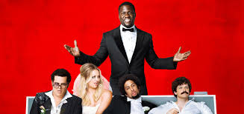

Grown–up’s Movie: | HIS | HER | AVG
1. Appropriate levels of sexuality? | 8 | 8 | 8
2. Appropriate levels of language? | 6.5 | 6.5 | 6.5
3. Appropriate levels of violence? | 9.5 | 9.5 | 9.5
4. Entertainment value for females? | 8.5 | 8.5 | 8.5
5. Entertainment value for males? | 8 | 8 | 8
6. Teaching moments, role models, moral of story? | 7 | 7.5 | 7.25
7. Is it a “classic”? (Replay value?) | 7.5 | 7.5 | 7.5
8. Audio/Visual effects? | 7 | 8 | 7.5
9. Not too cliché (unique and witty, not too slapstick) | 7 | 7 | 7
10. Climax/Resolution/Ending? | 8 | 8 | 8
GRAND TOTALS: |  |  | 77.75%

