CARRIE
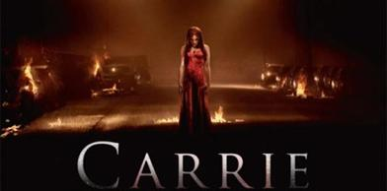
Grown–up’s Movie: | HIS | HER | AVG
1. Appropriate levels of sexuality? | 8.5 | 8.5 | 8.5
2. Appropriate levels of language? | 9.5 | 9.5 | 9.5
3. Appropriate levels of violence? | 8.5 | 9 | 8.75
4. Entertainment value for females? | 8 | 8 | 8
5. Entertainment value for males? | 7.5 | 7 | 7.25
6. Teaching moments, role models, moral of story? | 7 | 7 | 7
7. Is it a “classic”? (Replay value?) | 9 | 8 | 8.5
8. Audio/Visual effects? | 7 | 7 | 7
9. Not too cliché (unique and witty, not too slapstick) | 6 | 6 | 6
10. Climax/Resolution/Ending? | 6 | 6 | 6
GRAND TOTALS: |  |  | 76.5%

His Thoughts: Really not a lot to say here…Wasn’t scary in the slightest, wasn’t gory, wasn’t exciting, I could go on but I won’t. If a movie fails to give you stimuli in some way shape or form it fails,
simple as that- just like music. In my opinion if a song does not elicit an emotional response of some kind, it is ambient noise. This movie felt ambient. This was the same old story done basically exactly the same way with nothing new. Blah.
Her Thoughts: I didn't see the original so I didn't really know what to expect with this movie. After watching it, I have to say that I wasn't really that impressed with it... I thought it was a pretty generic high school story (classmates making fun of an odd girl...) with a paranormal twist (odd girl has telekinetic powers). Maybe the book was better, but there was no suspense or thrill in the movie- it was all very predictable.

