ENDER'S GAME
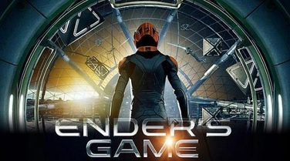
Family Movie: | HIS | HER | AVG
1. Appropriate for teenagers (eg. language, sexuality, violence)? | 10 | 10 | 10
2. Entertainment value for girl teenagers (12 and up)? | 8.5 | 8 | 8.25
3. Entertainment value for boy teenagers (12 and up)? | 8 | 8 | 8
4. Entertainment value for adult females? | 8 | 8 | 8
5. Entertainment value for adult males? | 9 | 9 | 9
6. Teaching moments, role models, moral of story? | 7 | 7 | 7
7. Is it a “classic”? (Replay value?) | 10 | 8 | 9
8. Audio/Visual effects? | 8.5 | 8.5 | 8.5
9. Not too cliché (unique and witty, not too slapstick) | 7 | 7.5 | 7.25
10. Climax/Resolution/Ending? | 7 | 7.5 | 7.25
GRAND TOTALS: |  |  | 82.25%

His Thoughts: I had this movie figured out in the first 15 minutes. I turned to Ashley and told her what was going to happen, down to the very end. And yeah, I have not read the books, so I have no clue if
they follow the books or not. Decent movie, nothing too terrible but nothing ground breaking, and very predictable. If you are a fan of sci fi movies you should watch it based solely off of the fact that there doesn’t seem to be very many around, but don’t expect to be seeing a classic here…
Her Thoughts: This movie was based off of a book series written by a well-known Mormon author so we had to see the movie to support him! Generally I'm not a huge fan of the sci-fi genre, so I knew this wouldn't be my favourite movie of all time. Overall it was a fairly good movie- there is a good twist near the end that I think will catch most people of guard if they haven't read the book (or have a super smart husband guessing what will happen and it actually does...) I thought the acting was great, so were the special effects. The movie didn't leave me blown away but was still enjoyable to watch.

