Far From Home: The Adventures of Yellow Dog
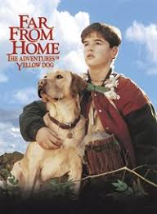

Kids and Family Movie: | HIS | HER | AVG
1. Is it a “Kids Friendly” movie? (eg. not scary, no cursing, sexuality) | 9 | 9 | 9
2. Entertainment value for children 12 and under? | 9 | 9 | 9
3. Entertainment value for teenagers? | 4 | 6 | 5
4. Entertainment value for parents? | 7 | 8 | 7.5
5. Entertainment value for males? | 7 | 8 | 7.5
6. Entertainment value for females? | 7 | 8 | 7.5
7. Teaching moments, role models, moral of story? | 5 | 5 | 5
8. Is it a “classic”? (Replay value?) | 8 | 8 | 8
9. Audio/Visual effects? | 7 | 7 | 7
10. Not too cliché (unique and witty, not too slapstick or potty)? | 5 | 5 | 5
GRAND TOTALs: |  |  | 70.5

