Keys of the Kingdom v 1.01
Joseph Smith explained the keys, “I will inform you that it is contrary to the economy of God for any member of the Church, or any one, to receive instruction for those in authority, higher than themselves; therefore you will see the impropriety of giving heed to them; but if any person have a vision or a visitation from a heavenly messenger, it must be for his own benefit and instruction; for the fundamental principles, government, and doctrine of the Church are vested in the keys of the kingdom.” (Teachings of the Prophet Joseph Smith, p. 21)
Bruce R. McConkie explained the keys of the kingdom thus:
“Two different usages of the term keys are found in the revelations. One has reference to the directive powers whereby the Church or kingdom and all its organizations are governed, the keys of the kingdom being the powers of presidency. The other usage refers to the means provided whereby something is revealed, discovered, or made manifest. Thus Joseph Smith and Oliver Cowdery were given the keys to translate and bring hidden scriptures to light (D&C 6:24-28). And thus Joseph held “the keys of the mysteries, and the revelations which are sealed” (D&C 28:7, 35:18, 64:5), meaning that he had the power and means at his disposal to bring these things to light and reveal them to the world. Similarly the higher priesthood “holdeth the key of the mysteries of the kingdom, even the key of the knowledge of God” (D&C 84:19-22), for it is only in and through and because of that priesthood that the mysteries of the kingdom can be learned and the knowledge of God obtained. The keys of the ministering of angels are resident in the Aaronic Priesthood (D&C 13, 107:20), and the Melchizedek Priesthood holds “the keys of all the spiritual blessings of the church- To have the privilege of receiving the mysteries of the kingdom of heaven, to have the heavens opened unto them, to commune with the general assembly and church of the Firstborn, and to enjoy the communion and presence of God the Father, and Jesus the mediator of the new covenant” (D&C 107:18-19). President Joseph F. Smith said: “What is a key? It is the right or privilege which belongs to and comes with the priesthood to have communication with God. Is not that a key? Most decidedly. We may not enjoy the blessings, or key, very much, but the key is in the priesthood. It is the right to enjoy the blessings of communication with the heavens, and the privilege and authority to administer in the ordinances of the gospel of Jesus Christ, to preach the gospel of repentance, and of baptism by immersion for the remission of sins. That is a key. You who hold the priesthood have the key or the authority, the right, the power or privilege to preach the gospel of Jesus Christ, which is the gospel of repentance and of baptism by immersion for the remission of sins.” (Gospel Doctrine, 5th ed., p.142)

Those having power to open the door to salvation are said to hold the keys of salvation, that is they are able to make salvation available to other men. These keys center in Christ, for salvation comes in and through his name only (Mosiah 3:16-18), and he directs how this great gift may be obtained and by whom. Adam, as the presiding high priest over the earth, holds “the keys of salvation under the counsel and direction of the Holy One” (D&C 78:16), and accordingly all the affairs of the kingdom of God on earth for all ages are administered under Adam’s direction and supervision. Under him the heads of the various dispensations and the prophets called in those eras have had power to administer salvation to men. (D&C 7). The President of the Church of Jesus Christ of Latter-Day Saints holds the keys of salvation for all men now living because he is the only one by whose authorization the sealing power of the priesthood can be used to seal men up to salvation and exaltation in the kingdom of God (D&C 132:7).
Keys are the right of presidency, the directing, controlling, governing power. The keys of the kingdom are the power, right, and authority to preside over the kingdom of God on earth (which is the Church) and to direct all of its affairs. President Joseph F. Smith taught: “Every man ordained to any degree of the priesthood has this authority delegated to him. But it is necessary that every act performed under this authority shall be done at the proper time and place, in the proper way, and after the proper order. The power of directing these labors constitutes the keys of the priesthood. In their fulness, the keys are held by only one person at a time, the Prophet and President of the Church. He may delegate any portion of this power to another, in which case that person holds the keys of that particular labor. Thus, the president of a temple, the president of a stake, the bishop of a ward, the president of a mission, the president of a quorum, each holds the keys of the labors performed in that particular body or locality. His priesthood is not increased by this special appointment, for a seventy who presides over a mission has no more priesthood than a seventy who labors under his direction; and the president of an elders quorum, for example, has no more priesthood than any member of that quorum. But he holds the power of directing the official labors performed in the mission or the quorum, or in other words, the keys of that division of that work. So it is throughout all the ramifications of the priesthood- a distinction must be carefully made between the general authority and the directing of the labor performed by that authority.” (Gospel Doctrine, 5th ed., p. 136). Through the ages various prophets have held various keys, by virtue of which they have been empowered to use their priesthood to perform specified labors. Adam holds the keys of presidency over all dispensations and is the presiding high priest (under Christ) over all the earth. (D&C 78:16, Teachings p.157-158, 169). Noah stands next to Adam in priesthood authority (Teachings p.157) and after these two come all the heads of the different gospel dispensations, together with a host of other mighty prophets. For example: Elijah held the keys of the sealing power in ancient Israel (D&C 27:9, 110:13-16, Malachi 4:5-6), as did Nephi the son of Helaman among the Nephites In the early years of the Christian Era (Helaman 10:4-10). One man named Elias held the keys of authority in the days of Abraham (D&C 110:12), while to another bearing the same name has been “committed the keys of bringing to pass the restoration of all things spoken by the mouth of all the holy prophets since the world began, concerning the last days.” (D&C 27:6). Moroni holds “the keys of the record of the stick of Ephraim” (D&C 27:5); John the Baptist the keys of the Aaronic Priesthood and the gospel of repentance (D&C 13, 84:26-28); Moses those whereby the priesthood may be used to gather Israel and lead the Ten Tribes from the lands of the north (D&C 110:11); Peter, James and John hold the keys of the kingdom and of the dispensation of the fulness of times (D&C 27:12-13, 128:20); and Raphael (whose mortal identity has not been revealed) holds the keys of his dispensation (D&C 128:21). All of these and others- “divers angels, from Michael or Adam down to the present time”- have come in the last days, “all declaring their dispensations, their rights, their keys, their honors, their majesty and glory, and the power of their priesthood (D&C 128:21). Thus Joseph Smith and his successors have been and are possessors of all of the keys of the kingdom of heaven, even as these were held by Peter and the ancient apostles (Matt.16:19, 18:18), and accordingly those so endowed have power to govern all the affairs of the earthly kingdom and direct the administration of all the ordinances of salvation and exaltation for worthy recipients (D&C 35:25, 42:69, 65, 90:2-3, 97:14, 115:19). “The keys of the kingdom,…belong always unto the Presidency of the High Priesthood” (D&C 81:2), and only one man on earth at a time, the President of the Church, can exercise them in their fulness (D&C 132:7). This necessarily must be so because keys are the right of presidency and there cannot be two equal heads, otherwise the Lord’s house would not be a house of order but of confusion (D&C 132:8-12). All of the keys of the kingdom, however, are conferred upon every man sustained as a member of the Council of the Twelve (D&C 112:14-34, 124:128). Thus when a member of the Council of the Twelve becomes the senior apostle of God on earth, he can exercise in their fulness the keys which theretofore have lain dormant in him (Doctrines of Salvation, vol. 3, pp.125-159). The keys of the kingdom- the right and power to govern the Lord’s affairs for and on his behalf- have been held by prophets in all ages, but when the Lord comes to reign personally upon the earth during the millennial era, he will take back the keys. Those who have held them will make an accounting to him of their stewardships at the place called Adam-ondi-Ahman, at which gathering Christ will receive “dominion, and glory, and a kingdom, that all people, nations, and languages, should serve him.” (Daniel 7:13-14). Eventually in the celestial day, “the keys of the kingdom shall be delivered up again unto the Father” (Inspired Version, Luke 3:8).
In the same sense that the Melchizedek Priesthood holds “the key of the knowledge of God” (D&C 84:19) and “of all the spiritual blessings of the church” in that holders of that priesthood may “have the heavens opened unto them” and “enjoy the communion and presence of God the Father, and Jesus the mediator of the new covenant” (D&C 107:18-19), so the Aaronic Priesthood holds the keys of the mistering of angels (D&C 13, 84:26-27, 107:20). That is, the Aaronic Priesthood opens the door to the ministering of angels, or in other words, those holding the lesser priesthood are in a position to have angels minister unto them. Wilford Woodruff, for instance, said: “I had the administration of angels while holding the office of a priest.” (Discourses of Wilford Woodruff, p. 298)
(Mormon Doctrine p.409-413)
In summary, the Holy Ghost will never reveal things unto an individual to which that individual does not have keys of the right of revelation for those things. The keys were given to Joseph and then to the Twelve and then were given to the Church as a whole. For a more complete breakdown of how we as individuals can come to know that Joseph Smith did in fact receive those keys and that the Church of Jesus Christ of Latter-Day Saints still holds those keys see my video/paper The Arm of Flesh.
There are only two questions left that one needs to answer. The first question is, how do you differentiate between receiving revelation for yourself versus receiving revelation for someone else? Or in the words of Joseph F. Smith that I made red above, “directing the official labors”. The second question we need to answer is, who in the Church holds keys?
Starting with the first question, everyone has the right or the key of revelation over themselves. Every other key has to be given to them. By the way, the key to receive revelation for your wife and family for a man is received at marriage. For example, we do not know if Joseph (husband of Mary) was sealed to Mary (but we do know they were married civilly) because there is evidence to support that Mary was in fact sealed to somebody else, but yet when revelation came it came to Joseph pertaining to his family which kept them safe on multiple occasions. So what is the difference between receiving revelation for oneself and receiving revelation through the keys for and on behalf of somebody else? The difference might be hard for people to understand at first but once you understand it, you will begin to understand just how serious a mistake regarding it actually is. Receiving revelation for oneself comes in the form of “thou shalt do” or “thou shalt know”, examples being, “the Book of Mormon is true” or “you should go on a mission”.
Revelation from the Lord will never conflict with the keys of the kingdom. It doesn’t matter how much you think you’ve received a specific revelation if it flies contrary to the keys of the kingdom- it is not of God. Eg. “the Book of Mormon is not true” or “you shouldn’t go on mission” (for men). There are a lot of people who believe they have received revelation contrary to the will of the Lord that’s been revealed through the keys of the kingdom. The keys of God have spoken- every worthy male should go on a mission unless the keys themselves “specify that one should tarry”. If the keys of God tell you that you shouldn’t go on a mission, don’t go on a mission. But if the keys of God have not come to you to tell you otherwise, you will not be given revelation contrary to the kingdom of God. If you are or believing you are receiving revelation that is contrary to the revealed will of the kingdom of God, examples being “I don’t have to go on a mission” or “I don’t have to get sealed in the temple first” or “you can delay your baptism indefinitely” or “you can delay having kids for a year” let me resolutely tell you that you either do not have a sincere heart, real intent or faith in Christ or worse, you are being led by false spirits.
For example, a Relief Society President (who doesn’t actually hold keys, but I will get to that later), she can ask “Lord, who would be the best counsellors for me?” The Lord can then answer her and give her names but when she goes to these individuals and asks them if they would be comfortable being a counselor, if she said, “the Lord wants you as my counselor” this is false doctrine. This is dangerous doctrine. She is now claiming to receive “thou shalt do” and “thou shalt know” from the Lord for another individual. She could say “the Lord has told me that you would be the best counselor for me” and that is accurate. Continuing in that same line of thought, that Relief Society President could have 5 care packages and pray and ask the Lord, “who should I give these to?” When delivering the packages an individual with tears in their eyes could say, “I really needed this”- to which the RS President could respond, “I know, the Lord told me that you needed this” or “the Lord told me that I needed to give you this and I didn’t know the reason why. I feel blessed to be an instrument in the Lord’s hands”. Can you start to see which one of these is wrong and which one of these is right? The Lord did not tell you that this individual needed it, the Lord told you that you needed to give it to the individual. That individual might not have actually needed it- maybe their child did or maybe their neighbor did etc. The Lord can still use you as an instrument in His hands to bring to pass much righteousness without you having keys over others. If you are or feel like you in your callings struggle with receiving revelation, chances are you are asking blasphemous questions, He can’t answer those questions. You ask the Lord, “Why does Sister Peacock seem to hate me?” or “What are Sister Jackson’s specific needs?” etc etc. You need to start asking questions the Lord can answer such as “Lord, what can I do to soften Sister Peacock’s heart?” or “Lord, I know that Sister Jackson is going through a tough time, is there anything I can do to help her?”
Using the same example, let’s pivot to the second half of the equation which is receiving “thou shalt do’s” for somebody else. The RS President finds out that a member of her RS is sick- she prays and asks a proper question, “What can I do to help this sister?” She gets an answer, “give her meals.” She then asks another proper question, “Who should I ask to help me give this sister meals?” She then after receiving her revelation goes up to a sister to ask her for help and says, “The Lord wants you, the Lord is asking you, will you deliver a meal to Sister Jones who is sick?” Is this correct? The answer is no. But let’s say she presented it the right way and asked, “Would you be willing to give a meal to Sister Jones who is sick?” and let’s say the individual says, “Oh, I’m sorry, I’m too busy this week.” Could your response be, “I prayed and asked the Lord who should deliver these meals and the Lord told me that you should be one of the sisters to deliver a meal. Will you please reconsider?” The answer is no, you could not say that. You were told by the Lord who to ask, He did not tell you what their response would be or even why you were supposed to ask these individuals. Without the keys of God you cannot receive the Lord’s revealed will for another. The Lord’s revealed will to another are the “thou shalt know” and “thou shalt do’s”- another way of saying this is, “directing the official labors” for the official labors are the “thou shalt know” and “thou shalt do’s”.
Another example of a common case in the church where people think they have keys is that of the roles of district leader, zone leader, assistant to the president etc. A district leader holds no keys over the missionaries of his district. Zero. A zone leader holds zero keys over the missionaries in his zone. Period. If a district leader says “The Lord told me you need to tract more in your area” or “the Lord told me that you need to do more service projects in your area” etc etc that district leader is lying or listening to false spirits. He has no right to receive revelation of “thou shalt know” or “thou shalt do” for you as a missionary. The same scenario above with the RS President plays out here. You can take all of the examples I used above and replace it with district leader, zone leader etc. This does not mean that missionaries don’t hold keys, for missionaries do hold keys. They hold keys over EVERY non-member of the Church within their mission’s boundaries. This means that the Holy Ghost can tell a missionary teaching a non-member “the Lord wants you to quit your job” or “the Lord promises you that if you read the scriptures He will lighten the burden of your addiction to cigarettes” etc. Or he could say “the Lord wants you to know that he is aware of the situation with your son” or “the Lord wants you to know that he is aware of your same sex attraction and that is why the Lord lead us to you today.” That being said, missionaries DO NOT hold keys over members of the Church or other missionaries. So if a missionary went to a less active member and said the same things “the Lord wants you to know….” Or “the Lord wants you to do…” it is not of God. This is why personally it frustrates me to no end when members of the Church attempt to dump responsibilities on missionaries that they themselves hold the keys for while missionaries dump onto members that which they don’t hold the keys for. Its like trying to walk on your hands and eat with your feet. I can promise you that if your prayers are accurate, are in the proper keys, that you will find that revelation will begin to flow freely. The Lord wants to talk to you, He wants to make His will known to you and He does this through the Holy Ghost through the proper keys. If you don’t have the proper keys, He can’t answer incorrect questions and the Holy Ghost testifies of truth, it does not testify of half-truths, or almost-truths or even mostly-truths.
Let’s phase into the last section of this which is: who actually holds keys? I will give you a key to answer this question, harharhar. And that is this, “does this person have the authority vested in them in the Church to interview me for worthiness?” Does the branch president’s first counselor have the right to interview a member of the branch for worthiness? No. Therefore he has no keys. Does the first counselor in a ward bishopric have the right to interview members of the ward? Yes. Therefore he has keys over the ward. Does a missionary have the right to interview a non-member for worthiness? Yes. Therefore he has keys over non-members. Does a missionary have the right to interview another missionary for worthiness? No. Therefore district leaders, zone leaders, senior companions etc have no keys over other missionaries. Does a mission president have the right to interview a non-member in his mission for worthiness? Yes. A mission president has keys over non-members in his mission. Can a mission president interview missionaries in his mission for worthiness. Yes, ergo mission presidents also have keys over missionaries. Can a mission president interview for worthiness ward members belonging to a stake in his mission? No, he does not have keys over members in stakes. Can a mission president interview branch members belonging to a district in his mission? Yes, therefore he has keys over members of districts in his mission. And you can use this test without fail throughout the entire church. So if an individual comes up to you and attempts to give you “thou shalt know” and “thou shalt do” directly from the Lord, ask yourself, does this person have the keys vested in them from the kingdom of God to be able to interview me for worthiness? (Interview for worthiness is synonymous with being a judge in Israel). And the opposite is true when dealing with other people- do I have the right vested in me by the keys of the Church to sit down with this individual and interview them for worthiness? If the answer is no then what you are telling people should not be “thou shalt know” or “thou shalt do’s”.
While I’m in the process of writing this, I just received an email from an individual who will obviously remain anonymous, who understood the rights of revelation and keys perfectly. This individual felt prompted to share something with me but did not attempt to tell me why the Lord wanted me to hear this. Such an individual could absolutely be prompted by the Spirit to share something personal with somebody else. But they can’t tell you why the Lord wanted it to happen; that’s something both parties will need to figure out themselves.
It’s already really easy for wolves in sheep’s clothing, as well as just confused members to spread misinformation throughout the church. If people understood the keys and the right of revelation the problems would be solved literally overnight.
“Do you have the right to say this?”
“No”
“Well then I don’t want to hear anything else you have to say!”
“But I saw an angel! I saw Jesus Christ himself! I saw Gabriel! Insert something here”
“Doesn’t matter, God bless”

And the flip side is true-
“You all need to put the blood of an animal above your doorframe! You need to lay all things before the bishop in Zion! You need to accept plural marriage! You need to pack everything you own and move out!”
“Do you have keys over me?”
“Yes, I do. I’m your bishop. I’m your stake president. I’m your Seventy. I’m your Prophet.”
“Then it doesn’t matter how crazy it sounds, I will do it, for I know that the Lord is not a God of confusion, He cannot lie, and I know that the Lord giveth no commandment unto the children of men save he shall prepare a way for them that they may accomplish the thing that he hath commanded them.”
One last thing before I get into the visual, and that is, what if there is a conflict between a bishop and a stake president? Or a stake president and an apostle? If that situation ever does arise in the future, think of it like the card game “War”, which ever one is higher, you go with. For our dispensation that goes the Father, then the Son, then Joseph Smith, then the current President of the Church, then the President of the Quorum of the Twelve, then the First Presidency of the Seventy, and then so on.
Below I have added a visual of the representation of the keys in the kingdom.

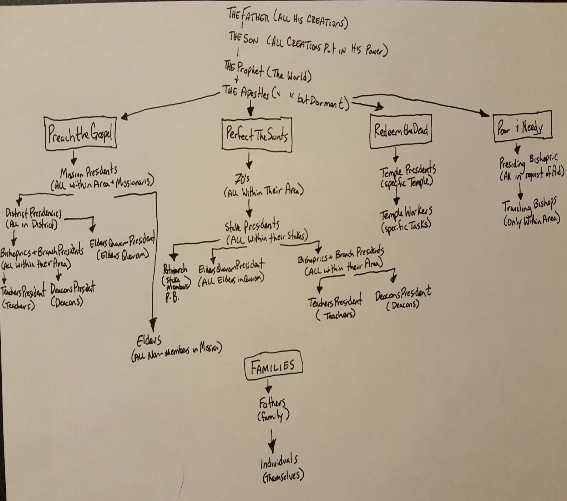
I know that as we follow the keys of the kingdom we will be upheld, and I also know, as Brigham Young knew, that “if you cut the thread that binds you to the [keys] you sink yourself to hell”. God bless, keep the faith, increase your testimony of the Savior and deepen your understanding of the doctrine taught in his restored church while it is yet day, in the name of Jesus Christ, Amen!

Additional References:
President Boyd K. Packer described that identifying mark of the true Church this way: “Revelation continues in the Church: the prophet receiving it for the Church; the president for his stake, his mission, or his quorum; the bishop for his ward; the father for his family; the individual for himself.”

-Boyd K. Packer, “We Believe All That God Has Revealed,” Ensign, May 1974, 95.

