LONE SURVIVOR
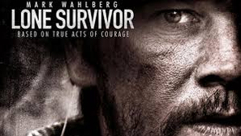

Grown–up’s Movie: | HIS | HER | AVG
1. Appropriate levels of sexuality? | 10 | 10 | 10
2. Appropriate levels of language? | 5 | 5 | 5
3. Appropriate levels of violence? | 7.5 | 7.5 | 7.5
4. Entertainment value for females? | 8.5 | 8 | 8.25
5. Entertainment value for males? | 9 | 9 | 9
6. Teaching moments, role models, moral of story? | 10 | 10 | 10
7. Is it a “classic”? (Replay value?) | 10 | 9 | 9.5
8. Audio/Visual effects? | 8 | 8 | 8
9. Not too cliché (unique and witty, not too slapstick) | 9 | 8 | 8.5
10. Climax/Resolution/Ending? | 9 | 9 | 9
GRAND TOTALS: |  |  | 84.75%

His Thoughts: Decent war movie, made into a great flick because it was a true story. If this wasn’t a true story it would be so-so and seem “not real”. The fact that this actually happened and that a man actually lived through such an event, and others lived and acted so bravely and selflessly is humbling. A hard movie to watch, but the humbling experience was priceless. A mature movie that didn’t cut out the violence or the language, they tried to paint the true story as accurately as they possibly could. Rough around the edges and piercing throughout, this was an amazing story.
Her Thoughts: This was a great movie. Loved the acting (always a little worried when Mark Wahlberg is in a movie but he did good) and the true story! Pretty amazing that the one guy survived through all of it. Worth watching.

