Look and Live
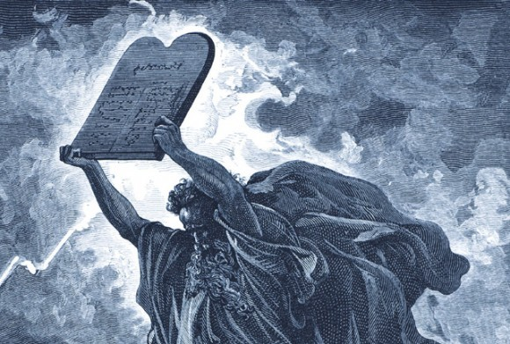
While Moses was communing with the Lord on Mt. Sinai the children of Israel were making a golden calf to worship, they were supposed to be worshipping the living God, and preparing themselves for The Law that Moses was to bring down from the Lord. Instead they had given themselves to idolatry, worshiping the workmanship of their own hands. Exodus chapter 32 (15-29) record what happens next: “And Moses turned, and went down from the mount, and the two tables of the testimony were in his hand: the tables were written on both their sides; on the one side and on the other were they written...
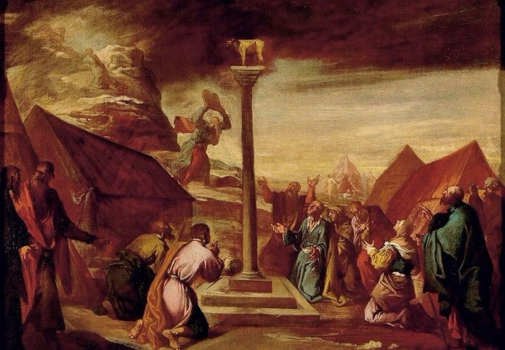
And it came to pass, as soon as he came nigh unto the camp, that he saw the calf, and the dancing: and Moses’ anger waxed hot, and he cast the tables out of his hands, and brake them beneath the mount. And he took the calf which they had made, and burnt it in the fire, and ground it to powder, and strawed it upon the water, and made the children of Israel drink of it. And Moses said unto Aaron, What did this people unto thee, that thou hast brought so great a sin upon them? And Aaron said, Let not the anger of my lord wax hot: thou knowest the people, that they are set on mischief. For they said unto me, Make us gods, which shall go before us: for as for this Moses, the man that brought us up out of the land of Egypt, we wot not what is become of him. And I said unto them, Whosoever hath any gold, let them break it off. So they gave it me: then I cast it into the fire, and there came out this calf. And when Moses saw that the people were naked; (for Aaron had made them naked unto their shame among their enemies:)
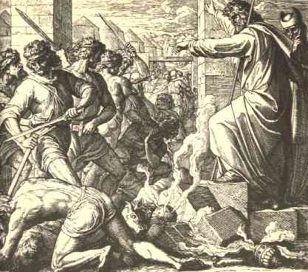
Then Moses stood in the gate of the camp, and said, Who is on the Lord’s side? let him come unto me. And all the sons of Levi gathered themselves together unto him. And he said unto them, Thus saith the Lord God of Israel, Put every man his sword by his side, and go in and out from gate to gate throughout the camp, and slay every man his brother, and every man his companion, and every man his neighbour. And the children of Levi did according to the word of Moses: and there fell of the people that day about three thousand men. For Moses had said, Consecrate yourselves to day to the Lord, even every man upon his son, and upon his brother; that he may bestow upon you a blessing this day.”

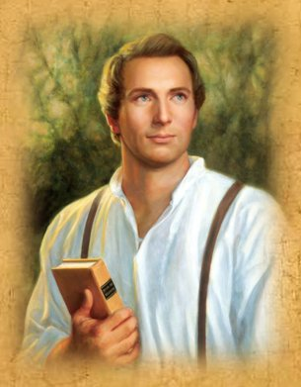
Moses, an ancient prophet, was a type of Joseph Smith to come. The Lord said in the Doctrine and Covenants chapter 103 (15-22)“15 Behold, I say unto you, the redemption of Zion must needs come by power; 16 Therefore, I will raise up unto my people a man, who shall lead them like as Moses led the children of Israel. For ye are the children of Israel, and of the seed of Abraham, and ye must needs be led out of bondage by power, and with a stretched-out arm. And as your fathers were led at the first, even so shall the redemption of Zion be. Therefore, let not your hearts faint, for I say not unto you as I said unto your fathers: Mine angel shall go up before you, but not my presence. But I say unto you: Mine angels shall go up before you, and also my presence, and in time ye shall possess the goodly land. Verily, verily I say unto you, that my servant Joseph Smith, Jun., is the man to whom I likened the servant to whom the Lord of the vineyard spake in the parable which I have given unto you. Therefore let my servant Joseph Smith, Jun., say unto the strength of my house, my young men and the middle aged—Gather yourselves together unto the land of Zion, upon the land which I have bought with money that has been consecrated unto me.”
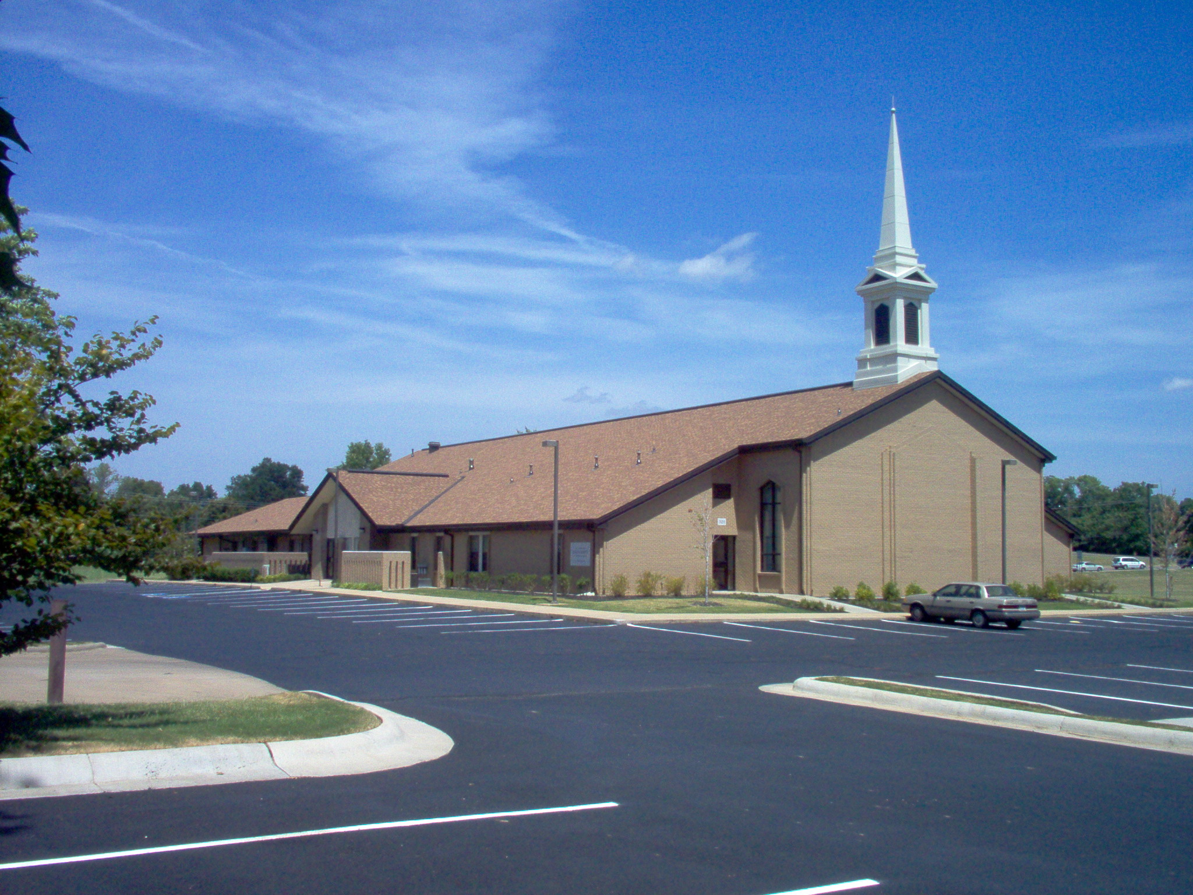
The command for Saints today was no different than the command to the ancient Israelites, we were to worship the Living God and prepare ourselves to live Celestial Law, or as the Lord put in in Doctrine and Covenants chapter 101: “Behold, it is my will, that all they who call on my name, and worship me according to mine everlasting gospel, should gather together, and stand in holy places; And prepare for the revelation which is to come…”
The Lord in Doctrine and Covenants chapter 101, however, further prophesied of the Saints failure to do so when He taught the parable of the nobleman and the olive trees: “And now, I will show unto you a parable, that you may know my will concerning the redemption of Zion. A certain nobleman had a spot of land, very choice; and he said unto his servants: Go ye unto my vineyard, even upon this very choice piece of land, and plant twelve olive trees; And set watchmen round about them, and build a tower, that one may overlook the land round about, to be a watchman upon the tower, that mine olive trees may not be broken down when the enemy shall come to spoil and take upon themselves the fruit of my vineyard. Now, the servants of the nobleman went and did as their lord commanded them, and planted the olive trees, and built a hedge round about, and set watchmen, and began to build a tower. And while they were yet laying the foundation thereof, they began to say among themselves: And what need hath my lord of this tower? And consulted for a long time, saying among themselves: What need hath my lord of this tower, seeing this is a time of peace? Might not this money be given to the exchangers? For there is no need of these things. And while they were at variance one with another they became very slothful, and they hearkened not unto the commandments of their lord. And the enemy came by night, and broke down the hedge; and the servants of the nobleman arose and were affrighted, and fled; and the enemy destroyed their works, and broke down the olive trees.”
Just like the children of Israel who grew tired of waiting for Moses to come back down off of that mountain, we as members of The Church of Jesus Christ of Latter-day Saints grew tired of waiting for Joseph Smith Jr. to come back down. In our waiting we have given ourselves to even more pernicious and evil forms of idolatry, idolatry that no longer is confined to a single location with a single golden calf, nah, we carry around our idolatry with us everywhere we go. We love it with all of our hearts, minds, and souls. We let it impact our every choice, our every decision, it’s in every room of our home, and our time is spent making money to buy more of it. “Love the Lord thy God with all of your heart, might, mind and strength!” is the command; the golden calf is the test, it always has been and always will be.
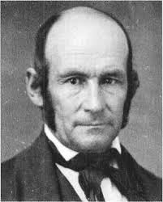
Heber C Kimball taught: “I want to say to you, my brethren, the time is coming when we will be mixed up in these now peaceful valleys to that extent that it will be difficult to tell the face of a Saint from the face of an enemy to the people of God. Then, brethren, look out for the great sieve, for there will be a great sifting time, and many will fall; for I say unto you there is a test, a Test, a TEST coming, and who will be able to stand? This church has before it many close places through which it must pass before the work of God is crowned with victory. To meet the difficulties that are coming it will be necessary for you to have knowledge of the truth of this work for yourselves. The difficulties will be of such character that the man or woman who does not possess this personal knowledge or witness will fall. If you have not got the testimony, live right and call upon the Lord and cease not ‘till you obtain it. If you do not, you will not stand. ” (Orson F. Whitney, Life of Heber C. Kimball, Salt Lake City: Bookcraft, 1945, p. 446.)
“[for] the Saints will be put to a test that will try the integrity of the best of them. The pressure will become so great that the more righteous among them will cry unto the Lord day and night until deliverance comes.
Then the Prophet Joseph and others will make their appearance and those who have remained faithful will be selected to return to Jackson County, Missouri and take part in the building of that beautiful city, the New Jerusalem.” (Heber C. Kimball, First Counselor in the First Presidency, May 1868, in Deseret News, 23 May 1931; see also Conference Report, Oct. 1930, p. 58-59)
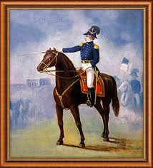
Aye, Joseph Smith shall return, just as Moses, and when he returns it will be just as Moses’ return from Mt Sinai. He will find Saints worshiping at the golden calf and Aaron leading them, or as the Lord taught, continuing in the parable of the nobleman and his olive trees: “Now, behold, the nobleman, the lord of the vineyard, called upon his servants, and said unto them, Why! what is the cause of this great evil? Ought ye not to have done even as I commanded you, and—after ye had planted the vineyard, and built the hedge round about, and set watchmen upon the walls thereof—built the tower also, and set a watchman upon the tower, and watched for my vineyard, and not have fallen asleep, lest the enemy should come upon you? And behold, the watchman upon the tower would have seen the enemy while he was yet afar off; and then ye could have made ready and kept the enemy from breaking down the hedge thereof, and saved my vineyard from the hands of the destroyer. And the lord of the vineyard said unto one of his servants: Go and gather together the residue of my servants, and take all the strength of mine house, which are my warriors, my young men, and they that are of middle age also among all my servants, who are the strength of mine house, save those only whom I have appointed to tarry; And go ye straightway unto the land of my vineyard, and redeem my vineyard; for it is mine; I have bought it with money. Therefore, get ye straightway unto my land; break down the walls of mine enemies; throw down their tower, and scatter their watchmen. And inasmuch as they gather together against you, avenge me of mine enemies, that by and by I may come with the residue of mine house and possess the land.”
D&C 112:24-26: “Behold, vengeance cometh speedily upon the inhabitants of the earth, a day of wrath, a day of burning, a day of desolation, of weeping, of mourning, and of lamentation; and as a whirlwind it shall come upon all the face of the earth, saith the Lord. And upon my house shall it begin, and from my house shall it go forth, saith the Lord; First among those among you, saith the Lord, who have professed to know my name and have not known me, and have blasphemed against me in the midst of my house, saith the Lord.”
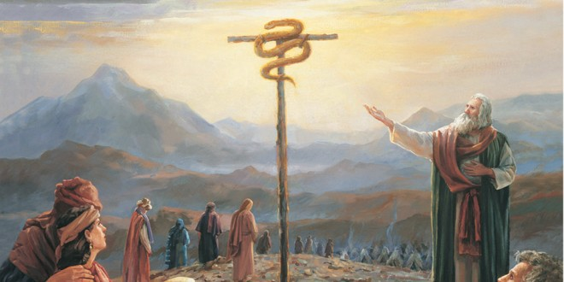
Numbers 21: 5-9 “And the people spake against God, and against Moses, Wherefore have ye brought us up out of Egypt to die in the wilderness? for there is no bread, neither is there any water; and our soul loatheth this light bread. And the Lord sent fiery serpents among the people, and they bit the people; and much people of Israel died. Therefore the people came to Moses, and said, We have sinned, for we have spoken against the Lord, and against thee; pray unto the Lord, that he take away the serpents from us. And Moses prayed for the people. And the Lord said unto Moses, Make thee a fiery serpent, and set it upon a pole: and it shall come to pass, that every one that is bitten, when he looketh upon it, shall live. And Moses made a serpent of brass, and put it upon a pole, and it came to pass, that if a serpent had bitten any man, when he beheld the serpent of brass, he lived.”
1 Nephi 17: 41 “And [the Lord] did straiten them in the wilderness with his rod; for they hardened their hearts, even as ye have; and the Lord straitened them because of their iniquity. He sent fiery flying serpents among them; and after they were bitten he prepared a way that they might be healed; and the labor which they had to perform was to look; and because of the simpleness of the way, or the easiness of it, there were many who perished.”
Alma 33: 19-22 Behold, [the Lord] was spoken of by Moses; yea, and behold a type was raised up in the wilderness, that whosoever would look upon it might live. And many did look and live. But few understood the meaning of those things, and this because of the hardness of their hearts. But there were many who were so hardened that they would not look, therefore they perished. Now the reason they would not look is because they did not believe that it would heal them. O my brethren, if ye could be healed by merely casting about your eyes that ye might be healed, would ye not behold quickly, or would ye rather harden your hearts in unbelief, and be slothful, that ye would not cast about your eyes, that ye might perish? If so, wo shall come upon you; but if not so, then cast about your eyes and begin to believe in the Son of God, that he will come to redeem his people…”
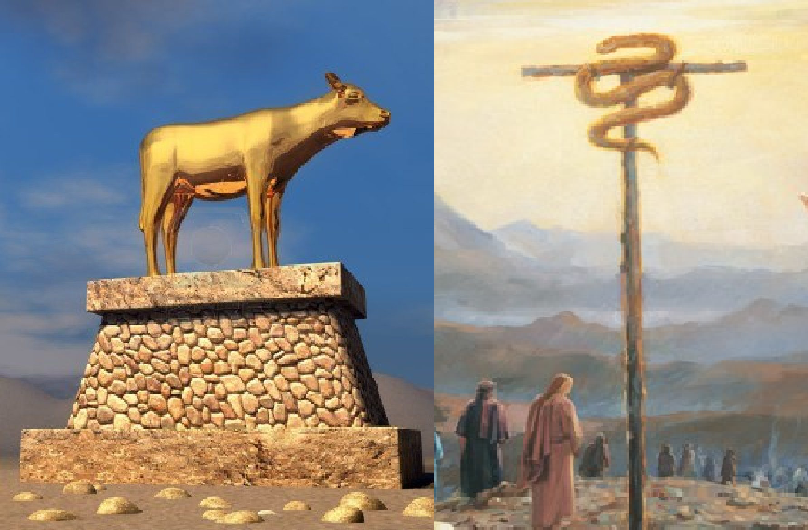
The Lord was angry with the children of Israel over the golden calf, so much so that many died by the sword and others had to drink the golden calf, yet here the Lord raised a brass serpent and commanded the people to “look and live”. Ask yourself, “What’s the difference between a brass serpent and a golden calf? Would not the children of Israel have been justified in proclaiming that “they would not worship a brass serpent but the living God!”, yet if they did so, they would have died. Ask yourself, “if my mother was stung, would I stop and look at a brass serpent? If my daughter, son, brother, etc. were stung would I stop and look at a brass serpent? Or would I run to their side and try to help them and shun the brass serpent as idolatry? Yet, if you were to, you all would have died. What made one “evil” and the “of God”? What made one “idolatry” and the other a “command from the Lord”? Both seem the same, both seem “evil”, yet one was of God, one would save all those who looked.
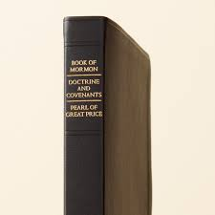
D&C 84: 54-61: “…your minds… have been darkened because of unbelief, and because you have treated lightly the things you have received— Which vanity and unbelief have brought the whole church under condemnation. And this condemnation resteth upon the children of Zion, even all. And they shall remain under this condemnation until they repent and remember the new covenant, even the Book of Mormon and the former commandments which I have given them, not only to say, but to do according to that which I have written— That they may bring forth fruit meet for their Father’s kingdom; otherwise there remaineth a scourge and judgment to be poured out upon the children of Zion. For shall the children of the kingdom pollute my holy land? Verily, I say unto you, Nay. Verily, verily, I say unto you who now hear my words, which are my voice, blessed are ye inasmuch as you receive these things; For I will forgive you of your sins with this commandment—that you remain steadfast in your minds in solemnity and the spirit of prayer, in bearing testimony to all the world of those things which are communicated unto you.”
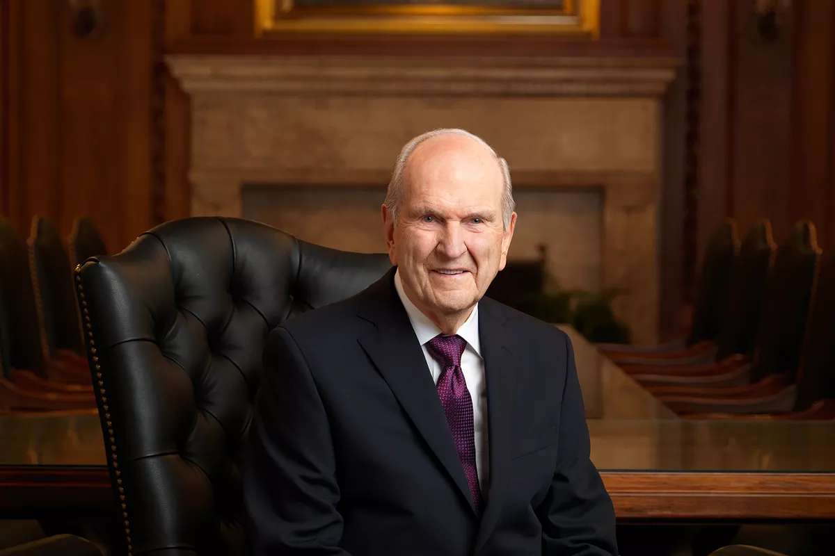
Doctrine and Covenants 1: 36-38 “… the Lord shall have power over his saints, and shall reign in their midst, and shall come down in judgment upon Idumea, or the world. Search these commandments, for they are true and faithful, and the prophecies and promises which are in them shall all be fulfilled. What I the Lord have spoken, I have spoken, and I excuse not myself; and though the heavens and the earth pass away, my word shall not pass away, but shall all be fulfilled, whether by mine own voice or by the voice of my servants, it is the same. For behold, and lo, the Lord is God, and the Spirit beareth record, and the record is true, and the truth abideth forever and ever. Amen.”
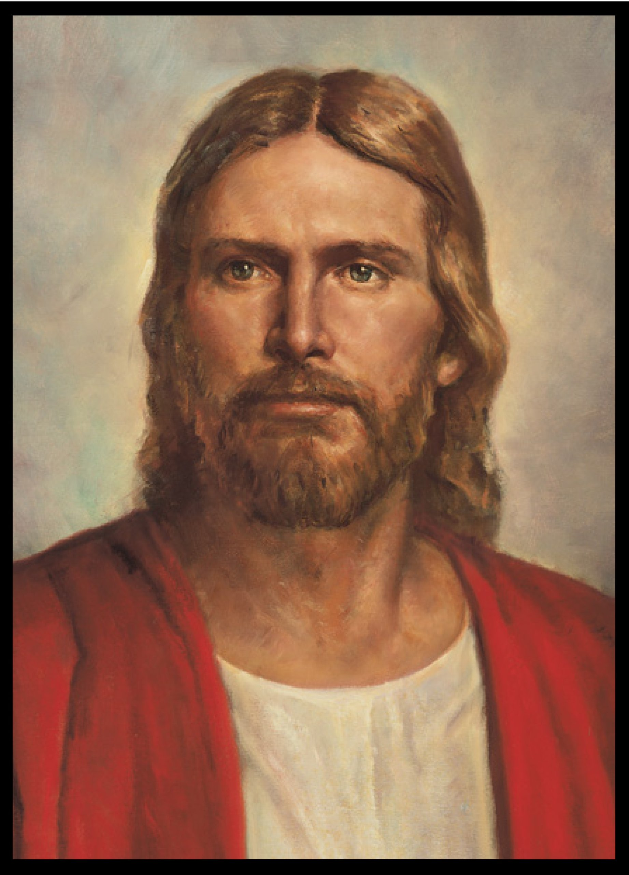
Isaiah 50:10 “Who is among you that feareth the Lord, that obeyeth the voice of his servant, that walketh in darkness, and hath no light? let him trust in the name of the Lord, and stay upon his God.”
Brothers and sisters, who among you fears the Lord? Who among you obeyeth the voice of [the Lord’s] servants? Who among you walketh in darkness and hath no light? Let us brothers and sisters trust in the name of our Lord, even Jesus the Christ, and stay upon our God! If the keys tell us to “look”, let us “look and live” I pray, in Jesus’ name, amen!

