The Lovely Bones
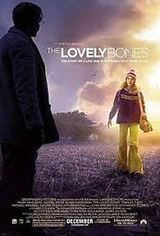
Grown–up’s Movie: | HIS | HER | AVG
1. Appropriate levels of sexuality? | 9.5 | 9 | 9.25
2. Appropriate levels of language? | 10 | 10 | 10
3. Appropriate levels of violence? | 6 | 6 | 6
4. Entertainment value for females? | 8 | 8.5 | 8.25
5. Entertainment value for males? | 5 | 6 | 5.5
6. Teaching moments, role models, moral of story? | 10 | 10 | 10
7. Is it a “classic”? (Replay value?) | 7 | 8 | 7.5
8. Audio/Visual effects? | 8.5 | 8 | 8.25
9. Not too cliché (unique and witty, not too slapstick) | 10 | 10 | 10
10. Climax/Resolution/Ending? | 5.5 | 6 | 5.75
GRAND TOTALS: |  |  | 80.5

