Mirror Mirror
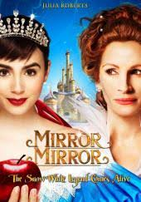

Kids and Family Movie: | HIS | HER | AVG
1. Is it a “Kids Friendly” movie? (eg. not scary, no cursing, sexuality) | 10 | 10 | 10
2. Entertainment value for children 12 and under? | 8 | 7.5 | 7.75
3. Entertainment value for teenagers? | 7 | 6.5 | 6.75
4. Entertainment value for parents? | 5 | 6 | 5.5
5. Entertainment value for males? | 6 | 6 | 6
6. Entertainment value for females? | 7.5 | 7.5 | 7.5
7. Teaching moments, role models, moral of story? | 5 | 5 | 5
8. Is it a “classic”? (Replay value?) | 3 | 3 | 3
9. Audio/Visual effects? | 6 | 6.5 | 6.25
10. Not too cliché (unique and witty, not too slapstick or potty)? | 4 | 4 | 4
GRAND TOTALs: |  |  | 61.75

