Has Joseph Smith Returned? Fireside

Section 1: Chris (Topher)

Wait… Joseph Smith was supposed to Return?

Firstly, from my own experience, the first time I ever heard of, or actually logically considered the fact that Joseph Smith would return was when I first saw Micah’s YouTube Video “Joseph Smith to Return”. It was so exciting to hear and at first it gave me a nice shock to hear that this was/is going to happen but then I sat back and realized “Of course he is going to return!” and “How have I never fully considered this before?!”. In my head it was always something that I knew would happen sometime in the future, but it was always a future event that I never really thought would get closer. I always associated his return with the Adam-ondi-ahman event but never considered that he had other works to perform outside of this. So anyway, it was a beautiful wakeup call so thanks Micah, and now this has become one of my favourite subjects to study.

So, everyone listening is almost certainly familiar with Micah’s papers on the return of Joseph Smith and this topic is discussed pretty regularly in Micah’s Firesides and in Discord. I’m going to be referencing both of Micah’s papers – “Joseph Smith to Return” and “Joseph Smith to Return Continued” as well as a new Paper Ammon has been working on regarding the subject. So, for really concise and clear explanations on the subject I’d recommend everyone reads these papers – Ammons will be finished shortly. I’m going to try and summarize the return of Joseph Smith from hours of material into minutes so I’m going to focus on specific things and then skip other things and assume those listening know what I am talking about and can you can go and study the full papers after.

The Institute BoM Teachers Manual - Have students read 3 Nephi 21:9–11. As they read, explain that Elder Jeffrey R. Holland of the Quorum of the Twelve Apostles identified the “servant” in these verses as Joseph Smith (see Christ and the New Covenant: The Messianic Message of the Book of Mormon [1997], 287–88).

3 Nephi 21:9-11 – Jesus talking to the Nephites and clarifying Isaiah 52:13-15
9 For in that day, for my sake shall the Father ªwork a work, which shall be a great and a ^{b}marvelous ^{c}work among them; and there shall be among them those who will not believe it, although a man shall declare it unto them.
10 But behold, the life of my servant shall be in my hand; therefore they shall not hurt him, although he shall be ªmarred because of them. Yet I will heal him, for I will show unto them that ^{b}my wisdom is greater than the cunning of the devil.
11 Therefore it shall come to pass that whosoever will not believe in my words, who am Jesus Christ, which the Father shall cause ªhim to bring forth unto the ^{b}Gentiles, and shall give unto him power that he shall bring them forth unto the Gentiles, (it shall be done even as Moses said) they shall be ^{c}cut off from among my people who are of the covenant.

The footnote for “marred” points to D&C 135:1 (happens to be CFM for next week)
1 To seal the testimony of this book and the Book of Mormon, we announce the martyrdom of Joseph Smith the Prophet, and Hyrum Smith the Patriarch. They were shot in Carthage jail, on the 27th of June, 1844, about five o’clock p.m., by an armed mob—painted black—of from 150 to 200 persons. Hyrum was shot first and fell calmly, exclaiming: I am a dead man! Joseph leaped from the window, and was shot dead in the attempt, exclaiming: O Lord my God! They were both shot after they were dead, in a brutal manner, and both received four balls.

So, now we have the Saviour talking about a Servant in the latter days (that was also prophesied of by Isaiah), who was confirmed to be Joseph Smith by a Latter-Day Apostle. This Servant was to be “marred”, and we now know this means “Martyred” because our wonderful footnotes literally point us to the Martyrdom of Joseph Smith.
Now, back in 3 Nephi 21:10 it says “he shall be marred because of them. Yet I will heal him, for I will show unto them that my wisdom is greater than the cunning of the devil.”
So, what does the Lord mean when he says he will “heal” him? Micah does a beautiful job of clarifying this in his paper with D&C 63:47-40, 52-54. To summarize this section, the Lord says that those who die in righteousness will be resurrected and receive an inheritance in Zion. He also says that these resurrections are the “things that ye must look for… and they are now nigh at hand”. So, healing a dead man is referring to his resurrection. How else do you heal a martyr? Also, the resurrection of the dead (or more specifically the resurrection of a specific person) is “the thing that ye must look for” in the last days and this is obviously not talking about Jesus because he has been resurrected for almost 2000 years and this revelation was given to Joseph Smith about a time to come which is “now nigh at hand” (Nigh at hand from 1831 must be really nigh now!). I recommend everyone read Micahs paper for the beautiful way he transposes Joseph’s name over all the scriptures referring to him and it makes everything really clear.

Brigham Young said “In the Millennium, when the Kingdom of God is established on the earth in power, glory and perfection, and the reign of wickedness that has so long prevailed is subdued, the Saints of God will have the privilege of building their temples, and of entering into them, becoming, as it were, pillars in the temples of God, and they will officiate for their dead. Then we will see our friends come up, and perhaps some that we have been acquainted with here. If we ask who will stand at the head of the resurrection in this last dispensation, the answer is - Joseph Smith, Junior, the Prophet of God. He is the man who will be resurrected and receive the keys of the resurrection, and he will seal this authority upon others, and they will hunt up their friends and resurrect them when they shall have been officiated for, and bring them up. And we will have revelations to know our forefathers clear back to Father Adam and Mother Eve, and we will enter into the temples of God and officiate for them. Then man will be sealed to man until the chain is made perfect back to Adam, so that there will be a perfect chain of Priesthood from Adam to the winding-up scene.” (Discourses of Brigham Young, p.116)

So, THIS is why we are so excited about, and looking forward to his resurrection! We need to look for it! “He is the man who will be resurrected and receive the keys of the resurrection” so it all starts with Joseph.

Parley P. Pratt, when he learned of Joseph Smith’s death:
“I walked onward, weighed down as it were unto death. When I could endure it no longer, I cried out aloud, saying, ‘Oh, Lord, in the name of Jesus Christ I pray Thee, show me what these things mean, and what I shall say to Thy people?’ “Suddenly the Spirit of God came upon me, and filled my heart with joy and gladness indescribable; and while the spirit of revelation glowed in my bosom with as visible a warmth and gladness as if it were fire, the Spirit said unto me, ‘Lift up your head and rejoice. For behold, it is well with my servants Joseph and Hyrum. My servant Joseph still holds the keys of my kingdom in this dispensation, and he shall stand in due time on the earth, in the flesh, and fulfill that to which he is appointed.’” (Parley P. Pratt, Autobiography of Parley P. Pratt, (Salt Lake City: Deseret Book, 1938, 1970), p. 333; emphasis added.)

So, once again we obviously know he will be resurrected as we all will be, Joseph needs to “fulfill that which is appointed” which Micah will cover later in the fireside.
In the Autobiography of Wandle Mace he records Joseph Smith, to the Nauvoo Legion in his last address: “Those who are your friends are my friends, and I promise you when I come again, I will lead you forth, so that where I am you shall be with me.” (Autobiography of Wandle Mace, typescript, BYU Special Collections, pp. 131-132; emphasis added.)
Joseph Smith, to the Nauvoo Legion the final time: “‘Boys---he always called us ‘his boys’---don’t be sad, don’t be cast down, I will come back again.’ After a little hesitation he added, ‘as soon as I can.’ That expression, ‘as soon as I can,’ sank deep into my heart and confirmed my fears. I never expected to see him again alive. The sad expression upon his face as he looked upon us, ‘his boys,’ for the last time I shall never forget. I felt in my inmost soul that he was going to be butchered, and we should see him no more alive.” (Autobiography of Wandle Mace, typescript, BYU Special Collections, pp. 145-146; emphasis added.)

Brigham Young in the Journal of Discourses said:
“Joseph Smith, Junior, will again be on this earth dictating plans . . . and he will never cease his operations, under the directions of the Son of God, until the last ones of the children of men are saved that can be, from Adam till now.” (Brigham Young, October 9, 1859, Journal of Discourses 7:289; emphasis added)

Also:
“There is an almighty work to perform in the spirit world. Joseph has not yet got through there. When he finishes his mission in the spirit world, he will be resurrected, but he is not yet done there. . . . When his spirit again quickens his body, he will ascend to heaven, present his resurrected body to the Father and the Son, receive his commission as a resurrected being, and visit his brethren on this earth, as did Jesus after His resurrection.” (Brigham Young, March 15, 1857, Journal of Discourses 4:285-286.)

Also:
“I will refer you to a discourse I delivered here last season upon the subject of the resurrection and the Millennium. . . . Joseph, Hyrum, Father Smith and many others will be there to dictate and preside. Joseph will stand at the head of this dispensation and hold the keys of it, for they are not taken from him; they never were in time; they never will be in eternity. I shall be there if I live or if I die.” (Brigham Young, April 8, 1853, Journal of Discourses 6:308.)

Also:
“I said to Brother Joseph, the spring before he was killed, ‘You are laying out work for twenty years.’ He replied, ‘You have as yet scarcely begun to work; but I will set you enough to last you during your lives, for I am going to rest.’ All I can do or ask now is to do the work, so that it will be right and acceptable to him when he comes here again.” (Brigham Young, October 7, 1857, Journal of Discourses 5:331; emphasis added.)

Heber C. Kimball in the Journal of Discourses said:
“Do you suppose that if Brother Brigham were to die tomorrow, and if Joseph is resurrected, which he will be so soon as his mission is filled in the spirit world, that Joseph will permit Brother Brigham’s body to remain any longer in the grave than may be requisite? No, for he then will have need of the assistance of his faithful resurrected brethren, as he now has of faithful spirits.” (Heber C. Kimball, March 15, 1857, Journal of Discourses 4:294-295; emphasis added)
Heber also said:
“I am pretty sure of one thing: we shall go to Jackson County, Missouri; that is, those who do right and honor their callings, doing what they have been told to do. You will be blessed, and you will see the day when Presidents [Brigham] Young, [Heber C.] Kimball, and [Daniel H.] Wells, and the Twelve Apostles will be in Jackson County, Missouri, laying out your inheritances. In the flesh? Of course. We should look well without being in the flesh! We shall be there in the flesh, and all our enemies cannot prevent it.
“Brother Wells, you may write that. You will be there, and Willard [Richards] will be there, and also Jedediah [M. Grant], and Joseph and Hyrum Smith, and David [W. Patten], and Parley [P. Pratt]; and the day will be when I will see those men in the general assembly of the Church of the First Born, in the great council of God in Jerusalem, too. Will we want you to be along? I heard Joseph say twice that Brother Brigham and I should be in that council in Jerusalem, when there should be a uniting of the two divisions of God’s government.” (Heber C. Kimball, April 7, 1861, Journal of Discourses 9:27)

Brigham Young – Millennial Star
“Will the Saints arise from the dead? Yes. Who will know it? But a few. When the resurrection commences, I say but few will know it; and allow me to inform you, when you have seen Joseph, and Hyrum, and Father Smith, and many others, risen from the dead, and you elders go abroad preaching, you will not tell the world of their resurrection, for they will not believe it.
“You may testify that Father Smith has arisen, that Joseph and Hyrum again possess their bodies; that they again live in the flesh, and they will laugh you to scorn, and persecute you to the death, if they have the power, for your testimony’s sake.
“Will the Saints rise from the dead before the world is converted? Yes. You may despair of ever seeing all creation converted to the Lord Jesus, or to the faith of the holy gospel. Will you see the resurrection? Yes, you will be in it, and enjoy it; you will be in the first resurrection. Will the world believe it, and know of it? They will not.” (Brigham Young, October 3, 1852, Millennial Star 16:594 and Deseret News, May 11, 1854)

Why Does it Even Matter?

We are commanded to look for the signs of the coming of Jesus Christ and as mentioned above we are literally commanded to look for Josephs resurrection. We don’t want to be unprepared for his coming like a ‘thief in the night’ (D&C 106:4-5.) There is a reason that there are more scriptures related to signs and Prophecy preceding the Second Coming than any other subject aside from the Saviours ministry… it is knowledge for our preparation. (Parables of the ‘Wheat & The Tares, 10 Virgins etc).
You will all hopefully remember when Wendy Nelson gave this statement at a Young Adults Devotional Meeting:
“So, now a question as I conclude: What if you learned that the Savior had already returned to this earth—that He, as part of His Second Coming, had already met with some of His true followers in several marvelous, large gatherings — gatherings about which the world, including CNN and the blogosphere, knew nothing. If you found out that the Savior was already on the earth, what would you desperately want to do today, and what would you be willing and ready to do tomorrow?” (Becoming the Person You Were Born to Be - Wendy Watson Nelson - An Evening with President Russell M. Nelson Worldwide Devotional for Young Adults • January 10, 2016 • Brigham Young University–Hawaii)
This statement sent many into a tailspin! For those of us that heard the statement and had not taken to serious reflection, this was a moment to consider just how ready we were. Here is one of the most common responses I have seen to this statement:
A question to answer to yourself right now – How did I feel when I heard this statement? Was your answer “excited”? Or was it perhaps a feeling of “fear and being unprepared”? If a simple statement like this shakes us enough to feel like we need to “get our acts together” then we might do well to take another look at the parable of the Ten Virgins and think about which of the five virgins we are.

Once Joseph returns (or perhaps he has already?) he holds the Keys and he has a LOT of work to do and he will need help to do it – see Micah’s Paper/YouTube video “Josephs Boys” and we need to be preparing ourselves to be worthy so that Joseph can call upon us to assist him in his work.

The Year 2020 – 200th Anniversary of the Restoration of the Gospel
The year 2020 was a significant milestone for the Church of Jesus Christ of Latter-Day Saints.
This year, we commemorate the 200th anniversary of one of the most significant events in the history of the world—namely, the appearance of God the Father and His Beloved Son, Jesus Christ, to Joseph Smith. During that singular vision, God the Father pointed to Jesus Christ and said: “This is My Beloved Son. Hear Him!” Opening Message – April 2020 General Conference. President Russell M. Nelson
We received the ‘Bicentennial Proclamation to the World: The Restoration of the Fulness of the Gospel of Jesus Christ.
President Nelson personally confirmed that Joseph Smith still claims authority as the Prophet of our dispensation. We were also reminded that the Restoration of the Gospel is not yet complete and that all Gospel knowledge would be brought forth:
“Regardless of where you live or what your circumstances are, the Lord Jesus Christ is your Savior, and God’s prophet Joseph Smith is your prophet. He was foreordained before the foundation of the earth to be the prophet of this last dispensation, when “nothing shall be withheld” from the Saints. Revelation continues to flow from the Lord during this ongoing process of restoration.” Hear Him - April 2020 General Conference. President Russell M. Nelson
The Prophet re-centred us on the name of the Lords Church and a reminder to whom we worship:
“As we commemorate the event that was launched in 1820, it is important to remember that while we revere Joseph Smith as a prophet of God, this is not the church of Joseph Smith, nor is it the church of Mormon. This is the Church of Jesus Christ. He decreed exactly what His Church should be called: “For thus shall my church be called in the last days, even The Church of Jesus Christ of Latter-day Saints.” Opening the Heavens for Help – April 2020 General Conference. President Russell M Nelson
We also experienced a ‘Hosanna Shout’ which is normally reserved for the dedication of Temples:
“This sacred shout was first given in this dispensation at the dedication of the Kirtland Temple on March 27, 1836. It is now given at the dedication of each temple. It is a sacred tribute to the Father and the Son, symbolizing the reaction of the multitude when the Savior made His triumphal entry into Jerusalem. It also reaffirms what young Joseph experienced that day in the Sacred Grove﻿—namely, that the Father and the Son are two glorified Beings, whom we worship and praise.”
According to the ‘Guide to the Scriptures’ here is the symbolic meaning of the Hosanna Shout:
At the Feast of Tabernacles, which celebrated the Lord’s deliverance of Israel into the promised land, people chanted the words of Psalm 118 and waved palm branches. At the Lord’s triumphal entry into Jerusalem, the multitudes cried “Hosanna” and spread palm branches for Jesus to ride upon, thus demonstrating their understanding that Jesus was the same Lord who had delivered Israel anciently (Ps. 118:25–26; Matt. 21:9, 15; Mark 11:9–10; John 12:13). These people recognized Christ as the long-awaited Messiah.
During the April 2020 General Conference President Nelson emphasized the importance of the restoration of the Gospel through Joseph Smith by making a formal proclamation, reminded us all that we don’t worship him though he continues to be our Prophet (holds keys/authority), that the Restoration is ongoing and performs the sacred ‘Hosanna Shout’ signifying a prophesied return…
With a solid understanding of Joseph’s ministry and mission, these all sound like references pointing to the return of Joseph Smith.

Section 2: Ammon

Removal of the Angel Moroni from the Temple - 2020
It also came to my attention that the Church has generally ceased placing the ‘Angel Moroni’ on new Temples. For example, let’s take a look at the Temples announced at the 2020 April and October general Conferences:
“Today we are pleased to announce plans to construct eight new temples in the following locations: Bahía Blanca, Argentina; Tallahassee, Florida; Lubumbashi, Democratic Republic of the Congo; Pittsburgh, Pennsylvania; Benin City, Nigeria; Syracuse, Utah; Dubai, United Arab Emirates; and Shanghai, People’s Republic of China.”

Bahía Blanca, Argentina
Temple Rendering: No Official Rendering has been publicly released to date. (Found this image in google)
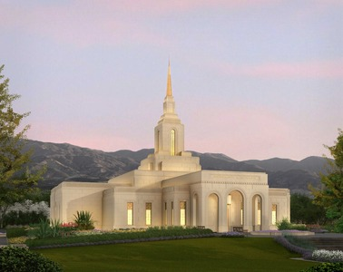

Tallahassee, Florida
Temple Rendering: On January 13, 2021, an official exterior rendering of the Tallahassee Florida Temple was released.
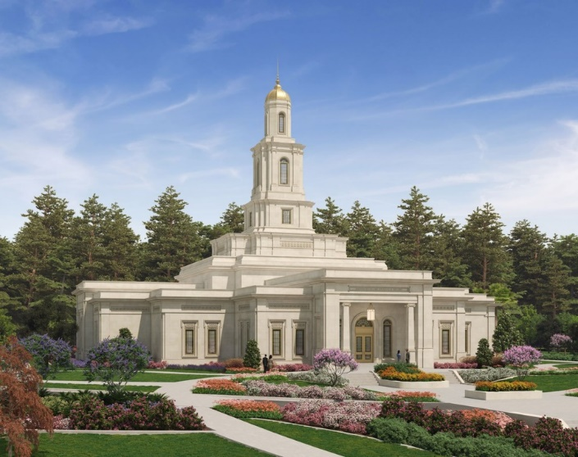
Tallahassee, Florida
Temple Rendering: On January 13, 2021, an official exterior rendering of the Tallahassee Florida Temple was released.

Lubumbashi, Democratic Republic of the Congo
Temple Rendering: No Official Rendering has been publicly released to date.

Pittsburgh Pennsylvania Temple
Temple Rendering: On January 19, 2021, an official exterior rendering of the Pittsburgh Pennsylvania Temple was released.
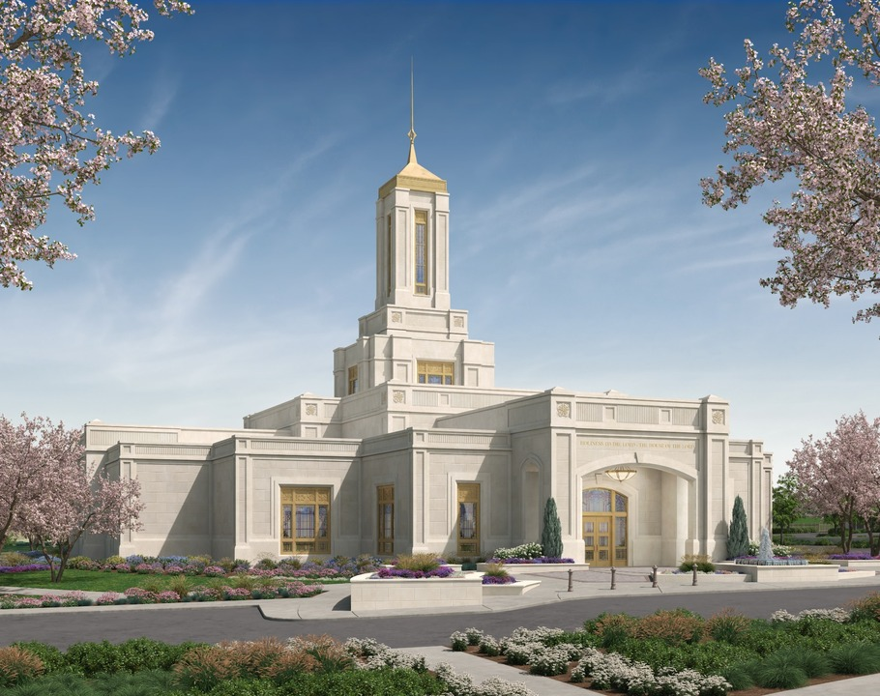

Benin City, Nigeria
Temple Rendering: No Official Rendering has been publicly released to date.

Syracuse, Utah
Temple Rendering: On February 16, 2021, an official exterior rendering of the Syracuse Utah Temple was released.
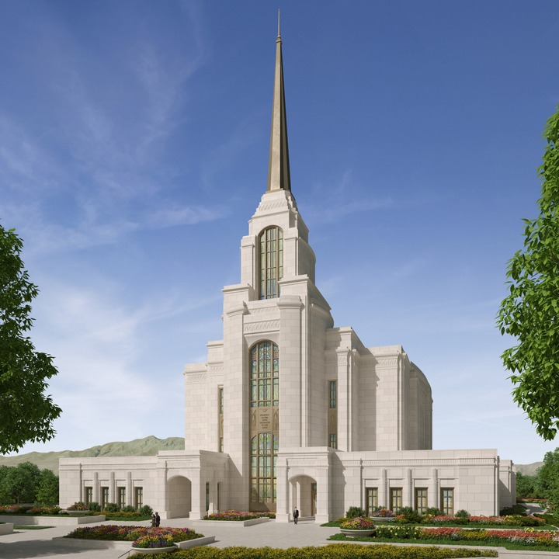

Dubai, United Arab Emirates
Temple Rendering: No Official Rendering has been publicly released to date.

Shanghai, People’s Republic of China
Temple Rendering: No Official Rendering has been publicly released to date.

I found it fascinating that of all the Temples announced in April 2020, none of the official renderings actually depict an Angel Moroni statue. So the question one might ask is – “Do early renderings simply not include a depiction of the Angel?”

In short I have found that in the past, all renderings prior to 2019 did depict the Angel Moroni. Here are just a handful for reference:

Anchorage Alaska Albuquerque New Mexico
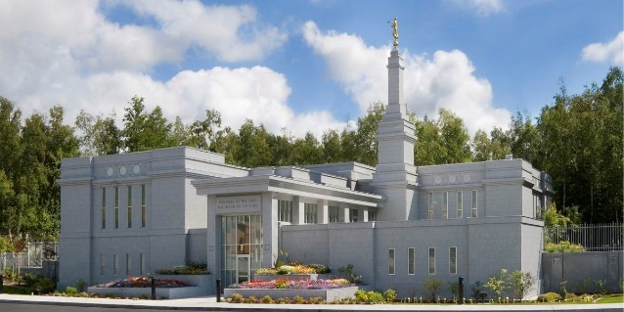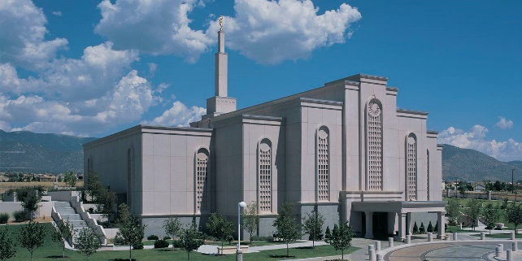

Adelaide Australia Accra Ghana
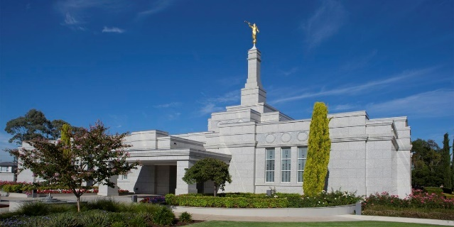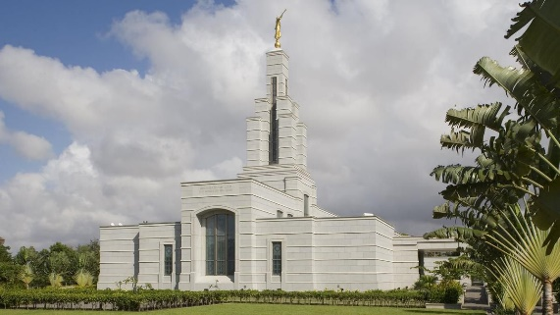

Another Question then arises – “Do recently completed Temples have an Angel?”. While I was looking through the renderings for the recently announced Temples, I also looked over some that were recently completed and found that they do have the Angel present. Several Temples that have been recently completed right up to the Pocatello, Idaho Temple dedicated on 7 November 2021 have the Angel.

Recently completed Temples still have the Angel yet those in planning phase from at least as far back as 2020 do not. There appears to have been a fairly consistent change made here. There is of course a lengthy period of years between the announcement phase until dedication. Let’s try and pin this down further – Do newer Temples under construction have the Angel? Here is list of all Temples under Construction as at 16/11/21. They are listed from oldest announcement date to newest and I have noted by each one if it will have an Angel Moroni:

Temples Under Construction – Angel Moroni Yes / No
No. | Temple | Groundbreaking
171 | Rio de Janeiro Brazil Temple† - Has an Angel Moroni | 4 March 2017
172 | Abidjan Ivory Coast Temple - Has an Angel Moroni | 8 November 2018
173 | Urdaneta Philippines Temple - Has an Angel Moroni | 16 January 2019
174 | Bangkok Thailand Temple – No Angel Moroni | 26 January 2019
175 | Yigo Guam Temple – No Angel Moroni | 4 May 2019
176 | Praia Cape Verde Temple – No Angel Moroni | 4 May 2019
177 | San Juan Puerto Rico Temple – No Angel Moroni | 4 May 2019
178 | Quito Ecuador Temple – Has an Angel Moroni | 11 May 2019
179 | Lima Peru Los Olivos Temple – No Angel Moroni | 8 June 2019
180 | Belém Brazil Temple – Has An Angel Moroni | 17 August 2019
181 | Saratoga Springs Utah Temple – Has An Angel Moroni | 19 October 2019
182 | Puebla Mexico Temple – Has An Angel Moroni | 30 November 2019
183 | Richmond Virginia Temple – Has An Angel Moroni | 11 April 2020
184 | Layton Utah Temple – Has An Angel Moroni | 23 May 2020
185 | Alabang Philippines Temple – No Angel Moroni | 4 June 2020
186 | Auckland New Zealand Temple – No Angel Moroni | 13 June 2020
187 | Feather River California Temple – Has An Angel Moroni | 18 July 2020
188 | Orem Utah Temple – No Angel Moroni | 5 September 2020
189 | San Pedro Sula Honduras Temple – No Angel Moroni | 5 September 2020
190 | Brasília Brazil Temple – No Angel Moroni | 26 September 2020
191 | Moses Lake Washington Temple – No Angel Moroni | 10 October 2020
192 | Taylorsville Utah Temple – No Angel Moroni | 31 October 2020
193 | Salta Argentina Temple – Has An Angel Moroni | 4 November 2020
194 | Bentonville Arkansas Temple – No Angel Moroni | 7 November 2020
195 | Red Cliffs Utah Temple – Has An Angel Moroni | 7 November 2020
196 | Cobán Guatemala Temple – No Angel Moroni | 14 November 2020
197 | Davao Philippines Temple – No Angel Moroni | 14 November 2020
198 | McAllen Texas Temple – No Angel Moroni | 21 November 2020
199 | Antofagasta Chile Temple – No Angel Moroni | 27 November 2020
200 | Bengaluru India Temple – No Angel Moroni | 2 December 2020
201 | Okinawa Japan Temple – No Angel Moroni | 5 December 2020
202 | Harare Zimbabwe Temple – No Angel Moroni | 12 December 2020
203 | Mendoza Argentina Temple – No Angel Moroni | 17 December 2020
204 | Deseret Peak Utah Temple – No Angel Moroni | 15 May 2021
205 | Tallahassee Florida Temple – No Angel Moroni | 5 June 2021
206 | Syracuse Utah Temple – No Angel Moroni | 12 June 2021
207 | Helena Montana Temple – No Angel Moroni | 26 June 2021
208 | Salvador Brazil Temple – No Angel Moroni | 7 August 2021
209 | Pittsburgh Pennsylvania Temple – No Angel Moroni | 21 August 2021
210 | Neiafu Tonga Temple – No Angel Moroni | 11 September 2021
211 | Nairobi Kenya Temple – No Angel Moroni | 11 September 2021
212 | Phnom Penh Cambodia Temple – No Angel Moroni | 18 September 2021
213 | Casper Wyoming Temple – No Angel Moroni | 9 October 2021
214 | Pago Pago American Samoa Temple – No Angel Moroni | 30 October 2021
† Dedication announced

You will note that up until the 195th Temple announced there were some planned with and without the Angel. From the 196th to the 210th onward however, there has not been a single Temple under construction (as at 16/11/21) with an Angel Moroni planned for instalment.
I continued the review of the 215th Temple right through to the 265th being the latest temple. As at 16/11/21 roughly 30% of these have an official rendering and none of them are depicted with the Angel Moroni. (Official renderings would normally include the Angel Moroni in previous Temples). This means that the consideration to discontinue the use of the Angel Moroni likely occurred prior to 2020 however we know for a fact that there have been no Temples announced or under construction with ground broken after November 2020.
As I continued this research, I found some more fascinating information. What about Temples undergoing renovation? If the removal of the Angel is intentional, has it been removed from any Temples undergoing renovation? The answer is YES!
President Nelson specifically mentioned the Hong Kong Temple renovation in his 2020 April Conference Temple announcement as one going through renovation so I looked into it further:
“For more than two decades, temple-worthy members in the People’s Republic of China have attended the Hong Kong China Temple. But in July 2019, that temple was closed for long-planned and much-needed renovation.” Go Forward in Faith – Russell M. Nelson April General Conference.
I served in Hong Kong as a missionary (Ammon Wilkes) from 2006-08 so the Temple holds a special place in my heart. Here is what it looked like when I served there:
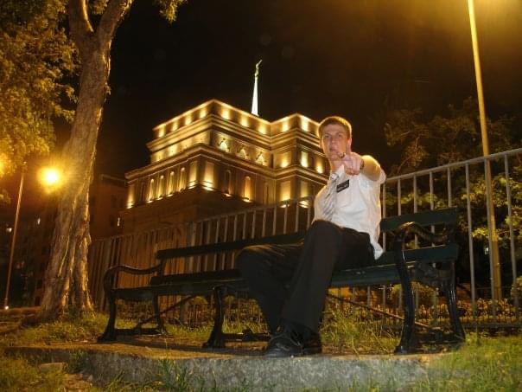

Here is a media release on the renovation and a rendering of what it will look like upon completion:
Church Releases Hong Kong China Temple Renovation Details 6 August 2019 - Hong Kong News Release
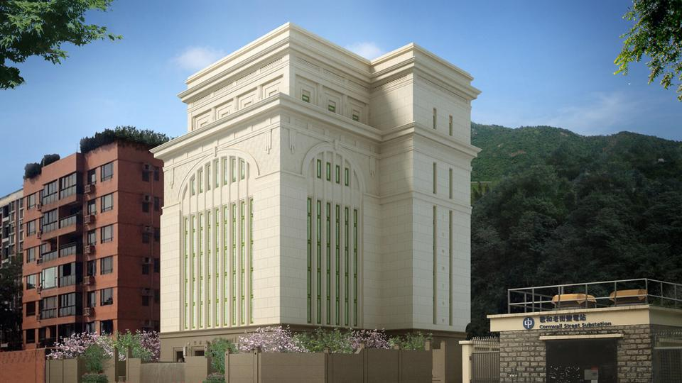
“This temple has faithfully served Church members in the Asia area for more than 20 years,” said Brent Roberts, managing director of the Church’s Special Projects Department. “But like all buildings, systems wear out and updates and refreshing become necessary. This work over the next three years will beautify and rejuvenate this beautiful House of the Lord.”
The five-story temple’s exterior stone will be replaced, and some of the windows will be reworked. Additionally, the rooms will be reconfigured to create a better patron experience. This includes renovating one of the floors that was used as a meetinghouse and incorporating it into the temple experience.
Workers will also take steps to strengthen the building against water and moisture. New art glass will be installed – adhering to the oriental design familiar to temple visitors – and new pieces of artwork and furniture will be added. The exterior landscaping and grounds will also be refreshed. The temple’s existing steeple will be removed.
“These improvements will add to the beauty of this magnificent temple,” said Mark Berry, senior project manager. “Our architects have worked meticulously to draw up plans to preserve and strengthen this structure, and our local contractors will make those plans a reality over the next three years.”
This is interesting. The Angel Moroni will be removed from the Temple! So the removal of the Angel is not only limited to Temples recently announced or under construction, but also may include Temples having their Angels removed through renovation. This is clearly an intentional decision.
In Summary:
- In all my research I did not identify a symbolic reason given for the removal of the Angel Moroni. Just a mention that it is an ‘improvement’ to add ‘beauty’ the building.
- There are no new Temples being announced that depict the Angel Moroni in official Church renderings.
- There are no Temples under construction with ground-breaking dates later than 14th November 2021 with the Angel Moroni.
- Temples undergoing major renovation may have the Angel Moroni removed.

(Possibly include scriptural examples of symbolism being fulfilled and therefore removed IE Saviour rending the veil in the temple. Possibly save for later in the paper?)
The removal of the Angel Moroni from our Temples is such a major symbolic change that I knew I needed to better understand what it represents.

What Does The Angel Moroni Represent?
What is the purpose of Temple Symbolism:
“Much of what is done in Latter-day Saint temples is symbolic. Temple symbolism, however, extends well beyond the ordinances performed within the temples. From the Kirtland Temple’s pulpits representing the different orders of the priesthood to the stones on the Salt Lake Temple representing the universe and one’s relationship to God, exterior temple symbolism complements the principles learned within.”
“Symbols are powerful teaching tools. Like the Master’s parables, they allow individuals to learn on their own level—superficially or profoundly—according to their degree of preparation and sensitivity. This is particularly true of teachings Latter-day Saints receive in the temple.
BYU Scholars Archive Citation. Cowan, Richard O. (2012) "Latter-day Saint Temples as Symbols," Journal of Book of Mormon Studies: Vol. 21 : No. 1 , Article 2.
Available at: https://scholarsarchive.byu.edu/jbms/vol21/iss1/2

The Angelic Weathervane of the Nauvoo Temple
Noting how symbolically significant the ‘Angel Moroni’ statue is to our Temples, If we can isolate its symbolic meaning then we may come to understand the purpose of its removal from Temples.
Let’s go right back to where it all began. The first representation of an Angel atop a temple was a weathervane on the Nauvoo Temple:

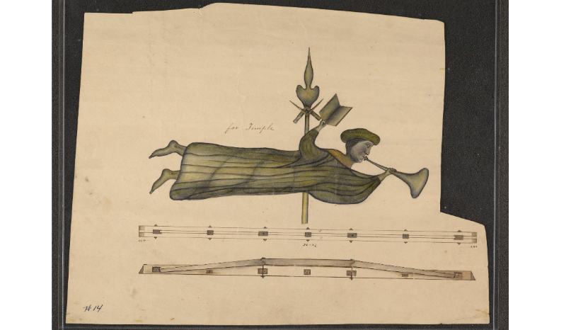
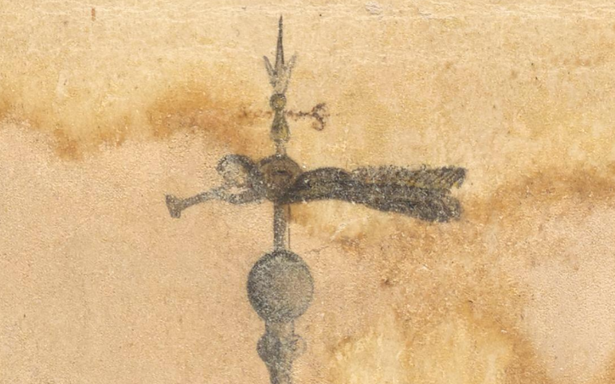
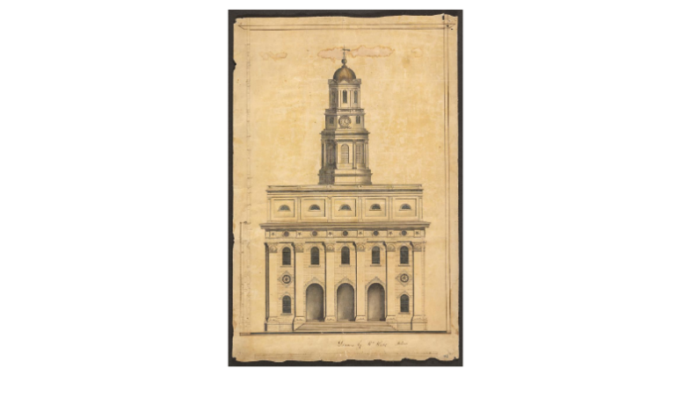
William Weeks Original Drawings of the Temple and the Angel Weather Vane:
https://catalog.churchofjesuschrist.org/record/b2de54fa-3c2a-4f3f-bc4b-0ba12fdaa480/0?view=browse

“The original Nauvoo Temple was an inspired masterpiece of architecture and craftsmanship. The Prophet Joseph Smith directed the work, but architect William Weeks translated those directions into workable plans. These architectural drawings demonstrate William’s skill and attention to detail, which later helped modern builders reconstruct the Nauvoo Temple.
When the Prophet announced plans to build a temple, William and other architects submitted designs. William’s nephew, F. M. Weeks, recalled William telling him that “when [William] went in and showed his plans, Joseph Smith grabbed him, hugged him and said ‘you are the man I want.’”
Joseph Smith received many instructions about the temple by revelation, and he was considered the chief architect for the temple. Weeks then drew up the detailed plans and supervised construction. However, the two did not always agree on the building details. When Joseph instructed William that the office windows on the middle floors should be round, William objected, saying that the building was too short for that style of window. Joseph replied, “I wish you to carry out my designs. I have seen in vision the splendid appearance of that building illuminated, and will have it built according to the pattern shown me.” William complied, and the temple was built with round windows.” (Nauvoo Temple Architect – William Weeks). History of his appointment as Architect: https://history.churchofjesuschrist.org/content/museum/william-weeks-architect-of-the-nauvoo-temple?lang=eng)
William initially told Joseph that circular windows were a structural issue and that he would need to redesign the structure of the building to accommodate it. I share the above to illustrate the exactness that Joseph required of William Weeks when designing the Temple he saw in vision (D&C 124:42) – Right down to the shapes of the windows with no regard to labour or cost. Noting this incredible attention to detail to the windows, font, sun stones and various other symbolic aspects of the building, we can be certain that the Angelic weathervane was divinely inspired.
“The Lighthouse of Alexandria also had figures of heavenly angels, four of them on the side facades, and Triton the “trumpeter of the sea” atop the dome. The angel atop the Nauvoo temple was originally a weathervane, and the first important weather vane in history was Triton atop the Tower of Winds. The similarity is unmistakable.
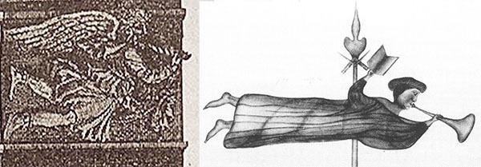
Triton’s metal rod attracted lightning bolts resulting in fantastic supernatural displays. But his real function was to indicate the prevailing wind. A building with a weather vane was the first thing to be placed in the middle of a city, said Vitruvius, and based on the wind patterns the city streets would be laid out.[18] The city would thus be situated according to the four “quarters from which winds blow.”
The bell tower of Nauvoo thus assumed several functions: Ring forth the sun/ resurrection, indicate the four winds or four quarters, and tell the time. As the “heavenly messenger” and “trumpeter of the sea”, Triton’s similarity to the Nauvoo angel can be explained with a verse from the Pearl of Great Price:
“And righteousness will I send down out of heaven; and truth will I send forth out of the earth, to bear testimony of mine Only Begotten; his resurrection from the dead; yea, and also the resurrection of all men; and righteousness and truth will I cause to sweep the earth as with a flood, to gather out mine elect from the four quarters of the earth, unto a place which I shall prepare, an Holy City, that my people may gird up their loins, and be looking forth for the time of my coming; for there shall be my tabernacle, and it shall be called Zion, a New Jerusalem.” (Moses 7:62) Architecture of the Nauvoo Temple - Benjamin Blankenbehler
Noting the Symbolic correlation between this Angel and the above scripture, lets break down the scriptural interpretation further. Righteousness being sent down out of Heaven – Is the Angelic weathervane on the Nauvoo Temple a sign that Angels are coming to help us on Earth to prepare for the Second Coming of the Saviour by building Zion, the New Jerusalem? Who is specifically represented by the Angel?
Extract from ‘The II LDS Archives’ Paper ‘The New Jerusalem’:
After reading Moses 7:62 Joseph Smith explained, “Now I understand by this quotation, that God clearly manifested to Enoch the redemption which He prepared, by offering the Messiah as a Lamb slain from before the foundation of the world; and by virtue of the same, the glorious resurrection of the Saviour, and the resurrection of all the human family, even a resurrection of their corporeal bodies, is brought to pass; and also righteousness and truth are to sweep the earth as with a flood. And now, I ask, how righteousness and truth are going to sweep the earth as with a flood? I will answer. Men and angels are to be co-workers in bringing to pass this great work, and Zion is to be prepared, even a new Jerusalem, for the elect that are to be gathered from the four quarters of the earth, and to be established an holy city, for the tabernacle of the Lord shall be with them.” (Teachings of the Prophet Joseph Smith, p. 84)

“And now I am prepared to say by the authority of Jesus Christ, that not many years shall pass away before the United States shall present such a scene of bloodshed as has not a parallel in the history of our nation; pestilence, hail, famine, and earthquake will sweep the wicked of this generation from off the face of the land, to open and prepare the way for the return of the lost tribes of Israel from the north country. The people of the Lord, those who have complied with the requirements of the new covenant, have already commenced gathering together to Zion, which is in the state of Missouri” (Teachings of the Prophet Joseph Smith, p.17)

Once again, the macro timeline stands. Sickness comes because it paves the way for the scourge. Days of tribulation kickstart - two years in the 10 tribes return for the north country, once celestial law has been restored (the new covenant) and they are living it, they can redeem Jackson County and build New Jerusalem. Angels will assist in the building of New Jerusalem. John Taylor described this building in a vision he had [that was] subsequently recorded: “Immediately after I seemed to be standing on the left bank of the Missouri River, opposite the City of Independence, but there was no city. I saw the whole state of Missouri and Illinois and all of Iowa, a complete desert with no living being there. A short distance from the river however, I saw twelve men dressed in temple robes, standing in a square or nearly so (and I understood it represented the Twelve Gates of the New Jerusalem.) Their hands were uplifted in consecration of the ground and laying the corner stone of the temple. I saw myraids of angels hovering over them, and saw also an immense pillar of clouds over them and heard the angels singing the most heavenly music. The words were “Now is established the Kingdom of God and his Christ, which shall never more be thrown down. I saw people coming from the river and from the desert places a long way off to help build the temple and it seemed that hosts of angels all helped to get material to build with and I saw some of them who wore temple clothes come and build the temple and the city, and all the time I saw the great pillar of clouds hovering over the place.” (Wilford Woodruff’s Journal, June 15, 1878, “A Vision, Salt Lake City, Night of Dec 16, 1877”)

Turning to Moses 7: 62 And righteousness will I send down out of heaven; and truth will I send forth out of the earth, to bear testimony of mine Only Begotten; his resurrection from the dead; yea, and also the resurrection of all men; … Doing a point of reference, many members will say the righteousness out of heaven is the restoration of keys, powers, priesthood to the earth and the coming forth of the Book of Mormon is the truth sent forth out of the earth. I have a different interpretation that I believe is correct and will become more apparent as we go through the rest of these verses. I believe that this is Joseph Smith coming down from heaven after his resurrection and the truth that is being called forth from out of the earth is the 10 tribes. Notice right up front that this interpretation makes more sense - we know that from the history of the church that the Book of Mormon came forth BEFORE any of the keys, priesthood etc so right off the bat you have a chronology problem with the first interpretation. Secondly, once again, the Lord is making reference to this event testifying of “the resurrection of all men”. Why would that be included here? (Watch/read my video/paper Joseph Smith to Return for my complete breakdown of this, the Lord says in D&C that the resurrection, or more specifically the resurrection of a single man, is the sign that we should look for), But continuing with the verse, “…and righteousness and truth will I cause to sweep the earth as with a flood, to gather out mine elect from the four quarters of the earth, …” Members put this point of reference as the missionary force sweeping the earth. I, however, put this as the 144,000 going forth and sweeping the earth. Let us continue reading, “….unto a place which I shall prepare, an Holy City, that my people may gird up their loins, and be looking forth for the time of my coming; for there shall be my tabernacle, and it shall be called Zion, a New Jerusalem.”
We now have a reference point for this Nauvoo weathervane Angel. It represents the resurrected Prophet Joseh Smith coming down from heaven after his resurrection – a sign to look for in the latter days in preparation for the building up and gathering unto Zion and ushering in the return of the Saviour.

The Salt Lake Temple Angel, by Cyrus Dallin
The Salt Lake Temple, dedicated in 1893, was the first temple topped with an angel that was formally identified as Moroni. When President Wilford Woodruff asked non-LDS artist Cyrus Dallin to create a statue, Dallin declined, saying he “didn’t believe in angels.” Knowing that Dallin’s parents had once been active Latter-day Saints, President Woodruff encouraged him to consult with his mother.
Cyrus Dallin was born in Springville, Utah, on 22 November 1861. His ancestors converted to the Church in England and immigrated to Utah in 1851. Once there, however, Dallin’s parents joined the Presbyterian Church. As a child he loved sketching and modelling with clay. Eventually he studied art in Boston.
“I consider that my ‘Angel Moroni’ brought me nearer to God than anything I ever did. It seemed to me that I came to know what it means to commune with angels from heaven.”
I Saw Another Angel Fly – Ensign Jan 2000. J. Michael Hunter

J. Michael Hunter was a reference librarian for the Church Historical Department Library. He rightly points out that the Angel atop the Salt Lake Temple that has colloquially become known as the ‘Angel Moroni’ was conceptualised by a non-LDS artist. I have not been able to find any record of Wilford Woodruff providing instruction to him on the name or appearance of the statute other than the fact that it must depict an Angel. Cyrus Dallin named the statue ‘The Angel Moroni’ which has remained the name used by the Church until the present day.

This is fascinating to me. With the knowledge that a non-member Artist conceptualised and named the Statue, should we simply take the symbolism of it at face value without any deeper investigation? Is it really only symbolising the role of the resurrected Moroni in our day?

Leonardo Da Vinci was a famous Artist that painted the ‘Mona Lisa’. He called the woman in his painting Mona Lisa, however over several decades there has been extensive research into the actual woman depicted in the painting. The subject of the painting is generally thought to be Lisa Gherardi, who was the wife of Francesco del Giocondo. This is not revealed in the naming of the artwork alone, but through careful review of the symbolism (a specific woman in this case) used by the artist. We see similar cases of artwork being assigned a name for reference, however on the name alone one cannot understand the pieces full artistic/symbolic meaning. Consider the additional examples of ‘The Creation of Adam by Michelangelo’, ‘The Last Supper by Leonardo da Vinci’ and ‘The Thinker by Auguste Rodin’. To appreciate and understand the symbolic meaning of each piece will take more research and understanding that at their name value alone.

Let’s stop here for a moment before we continue and once again reflect on the importance and depth of meaning in Temple Symbolism:
“Symbols are powerful teaching tools. Like the Master’s parables, they allow individuals to learn on their own level—superficially or profoundly—according to their degree of preparation and sensitivity. This is particularly true of teachings Latter-day Saints receive in the temple.
Have modern Prophets provided additional keys to understand the symbolic meaning of the ‘Angel Moroni’ statue? YES!
President Hinckley said that the ‘Angel Moroni’ statue was to represent the angel in revelations 14:6-7:
“The occasion is the placing of the capstone of the temple, the great round granite sphere which crowns the highest steeple on the east end. It is a day of celebration. Atop the ball is a bronze figure gilded with gold. The figure represents Moroni—prophet, writer, and compiler of the Book of Mormon. The figure represents the angel spoken of by John the Revelator when he declared with prophetic vision:
6 And I saw another angel fly in the midst of heaven, having the everlasting gospel to preach unto them that dwell on the earth, and to every nation, and kindred, and tongue, and people,
7 Saying with a loud voice, Fear God, and give glory to him; for the hour of his judgment is come: and worship him that made heaven, and earth, and the sea, and the fountains of waters.” (This Peaceful House of God – April 1993)
Joseph Smith to work with Moroni and hold responsibility over restoring the Gospel to all the world:
There was no prophet in all Christendom at the time the new revelation was to be given. So God raised up a new prophet to receive that revelation, to publish the Book of Mormon, and to direct the preaching of the true gospel in every nation.
And who was that prophet? Joseph Smith, Jr. He was the divinely called seer of latter days. He was the modern revelator. He was the translator and publisher of the Book of Mormon under the direction of Almighty God.
Not only was he a divinely chosen prophet himself, but under his hands other prophets were raised up to carry on the work after him.
We are those other prophets! We hold the divine authority of Jesus Christ! We speak in his name and declare his word! And our testimony is true! “Evidence of Things Not Seen” – Mark E. Peterson
President Faust connected the work that this Angel would undertake to the Prophet Joseph Smith:
“The Apostle John saw in vision the time when “another angel [would] fly in the midst of heaven, having the everlasting gospel to preach unto them that dwell on the earth, and to every nation, and kindred, and tongue, and people.” This prophecy has been fulfilled. Because we believe the fulness of the gospel of Jesus Christ has been restored in our time by the Prophet Joseph Smith, we wish to give all people an opportunity to know and accept this message.” The Restoration of All Things - James E. Faust
This quote may cause one confusion so let’s review it further. It states that the prophecy in Revelations 14:6-7 relates to Joseph Smith (another solid confirmation of who the ‘Angel Moroni’ represents!) and has been fulfilled as the fullness of the Gospel has been restored. Whilst it is true that the Gospel has been restored, it is also true that we are witnessing an ‘ongoing restoration’ to use President Nelson’s words and that the latter part of that prophecy remains to be completed in futurity. We have not yet preached the gospel to every nation, kindred, tongue and people.
We have established that the symbolism of the ‘Angel Moroni’ statue relates to the Angel that John the Revelator saw in vision.
Joseph Smith expounded on this vision seen by John and explained how and when it would be fulfilled:
“I was once praying earnestly upon this subject, and a voice said unto me, “My son, if thou livest until thou art eighty-five years of age, thou shalt see the face of the Son of Man.” I was left to draw my own conclusions concerning this; and I took the liberty to conclude that if I did live to that time, He would make His appearance. But I do not say whether He will make His appearance or I shall go where He is. I prophesy in the name of the Lord God, and let it be written—the Son of Man will not come in the clouds of heaven till I am eighty-five years old. Then read the 14th chapter of Revelation, 6th and 7th verses—“And I saw another angel fly in the midst of heaven, having the everlasting gospel to preach unto them that dwell on the earth, and to every nation, and kindred, and tongue, and people, saying with a loud voice, Fear God and give glory to Him, for the hour of His judgment is come.” And Hosea, 6th chapter, After two days, etc.,—2,520 years; which brings it to 1890. The coming of the Son of Man never will be—never can be till the judgments spoken of for this hour are poured out: which judgments are commenced. Paul says, “Ye are the children of the light, and not of the darkness, that that day should overtake you as a thief in the night.” It is not the design of the Almighty to come upon the earth and crush it and grind it to powder, but he will reveal it to His servants the prophets.
Judah must return, Jerusalem must be rebuilt, and the temple, and water come out from under the temple, and the waters of the Dead Sea be healed. It will take some time to rebuild the walls of the city and the temple, &c.; and all this must be done before the Son of Man will make His appearance. There will be wars and rumors of wars, signs in the heavens above and on the earth beneath, the sun turned into darkness and the moon to blood, earthquakes in divers places, the seas heaving beyond their bounds; then will appear one grand sign of the Son of Man in heaven. But what will the world do? They will say it is a planet, a comet, etc. But the Son of Man will come as the sign of the coming of the Son of Man, which will be as the light of the morning cometh out of the east. (April 6, 1843.) DHC 5:336-337 THE PROPHET ON THE SECOND COMING OF CHRIST - TPJS 286 - Remarks at the Conference of the Church
What was the question that drew out the answer here? What was Joseph praying earnestly on to understand? It was regarding the timing of the second coming. Here Joseph is explaining that he understands the Second coming will not occur for at least several more decades and that several more prophecies must be fulfilled prior to the Saviours return. As this sermon was delivered at a General Conference of the Church it means the visitation of the Angel Moroni to Joseph preceded this Conference by several years, therefore Joseph read Revelations 14:6-7 as events that lie in futurity. This means that the symbolic role of the Angel seen by John in Heaven was not completed by Moroni alone. This also means that Joseph understood the fulfilment of that prophecy related to work he would personally undertake and be responsible for as the Prophet of the Restoration and head of the last dispensation of the fullness of times.
Are there any other indications given that Revelations 14:6-7 fulfilment may lie in futurity? Yes!!
“Has the Gospel of the kingdom commenced in the last days? And will God take it from the man until He takes him Himself?
I have read it precisely as the words flowed from the lips of Jesus Christ. John the Revelator saw an angel flying through the midst of heaven, having the everlasting Gospel to preach unto them that dwell on the earth. The scripture is ready to be fulfilled when great wars, famines, pestilence, great distress, judgments, &c., are ready to be poured out on the inhabitants of the earth.
John saw the angel having the holy Priesthood, who should preach the everlasting Gospel to all nations. God had an angel—a special messenger—ordained and prepared for that purpose in the last days. Woe, woe be to that man or set of men who lift up their hands against God and His witness (Joseph Smith is speaking of himself here) in these last days: for they shall deceive almost the very chosen ones! Joseph Smith - TPJS 365
I have identified at least two sermons from Joseph where he states that Revelations 14:6-7 were to be fulfilled in futurity amongst the calamities of the last days and that Joseph Smith’s mission is a critical part of the symbolism of the ‘Angel Moroni’ statue. Here is a more modern confirmation from the Prophet Gordon B. Hinkley that this prophecy was yet to be fulfilled:
The proceedings of this conference will be carried across the world, and the speakers will be heard and seen by Latter-day Saints on every continent. We have come a very long way in realizing the fulfillment of the vision set forth in the book of Revelation: “And I saw another angel fly in the midst of heaven, having the everlasting gospel to preach unto them that dwell on the earth, and to every nation, and kindred, and tongue, and people” (Rev. 14:6). Gordon B Hinckley - “O That I Were an Angel, and Could Have the Wish of Mine Heart”
Well if that is the case, it would mean that the prophecy was not fulfilled by the Angel Moroni (at least not in its fullness) because Moroni had already come and his mission was accomplished. It has now been 200 years since Moroni visited and we are told that we are now seeing the fulfilment of the last days prophecies, which would include the work which John saw an "...angel flying through the midst of heaven, having the everlasting Gospel to preach unto them that dwell on the earth."
Therefore, if the Angel Moroni is what we call the figure on our Temples and it was based on the scripture in Revelations 14:6-7 (according to President Hinckley) that will see its fulfillment by the Prophet Joseph as the head of the last dispensation upon his return to the Earth as a resurrected being (Angel).

Section 3: Micah

The Angel Moroni Dropped His Trumpet – 2020
On the 18th March, 2020 the Salt Lake area experienced an Earth Quake and the Angel Moroni sitting atop the Temple dropped his trumpet.
“In the latest stage of the renovation of the Salt Lake Temple, the angel Moroni* statue and circular capstone beneath its feet were removed from the temple’s central east spire. These historic items were carried Monday morning through the air to the ground via crane for preservation and refurbishing. This will prepare both items for a later reinstallation.
“The Salt Lake Temple is the house of the Lord, and it is being shored up and strengthened to be able to stand for generations to come,” said Andy Kirby, director of historic temple renovations. “Each aspect of this project plays an important role in helping this sacred structure to remain a symbol of permanence, optimism, and faith for people around the world.”
The removal of the statue and capstone had long been planned as part of the temple’s years-long structural and seismic renovation. The timeline for this portion of the project was sped up following a 5.7 magnitude earthquake in March 2020 that shook the trumpet out of Moroni’s right hand and caused other minor damage.“ (18 May 2020 - Salt Lake City News Release.)
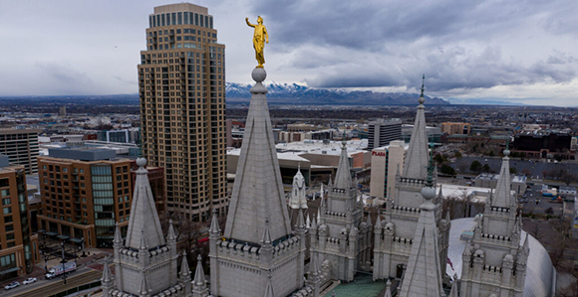
The angel Moroni statue atop the Salt Lake Temple of The Church of Jesus Christ of Latter-day Saints stands with its trumpet missing after a 5.7 magnitude earthquake centered in Magna hit on Wednesday, March 18, 2020. Photo by Spenser Heaps, Deseret News.

- This caused reflection on the Temple foundations which were inadequate to sustain the structure through to the Millennium.
- We know this is full of symbolic meaning, hence the Prophet has been referring to this strengthening of foundations heavily since this occurred. This strengthening is symbolic of our need to sort out our spiritual foundations because they may not be sound enough right now to see us through to the millennium.

Summary / Conclusion – How do these symbols and events determine he has returned?
- So… what was the significance of Moroni dropping his Trumpet?
- What would fulfilment of the purpose of the Angel Joseph look like? His return. Share examples of times where a person like the Saviour has been symbolised, returned and then the symbol has been fulfilled. Law of Moses etc. The saviour rending the veil of his Temple?
- If we know Joseph Smith needs to return and complete his mission as represented by the symbolic meaning of the ‘Angel Moroni’ statue, then what can the removal of this Temple figure represent? The fulfilment of Joseph Smith returning as a resurrected being to finish his work appears to be symbolised by the removal of the Angel figure from the Temple.
- Tie this into The Church of Jesus Christ of Latter-day Saints changed its symbol from the angel to Jesus Christ walking through the arch.

What was Josephs Mission to Accomplish upon his return?
- Keys of the Resurrection
“If we ask who will stand at the head of the resurrection in this last dispensation, the answer is: Joseph Smith, Junior, the Prophet of God. He is the man who will be resurrected and receive the keys of the resurrection, and he will seal this authority upon others, and they will hunt up their friends and resurrect them when they shall have been officiated for, and bring them up.
(Brigham Young, August 24, 1872, Journal of Discourses 15:138-139)
Heber C. Kimball:
“Do you suppose that if Brother Brigham were to die tomorrow, and if Joseph is resurrected, which he will be so soon as his mission is filled in the spirit world, that Joseph will permit Brother Brigham’s body to remain any longer in the grave than may be requisite? No, for he then will have need of the assistance of his faithful resurrected brethren, as he now has of faithful spirits.” (Heber C. Kimball, March 15, 1857, Journal of Discourses 4:294-295; emphasis added)
“I am pretty sure of one thing: we shall go to Jackson County, Missouri; that is, those who do right and honor their callings, doing what they have been told to do. You will be blessed, and you will see the day when Presidents [Brigham] Young, [Heber C.] Kimball, and [Daniel H.] Wells, and the Twelve Apostles will be in Jackson County, Missouri, laying out your inheritances. In the flesh? Of course. We should look well without being in the flesh! We shall be there in the flesh, and all our enemies cannot prevent it.
“Brother Wells, you may write that. You will be there, and Willard [Richards] will be there, and also Jedediah [M. Grant], and Joseph and Hyrum Smith, and David [W. Patten], and Parley [P. Pratt]; and the day will be when I will see those men in the general assembly of the Church of the First Born, in the great council of God in Jerusalem, too. Will we want you to be along? I heard Joseph say twice that Brother Brigham and I should be in that council in Jerusalem, when there should be a uniting of the two divisions of God’s government.” (Heber C. Kimball, April 7, 1861, Journal of Discourses 9:27)
Heber C. Kimball told the Saints in Nauvoo that “Joseph will be the first man who will rise from the dead, and then all men according to their proper order.” (History of the Church 7:340)
“Will the Saints arise from the dead? Yes. Who will know it? But a few. When the resurrection commences, I say but few will know it; and allow me to inform you, when you have seen Joseph, and Hyrum, and Father Smith, and many others, risen from the dead, and you elders go abroad preaching, you will not tell the world of their resurrection, for they will not believe it.
“You may testify that Father Smith has arisen, that Joseph and Hyrum again possess their bodies; that they again live in the flesh, and they will laugh you to scorn, and persecute you to the death, if they have the power, for your testimony’s sake.
“Will the Saints rise from the dead before the world is converted? Yes. You may despair of ever seeing all creation converted to the Lord Jesus, or to the faith of the holy gospel. Will you see the resurrection? Yes, you will be in it, and enjoy it; you will be in the first resurrection. Will the world believe it, and know of it? They will not.” (Brigham Young, October 3, 1852, Millennial Star 16:594 and Deseret News, May 11, 1854)
D&C 63:47-49, 52-54
47 He that is faithful and endureth shall overcome the world.
48 He that sendeth up treasures unto the land of Zion shall receive an inheritance in this world, and his works shall follow him, and also a reward in the world to come.
49 Yea, and blessed are the dead that die in the Lord, from henceforth, when the Lord shall come, and old things shall pass away, and all things become new, they shall rise from the dead and shall not die after, and shall receive an inheritance before the Lord, in the holy city.
52 Wherefore, for this cause preached the apostles unto the world the resurrection of the dead.
53 These things are the things that ye must look for; and, speaking after the manner of the Lord, they are now nigh at hand, and in a time to come, even in the day of the coming of the Son of Man.
54 And until that hour there will be foolish virgins among the wise; and at that hour cometh an entire separation of the righteous and the wicked; and in that day will I send mine angels to pluck out the wicked and cast them into unquenchable fire.
So when the Lord is referring to healing a dead man he is referring to the resurrection. But not only that, we gain another bit of crucial information regarding this event (Joseph Smith’s resurrection) in regard to last day timelines and prophecies. And that is found in verse 52 and 53. The Lord says here that this is the reason why the apostles preached the resurrection of the dead, for the resurrection of the dead (or more specifically the resurrection of a specific person) is “the thing that ye must look for” in the last days and this is obviously not talking about Jesus because he has been resurrected for almost 2000 years.

- Redemption of Zion
D&C 101
55 And the lord of the vineyard said unto one of his servants: Go and gather together the residue of my servants, and take all the strength of mine house, which are my warriors, my young men, and they that are of middle age also among all my servants, who are the strength of mine house, save those only whom I have appointed to tarry;
56 And go ye straightway unto the land of my vineyard, and redeem my vineyard; for it is mine; I have bought it with money.
57 Therefore, get ye straightway unto my land; break down the walls of mine enemies; throw down their tower, and scatter their watchmen.
58 And inasmuch as they gather together against you, avenge me of mine enemies, that by and by I may come with the residue of mine house and possess the land.
D&C 103
15 Behold, I say unto you, the redemption of Zion must needs come by power;
16 Therefore, I will raise up unto my people a man, who shall lead them like as Moses led the children of Israel.
17 For ye are the children of Israel, and of the seed of Abraham, and ye must needs be led out of bondage by power, and with a stretched-out arm.
18 And as your fathers were led at the first, even so shall the redemption of Zion be.
19 Therefore, let not your hearts faint, for I say not unto you as I said unto your fathers: Mine angel shall go up before you, but not my presence.
20 But I say unto you: Mine angels shall go up before you, and also my presence, and in time ye shall possess the goodly land.
21 Verily, verily I say unto you, that my servant Joseph Smith, Jun., is the man to whom I likened the servant to whom the Lord of the vineyard spake in the parable which I have given unto you.
22 Therefore let my servant Joseph Smith, Jun., say unto the strength of my house, my young men and the middle aged—Gather yourselves together unto the land of Zion, upon the land which I have bought with money that has been consecrated unto me.
23 And let all the churches send up wise men with their moneys, and purchase lands even as I have commanded them.
24 And inasmuch as mine enemies come against you to drive you from my goodly land, which I have consecrated to be the land of Zion, even from your own lands after these testimonies, which ye have brought before me against them, ye shall curse them;
25 And whomsoever ye curse, I will curse, and ye shall avenge me of mine enemies.
26 And my presence shall be with you even in avenging me of mine enemies, unto the third and fourth generation of them that hate me.
Blessing given by Joseph Smith Sr. (January 23, 1833)
…The presidency then took the seat in their turn, according to their age, beginning at the eldest, and received their anointing and blessing under the hand, of father Smith; and in my turn my father anointed my head, and sealed upon me the blessings of Moses, to lead Israel in the latter Days, even as Moses led him in days of old; also the blessings of Abraham, Isaac and Jacob. All of the Presidency laid th[e]ir hands upon me, and pronounced upon my head many prophecies, and blessings, many of which I shall not notice at this time.

- Protect and preserve God’s people from the famine
Ether 13:6-8
6 …New Jerusalem should be built up upon this land, unto the remnant of the seed of Joseph, for which things there has been a type.
7 For as Joseph brought his father down into the land of Egypt, even so he died there; wherefore, the Lord brought a remnant of the seed of Joseph out of the land of Jerusalem, that he might be merciful unto the seed of Joseph that they should perish not, even as he was merciful unto the father of Joseph that he should perish not.
8 Wherefore, the remnant of the house of Joseph shall be built upon this land; and it shall be a land of their inheritance; and they shall build up a holy city unto the Lord, like unto the Jerusalem of old; and they shall no more be confounded, until the end come when the earth shall pass away. let’s expound on this even more.
Joseph in Egypt (Genesis 37-50) | Joseph Smith Jr.
Joseph’s brothers were jealous of him and cast him into a pit. Later they told their father that Joseph had been slayed by wild beasts. | “In the evening I attended meeting in the Seventies’ Hall. George J. Adams preached and I made some observations afterwards, and related a dream which I had a short time since. I thought I was riding out in my carriage, and my guardian angel was along with me. We went past the Temple and had not gone much further before we espied two large snakes so fast locked together that neither of them had any power. I inquired of my guide what I was to understand by that. He answered, “Those snakes represent Dr. Foster and Chauncey L. Higbee. They are your enemies and desire to destroy you; but you see they are so fast locked together that they have no power of themselves to hurt you.” I then thought I was riding up Mulholland street, but my guardian angel was not along with me. On arriving at the prairie, I was overtaken and seized by William and Wilson Law and others, saying, “Ah, ah! We have got you at last! We will secure you and put you in a safe place!” and, without any ceremony dragged me out of my carriage, tied my hands behind me, and threw me into a deep, dry pit, where I remained in a perfectly helpless condition, and they went away. While struggling to get out, I heard Wilson Law screaming for help hard by. I managed to unloose myself so as to make a spring, when I caught hold of some grass which grew at the edge of the pit.  I looked out of the pit and saw Wilson Law at a little distance attacked by ferocious wild beasts, and heard him cry out, “Oh Brother Joseph, come and save me!” I replied, “I cannot, for you have put me into this deep pit.” On looking out another way, I saw William Law with outstretched tongue, blue in the face, and the green poison forced out of his mouth, caused by the coiling of a large snake around his body. It had also grabbed him by the arm, a little above the elbow, ready to devour him. He cried out in the intensity of his agony, “Oh, Brother Joseph, Brother Joseph, come and save me, or I die!” I also replied to him, “I cannot, William; I would willingly, but you have tied me and put me in this pit, and I am powerless to help you or liberate myself.” In a short time after my guide came and said aloud, “Joseph, Joseph, what are you doing there?” I replied, “My enemies fell upon me, bound me and threw me in.” He then took me by the hand, and drew me out of the pit, set me free, and we went away rejoicing. (June 13, 1844—DHC 6:461-462)
Joseph is sold into Egypt as a slave and ends up in prison. While in prison he is given the keys of the prison and maintained a role managing the prison. | “If my life is of no value to my friends, it is of no value to me. Hyrum, we are going back.” (See Essentials in Church History, p. 374.)  “I am going like a lamb to the slaughter, but I am as calm as a summer’s morning I have a conscience void of offense toward God and toward all men.” (Essentials in Church History, p. 376.)  D&C 135  1 To seal the testimony of this book and the Book of Mormon, we announce the martyrdom of Joseph Smith the Prophet, and Hyrum Smith the Patriarch. They were shot in Carthage jail, on the 27th of June, 1844, about five o’clock p.m., by an armed mob—painted black—of from 150 to 200 persons. Hyrum was shot first and fell calmly, exclaiming: I am a dead man! Joseph leaped from the window, and was shot dead in the attempt, exclaiming: O Lord my God! They were both shot after they were dead, in a brutal manner, and both received four balls.  2 John Taylor and Willard Richards, two of the Twelve, were the only persons in the room at the time; the former was wounded in a savage manner with four balls, but has since recovered; the latter, through the providence of God, escaped, without even a hole in his robe.  3 Joseph Smith, the Prophet and Seer of the Lord, has done more, save Jesus only, for the salvation of men in this world, than any other man that ever lived in it. In the short space of twenty years, he has brought forth the Book of Mormon, which he translated by the gift and power of God, and has been the means of publishing it on two continents; has sent the fulness of the everlasting gospel, which it contained, to the four quarters of the earth; has brought forth the revelations and commandments which compose this book of Doctrine and Covenants, and many other wise documents and instructions for the benefit of the children of men; gathered many thousands of the Latter-day Saints, founded a great city, and left a fame and name that cannot be slain. He lived great, and he died great in the eyes of God and his people; and like most of the Lord’s anointed in ancient times, has sealed his mission and his works with his own blood; and so has his brother Hyrum. In life they were not divided, and in death they were not separated!  Brigham Young:  “He holds the keys of that kingdom for the last dispensation---the keys to rule in the spirit world; and he rules there triumphantly, for he gained full power and a glorious victory over the power of Satan while he was yet in the flesh, and was a martyr to his religion and to the name of Christ, which gives him a most perfect victory in the spirit world. He reigns there as supreme a being in his sphere, capacity, and calling, as God does in heaven.” (Journal of Discourses 7:289, October 9, 1859)
Pharaoh, the sun god, raises Joseph from prison and makes him his governor. | 3 Nephi 21:10  10 But behold, the life of my servant shall be in my hand; therefore they shall not hurt him, although he shall be marred because of them. Yet I will heal him, for I will show unto them that my wisdom is greater than the cunning of the devil.  The Lord promises that though Joseph Smith is martyred “yet I will resurrect him”.
Joseph in Egypt prepares the people and saves them from the seven-year famine. | “For, like Joseph of old shall he be: he shall save the just from desolation, by the wise counsel of the Almighty; for by his direction shall they gather into storehouses and barns, till they overflow with the richness of the fruit of harvest: and by this means shall the just be saved from famine, while the nations of the wicked are distressed and faint.” (Patriarchal blessing given in the evening of September 22, 1835, and recorded October 3, 1835. Oliver Cowdery)  “Before that day comes, however, the Saints will be put to a test that will try the integrity of the best of them. The pressure will become so great that the more righteous among them will cry unto the Lord day and night until deliverance comes. Then the Prophet Joseph and others will make their appearance and those who have remained faithful will be selected to return to Jackson County, Missouri and take part in the building of that beautiful city, the New Jerusalem.” (Heber C. Kimball, First Counselor in the First Presidency, May 1868, in Deseret News, 23 May 1931; see also Conference Report, Oct. 1930, p. 58-59)
Two+ years into the famine Joseph’s brothers join Joseph in the foreign land under the direction of Joseph. Eventually even Joseph’s father joins him in the foreign land once everything is prepared. | “Pestilence, hail, famine, and earthquake will sweep the wicked of this generation from off the face of the land, to open and prepare the way for the return of the lost tribes of Israel from the north country.” (TPJS, p.17)  “In due time shall he go forth toward the north, and by the power of his word shall the deep begin to give way and the ice melt before the sun. By the keys of the Kingdom shall he lead Israel into the land of Zion while the house of Jacob shouts in the danse and in the song—Joy, O my soul, in that day, for thou shalt be with him and bear thy part in the keys which are confirmed thee for an everlasting priesthood, forever and ever—Joy, O my heart, in that day, with thanksgiving and with praise, for thou shalt stand with him before the hosts of Israel—the lame shall leap as a hart, the old shall renew his strength, and the virgin of Israel, with the youth, shall exalt the name of our God upon harps and instruments of tens[e] strings” (Patriarchal blessing given in the evening of September 22, 1835, and recorded October 3, 1835. Oliver Cowdery)  D&C 133:26-34  26 And they who are in the north countries shall come in remembrance before the Lord; and their prophets shall hear his voice, and shall no longer stay themselves; and they shall smite the rocks, and the ice shall flow down at their presence.  27 And an highway shall be cast up in the midst of the great deep.  28 Their enemies shall become a prey unto them,  29 And in the barren deserts there shall come forth pools of living water; and the parched ground shall no longer be a thirsty land.  30 And they shall bring forth their rich treasures unto the children of Ephraim, my servants.  31 And the boundaries of the everlasting hills shall tremble at their presence.  32 And there shall they fall down and be crowned with glory, even in Zion, by the hands of the servants of the Lord, even the children of Ephraim.  33 And they shall be filled with songs of everlasting joy.  34 Behold, this is the blessing of the everlasting God upon the tribes of Israel, and the richer blessing upon the head of Ephraim and his fellows.  3 Nephi 21:23-29, 2 Nephi 22:1  23 And they shall assist my people, the remnant of Jacob, and also as many of the house of Israel as shall come, that they may build a city, which shall be called the New Jerusalem.  24 And then shall they assist my people that they may be gathered in, who are scattered upon all the face of the land, in unto the New Jerusalem.  25 And then shall the power of heaven come down among them; and I also will be in the midst.  26 And then shall the work of the Father commence at that day, even when this gospel shall be preached among the remnant of this people. Verily I say unto you, at that day shall the work of the Father commence among all the dispersed of my people, yea, even the tribes which have been lost, which the Father hath led away out of Jerusalem.  27 Yea, the work shall commence among all the dispersed of my people, with the Father to prepare the way whereby they may come unto me, that they may call on the Father in my name.  28 Yea, and then shall the work commence, with the Father among all nations in preparing the way whereby his people may be gathered home to the land of their inheritance.  29 And they shall go out from all nations; and they shall not go out in haste, nor go by flight, for I will go before them, saith the Father, and I will be their rearward.  1 And then shall that which is written come to pass: Sing, O barren, thou that didst not bear; break forth into singing, and cry aloud, thou that didst not travail with child; for more are the children of the desolate than the children of the married wife, saith the Lord.  Moses 7:61-62  61 …but my people will I preserve;  62 And righteousness will I send down out of heaven; and truth will I send forth out of the earth, to bear testimony of mine Only Begotten; his resurrection from the dead; yea, and also the resurrection of all men; and righteousness and truth will I cause to sweep the earth as with a flood, to gather out mine elect from the four quarters of the earth, unto a place which I shall prepare, an Holy City, that my people may gird up their loins, and be looking forth for the time of my coming; for there shall be my tabernacle, and it shall be called Zion, a New Jerusalem.

Blessing given by Oliver Cowdery (September 22, 1835)
For, like Joseph of old shall he be: he shall save the just from desolation, by the wise counsel of the Almighty; for by his direction shall they gather into storehouses and barns, till they overflow with the richness of the fruit of harvest: and by this means shall the just be saved from famine, while the nations of the wicked are distressed and faint.

- Translate the sealed portion
2 Nephi 27
5 For behold, the Lord hath poured out upon you the spirit of deep sleep. For behold, ye have closed your eyes, and ye have rejected the prophets; and your rulers, and the seers hath he covered because of your iniquity.
6 And it shall come to pass that the Lord God shall bring forth unto you the words of a book, and they shall be the words of them which have slumbered.
7 And behold the book shall be sealed; and in the book shall be a revelation from God, from the beginning of the world to the ending thereof.
8 Wherefore, because of the things which are sealed up, the things which are sealed shall not be delivered in the day of the wickedness and abominations of the people. Wherefore the book shall be kept from them.
9 But the book shall be delivered unto a man, and he shall deliver the words of the book, which are the words of those who have slumbered in the dust, and he shall deliver these words unto another;
10 But the words which are sealed he shall not deliver, neither shall he deliver the book. For the book shall be sealed by the power of God, and the revelation which was sealed shall be kept in the book until the own due time of the Lord, that they may come forth; for behold, they reveal all things from the foundation of the world unto the end thereof.
11 And the day cometh that the words of the book which were sealed shall be read upon the house tops; and they shall be read by the power of Christ; and all things shall be revealed unto the children of men which ever have been among the children of men, and which ever will be even unto the end of the earth.
24 And again it shall come to pass that the Lord shall say…
25 Forasmuch as this people draw near unto me with their mouth, and with their lips do honor me, but have removed their hearts far from me, and their fear towards me is taught by the precepts of men—
26 Therefore, I [shall deliver to him the words that he shall read and] will proceed to do a marvelous work among this people, yea, a marvelous work and a wonder, for the wisdom of their wise and learned shall perish, and the understanding of their prudent shall be hid.

Blessing given by Oliver Cowdery (September 22, 1835)
The records of past ages and generations, and the histories of ancient days shall he bring forth: even the record of the Nephites shall he again obtain, with all those hid up by Mormon, and others who were righteous, and many others, till he is overwhelmed with knowledge. No precious thing shall slumber from his possession, for he shall be covered with the most choice of all ages, till his soul shall be satisfied and his heart shall say, Enough, Enough!
In his hands shall the Urim and Thummim remain and the holy ministry, and the keys of the evangelical priesthood, also, for an everlasting priesthood forever, even the patriarchal; for, behold, he is the first patriarch in the last days. He shall sit in the great assembly and general council of patriarchs, and execute the will and commandment of God under the direction of the Ancient of Days; for he shall have his place and act in his station. Behold, my brother Joseph is blessed: blessed are all who bless him, and bles sed are all those whom he blesses. Multitudes, multitudes, shall come to a knowledge of the truth through his ministry, and he shall be welcomed into the presence of kings and the great ones of the earth; for he shall claim his place among the nobles of the earth and shall be reverenced by them.

- Reveal the Secret dark acts of the world
Alma 37:21-26
21 And now, I will speak unto you concerning those twenty-four plates, that ye keep them, that the mysteries and the works of darkness, and their secret works, or the secret works of those people who have been destroyed, may be made manifest unto this people; yea, all their murders, and robbings, and their plunderings, and all their wickedness and abominations, may be made manifest unto this people; yea, and that ye preserve these interpreters.
22 For behold, the Lord saw that his people began to work in darkness, yea, work secret murders and abominations; therefore the Lord said, if they did not repent they should be destroyed from off the face of the earth.
23 And the Lord said: I will prepare unto my servant Gazelem, a stone, which shall shine forth in darkness unto light, that I may discover unto my people who serve me, that I may discover unto them the works of their brethren, yea, their secret works, their works of darkness, and their wickedness and abominations.
24 And now, my son, these interpreters were prepared that the word of God might be fulfilled, which he spake, saying:

25 I will bring forth out of darkness unto light all their secret works and their abominations; and except they repent I will destroy them from off the face of the earth; and I will bring to light all their secrets and abominations, unto every nation that shall hereafter possess the land.
26 And now, my son, we see that they did not repent; therefore they have been destroyed, and thus far the word of God has been fulfilled; yea, their secret abominations have been brought out of darkness and made known unto us.
- To be the angel flying through the midst of heaven
“I have read it precisely as the words flowed from the lips of Jesus Christ. John the Revelator saw an angel flying through the midst of heaven, having the everlasting Gospel to preach unto them that dwell on the earth.” (Teachings of the Prophet Joseph Smith, p.365)
Joseph Smith here identified himself as John’s “angel flying through the midst of heaven.”
Continuing with the quote, “The scripture is ready to be fulfilled…” (Teachings of the Prophet Joseph Smith, p.365)
Joseph Smith has identified himself as this angel and then says this prophecy is ready to be fulfilled, meaning a future event. At this point in time, 1844, the Book of Mormon was already published (Moroni), and the Church of Jesus Christ of Latter-Days Saints is already restored and missionary work had already commenced. Firstly, Joseph Smith did not believe that this angel was Moroni or any of the angels that appeared at Kirtland Temple because they appeared in the past and this event was to happen in the future. So when would this happen? Joseph explains as he continues,
“…when great wars, famines, pestilence, great distress, judgments, etc. are ready to be poured out on the inhabitants of the earth.” (Teachings of the Prophet Joseph Smith, p.365)
Blessing given by Oliver Cowdery (September 22, 1835)
In due time shall he go forth toward the north, and by the power of his word shall the deep begin to give way and the ice melt before the sun. By the keys of the Kingdom shall he lead Israel into the land of Zion while the house of Jacob shouts in the danse and in the song— Joy, O my soul, in that day, for thou shalt be with him and bear thy part in the keys which are confirmed thee for an everlasting priesthood, forever and ever— Joy, O my heart, in that day, with thanksgiving and with praise, for thou shalt stand with him before the hosts of Israel— the lame shall leap as a hart, the old shall renew his strength, and the virgin of Israel, with the youth, shall exalt the name of our God upon harps and instruments of tens[e] strings.
Isaiah 49:4-5
4 Then I said, I have labored in vain, I have spent my strength for naught and in vain; surely my judgment is with the Lord, and my work with my God.
5 And now, saith the Lord—that formed me from the womb that I should be his servant, to bring Jacob again to him—though Israel be not gathered, yet shall I be glorious in the eyes of the Lord, and my God shall be my strength.
Taking the manual and replacing every reference to Old Israel (history lesson) with Joseph Smith specifically will make it read as follows:
(17-6) Isaiah 49:4–12. Did the Lord Forget [Joseph Smith], His Chosen [Prophet]?
The Restoration was a long time in coming. During the years of [restoration, Joseph Smith] undoubtedly felt lonely and forsaken by the Lord. Isaiah 49:4–12 shows that loneliness. Verse 4 describes the attitude of [Joseph Smith] somewhat discouraged, yet not completely so: “I have spent my strength … in vain: yet surely my judgment is with the Lord” (Isaiah 49:4).
Nephi spoke of the [Latter-Day Saints] in their cast-off condition as being “a hiss and a byword and … hated among all nations” (1 Nephi 19:14). Isaiah 49:7 describes that condition: men despise and abhor the Lord’s covenant people. But [the church] still has hope: “Though Israel be not gathered, yet shall I [Joseph Smith] be glorious in the eyes of the Lord” (v. 5). [Joseph Smith] will yet be raised and restored and stand as “a light to the Gentiles” and as a beacon of “salvation unto the end of the earth” (v. 6). “In an acceptable time” God will hear [the righteous remnant in the church,] their cry and “give thee [“my servant,” in 1 Nephi 21:8] for a covenant of the people” (Isaiah 49:8). That began with the call of Joseph Smith, [but will not see its completeness until after Joseph Smith returns].”
- To be the messenger who prepares the way and restores the covenant (i.e. Celestial Law, tied to the one above)and discerns

3 Nephi 21:
10 But behold, the life of my servant shall be in my hand; therefore they shall not hurt him, although he shall be marred because of them. Yet I will heal him, for I will show unto them that my wisdom is greater than the cunning of the devil.
11 Therefore it shall come to pass that whosoever will not believe in my words, who am Jesus Christ, which the Father shall cause [Joseph Smith] to bring forth unto the Gentiles, and shall give unto [Joseph Smith] power that he shall bring them forth unto the Gentiles, (it shall be done even as Moses said) they shall be cut off from among my people who are of the covenant.
3 Nephi 24
1 And it came to pass that he commanded them that they should write the words which the Father had given unto Malachi, which he should tell unto them. And it came to pass that after they were written he expounded them. And these are the words which he did tell unto them, saying: Thus said the Father unto Malachi—Behold, I will send my messenger, and he shall prepare the way before me, and the Lord whom ye seek shall suddenly come to his temple, even the messenger of the covenant, whom ye delight in; behold, he shall come, saith the Lord of Hosts.
18 Then shall ye return and discern between the righteous and the wicked, between him that serveth God and him that serveth him not.
Elder Heber C. Kimball
Then the Prophet Joseph and others will make their appearance and those who have remained faithful will be selected to return to Jackson County, Missouri and take part in the building of that beautiful city, the New Jerusalem.”

- Jesus Christ (D&C 105: 35-37, D&C 63:41)

"There has been a day of calling, but the time has come for a day of choosing; and let those be chosen that are worthy. And it shall be manifest unto my servant, by the voice of the Spirit, those that are chosen; and they shall be sanctified; And inasmuch as they follow the counsel which they receive, they shall have power after many days to accomplish all things pertaining to Zion."
"Behold, I, the Lord, will give unto my servant Joseph Smith, Jun., power that he shall be enabled to discern by the Spirit those who shall go up unto the land of Zion, and those of my disciples who shall tarry."

Ammon’s closing testimony/thoughts:
We established Joseph is the Angel in John the revelators dream. Therefore he is the symbol of the angel on our temples. We know that Joseph is to return AND I BELIEVE THAT HE HAS RETURNED! So what is the symbolism of the angel being removed from the Temple? Simply that he has now returned. The symbol has been fulfilled.
Understand the significance of this. He is back. Go back and review what Micah taught about what happens next. Those things are now at our doorstep. Understand them and be prepared for them. Now more than EVER we need to strengthen our testimony foundations. We are in a testing period and our next goal is to redeem and build up Zion, the New Jerusalem. That is our goal. That is our escape. It is our time. The saviour will then return and dwell in the midst of us there.

Aaron, Zion’s Worthy Boomer, Thoughts on the figure of Angel Moroni on temples...and no longer including them:

“We live in a world of symbols. No man or woman can come out the the temple endowed as he should be, unless he has seen,m beyond the symbol, the mighty realities for which the symbols stand.” Elder John A Widtsoe, “Temple Worship.” April 1921.

Let us consider a symbol in the outside of most temples. In the Nauvoo Era of the Church, that temple had an angel atop its tower. It was referred to as THE angel, and sometimes Revelations 14:6 was recited. “And I saw another angel fly in the midst of heaven, having the everlasting gospel to preach unto them that dwell on the earth, and to every nation, and kindred, and tongue, and people,”

And so everyone smiles and nods in agreement, satisfied that it must be Moroni, but the verse ends with a comma, NOT a period. Remember that all scripture, even the Doctrine & Covenants, was revealed in paragraph and chapter form. Man added verses to make indexing and references easier.

But the rest of the declaration of this angel, the part after that comma, does NOT sound like Moroni. Continuing with verses 7 onward of Revelation 14:

“7 Saying with a loud voice, Fear God, and give glory to him; for the hour of his judgment is come: and worship him that made heaven, and earth, and the sea, and the fountains of waters.
“8 And there followed another angel, saying, Babylon is fallen, is fallen, that great city, because she made all nations drink of the wine of the wrath of her fornication.
“9 And the third angel followed them, saying with a loud voice, If any man worship the beast and his image, and receive his mark in his forehead, or in his hand,
“10 The same shall drink of the wine of the wrath of God, which is poured out without mixture into the cup of his indignation; and he shall be tormented with fire and brimstone in the presence of the holy angels, and in the presence of the Lamb:
11 And the smoke of their torment ascendeth up for ever and ever: and they have no rest day nor night, who worship the beast and his image, and whosoever receiveth the mark of his name.
12 Here is the patience of the saints: here are they that keep the commandments of God, and the faith of Jesus.”

With an understanding of the last days timeline, we should be able to recognize these visions of John as 7th seal events, NOT 4th/5th seal transition events where the resurrected Moroni has a key role.

So, the figure of an angel atop the Nauvoo Temple had no official name. However, if you search for a clear image of that angel flying sideways, you’ll notice some curious clothing the angel wears. Huh. Thats another subtopic.

The Nauvoo Temple was abandoned by force and later destroyed. Moving to the late 1880’s and Cyrus Dallin, a non-member, was commissioned to sculpt a new angel for the top of the Salt Lake Temple, due to be finished in a few years. He was already a seasoned craftsman, but wanted his customer to be satisfied. His first suggestion was that the figure had to be larger than life-sized, or it wouldn’t be seen 210 feet below. He also said that, from an engineering point, if the figure stood vertically, rather than horizontal, it would be easier to keep up there. MANY members of the Twelve offered this opinion. During the commission, and in his paperwork, the figure was referred to as Gabriel, as that was a common Christian tradition for generations, especially among the mostly European converts arriving to Utah.

Emily Utt, curator for the Church History Department has researched this topic extensively. She said in this article: “Before the statue went on top of the Salt Lake Temple, Church leaders wanted to view it in Dallin’s studio. One of the Apostles said, “We should call him Moroni.” And within about a week, it was no longer being called Gabriel. It was being called Moroni.

Utt continues: “Dallin’s Moroni was created in a neoclassical style, has flowing robes with a short cloak and leaves his arms bare and wears a cap. Utt says that no evidence has been found explaining why it needed to be Moroni, but the name stuck thereafter.

60 years went by and the Church then had 8 Temples, and only 1 had an angel on top. In 1955, the Los Angeles Temple got an angel. 20 more years went by and the Washington DC Temple was the 3rd temple to get an angel. Modern technology made the process easier, lighter and cheaper and soon, almost every temple got one. They even added angels to older temples, which didn’t originally have one, including Idaho Falls, Bern Switzerland and Provo. Not every temple got one, including Oakland and others.

So, the figure of an angel is identified as Moroni only culturally and by tradition. The first time it was ever called “The figure of Moroni” was by President Gordon B. Hinckley in October 1997 General Conference (“Looking to the Future”).

ALL OF A SUDDEN, beginning with the administration of President Nelson, temples aren’t getting angels. Those announced previously, such as Saratoga Springs, will get them, but none announced after THE HINGE POINT. NONE.

Let’s make some macro-level observations. So the Salt Lake Temple has an angel, as did Nauvoo. Both temples were at the headquarters of the Church at the time. No one, member or not, thinks we have 150+ angels bringing messages. Although styles and sizes changes, its understood as one angel. So WHAT do the angels atop the other temples represent? I think its a simple symbol that associates that individual temple (be it Denver or Kiev) with the Salt Lake Temple. Both to members and non-members it says “this building is an emulation or satellite of the Salt Lake Temple.”

So why drop that symbol at THE HINGE POINT of our dispensation? Although we will never abandon it, The Salt Lake Temple will in coming years not be THE headquarters temple. It will no longer be the standard, the icon. It will be one of our cherished temples for sure, but, just as the Saints who had the Kirtland Temple as their symbol, they later had to rally with Nauvoo was their HQ. And as they moved west, the Salt Lake Temple became their icon and all others were patterned after it. But in a few years, we will want people to recognize/associate each local temple with THE temple at THE central place. The New Jerusalem Temple.

We do not know what symbol or what emblem will become the icon for the New Jerusalem Temple, or if any at all will be given. But until then, the implied and intentional symbol of “this building is a satellite of the Salt Lake Temple” is ending.

And that angel who comes to declare all those 7th seal final warnings? It is Gabriel or Moroni? Well, Gabriel came many times. We know that the Angel Gabriel was known as Noah in his mortal life. Gabriel appeared to Elisabeth and Zacharias to announce John the Baptist’s birth. He appeared to Mary as well.

From the Old Testament Student Manual (28-43), “The messenger sent to Daniel was the ancient prophet Noah. The Prophet Joseph Smith explained the relationship that Noah has to the human family and thus gave great insight into why he was directly associated with events on the earth after his mortal ministry: “The Priesthood was first given to Adam; he obtained the First Presidency, and held the keys of it from generation to generation. He obtained it in the Creation, before the world was formed, as in Gen. 1:26–28. He had dominion given him over every living creature. He is Michael the Archangel, spoken of in the Scriptures. Then to Noah, who is Gabriel; he stands next in authority to Adam in the Priesthood; he was called of God to this office, and was the father of all living in his day, and to him was given the dominion. These men held keys first on earth, and then in heaven.” (History of the Church, 3:385–86.)

Noah, and later as an angel, Gabriel, seems to have completed his mission for his assigned dispensation. Moroni also seems to have completed his divine post-mortal mission as well. So is the figure of the angel symbolic of a past event or a future one? Remember those versus after Revelations 14:6 are 7th seal (future) events.

“Noah came before the flood. I have come before the fire.” - Quoted by President Lorenzo Snow, journal entry of 1 January 1892, diary of Abraham H. Cannon.

“The Prophet said to me about sixteen years ago [at Kirtland], ‘If I was to show the Latter-day Saints all the revelations that the Lord has shown unto me, there is scarce a man that would stay with me, they could not bear it” —President Brigham Young, Millennial Star, Volume 13, Page 257 (1 September 1851)

“Brethren, if I were to tell you all I know of the kingdom of God, I do know that you would rise up and kill me.” Brigham arose and said, “Don’t tell me anything that I can’t bear, for I don’t want to apostatize.” —recalled by Elder Parley P. Pratt, Millenial Star Volume 55, (September 4, 1893).

So, when we read in Revelations 14:6-7 “And I saw another angel fly in the midst of heaven, having the everlasting gospel to preach unto them that dwell on the earth, and to every nation, and kindred, and tongue, and people, saying with a loud voice, “Fear God, and give glory to him; for the hour of his judgment is come: and worship him that made heaven, and earth, and the sea, and the fountains of waters.”

What a wake up call that will be!

“Wake up the world for the conflict of justice; Millions shall know Brother Joseph again.” Hymns, 27.
--
Aaron K. Allen, Owner
Allen's Commercial Arts, LLC
(435)233-7000
Allen's Commercial Arts LLC provides luxury interior architectural finishes worldwide.

