PACIFIC RIM
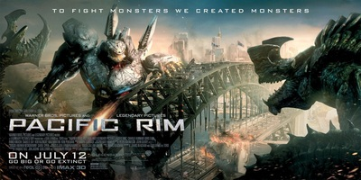
Family Movie: | HIS | HER | AVG
1. Appropriate for teenagers (eg. language, sexuality, violence)? | 9.5 | 9.5 | 9.5
2. Entertainment value for girl teenagers (12 and up)? | 8 | 8 | 8
3. Entertainment value for boy teenagers (12 and up)? | 10 | 10 | 10
4. Entertainment value for adult females? | 8.5 | 8.5 | 8.5
5. Entertainment value for adult males? | 10 | 9.5 | 9.75
6. Teaching moments, role models, moral of story? | 8 | 8 | 8
7. Is it a “classic”? (Replay value?) | 9.5 | 9.5 | 9.5
8. Audio/Visual effects? | 10 | 10 | 10
9. Not too cliché (unique and witty, not too slapstick) | 8.5 | 8.5 | 8.5
10. Climax/Resolution/Ending? | 9.5 | 9.5 | 9.5
GRAND TOTALS: |  |  | 91.25%

His Thoughts: This is going to turn out to be one of the best MISSED movies of the summer. I don’t know why more people are not talking about this movie, after watching this in IMAX following Man of Steel in IMAX the bar on audio/visual has been raised to a whole new level. This movie was the best attempt at a unique and fun “monster movie” I have seen in my entire lifetime- period. This movie was extremely clean with them not using their one free “F-Bomb” that PG-13 movies get while not allowing any blood and gore or sex talk. This movie is the kind of movie that dads should be lined up around the block to be watching with their sons, and if their daughters and wives talked their way into coming they will NOT be disappointed. What a fun, unique, visually stunning movie?! This movie will be one of the best movies of the summer and gets Ashley and I’s “Must Go” for being such a treat. This movie lived up to the hype and delivered the goods. They were even handing out free complimentary posters when we went in to see it in IMAX, HOW FLIPPEN FUN! What a cool experience, parents should not miss this experience with their families, once in a life time experience to see this in IMAX!
Her Thoughts: This was a great summer movie- tons of superb visuals and audio! The story may not have been the most in depth plot, but it was a very unique story. Loved the feel of the movie- the world coming together to fight back against these big monsters! A very fun time, especially if you see it in IMAX.

