Paranorman
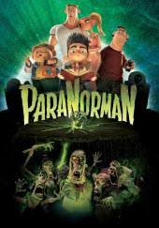
Kids and Family Movie: | HIS | HER | AVG
1. Is it a “Kids Friendly” movie? (eg. not scary, no cursing, sexuality) | 9 | 8 | 8.5
2. Entertainment value for children 12 and under? | 7 | 7 | 7
3. Entertainment value for teenagers? | 3 | 3 | 3
4. Entertainment value for parents? | 1 | 2 | 1.5
5. Entertainment value for males? | 6 | 6 | 6
6. Entertainment value for females? | 5 | 5 | 5
7. Teaching moments, role models, moral of story? | 6 | 5 | 5.5
8. Is it a “classic”? (Replay value?) | 0 | 0 | 0
9. Audio/Visual effects? | 8.5 | 8.5 | 8.5
10. Not too cliché (unique and witty, not too slapstick or potty)? | 1 | 1 | 1
GRAND TOTALs: |  |  | 46

