Pre-Conference Thoughts April 2022
What this is: an opportunity for myself to reflect on myself, my growth, those around me, the church, etc. in preparing myself for conference this coming weekend
What this is not: an opportunity to “raw raw!” the Church, sugar coat things, or repeat ad nauseam “how excited I am for conference!” for a few hours…
With that said, if you continue from this point on knowing what this is only to get upset, it is you that is the problem, not I… Period. You want mindless fan fair and dopamine hits so your brain doesn’t have to actually think for itself, I’m sure there is a boomer Youtube video out there with your name on it…
For years, whenever leaders of the church called us “Mormons” I cringed, and in most cases I raised my voice is opposition to it- but I always followed the keys. When President Monson did his “Meet the Mormons!” I created an account on the website and answered questions with Ashley because we were asked to do so- but I voiced my displeasure and prayed that someday this would be corrected. President Nelson became the prophet and changed the policy, and overnight the same people who attacked me for “critiquing the prophet of God!” all of the sudden were hell bent (and I mean that literally, they were and are bent on going straight to hell) whenever I referred to myself as LDS or as a “Latter-day Saint”… No apology was given by members of my branch, or my family, or by missionaries, etc. that got in my face every time I voiced my displeasure of “Meet the Mormons” (while I did the program- most of which getting upset at me never even bothered!)…
Why do I bring this up? Because there are two things really bothering me at the moment, one is currently still being pushed by the leadership and the other the leadership is painfully silent on and once again I pray that this will someday be changed… No, I’m not talking about women and the priesthood, or horrendous sins becoming accepted in the most sacred places on earth- no, I’m grounded in truth, the pyramid of truth, I’m talking about eternal truths that we as Saints need to align our will with the Father’s on and stop trying to make God’s will fit our narratives (just like the “Meet the Mormons”)
I've been preparing myself and my thoughts leading up to conference now for a while... I didn't think it was possible, but I actually think (and it is probably already obvious to some listening thus far) that I'm going to tick a lot more people off tonight, hahaha- good times!...
So what is the first issue I have?
People continue to ask me and each other "what do you hope for in conference?" or "what do you hope to hear?" etc. etc. etc. every single conference and the answers people give blow me away (in a bad way) and the rationale is even weaker...
After really studying the last few months in the School of Joseph’s Boys- the Light of Christ vs Holy Ghost, the Pyramid of Truth, etc. etc. etc. the realization of the first point, I hope, should be sinking into everyone's minds... The question everyone really should be asking themselves dealing with general conference is this:
"What can I learn/hear in conference that I cannot learn/hear on my own?"
The answer to that question can literally be summed up in two points tied to the keys of the kingdom... So what should we desire from conference? Those two things... for everything else, EVERYTHING else we can obtain ourselves through diligent scripture study with the Gift of the Holy Ghost, and if we are not obtaining it in that manner and expecting conference to do it for us by osmosis, well, then we are "lazy learners and lax disciples" in deed...
"What can we learn/hear in conference that we cannot learn/hear on our own?"
- “Thou shalt do for the church/world collectively”: these are given in the form of counsel, “urgings”, policy, direct commands, etc. It is fascinating to me, that the keys of the Kingdom only can do two things for us that we cannot do for ourselves, and they are the things we A) don’t look for and B) rationalize away the need to listen to them when they do give it… A prophet (or anyone with keys of authority over another) can declare “thou shalt dos” for those they have stewardship over- they do not need to have a sustaining vote to bring it into being.
- “Thou shalt know for the church/world collectively”: these are given in the form of new doctrine, new declarations, new proclamations, etc. new doctrine, or for that matter all doctrine, declared or taught at conference needs to be sustained by the entire quorum of Apostles- even a prophet cannot unilaterally declare doctrine.
So where in lies the first major problem that I wish we would stop perpetuating in this generation of men? That if it doesn’t fall into these two categories, there is nothing you “gained” at conference that one could not, and should be, gaining on their own in personal study. I’ve said it in the past and I’ll say it again- for the righteous, conference is becoming more of a way to confirm what you have been studying the last six months is truly what the Lord wanted you to be studying, and very few if any real direction from the keys. Let it be clear, that through personal study and with the Lord and the Holy Ghost, one can and should be learning much clearer “thou shalt knows and dos” for them specifically then they will obtain at conference… So where in lies the first problem that has to be, and will eventually be corrected (just like “Meet the Mormons”)?
“Come to Conference with a question, ANY question, and I promise you that the Lord will answer your question at Conference!”
No. No, no, no, NO NO NO!
Elder Eldred G. Smith taught (Ask, Seek, and Knock):
Oliver Cowdery learned this lesson too. It seems that he had made an attempt to translate and failed, as a result of which we have the revelation given in Section 9 of the Doctrine and Covenants, which is a key to revelation, in which the Lord said to Oliver Cowdery through Joseph Smith: "Behold, you have not understood; you have supposed that I would give it unto you, when you took no thought save it was to ask me.
"But, behold, I say unto you, that you must study it out in your mind; then you must ask me if it be right, and if it is right I will cause that your bosom shall burn within you; therefore, you shall feel that it is right.
"But if it be not right you shall have no such feelings, but you shall have a stupor of thought that shall cause you to forget the thing which is wrong; therefore, you cannot write that which is sacred save it be given you from me" D&C 9:7-9
As it was with Oliver Cowdery, so also we may have assumed that all the Prophet Joseph Smith did was to look into the Urim and Thummim and all the rest was done for him, with no other effort on his part.
And now we are doing this as a church? We are teaching ourselves, our children, etc. that we can literally take no thought whatever, take no initiative on our own, no effort feasting on the Words of Christ, etc. and simply sit in front of a TV and have the answers given to us via osmosis? Simply by asking the question and siting still? This is utter pish-posh, but it is reflective of the current state of the Latter-day Saints, a state that Hugh Nibley described in pointed detail when he said:
My sense of urgency comes from the fact that I spend all my days now with the scriptures. And the two marks of the Church I see are and have been for a long time these: a reverence for wealth and a contempt for the scriptures. Naturally, the two go hand in hand. We should call attention to the fact that these things we are doing are against the work of the Lord. There is one saying of Joseph Smith I think of quite often: “If the heavens seem silent at a time when we desperately need revelation, it is because of covetousness in the Church. God has often sealed up the heavens because of covetousness.” And now the Church isn’t just shot through with covetousness, it is saturated with covetousness. And so the heavens are going to be closed. We’re told we don’t get revelation if we put our trust in money in the bank.
- Hugh Nibley (“Nibley Talks about Contemporary Issues,” 13)
https://scholarsarchive.byu.edu/cgi/viewcontent.cgi?article=1055&context=mi
We as members have developed a contempt for the scriptures, for hard earned eternal truths, for the expanding of the intelligence, etc. we have instead placed “wealth” as our God and our image to the world. Let me here, boldly declare, that you will obtain no profound spiritual knowledge worth anything bought so cheaply- so stop teaching it like that is the case. We go to conference to hear “thou shalt knows” and “thou shalt dos” and everything else is simply “nourishment from the good Word of God” that we can be and should be obtaining on our own, in our families, in preparation for the return of the true patriarchal order patterned after the eternal patriarchal order of heaven… We need to stop waiting on the Brethren to confirm where we are on the Macro Last-day Timeline… We need to stop waiting on the Brethren to teach us what we already should know by studying the books we already have at our disposal… It is not the Brethren’s job!
Elder Bednar clearly taught us (Prepared to Obtain Every Needful Thing):
If all you or I know about Jesus Christ and His restored gospel is what other people teach or tell us, then the foundation of our testimony of Him and His glorious Latter-day work is built upon sand. We cannot rely exclusively upon or borrow gospel light and knowledge from other people — even those whom we love and trust
D&C 45
71 And it shall come to pass that the righteous shall be gathered out from among all nations, and shall come to Zion, singing with songs of everlasting joy.
72 And now I say unto you, keep these things from going abroad unto the world until it is expedient in me, that ye may accomplish this work in the eyes of the people, and in the eyes of your enemies, that they may not know your works until ye have accomplished the thing which I have commanded you;
There will be, and are in fact things that the brethren are specifically told not to talk about… But, we can take solace in the fact that President Nelson recently said that one of the things he recently learned and will never forget is that “the Lord is able and is doing His own work”- and how does the Lord do this? Through the weak things of the earth, through the young and middle aged men, etc. etc. etc.
So with that said, I huge part of what I wanted to talk about today was actually the School of Joseph’s Boys… For two reasons
1. Conference becomes the means by which we confirm that what we have been doing/studying the last six months is from the Lord
and
2. Because it becometh us all to learn these doctrines, gain testimonies of them, and commit to live them on our own- it is not on the brethren
So what is the School of Joseph’s Boys? It is a group of Saints dedicated to study, community, Zion, etc. with the aim to become “one heart and one mind” with respects to doctrine and our faith in The Church of Jesus Christ of Latter-day Saints. We hold no keys, we obviously don’t “represent the church”, and all the other ridiculous things people now have to say or the corporation arm comes after you- what we are is simply a group of Saints seeking to build Zion, first in our minds, hearts, and community in preparation for the real deal- for if we don’t desire it, seek after it, and become, we will not invited to the actual thing, we will not obtain the actual blessing… Period… So, how can we join it, and how does it run?
What is the School of Joseph’s Boys and what is it’s purpose?
First and foremost this is run on Discord, on the server Zion or Bust!, Discord being an ad free social sharing platform that is free to download and use on phone, pc, etc.
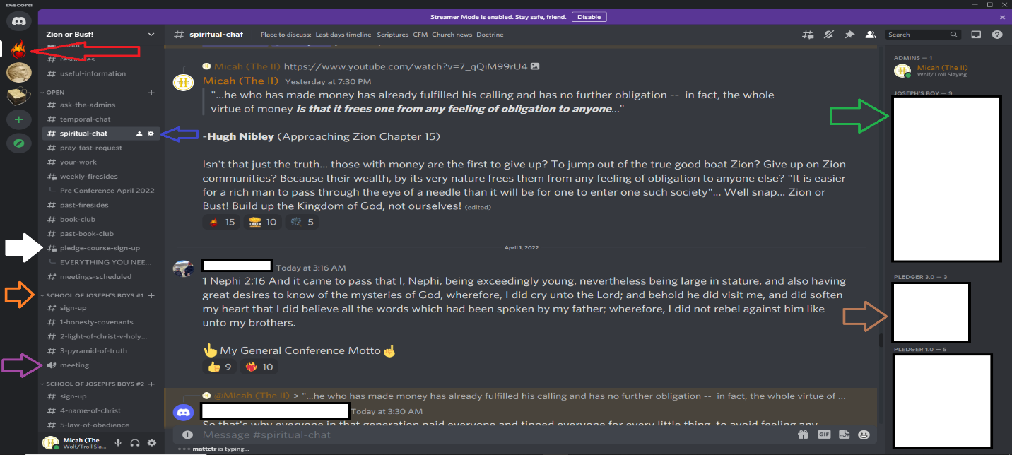
To help create a one heart, one mind community, with hearts knit, with feet planted firmly in the doctrine of The Church of Jesus Christ of Latter-day Saints. Know the doctrine, learn to work in a Zion group, and share the gospel. This is entirely optional, for those who want a more doctrinal centered experience with a hands on approach in a study group with others
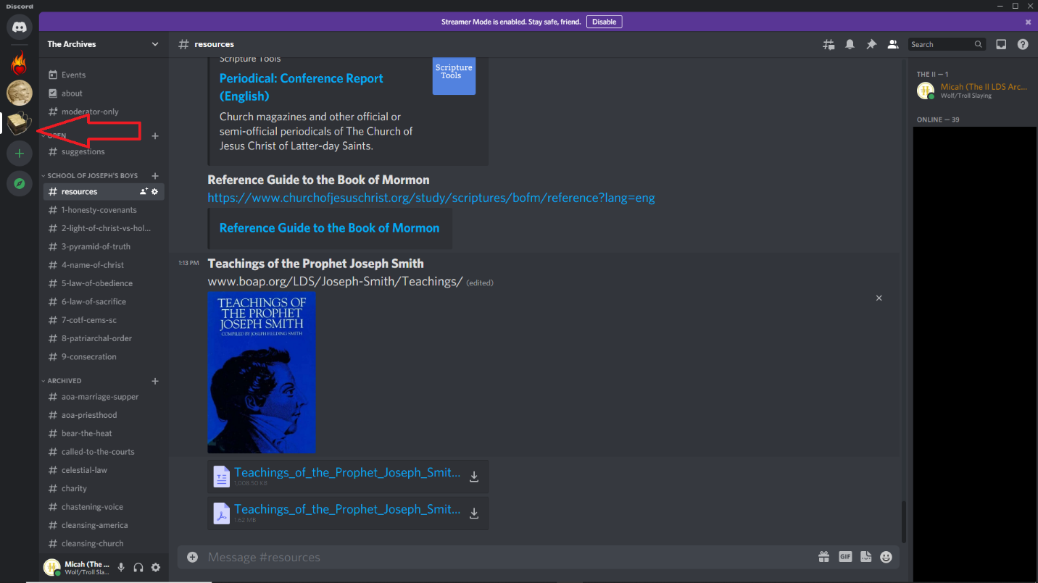
Our Stake President at Priesthood Conference (Midland MI Stake 03/20) went over "Honesty/Covenants" and then went through every point that we are doing in School of Joseph's Boys... The Law of the Gospel, the Law of Obedience, the Law of Sacrifice, etc. etc. etc.
Literally, every, single, point...
Then committed us all to learn about them, live up to our covenants, and teach them to others
Once again, this was confirmation of what we have been studying being the will and mind of our Savior, and I expect the same to play out this weekend during conference.
I've said it before and will say it again... We have PMG to get people into The Church of Jesus Christ of Latter-day Saints... the temple was where we learned how to get into The Church of the Firstborn, and we are no longer teaching that in the temple. The ordinance time is being cut down to bare bones- the making of the covenant is now the key, while the learning of the covenants themselves are now pre/post expected... When everything goes down, there will be those sent out to "gather people in and unto the Church of the Firstborn" (i.e. "second mission dreams") and they will be teaching this- what is contained in the School of Joseph's Boys... Same topics and themes designed to help members of The Church of Jesus Christ of Latter-day Saints become members of the Church of the Firstborn... (what used to be contained in the older much longer endowment sessions)

The Stake President at the end of his talk mentioned that Elder Cook (who was the one who taught all the Stake Presidents this same topic to go and teach their stakes!) told him that "he had seen the face of the Savior, and knows that he lives"... Which is the climax to the entire subject found in "the Church of the Firstborn"...
Our stake president further committed us to study the first 4 chapters of the handbook and to review the covenants we make in the temple and gave us this new church webpage:
https://www.churchofjesuschrist.org/temples/prophetic-teachings-on-temples?lang=eng
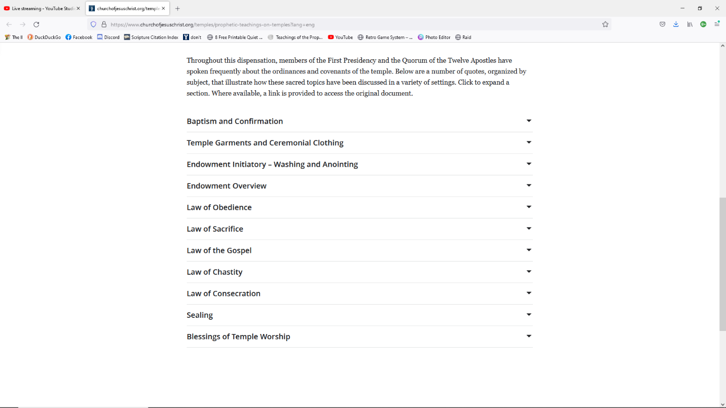
We in the School of Joseph’s Boys have been doing this now for the last few months… The Lord is gathering the gatherers, he is preparing those who desire to be used by Him in the coming days, months, years… and we are proving if we are worthy of that blessing or not- and let me bear my solemn testimony that being used by the Lord truly is one of the greatest of blessings!
I truly expect that a lot of conference will be, once again, nothing new, but rather a confirmation to those with ears tuned to the Savior’s voice, and eye open to His ways, that they have been following the correct path the last six months… I fully expect a focus dealing with the above- all of which tie directly into rending the veil which is exactly where we currently are in the Macro Last-day Timeline:
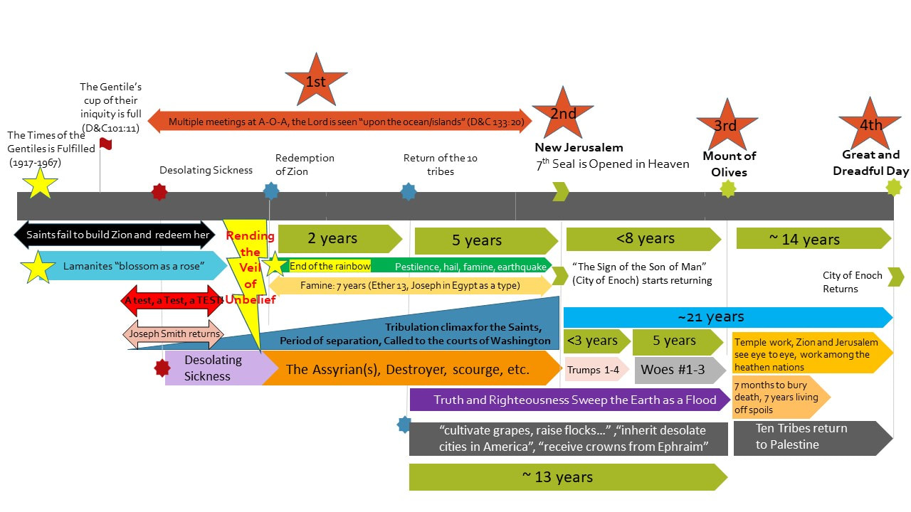
What do we need as Saints of the most High God, in order to rend the veil of unbelief? Exactly what we have been focusing on in the School of Joseph’s Boys, exactly what our Stake President just taught us and committed us to study and then teach to others, etc. and I fully expect a large focus of this conference to be on the same. Will we get the standard fan fair milk that conference has become? Of course… Will we get our announcement that BYU will be shutting down, Celestial Law is being reinstated, etc? Fingers crossed! But I fully expect a large focus to be the above… And those that have not been listening to the Voice of the Savior the past six months, and/or those who haven’t given Him the time will be playing “catch up” at conference… But be warned, if you are constantly playing “catch up”, that by its very definition makes one an “unwise servant”… If you decided last conference to all of the sudden take “following the prophet” seriously, or the study of that topic, I’m sorry, too late! You are playing catch up! If you decided a couple conferences ago to all of the sudden take “temporal preparedness” seriously, or the study of that topic, once again, I’m sorry, TOO LATE! Likewise with this conference, if you aren’t ready for what is going to be taught but once it IS taught this coming weekend THEN you will take it seriously- TOOOOOOOOOO LAAAAAATTTTE!
“Do it now, time is running out!” –President Nelson
We have to decide if this man of God is a Prophet of God- Prophets of God cannot lie to the people. Either he is a prophet and time WAS running out 3 years ago, or he is a raving mad man and what does any of this even matter then… Do it now, time is running out! In the name of Jesus Christ, amen!

