Preface

v. 1.03

The Macro Last-day Timeline: Overview
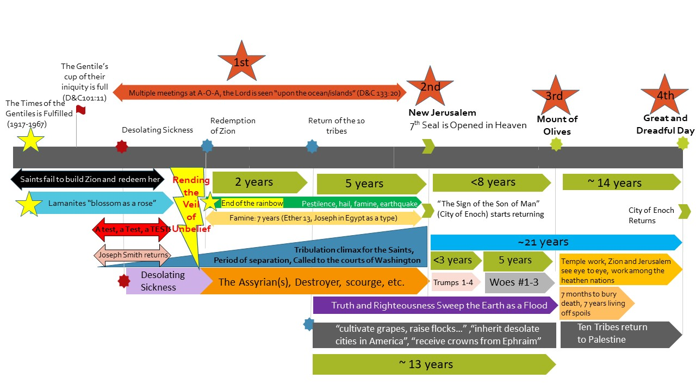

The Macro Last-day Timeline: Part One

Doctrines of the Gospel Student Manual, Chapter 36: The Lord’s Second Coming
The Savior will make several appearances before His Second Coming to all the world.
1st
- Christ will appear at Adam-ondi-Ahman (see Daniel 7:9–10, 13–14; D&C 116).

- The Savior will appear to those in the New Jerusalem in America (see 3 Nephi 21:23–25; D&C 45:66–67).
2nd

3rd
- The Savior will appear to the Jews in Jerusalem (see D&C 45:48, 51–53; Zechariah 12:10; 14:2–5).

4th
- The Lord will appear in glory to all mankind (see D&C 45:44; 101:23; Matthew 24:30; Isaiah 40:5; JST Revelation 1:7).

Bruce R. McConkie (The Millennial Messiah, p.578–79)
4th
“Before the Lord Jesus descends openly and publicly in the clouds of glory, attended by all the hosts of heaven; before the great and dreadful day of the Lord sends terror and destruction from one end of the earth to the other;
3rd
before he stands on Mount Zion, or sets his feet on Olivet,

or utters his voice from an American Zion or a Jewish Jerusalem; before all flesh shall see him together; before any of his appearances, which taken together comprise the second coming of the Son of God﻿
2nd
—before all these, there is to be a secret appearance to selected members of his Church. He will come in private to his prophet and to the apostles then living. Those who have held keys and powers and authorities in all ages from Adam to the present will also be present.”
1st

Charles W. Penrose (Old Testament Student Manual 1 Kings-Malachi, Enrichment I: The Battle of Armageddon: A Prophetic View, Section (I-8) Armageddon: The Deliverance p.295/ The Second Advent, Millennial Star, 10 Sept. 1859, 583)
2nd
“[Christ’s] next appearance [after his appearance in the New Jerusalem]

will be among the distressed and nearly vanquished sons of Judah. At the crisis of their fate, when the hostile troops of several nations are ravaging the city and all the horrors of war are overwhelming the people of Jerusalem, he will set his feet upon the Mount of Olives, which will cleave and part asunder at his touch. Attended by a host from heaven, he will overthrow and destroy the combined armies of the Gentiles, and appear to the worshipping Jews as the mighty Deliverer and Conquerer so long expected by their race; and while love, gratitude, awe, and admiration swell their bosoms, the Deliverer will show them the tokens of his crucifixion and disclose himself as Jesus of Nazareth, whom they had reviled and whom their fathers put to death. Then will unbelief depart from their souls, and ‘the blindness in part which has happened unto Israel’ be removed.
3rd
4th
The great and crowning advent of the Lord will be subsequent to these two appearances; but who can describe it in the language of mortals? The tongue of man falters, and the pen drops from the hand of the writer, as the mind is rapt in contemplation of the sublime and awful majesty of his coming to take vengeance on the ungodly and to reign as King of the whole earth. He comes! The earth shakes, and the tall mountains tremble; the mighty deep rolls back to the north as in fear, and the rent skies glow like molten brass. He comes! The dead Saints burst forth from their tombs, and ‘those who are alive and remain’ are ‘caught up’ with them to meet him. The ungodly rush to hide themselves from his presence, and call upon the quivering rocks to cover them. He comes! with all the hosts of the righteous glorified. The breath of his lips strikes death to the wicked. His glory is a consuming fire. The proud and rebellious are as stubble; they are burned and ‘left neither root nor branch.’ He sweeps the earth ‘as with the besom of destruction.’ He deluges the earth with the fiery floods of his wrath, and the filthiness and abominations of the world are consumed. Satan and his dark hosts are taken and bound﻿—the prince of the power of the air has lost his dominion, for He whose right it is to reign has come, and ‘the kingdoms of this world have become the kingdoms of our Lord and of his Christ.’”

Ezra Taft Benson (Five Marks of the Divinity of Jesus Christ, New Era, December 1980)
Last, I Name As a Mark of His Divinity His Promised Coming.
He told the Twelve, “I go to prepare a place for you.
“And if I go and prepare a place for you, I will come again.” (John 14:2–3; italics added.)
As the time of His departure drew nigh, He took them to a place outside of Bethany. There He imparted His last instructions and blessing to the Twelve. He then arose “while they beheld” and ascended to heaven, and two heavenly messengers appeared and spoke: “Ye men of Galilee, why stand ye gazing up into heaven? this same Jesus, which is taken up from you into heaven, shall so come in like manner as ye have seen him go into heaven.” (Acts 1: 9–11; italics added.)
Since that day, 19 centuries have come and gone. Because He has not yet come, some scoffingly say, as Peter prophesied, “Where is the promise of his coming? for since the fathers fell asleep, all things continue as they were from the beginning of the creation” (2 Pet. 3:4).
Before He comes, the testimony of the servants of God will be rejected, by and large. Because of this rejection, great calamities will befall the nations of the world, for the Lord Himself has declared:
“For after your testimony cometh the testimony of earthquakes, that shall cause groanings in the midst of her, and men shall fall upon the ground and shall not be able to stand.
“And also cometh the testimony of the voice of thunderings, and the voice of lightnings, and the voice of tempests, and the voice of the waves of the sea heaving themselves beyond their bounds.
“And all things shall be in commotion; and surely, men’s hearts shall fail them; for fear shall come upon all people.” (D&C 88:89–91.)
“And there shall be men standing in that generation, that shall not pass until they shall see an overflowing scourge; for a desolating sickness shall cover the land.
(The reason why President Benson believed that this was an important message to proclaim to this generation of single adults and why he also proclaimed “this is a marked generation” [In His Steps, 1988] is because he understood the prophecy regarding the times of the Gentiles being fulfilled.)
“But my disciples shall stand in holy places, and shall not be moved; but among the wicked, men shall lift up their voices and curse God and die.
“And there shall be earthquakes also in divers places, and many desolations; yet men will harden their hearts against me, and they will take up the sword, one against another, and they will kill one another.” (D&C 45:31–33.)
The world will present a scene of conflict such as has never been experienced before. Still, men’s hearts will be hardened to the revelations from heaven. Even greater signs shall then be given to manifest the approaching great day of the Lord.
“And they shall see signs and wonders, for they shall be shown forth in the heavens above, and in the earth beneath.
“And they shall behold blood, and fire, and vapors of smoke.
“And before the day of the Lord shall come, the sun shall be darkened, and the moon shall be turned into blood, and the stars fall from heaven.” (D&C 45:40–42.)
I realize this is not a pleasant picture. I take no delight in its portrayal, nor do I look forward to the day when calamities shall come upon mankind. But these words are not my own; the Lord has spoken them. Knowing what we know as His servants, can we hesitate to raise a warning voice to all who will listen that they may be prepared for the days ahead?
Silence in the face of such calamity is sin!
But, there is a bright side to an otherwise gloomy picture﻿—the coming of our Lord in all His glory. His coming will be both glorious and terrible, depending on the spiritual condition of those who remain.
His first appearance will be to the righteous Saints who have gathered to the New Jerusalem. In this place of refuge they will be safe from the wrath of the Lord, which will be poured out without measure on all nations.
2nd
Modern revelation provides this description:
“And the glory of the Lord shall be there, and the terror of the Lord also shall be there, insomuch that the wicked will not come unto it, and it shall be called Zion.
“And it shall come to pass among the wicked, that every man that will not take his sword against his neighbor must needs flee unto Zion for safety.
“And there shall be gathered unto it out of every nation under heaven; and it shall be the only people that shall not be at war one with another.” (D&C 45:67–69.)

The second appearance of the Lord will be to the Jews. To these beleaguered sons of Judah, surrounded by hostile Gentile armies, who again threaten to overrun Jerusalem, the Savior﻿—their Messiah﻿—will appear and set His feet on the Mount of Olives, “and it shall cleave in twain, and the earth shall tremble, and reel to and fro, and the heavens also shall shake” (D&C 45:48).
3rd
The Lord Himself will then rout the Gentile armies, decimating their forces (see Ezek. 38, 39). Judah will be spared, no longer to be persecuted and scattered. The Jews will then approach their Deliverer and ask, “What are these wounds in thine hands and in thy feet?
“… I will say unto them: These wounds are the wounds with which I was wounded in the house of my friends. I am he who was lifted up. I am Jesus that was crucified. I am the Son of God.
“And then shall they weep because of their iniquities; then shall they lament because they persecuted their king.” (D&C 45:51–53.)
What a touching drama this will be! Jesus﻿—Prophet, Messiah, King﻿—will be welcomed in His own country!
Jerusalem will become an eternal city of peace!
The sons of Judah will then realize this promise:
“After their pain (the tribe of Judah) shall be sanctified in holiness before the Lord, to dwell in his presence day and night, forever and ever” (D&C 133:35).
The third appearance of Christ will be to the rest of the world. Here is His description of His Coming:
4th
“And the Lord shall be red in his apparel, and his garments like him that treadeth in the wine-vat.
“And so great shall be the glory of his presence that the sun shall hide his face in shame, and the moon shall withhold its light, and the stars shall be hurled from their places.” (D&C 133:48–49.)
All nations will see Him “in the clouds of heaven, clothed with power and great glory; with all the holy angels; …
“And the Lord shall utter his voice, and all the ends of the earth shall hear it; and the nations of the earth shall mourn, and they that have laughed shall see their folly.
“And calamity shall cover the mocker, and the scorner shall be consumed; and they that have watched for iniquity shall be hewn down and cast into the fire.” (D&C 45:44, 49–50.)
Yes, come He will!
He will come in a day of wickedness, a time when men and women will be “eating and drinking, marrying and giving in marriage” (Matt. 24:38).
He will come at a time of great upheaval and tribulation when the “whole earth shall be in commotion” (D&C 45:26).
He will come at a time when the Jewish nation is faced with extermination.
He will come as a thief in the night﻿—when the world least expects Him to come.
“But of that day, and hour, no one knoweth; no, not the angels of God in heaven, but my Father only” (JS﻿—M 1:40).
Today, I gratefully bear testimony to the marks which bear witness to His divinity: His divine birth, His ministry, His resurrection, His atoning sacrifice, His promised coming.
I testify of His great love and condescension for all our Father’s children, and His willingness to receive all who will come to partake of this goodness and mercy.
Yes, as the Book of Mormon testifies, “he denieth none that come unto him, black and white, bond and free, male and female; and he remembereth the heathen; and all are alike unto [him]” (2 Ne. 26:33).
God bless you, the youth of Zion, to believe and to be valiant in your testimony of Him whom we declare to the world to be our Lord, our Master, our Savior, our Redeemer, our God. In the name of Jesus Christ, amen.
Hyrum Andrus (Moroni’s Visit, Chapter 14: The Prophetic Vision of the Last Days)
“Christ’s appearance [at the Great and Dreadful day] will be the consummating event in a series of events that will lead to the establishment of the Lord’s universal kingdom and the renewal of the earth to paradisiacal glory.
1st
Christ’s “presence,” for example, will be with the Saints who go to establish the center place of the New Jerusalem (D&C 103:15–20). Then, after the ten lost tribes have returned, Moroni explained, Jesus will “come to Zion.” He will also come to the great council at Adam-ondi-Ahman, where he will be given “dominion, and glory, and a kingdom, that all people, nations, and languages, should serve him”—not that they will then do so, but in preparation for his millennial reign (Daniel 7:14; emphasis added).
2nd
When the work of the 144,000 great high priests is sufficiently complete in gathering the righteous into the Church of the Firstborn (D&C 77:11), Jesus will come to his temple in the New Jerusalem to place the capstone on his eternal gospel family and gather all things in one (D&C 42:36; Revelation 14:1–5).
3rd
Jesus will then appear to the Jews, to redeem them as a nation and to establish Jerusalem as the other central city, besides Mount Zion, of his millennial kingdom.

Having established his law and his program of Zion among Israel on earth by these earlier visits, Jesus will then appear to the world in glory to cleanse it of wickedness (D&C 101:23–35) and to make his kingdom universal. In quoting the fourth chapter of Malachi, Moroni rendered the first verse thus: “For behold, the day cometh that shall burn as an oven, and all the proud, yea, and all that do wickedly shall burn as stubble; for they that come shall burn them, saith the Lord of Hosts, that it shall leave them neither root nor branch” (JS–H 1:37; emphasis added). This rendition indicates that when Christ comes to the world in glory, he will not come alone. By revelation to Joseph Smith the Lord declared that he would reveal himself “from heaven with power and great glory, with all the hosts thereof” (D&C 29:11; emphasis added). In the Bible, Malachi’s statement does not indicate how the wicked will be burned, but Moroni and revelations to Joseph Smith make it clear that the wicked will be consumed by the glory of Christ and of those who accompany him when the Lord appears in the clouds of heaven (D&C 29:11–12, 21).”
4th

Doctrine and Covenants Student Manual, Enrichment H: The Last Days, p.404
(H-10) Christ’s Appearance to Mankind
When the Lord returns He will make some appearances to specific groups and then culminate His return by His appearance in great power, majesty, and glory, in such a manner that all the world will see Him (see D&C 133:17–22 and 101:22–23). Four appearances of the Lord have had particular mention by the prophets: two of these appearances will be to the Saints; one appearance will be to the Jews; and the fourth will be His final coming to the world.
The appearance at the city of New Jerusalem. The Lord “shall suddenly come to his temple” (D&C 133:2), a temple yet to be built in Jackson County, Missouri (see D&C 84:1–5; 97:10, 15–16). Elder Charles W. Penrose said that the Lord would make His appearance first among the Saints and “that appearance will be unknown to the rest of mankind. He will come to the Temple prepared for him, and his faithful people will behold his face, hear his voice, and gaze upon his glory. From his own lips they will receive further instructions for the development and beautifying of Zion and for the extension and sure stability of his Kingdom.” (Millennial Star, 10 Sept. 1859, pp. 582–83.)
The appearance at Adam-ondi-Ahman. The Lord will appear to the Saints at a great sacrament meeting at Adam-ondi-Ahman in Daviess County, Missouri, attended by those who have held the keys of the priesthood during all the gospel dispensations and by faithful Saints from all ages. The Prophet Joseph Smith said that “Daniel in his seventh chapter speaks of the Ancient of Days; he means the oldest man, our father Adam, Michael, he will call his children together and hold a council with them to prepare them for the coming of the Son of Man. He (Adam) is the father of the human family and presides over the spirits of all men, and all that have had the keys must stand before him in this grand council.” (History of the Church, 3:386–87; see also D&C 116.) Elder Joseph Fielding Smith wrote: “Not many years hence there shall be another gathering of high priests and righteous souls in this same valley of Adam-ondi-Ahman. At this gathering Adam, the Ancient of Days, will again be present. At this time the vision which Daniel saw will be enacted. The Ancient of Days will sit. There will stand before him those who have held the keys of all dispensations, who shall render up their stewardship to the first patriarch of the race, who holds the keys of salvation. This shall be a day of judgment and preparation. “In this council Christ will take over the reins of government, officially, on the earth, and the kingdom and dominions, and the greatness of the kingdom under the whole heaven, shall be given to the saints of the Most High. . . . “Until this grand council is held, Satan shall hold rule in the nations of the earth; but at that time thrones are to be cast down and man’s rule shall come to an end. . . . Then shall he give the government to the saints of the Most High.... “[This council] shall precede the coming of Jesus Christ as a thief in the night, unbeknown to all the world.” (Way to Perfection, pp. 289–91.) President Lorenzo Snow, speaking of those who will be living in Jackson County at that time, said: “If you will not have seen the Lord Jesus at that time you may expect Him very soon, to see him, to eat and drink with Him, to shake hands with Him and to invite him to your houses as He was invited when He was here before” (Deseret News, 15 June 1901, p. 1).
The appearance at the Mount of Olives. The Savior’s appearance to the Jews will occur when Jerusalem and its environs are besieged by many nations. At the close of a long and costly war, known as the battle of Armageddon, the Jews will flee for safety to the Mount of Olives. There the Savior will make His appearance. (See D&C 45:48–53; 77:15; 133:35; Revelation 11:1–13; Zechariah 14:1–9). Elder Parley P. Pratt summarized the events associated with that appearance: “Zechariah, chapter 14, has told us much concerning the great battle and overthrow of the nations that fight against Jerusalem, and he has said, in plain words, that the Lord shall come at the very time of the overthrow of that army; yes, in fact, even while they are in the act of taking Jerusalem, and have already succeeded in taking one-half the city, spoiling their houses, and ravishing their women. Then, behold, their long-expected Messiah, suddenly appearing, shall stand upon the Mount of Olives, a little east of Jerusalem, to fight against those nations and deliver the Jews. Zechariah says the Mount of Olives shall cleave in twain, from east to west, and one-half of the mountain shall remove to the north while the other half falls off to the south, suddenly forming a very great valley into which the Jews shall flee for protection from their enemies as they fled from the earthquake in the days of Uzziah, king of Judah; while the Lord cometh and all the saints with Him. Then will the Jews behold that long, long-expected Messiah, coming in power to their deliverance, as they always looked for him. He will destroy their enemies, and deliver them from trouble at the very time they are in the utmost consternation, and about to be swallowed up by their enemies. But what will be their astonishment when they are about to fall at the feet of their Deliverer and acknowledge him their Messiah! They discover the wounds which were once made in his hands, feet, and side; and on inquiry, at once recognize Jesus of Nazareth, the King of the Jews, the man so long rejected. Well did the prophet say, they shall mourn and weep, every family apart, and their wives apart. But, thank heaven, there will be an end to their mourning; for he will forgive their iniquities and cleanse them from uncleanness. Jerusalem shall be a holy city from that time forth.” (Voice of Warning, pp. 32–33.)
The Second Coming: the appearance to the whole world. As the Lord’s Second Coming approaches, signs will mark this epochal event. One of the last of these signs is the sign of the Son of Man (see D&C 88:93; JS—M 1:36). The Prophet Joseph Smith said: “Then will appear one grand sign of the Son of Man in heaven. But what will the world do? They will say it is a planet, a comet, &c. But the Son of Man will come as the sign of the coming of the Son of Man, which will be as the light of the morning cometh out of the east.” (History of the Church, 5:337.) Following the sign there will be “silence in heaven for the space of half an hour, and immediately after shall the curtain of heaven be unfolded” and the Lord will make His appearance (D&C 88:95). So great will be the glory and power of His coming that the earth will tremble, the sun shall hide his face in shame, the mountains will melt and flow down, and the waters of the seas will boil (see D&C 133:40–42, 49; 101:25). All that is corruptible will be consumed and destroyed by the brightness of His presence (see D&C 5:19; 101:24–25). The Lord will wear red clothing, signifying His great atoning sacrifice and also His judgments upon the wicked (see D&C 133:48–51). At this long-awaited day the Lord’s people will receive the reward for their faithfulness and endurance (see D&C 54:10; 133:52–53). Both the righteous living and the celestial dead will be caught up to meet the Lord in the air to be rewarded according to their deeds while the wicked are destroyed and cast into outer darkness (see D&C 88:96–97; 101:89–91). This will be the “great and dreadful day of the Lord” (D&C 110:14, 16).
April 2021 Liahona Magazine, “He is Risen: Who Saw and Will See the Resurrected Christ”
In the April 2021 Liahona magazine, the Church put out the following and note carefully the section entitled “Future”:
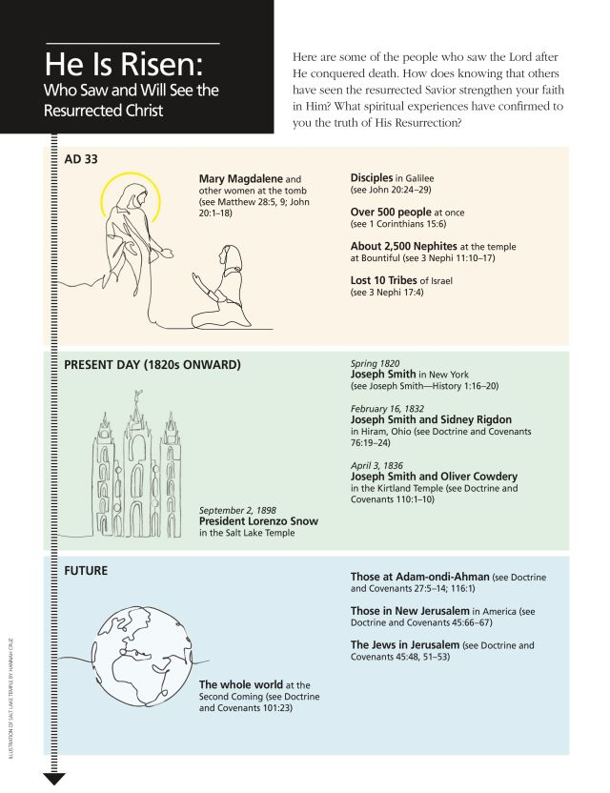
1st
3rd
2nd
4th
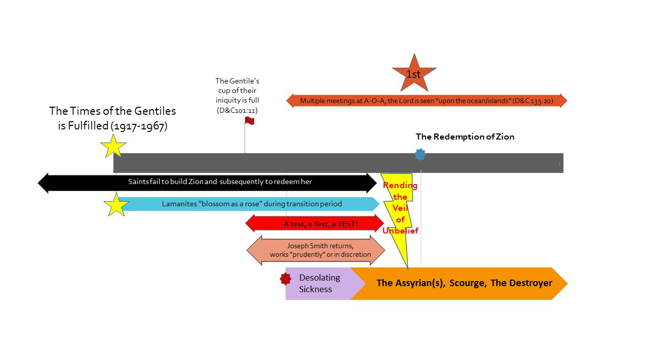
The Macro Last-day Timeline: Part Two
1. Saints Fail to Build Zion and Subsequently to Redeem Her:.
The Lord told the Saints in Doctrine and Covenants 84 that the New Jerusalem (Zion) will be built in Missouri (vs. 1-5) and later in the revelation the Lord gives warnings against those who reject the gospel (vs. 92-97). The Saints rejected the fulness of the gospel (Celestial law, D&C 45:28-29) and in consequence of that they were driven from Jackson County Missouri (D&C 101:1-8). The Lord then told the Saints that he could “redeem and make Jackson County a ‘city of Holiness” at any time (Doctrine and Covenants 105:1-2). This teaches us that Zion could have been redeemed at any time if the Saints became righteous enough. The Saints were driven to the mountains to gain experience and become righteous enough so as to qualify for the redemption (D&C 105:9-11). In this the Lord commands the Saints to learn their duty so as to live the laws required for the redemption of Zion and the building of New Jerusalem. Brigham Young taught us that all it would take is a year for the Saints to get themselves ready (Journal of Discourses 11:300).The Lord warned however, if the Saints failed to live the gospel, if they failed to redeem Zion, if they failed to read, understand, and live the Book of Mormon and Doctrine and Covenants that “there remained a scourge” (D&C 84 54-58) and that it will be poured out, as the Lord says, “first upon My house, first among those among you who profess to know me and know me not” (D&C 112:24-26). We learn that “to know the Savior”, or to “know the Savior’s voice” is to know the scriptures (D&C 84:43-53)- with a focus on The Book of Mormon and Doctrine and Covenants. The Saints’ time to get themselves ready runs out when the Gentiles’ cup of iniquity is full. In D&C 101 with the Parable of the Nobleman and the Olive Trees we learn that if we had built the tower (New Jerusalem) the destroyer would not have come, so the ultimate failure is the failure to build the tower (i.e., redeem Zion and build New Jerusalem).

2. Times of the Gentiles is Fulfilled:
The times of the Gentiles began with Peter (New Testament Student Manual p.180, President Joseph Fielding Smith Conference Report April 1966, 13), the times of the Gentiles reaching its fulness did not occur until Joseph Smith’s life (Joseph Smith History 1:41, D&C 35:17, D&C 45:28). The times of the Gentiles were fulfilled between 1917-1967, we know this for the Lord prophesied, “The Jews won’t return to Jerusalem until after the times of the gentiles be fulfilled” (JST Luke 21:20-24, 32) and thus “the generation in which the times of the gentiles was fulfilled” can be identified. The Lord promised a lot of things to “this generation”, the most spectacular being that they “will not all pass before seeing all things”, i.e., “the second coming of Jesus Christ”. This was “the sign” the Savior gave for those to look for with regards to the Savior’s return. This generation was also promised to witness the times of the Gentiles ending, which happens at the Mount of Olives (Old Testament Student Manual 1 Kings-Malachi p.293/A Voice of Warning p.33).

3. The Lamanites Blossom as a Rose:
This prophesy from the Lord, found in 3 Nephi 21:1-7 (D&C 3:16-20, D&C 49:24), is also one of “the signs” given to know that the next major signs and events were going to happen (3 Nephi 21:8-28). The “Lamanites” consist of anyone of literal ancestral descent and those adopted into the tribe of Manasseh. So simply put, “Lamanites blossoming as a Rose” would be membership in The Church of Jesus Christ of Latter-day Saints from the “Tribe of Manasseh” exploding- this once again includes both literal and adopted (3 Nephi 21:22).

4. The Gentiles’ Cup of Iniquity is Full:
The Lord said that certain events would not start to transpire until the gentiles’ cup of their iniquity is full (D&C 101:11). The Lord also said that He would not suffer there to be a “king” in this land (America) for the Lord is the King (2 Nephi 10:11-14). Prophets of God warned again and again of society’s gradual decay and the consequences of not repenting and thus reaching the point of the cup of their iniquity being full. In the 1970’s President Kimball warned that the choice currently before the nation (to serve God or as President Nelson put it, “let God prevail”) would determine the nation’s fate (President Spencer W. Kimball, The Foundations of Righteousness, Ensign Nov 1977). In 1995 we were warned that the choice we were then making as a nation as well as a church membership would bring about “the calamities foretold by ancient and modern prophets” (The Family: A Proclamation to the World), and in 2015 we sealed our fate (legalizing homosexual marriage), making the cup of our iniquity full. As Brother Hyrum Andrus put it, “The Lord has said he is going to [cleanse America when the cup of their iniquity is full], and unless he wants to offer an apology to Sodom and Gomorrah, he's going to have to do it.” (Hyrum Andrus, Lecture 7 Nephi's Prophecy of the Last Days #1). The sin of Sodom and Gomorrah was homosexuality (Isaiah 3:9-11, Jude 1:7) and the destruction of the cities was “an ensample unto those that after should live ungodly” (2 Peter 2:6). Today we continue to wrap our arms around sin and Babylon and forsake Celestial law.
5. Desolating sickness:
McConkie said, “an overflowing scourge shall cover the earth AND a desolating sickness shall sweep the land.” (Stand Independent above All Other Creatures, 1979) This is taken from D&C 45:31. Isaiah further clarifies, “what will ye do in the day of visitation (scourge)?” and “what will ye do in the day of the desolation (sickness) which shall come from far?” (2 Nephi 20:3/Isaiah 10:3) So we learn from Isaiah that the sickness originates or will come from outside of Ephraim. I would also point out that Isaiah was familiar with Gentile and Jew terminology and he failed to use it here, meaning “far” most assuredly is a reference from Isaiah to heathen nations. We know, due to the collection of scriptures surrounding this sickness, that it paves the way for the scourge in America (Isaiah 28). We also learn that the sickness and scourge are to be “vexations, only to understand the report.” (Isaiah 28:19) The sickness and scourge are not the 7 angels/vials/plagues to be poured out because those are designed to sweep people (kill) off the land, not just vexations. The sign that Jesus gave to the Jews in Jerusalem to know when the Jews’ scourging and destruction would kickstart was that a specific generation would live to see Jerusalem compassed with armies (Luke 21:20, D&C 45:19-21). The Lord similarly warned that when the generation in which the times of gentiles was fulfilled lived to see a desolating sickness sweep the land they would likewise know that scourging and destruction will be imminent (D&C 45:30-33).
6. Overflowing scourge:
The term scourge(d) is used doctrinally almost exclusively as a “whip” and is used contextually by the Lord almost entirely to mean one group of people oppressing or vexing another group of people (see LDS Topical Guide for “scourge”). Joseph Smith whenever talking about “the scourge” said to “flee from it” (Teachings of the Prophet Joseph Smith p.17-18)- you can’t flee from a sickness, in fact fleeing from a city with the sickness/plague/etc. to another “clean” city is exactly how you spread it-it is counterintuitive. The scourge is exactly what the Savior said it would be in 3 Nephi 20:28, one group scourging another. The Lord also identifies the group doing the scourging in those same passages (“the Gentiles”, 3 Nephi 20:27). Another name for the Gentiles who are doing the scourging at this time is the Assyrian(s) or as described in D&C 101:54, “the destroyer”. The Assyrian(s) or “the destroyer” or the scourge rise in conjunction with or because of the sickness that sweeps the land (D&C 45:31). These events transpire surrounding the building of New Jerusalem and thus take place primarily in America (TPJS p.17-18). The Assyrian is simply the leader of the group that is doing the scourging. This group we know is an unelected group (Isaiah 10:8/2 Nephi 20:8) and thus are Gadianton robbers. We also learn in Isaiah Chapter 10 that this group are princes (Isaiah 10:8) whose hands “found the kingdoms of the idols” (Isaiah 10:10). We also learn in Isaiah 14 that the battle of ideas that will be taking place here will be the Assyrian(s) saying we shouldn’t lose a single person/a single death is unacceptable whereas the rest of America says freedom/some people will die (this mirrors the war in heaven) (Isaiah Chapter 14). If the Assyrian(s) rise to power because of the sickness, it begs to reason that “the thing they are promising to protect people from” is the sickness.

7. Joseph Smith to Return:
Joseph Smith will be resurrected (3 Nephi 21:10) and will return. The ensign (D&C 113:5-6, Isaiah 5:26, Isaiah 11:10), the root of Jesse (Isaiah Chapter 11), my servant (3 Nephi 20-25), one mighty and strong (D&C 85:7), one like Moses (D&C 103:16) are all references to Joseph Smith. Joseph Smith was promised certain things, among them being, the successful implementation of Celestial law, the translation of the sealed portion of the Book of Mormon, the building of New Jerusalem and the calling home of the ten tribes, etc. (see Joseph Smith’s patriarchal blessings)- none of which Joseph Smith did in life and all of which need to happen as the next steps, therefore Joseph must return at this time. However, the Lord repeatedly said that this servant would be instructed of the Lord at this time and will work “prudently” (Isaiah 42:1-4, Isaiah 52:13, 3 Nephi 20:43) or in modern vernacular, in discretion (Isaiah 28:26). Brigham Young also taught that the general membership of the church might not be privy to Joseph Smith’s return and actions for some time after (Brigham Young, October 3, 1852, Millennial Star 16:594 and Deseret News, May 11, 1854).

8. A test, a Test, a TEST:
“…The time is coming when we will be mixed up in these now peaceful valleys to that extent that it will be difficult to tell the face of a Saint from the face of an enemy to the people of God. Then, brethren, look out for the great sieve, for there will be a great sifting time, and many will fall; for I say unto you there is a test, a Test, a TEST coming, and who will be able to stand?” (Orson F. Whitney, Life of Heber C. Kimball, Salt Lake City: Bookcraft, 1945, p. 446) We know that when this prophesied test takes place that the Assyrian(s)/scourge/destroyer/etc. is already around and busy. We learn what the test is in a multitude of parables and teachings (e.g., the Parable of the Ten Virgins, the Parable of the Pearl, the Parable of the Treasure in the Field etc.). This test “will try the integrity of the best of Saints” and Joseph Smith will be watching as the test is being implemented (3 Nephi 24 and 25).
9. Rending the Veil of Unbelief:
The Lord taught us Himself that rending the veil of unbelief is a part of, if not entirely so, the test (3 Nephi 26:8-11). Rending the veil of unbelief is a process of having faith as the brother of Jared. We learn what that faith is with the story of the brother of Jared (Ether 4) and in Joseph Smith’s Lectures on Faith. Another prerequisite for rending the veil of unbelief (also tied to faith) is that of having a perfect willingness to live Celestial law. President Lorenzo Snow taught us that at the very least Saints would have to have a perfect willingness to live Celestial law before the redemption of Zion would take place (Lorenzo Snow, April 5 1877, Journal of Discourses, 18:375). Celestial law has to be reinstated. Zion can’t be built by those not living celestial law (D&C 105:1-6). Celestial law contains the law of consecration (D&C 42:2,18-69; 78:1-32), law of Celestial marriage (D&C 132) etc. The fullness of the law of consecration as pertaining to Zion will not be reinstated until after the redemption of Zion (D&C 105:34), however the law of Celestial Marriage could be reinstated pre-redemption of Zion as “the first shall be last and the last first” (Matthew 19:30, 20:16), i.e. the first principles we failed/lost could be the last brought back, and the last principles we failed/lost could be the first brought back. Rending the veil of unbelief has other immediate effects including the revealing of the sealed portion of the Book of Mormon translated by Joseph Smith (2 Nephi 27, Ether 4).

10. The Redemption of Zion:
Jesus Christ personally shows up “in the mountains”, as Joseph Smith taught “This people will go into the Rocky Mountains; they will there build temples to the Most High. They will raise up a posterity there, and the Latter-day Saints who dwell in [those] mountains will stand in the flesh until the coming of the Son of Man. The Son of Man will come to them while in the Rocky Mountains.” (Wilford Woodruff, Conference Report, April 1898, p. 57.) We learn of the nature of this meeting in the Parable of the Nobleman and the Olive Trees found in Doctrine and Covenants 101. The Lord then sends Joseph Smith who will “gather the strength [of the Lord’s house], the young and middle-aged men” who will march back and redeem Zion “overshadowed by day in the form of a cloud and a pillar of flaming fire by night, the Lord’s voice being uttered forth before his army” (Doctrine and Covenants Student Manual, p.249-250, Journal of Discourses 15:364).

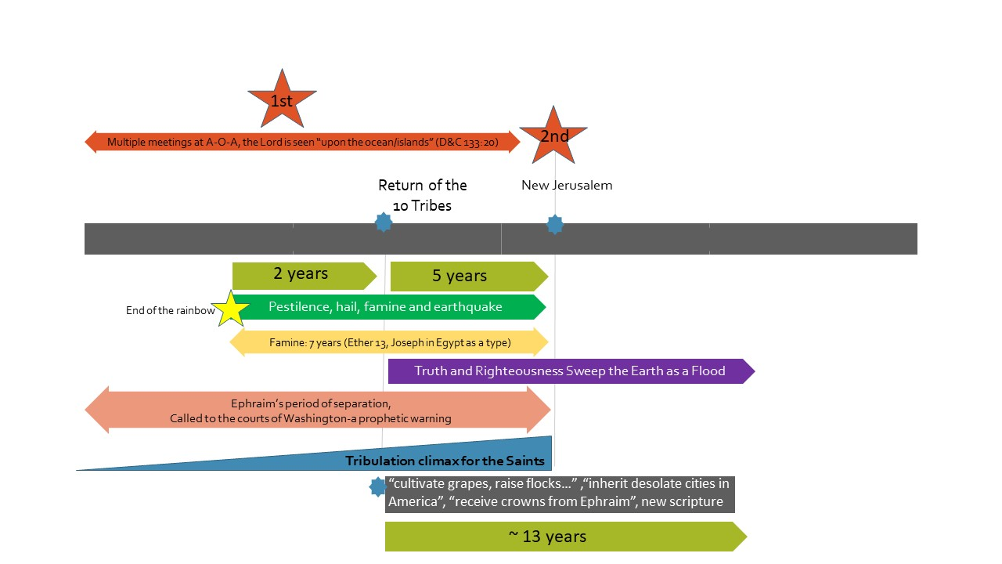
The Macro Last-day Timeline: Part Three

1. Called to Washington:
Before the Lord destroys a people, there is always a prophet called to give a final warning (2 Nephi 25:9)-this is it for America. Some examples from the scripture include Isaiah going to the king of Israel (Isaiah 1-14), Abinadi to King Noah (Mosiah 11-17), Moses to Pharaoh (Exodus 5), etc. This event, called to Washington, is Joseph Smith and/or the apostles going to the leaders of the United States of America (Brigham Young, recorded in a letter from Amanda H. Wilcox to Susie Young Gates, March, 11, 1904; Historical Dept. of the Church). Joseph Smith tells the leaders of the USA that they should not trust in the arm of flesh but rather the child that is shortly to be born, which is New Jerusalem (Isaiah 7, 2 Nephi 17, 3 Nephi 24 and 25). The prophet’s warning to the president of the United States also contains a warning in which he says that once “the child” (New Jerusalem) is born, not 3.5 years will pass before modern alliances are broken, scattered and their wealth taken (Isaiah 8/2 Nephi 18). We know from 3 Nephi 21 that Joseph will be “healed” (resurrected) and will then “shut the mouths of kings”, this is one and the same series of events (verses 8-10). It is also recorded in 3 Nephi 24 and 25 with Joseph as the same prophetic messenger. We know this won’t happen until the open return of Joseph Smith, and that doesn’t occur until the redemption of Zion (Parable of the Nobleman and the Olive Trees in D&C 101).

2. Ephraim’s Period of Separation:
The carcasses being torn in half (Isaiah 5:25), the wheat and the tares (D&C 86:1-7), the parable of the 10 virgins (Matthew 25:1-13), etc. all refer to this same time period in which the church will be purged as members say “we have enough” and that which they already have will be taken from them (2 Nephi 28:29-30). "Whenever the Lord prepares for Zion, there must be a division among the people." (Hugh Nibley, Approaching Zion, Chapter 2; JD 9:144). Imagine, “How would my life be different if my knowledge gained from the Book of Mormon were suddenly taken away?” (President Nelson, Closing Remarks, Oct 2019); “The time is coming when those who do not obey the Lord will be separated from those who do (see Doctrine and Covenants 86:1–7)” (President Nelson, The Future of the Church: Preparing the World for the Savior’s Second Coming, Ensign April 2020). We learn from Isaiah that this separation occurs primarily due to people unable or unwilling to accept new knowledge, “the whole staff of bread, the whole stay of water” (Isaiah 3:1, 2 Nephi 13:1, Book of Mormon Student Manual Chapter 10). The implementation of Celestial law as well as the new doctrine being revealed and the Saints’ pride in being unable or unwilling to accept them will be the primary causes of peoples’ apostasy. The Lord describes this division as being between those who stand in holy places and will not be moved vs those who lift up their voices, curse God and die (D&C 45:32). Those that stand in holy places are those who follow the counsel of the keys (D&C 1:14) and those who follow the counsel of the keys will be the wheat who are gathered into the garners (D&C 105:36-37). This period overlaps “a test, a Test, a TEST” with the test ending with the open return of Joseph Smith; this period continues and progressively becomes more intense.
3. Adam-ondi-Ahman;
This is the first “coming” or first star mentioned in part one, which cannot occur until after the redemption of Zion, for Joseph Smith does not openly return until the redemption of Zion (D&C 101:55-62) and Joseph Smith is openly present at Adam-ondi-Ahman (TPJS p.364-365). The first of many meetings at this location takes place and will continue to take place as the city of the New Jerusalem is constructed (Joseph Fielding Smith, The Progress of Man, 481–82). The law of consecration as pertaining to the New Jerusalem will also roll forward at this time (D&C 105:34). This will be the beginning of the second time the Lord redeems Israel (Isaiah 11:11), also known as “hunters of men” (Jeremiah 16:16). The Lord first sent for fishers (the missionaries of The Church of Jesus Christ of Latter-Day Saints), in this day he will send forth hunters (the 144,000 of the Church of the Firstborn, now in its infancy). Their job is to bring as many as they can into the Church of the Firstborn (Orson Pratt, Journal of Discourses vol. 16, pp. 312-326). The first meetings that take place will be primarily selective priesthood holders (The Millennial Messiah, p.578-579)- this is not the same thing as the Marriage Supper of the Lamb, there are multiple events that take place in this area.

4. End of the Rainbow:
“I have asked of the Lord concerning His coming; and while asking the Lord, He gave a sign and said, ‘In the days of Noah I set a bow in the heavens as a sign and token that in any year that the bow should be seen the Lord would not come; but there should be seed time and harvest during that year; but whenever you see the bow withdrawn, it shall be a token that there shall be famine, pestilence, and great distress among the nations, and that the coming of the Messiah is not far distant.’” (Joseph Smith, TPJS, pp. 340-41). Considering what comes next and the similarity of the language we know that the “bow in the heavens”, i.e., “the rainbow”, will stop being seen before the famine and before the coming of the Messiah. This is not a sign that says, “in one year the Messiah will come”, this is a sign that says, “within one year there shall be famine, pestilence and great distress among the nations, and that the coming of the Messiah is not far distant.”
5. Pestilence, Hail, Famine, & Earthquake:
“…the United States shall present such a scene of bloodshed as has not a parallel in the history of our nation; pestilence, hail, famine, and earthquake will sweep the wicked of this generation from off the face of the land, to open and prepare the way for the return of the lost tribes of Israel from the north country.” –Joseph Smith Jr (TPJS, p. 17). These events are what are described by John after he sees the 6th seal being broken in heaven (Revelation 6:12-17). These same events are discussed in D&C 88:87-97, in which the Lord said in the early 1800’s “for not many days hence…” meaning these events hadn’t taken place pre-1800’s. The same series of events are discussed in 3 Nephi chapters 20 and 21, Moses 7:60-66, JS-M, TPJS p.287, etc. Joseph Smith also identified these events as being future from his time (TPJS p.287). President Nelson recently warned that these events are still yet future, “Physical and spiritual tempests are a part of life on the earth, as the COVID-19 pandemic has reminded us. Of the time prior to His Second Coming, the Savior predicted days of great tribulation. He said, “There shall be famines, and pestilences, and earthquakes, in divers places” (Joseph Smith—Matthew 1:29)” (Liahona, January 2021, Grow Into the Principle of Revelation).
6. 7 Year Famine (Tribulations) Start:
We learn about the details surrounding the famine from Joseph in Egypt as a type (Ether 13:6-8). It is mentioned in point 5 above but is important enough that it also gets its own point here. Is this “tribulation” or is this “famine”? Frankly I think the word game is moot, as a “tribulation” might not have a “famine” but a “famine” always causes “tribulation”; so to say “there will be a famine” means “there will be tribulation”. Will this “tribulation” be different than the “tribulation of Judah”? You better believe it. Will these two tribulations have many things in common? You better believe it. Remember, “the first shall be last and the last shall be first” (Matthew 19:30, 20:16)- this is what we call a chiasmus or the mirror principle. Preparing for this famine is what separates the five foolish virgins vs. the five wise (Matthew 24:31-51; 25:1-13).

7. Return of the 10 Tribes:
At this time Joseph Smith calls the 10 tribes home, they are revealed and return as a body. We learn from the story of Joseph being sold into Egypt being “a type” of how things will play out directly before the redemption of Zion as well as the building of the New Jerusalem, that Joseph’s brothers (10 tribes) will return 2 years (Genesis 45:6) into the 7 years of “famine/tribulation” (Ether 13). When they get to Zion the journey will have been so miraculous “that it shall no more be said, The Lord liveth, that brought up the children of Israel out of the land of Egypt; But, The Lord liveth, that brought up the children of Israel from the land of the north” (Jeremiah 16:14-15). Then will be sung the song “sing thou barren” (3 Nephi 22:1). How long will they remain in Zion? Elder Pratt answered the same question, “How long will they who come from the north countries tarry in the heights of Zion? Sometime. They have got to raise wheat, cultivate the grape, wine and oil, raise flocks and herds, and their souls will have to become as a watered garden” (Orson Pratt, Journal of Discourses, 18:25). They will remain there until the events at the Mount of Olives, at which point they will return to Palestine (Orson Pratt, Journal of Discourses, 18:68). The remaining 144,000 will be chosen (“elected”) from the returned ten tribes, 12,000 from each of the tribes are chosen, sealed in their foreheads set apart, and sent out to gather (Revelation Chapter 7). They will be purified as silver in that Holy City in one of its Holy Temples (3 Nephi 24:1-7).
8. Truth and Righteousness Sweep the Earth As A Flood:
Joseph Smith taught us that in the Parable of the Mustard Seed the fowls lodging in the branches were the angels of God. Joseph continued teaching us that the angels doing the lodging would be our ancestors. On another occasion Joseph Smith said that when this work takes place, when truth and righteousness sweep the earth, that “angels and men are to be co-workers” (TPJS p.159, 84). These are the 144,000. Angels will continue to free-flow intelligence to those living in New Jerusalem, giving direction on how the city is to be built and what is to be done (“Section 133, The Lord’s Appendix to the Doctrine and Covenants,” Doctrine and Covenants Student Manual (2002), 335–43). Also, in connection with this truth sweeping the earth as a flood (Moses 7:61-62), we have the sealed portion of the Book of Mormon which by this point in time will have been brought forth (2 Nephi 27, Ether 4), but we will also have the scriptures of the returned ten tribes (Talmage, Conference Report, Oct. 1916, p. 76). Knowledge from this point on will begin to trickle forth as from a dam that has sprung leaks. It is a gradual process until the dam is finally broken and the world is flooded with knowledge (D&C 121:26-33; 128:18-19). Another important series of events that will transpire regarding revealing of truth is discussed in detail in Alma 37; Joseph Smith will bring forth or reveal the works of darkness of the world.

9. Tribulation Climaxes for the Saints:
Also referred to as the yoke or burden of the Assyrian (Isaiah 10:27), or the wrath of the Dragon (JST Revelation 12:13-17). As the New Jerusalem is being built the Assyrian’s influence and power will get “even to the neck” (Isaiah 8:8), it will almost surround the city. John the Revelator sees that when the Dragon can’t get the child (New Jerusalem), the Dragon is wroth and goes after soft targets, those he can get- members of the church worldwide who for whatever reason are not in New Jerusalem (JST Revelation 12:13-17), for those who will not flee must take us the sword to fight against his neighbor (D&C 45:68). There will be many evil alliances made at this time and many anti-Christs (necromancers) will arise that perform great miracles in direct opposition to truth (Isaiah 8:19, Old Testament Student Manual p.146, JS-Matthew 21-25).
10. New Jerusalem:
The 144,000 and an innumerable host (Revelation 7), putting the “cap stone on” (Joseph Smith, History, 1838-1856, volume E-1 [1 July 1843-30 April 1844]), Jesus “suddenly appears in His temple” (3 Nephi 24:21) etc. are all tied to the same event, the Anointing in New Jerusalem. “I saw in the night visions, and, behold, one like the Son of man came with the clouds of heaven, and came to the Ancient of days, and they brought him near before him. And there was given him dominion, and glory, and a kingdom, that all people, nations, and languages, should serve him: his dominion is an everlasting dominion, which shall not pass away, and his kingdom that which shall not be destroyed.” (Daniel 7:13-14). President Spencer W. Kimball taught, “when Satan is bound in a single home- when Satan is bound in a single life- the Millennium has already begun in that home, in that life” (The Teachings of Spencer W. Kimball, ed. Edward L. Kimball [1982], p.172). With this definition of “the Millennium”, the Millennium begins for the Saints of God at the time of the Anointing, for Jesus will be dwelling in the midst of New Jerusalem and Satan will be bound there. Using the same definition, the “Millennium” for the Jews will start after the Mount of Olives, and the “Millennium” for the world will start at the Great and Dreadful Day. That being said however, the events at the Mount of Olives or the Great and Dreadful Day officially begin the “1,000 years”, for we know the Lord could have appeared in the New Jerusalem during any generation righteous enough to redeem and build the New Jerusalem (D&C 105:1-2), whereas the events at the Mount of Olives and the Great and Dreadful Day are fixed.

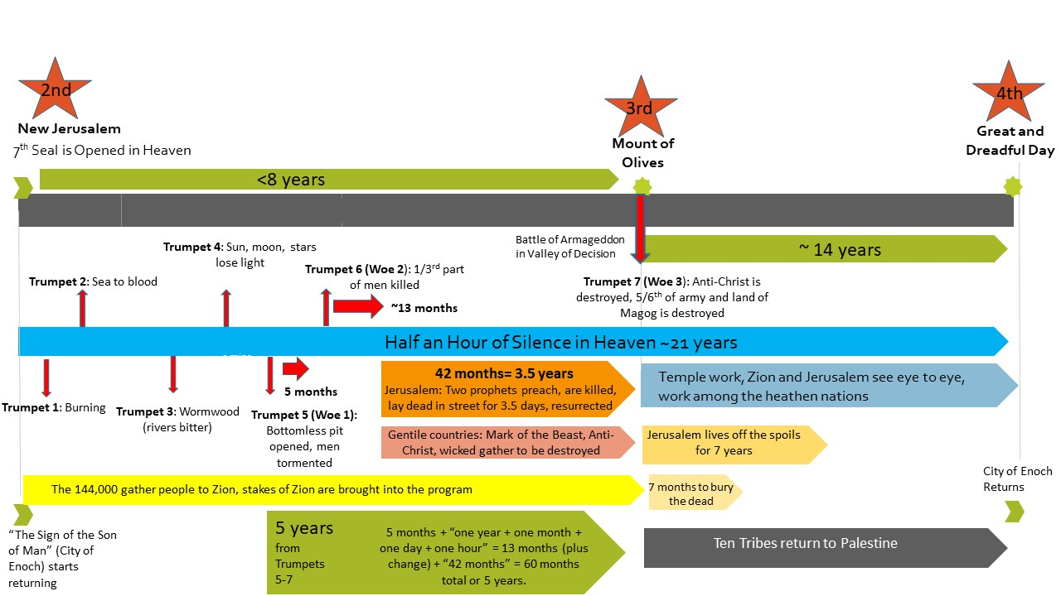
The Macro Last-day Timeline: Part Four

1. Sign of the Son of Man:
The 7th seal is opened in heaven (Revelation 8:1) around the same time that the sign of the Son of Man appears (D&C 88:91-95). It was documented that Joseph Smith said that the sign of the Son of Man is the city of Enoch returning and that it will resemble a planet or a comet and that only the righteous will understand it’s significance (The Words of Joseph Smith: The Contemporary Accounts of the Nauvoo Discourses of the Prophet, p.181). This sign is a countdown to the Great and Dreadful Day. We know this because the City of Enoch returns (gets to Earth) “at the end of the world” (JST Genesis 14:34, Moses 7:61-66) and we know that “the end of the world” means or is synonymous with “the destruction of the wicked, which is the end of the world” (JS-Matthew 1:4), and “the destruction of the wicked” is a reference to the Great and Dreadful Day (Doctrines of the Gospel Student Manual, Chapter 36: The Lord’s Second Coming). Moroni further clarified to Joseph Smith that those who come with the Savior at the Great and Dreadful Day will be those who burn the wicked (JS-H 1:37). The time of this countdown, the space between first seeing the sign of the Son of Man in the sky and it’s actual arrival to Earth, (“silence in heaven for about half an hour”) is most often calculated with 1 day = 1000 years (2 Peter 3:8). This calculation works out to be 20.8 years or ~ 21 years.
2. Day of the Jews/144,000;
At this day the gospel will be primarily preached to the Jews and Israel. Before this day the 144,000 were being selected, called, ordained and purified in the temple and were helping gather people in and unto the New Jerusalem (3 Nephi 21:23-29, 3 Nephi 24:1-3, Revelation 7, Moses 7:61-62). As Elder Orson Pratt taught, they (the 144,000) would need to be purified in the temple in the New Jerusalem so that when they went out in the days of vengeance they would not be overcome by plague, pestilence, etc. (Journal of Discourses 15:365-66). This is the day that the 144,000 will go off and perform this missionary work as the days of vengeance are poured out. This obviously includes missionary work to Old Jerusalem.

3. Trumpets #1-4:
The days of vengeance begin with the blowing of these four trumpets (Revelation 8:7-12). Many Christians lump these four together as these four judgments appear to be one large event and the scriptures do not provide time periods for these (e.g. The Wormwood Prophecy, Thomas Horn). Elder Orson Pratt did say, “the sounding of the trumpets does not take place, as many have supposed, in rapid succession, but certain events have to be accomplished between their respective soundings” (Journal of Discourses, 16:43). These events will take place literally and the horn(s) will be heard (Journal of Discourses, Orson Pratt, 16:45, 18:28). But that does not mean that the space between the successive blowing of the first four trumpets is as short as days, weeks or months, for we know that Woe #1 lasts 5 months (Revelation 9:5). These four blasts include burning, Wormwood, etc. There are those who have speculated that this event could all be related to a single meteor (for example) with the first horn being break-off debris burning up cities, the second being the break-off hitting the sea and causing the sea to turn to blood, the third trump being the actual meteor named Wormwood hitting the earth and the fourth trumpet being the third part of the sun being smitten either by now dust debris in the atmosphere or by the earth spinning faster than it did previously etc. It is very likely that whatever you speculate the cause of these four trumpets to be, they are all related and are in fact a single larger event. This is made clear by the separating of the first four trumpets as a group and the last three trumpets as “the three woes.”

4. Woe #1:
The bottomless pit is opened for the last three woes (Revelation 9:1-10). This is when the anti-Christ is first mentioned (Revelation 9:11). Those that mention the anti-Christ before all the events listed before woe #1 are confused with the points of reference. This is also the first event that a specific time is given- 5 months- in which battle readiness is reduced i.e., men are tormented.
5. Woe #2:
The next woe is broken into two parts but is a single trumpet. The anti-Christ and his army are loosed and kill a third part of men in one year + one month + one day + one hour (Revelation 9:14-21), and this is when the “mark of the beast” is introduced (Revelation 13). After that event the focus changes to Old Jerusalem- this is where the two prophets hold off the armies of Gog of Magog for three and a half years, we have the battle in the Valley of Decision i.e., the Battle of Armageddon, the two prophets being slain, and the city of Jerusalem being ravished (Revelation 11, Old Testament Student Manual 1 Kings-Malachi, Enrichment I: The Battle of Armageddon: A Prophetic View, p.291-295).
6. Mount of Olives:
This is Woe #3; Christ appears at the Mount of Olives. The two prophets are resurrected, the Jews flee into the newly formed valley where they meet the Savior, the earthquake takes place, the anti-Christ is destroyed and the lands of Magog are likewise destroyed (Revelation 14:14-20, Old Testament Student Manual 1 Kings-Malachi, Enrichment I: The Battle of Armageddon: A Prophetic View, p.291-295).
7. Jerusalem is Rebuilt/Ten Tribes Return to Palestine:
It says that it will take seven months to bury the dead and people will be able to live off the spoils for seven years (Ezekiel 39:8–16), this means that the Great and Dreadful Day will not occur for at least seven years after the events at the Mount of Olives. Joseph Smith taught, “Jerusalem must be rebuilt, and the temple and water come out from under the temple, and the waters of the Dead Sea be healed. It will take some time to rebuild the walls of the city and the temple, etc; and all this must be done before the Son of Man will make His appearance.” (TPJS, p.286). The ten tribes will begin to receive their permanent inheritances at this time (Orson Pratt, Journal of Discourses, 18:68).

8. Uniting of the Two World Capitals:
Jerusalem becomes the second world capital of the Lord’s kingdom with the law going forth from Mount Zion and the word from Jerusalem (Isaiah 2:3, Micah 4:2, TPJS p.252). At this day, “The envy also of Ephraim shall depart, and the adversaries of Judah shall be cut off: Ephraim shall not envy Judah, and Judah shall not vex Ephraim” (Isaiah 11:13).
9. Missionary Work Among Heathen Nations:
The Gentiles had their day of choosing the Lord or being destroyed temporally and spiritually (1 Nephi 14:7), then the Jews had their time to likewise choose the Lord or be destroyed (Day of the Jews/144,000); this is the day of the heathen nations, i.e. the nations without an Abrahamic background (D&C 45:54). Joseph Smith taught, “The heathen nations who will not come up to worship will be visited with the judgments of God, and must eventually be destroyed from the earth” (TPJS, p.268).
10. The Great and Dreadful Day:
We know that the Great and Dreadful Day is at least 7 years post-Mount of Olives events (Ezekiel 39:8-16) and it is also most often speculated that the “silence in heaven” is 21 years (2 Peter 3:8)- this jibes well because we know that the Lord breaks last days events into periods of seven (Old Testament Student Manual Kings-Malachi, Daniel 9:24-27). We also know that from the opening of the 7th seal to the events at the Mount of Olives (woe #3) it will be at least 60 months or 5 years (woe #1 =5 months, woe #2=55 months). With dualism we can speculate also that the time period from the opening of the 7th seal to the battle in the Valley of Decision is not greater than 8 years (2 Nephi 17:16-24, Isaiah 7:16). Taking the above information it is more than likely that there will be seven years to the Mount of Olives from the opening of the 7th seal, and fourteen years to the Great and Dreadful Day from the Mount of Olives (completing the half an hour of silence and keeping things in multiples of seven). At this event the Lord appears in glory to all mankind. The Doctrines of the Gospel Student Manual, Chapter 36 explains what happens at the “Great and Dreadful Day (see D&C 45:44; 101:23; Matthew 24:30; Isaiah 40:5; JST Revelation 1:7): the veil will be removed from the earth when the Savior appears (see D&C 88:95; 38:8; 101:23) and faithful Saints, both living and dead, will be caught up to meet Christ at His coming (see D&C 88:96-98; 45:45; 76:63; 1 Thessalonians 4:16-17).” The City of Enoch also makes its appearance at this time and the reunion of those from the earth and those of the City of Enoch then takes place (Moses 7:63-64), everything of a telestial order or lower will be destroyed (Joseph Fielding Smith, Doctrines of Salvation, 1:86–87) and the earth will be partially rolled back to the presence of God (TPJS, p.181).

