RUSH
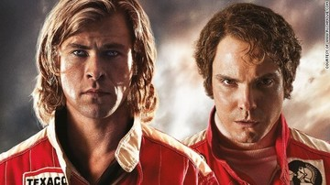
Grown–up’s Movie: | HIS | HER | AVG
1. Appropriate levels of sexuality? | 5 | 5 | 5
2. Appropriate levels of language? | 8.5 | 8.5 | 8.5
3. Appropriate levels of violence? | 10 | 9.5 | 9.25
4. Entertainment value for females? | 8 | 8 | 8
5. Entertainment value for males? | 8 | 8 | 8
6. Teaching moments, role models, moral of story? | 5 | 6 | 5.5
7. Is it a “classic”? (Replay value?) | 10 | 10 | 10
8. Audio/Visual effects? | 7.5 | 7 | 7.25
9. Not too cliché (unique and witty, not too slapstick) | 8.5 | 8.5 | 8.5
10. Climax/Resolution/Ending? | 7 | 7 | 7
GRAND TOTALS: |  |  | 77%

His Thoughts: I understand that this was about a “playboy” kinda guy but I really didn’t need to see all the graphic sex stuff to keep me interested. Everyone has a sex life, yes, almost all of the time it is completely not interesting. I want to know the man, what he was, how he did it, etc… Following one man’s sex life and painting it like that “was the man” was a shallow painting of someone. Imagine how liberals would be if you did that to Clinton? Hahaha… Needless to say super interesting movie that just went down “roads” that it really didn’t need to; losing a lot of the audience and my interest in the process. You could hear the audience mutter “they really didn’t need to show this…” and I couldn’t have agreed more- this movie would have been better, with less…
Her Thoughts: Overall this was a pretty good movie. Based on true events, it follows two Formula 1 race car drivers. It was neat to see the rivalry between these two men and how they pushed each other to be the best they could be because of their own differences. I thought the actors were very good. Could have been cleaned up a bit- that would have made the movie do better.

