Sharpening the Sword
#1 (v 1.00)

Golden Scripture #1
Amos 3: 7 Surely the Lord God will do nothing until he revealeth his secret unto his servants the prophets.
Application: Need for a prophet, working definition of a prophet, etc.
Golden Scripture #2
Moroni 10: 4 And when ye shall receive these things, I would exhort you that ye would ask God, the Eternal Father, in the name of Christ, if these things are not true; and if ye shall ask with a sincere heart, with real intent, having faith in Christ, he will manifest the truth of it unto you, by the power of the Holy Ghost.
Application: How to know something personally is true and the requirements
Story/Scripture Chain #1:
JSH 1:
5 Some time in the second year after our removal to Manchester, there was in the place where we lived an unusual excitement on the subject of religion. It commenced with the Methodists, but soon became general among all the sects in that region of country. Indeed, the whole district of country seemed affected by it, and great multitudes united themselves to the different religious parties, which created no small stir and division amongst the people, some crying, “Lo, here!” and others, “Lo, there!” Some were contending for the Methodist faith, some for the Presbyterian, and some for the Baptist.
[“religious fighting”] image: cross + fist
7 I was at this time in my fifteenth year. My father’s family was proselyted to the Presbyterian faith, and four of them joined that church, namely, my mother, Lucy; my brothers Hyrum and Samuel Harrison; and my sister Sophronia.
[“family divided”] image: house broken in half
8 During this time of great excitement my mind was called up to serious reflection and great uneasiness; but though my feelings were deep and often poignant, still I kept myself aloof from all these parties, though I attended their several meetings as often as occasion would permit. In process of time my mind became somewhat partial to the Methodist sect, and I felt some desire to be united with them; but so great were the confusion and strife among the different denominations, that it was impossible for a person young as I was, and so unacquainted with men and things, to come to any certain conclusion who was right and who was wrong.
[“Joseph confused/undecided”] image: a question mark
10 In the midst of this war of words and tumult of opinions, I often said to myself: What is to be done? Who of all these parties are right; or, are they all wrong together? If any one of them be right, which is it, and how shall I know it?
11 While I was laboring under the extreme difficulties caused by the contests of these parties of religionists, I was one day reading the Epistle of James, first chapter and fifth verse, which reads: If any of you lack wisdom, let him ask of God, that giveth to all men liberally, and upbraideth not; and it shall be given him.
12 Never did any passage of scripture come with more power to the heart of man than this did at this time to mine. It seemed to enter with great force into every feeling of my heart. I reflected on it again and again, knowing that if any person needed wisdom from God, I did; for how to act I did not know, and unless I could get more wisdom than I then had, I would never know; for the teachers of religion of the different sects understood the same passages of scripture so differently as to destroy all confidence in settling the question by an appeal to the Bible.
13 At length I came to the conclusion that I must either remain in darkness and confusion, or else I must do as James directs, that is, ask of God. I at length came to the determination to “ask of God,” concluding that if he gave wisdom to them that lacked wisdom, and would give liberally, and not upbraid, I might venture.
[“Joseph Smith figures out how to gain more knowledge”] image: light bulb turned on
14 So, in accordance with this, my determination to ask of God, I retired to the woods to make the attempt. It was on the morning of a beautiful, clear day, early in the spring of eighteen hundred and twenty. It was the first time in my life that I had made such an attempt, for amidst all my anxieties I had never as yet made the attempt to pray vocally.
15 After I had retired to the place where I had previously designed to go, having looked around me, and finding myself alone, I kneeled down and began to offer up the desires of my heart to God…
[“Joseph prays”] image: two hands together
15…I had scarcely done so, when immediately I was seized upon by some power which entirely overcame me, and had such an astonishing influence over me as to bind my tongue so that I could not speak. Thick darkness gathered around me, and it seemed to me for a time as if I were doomed to sudden destruction.
16 But, exerting all my powers to call upon God to deliver me out of the power of this enemy which had seized upon me, and at the very moment when I was ready to sink into despair and abandon myself to destruction—not to an imaginary ruin, but to the power of some actual being from the unseen world, who had such marvelous power as I had never before felt in any being—
[“satan attacks”] image: dagger
just at this moment of great alarm, I saw a pillar of light exactly over my head, above the brightness of the sun, which descended gradually until it fell upon me.
17 It no sooner appeared than I found myself delivered from the enemy which held me bound. When the light rested upon me I saw two Personages, whose brightness and glory defy all description, standing above me in the air. One of them spake unto me, calling me by name and said, pointing to the other—This is My Beloved Son. Hear Him!
18 My object in going to inquire of the Lord was to know which of all the sects was right, that I might know which to join. No sooner, therefore, did I get possession of myself, so as to be able to speak, than I asked the Personages who stood above me in the light, which of all the sects was right (for at this time it had never entered into my heart that all were wrong)—and which I should join.
19 I was answered that I must join none of them, for they were all wrong; and the Personage who addressed me said that all their creeds were an abomination in his sight; that those professors were all corrupt; that: “they draw near to me with their lips, but their hearts are far from me, they teach for doctrines the commandments of men, having a form of godliness, but they deny the power thereof.”
[“Joseph’s First Vision”] image: light coming between trees
Application: To teach of Joseph Smith, the First Vision, the Restoration, etc. You obviously will not be using the entire story every time you teach it, in fact the overwhelming majority what was highlighted in gold will only be what you will be using. Having the entire story done in your scriptures however, will make it that much easier if you ever do teach more of the story or are asked on the fly to do so.
Story/Scripture Chain #2:
@JSH 1: 17b
“God, Privilege of Seeing” pg. 180
-Gen 32:30 pg. 51
-Ex. 33:11 pg. 132
-Deut. 34:10 pg. 308
-Job 19:26 pg. 694
@Gen 32:30b
“God, Privilege of Seeing” pg. 180
-Ex. 33:11 pg. 132
-Deut. 34:10 pg. 308
-Job 19:26 pg. 694
@Ex. 33:11b
“God, Privilege of Seeing” pg. 180
-Gen 32:30 pg. 51
-Deut. 34:10 pg. 308
-Job 19:26 pg. 694
@Deut 34:10b
“God, Privilege of Seeing” pg. 180
-Gen 32:30 pg. 51
-Ex. 33:11 pg. 132
-Job 19:26 pg. 694
@Job 19:26
-TG pg. 180
-Gen 32:30 pg. 51
-Ex. 33:11 pg. 132
-Deut. 34:10 pg. 308
@Ex. 33:20a
- JST Ex. 33:20 pg 800
- Show me “no man can see God and live”, if they can’t show you, level shift and move on, if they can:
- What translation of the Bible are you using? Mine, in the “Inspired Translation” it says _____, what does yours say for Ex. 33:11 (on the same page)? Your translation stinks… Yours don’t jibe, mine does!
@John 1:18b+c
“God, Privilege of Seeing” pg. 180
JST “… except he hath borne record of the son…”
-Gen 32:30 pg. 51
-Ex. 33:11 pg. 132
-Deut. 34:10 pg. 308
-Job 19:26 pg. 69
- Show me “no man can see God and live”, if they can’t show you, level shift and move on, if they can:
- What translation of the Bible are you using? Mine, in the “Inspired Translation” it says _____, what does yours say for Ex. 33:11? Your translation stinks… Yours don’t jibe, mine does!

Application: If the concern “no man shall/will see God and live!” comes up while teaching the First Vision/Restoration. Examples of how to use it and when to use it are given above. If they can’t show you a scripture than move on…

Fire Scriptures of the Day: 2 Nephi 29
6 Thou fool, that shall say: A Bible, we have got a Bible, and we need no more Bible. Have ye obtained a Bible save it were by the Jews?
7 Know ye not that there are more nations than one? Know ye not that I, the Lord your God, have created all men, and that I remember those who are upon the isles of the sea; and that I rule in the heavens above and in the earth beneath; and I bring forth my word unto the children of men, yea, even upon all the nations of the earth?
8 Wherefore murmur ye, because that ye shall receive more of my word? Know ye not that the testimony of two nations is a witness unto you that I am God, that I remember one nation like unto another? Wherefore, I speak the same words unto one nation like unto another. And when the two nations shall run together the testimony of the two nations shall run together also.
9 And I do this that I may prove unto many that I am the same yesterday, today, and forever; and that I speak forth my words according to mine own pleasure. And because that I have spoken one word ye need not suppose that I cannot speak another; for my work is not yet finished; neither shall it be until the end of man, neither from that time henceforth and forever.
10 Wherefore, because that ye have a Bible ye need not suppose that it contains all my words; neither need ye suppose that I have not caused more to be written.
11 For I command all men, both in the east and in the west, and in the north, and in the south, and in the islands of the sea, that they shall write the words which I speak unto them; for out of the books which shall be written I will judge the world, every man according to their works, according to that which is written.
Application: For those who become hardened and proclaim “a bible a bible we have got a bible”. Doing a search in the Topical Guide “Scriptures, Lost” found on page 452 of the topical guide will also help with expounding this. Writing “TG: Scriptures, Lost pg 452” in the margins of 2 Nephi 29: 6-11 is also recommended

Example of “story drawing images”:
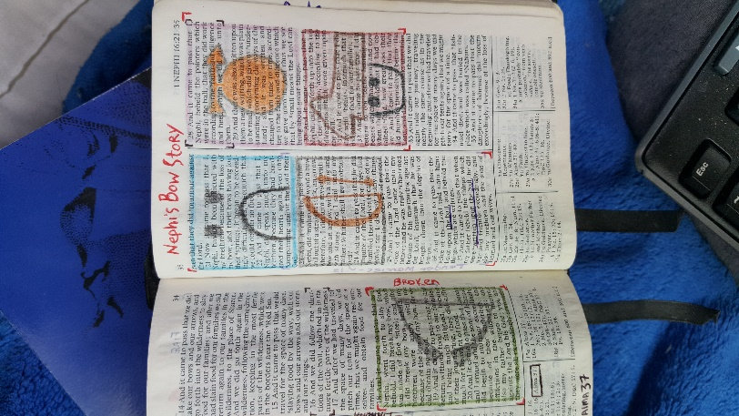
Example of “Fire”:
