Sharpening the Sword
#2 (v. 1.00)

Golden Scripture #1
1 Corinthians 10: 1-4 Moreover, brethren, I would not that ye should be ignorant, how that all our fathers were under the cloud, and all passed through the sea; And were all baptized unto Moses in the cloud and in the sea; And did all eat the same spiritual meat; And did all drink the same spiritual drink: for they drank of that spiritual Rock that followed them: and that Rock was Christ.
Application: Baptism and Gift of the Holy Ghost before John the Baptist
Golden Scripture #2
Mark 16:16 He that believeth and is baptized shall be saved; but he that believeth not shall be damned.
Application: Baptism is essential
Story/Scripture Chain #1:
ACTS 19: 1-6
And it came to pass, that, while Apollos was at Corinth, Paul having passed through the upper coasts came to Ephesus: and finding certain disciples, He said unto them, Have ye received the Holy Ghost since ye believed? And they said unto him, We have not so much as heard whether there be any Holy Ghost. And he said unto them, Unto what then were ye baptized? And they said, Unto John’s baptism. Then said Paul, John verily baptized with the baptism of repentance, saying unto the people, that they should believe on him which should come after him, that is, on Christ Jesus. When they heard this, they were baptized in the name of the Lord Jesus. And when Paul had laid his hands upon them, the Holy Ghost came on them; and they spake with tongues, and prophesied.
Acts 19: 13-16
Then certain of the vagabond Jews, exorcists, took upon them to call over them which had evil spirits the name of the Lord Jesus, saying, We adjure you by Jesus whom Paul preacheth. And there were seven sons of one Sceva, a Jew, and chief of the priests, which did so. And the evil spirit answered and said, Jesus I know, and Paul I know; but who are ye? And the man in whom the evil spirit was leaped on them, and overcame them, and prevailed against them, so that they fled out of that house naked and wounded.
Because these stories are so small (as seen above) I’ve posted two; drawing multiple pictures because of their size is basically impossible. You can draw one or two pictures for Acts 19: 1-6 such as baptism/hands, or simply draw the symbol for baptism + HG to let you know that that is the story so that you can find it easily (or write it in the margins). The LDS symbol for baptism used by missionaries is a squiggly line for water and an arrow going under the water, like so:
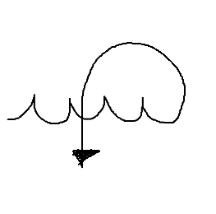
You could also draw a picture of a devil/demon for Acts 19: 13-16 to remind you that that is the story being told there (or simply write “Priesthood Authority” in the margins, etc. etc.). Another solid way I have found to highlight your scriptures for teaching SMALLER stories is by alternating colors where you plan on stopping and explaining what has just happened before continuing on, as I have shown above.
Application: Multiple baptisms for the aim to be baptized by the property authority and into the proper church (i.e. “John’s congregation into Jesus’) are okay; Gift of the Holy Ghost is by the laying on of hands; priesthood authority is required to baptize, give the Gift of the Holy Ghost and cast out demons/devils or heal etc.
Story/Scripture Chain #2:
@JSH 1: 17ish
-“Prophets After Jesus: Acts 11 +13 pg. 1386-1387”
@Acts 11: 27-28
(27a) *Acts 13:1
-Acts 15: 32 pg. 1393
-Acts 21: 10-11 pg. 1403
@Acts 13: 1
-Acts 11: 27-28 pg. 1386
-Acts 15: 32 pg. 1393
-Acts 21:10-11 pg 1403
@Acts 15: 32
-Acts 11: 27-28 pg. 1386
-Acts 13:1 pg. 1387
-Acts 21:10-11 pg 1403
@Acts 21: 10-11
-*11a Acts 11: 27-28 (pg. 1386)
-Acts 13:1 pg. 1387
-Acts 15:32 pg. 1393
Application: There were prophets after Jesus Christ with examples of them prophesying
Fire Scriptures of the Day: 1 Corinthians 7: 1-9
1 Now concerning the things whereof ye wrote unto me: It is good for a man not to touch a woman.
2 Nevertheless, to avoid fornication, let every man have his own wife, and let every woman have her own husband.
3 Let the husband render unto the wife due benevolence: and likewise also the wife unto the husband.
4 The wife hath not power of her own body, but the husband: and likewise also the husband hath not power of his own body, but the wife.
5 Defraud ye not one the other, except it be with consent for a time, that ye may give yourselves to fasting and prayer; and come together again, that Satan tempt you not for your incontinency.
6 But I speak this by permission, and not of commandment.
7 For I would that all men were even as I myself. But every man hath his proper gift of God, one after this manner, and another after that.
8 I say therefore to the unmarried and widows, It is good for them if they abide even as I.
9 But if they cannot contain, let them marry: for it is better to marry than to burn.

Application: There are Joseph Smith translations here but people won’t use them so I wouldn’t either- sounds much much worse without them… Verses 2 and 9 are the key, so remember to underline those two individual verses before drawing your fire. Getting married is “better than to burn”…
Example of “story drawing images”:
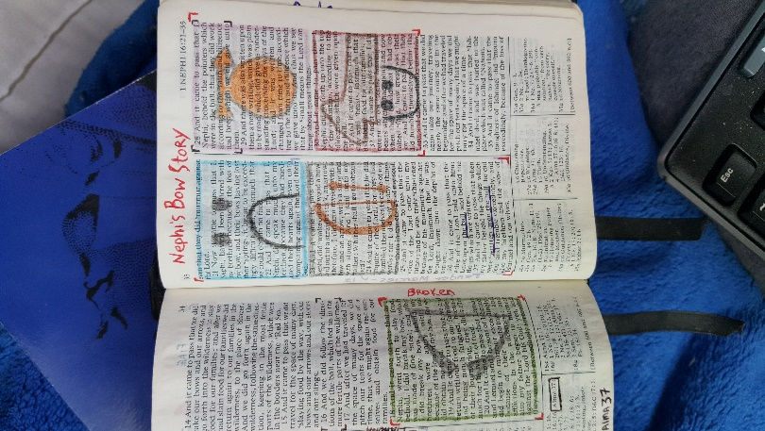
Example of “Fire”:
