Sharpening the Sword
#3 (v 1.01)

Golden Scripture #1
James 1: 5 If any of you lack wisdom, let him ask of God, that giveth to all men liberally, and upbraideth not; and it shall be given him.
Application: Can be used in conjunction with Moroni 10, but is also used all the time when teaching Joseph Smith. You might want to pen in the margin “liberally = freely” and “upbraideth not= doesn’t get upset” and in face memorize the scripture thus, most people will have a hard time understanding the scripture if you do not. Easier to just recite the “modern” version vs the kjv…
Golden Scripture #2
1 Corinthians 3:16-17 Know ye not that ye are the temple of God, and that the Spirit of God dwelleth in you? If any man defile the temple of God, him shall God destroy; for the temple of God is holy, which temple ye are.
Application: A foundational requirement for understanding before teaching the Lord’s Law of Health (most commonly and incorrectly called “The Word of Wisdom)
Story/Scripture Chain #1:
1 Nephi 16:
18 And it came to pass that as I, Nephi, went forth to slay food, behold, I did break my bow, which was made of fine steel; and after I did break my bow, behold, my brethren were angry with me because of the loss of my bow, for we did obtain no food.
19 And it came to pass that we did return without food to our families, and being much fatigued, because of their journeying, they did suffer much for the want of food.
20 And it came to pass that Laman and Lemuel and the sons of Ishmael did begin to murmur exceedingly, because of their sufferings and afflictions in the wilderness; and also my father began to murmur against the Lord his God; yea, and they were all exceedingly sorrowful, even that they did murmur against the Lord.
21 Now it came to pass that I, Nephi, having been afflicted with my brethren because of the loss of my bow, and their bows having lost their springs, it began to be exceedingly difficult, yea, insomuch that we could obtain no food.
22 And it came to pass that I, Nephi, did speak much unto my brethren, because they had hardened their hearts again, even unto complaining against the Lord their God.
[“bow breaks + no food”] image: bow breaking + frowny face
23 And it came to pass that I, Nephi, did make out of wood a bow, and out of a straight stick, an arrow; wherefore, I did arm myself with a bow and an arrow, with a sling and with stones. And I said unto my father: Whither shall I go to obtain food?
24 And it came to pass that he did inquire of the Lord, for they had humbled themselves because of my words; for I did say many things unto them in the energy of my soul.
[“bow building + problem solving”] image: bow and arrows
25 And it came to pass that the voice of the Lord came unto my father; and he was truly chastened because of his murmuring against the Lord, insomuch that he was brought down into the depths of sorrow.
26 And it came to pass that the voice of the Lord said unto him: Look upon the ball, and behold the things which are written.
27 And it came to pass that when my father beheld the things which were written upon the ball, he did fear and tremble exceedingly, and also my brethren and the sons of Ishmael and our wives.
28 And it came to pass that I, Nephi, beheld the pointers which were in the ball, that they did work according to the faith and diligence and heed which we did give unto them.
29 And there was also written upon them a new writing, which was plain to be read, which did give us understanding concerning the ways of the Lord; and it was written and changed from time to time, according to the faith and diligence which we gave unto it. And thus we see that by small means the Lord can bring about great things.
[“humbling + direction”] image: a man bowing + compass/liahona
30 And it came to pass that I, Nephi, did go forth up into the top of the mountain, according to the directions which were given upon the ball.
31 And it came to pass that I did slay wild beasts, insomuch that I did obtain food for our families.
32 And it came to pass that I did return to our tents, bearing the beasts which I had slain; and now when they beheld that I had obtained food, how great was their joy! And it came to pass that they did humble themselves before the Lord, and did give thanks unto him.
[“prevail with God”] image: deer (or any hunted animal you can draw) + smiley face

Application: Overcoming trials, how to and how to not respond to difficulties/setbacks, etc. This is a great story to use and teach when “anti-anting” someone (when things happen, what are you going to do?)
Story/Scripture Chain #2:
Mosiah 23:
25 For behold, it came to pass that while they were in the land of Helam, yea, in the city of Helam, while tilling the land round about, behold an army of the Lamanites was in the borders of the land.
26 Now it came to pass that the brethren of Alma fled from their fields, and gathered themselves together in the city of Helam; and they were much frightened because of the appearance of the Lamanites.
[“the enemy shows up”] image: swords crossed
27 But Alma went forth and stood among them, and exhorted them that they should not be frightened, but that they should remember the Lord their God and he would deliver them.
28 Therefore they hushed their fears, and began to cry unto the Lord that he would soften the hearts of the Lamanites, that they would spare them, and their wives, and their children.
29 And it came to pass that the Lord did soften the hearts of the Lamanites. And Alma and his brethren went forth and delivered themselves up into their hands; and the Lamanites took possession of the land of Helam.
[“surrender”] image: white flag
30 Now the armies of the Lamanites, which had followed after the people of king Limhi, had been lost in the wilderness for many days.
[“army is lost”] image: question mark
36 And it came to pass that the Lamanites promised unto Alma and his brethren, that if they would show them the way which led to the land of Nephi that they would grant unto them their lives and their liberty.
37 But after Alma had shown them the way that led to the land of Nephi the Lamanites would not keep their promise; but they set guards round about the land of Helam, over Alma and his brethren.
[“tricked + bondage”] image: knife in back
Mosiah 24:
8 And now it came to pass that Amulon began to exercise authority over Alma and his brethren, and began to persecute him, and cause that his children should persecute their children.
9 For Amulon knew Alma, that he had been one of the king’s priests, and that it was he that believed the words of Abinadi and was driven out before the king, and therefore he was wroth with him; for he was subject to king Laman, yet he exercised authority over them, and put tasks upon them, and put task-masters over them.
10 And it came to pass that so great were their afflictions that they began to cry mightily to God.
[“afflictions + crying”] image: man getting whipped + shouting
11 And Amulon commanded them that they should stop their cries; and he put guards over them to watch them, that whosoever should be found calling upon God should be put to death.
12 And Alma and his people did not raise their voices to the Lord their God, but did pour out their hearts to him; and he did know the thoughts of their hearts.
[“gagged”] image: thought bubble with “…”
13 And it came to pass that the voice of the Lord came to them in their afflictions, saying: Lift up your heads and be of good comfort, for I know of the covenant which ye have made unto me; and I will covenant with my people and deliver them out of bondage.
14 And I will also ease the burdens which are put upon your shoulders, that even you cannot feel them upon your backs, even while you are in bondage; and this will I do that ye may stand as witnesses for me hereafter, and that ye may know of a surety that I, the Lord God, do visit my people in their afflictions.
15 And now it came to pass that the burdens which were laid upon Alma and his brethren were made light; yea, the Lord did strengthen them that they could bear up their burdens with ease, and they did submit cheerfully and with patience to all the will of the Lord.
[“burdens made light”] image: feather
16 And it came to pass that so great was their faith and their patience that the voice of the Lord came unto them again, saying: Be of good comfort, for on the morrow I will deliver you out of bondage.
17 And he said unto Alma: Thou shalt go before this people, and I will go with thee and deliver this people out of bondage.
18 Now it came to pass that Alma and his people in the night-time gathered their flocks together, and also of their grain; yea, even all the night-time were they gathering their flocks together.
19 And in the morning the Lord caused a deep sleep to come upon the Lamanites, yea, and all their task-masters were in a profound sleep.
20 And Alma and his people departed into the wilderness; and when they had traveled all day they pitched their tents in a valley, and they called the valley Alma, because he led their way in the wilderness.
[“Lord delivers His people”] image: wings
21 Yea, and in the valley of Alma they poured out their thanks to God because he had been merciful unto them, and eased their burdens, and had delivered them out of bondage; for they were in bondage, and none could deliver them except it were the Lord their God.
22 And they gave thanks to God, yea, all their men and all their women and all their children that could speak lifted their voices in the praises of their God.
[“gratitude”] image: “g” in a circle

Application: There are a million applications for this story. As with Joseph Smith’s first vision story, this is a large one with a “golden scripture” in it that you most likely should memorize over time. You, most of the time will not be teaching or using the entire story, in fact the majority of the time, just like with the Joseph Smith first vision you would be focusing in on the golden scriptures only, but having the entire story laid out will enable you quickly to give more or less of the story as the Spirit dictates. Addictions, problems, tribulations, etc. can be related to “burdens”, and the promise from the Lord is that when we covenant with Him and work, He will make up the difference and will lighten the load so that we cannot feel the burden upon our backs. Writing a footnote for Ether 12:27 (pg. 510) and 2 Nephi 25: 23 (pg. 99) around Mosiah 24: 14 is recommended.

Fire Scriptures of the Day: Alma 32
14 And now, as I said unto you, that because ye were compelled to be humble ye were blessed, do ye not suppose that they are more blessed who truly humble themselves because of the word?
15 Yea, he that truly humbleth himself, and repenteth of his sins, and endureth to the end, the same shall be blessed—yea, much more blessed than they who are compelled to be humble because of their exceeding poverty.
16 Therefore, blessed are they who humble themselves without being compelled to be humble; or rather, in other words, blessed is he that believeth in the word of God, and is baptized without stubbornness of heart, yea, without being brought to know the word, or even compelled to know, before they will believe.
17 Yea, there are many who do say: If thou wilt show unto us a sign from heaven, then we shall know of a surety; then we shall believe.
18 Now I ask, is this faith? Behold, I say unto you, Nay; for if a man knoweth a thing he hath no cause to believe, for he knoweth it.
19 And now, how much more cursed is he that knoweth the will of God and doeth it not, than he that only believeth, or only hath cause to believe, and falleth into transgression?
Application: For those who become hardened against baptism or who want to “wait a season”. If they humble themselves and believe and are baptized they will be blessed greatly; if they do not they will be compelled to be humble by the Lord. If they, at the time of being compelled to be humble, do submit they will be blessed far less than if they had earlier, and if they still won’t repent they will be cut off.
Example of “story drawing images”:
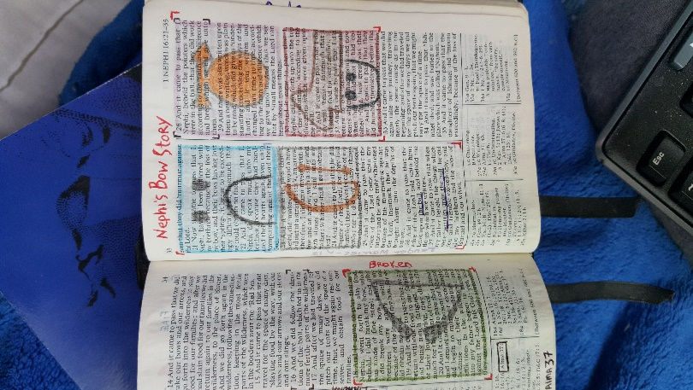
Example of “Fire”:
