Sharpening the Sword
#4 (v 1.00)

Golden Scripture #1
Malachi 3: 8 Will a man rob God? Yet ye have robbed me. But ye say, Wherein have we robbed thee? In tithes and offerings. 9 Ye are cursed with a curse: for ye have robbed me, even this whole nation. Bring ye all the tithes into the storehouse, that there may be meat in mine house, and prove me now herewith, saith the LORD of hosts, if I will not open you the windows of heaven, and pour you out a blessing, that there shall not be room enough to receive it.
Application: One of the best scriptures to teach tithing. Verse 8 footnote c “TG Tithing” I’d write a pg. 530” next to for easy access, it isn’t really worth a full scripture chain. In fact, if these verses aren’t enough, typically the Bible Dictionary “Tithe” is a better idea to read vs a scripture chain- found on page 785. Writing “B.D. Tithe pg. 785” in the margins is suggested.
Golden Scripture #2
Exodus 20: 3 Thou shalt have no other gods before me. 4 Thou shalt not make unto thee any graven image, or any likeness of any thing that is in heaven above, or that is in the earth beneath, or that is in the water under the earth: 5 Thou shalt not bow down thyself to them, nor serve them: for I the LORD thy God am a jealous God, visiting the iniquity of the fathers upon the children unto the third and fourth generation of them that hate me; 6 And shewing mercy unto thousands of them that love me, and keep my commandments. 7 Thou shalt not take the name of the LORD thy God in vain; for the LORD will not hold him guiltless that taketh his name in vain. 8 Remember the sabbath day, to keep it holy. 9 Six days shalt thou labour, and do all thy work: 10 But the seventh day is the sabbath of the LORD thy God: in it thou shalt not do any work, thou, nor thy son, nor thy daughter, thy manservant, nor thy maidservant, nor thy cattle, nor thy stranger that is within thy gates: 11 For in six days the LORD made heaven and earth, the sea, and all that in them is, and rested the seventh day: wherefore the LORD blessed the sabbath day, and hallowed it. 12 Honour thy father and thy mother: that thy days may be long upon the land which the LORD thy God giveth thee. 13 Thou shalt not kill. 14 Thou shalt not commit adultery. 15 Thou shalt not steal. 16 Thou shalt not bear false witness against thy neighbour. 17 Thou shalt not covet thy neighbour’s house, thou shalt not covet thy neighbour’s wife, nor his manservant, nor his maidservant, nor his ox, nor his ass, nor any thing that is thy neighbour’s.
Application: The Ten Commandments. These are still listed separately in PMG’s “Commandments” chapter, they are that important. They are also key to being able to create scripture chains for a lot of the other commandments easily in one location, so all you need to remember is “Exodus 20” and you’ll have the launch point for your scripture chains.
Story/Scripture Chain #1:
1 Samuel 15:
1 Samuel also said unto Saul, The LORD sent me to anoint thee to be king over his people, over Israel: now therefore hearken thou unto the voice of the words of the LORD.
2 Thus saith the LORD of hosts, I remember that which Amalek did to Israel, how he laid wait for him in the way, when he came up from Egypt.
3 Now go and smite Amalek, and utterly destroy all that they have, and spare them not; but slay both man and woman, infant and suckling, ox and sheep, camel and ass.
[“prophet commands”] image: pointing finger
4 And Saul gathered the people together, and numbered them in Telaim, two hundred thousand footmen, and ten thousand men of Judah.
5 And Saul came to a city of Amalek, and laid wait in the valley.
6 And Saul said unto the Kenites, Go, depart, get you down from among the Amalekites, lest I destroy you with them: for ye shewed kindness to all the children of Israel, when they came up out of Egypt. So the Kenites departed from among the Amalekites.
7 And Saul smote the Amalekites from Havilah until thou comest to Shur, that is over against Egypt.
[“Saul and army attack”] image: sword
8 And he took Agag the king of the Amalekites alive, and utterly destroyed all the people with the edge of the sword.
9 But Saul and the people spared Agag, and the best of the sheep, and of the oxen, and of the fatlings, and the lambs, and all that was good, and would not utterly destroy them: but every thing that was vile and refuse, that they destroyed utterly.
[“Saul spares king and livestock”] image: crown + sheep
13 And Samuel came to Saul: and Saul said unto him, Blessed be thou of the LORD: I have performed the commandment of the LORD.
14 And Samuel said, What meaneth then this bleating of the sheep in mine ears, and the lowing of the oxen which I hear?
[“Samuel questions Saul”] image: question mark
15 And Saul said, They have brought them from the Amalekites: for the people spared the best of the sheep and of the oxen, to sacrifice unto the LORD thy God; and the rest we have utterly destroyed.
[“Saul’s excuse”] image: exclamation mark
16 Then Samuel said unto Saul, Stay, and I will tell thee what the LORD hath said to me this night. And he said unto him, Say on.
17 And Samuel said, When thou wast little in thine own sight, wast thou not made the head of the tribes of Israel, and the LORD anointed thee king over Israel?
18 And the LORD sent thee on a journey, and said, Go and utterly destroy the sinners the Amalekites, and fight against them until they be consumed.
19 Wherefore then didst thou not obey the voice of the LORD, but didst fly upon the spoil, and didst evil in the sight of the LORD?
[“Samuel Questions Saul”] image: question mark
20 And Saul said unto Samuel, Yea, I have obeyed the voice of the LORD, and have gone the way which the LORD sent me, and have brought Agag the king of Amalek, and have utterly destroyed the Amalekites.
21 But the people took of the spoil, sheep and oxen, the chief of the things which should have been utterly destroyed, to sacrifice unto the LORD thy God in Gilgal.
[“Saul’s excuse”] image: exclamation mark
22 And Samuel said, Hath the LORD as great delight in burnt offerings and sacrifices, as in obeying the voice of the LORD? Behold, to obey is better than sacrifice, and to hearken than the fat of rams.
23 For rebellion is as the sin of witchcraft, and stubbornness is as iniquity and idolatry. Because thou hast rejected the word of the LORD, he hath also rejected thee from being king.
[“obedience greater than sacrifice”] image: exclamation mark + ear
26 And Samuel said unto Saul, I will not return with thee: for thou hast rejected the word of the LORD, and the LORD hath rejected thee from being king over Israel.
27 And as Samuel turned about to go away, he laid hold upon the skirt of his mantle, and it rent.
28 And Samuel said unto him, The LORD hath rent the kingdom of Israel from thee this day, and hath given it to a neighbour of thine, that is better than thou.
[“rent and cast off”] image: ripped cloak
Application: Exact obedience is more important than sacrifice. Simply believing is not enough, one has to be obedient to the Lord’s commands or they will be torn off and cast off like Saul’s cloak, or as Christ taught in the New Testament “if salt loses its savor it is thenceforth good for nothing but to be cast out and cast under foot of man”.
Story/Scripture Chain #2:
@Exodus 20:8
-BD “Sabbath” pg. 764
-Acts 20: 7 pg. 1401
-1 Cor 16:2 pg. 1459
-Rev 1: 10 pg. 1566
@BD “Sabbath”
*After the ascension…
Acts 20: 7 pg. 1401;1 Cor 16:2 pg. 1459;Rev 1: 10 pg. 1566
@Acts 20: 7
-BD “Sabbath” pg. 764
-1 Cor 16:2 pg. 1459
-Rev 1: 10 pg. 1566
@1 Cor 16:2
-BD “Sabbath” pg. 764
-Acts 20: 7 pg. 1401
-Rev 1: 10 pg. 1566
@Rev 1: 10
-BD “Sabbath” pg. 764
-Acts 20: 7 pg. 1401
-1 Cor 16:2 pg. 1459
Application: If the concern “the Sabbath is on Saturday!” comes up while teaching the Ten Commandments or Keep the Sabbath Day Holy. The Sabbath was moved from Saturday to Sunday (aka “the first day of the week” aka “the Lord’s day”) in remembrance/celebration/etc. of Jesus Christ’s resurrection. They partook of the sacrament on that day confirming it very much did become their “Sabbath”…

Fire Scriptures of the Day: Malachi 4:
1 For, behold, the day cometh, that shall burn as an oven; and all the proud, yea, and all that do wickedly, shall be stubble: and the day that cometh shall burn them up, saith the LORD of hosts, that it shall leave them neither root nor branch.
2 But unto you that fear my name shall the Sun of righteousness arise with healing in his wings; and ye shall go forth, and grow up as calves of the stall.
3 And ye shall tread down the wicked; for they shall be ashes under the soles of your feet in the day that I shall do this, saith the LORD of hosts.
4 Remember ye the law of Moses my servant, which I commanded unto him in Horeb for all Israel, with the statutes and judgments.
Application: The law of Moses given at Horeb is the Ten Commandments… The consequences of not obeying the Ten Commandments are laid out a well as the promised blessings for those who do fear the Lord and keep the Ten Commandments are given.

Example of “story drawing images”:
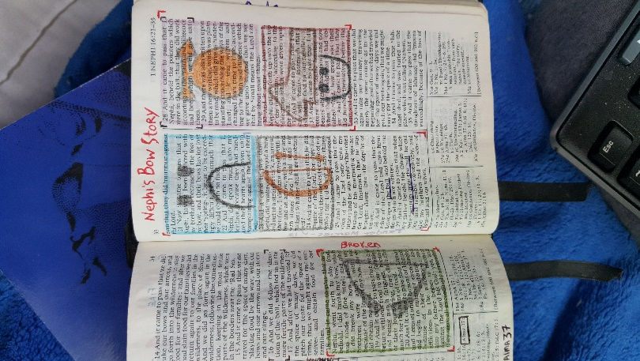
Example of “Fire”:
