The Spiderwick Chronicles
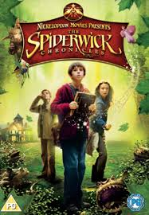
Family Movie: | HIS | HER | AVG
1. Appropriate for teenagers (eg. language, sexuality, violence)? | 8 | 8 | 8
2. Entertainment value for girl teenagers (12 and up)? | 8.5 | 8.5 | 8.5
3. Entertainment value for boy teenagers (12 and up)? | 7 | 7 | 7
4. Entertainment value for adult females? | 8 | 8 | 8
5. Entertainment value for adult males? | 7 | 7 | 7
6. Teaching moments, role models, moral of story? | 5 | 5 | 5
7. Is it a “classic”? (Replay value?) | 7 | 7.5 | 7.25
8. Audio/Visual effects? | 8 | 8.5 | 8.25
9. Not too cliché (unique and witty, not too slapstick) | 3 | 5 | 4
10. Climax/Resolution/Ending? | 5 | 5 | 5
GRAND TOTALS: |  |  | 68

