THE AMAZING SPIDER MAN 2
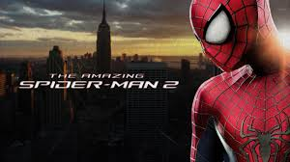

His Thoughts: This was another shock of a movie for my wife and myself… I am not a huge fan of Spider Man, never was, but what I did like about him was never in the last three Spider Man Movies… The first movie in this series of three I have to be honest, left me right where the first three left me- unsatisfied- BUT TOBY BLAH BLAH BLAH! None of them were epic, cut me a break… So-So at best! This movie- The Amazing Spider Man 2 was the first EPIC Spider Man in my life time. It had me crying in multiple spots, it had me amazed at the music and visuals, it was just simply epic. When they could make a scene epic, emotional, and gripping- THEY DID JUST THAT! They didn’t cheapen anything with weak undertones or flashy comic reliefs, they went as the expression goes “…. Deep!” and man did it pay off and man was it appreciated! Teaching moments, role models, the feel of the movie as far as audio/visual, the gripping storyline; this movie stuck to the original material better than any other Spider Man Movie to date (including the movie that this one was based on) and left my wife and I driving home going “wow, that movie was awesome…” over and over again! And to have two amazing super hero movies in such a short time (Captain America 2) I am feeling truly spoiled as typically you get about one a year and the others are so-so. You should see this movie if you are a fan of heroes, you should see this movie if you are a fan of Spider Man.
Her Thoughts: This movie was amazing! By far the best Spider Man movie made to date. The visuals were incredible and it was full of great music. The best part was the love story though :) The movie had me crying in about 4 different places. You have to see this one!

