THE CONJURING
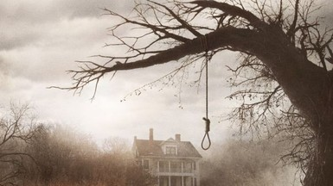
Grown–up’s Movie: | HIS | HER | AVG
1. Appropriate levels of sexuality? | 10 | 10 | 10
2. Appropriate levels of language? | 10 | 10 | 10
3. Appropriate levels of violence? | 9.5 | 9.5 | 9.5
4. Entertainment value for females? | 9 | 9 | 9
5. Entertainment value for males? | 8 | 8 | 8
6. Teaching moments, role models, moral of story? | 7 | 7 | 7
7. Is it a “classic”? (Replay value?) | 9 | 9 | 9
8. Audio/Visual effects? | 7.5 | 7.5 | 7.5
9. Not too cliché (unique and witty, not too slapstick) | 7 | 8 | 7.5
10. Climax/Resolution/Ending? | 7 | 7 | 7
GRAND TOTALS: |  |  | 84.5%

His Thoughts: Why was this movie rated R first of all? Insidious was scarier and was PG-13? Kinda silly! Because of that we have to put the movie in the “Adult” section which means it will score very high on its levels of appropriateness; this was NOT a gore fest, swearing party, or orgy but rather extremely clean… The movie is pretty scary, probably going into the top 10 scariest that I have seen; by no means being the top of the list…This movie is what you expect it to be, simple plot, haunted house, scary things happen, they live happily ever after. Because of that it really wouldn’t ever become a“classic” but because of its cleanliness and delivering a decent scare flick it really isn’t bad either. Be warned, if possessions and scary things are not your cup of coffee, this movie is not a good choice.
Her Thoughts: I thought this was a great scary movie! Probably in my top 4 scariest... I liked how it was based off of real events (makes it scarier) and I loved how cute the family was, which makes you feel so horrified for them having to go through such scary things! No blood/gore or swearing, making it a very clean movie (hard to find in the horror genre). If you like scary movies this should definitely be on your list to go see.

