THE HOBBIT: THE DESOLATION OF SMAUG
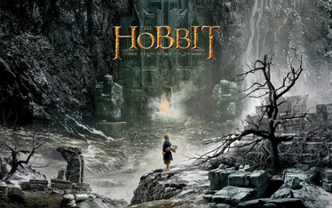
Family Movie: | HIS | HER | AVG
1. Appropriate for teenagers (eg. language, sexuality, violence)? | 9 | 9 | 9
2. Entertainment value for girl teenagers (12 and up)? | 8.5 | 8.5 | 8.5
3. Entertainment value for boy teenagers (12 and up)? | 9 | 9 | 9
4. Entertainment value for adult females? | 8 | 8.5 | 8.25
5. Entertainment value for adult males? | 9 | 9 | 9
6. Teaching moments, role models, moral of story? | 9 | 9 | 9
7. Is it a “classic”? (Replay value?) | 10 | 10 | 10
8. Audio/Visual effects? | 9 | 9 | 9
9. Not too cliché (unique and witty, not too slapstick) | 7 | 7.5 | 7.25
10. Climax/Resolution/Ending? | 7.5 | 7.5 | 7.5
GRAND TOTALS: |  |  | 86.5%

His Thoughts: This movie is Lord of the Rings; so I can’t be as “neutral” as I would like to be when it comes to grading how I liked the movie. The sound was great, the visuals on par with what you would
expect from this series, and the appeal is universal in its gender and age. The only issues I found with the movie were small, but might be enough to keep it from ever becoming “my favorite in the new Hobbit series”. Without any spoilers I will say there were issues/plot twists added into this movie that will make things very hard to tie into his “Lord of the Rings” movies while still making sense. Also the dragon was… Very large… I know the dragons were supposed to be big, but man, this thing made me wonder about the plausibility of an arrow doing any sort of damage to it even if it went deep into its flesh. Other than those gripes I had the movie was great; woman and younger people will like this movie better than the first as there was more action and even slight romance added and not as much “lore and walking around/singing in different environments”.
Her Thoughts: When I heard they were making The Hobbit into three movies I was a little confused about how they would stretch out the story that long. This movie shows why- they added things in that were not part of the book. That's not necessarily a bad thing, but if you are expecting it to follow the book exactly then you will be disappointed. It is a visually beautiful movie that I found more entertaining than the first Hobbit. They did a great job with the spiders, bear and dragon! Not a huge fan of where they stopped the movie (no feeling of closure) and am curious to see how they will finish off the trilogy! Overall a movie definitely worth seeing if you are a fan of the fantasy genre.

