THE SECRET LIFE OF WALTER MITTY
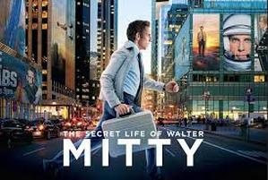
Family Movie: | HIS | HER | AVG
1. Appropriate for teenagers (eg. language, sexuality, violence)? | 10 | 10 | 10
2. Entertainment value for girl teenagers (12 and up)? | 7 | 7 | 7
3. Entertainment value for boy teenagers (12 and up)? | 7 | 7 | 7
4. Entertainment value for adult females? | 9 | 9 | 9
5. Entertainment value for adult males? | 8.5 | 8.5 | 8.5
6. Teaching moments, role models, moral of story? | 10 | 10 | 10
7. Is it a “classic”? (Replay value?) | 9 | 9 | 9
8. Audio/Visual effects? | 9 | 9 | 9
9. Not too cliché (unique and witty, not too slapstick) | 7.5 | 7.5 | 7.5
10. Climax/Resolution/Ending? | 9 | 9 | 9
GRAND TOTALS: |  |  | 86%

His Thoughts: Call me dumb but I loved this movie. Some of the most gorgeous scenery in a movie since A River Runs Through It for me. The storyline was slow, not rushed with needless and confusing plot twists and EXPLOSIONS!!! An adult movie (not because of adult material, rather the material would be mostly lost on a younger audience- much like Forrest Gump) that had amazing teaching messages and a feel good ending of hope and living your dreams. Surprised that I missed this one in theatres… The story is about a man trapped in his dreams and needed the courage to go out and live them.
Her Thoughts: This was a fantastic movie! The trailers made it look kind of weird but this was one of the better movies I have seen in a long time. Great message about facing fears and pursuing your dreams. Beautiful scenery and good music. This movie has it all :)

