THOR: THE DARK WORLD
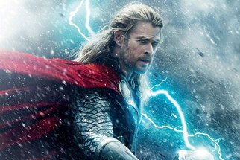
Family Movie: | HIS | HER | AVG
1. Appropriate for teenagers (eg. language, sexuality, violence)? | 9.5 | 9.5 | 9.5
2. Entertainment value for girl teenagers (12 and up)? | 9 | 9 | 9
3. Entertainment value for boy teenagers (12 and up)? | 8.5 | 8.5 | 8.5
4. Entertainment value for adult females? | 9 | 8.5 | 8.75
5. Entertainment value for adult males? | 8.5 | 8 | 8.25
6. Teaching moments, role models, moral of story? | 8.5 | 8.5 | 8.5
7. Is it a “classic”? (Replay value?) | 8.5 | 8.5 | 8.5
8. Audio/Visual effects? | 8.5 | 8.5 | 8.5
9. Not too cliché (unique and witty, not too slapstick) | 7.5 | 7.5 | 7.5
10. Climax/Resolution/Ending? | 8 | 8 | 8
GRAND TOTALS: |  |  | 85%

His Thoughts: This was better than the first and I enjoyed the first. There wasn’t any issues with major plot holes that we have come to expect in the new marvel movies (The hulk can’t control himself, everyone abandon ship! 5 minutes later… Oh don’t worry I can control myself now, because you see I figured out in the last 5 minutes… I AM ALWAYS ANGRY! RAAARRR…ORRRRRRR… Oh my word I am going to die, run, run, run, run, OH YEAH! I HAVE 30 OTHER IRON MAN SUITS BACK AT HOME!) The movie was funny but still serious enough to keep the men interested. Overall a great marvel movie in a sea of mediocrity.
Her Thoughts: Overall I thought this movie was on par with the first Thor. Pretty good story, pretty good visual effects, but nothing too extraordinary. I like the character of Thor but I am not a big fan of Natalie Portman who plays his girlfriend so maybe that's why I'm not overly excited about the movie. Worth watching on the whole as it is a good, clean fun.

