The Uninvited
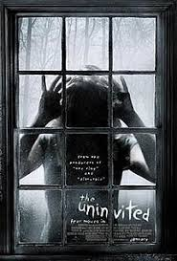
Family Movie: | HIS | HER | AVG
1. Appropriate for teenagers (eg. language, sexuality, violence)? | 6 | 6 | 6
2. Entertainment value for girl teenagers (12 and up)? | 8 | 8 | 8
3. Entertainment value for boy teenagers (12 and up)? | 5 | 6 | 5.5
4. Entertainment value for adult females? | 7.5 | 7.5 | 7.5
5. Entertainment value for adult males? | 6 | 6 | 6
6. Teaching moments, role models, moral of story? | 7 | 8 | 7.5
7. Is it a “classic”? (Replay value?) | 4 | 4 | 4
8. Audio/Visual effects? | 7 | 7 | 7
9. Not too cliché (unique and witty, not too slapstick) | 3 | 3 | 3
10. Climax/Resolution/Ending? | 0 | 2 | 1
GRAND TOTALS: |  |  | 55.5

